Supporting Information for

Juxtaposed slab dehydration, decarbonation and seismotectonic variation beneath the Philippine subduction zone based on 3-D modeling

Ye Zhu et al

This PDF file includes the following:

- Methods and model settings
- Tables S1-S3
- Figures S1-S6
- References for SI

Methods and model settings
On the basis of the thermomechanical Stag3d model (Tackley and Xie, 2003) and the finite difference method (FDM), we investigate the in situ along-strike slab thermal variation in the Philippine arc megathrust area and petrological metamorphic changes in the subducting oceanic lithosphere. An anelastic liquid approximation and equations for the conservation of mass, momentum, and energy are used in this study:
$∇⋅\left\{ρ_{s}(z,T_{s})v\right\}=0$, (1)
$-\frac{∂P}{∂x_{i}}+\frac{∂τ_{ij}}{∂x_{j}}-δ_{i3}ρ_{s}(z,T_{s})gα_{0}(T-T_{s})=0$, (2)
$ρ_{s}(z,T_{s})c_{p}(\frac{dT}{dt}+v⋅∇T)=k∇^{2}T+η(∇v)^{2}+δ_{i3}ρ_{s}(z,T_{s})gαTv_{z}+ρ_{s}(z,T_{s})H_{r}$, (3)
where $P$ is the pressure deviation from the lithostatic pressure, $α_{0}$ is the reference thermal expansivity, (,=1, 2, 3) is the stress tensor, and $δ_{ij}$ is the Kronecker delta. The energy equation includes the advection term, thermal diffusion term, viscous dissipation term, adiabatic heating term, and radioactive heating term. The main model parameters are listed in Tables S2 and S3.
The viscous flow law for wet olivine (Burkett and Billen, 2010) following laboratory experiments is included in this study. The deformation of olivine occurs by both diffusion creep ($df$) and dislocation creep ($ds$), where each mechanism accommodates a portion of the total strain rate (Hirth and Kohlstedt, 2003):
${\dot{ε}}_{t}={\dot{ε}}_{df}+{\dot{ε}}_{ds}$. (4)
The composite upper mantle viscosity under a given condition is as follows:
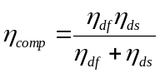, (5)
where $η_{df}$ and $η_{ds}$ are the diffusion creep and dislocation creep viscosities, respectively, for olivine. The general viscosity law is as follows:
$η_{df,ds}={\left(\frac{d^{p}}{A_{0}C_{OH}^{r}}\right)}^{\frac{1}{n}}{\dot{ε}}_{E}^{\frac{1-n}{n}}\exp\left(\frac{E_{0}+P_{l}V_{0}}{n_{0}RT_{a}}\right)$. (6)
Here, ${\dot{ε}}_{E}=(\frac{1}{2}{\dot{ε}}_{ij}{\dot{ε}}_{ij})^{\frac{1}{2}}$ is the square root of the second invariant of the strain rate tensor (e.g., Ranalli, 1995), $T_{a}$ is the absolute temperature, $R$ is the gas constant, and $P_{l}$ is the lithostatic pressure. The values of the model parameters for the diffusion and dislocation creep of olivine grains are tabulated in Table S1. The trenchward thermal structure follows the global depth and heat (GDH1) model (Stein and Stein, 1992; Grose and Afonso, 2013):
$T(z,t_{oc})=T_{m}\left[\frac{z}{d_{0}}+\frac{2}{π}\sum_{n-1}^{∞}{\frac{1}{n}sin⁡(\frac{nπz}{d_{0}})exp⁡(\frac{-n^{2}π^{2}{κt}_{oc}}{{d_{0}}^{2}})}\right]$ (7)
The time-evolving thermal boundary condition includes the initialization time. $T(z,t_{oc})$ is the temperature at depth $z$ and plate age $t_{oc}$ along the trench, $T_{m}$ is the lithospheric basal temperature, $κ$ is the thermal diffusivity, and $d_{o}$ is the minimum depth of the adiabatic heating layer.
The model incorporates 3-D geometric data for the incoming plate updated through seismic tomography (Slab2, Hayes et al., 2018) and real subduction velocities from the MORVEL (Argus et al., 2011; DeMets et al., 2010) datasets. The age of the oceanic plate is estimated at the trenchward model boundary based on the oceanic seafloor age obtained through the AuScope EarthByte (http://www.earthbyte.org, Müller et al., 2008). The thickness of the subducting plate is estimated according to the plate age (Yoshii, 1975). The incoming oceanic plate comprises a MORB layer at the top with a thickness of 7 km underlain by an ultramafic rock layer (Hacker et al., 2003). The model dimensions are 1600 km×800 km×400 km (along-arc length × across-arc length × depth) and 80×80×100 grids. The temperature boundary conditions agree with the plate cooling model (Grose and Afonoso, 2013). The bottom of the slab and the vertical planes are prescribed to be adiabatic and permeable, and the top surface is set to be at a fixed temperature (0°C) and rigid. The subduction velocities inside a prescribed 3-D constrained volume of oceanic lithosphere are given based on the kinematic plate subduction modeling method (Ji et al., 2016; Ji et al., 2017c):
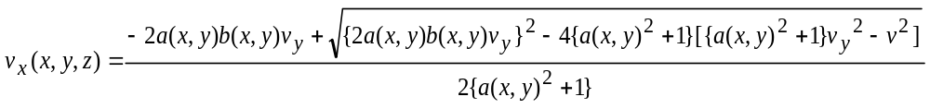, (8)
$v_{y}(x,y,z)=v_{y}$, (9)
$v_{z}(x,y,z)=a(x,y)v_{x}+b(x,y)v_{y}$, (10)
while
$a(x,y)=\frac{1}{2}[Z\left(x+Δx,y\right)-Z\left(x-Δx,y\right)]⋅\frac{z_{max}}{x_{max}}$, (11)
$b(x,y)=\frac{1}{2}[Z\left(x+Δx,y+Δy\right)-Z\left(x+Δx,y\right)+Z\left(x-Δx,y\right)-Z\left(x-Δx,y-Δy\right)]⋅\frac{z_{max}}{y_{max}}$. (12)
Here, $v$ is the subduction velocity, and $∆$ is the interval between two neighboring nodes along the axes. $x_{max}$, $y_{max}$, and $z_{max}$ indicate the model lengths along the $x$, $y$, and $z$ axes, respectively.
Surface heat flow observations from the Global Heat Flow Database (Pollack et al., 1993) and heat flow values from Curie point depth estimates (Li et al., 2017) are used to constrain the model (Fig. S1). Our model follows the trench temperature boundary of the plate cooling model (Stein and Stein, 1992; Grose and Afonso, 2013). We specified the subduction time to be at least 20 Myr to ensure that the model reached a steady thermal state with a temperature variation <10 °C over time with a lapse time of $≥$ 5 Myr. We tested the resolution and found that the temperature variance was <1%, with a maximum temperature variance <1.9% between the 80 × 80 × 100 and 96 × 96 × 100 meshes. We performed sensitivity tests to investigate the robustness of our modeling results and varied the mantle viscosity from 1.0×10¹⁹ Pa·s to 1.0×10²¹ Pa·s and the mantle density from 3250 kg/m³ to 3350 kg/m³. We present the benchmark model results as deviations from the reference models (ΔT and ΔH₂O) and show these results at different depths within the oceanic slab. The tests revealed that mantle density variations (±50 kg/m³) induce small temperature variations of <10 °C at depth.
Hacker et al. (2003) performed an extensive literature search to obtain physical properties of minerals relevant to subduction zones, and they presented a new compilation of physical properties of minerals relevant to subduction zones and new phase diagrams for mid-ocean ridge basalt, lherzolite, depleted lherzolite, harzburgite, and serpentinite. Their results show that the ultramafic mantle rocks such as harzburgite (olivine + orthopyroxene) represent the dominant rock type in mantle wedges and the uppermost mantle of the oceanic plate, and depleted lherzolite (olivine + orthopyroxene + clinopyroxene) is considered intermediate (Hacker et al., 2003). Seismological studies support the hypothesis that harzburgite represents the principal rock type in the upper mantle. The P-wave speeds observed by White et al. (1992) for the oceanic lower crust and mantle compared with P-wave speeds for various rocks at 200 MPa (Hacker et al., 2003) indicate that most oceanic uppermost mantle (suboceanic mantle) velocity measurements are best explained in terms of spinel harzburgite mantle composition. For the reasons above, in our petrological modeling approach, harzburgite is assumed to be the dominant ultramafic rock in the mantle wedge.
We established a P‒T‒wt%‒facies database according to Omori et al. (2009) (MORB) and Hacker et al. (2003) with P‒T grid intervals of 0.04 GPa (1.2 km) and 5°C. The temperature and pressure at every P‒T grid point were calculated from our 3D thermal model. The pressure (GPa) at every grid point was obtained by converting its depth (km) through the preliminary reference Earth model (PREM) parameters. Using the temperature and pressure provided by the numerical simulation, we estimated each facies domain and the corresponding water content (wt%) in every grid. Through the interpolation method, we obtained the intraslab water content distribution (wt%) at various depths and temperatures.
To calculate the intraslab slab dehydration rate, the 3-D water content at every grid was utilized. Slab dehydration (wt%/km) indicates the change in rock saturation water content (wt%) with distance (km) in the subduction direction between neighboring grids. We prescribed that the slab to be divided into >70 layers according to the mesh number, with the layer surface parallel to the plate interface. Then, the water content at a point on a layer surface was subsequently calculated from the water content at the grids surrounding this point via an interpolation method. Thus, the water content at each point on every layer surface was obtained. Next, the difference in the water content between two neighboring points in the subduction direction was divided by the point distance (which can be derived using the horizontal distance and vertical distance); subsequently, the degree of slab dehydration at each point on a layer could be obtained. First, we use interpolation to transform the water content values $wt(x,y,z)$ ($x$ and $y$ are the horizontal distances, and $z$ is the vertical distance of a node with a unit of km) into $wt(x,y,d)$, which is under another coordinate system of $(x,y,d)$ ($d$ indicates the grid depth relative to the subduction interface with a unit of km). For example, $wt(x,y,0)$ represents the water content value at the node $(x,y)$ on the subduction megathrust. Second, the water content differences between neighboring grids with the same depth from the interface ($d$ value) along the subducting slab are computed as the slab dehydration at a grid $(x,y,d)$.

$$dwt \left(x,y,d\right)=\frac{wt\left(x+1,y+tanα,d\right)-wt(x-1,y-tanα,d)}{\sqrt{4+4{\tan^{2}α+{\left\{z\left(x+1,y+tanα,d\right)-z(x-1,y-tanα,d)\right\}}^{2}}^{ }}}$$

where $α$ is the radius of subduction obliquity and $z$ indicates the grid depth (km) from the Earth’s surface. The final step is to transform the values of $dwt(x,y,d)$ into $dwt(x,y,z)$ (Suenaga et al., 2018). Based on these steps, the intraslab dehydration distribution was calculated well. The saturation of slab minerals varies during each subduction stage. Thus, slab dehydration (wt%/km) reflects the efficiency of fluid production by crystalline breakdown and fluid relaxation during subduction along the slab geometry.
The surface heat flow and Curie depth are correlated, following a theoretical thermal conduction relationship (e.g., Li et al., 2011, 2013):
$Q_{s}=K\frac{T_{c}-T_{0}}{Z_{b}-Z_{s}}+h_{r}^{2}H_{0}\frac{e^{\frac{{-Z}_{b}}{h_{r}}}-e^{\frac{-Z_{s}}{h_{r}}}}{Z_{b}-Z_{s}}+h_{r}H_{0}e^{\frac{{-Z}_{s}}{h_{r}}}$, (13)
where $Q_{s}$is the surface heat flow, $T_{c}$ is the Curie temperature at the Curie depth $Z_{b}$, $T_{O}$ is the temperature at the surface elevation $Z_{s}$, K is the average thermal conductivity of the magnetic layer (Table S4), $H_{0}$ is the heat production rate at the surface, and $h_{r}$ is the characteristic drop-off of heat production. The equation shows a nonlinear inverse relationship between heat flow and $Z_{b}$. For the lithosphere of the oceanic plate, we assume $H_{0}$= 1.37 μW/m³, $h_{r}$= 5.0 km, $T_{c}$ = 550 °C, $T_{O}$ = 5 °C, and $Z_{s}$ = 4 km. For continents, we take $H_{0}$ = 2.0 μW/m³, $h_{r}$ = 10.0 km, and $Z_{s}$ = -1 km to account for the larger radioactive contribution (Li et al., 2017). High heat flow measurements tend to be correlated with small Curie depths, and vice versa. The continental data can be best fitted with the theoretical curve of an average thermal conductivity K of ~2.5 W/m °C, and most oceanic data are best fitted with an average K = ~2.0 W/m °C (Li et al., 2013). These conductivities are compatible with those of granite and basalt (e.g., Turcotte and Schubert, 2002). Synthetic modeling suggests that the largest error in the estimated Curie depths using the linearized centroid method does not reach 35%, and the uncertainty in the surface heat flow is expected to be <20 mW/m² due to the selected fractal exponent and wavenumber bands for linear regressions and the observed surface heat flow in plate convergence zones (e.g., Li et al., 2013, 2017).

Table S1. Recorded M>7.5 earthquakes in the modeled region (USGS¹, 1900-2020)

time | latitude | longitude | depth (km) | mag | mag type | net | depthError | magError
2012-08-31T12:47:33.380Z | 10.811 | 126.638 | 28 | 7.6 | mww | us
2010-07-23T23:15:10.190Z | 6.776 | 123.259 | 640.6 | 7.5 | mwc | us
2010-07-23T22:51:11.840Z | 6.497 | 123.48 | 578 | 7.6 | mwc | us
2002-03-05T21:16:09.130Z | 6.033 | 124.249 | 31 | 7.5 | mwc | us
2001-01-01T06:57:04.170Z | 6.898 | 126.579 | 33 | 7.5 | mwc | us
1990-07-16T07:26:34.610Z | 15.679 | 121.172 | 25.1 | 7.7 | mw | us
1989-12-15T18:43:45.030Z | 8.337 | 126.729 | 24.4 | 7.6 | mw | us
1976-08-16T16:11:07.300Z | 6.262 | 124.023 | 33 | 7.9 | ms | us
1972-12-02T00:19:52.560Z | 6.405 | 126.64 | 60 | 8 | mw | iscgem | 4.8 | 0.3
1948-01-24T17:46:43.710Z | 10.714 | 122.235 | 15 | 7.8 | mw | iscgem | 4.6 | 0.2
1937-08-20T11:59:21.420Z | 14.569 | 121.675 | 15 | 7.64 | mw | iscgem | 3.8 | 0.47
1924-04-14T16:20:37.490Z | 6.625 | 126.167 | 15 | 8.12 | mw | iscgem | 51.3 | 0.66
¹ The earthquake catalog was downloaded from the USGS website (https://earthquake.usgs.gov/earthquakes/search/). These earthquakes are labeled with five-pointed stars in Fig. 1.

Table S2. Main model parameters

Model parameters Value Units
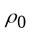
Standard density 3300ª kg·m⁻³
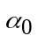Standard thermal expansion 3×10^{-5b} K⁻¹
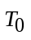
Standard temperature 1600 K
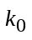
Standard thermal conductivity 2.9^{c} W·m⁻¹·K⁻¹
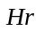
Radioactive heat generation rate in mantle 2.245×10^{-13a} W·m⁻³
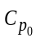
Standard specific heat at constant pressure 1200ª J·kg⁻¹·K⁻¹
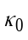Standard thermal diffusivity 7.6×10^{-7d} m²·s⁻¹
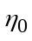Standard viscosity 1×10^{20c} Pa·s
Subduction velocity 7.8~9.3e cm·y⁻¹

 |  | Diffusion  creep^{f} | Dislocation creep^{f}
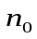 | Stress exponent | 1.0 | 3.5
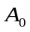 | Preexponential factor | 1.0 | 9.0×10⁻²⁰
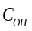 | OH concentration (H/10⁶ Si) | 1000 | 1000
 | C_{OH} exponent | 1.0 | 1.2
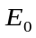 | Activation energy (kJ/mol) | 335 | 480
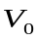 | Activation volume (m³/mol)
 | Upper mantle | 4.0×10⁻⁶ | 11.0×10⁻⁶
 | Lower mantle | 1.5×10⁻⁶ | -
 | Grain size (μm)
 | Upper mantle | 10,000 | -
 | Lower mantle | 40,000 | -
ª Wang et al. (1995) ^{b} Iwamori (1997) ^{c} Christensen (1996) ^{d} Yoshioka and Murakami (2007)
^{e} Argus et al. (2011) ^{f} Hirth and Kohlstedt (2003)
Table S3 Parameters for the model domains

Domains | Upper crust | Lower crust | Slab | Mantle | Accretionary prism
Density (kg/m³) | 2600 | 2900 | 3300 | 3300 | 2600
Viscosity (Pa·s) | 1×10²⁰ | 1×10²⁰ | 1×10²⁰ | 1×10²⁰ | 1×10²⁰
Radioactive heat (W/m³) | 7.3×10⁻¹⁰ | 1.4×10⁻¹⁰ | 2.245×10⁻¹³ | 2.245×10⁻¹³ | 7.3×10⁻¹⁰
for magnetic layers:  Oceanic  Continental | 1.37×10⁻⁶  2.0×10⁻⁶
Thermal conductivity (W/m·K) | 2.5 | 2.5 | 2.5 | 2.5 | 1.4
for magnetic layers:  Oceanic  Continental | 2.0  2.5

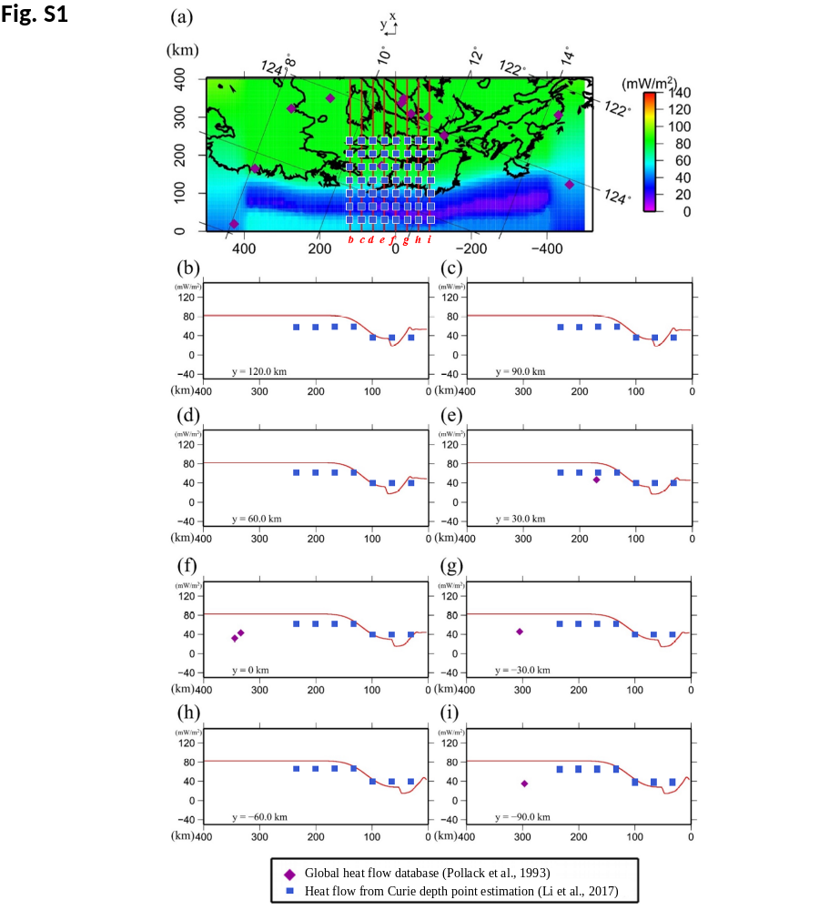

Fig. S1 (a) Spatial distribution of the surface heat flow calculated in this study. The observed and calculated surface heat flows are compared along trench-normal profiles “b” to “i” in panels (b) to (i). (b) Observed and calculated heat flows along profile b (y = 120 km) in (a). The purple diamonds and blue squares denote heat flow data from the global heat flow database (Pollack et al., 1993) and heat flow data from Curie point depth estimates (Li et al., 2017), respectively, within a width of 22.5 km along the profile. The red curve indicates the calculated heat flow along the profile. (c) Profile c (y = 90 km). (d) Profile d (y = 60 km). (e) Profile e (y = 30 km). (f) Profile f (y = 0 km). (g) Profile g (y = -30 km). (h) Profile h (y = -60 km). (i) Profile i (y = -90 km). The thermal conductivities K are assumed to be 1.5 W/m°C for the ocean (Grevemeyer et al., 2003; Li et al., 2017) and 2.5 W/m°C for the continent (Li et al., 2017).
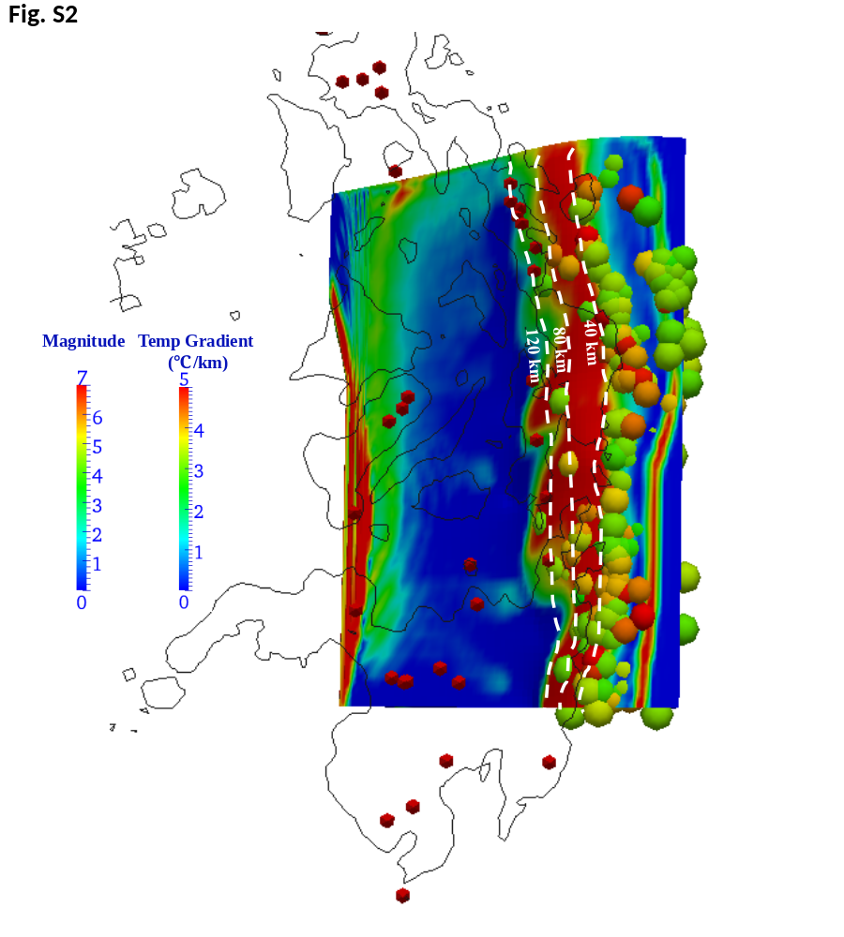

Fig. S2 Calculated temperature gradient distribution. The white dashed lines represent the depth contours of 40 km, 80 km, and 120 km from the subducting plate surface. The red cones indicate active arc volcanoes (Siebert et al., 2010). The colored spheres indicate the intraslab seismic events from January 2000 through December 2010 (IRIS; Trabant et al., 2012), with the color indicating the earthquake magnitude and size mimicking the rupture dimension.
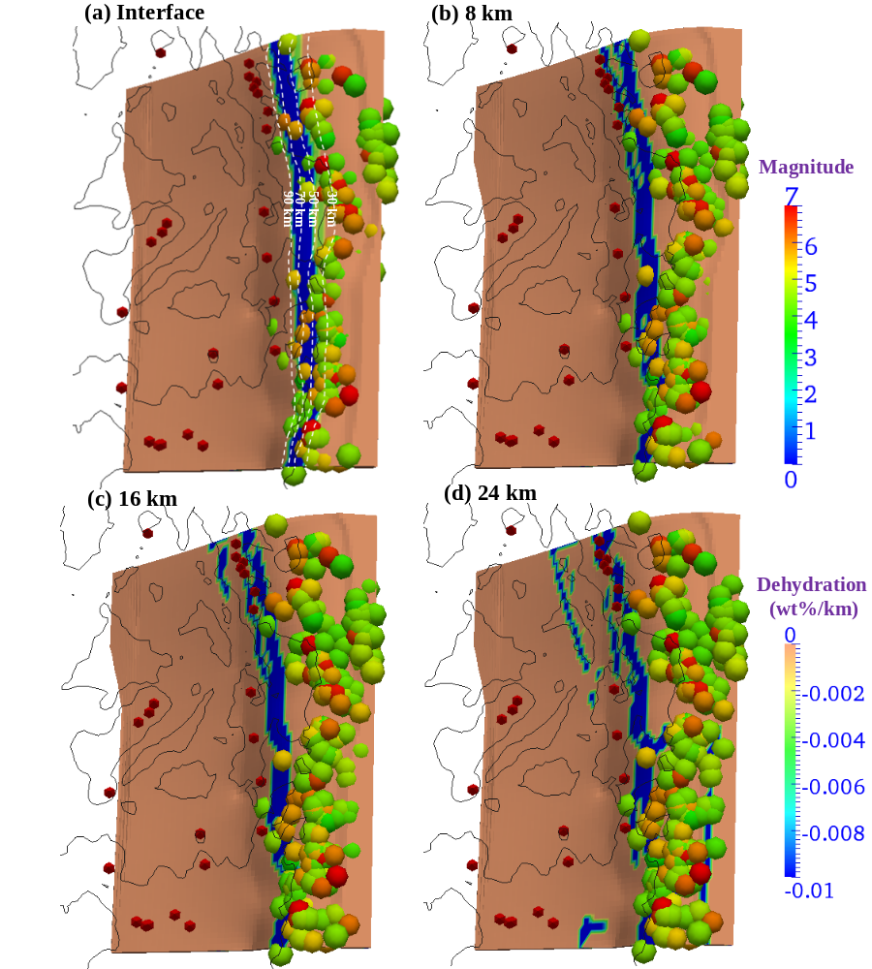

Fig. S3 Slab dehydration (wt%/km) of the incoming plate. The white dashed lines represent the depth contours of 30 km, 50 km, 70 km, and 90 km from the subducting plate surface. The colored spheres indicate the intraslab seismic events from January 2000 through December 2010 (IRIS; Trabant et al., 2012), with the color indicating the earthquake magnitude. The red cones indicate active arc volcanoes (Siebert et al., 2010). (a) The interface. (b) 8 km below the interface. (c) 16 km below the interface. (d) 24 km below the interface.

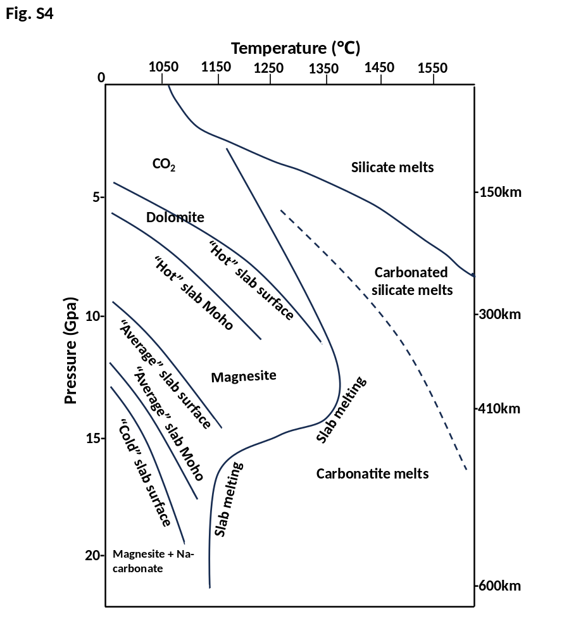
Fig. S4 The stability fields of carbon-bearing phases according to Thomson et al. (2016).
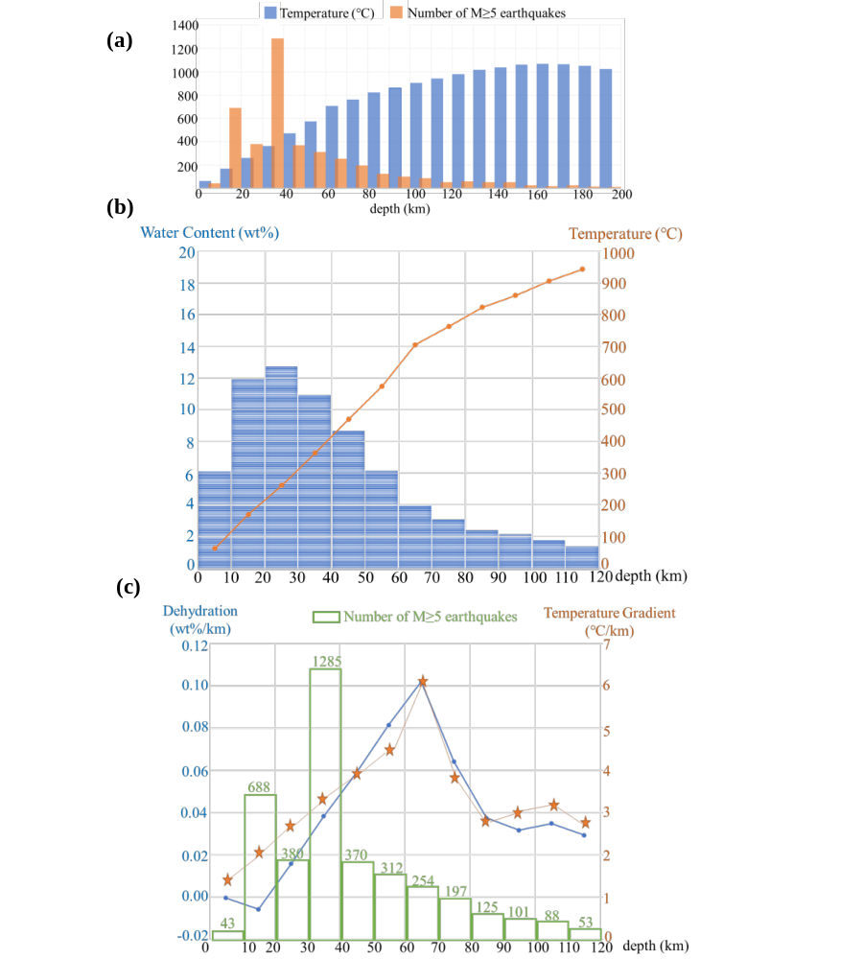

Fig. S5 (a) Distribution of M≥5 earthquakes from 1900 to 2023 and temperature at different depths. (b) The average water content (blue bars) and temperature (solid orange dots) of the slab at different depths. (c) Relationships among M≥5 earthquakes from 1900 to 2023 (green bars), dehydration (wt%/km, solid blue dots) and the average temperature gradient (orange five-point stars) at different depths in the Philippine Sea Plate.
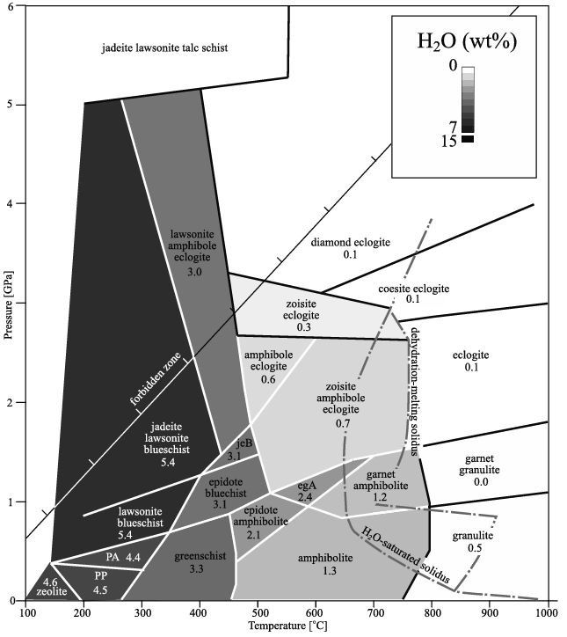
Figure.S6 Phase diagram for MORB (Hacker et al., 2003)

References for SI
- Argus, D. F., Gordon, R. G., DeMets, C., 2011. Geologically current motion of 56 plates relative to the no-net-rotation reference frame. Geochemistry, Geophysics, Geosystems 12(11).
- Burkett, E.R., Billen, M.I., 2010. Three-dimensionality of slab detachment due to ridge-trench collision: Laterally simultaneous boudinage versus tear propagation, Geochemistry, Geophysics, Geosystems 11, Q11012, doi:10.1029/2010GC003286.
- Christensen, U. R. 1996. The influence of trench migration on slab penetration into the lower mantle. Earth and Planetary Science Letters, 140(1-4), 27-39.
- DeMets, C., Gordon, R.G., Argus, D.F., 2010. Geologically current plate motions, Geophysics. J. Int., 181, 1, 1-80, doi: 10.1111/j.1365-246X.2009.04491. x.
- Grose, C.J., Afonso, J.C., 2013. Comprehensive plate models for the thermal evolution of oceanic lithosphere. Geochemistry, Geophysics, Geosystems 14, 3751-3778.
- Hacker, B. R., Abers, G. A., & Peacock, S. M., 2003. Subduction factory 1. Theoretical mineralogy, densities, seismic wave speeds, and H₂O contents. Journal of Geophysical Research: Solid Earth, 108(B1).
- Hacker, B., Abers, G., Peacock, S., Holloway, S.D., 2003. Subduction factory 2. Are intermediate-depth earthquakes in subducting slabs linked to metamorphic dehydration reactions? Journal of Geophysical Research 108(B1):1-16.
- Hayes, G.P., Moore, G.L., Portner, D.E., Hearne, M., Flamme, H., Furtney, M., Smoczyk, G.M., 2018. Slab2, a comprehensive subduction zone geometry model. Science 362, 58-61.
- Hirth, G., Kohlstedt, D., 2003. Rheology of the upper mantle and the mantle wedge: A view from the experimentalists, in Inside the Subduction Factory, In J. Eiler (Ed.), Geophysical monograph series, Vol. 138, pp. 83–105, Washington, DC: AGU.
- Iwamori, H., 1997. Heat sources and melting in subduction zones. J. Geophys. Res. Solid Earth 102, 14803-14820.
- Ji, Y., Yoshioka, S., Banay, Y.A., 2017a. Thermal state, Slab metamorphism, and interface seismicity in the Cascadia subduction zone based on 3-D modeling. Geophysical research letters 44, 9242-9252.
- Ji, Y., Yoshioka, S., Manea, V.C., Manea, M., 2017b. Seismogenesis of dual subduction beneath Kanto, central Japan controlled by fluid release. Scientific reports 7, 1-8.
- Ji, Y., Yoshioka, S., Manea, V.C., Manea, M., Matsumoto, T., 2017c. Three-dimensional numerical modeling of thermal regime and slab dehydration beneath Kanto and Tohoku, Japan. Journal of Geophysical Research: Solid Earth 122, 332-353.
- Ji, Y., Yoshioka, S., Matsumoto, T., 2016. Three-dimensional numerical modeling of temperature and mantle flow fields associated with subduction of the Philippine Sea plate, southwest Japan. Journal of Geophysical Research: Solid Earth 121(6), 4458-4482. doi:10.1002/2016JB012912.
- Li, C.F., 2011. An integrated geodynamic model of the Nankai subduction zone and neighboring regions from geophysical inversion and modeling. J. Geodyn. 51, 64-80.
- Li, C.F., Lu, Y., Wang, J., 2017. A global reference model of Curie-point depths based on EMAG2. Scientific reports 7, 1-9.
- Li, Z.H., Xu, Z., Gerya, T., Burg, J.P., 2013. Collision of continental corner from 3-D numerical modeling. Earth and Planetary Science Letters, 380, 98-111.
- Müller, R.D., Sdrolias, M., Gaina, C., Roest, W.R., 2008. Age, spreading rates, and spreading asymmetry of the world's ocean crust, Geochem. Geophysics, Geosystems 9 (4), Q04006, doi:10.1029/2007GC001743.
- Omori, T., Watanabe, K., Umetsu, R. Y., Kainuma, R., Ishida, K., 2009. Martensitic transformation and magnetic field-induced strain in Fe-Mn-Ga shape memory alloy. Applied Physics Letters, 95(8), 082508.
- Pollack, H.N., Hurter, S.J. Johnson, J.R. 1993. Heat flow from the earth's interior: analysis of the global data set. Reviews of Geophysics 31(3), 267-280.
- Ranalli, G., 1995. Rheology of the earth. Tectonophysics 269(3), doi:10.1016/S0040-1951(96)00042-X.
- Siebert, L., Simkin, T., Kimberly, P., 2010. Volcanoes of the World.
- Stein, C. A., Stein, S., 1992. A model for the global variation in oceanic depth and heat flow with lithospheric age. Nature 359(6391), 123-129, doi:10.1038/359123a0.
- Suenaga N., Yoshioka S., Ji, Y., 2021. 3-D thermal regime and dehydration processes around the regions of slow earthquakes along the Ryukyu Trench, Scientific Reports, 11(1), 11251, doi:10.1038/s41598-021-90199-2.
- Tackley, P.J., Xie, S., 2003. Stag3D: A code for modeling thermochemical multiphase convection in Earth's mantle. Computational Fluid and Solid Mechanics 2003, edited by K. J. Bathe, pp. 1524-1527, Elsevier B.V., Amsterdam, Netherlands.
- Thomson, A. R., Walter, M. J., Kohn, S. C., Brooker, R. A. (2016). Slab melting as a barrier to deep carbon subduction. Nature, 529(7584), 76-79.
- Trabant, C., Hutko, A. R., Bahavar, M., Karstens, R., Ahern, T., & Aster, R. (2012). Data products at the IRIS DMC: Stepping stones for research and other applications. Seismological Research Letters, 83(5), 846-854.
- Turcotte, D.L., Schubert, G., 2002. Geodynamics, 2nd ed., pp. 186, Cambridge Univ. Press, Cambridge, U. K.
- Wang, K., Hyndman, R.D., Yamano, M., 1995. Thermal regime of the Southwest Japan subduction zone: effects of age history of the subducting plate. Tectonophysics 248, 53-69.
- White, R.S., McKenzie, D., O'Nions, R.K., 1992. Oceanic crustal thickness from seismic measurements and rare earth element inversions. Journal of Geophysical Research: Solid Earth 97, 19683-19715.
- Yoshii, T., 1975. Regionality of group velocities of Rayleigh waves in the Pacific and thickening of the plate. Earth and Planetary Science Letters 25, 305-312.
- Yoshioka, S., Murakami, K., 2007. Temperature distribution of the upper surface of the subducted Philippine Sea Plate along the Nankai Trough, southwest Japan, from a three-dimensional subduction model: relation to large interplate and low-frequency earthquakes. Geophysical Journal International.

