SUPPLEMENTARY MATERIAL
Supplementary Figure 1. Scatterplot of zonulin and 16s rRNA gene copies among 76 healthy controls.
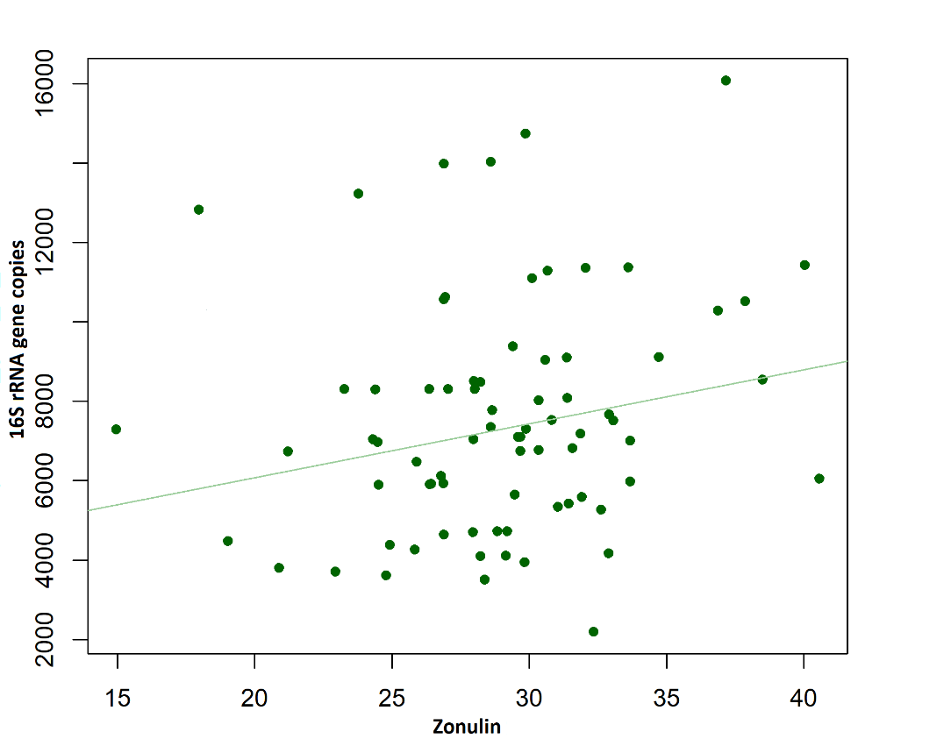

Supplementary Figure 2. Odds ratiosª (ORs) and 95% confidence intervals (CI) according to combination of zonulin tertiles and 16S rRNA gene copies quintiles among 39 colon cancer cases and 148 tumor-free subjects; Italy 2017-2019
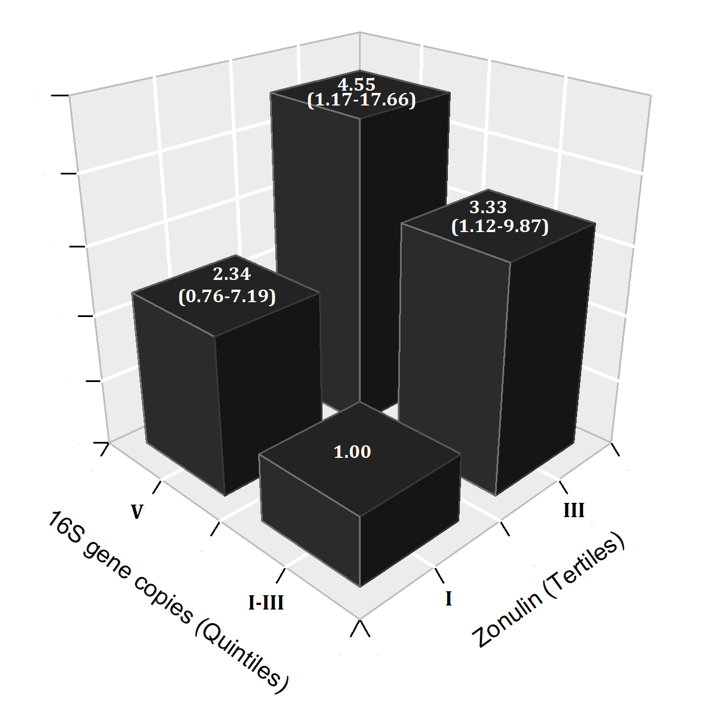
ª Estimated from logistic regression model adjusted for study center, sex, age, education, 16S rRNA gene copies quintiles and zonulin tertiles.

