Supplementary information for

Nonlinear changes in urban heat island intensity, urban breeze intensity, and urban air pollutant concentration with roof albedo

Kyeongjoo Park¹ & Jong-Jin Baik^{1*}

¹School of Earth and Environmental Sciences, Seoul National University, Seoul 08826, South Korea

*Corresponding author:
Prof. Jong-Jin Baik
Email: jjbaik@snu.ac.kr
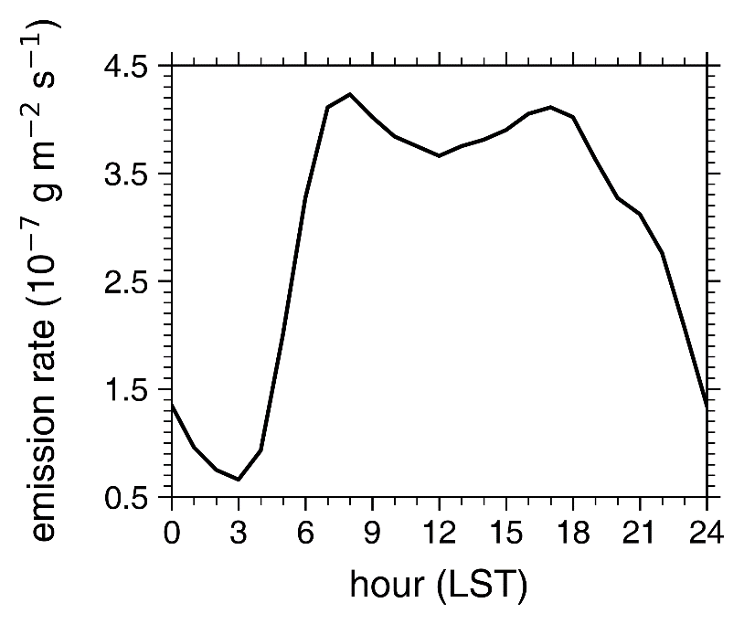

Figure S1. Diurnal variation of the emission rate of the passive tracer (carbon monoxide).
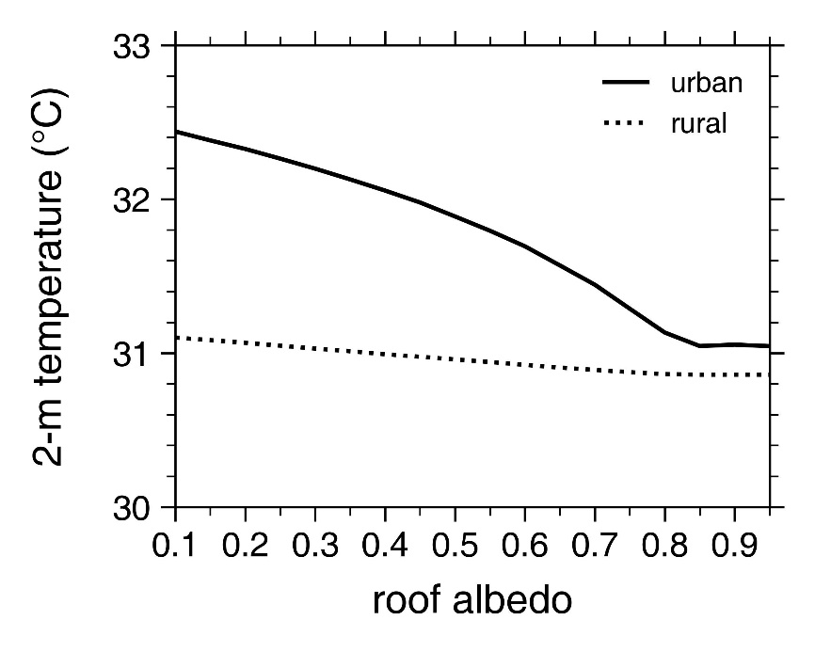

Figure S2. Daytime mean urban (solid) and rural (dotted) 2-m temperatures as a function of roof albedo.
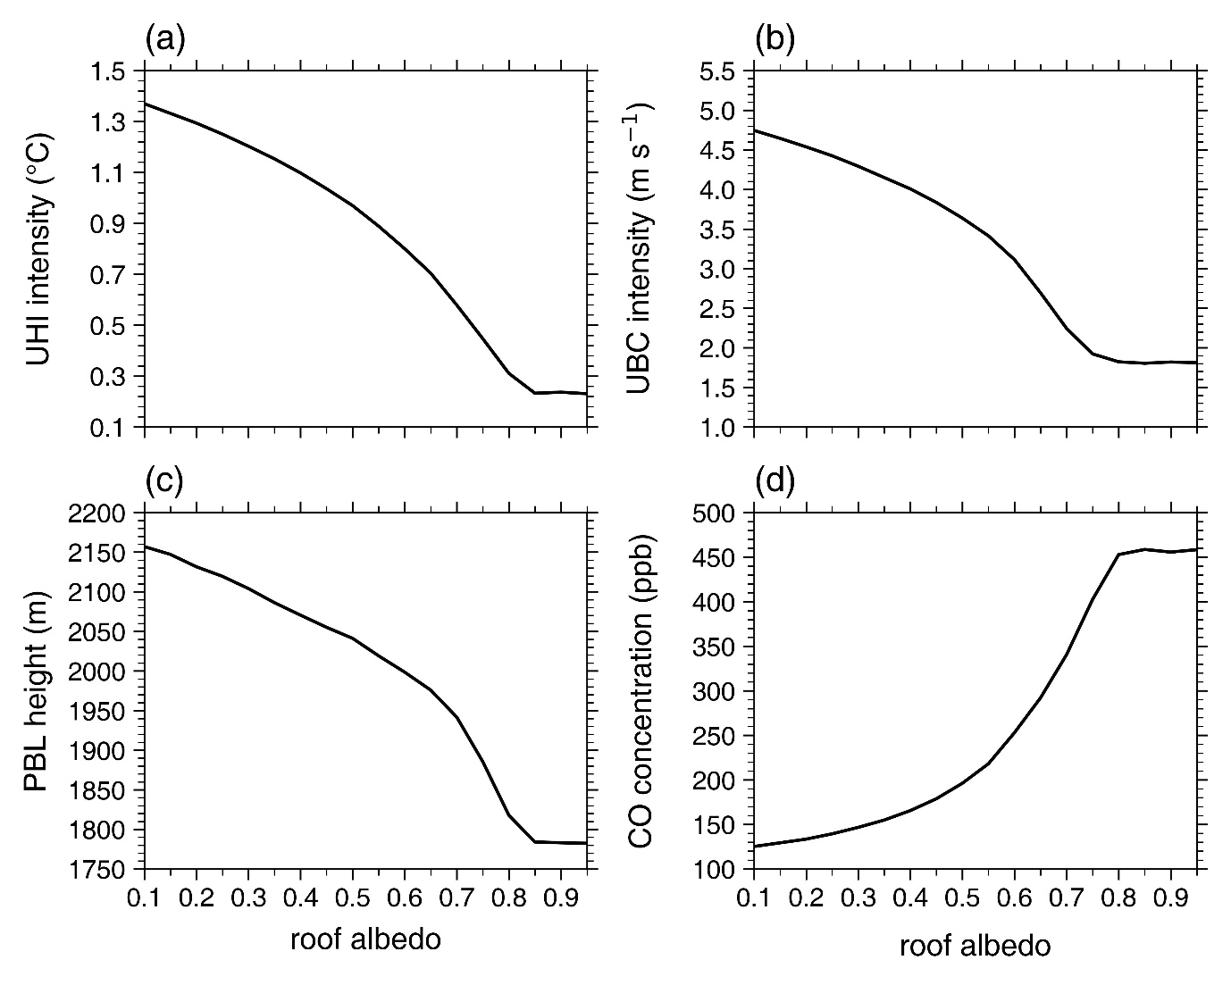

Figure S3. Same as Fig. 1 except for the experiments with the 1000-m horizontal grid interval.
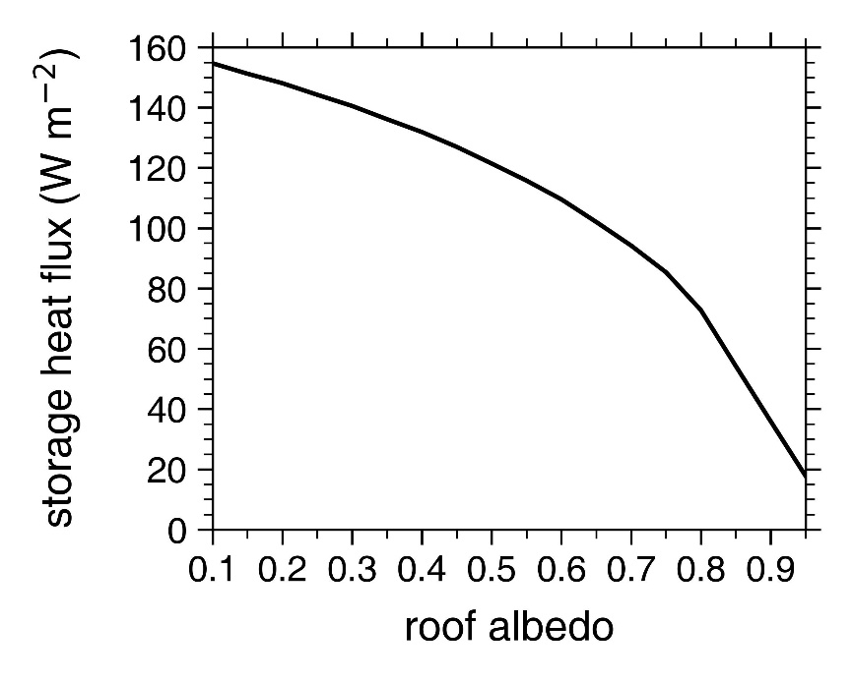

Figure S4. Same as Fig. 3d except for the mean roof storage heat flux from 0600 LST to 1100 LST.
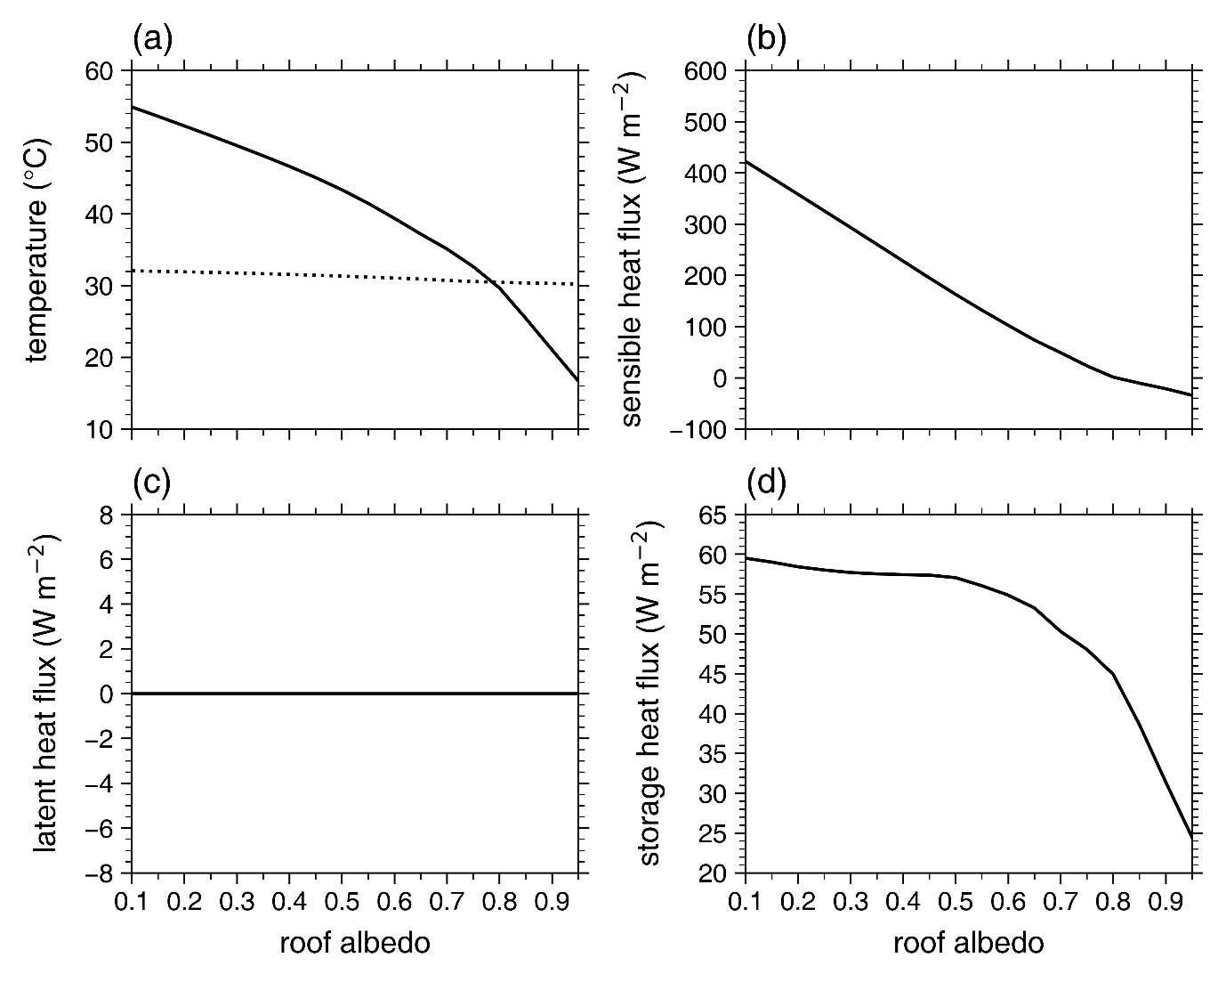

Figure S5. Same as Fig. 3 except for the experiments with the SLUCM.

