Optimization of a Novel Expression System for Recombinant Protein Production in CHO Cells
Running title: Novel CHO cell expression system

Junhe Zhang^{1, 2, 3, 4} *, Chenyang Du^{1, 2, 4 #}, Yue Pan³, Zhan Zhang³, Ruoyuan Feng³, Mengyao Ma³, Tianyun Wang^{2, 3*}

¹Institutes of Health Central Plains, Xinxiang Key Laboratory for Tumor Drug Screening and Targeted Therapy, Xinxiang Medical University, Xinxiang 453003, China;
²International Joint Research Laboratory for Recombinant Pharmaceutical Protein Expression System of Henan, Xinxiang 453003, China;
³School of Basic Medical Sciences, Xinxiang Medical University, Xinxiang 453003, China
⁴These authors contributed equally: Junhe Zhang and Chenyang Du.

Corresponding author:
Tianyun Wang,
International Joint Research Laboratory for Recombinant Pharmaceutical Protein Expression System of Henan,
Xinxiang Medical University,
Xinxiang 453003,
No. 601 Jinsui Road,
Henan Province,
China
Tel: 86-373-3029488
E-mail: wtianyuncn@126.com

Junhe Zhang,
Institutes of Health Central Plains,
Xinxiang Medical University,
Xinxiang 453003,
No. 601 Jinsui Road,
Henan Province,
China
Tel: 86-373-3831761
E-mail: zjh@xxmu.edu.cn

Figure legends
Fig S1. Vector diagram used in this study
A. pCMV-eGFP-F2A-RFP | B. pCMV-Kozak-eGFP-F2A-RFP
C. pCMV-Kozak-Leader-eGFP-F2A-RFP | D. pCMV-SEAP-F2A-RFP-Blasticdin
E. pCMV-Kozak-SEAP-F2A-RFP-Blasticdin | F. pCMV-Kozak-Leader-SEAP-F2A-RFP-Blasticdin
G. pCMV-IL3-F2A-RFP-Blasticdin | H. pCMV-IL3-Kozak-F2A-RFP-Blasticdin
I. pCMV-IL3-Kozak-Leader-F2A-RFP-Blasticdin

Fig S2. The circular PX459 vector is phosphoryl cleaved to obtain a linearized PX459 vector that is ligated to the sgRNA.

Fig S3. The sequencing results after sgRNA ligation with a linearized PX459 vector.

Fig S4. The DNA sequencing results for monoclonal strains.

Figure S1

Figure S2
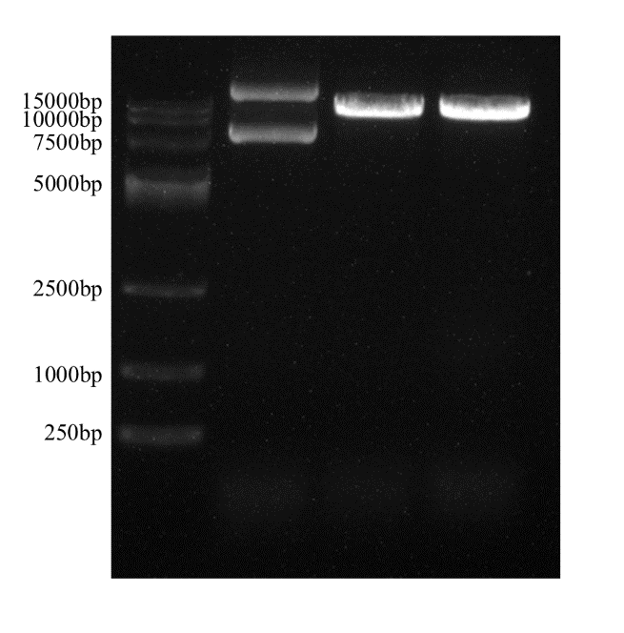

Figure S3

Figure S4

