Appendix I (Analysis by Age)
Brands' preference weights and the adjusted odds ratios for preferring each class’s brand over its generic counterpart while holding the other classes constant (Analysis by age)
Attribute  (brands) | β | 95 % CI |  | AOR | 95 % CI |  |  | P
Attribute  (brands) | β | lower | upper | AOR | lower | upper |  | P
 | Below 68 years old (n = 70)
Aspirin | -0.32 | -0.45 | -0.18 | 0.73 | 0.64 | 0.83 |  | < .001*
Beta-blocker | 0.72 | 0.58 | 0.85 | 2.05 | 1.79 | 2.34 |  | < .001*
Statin | 0.49 | 0.32 | 0.66 | 1.63 | 1.38 | 1.94 |  | < .001*
RAAS blocker | 1.05 | 0.90 | 1.20 | 2.86 | 2.47 | 3.32 |  | < .001*
Price | -0.01 | -0.01 | -0.01 | 0.99 | 0.99 | 0.99 |  | < .001*
 | 68 years old and above (n = 79)
Aspirin | -0.35 | -0.49 | -0.22 | 0.70 | 0.61 | 0.80 |  | < .001*
Beta-blocker | 0.76 | 0.63 | 0.89 | 2.14 | 1.88 | 2.45 |  | < .001*
Statin | 0.30 | 0.14 | 0.46 | 1.35 | 1.15 | 1.58 |  | < .001*
RAAS blocker | 1.27 | 1.12 | 1.41 | 3.55 | 3.06 | 4.11 |  | < .001*
Price | -0.01 | -0.01 | -0.01 | 0.99 | 0.99 | 0.99 |  | < .001*
AOR indicates adjusted odds ratio for preferring a class’s brand over its generic counterpart because it provides a higher utility from the perspective of the 149 dissatisfied patients (with at least one of the generic). β indicates preference weight. 95% CI indicates 95% confidence interval.

Appendix II (Analysis by Education)
Brands' preference weights and the adjusted odds ratios for preferring each class’s brand over its generic counterpart while holding the other classes constant (Analysis by education)
Attribute  (brands) | β | 95 % CI |  | AOR | 95 % CI |  |  | P
Attribute  (brands) | β | lower | upper | AOR | lower | upper |  | P
 | At least intermediate education (n = 88)
Aspirin | -0.31 | -0.43 | -0.20 | 0.73 | 0.65 | 0.82 |  | < .001*
Beta-blocker | 0.81 | 0.69 | 0.93 | 2.25 | 2.00 | 2.54 |  | < .001*
Statin | 0.18 | 0.03 | 0.33 | 1.19 | 1.03 | 1.38 |  | .018*
RAAS blocker | 0.99 | 0.86 | 1.12 | 2.70 | 2.37 | 3.08 |  | < .001*
Price | 0.00 | -0.01 | 0.00 | 1.00 | 0.99 | 1.00 |  | < .001*
 | Below intermediate education (n = 61)
Aspirin | -0.25 | -0.42 | -0.08 | 0.78 | 0.66 | 0.92 |  | .004*
Beta-blocker | 0.74 | 0.57 | 0.91 | 2.09 | 1.76 | 2.47 |  | < .001*
Statin | 0.78 | 0.58 | 0.98 | 2.17 | 1.78 | 2.66 |  | < .001*
RAAS blocker | 1.57 | 1.38 | 1.76 | 4.82 | 3.98 | 5.84 |  | < .001*
Price | -0.02 | -0.02 | -0.02 | 0.98 | 0.98 | 0.98 |  | < .001*
AOR indicates adjusted odds ratio for preferring a class’s brand over its generic counterpart because it provides a higher utility from the perspective of the 149 dissatisfied patients (with at least one of the generic). β indicates preference weight. 95% CI indicates 95% confidence interval.

Appendix III (Analysis by Income)
Brands' preference weights and the adjusted odds ratios for preferring each class’s brand over its generic counterpart while holding the other classes constant (Analysis by income)
Attribute  (brands) | β | 95 % CI |  | AOR | 95 % CI |  |  | P
Attribute  (brands) | β | lower | upper | AOR | lower | upper |  | P
 | In debt (n = 62)
Aspirin | -0.36 | -0.53 | -0.20 | 0.69 | 0.59 | 0.82 |  | < .001*
Beta-blocker | 0.84 | 0.68 | 1.01 | 2.33 | 1.97 | 2.75 |  | < .001*
Statin | 1.02 | 0.82 | 1.22 | 2.78 | 2.28 | 3.39 |  | < .001*
RAAS blocker | 1.23 | 1.05 | 1.41 | 3.42 | 2.86 | 4.10 |  | < .001*
Price | -0.02 | -0.02 | -0.02 | 0.98 | 0.98 | 0.98 |  | < .001*
 | Not in debt (n = 87)
Aspirin | -0.31 | -0.43 | -0.19 | 0.73 | 0.65 | 0.83 |  | < .001*
Beta-blocker | 0.74 | 0.62 | 0.86 | 2.10 | 1.86 | 2.37 |  | < .001*
Statin | 0.07 | -0.08 | 0.22 | 1.07 | 0.92 | 1.24 |  | .368
RAAS blocker | 1.19 | 1.06 | 1.33 | 3.30 | 2.88 | 3.78 |  | < .001*
Price | 0.00 | -0.01 | 0.00 | 1.00 | 0.99 | 1.00 |  | < .001*
AOR indicates adjusted odds ratio for preferring a class’s brand over its generic counterpart because it provides a higher utility from the perspective of the 149 dissatisfied patients (with at least one of the generic). β indicates preference weight. 95% CI indicates 95% confidence interval.

Appendix IV: Relative importance by age, education, and income
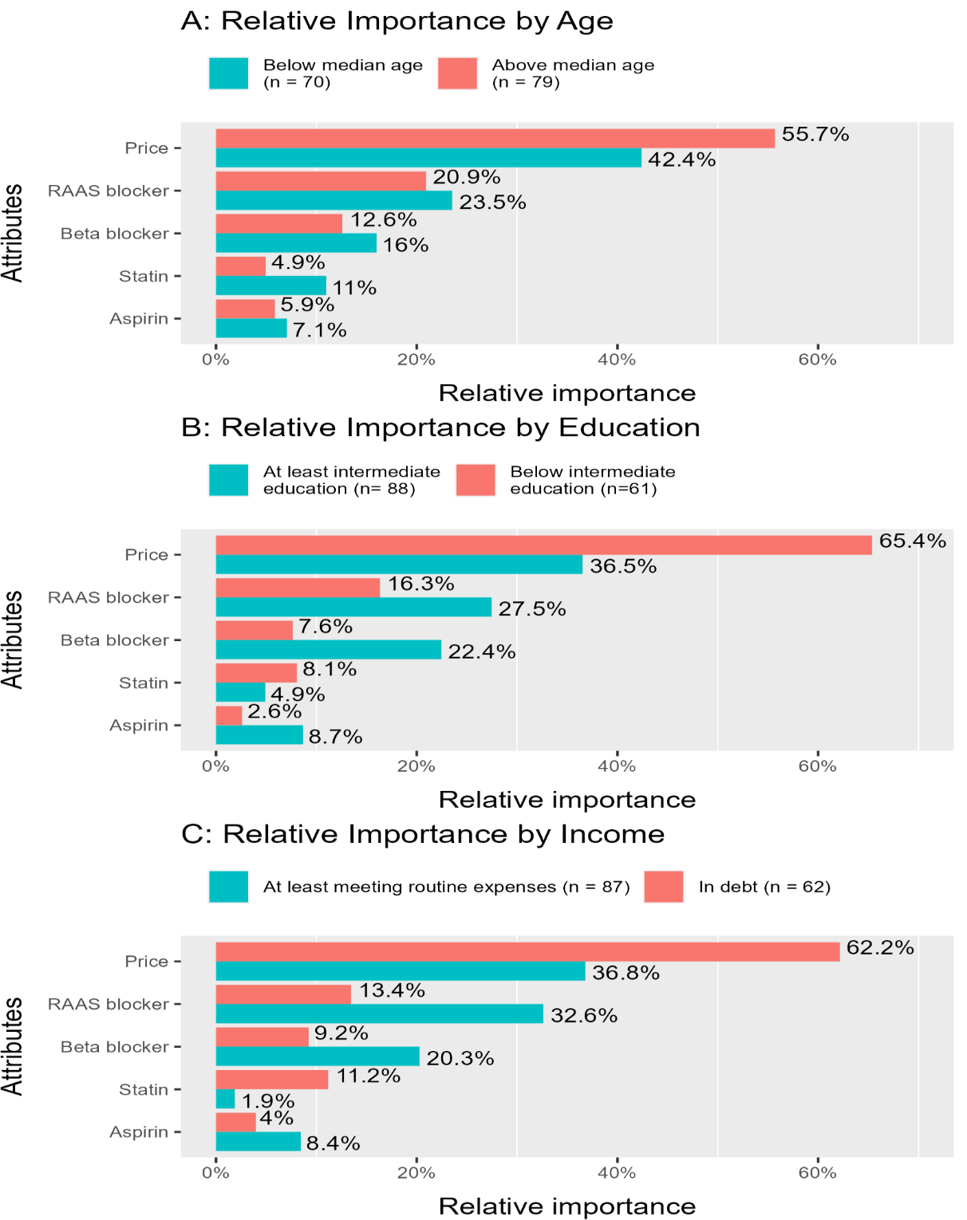

Appendix V (Levels of Satisfaction with the generics)
Levels of patients' acceptance of using the dispensed generic cardiovascular drugs (n (%))
CHD drug class | Satisfied with the generic | Brand inclined
CHD drug class | Satisfied with the generic | Intention to change | Changed to brand
Aspirin | 50 (34%) | 81 (54%) | 18 (12%)
Beta-Blocker | 30 (20%) | 69 (46%) | 50 (34%)
Statin | 41 (28%) | 95 (63%) | 13 (9%)
RAAS Blocker | 22 (15%) | 75 (50%) | 52 (35%)

Appendix VI (Drivers for Brand Inclinations)
Drivers for inclination in brand-inclined patients (n (%))
 | Aspirin  (n = 99) | Beta-Blocker (n = 119) | Statin  (n = 108) | RAAS Blocker (n =127)
Internal Drivers | 91 (91.9%) | 95 (79.8%) | 98 (90.7%) | 96 (75.6%)
I tried the generic, but I found it not effective | 54 (54.5%) | 65 (54.6%) | 64 (59.3%) | 67 (52.8%)
I believe any brand is better | 35 (35.4%) | 30 (25.2%) | 34 (31.5%) | 29 (22.8%)
The generic causes me side effects | 2 (2.0%) | 0 (0%) | 0 (0%) | 0 (0%)
External Drivers | 8 (8.1%) | 24 (20.2%) | 10 (9.3%) | 31 (24.4%)
The advice of my health insurance doctor | 1 (1.0%) | 8 (6.7%) | 1 (0.9%) | 13 (10.2%)
The advice of my private doctor (outside of health insurance) | 6 (6.1%) | 15 (12.6%) | 8 (7.4%) | 17 (13.4%)
The advice of a friend or relative | 1 (1.0%) | 1 (0.8%) | 1 (0.9%) | 1 (0.8%)

Appendix VII (Detailed sociodemographic)
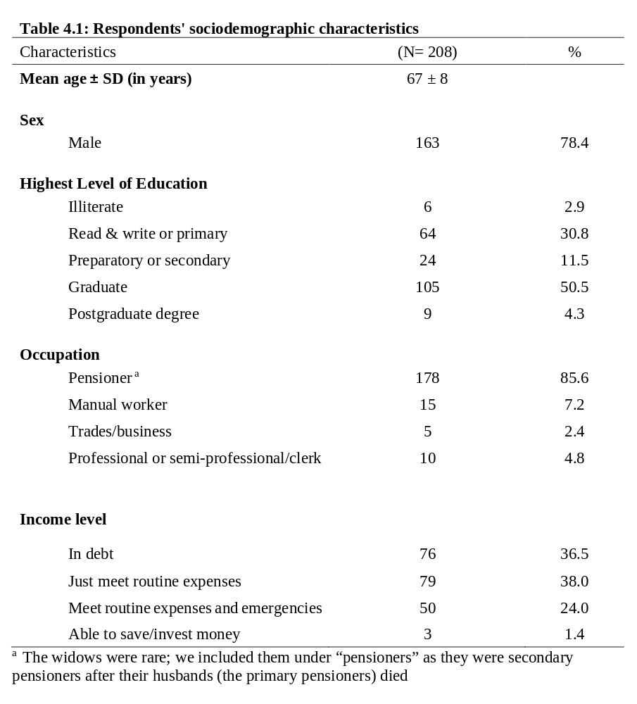
Appendix VIII (Analysis by sex)
Brands' preference weights and the adjusted odds ratios for preferring each class’s brand over its generic counterpart while holding the other classes constant (Analysis by sex)
Attribute  (brands) | β | 95 % CI |  | AOR | 95 % CI |  |  | P
Attribute  (brands) | β | lower | upper | AOR | lower | upper |  | P
 | Male (n = 114)
Aspirin | -0.29 | -0.39 | -0.18 | 0.75 | 0.68 | 0.84 |  | < .001*
Beta-blocker | 0.78 | 0.68 | 0.89 | 2.19 | 1.97 | 2.44 |  | < .001*
Statin | 0.44 | 0.30 | 0.57 | 1.55 | 1.36 | 1.76 |  | < .001*
RAAS blocker | 1.09 | 0.97 | 1.21 | 2.99 | 2.65 | 3.36 |  | < .001*
Price | -0.01 | -0.01 | -0.01 | 0.99 | 0.99 | 0.99 |  | < .001*
 | Female (n = 35)
Aspirin | -0.51 | -0.70 | -0.31 | 0.60 | 0.49 | 0.74 |  | < .001*
Beta-blocker | 0.57 | 0.38 | 0.76 | 1.77 | 1.46 | 2.14 |  | < .001*
Statin | 0.31 | 0.07 | 0.55 | 1.36 | 1.07 | 1.74 |  | .013*
RAAS blocker | 1.33 | 1.12 | 1.55 | 3.79 | 3.06 | 4.71 |  | < .001*
Price | -0.01 | -0.01 | -0.01 | 0.99 | 0.99 | 0.99 |  | < .001*
AOR indicates adjusted odds ratio for preferring a class’s brand over its generic counterpart because it provides a higher utility from the perspective of the 149 dissatisfied patients (with at least one of the generic). β indicates preference weight. 95% CI indicates 95% confidence interval.

