Morphological Phenotype of Right Ventricular Outflow Tract Is Associated with Cardiovascular Outcomes and Premature Death

Supplemental Material
Methods. Supplemental Methods 2

Table S1. Morphological Statistics of RVOT in Stage One 4
Table S2. Logistic Regression Analysis of Association of CVDs Morbidity with Other Characteristics in Stage One 5
Table S3. Logistic Regression Analysis of Association of CVDs Morbidity with pSBV in Stage Two 6
Table S4. Logistic Regression Analysis of Association of CAS Morbidity with pSBV in Stage Two 7
Table S5. Logistic Regression Analysis of Association of CM Morbidity with pSBV in Stage Two 8
Table S6. Logistic Regression Analysis of Association of SCD Mortality with pSBV in Stage Two 9
Table S7. Logistic Regression Analysis of Association of SCD Mortality with tS 10
Table S8. Logistic Regression Analysis of Association of SCD Mortality with Other Characteristics in Stage One 11
Table S9. Comparison of Age at Death in Disease-Dominant Death and SCD Groups 12
Table S10. Multivariate Linear Regression Analysis for Age at Death in SCD Group 13
Table S11. Comparison of the Training, Validation and Test Cohorts 14
Table S12. Statistical Indicators of Eight Machine Learning Algorithms in Training, Validation and Test Sets 15

Figure S1. Missingness Map in Internal and External Set 17
Figure S2. Application of the Established Nomogram in Diagnosing CAS 18
Figure S3. Schematic Diagram of Measurement of RVOT Morphology by Cardiac Ultrasound 19

Supplemental References 20

Supplemental Methods
- Gross Examination and Tissue Processing
Along the anterior ventricular sulcus to the apex, the right ventricle was opened at commissural points at the end of anterior valvular sinus and left valvular sinus, fully exposing the septum of right ventricular outflow tract (RVOT). Sub-valve plane was defined to be through two lower of three hinge points of the valves in the RVOT. Supra-valve plane was defined to be through two higher of three commissural points at the end of the valvular sinuses. Mid-valve plane was defined to be at the mid-point between the sub-valve and the supra-valve planes. Perimeters of three planes were measured. The interval between supraventricular crest and pulmonary valve was defined as the distance from the highest point of the supraventricular crest to the lowest hinge point of the pulmonary valve, which was considered as the shortest length of RVOT. The myocardium thickness of free wall was measured at sub-valve plane directly below the commissural point at the end of anterior and right valve sinuses, epicardial fat excluded. The septum thickness was defined as from endocardium to the boundary between myocardium and septum-aortic root space, at the sub-valve plane below the commissural point at the end of right and left valve sinuses.

- Development and Validation of Machine Learning Models
2.1 Dataset collection and processing
The machine learning model was constructed based on the anatomical features of heart, morphologic features of RVOT, and general information including age, sex, height, and abdominal subcutaneous fat thickness. Cases collected from January 2017 to December 2021 were enrolled as the internal dataset, which was then split into training and validation set at a ratio of 7:3. The model was finally evaluated in an external test set which enrolled 654 cases collected in 2022 and 2023.
For data processing, we implemented the missForest method ¹, a robust imputation technique that can deal with missing values, to fill the small number of missing data in the internal and external dataset separately. Subsequently, all continuous variables were standardized in the training, validation, and external test set based on the mean value and the standard deviation of each variable in the training set. For the standardization, each individual value was subtracted by the mean value, and then divided by the standard deviation.
2.2 Feature selection
We applied the least absolute shrinkage and selection operator (LASSO) method, a satisfactory approach that works by shrinking the coefficient of noninfluential variables to zero with only a few important variables retained in the final model, for the feature selection in the training set. The minimal penalty parameter λ plus 1 standard error based on 10-fold cross validation procedure in the training set was selected as the optimal hyperparameter for LASSO approach, which can yield a more parsimonious model.
2.3 Machine learning development
Eight machine learning models were selected as the candidates, including random forest, extreme gradient boosting trees model, adaptive boosting trees model, logistic regression (LR) model, support vector machine with radial basis function kernel, Gaussian Naïve Bayes, k-nearest neighbor algorithm, and single-hidden-layer neural network. Machine learning models were developed in the training set and the grid search strategy with 5-fold cross validation was applied for tuning the hyperparameters. Specially, a nomogram was constructed for the visualization of the LR model. Each variable selected by LASSO regression corresponded to a point at each value based on the coefficient in LR model and a total point was calculated by the sum of the points of all included variables for each case. The relation between the total point and the predicted probability was shown on the bottom of the nomogram.
2.4 Model evaluation
All models based on the optimal hyperparameters were evaluated in the training set by 5-fold cross validation, and subsequently in the validation set and external test set with the same hyperparameters. The discrimination performance of each model was compared according to the area under the receiver operating characteristic curve (AUC). The accuracy, sensitivity, specificity, positive predictive value, negative predictive value, F1 score, and Kappa value were also calculated based on the cutoff value which was determined by the maximal Youden index in the training set. The calibration capability was examined by calibration curve together with calibration slope and calibration-in-the-large. Decision Curve Analyses were carried out to assess the application value of models.

Table S1. Morphological Statistics of RVOT in Stage One

Statistics ª | pSBV (cm) | pSPV (cm) | pMV (cm) | iSCPV (cm) | tF (mm) | tS (mm)
N/All | 1278/1305 | 1271/1305 | 1268/1305 | 1287/1305 | 1304/1305 | 1304/1305
Mean±SD / Median (Q1, Q3) | 7.62±0.90 | 6.66±0.76 | 7.13±0.83 | 0.91±0.27 | 3.0 (2.0,3.5) | 2.5 (2.0,3.0)
ª The condition of pSBV in 27 cases, pSPV in 34 cases, pMV in 37 cases, iSCPV in 18 cases, tF in 1 cases and tS in 1 cases was unavailable because RVOTs of those cases were permanently removed or destroyed in different degrees during postmortem examination. pSBV=perimeter of sub-valve; pSPV=perimeter of supra-valve; pMV=perimeter of mid-valve; iSCPV=interval between supraventricular crest-pulmonary valve; tF=thickness of free wall; tS=thickness of septum.
Table S2. Logistic Regression Analysis of Association of CVDs Morbidity with Other Characteristics in Stage One

Characteristics |  | Univariate |  | Multivariate ª
 |  | OR (95%CI) | P | OR (95%CI) | P
pSPV |  | 2.307 (1.952,2.726) | <0.001 | 1.042 (0.840,1.292) | 0.708
pMV |  | 2.201 (1.874,2.586) | <0.001 | 1.141 (0.936,1.391) | 0.191
iSCPV |  | 1.788 (1.186,2.696) | 0.006 | 1.300 (0.794,2.129) | 0.297
tF ^{b} | tF≥3.5mm | 1.597 (1.249,2.043) | <0.001 | 1.112 (0.834,1.484) | 0.469
tF ^{b} | tF<2.0mm | 0.655 (0.438,0.979) | 0.039 | 0.714 (0.448,1.139) | 0.158
tS ^{b} | tS≥3.0mm | 1.215 (0.954,1.546) | 0.114 | 1.026 (0.772,1.363) | 0.861
tS ^{b} | tS<2.0mm | 0.654 (0.469,0.911) | 0.012 | 0.815 (0.552,1.203) | 0.303
ª This model consists of age at death, sex, heart weight and ASFT. ^{b} Both tF and tS were converted to categorical variables divided by quartiles (Q1, Q3) in 1305 cases, and X<Q1 and X≥Q3 were compared to Q1≤X<Q3. pSPV=perimeter of supra-valve; pMV=perimeter of mid-valve; iSCPV=interval between supraventricular crest-pulmonary valve; tF=thickness of free wall; tS=thickness of septum; CVD=cardiovascular disease.
Table S3. Logistic Regression Analysis of Association of CVDs Morbidity with pSBV in Stage Two

Variables | Univariate |  | Multivariate ª
Variables | OR (95%CI) | P | OR (95%CI) | P
Age at death | 1.048 (1.041,1.055) | <0.001 | 1.038 (1.031,1.046) | <0.001
Sex | 1.938 (1.608,2.335) | <0.001 | 1.342 (1.047,1.721) | 0.020
Heart weight | 1.012 (1.011,1.013) | <0.001 | 1.009 (1.008,1.011) | <0.001
ASFT | 1.238 (1.143,1.341) | <0.001 | 1.114 (1.004,1.236) | 0.042
pSBV≥7.7cm vs pSBV<7.7cm ^{b} | 2.246 (1.895,2.661) | <0.001 | 1.264 (1.031,1.549) | 0.024
ª The model is adjusted for age at death, sex, heart weight and ASFT. ^{b} pSBV was converted to a dichotomous variable at the cut-off of median (7.7cm) in 2370 cases. ASFT=abdominal subcutaneous fat thickness; pSBV=perimeter of sub-valve; CVD=cardiovascular disease.
Table S4. Logistic Regression Analysis of Association of CAS Morbidity with pSBV in Stage Two

Variables | Univariate |  | Multivariate ª
Variables | OR (95%CI) | P | OR (95%CI) | P
Age at death | 1.061 (1.052,1.069) | <0.001 | 1.062 (1.052,1.071) | <0.001
Sex | 2.912 (2.302,3.684) | <0.001 | 3.184 (2.314,4.382) | <0.001
Heart weight | 1.011 (1.010,1.013) | <0.001 | 1.006 (1.004,1.008) | <0.001
ASFT | 1.130 (1.034,1.235) | 0.007 | 1.284 (1.133,1.454) | <0.001
pSBV≥7.6cm vs pSBV<7.6cm ^{b} | 2.174 (1.794,2.636) | <0.001 | 1.325 (1.044,1.681) | 0.021
ª The model is adjusted for age at death, sex, heart weight and ASFT. ^{b} pSBV was converted to a dichotomous variable at the cut-off of median (7.6cm) in 1753 cases. ASFT= abdominal subcutaneous fat thickness; CAS=coronary atherosclerosis; pSBV=perimeter of sub-valve.
Table S5. Logistic Regression Analysis of Association of CM Morbidity with pSBV in Stage Two

Variables | Univariate |  | Multivariate ª
Variables | OR (95%CI) | P | OR (95%CI) | P
Age at death | 1.015 (0.999,1.031) | 0.062 | 0.981 (0.958,1.004) | 0.106
Sex | 1.635 (0.947,2.823) | 0.078 | 0.490 (0.239,1.005) | 0.052
Heart weight | 1.017 (1.013,1.020) | <0.001 | 1.017 (1.013,1.022) | <0.001
ASFT | 1.355 (1.124,1.634) | 0.001 | 0.932 (0.711,1.220) | 0.607
pSBV≥7.5cm vs pSBV<7.5cm ^{b} | 5.374 (2.858,10.107) | <0.001 | 2.660 (1.319,5.361) | 0.006
ª The model is adjusted for age at death, sex, heart weight and ASFT. ^{b} pSBV was converted to a dichotomous variable at the cut-off of median (7.5cm) in 1000 cases. ASFT= abdominal subcutaneous fat thickness; CM=cardiomyopathies; pSBV=perimeter of sub-valve.
Table S6. Logistic Regression Analysis of Association of SCD Mortality with pSBV in Stage Two

Variables | Univariate |  | Multivariate ª
Variables | OR (95%CI) | P | OR (95%CI) | P
Age at death | 1.006 (0.999,1.013) | 0.074 | 0.985 (0.977,0.993) | <0.001
Sex | 2.619 (2.103,3.262) | <0.001 | 1.432 (1.116,1.838) | 0.005
Heart weight | 1.005 (1.004,1.006) | <0.001 | 1.003 (1.002,1.004) | <0.001
ASFT | 1.070 (0.980,1.168) | 0.132 | / | /
CAS | 3.518 (2.887,4.287) | <0.001 | 3.346 (2.649,4.226) | <0.001
CM | 2.211 (1.613,3.030) | <0.001 | 1.441 (0.996,2.085) | 0.052
pSBV≥7.8cm vs pSBV<7.8cm ^{b} | 2.033 (1.677,2.463) | <0.001 | 1.448 (1.165,1.798) | 0.001
ª The model is adjusted for age at death, sex, heart weight, CAS and CM. ^{b} pSBV was converted to a dichotomous variable at the cut-off of median (7.8cm) in 1746 cases. ASFT=abdominal subcutaneous fat thickness; CAS=coronary atherosclerosis; CM=cardiomyopathies; pSBV=perimeter of sub-valve; SCD=sudden cardiac death.

Table S7. Logistic Regression Analysis of Association of SCD Mortality with tS

Variables | Stage one (924 cases) |  | Stage two (1746 cases)
Variables | Univariate OR (95%CI) / P | Multivariate ª OR (95%CI) / P | Univariate OR (95%CI) / P | Multivariate ª OR (95%CI) / P
Age at death | 1.009 (1.000,1.019) / 0.041 | 0.987 (0.976,0.998) / 0.023 | 1.006 (0.999,1.013) / 0.074 | 0.986 (0.978,0.994) / <0.001
Sex | 2.982 (2.207,4.030) / <0.001 | 1.656 (1.182,2.321) / 0.003 | 2.619 (2.103,3.262) / <0.001 | 1.517 (1.186,1.942) / 0.001
Heart weight | 1.006 (1.004,1.007) / <0.001 | 1.004 (1.002,1.006) / <0.001 | 1.005 (1.004,1.006) / <0.001 | 1.003 (1.002,1.004) / <0.001
ASFT | 1.062 (0.946,1.193) / 0.308 | / | 1.070 (0.980,1.168) / 0.132 | /
CAS | 3.423 (2.604,4.500) / <0.001 | 2.852 (2.061,3.945) / <0.001 | 3.518 (2.887,4.287) / <0.001 | 3.305 (2.622,4.166) / <0.001
CM | 1.733 (1.156,2.599) / 0.008 | 0.866 (0.535,1.401) / 0.558 | 2.211 (1.613,3.030) / <0.001 | 1.464 (1.012,2.118) / 0.043
tS≥3.0mm vs tS<3.0mm ^{b} | 1.913 (1.453,2.519) / <0.001 | 1.453 (1.071,1.971) / 0.016 | 1.676 (1.378,2.038) / <0.001 | 1.267 (1.019,1.574) / 0.033
ª The model is adjusted for age at death, sex, heart weight, CAS and CM. ^{b} tS was converted to a dichotomous variable at the cut-off of upper quartile (3.0mm). ASFT=abdominal subcutaneous fat thickness; CAS=coronary atherosclerosis; CM=cardiomyopathies; tS=thickness of septum; SCD=sudden cardiac death.

Table S8. Logistic Regression Analysis of Association of SCD Mortality with Other Characteristics in Stage One

Characteristics |  | Univariate |  | Multivariate ª
 |  | OR (95%CI) | P | OR (95%CI) | P
pSPV |  | 1.499 (1.250,1.797) | <0.001 | 1.090 (0.859,1.382) | 0.478
pMV |  | 1.684 (1.406,2.016) | <0.001 | 1.276 (1.027,1.586) | 0.028*
iSCPV |  | 1.684 (1.027,2.760) | 0.039 | 1.253 (0.720,2.181) | 0.425
tF ^{b} | tF≥3.5mm | 1.249 (0.937,1.665) | 0.129 | 0.938 (0.682,1.290) | 0.693
tF ^{b} | tF<2.0mm | 0.558 (0.339,0.917) | 0.021 | 0.673 (0.388,1.166) | 0.158
This model consists of age at death, sex, heart weight, CAS and CM. ^{b} tF was converted to a categorical variable divided by quartiles in 924 cases of disease-dominant deaths, while tF<Q1 (2.0mm) and tF≥Q3 (3.5mm) were compared to 2.0mm≤tF<3.5mm.CAS=coronary atherosclerosis; CM=cardiomyopathies; pSPV=perimeter of supra-valve; pMV=perimeter of mid-valve; iSCPV=interval between supraventricular crest-pulmonary valve; tF=thickness of free wall; SCD=sudden cardiac death. * represents P<0.05.

Table S9. Comparison of Age at Death in Disease-Dominant Death and SCD Groups

Group | Age at death (y) |  |  | P ª | P1 ^{b} | P2 ^{b}
Group | tS<2.0mm | 2.0mm≤tS<3.0mm | tS≥3.0mm | P ª | P1 ^{b} | P2 ^{b}
Disease-dominant death (n=1746) | 47.4±15.3 | 48.6±14.3 | 45.4±14.1 | <0.001 | 0.591 | <0.001
SCD (n=946) | 48.9±14.7 | 50.1±14.4 | 45.1±13.6 | <0.001 | 0.809 | <0.001
ª P value was determined by one-way analysis of variance. ^{b} P value was determined by Scheffe post-hoc comparison (P1, comparison in tS<2.0mm and 2.0mm≤tS<3.0mm; P2, comparison in tS≥3.0mm and 2.0mm≤tS<3.0mm). SCD=sudden cardiac death; tS=thickness of septum.
Table S10. Multivariate Linear Regression Analysis for Age at Death in SCD Group

Variables | B | SE | β (95%CI) | P
Constant | 41.941 | 1.893 | - | <0.001
Sex | -9.551 | 1.169 | -0.259 (-0.320, -0.196) | <0.001
Heart weight | 0.033 | 0.004 | 0.253 (0.193, 0.314) | <0.001
ASFT | -3.004 | 0.448 | -0.205 (-0.267, -0.146) | <0.001
CAS | 12.520 | 0.893 | 0.414 (0.356, 0.471) | <0.001
tS≥3.0mm vs tS<3.0mm ª | -4.415 | 0.829 | -0.154 (-0.211, -0.097) | <0.001
This model consists of sex, heart weight, ASFT and CAS. F=66.368, p<0.001. R²=0.264, adjusted R²=0.260. ª tS was converted to a dichotomous variable at the cut-off of upper quartile (3.0mm). ASFT=abdominal subcutaneous fat thickness; CAS=coronary atherosclerosis; SCD=sudden cardiac death; tS=thickness of septum.
Table S11. Comparison of the Training, Validation and Test Cohorts

Candidate variable |  | Training set | Validation set | Test set | P ª
n |  | 1204 | 512 | 654
Cardiovascular disease (%) | Yes | 716 (59.5) | 315 (61.5) | 415 (63.5) | 0.234
 | No | 488 (40.5) | 197 (38.5) | 239 (36.5)
Missingness (%) |  | 309 (2.1) | 122 (2.0) | 51 (0.3) | <0.001*
Sex (%) | Male | 912 (75.7) | 377 (73.6) | 470 (71.9) | 0.178
 | Female | 292 (24.3) | 135 (26.4) | 184 (28.1)
Age (y) |  | 45.64 ± 14.96 | 45.76 ± 15.34 | 48.48 ± 14.64 | <0.001*
Body height (cm) |  | 164.36 ± 8.21 | 163.94 ± 8.06 | 164.20 ± 8.38 | 0.624
Abdominal subcutaneous fat thickness (cm) |  | 2.14 ± 1.14 | 2.11 ± 1.06 | 2.24 ± 1.01 | 0.082
Left ventricular wall thickness (cm) |  | 1.23 ± 0.20 | 1.22 ± 0.20 | 1.24 ± 0.17 | 0.041*
Right ventricular wall thickness (cm) |  | 0.31 ± 0.09 | 0.30 ± 0.07 | 0.30 ± 0.06 | 0.006*
Circumference of tricuspid annulus (cm) |  | 11.47 ± 0.90 | 11.45 ± 0.89 | 11.49 ± 0.81 | 0.721
Circumference of pulmonary annulus (cm) |  | 7.85 ± 0.81 | 7.80 ± 0.78 | 7.77 ± 0.81 | 0.169
Circumference of mitral annulus (cm) |  | 9.25 ± 0.95 | 9.22 ± 0.99 | 9.16 ± 0.91 | 0.135
Circumference of aortic annulus (cm) |  | 7.04 ± 0.72 | 7.01 ± 0.75 | 7.02 ± 0.69 | 0.756
Perimeter of sub-valve (cm) |  | 7.71 ± 0.91 | 7.64 ± 0.90 | 7.60 ± 0.88 | 0.040*
Thickness of septum (mm) |  | 2.5 (2.0, 3.0) | 2.5 (2.0, 3.0) | 2.5 (2.0, 3.0) | 0.590
ª P value was determined by chi-square test, one-way analysis of variance or Kruskal-Wallis H test. * represents P<0.05.
Table S12. Statistical Indicators of Eight Machine Learning Algorithms in Training, Validation and Test Sets

Model | Cutoff * | Dataset | Accuracy (95%CI) | Sensitivity | Specificity | PPV | NPV |  | F1 score |  | Kappa
Random forest | 0.563 | Training set | 0.679 (0.652-0.706) | 0.761 | 0.559 | 0.717 |  | 0.615 |  | 0.738 | 0.325
Random forest | 0.563 | Validation set | 0.699 (0.657-0.739) | 0.752 | 0.614 | 0.757 |  | 0.608 |  | 0.755 | 0.366
Random forest | 0.563 | Test set | 0.708 (0.671-0.743) | 0.810 | 0.531 | 0.750 |  | 0.617 |  | 0.779 | 0.351
Logisitic regression | 0.568 | Training set | 0.681 (0.654-0.707) | 0.728 | 0.613 | 0.734 |  | 0.605 |  | 0.731 | 0.340
Logisitic regression | 0.568 | Validation set | 0.715 (0.674-0.754) | 0.721 | 0.706 | 0.796 |  | 0.612 |  | 0.757 | 0.414
Logisitic regression | 0.568 | Test set | 0.711 (0.675-0.745) | 0.759 | 0.628 | 0.780 |  | 0.600 |  | 0.769 | 0.383
GNB | 0.455 | Training set | 0.686 (0.659-0.712) | 0.750 | 0.592 | 0.730 |  | 0.618 |  | 0.740 | 0.344
GNB | 0.455 | Validation set | 0.713 (0.672-0.752) | 0.724 | 0.695 | 0.792 |  | 0.612 |  | 0.756 | 0.409
GNB | 0.455 | Test set | 0.709 (0.673-0.744) | 0.747 | 0.644 | 0.785 |  | 0.595 |  | 0.765 | 0.385
KNN | 0.679 | Training set | 0.543 (0.515-0.572) | 0.492 | 0.619 | 0.654 |  | 0.453 |  | 0.561 | 0.104
KNN | 0.679 | Validation set | 0.527 (0.483-0.571) | 0.476 | 0.609 | 0.661 |  | 0.421 |  | 0.554 | 0.079
KNN | 0.679 | Test set | 0.517 (0.478-0.556) | 0.422 | 0.682 | 0.697 |  | 0.404 |  | 0.526 | 0.091
AdaBoost | 0.629 | Training set | 0.660 (0.633-0.687) | 0.637 | 0.695 | 0.754 |  | 0.566 |  | 0.690 | 0.320
AdaBoost | 0.629 | Validation set | 0.699 (0.657-0.739) | 0.651 | 0.777 | 0.823 |  | 0.582 |  | 0.727 | 0.402
AdaBoost | 0.629 | Test set | 0.662 (0.624-0.698) | 0.631 | 0.715 | 0.794 |  | 0.528 |  | 0.703 | 0.322
XGBoost | 0.546 | Training set | 0.680 (0.653-0.707) | 0.750 | 0.578 | 0.723 |  | 0.612 |  | 0.736 | 0.331
XGBoost | 0.546 | Validation set | 0.717 (0.676-0.755) | 0.746 | 0.670 | 0.783 |  | 0.623 |  | 0.764 | 0.410
XGBoost | 0.546 | Test set | 0.717 (0.681-0.751) | 0.790 | 0.590 | 0.770 |  | 0.618 |  | 0.780 | 0.384
SVM | 0.62 | Training set | 0.667 (0.640-0.694) | 0.672 | 0.660 | 0.743 |  | 0.578 |  | 0.706 | 0.324
SVM | 0.62 | Validation set | 0.711 (0.670-0.75) | 0.683 | 0.756 | 0.817 |  | 0.598 |  | 0.744 | 0.418
SVM | 0.62 | Test set | 0.694 (0.657-0.729) | 0.704 | 0.678 | 0.791 |  | 0.568 |  | 0.745 | 0.366
Nnet | 0.607 | Training set | 0.670 (0.643-0.697) | 0.670 | 0.670 | 0.749 |  | 0.581 |  | 0.707 | 0.332
Nnet | 0.607 | Validation set | 0.715 (0.674-0.754) | 0.695 | 0.746 | 0.814 |  | 0.605 |  | 0.750 | 0.423
Nnet | 0.607 | Test set | 0.697 (0.606-0.732) | 0.704 | 0.686 | 0.796 |  | 0.571 |  | 0.747 | 0.374
* The cutoff value was determined the maximal Youden index in the training set. PPV=Positive predictive value; NPV=Negative predictive value; GNB=Gaussian Naïve Bayes; KNN=k-nearest neighbor; AdaBoost=adaptive boosting trees; XGBoost=extreme gradient boosting trees; SVM=support vector machine; Nnet=single-hidden-layer neural network.
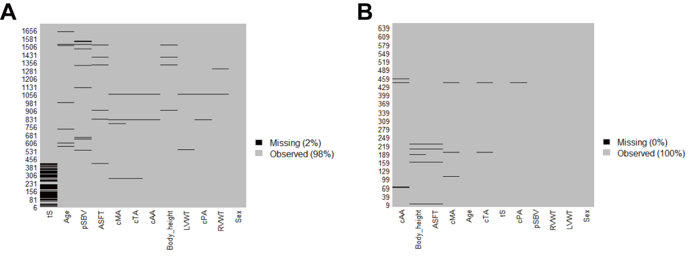

Figure S1. Missingness map in the internal set and external test set. (A) internal set, (B) external set. ASFT=Abdominal subcutaneous fat thickness; LVWT=left ventricular wall thickness; RVWT=right ventricular wall thickness; cTA=circumference of tricuspid annulus; cPA=circumference of pulmonary annulus; cMA=circumference of mitral annulus; cAA=circumference of aortic annulus; pSBV=perimeter of sub-valve; tS=thickness of septum.

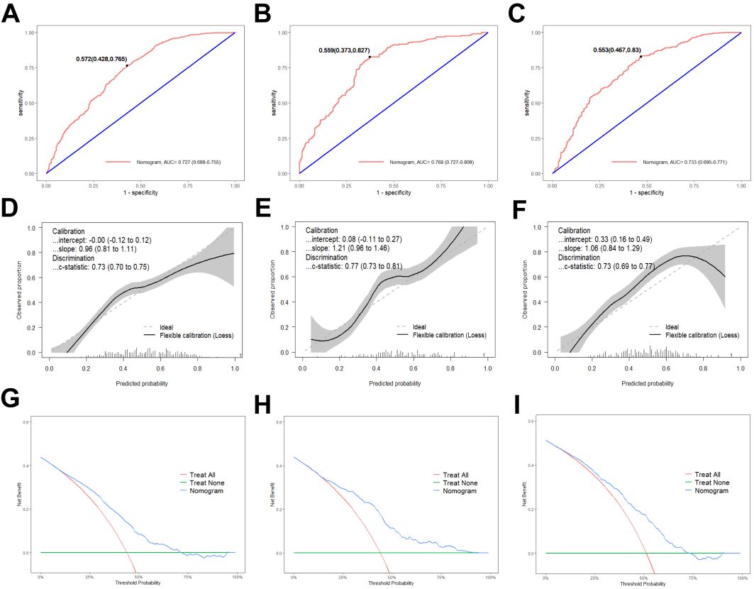

Figure S2. Application of the established nomogram in diagnosing CAS. A-C ROC curves of the nomogram for diagnosing CAS in the training (A), validation (B) and test (C) set, respectively. D-F Calibration curves in the training (D), validation (E) and test (F) set, respectively. G-I Decision curves in the training (G), validation (H) and test (I) set, respectively. CAS=coronary atherosclerosis.

Figure S3. Schematic diagram of measurement of RVOT morphology by cardiac ultrasound. The morphology of RVOT was measured from parasternal short axis section by cardiac ultrasound (left), and end-diastolic RVOT diameter (blue dash line) was measured at the plane below pulmonary valves (right). AV=aortic valve; LA=left atrium; PA=pulmonary artery; PSAX=parasternal short axis; PV=pulmonary valve; RA=right atrium; RVOT=right ventricular outflow tract; RVOTd=RVOT diameter; TV=tricuspid valve.
Supplemental References
1. Stekhoven, D. J. & Bühlmann P. MissForest--non-parametric missing value imputation for mixed-type data. Bioinformatics 28, 112-118 (2012).

