Supplementary materials for
Screening and validation of the optimal panel of housekeeping genes for 4T1 murine breast carcinoma and metastasis studies

Jorge Lucas Nascimento Souza^{a,d}, Ana Rafaela Antunes Portoª, Izabela da Silva Oliveiraª, Chiara Cássia Oliveira Amorimª, Luiz Octávio Pires^{b}, Isabela de Brito Duvalª, Luisa Vitor Braga do Amaralª, Andressa Mariana Saldanha-Eliasª, Amanda Dias Gomes^{b}, Amanda Cristine dos Santos^{b}, Fernanda Rezende Souza^{c}, Evelyn Ane Oliveira^{c}, Geovanni Dantas Cassali^{c}, Valbert Nascimento Cardoso^{b}; Simone Odília Antunes Fernandes^{b}, Ricardo Toshio Fujiwaraª, Remo Castro Russo^{d}, Lilian Lacerda Bueno^{a,*}

ªLaboratory of Immunobiology and Control of Parasites, Department of Parasitology, Institute of Biological Sciences, Universidade Federal de Minas Gerais, Belo Horizonte,
Brazil.

^{b}Laboratory of Radioisotopes, Department of Clinical and Toxicological Analysis, Faculty of Pharmacy, Universidade Federal de Minas Gerais, Belo Horizonte, Brazil.

^{c}Laboratory of Comparative Pathology, Department of Pathology, Institute of Biological Sciences, Universidade Federal de Minas Gerais, Belo Horizonte, Brazil.

^{d}Laboratory of Pulmonary Immunology and Mechanics, Department of Physiology and Biophysics, Institute of Biological Sciences, Universidade Federal de Minas Gerais, Belo Horizonte, Brazil.

*Corresponding author: Lilian Lacerda Bueno, Laboratory of Immunobiology and Control of Parasites, Department of Parasitology, Institute of Biological Sciences, Universidade Federal de Minas Gerais, Belo Horizonte, Brazil. Avenida Antônio Carlos 6627, Belo Horizonte, 31270-901, Minas Gerais, Brazil. E-mail: lilacerdabueno@gmail.com

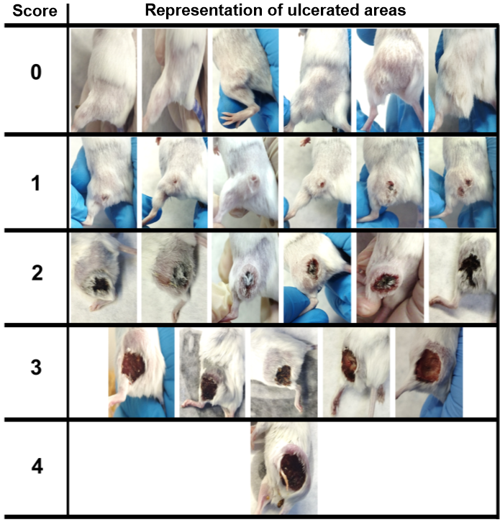
Figure 1: Images of the appearance of the ulcer according to the score.

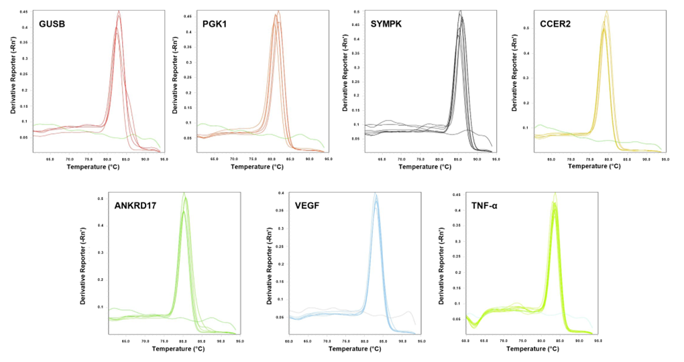
Figure 2: Dissociation curves of five HKGs candidates and two target-genes VEGF and TNF-α

Table 1: Score grades according to the evolution of ulcerated areas in the primary tumor of BALB/c mice with induction of breast carcinoma with injection of 4T1 cells into the flank.
Score | Evaluation of ulcer
0 | Absence of primary tumor or in the presence of tumor, absence of ulcerated areas (absent)
1 | Presence of a small ulcerated area still in its initial phase, occupying 1/3 or less of the tumor circumference (discreet)
2 | Presence of an ulcerated area occupying more than 1/3 of the circumference of the tumor with a dark red to black color (marked)
3 | Presence of an ulcerated area occupying more than 50% of the circumference of the primary tumor and infiltrating inwards (intense)
4 | Ulcerated area deepening inwards, forming borders on the tumor or with signs of tissue loss in the lower limb

