The effects of RT-qPCR standards on reproducibility and comparability in monitoring SARS-CoV-2 levels in wastewater
Aapo Juutinen^{a, b, #}, Ananda Tiwari^{c, d, #}, Anna-Maria Hokajärvi^{c}, Oskari Luomalaª, Aleksi Kolehmainen^{c}, Eveliina Nurmi^{c}, Elisa Salmivirta^{c}, Tarja Pitkänen^{c,d}, Anssi Lipponen^{c,e*}
ªDepartment of Health Security, Finnish Institute for Health and Welfare, Mannerheimintie 166, 00271, Helsinki, Finland

^{b}Research Unit of Population Health, Faculty of Medicine, University of Oulu, Finland
^{c}Department of Health Security, Expert Microbiology Research Unit, Finnish Institute for Health and Welfare.
^{d}Department of Food Hygiene and Environmental Health, Faculty of Veterinary Medicine, University of Helsinki, Finland.
^{e}University of Eastern Finland, Department of Medicine, Unit of Biomedicine, Kuopio, Finland.

# AJ and AT contributed equally and shared the first authorship.
*Corresponding author: Anssi Lipponen (anssi.lipponen@thl.fi)

Supplemental table S1. Description of wastewater treatment plants in this study¹.

WWTP, location | Municipalities served by the WWTP | Number of samples included (N) | Population served / total in the area (coverage) | 24h-composite sampling  method | Industrial wastewater proportion  %
Viikinmäki, Helsinki | Helsinki, Sipoo, Kerava, Tuusula, Järvenpää, Pornainen, Mäntsälä, Vantaa (half of the population) | 39 | 860 000 / 946 321 (0.91) | Flow and time | 7
Suomenoja, Espoo | Espoo, Vantaa (half of the population), Kirkkonummi, Kauniainen, Siuntio | 38 | 390 000 / 465 142 (0.84) | Flow | 5
Kakolanmäki, Turku | Turku, Naantali, Masku, Raisio, Kaarina, Paimio, Mynämäki, Nousiainen, Rusko, Lieto, Aura, Pöytyä, Oripää, Marttila | 38 | 300 000 /346 367 (0.87) | Flow | 15
Taskila, Oulu | Oulu, Muhos, Utajärvi, Ii | 35 | 200 000 / 227 297 (0.88) | Time | NA
Viinikanlahti, Tampere | Tampere, Kangasala, Pirkkala, Lempäälä | 40 | 200 000 /314 171 (0.64) | Flow | NA
Nenäinniemi, Jyväskylä | Jyväskylä, Laukaa, Muurame, Uurainen | 39 | 154 600 /175 415 (0.88) | Flow | 10
Kuhasalo, Joensuu | Joensuu, Kontiolahti, Liperi, Polvijärvi | 33 | 98 000 /108 120 (0.91) | Flow | 20
Lehtoniemi, Kuopio | Kuopio | 32 | 90 697 /119 533 (0.76) | Flow and time | NA
Pått, Vaasa | Vaasa, Mustasaari, Maalahti | 33 | 69 500 /92 576 (0.75) | Flow | NA
Total |  | 327

Supplemental table S2. Nucleic acid sequences of the primers and probes used in the study to detect SARS-CoV-2 and Mengovirus.

Target virus | Oligonucleotide | Sequence and label (5' → 3') | Reference
SARS-CoV-2 | 2019-nCoV_N2-F | TTACAAACATTGGCCGCAAA | Lu et al. 2020²
 | 2019-nCoV_N2-R | GCGCGACATTCCGAAGAA | Lu et al. 2020²
 | 2019-nCoV_N2- P | FAM-ACAATTTGCCCCCAGCGCTTCAG-BHQ1 | Lu et al. 2020²
Mengovirus | Mengo 110 | GCG GGT CCT GCC GAA AGT | Pintó et al. 2009³
 | Mengo 209 | GAA GTA ACA TAT AGA CAG ACG CAC AC | Pintó et al. 2009³
 | Mengo 147 | FAM-ATC ACA TTA CTG GCC GAA GC-MGB | Pintó et al. 2009³
FAM: 6-carboxyfluorescein; BHQ1: Black Hole Quencher 1; MGB: Minor Groove Binder.For SARS-CoV-2 and Mengovrus primers were purchased from IDT with standard purification. SARS-CoV-2 probe were purchased from IDT and for Mengovirus from Applied Biosystems with HPLC purification.

Supplemental Table S3. Details of RT-qPCR reactions and the cycling conditions used in the study.

Target | Reaction volume | RT-qPCR reaction mix | Thermal cycling conditions | Reference
SARS-CoV-2 | 25 μl | RNA sample: 5 μl  Primers: 0.2 μM  Probe: 0.2 μM  TaqMan Fast Virus 1-step Master Mix: 6.25 ul | 50°C for 5 min for reverse transcription, followed by 95°C for 20 s, and then 45 cycles of 95°C for 15 s and 58°C for 1 min | Lu et al. 2020²,  Medema et al. 2020⁴
Mengo-virus | 25 μl | RNA sample: 5 μl  Primers: 0.8 μM  Probe: 0.2 μM  TaqMan Fast Virus 1-step Master Mix: 6.25 ul | 50°C for 5 min for reverse transcription, followed by 95°C for 20 s, and then 45 cycles of 95°C for 15 s and 60°C for 1 min. | Pintó et al. 2009³,  ISO/TS 15216-1:2017⁵

Supplemental table S4. Comparison of the slopes between the standards. ANOVA indicated differences between IDT vs. CODEX and IDT vs. EURM019 (p<0.001).

 |  | Df | Sum.Sq | Mean.sq | F value | P-value
IDT vs. CODEX | Between groups | 1 | 2.2 | 2.2 | 136.9 | < 0.001
 | Within groups | 46 | 0.7 | 0.02
IDT vs. EURM019 | Between groups | 1 | 1.2 | 1.2 | 29.1 | < 0.001
 | Within groups | 54 | 2.2 | 0.04

Supplemental table S5. Comparison of the efficiencies between the standards. ANOVA indicated differences between IDT vs. CODEX and IDT vs. EURM019 (p<0.001).

 |  | Df | Sum.Sq | Mean.sq | F value | P-value
IDT vs. CODEX | Between groups | 1 | 4829 | 4829 | 122.8 | < 0.001
 | Within groups | 46 | 1809 | 39
IDT vs. EURM019 | Between groups | 1 | 2977 | 2977.2 | 28.58 | < 0.001
 | Within groups | 54 | 5625 | 104.2
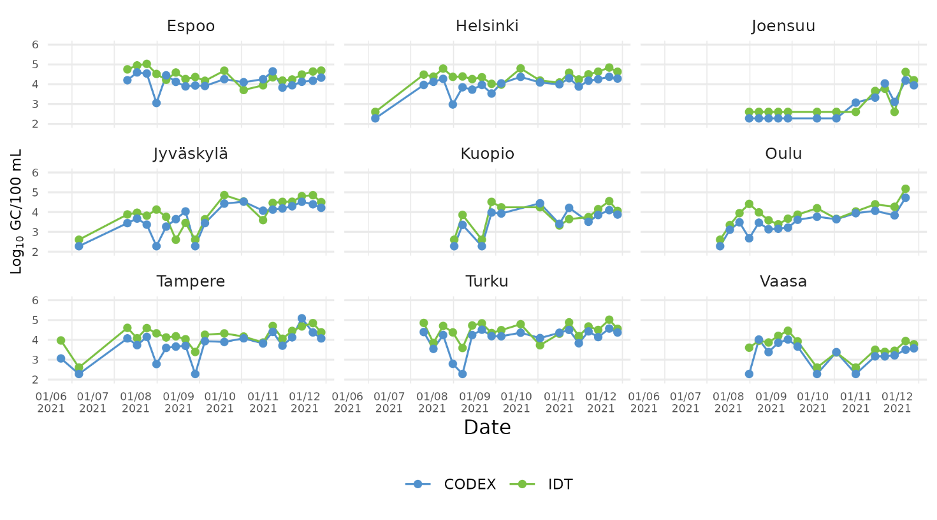Supplemental figure S1. Time series of number of virus RNA-copies with IDT and CODEX standards by municipality. IDT samples in green, CODEX in blue.
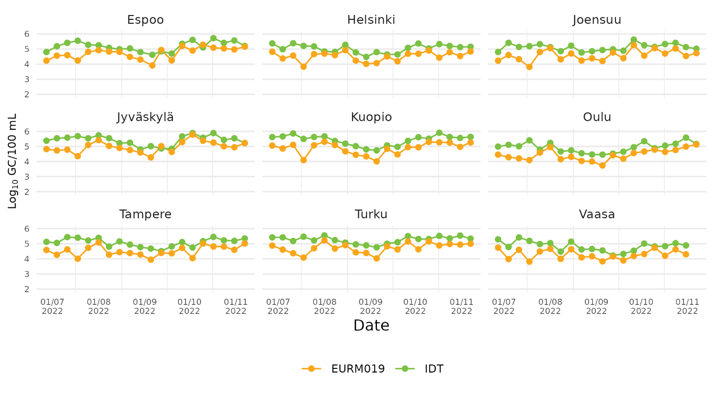Supplemental figure S2. Time series of number of virus RNA-copies with IDT and EURM019 standards by municipality. IDT samples in green, EURM019 in orange.
MIQE checklist
ITEM TO CHECK | IMPORTANCE | CHECKLIST
EXPERIMENTAL DESIGN
Definition of experimental and control groups | E | Provided in materials and methods.
Number within each group | E | Provided in materials and methods.
Assay carried out by core lab or investigator's lab? | D | In laboratory of Finnish Institute for Health and Welfare laboratory, Kuopio, Finland.
Acknowledgement of authors' contributions | D | See authors' contributions in main text.
SAMPLE
Description | E | Total RNA extracted from wastewater.
Volume/mass of sample processed | D | See materials and methods section 2.3 for details.
Microdissection or macrodissection | E | Not relevant to this study
Processing procedure | E | See materials and methods section 2.3 for details.
If frozen - how and how quickly? | E | Not relevant to this study
If fixed - with what, how quickly? | E | Not relevant to this study
Sample storage conditions and duration (especially for FFPE samples) | E | Fresh wastewater samples were used. Standard by description in Materials and Methods
NUCLEIC ACID EXTRACTION
Procedure and/or instrumentation | E | See materials and methods section 2.3
Name of kit and details of any modifications | E | See materials and methods section 2.3
Source of additional reagents used | D | Not relevant to this study
Details of DNase or RNAse treatment | E | Not relevant to this study
Contamination assessment (DNA or RNA) | E | Not relevant to this study
Nucleic acid quantification | E | Not relevant to this study
Instrument and method | E | Not relevant to this study
Purity (A260/A280) | D | Not relevant to this study
Yield | D | Not relevant to this study
RNA integrity method/instrument | E | Not relevant to this study
RIN/RQI or Cq of 3' and 5' transcripts | E | Not relevant to this study
Electrophoresis traces | D | Not relevant to this study
Inhibition testing (Cq dilutions, spike or other) | E | See materials and methods section 2.4
REVERSE TRANSCRIPTION
Complete reaction conditions | E | One step RT-qPCR mastermix were used. See materials and methods section 2.4
Amount of RNA and reaction volume | E | 5µl of template nucleic acid in 25µl reaction
Priming oligonucleotide (if using GSP) and concentration | E | One step master mix used and so unknown
Reverse transcriptase and concentration | E | One step master mix used and so unknown
Temperature and time | E | 50C 5 min. See suppplementary Table S3.
Manufacturer of reagents and catalogue numbers | D | Applied Biosystems, ThermoFisher Scientific, #4444436,
Cqs with and without RT | D* | Not applicable for this study
Storage conditions of cDNA | D | Not applicable for this study
qPCR TARGET INFORMATION
If multiplex, efficiency and LOD of each assay. | E | Not applicable for this study
Sequence accession number | E | N2 gene of SARS-CoV-2 by 2019-nCoV_N2-F and 2019-nCoV_N2-R primers (Lu et al. 2020).
Location of amplicon | D | N2 gene
Amplicon length | E | 67 bp (Lu et al. 2020)
In silico specificity screen (BLAST, etc) | E | See (Lu et al. 2020)
Pseudogenes, retropseudogenes or other homologs? | D | See (Lu et al. 2020)
Sequence alignment | D | See (Lu et al. 2020)
Secondary structure analysis of amplicon | D | See (Lu et al. 2020)
Location of each primer by exon or intron (if applicable) | E | See (Lu et al. 2020)
What splice variants are targeted? | E | See (Lu et al. 2020)
qPCR OLIGONUCLEOTIDES
Primer sequences | E | Supplemental Table S2
RTPrimerDB Identification Number | D | Not applicable for this study
Probe sequences | D** | Supplemental Table S2
Location and identity of any modifications | E | No modifications were done
Manufacturer of oligonucleotides | D | IDT
Purification method | D | N2 Primers with standard purifiaction and probes with HPLC.
qPCR PROTOCOL
Complete reaction conditions | E | See materials and methods section 2.4
Reaction volume and amount of cDNA/DNA | E | By one step mastermix (Applied Biosystems, ThermoFisher Scientific, #4444436), see supplemental Table S3.
Primer, (probe), Mg++ and dNTP concentrations | E | By one step mastermix (Applied Biosystems, ThermoFisher Scientific, #4444436)
Polymerase identity and concentration | E | By one step mastermix (Applied Biosystems, ThermoFisher Scientific, #4444436)
Buffer/kit identity and manufacturer | E | By one step mastermix (Applied Biosystems, ThermoFisher Scientific, #4444436)
Exact chemical constitution of the buffer | D | By one step mastermix (Applied Biosystems, ThermoFisher Scientific, #4444436)
Additives (SYBR Green I, DMSO, etc.) | E | Not used.
Manufacturer of plates/tubes and catalog number | D
Complete thermocycling parameters | E | Supplemental Table S3
Reaction setup (manual/robotic) | D | Manual pipeting.
Manufacturer of qPCR instrument | E | QuantStudio 6 Flex real-time PCR system (Applied Biosystems, ThermoFisher Scientific)
qPCR VALIDATION
Evidence of optimisation (from gradients) | D
Specificity (gel, sequence, melt, or digest) | E | Supplemental table S2 and (Lu et al. 2020)
For SYBR Green I, Cq of the NTC | E | Not relevant to this study
Standard curves with slope and y-intercept | E | See results 3.1, Table 2
PCR efficiency calculated from slope | E | See results 3.1, Table 2
Confidence interval for PCR efficiency or standard error | D | See results 3.1, Table 2
r2 of standard curve | E | See results 3.1, Table 2
Linear dynamic range | E | See results 3.1
Cq variation at lower limit | E | See results 3.1
Confidence intervals throughout range | D
Evidence for limit of detection | E | See results 3.1
If multiplex, efficiency and LOD of each assay. | E | Not applicable for this study
DATA ANALYSIS
qPCR analysis program (source, version) | E | QuantStudio Real-Time PCR Software v1.7.2
Cq method determination | E | Threshold
Outlier identification and disposition | E | QuantStudion QC tools that uses calculated confidence in between replicates. If over 2 standarpoint outliers in standard curve, experiment was repeated.
Results of NTCs | E | NTCs did not exceeded threshold.
Justification of number and choice of reference genes | E | Not relevant to this study
Description of normalisation method | E | Not applicable for this study
Number and concordance of biological replicates | D
Number and stage (RT or qPCR) of technical replicates | E | 2 techincal relpicates in RT-qPCR for wastewater samples and each standard points.
Repeatability (intra-assay variation) | E | See results 3.1, Table 2
Reproducibility (inter-assay variation, %CV) | D | Not applicable for this study
Power analysis | D | Not applicable for this study
Statistical methods for result significance | E | See materials and methods
Software (source, version) | E | QuantStudio 6 Flex real-time PCR system (Applied Biosystems, ThermoFisher Scientific)
Cq or raw data submission using RDML | D | Data availabe according to data availabilty statement.

References
1. Tiwari, A. et al. Detection and quantification of SARS-CoV-2 RNA in wastewater influent in relation to reported COVID-19 incidence in Finland. Water Res. 215, 118220 (2022).
2. Lu, X. et al. US CDC Real-Time Reverse Transcription PCR Panel for Detection of Severe Acute Respiratory Syndrome Coronavirus 2. Emerg. Infect. Dis. 26, 1654–1665 (2020).
3. Pintó, R. M., Costafreda, M. I. & Bosch, A. Risk Assessment in Shellfish-Borne Outbreaks of Hepatitis A. Appl. Environ. Microbiol. 75, 7350–7355 (2009).
4. Medema, G., Heijnen, L., Elsinga, G., Italiaander, R. & Brouwer, A. Presence of SARS-Coronavirus-2 RNA in Sewage and Correlation with Reported COVID-19 Prevalence in the Early Stage of the Epidemic in The Netherlands. Environ. Sci. Technol. Lett. 7, 511–516 (2020).
5. ISO 15216-1:2017. Microbiology of the food chain, Horizontal method for determination of hepatitis A virus and norovirus using real-time RT-PCR, Part 1: Method for quantification. (2017).

