Supplementary material
Longitudinal Analysis of ARDS Variability and Biomarker Predictive Power in Burn Patients

Jaechul Yoon1, Dohern Kym,1,2*, Yong Suk Cho1,2, Jun Hur1,2, Dogeon Yoon2

1. Department of Surgery and Critical Care, Burn Center, Hangang Sacred Heart Hospital, Hallym University Medical Center, 12, Beodeunaru-ro 7-gil, Yeongdeungpo-gu, Seoul, Korea, 07247

2. Burn Institutes, Hangang Sacred Heart Hospital, Hallym University Medical Center, 12, Beodeunaru-ro 7-gil, Yeongdeungpo-gu, Seoul, Korea, 07247

*Corresponding authors
Department of Surgery and Critical Care, Burn Center, Hangang Sacred Heart Hospital, College of Medicine, Hallym University 12, Beodeunaru-ro 7-gil, Yeongdeungpo-gu, Seoul, Korea, 07247
Tel. 82-2-2639-5446, Fax. 82-2-2678-4386, E-mail: dohern@hallym.or.kr

Contents
Figure S1. Elbow method, guided by key statistical metrics. 3
Table S1. Cluster-based PF ratio by Hospital Days 4
Figure S2. Trajectory of Creatinine for all patients by Hospital days 4
Table S2. Adjusted Odds Ratios for AKI Based on Various Predictors Controlling for Patient and Disease Factors 5
Table S3. NRI for Predictors of AKI by Cluster 8
Table S4. IDI for Predictors of AKI by Cluster 11
Table S5. Net Benefit Comparison for AKI Prediction by Decision Curve Analysis 14

Figure S1. Elbow method, guided by key statistical metrics.
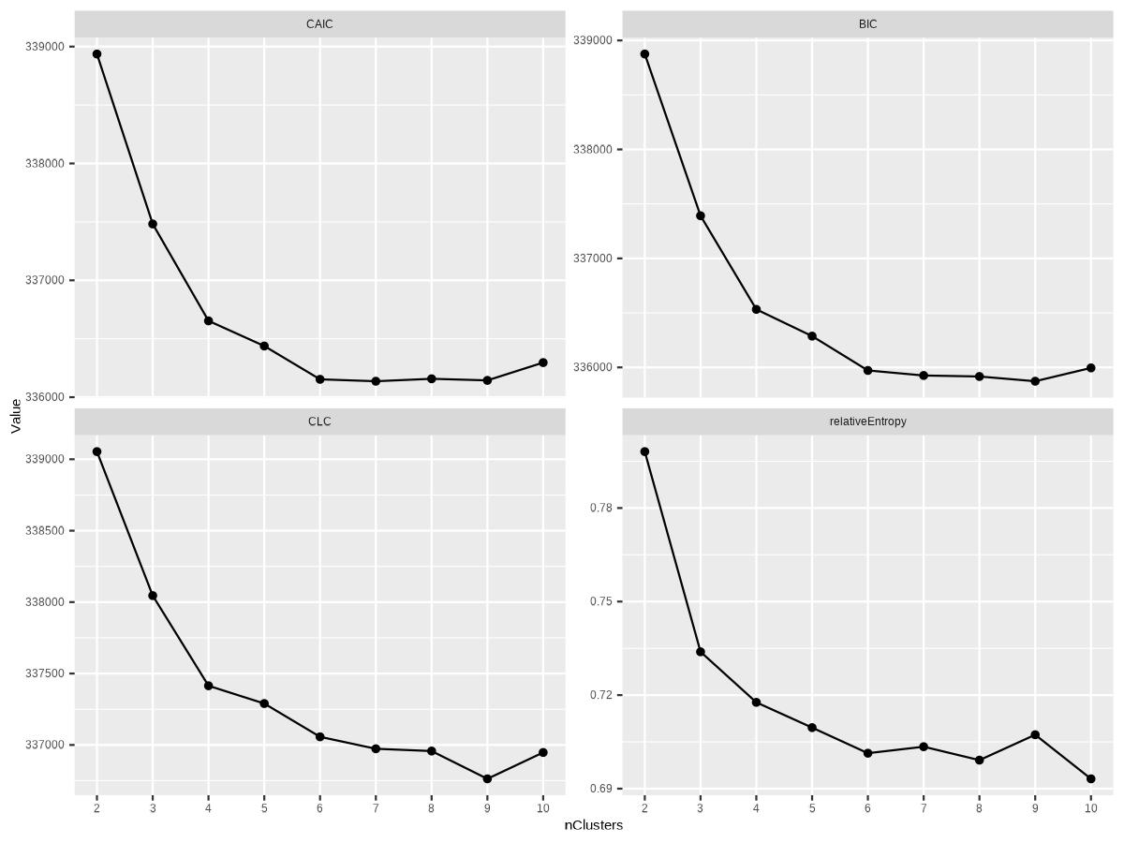

Table S1. Cluster-based PF ratio by Hospital Days
Group | Characteristic | HD 1, N = 567 (38.2%) | HD 8, N = 375 (25.3%) | HD 15, N = 242 (16.3%) | HD 22, N = 181 (12.2%) | HD 30, N = 118 (7.96%)
A | PF ratio | 190.6 ± 82.8 (117.3 - 418.0) | 168.0 ± 50.4 (117.3 - 354.5) | 166.1 ± 53.4 (117.3 - 345.0) | 181.6 ± 56.2 (117.3 - 359.8) | 209.9 ± 74.0 (117.3 - 405.2)
B | PF ratio | 340.0 ± 78.8 (117.3 - 418.0) | 224.8 ± 68.1 (117.3 - 418.0) | 202.8 ± 68.8 (117.3 - 418.0) | 211.6 ± 72.7 (117.3 - 418.0) | 244.6 ± 85.8 (117.3 - 418.0)
C | PF ratio | 213.2 ± 82.9 (117.3 - 418.0) | 236.5 ± 69.9 (117.3 - 418.0) | 247.5 ± 70.8 (117.3 - 418.0) | 277.6 ± 74.6 (117.3 - 418.0) | 294.4 ± 87.7 (117.3 - 418.0)
D | PF ratio | 289.1 ± 93.8 (117.3 - 418.0) | 320.6 ± 77.0 (128.8 - 418.0) | 328.9 ± 78.1 (117.3 - 418.0) | 334.5 ± 78.6 (117.3 - 418.0) | 340.9 ± 92.1 (117.3 - 418.0)

Figure S2. Trajectory of Creatinine for all patients by Hospital days
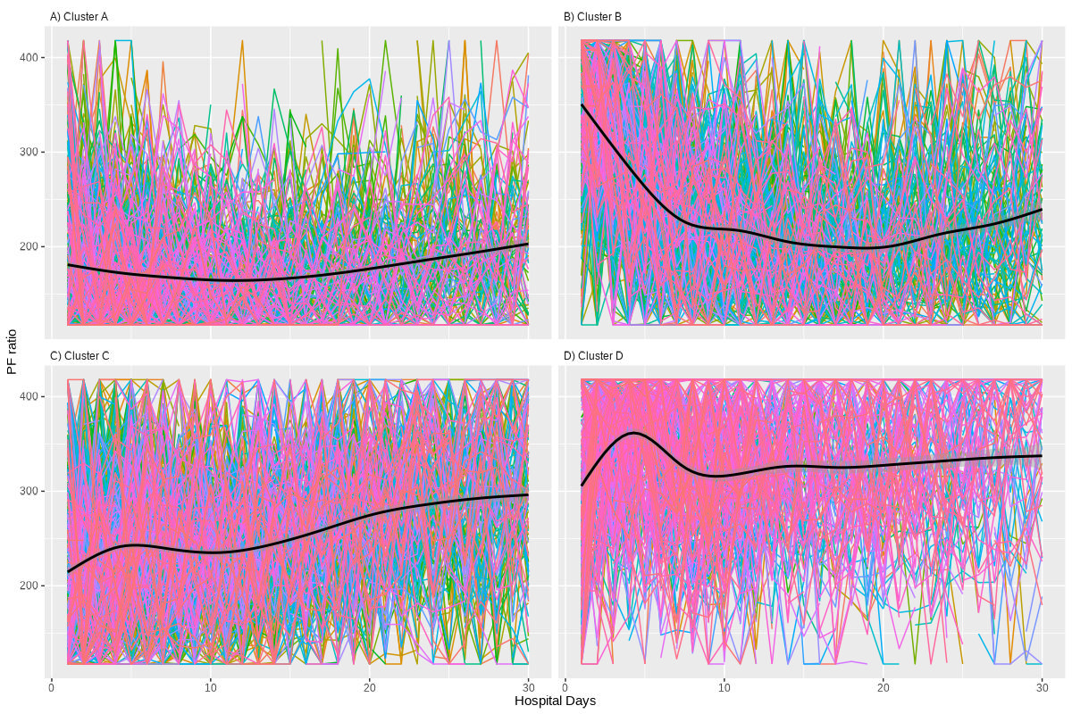

Table S2. Adjusted Odds Ratios for AKI Based on Various Predictors Controlling for Patient and Disease Factors
Clusters | Predictors | Adjusted odd (95%CI) ª | p-value | Prevalence
Cluster A
 | Albumin | 0.312 (0.228~0.419) | <0.001 ** | 66.1% (375/567)
 | WBC | 0.391 (0.290~0.515) | <0.001 ** | 66.1% (375/567)
 | Platelet | 0.480 (0.377~0.604) | <0.001 ** | 66.1% (375/567)
 | PT | 2.221 (1.715~2.925) | <0.001 ** | 64.9% (352/542)
 | PF ratio | 0.284 (0.180~0.435) | <0.001 ** | 66.1% (375/567)
 | Lactate | 0.415 (0.298~0.565) | <0.001 ** | 65.8% (364/553)
 | pO2 | 0.492 (0.370~0.647) | <0.001 ** | 66.3% (375/566)
 | pCO2 | 1.602 (1.259~2.046) | <0.001 ** | 66.3% (375/566)
 | RDW | 1.616 (1.250~2.104) | <0.001 ** | 66.1% (375/567)
 | BUN | 0.799 (0.631~1.010) | 0.061 | 66.1% (375/567)
 | Creatinine | 0.871 (0.694~1.089) | 0.227 | 66.1% (375/567)
 | pH | 1.079 (0.811~1.451) | 0.606 | 66.3% (375/566)
 | TB | 1.042 (0.840~1.293) | 0.711 | 66.1% (374/566)
Cluster B
 | PF ratio | 0.125 (0.081~0.185) | <0.001 ** | 36.7% (241/656)
 | Albumin | 0.183 (0.127~0.256) | <0.001 ** | 36.9% (240/651)
 | WBC | 0.250 (0.182~0.334) | <0.001 ** | 36.9% (240/651)
 | pO2 | 0.294 (0.216~0.390) | <0.001 ** | 36.8% (241/655)
 | Platelet | 0.387 (0.294~0.500) | <0.001 ** | 36.9% (240/651)
 | Lactate | 0.336 (0.245~0.452) | <0.001 ** | 36.7% (232/632)
 | PT | 3.170 (2.278~4.513) | <0.001 ** | 36.2% (229/632)
 | BUN | 0.537 (0.409~0.696) | <0.001 ** | 36.9% (240/651)
 | Creatinine | 0.540 (0.408~0.704) | <0.001 ** | 36.9% (240/651)
 | RDW | 1.695 (1.327~2.175) | <0.001 ** | 36.9% (240/651)
 | pCO2 | 1.480 (1.158~1.900) | 0.002 * | 36.8% (241/655)
 | pH | 1.278 (0.983~1.672) | 0.070 | 36.9% (241/654)
 | TB | 0.988 (0.786~1.243) | 0.921 | 36.8% (241/655)
Cluster C
 | Albumin | 0.245 (0.176~0.335) | <0.001 ** | 50.4% (284/564)
 | WBC | 0.461 (0.358~0.588) | <0.001 ** | 50.4% (284/564)
 | Platelet | 0.466 (0.357~0.599) | <0.001 ** | 50.4% (284/564)
 | RDW | 2.124 (1.629~2.801) | <0.001 ** | 50.4% (284/564)
 | PT | 2.190 (1.640~2.965) | <0.001 ** | 49.9% (273/547)
 | Lactate | 0.527 (0.408~0.673) | <0.001 ** | 50.8% (279/549)
 | Creatinine | 0.540 (0.415~0.696) | <0.001 ** | 50.4% (284/564)
 | BUN | 0.610 (0.475~0.776) | <0.001 ** | 50.4% (284/564)
 | PF ratio | 0.561 (0.405~0.767) | <0.001 ** | 50.4% (284/564)
 | pO2 | 0.645 (0.491~0.841) | 0.001 * | 50.4% (284/564)
 | pH | 1.255 (0.989~1.602) | 0.064 | 50.4% (284/564)
 | pCO2 | 1.205 (0.961~1.512) | 0.106 | 50.4% (284/564)
 | TB | 0.986 (0.780~1.246) | 0.904 | 50.4% (284/563)
Cluster D
 | Albumin | 0.261 (0.179~0.372) | <0.001 ** | 21.4% (113/529)
 | Lactate | 0.218 (0.136~0.331) | <0.001 ** | 21.7% (112/517)
 | WBC | 0.320 (0.224~0.443) | <0.001 ** | 21.4% (113/529)
 | PF ratio | 0.281 (0.188~0.406) | <0.001 ** | 21.7% (115/531)
 | RDW | 2.450 (1.820~3.334) | <0.001 ** | 21.4% (113/529)
 | PT | 2.832 (2.006~4.081) | <0.001 ** | 20.6% (106/515)
 | pO2 | 0.399 (0.281~0.551) | <0.001 ** | 21.7% (115/531)
 | Platelet | 0.418 (0.292~0.585) | <0.001 ** | 21.4% (113/529)
 | Creatinine | 0.477 (0.330~0.671) | <0.001 ** | 21.4% (113/529)
 | pCO2 | 1.617 (1.188~2.214) | 0.002 * | 21.7% (115/531)
 | pH | 1.649 (1.192~2.312) | 0.003 * | 21.4% (113/529)
 | BUN | 0.634 (0.454~0.870) | 0.006 * | 21.4% (113/529)
 | TB | 0.993 (0.756~1.299) | 0.960 | 21.4% (113/529)
ª All adjusted odds ratios were calculated controlling for age, TBSA, inhalation injury, AKI, sepsis, and the use of ventilators and CRRT.
** Indicates P-value < 0.001. * Indicates P-value < 0.05

Table S3. NRI for Predictors of AKI by Cluster
Clusters | Predictors | NRI (95%CI) | p-value | Prevalence
Cluster A
 | Albumin | 0.421 (0.251~0.591) | <0.001 ** | 375/567 (66.1%)
 | PT | 0.168 (-0.008~0.343) | 0.061 | 352/542 (64.9%)
 | WBC | 0.151 (-0.023~0.324) | 0.089 | 375/567 (66.1%)
 | Lactate | 0.058 (-0.117~0.234) | 0.516 | 364/553 (65.8%)
 | Platelet | 0.010 (-0.163~0.183) | 0.910 | 375/567 (66.1%)
 | PF ratio | Reference |  | 375/567 (66.1%)
 | pCO2 | -0.394 (-0.565~-0.223) | <0.001 ** | 375/566 (66.3%)
 | RDW | -0.245 (-0.418~-0.072) | 0.005 * | 375/567 (66.1%)
 | pO2 | -0.192 (-0.365~-0.019) | 0.030 * | 375/566 (66.3%)
Cluster B
 | PF ratio | Reference |  | 241/656 (36.7%)
 | pCO2 | -1.135 (-1.266~-1.004) | <0.001 ** | 241/655 (36.8%)
 | Creatinine | -1.027 (-1.165~-0.890) | <0.001 ** | 240/651 (36.9%)
 | RDW | -1.022 (-1.160~-0.885) | <0.001 ** | 240/651 (36.9%)
 | BUN | -0.976 (-1.116~-0.836) | <0.001 ** | 240/651 (36.9%)
 | pO2 | -0.935 (-1.076~-0.795) | <0.001 ** | 241/655 (36.8%)
 | Platelet | -0.822 (-0.968~-0.676) | <0.001 ** | 240/651 (36.9%)
 | PT | -0.784 (-0.934~-0.635) | <0.001 ** | 229/632 (36.2%)
 | Lactate | -0.775 (-0.925~-0.625) | <0.001 ** | 232/632 (36.7%)
 | Albumin | -0.457 (-0.612~-0.302) | <0.001 ** | 240/651 (36.9%)
 | WBC | -0.374 (-0.531~-0.218) | <0.001 ** | 240/651 (36.9%)
Cluster C
 | Albumin | 0.845 (0.696~0.994) | <0.001 ** | 284/564 (50.4%)
 | WBC | 0.447 (0.286~0.607) | <0.001 ** | 284/564 (50.4%)
 | Platelet | 0.431 (0.271~0.590) | <0.001 ** | 284/564 (50.4%)
 | PT | 0.362 (0.197~0.526) | <0.001 ** | 273/547 (49.9%)
 | RDW | 0.356 (0.193~0.518) | <0.001 ** | 284/564 (50.4%)
 | Lactate | 0.329 (0.165~0.494) | <0.001 ** | 279/549 (50.8%)
 | BUN | 0.127 (-0.037~0.292) | 0.130 | 284/564 (50.4%)
 | Creatinine | 0.126 (-0.038~0.290) | 0.131 | 284/564 (50.4%)
 | PF ratio | Reference |  | 284/564 (50.4%)
 | pO2 | -0.058 (-0.222~0.106) | 0.485 | 284/564 (50.4%)
Cluster D
 | Lactate | 0.293 (0.087~0.499) | 0.005 * | 112/517 (21.7%)
 | WBC | 0.219 (0.013~0.426) | 0.037 * | 113/529 (21.4%)
 | Albumin | 0.185 (-0.022~0.393) | 0.079 | 113/529 (21.4%)
 | PF ratio | Reference |  | 115/531 (21.7%)
 | pCO2 | -0.602 (-0.796~-0.407) | <0.001 ** | 115/531 (21.7%)
 | pO2 | -0.565 (-0.764~-0.366) | <0.001 ** | 115/531 (21.7%)
 | BUN | -0.495 (-0.696~-0.295) | <0.001 ** | 113/529 (21.4%)
 | pH | -0.465 (-0.667~-0.263) | <0.001 ** | 113/529 (21.4%)
 | RDW | -0.387 (-0.586~-0.187) | <0.001 ** | 113/529 (21.4%)
 | Creatinine | -0.322 (-0.527~-0.117) | 0.002 * | 113/529 (21.4%)
 | PT | -0.195 (-0.405~0.015) | 0.068 | 106/515 (20.6%)
 | Platelet | -0.107 (-0.314~0.101) | 0.314 | 113/529 (21.4%)

Table S4. IDI for Predictors of AKI by Cluster
Clusters | Predictors | IDI (95%CI) | p-value | Prevalence
Cluster A
 | Albumin | 0.033 (0.002~0.064) | 0.038 * | 375/567 (66.1%)
 | WBC | 0.013 (-0.015~0.042) | 0.358 | 375/567 (66.1%)
 | PT | 0.009 (-0.017~0.036) | 0.490 | 352/542 (64.9%)
 | Platelet | 0.006 (-0.022~0.033) | 0.682 | 375/567 (66.1%)
 | PF ratio | Reference |  | 375/567 (66.1%)
 | RDW | -0.037 (-0.060~-0.014) | 0.002 * | 375/567 (66.1%)
 | pCO2 | -0.033 (-0.055~-0.011) | 0.004 * | 375/566 (66.3%)
 | pO2 | -0.014 (-0.033~0.006) | 0.172 | 375/566 (66.3%)
 | Lactate | -0.011 (-0.041~0.018) | 0.439 | 364/553 (65.8%)
Cluster B
 | PF ratio | Reference |  | 241/656 (36.7%)
 | pCO2 | -0.177 (-0.206~-0.149) | <0.001 ** | 241/655 (36.8%)
 | RDW | -0.172 (-0.203~-0.141) | <0.001 ** | 240/651 (36.9%)
 | BUN | -0.165 (-0.198~-0.133) | <0.001 ** | 240/651 (36.9%)
 | Creatinine | -0.163 (-0.194~-0.131) | <0.001 ** | 240/651 (36.9%)
 | Lactate | -0.127 (-0.161~-0.092) | <0.001 ** | 232/632 (36.7%)
 | PT | -0.124 (-0.157~-0.092) | <0.001 ** | 229/632 (36.2%)
 | Platelet | -0.121 (-0.155~-0.087) | <0.001 ** | 240/651 (36.9%)
 | pO2 | -0.089 (-0.113~-0.066) | <0.001 ** | 241/655 (36.8%)
 | WBC | -0.063 (-0.099~-0.026) | <0.001 ** | 240/651 (36.9%)
 | Albumin | -0.052 (-0.087~-0.017) | 0.004 * | 240/651 (36.9%)
Cluster C
 | Albumin | 0.096 (0.067~0.125) | <0.001 ** | 284/564 (50.4%)
 | Platelet | 0.033 (0.013~0.053) | 0.001 * | 284/564 (50.4%)
 | WBC | 0.032 (0.010~0.054) | 0.004 * | 284/564 (50.4%)
 | PT | 0.023 (0.004~0.042) | 0.018 * | 273/547 (49.9%)
 | RDW | 0.022 (0.002~0.041) | 0.029 * | 284/564 (50.4%)
 | Lactate | 0.018 (-0.000~0.037) | 0.056 | 279/549 (50.8%)
 | Creatinine | 0.012 (-0.006~0.030) | 0.179 | 284/564 (50.4%)
 | BUN | 0.002 (-0.015~0.018) | 0.852 | 284/564 (50.4%)
 | PF ratio | Reference |  | 284/564 (50.4%)
 | pO2 | -0.005 (-0.016~0.005) | 0.331 | 284/564 (50.4%)
Cluster D
 | Lactate | 0.025 (-0.017~0.067) | 0.237 | 112/517 (21.7%)
 | Albumin | 0.003 (-0.037~0.043) | 0.880 | 113/529 (21.4%)
 | WBC | 0.002 (-0.042~0.046) | 0.937 | 113/529 (21.4%)
 | PF ratio | Reference |  | 115/531 (21.7%)
 | BUN | -0.094 (-0.125~-0.063) | <0.001 ** | 113/529 (21.4%)
 | pH | -0.091 (-0.123~-0.059) | <0.001 ** | 113/529 (21.4%)
 | pCO2 | -0.084 (-0.112~-0.056) | <0.001 ** | 115/531 (21.7%)
 | Creatinine | -0.074 (-0.107~-0.041) | <0.001 ** | 113/529 (21.4%)
 | Platelet | -0.043 (-0.078~-0.007) | 0.019 * | 113/529 (21.4%)
 | pO2 | -0.037 (-0.059~-0.014) | 0.001 * | 115/531 (21.7%)
 | RDW | -0.033 (-0.071~0.004) | 0.083 | 113/529 (21.4%)
 | PT | -0.031 (-0.067~0.006) | 0.099 | 106/515 (20.6%)

Table S5. Net Benefit Comparison for AKI Prediction by Decision Curve Analysis
Clusters | Strategy | Threshold_0.3 | Threshold_0.35 | Threshold_0.4 | Threshold_0.45 | Threshold_0.5 | Threshold_0.55 | Threshold_0.6 | Threshold_0.65 | Threshold_0.7 | Threshold_0.75 | Threshold_0.8 | Threshold_0.85 | Threshold_0.9 | Threshold_0.95
Cluster A
 | Cystatin C | 0.576 (0.505~0.648) | 0.576 (0.502~0.648) | 0.540 (0.463~0.616) | 0.529 (0.449~0.607) | 0.514 (0.433~0.595) | 0.483 (0.397~0.568) | 0.461 (0.372~0.547) | 0.433 (0.340~0.522) | 0.397 (0.299~0.491) | 0.374 (0.270~0.473) | 0.374 (0.270~0.470) | 0.335 (0.218~0.443) | 0.380 (0.322~0.440) | 0.346 (0.289~0.407)
 | PT | 0.592 (0.517~0.665) | 0.571 (0.494~0.648) | 0.534 (0.453~0.616) | 0.503 (0.416~0.588) | 0.497 (0.412~0.582) | 0.492 (0.402~0.578) | 0.466 (0.370~0.560) | 0.432 (0.327~0.534) | 0.387 (0.272~0.497) | 0.380 (0.262~0.494) | 0.346 (0.213~0.471) | 0.371 (0.236~0.488) | 0.279 (0.109~0.424) | 0.285 (0.071~0.433)
 | eGFR cys | 0.599 (0.527~0.669) | 0.561 (0.485~0.636) | 0.547 (0.470~0.624) | 0.532 (0.449~0.612) | 0.508 (0.422~0.593) | 0.518 (0.433~0.601) | 0.458 (0.368~0.546) | 0.434 (0.340~0.525) | 0.399 (0.295~0.498) | 0.341 (0.227~0.448) | 0.385 (0.282~0.481) | 0.361 (0.258~0.455) | 0.374 (0.316~0.435) | 0.313 (0.258~0.370)
 | Albumin | 0.568 (0.490~0.644) | 0.559 (0.477~0.638) | 0.538 (0.452~0.622) | 0.520 (0.430~0.607) | 0.469 (0.374~0.562) | 0.429 (0.330~0.527) | 0.397 (0.287~0.503) | 0.385 (0.271~0.493) | 0.335 (0.207~0.456) | 0.313 (0.175~0.441) | 0.257 (0.094~0.403) | 0.212 (0.022~0.379) | 0.184 (-0.052~0.385) | 0.279 (0.073~0.428)
 | TB | 0.566 (0.488~0.642) | 0.544 (0.460~0.625) | 0.514 (0.427~0.601) | 0.505 (0.415~0.594) | 0.492 (0.398~0.584) | 0.471 (0.371~0.567) | 0.436 (0.328~0.539) | 0.396 (0.284~0.505) | 0.376 (0.253~0.494) | 0.302 (0.161~0.437) | 0.313 (0.168~0.449) | 0.324 (0.165~0.467) | 0.223 (0.023~0.395) | 0.022 (-0.324~0.307)
 | Creatinine | 0.551 (0.471~0.630) | 0.532 (0.447~0.614) | 0.512 (0.423~0.599) | 0.511 (0.420~0.601) | 0.480 (0.383~0.578) | 0.443 (0.339~0.545) | 0.416 (0.306~0.526) | 0.381 (0.265~0.496) | 0.354 (0.225~0.479) | 0.279 (0.132~0.420) | 0.196 (0.029~0.357) | 0.279 (0.123~0.420) | 0.335 (0.187~0.461) | 0.341 (0.284~0.399)
 | Treat All | 0.537 (0.454~0.617) | 0.502 (0.412~0.588) | 0.460 (0.363~0.554) | 0.411 (0.305~0.513) | 0.352 (0.236~0.464) | 0.280 (0.151~0.405) | 0.190 (0.045~0.331) | 0.074 (-0.092~0.235) | -0.080 (-0.273~0.107) | -0.296 (-0.528~-0.071) | -0.620 (-0.910~-0.339) | -1.160 (-1.547~-0.785) | -2.240 (-2.820~-1.678) | -5.480 (-6.641~-4.355)
Cluster B
 | Cystatin C | 0.171 (0.114~0.229) | 0.142 (0.089~0.196) | 0.138 (0.087~0.189) | 0.120 (0.070~0.170) | 0.108 (0.061~0.155) | 0.094 (0.047~0.141) | 0.097 (0.051~0.142) | 0.099 (0.057~0.141) | 0.098 (0.058~0.137) | 0.108 (0.077~0.140) | 0.104 (0.074~0.136) | 0.104 (0.074~0.136) | 0.104 (0.074~0.136) | 0.104 (0.074~0.136)
 | eGFR cys | 0.178 (0.122~0.235) | 0.146 (0.092~0.200) | 0.136 (0.086~0.186) | 0.101 (0.053~0.149) | 0.108 (0.062~0.155) | 0.100 (0.054~0.145) | 0.097 (0.054~0.139) | 0.091 (0.049~0.132) | 0.099 (0.063~0.135) | 0.104 (0.074~0.136) | 0.104 (0.074~0.136) | 0.104 (0.074~0.136) | 0.104 (0.074~0.136) | 0.104 (0.074~0.136)
 | PT | 0.165 (0.107~0.225) | 0.142 (0.081~0.205) | 0.113 (0.052~0.174) | 0.081 (0.024~0.138) | 0.077 (0.019~0.137) | 0.054 (-0.005~0.114) | 0.071 (0.014~0.129) | 0.068 (0.012~0.124) | 0.050 (-0.009~0.107) | 0.069 (0.012~0.124) | 0.073 (0.015~0.128) | 0.068 (0.002~0.125) | 0.108 (0.077~0.140) | 0.104 (0.074~0.136)
 | Albumin | 0.163 (0.104~0.223) | 0.132 (0.074~0.192) | 0.106 (0.045~0.167) | 0.080 (0.017~0.145) | 0.081 (0.015~0.148) | 0.065 (-0.003~0.135) | 0.056 (-0.013~0.127) | 0.030 (-0.047~0.109) | 0.023 (-0.062~0.108) | 0.054 (-0.028~0.133) | 0.093 (0.019~0.160) | 0.081 (0.003~0.149) | 0.058 (-0.038~0.137) | 0.112 (0.080~0.144)
 | Creatinine | 0.135 (0.069~0.201) | 0.103 (0.035~0.172) | 0.051 (-0.020~0.124) | 0.009 (-0.066~0.083) | -0.008 (-0.087~0.070) | 0.016 (-0.058~0.091) | 0.004 (-0.074~0.080) | 0.032 (-0.039~0.105) | 0.071 (0.008~0.136) | 0.081 (0.019~0.140) | 0.089 (0.028~0.143) | 0.102 (0.050~0.149) | 0.116 (0.083~0.148) | 0.104 (0.074~0.136)
 | Treat All | 0.084 (0.014~0.157) | 0.014 (-0.062~0.092) | -0.068 (-0.150~0.016) | -0.165 (-0.255~-0.073) | -0.282 (-0.381~-0.181) | -0.424 (-0.534~-0.312) | -0.602 (-0.726~-0.476) | -0.831 (-0.972~-0.687) | -1.136 (-1.301~-0.968) | -1.564 (-1.761~-1.362) | -2.205 (-2.451~-1.952) | -3.273 (-3.602~-2.936) | -5.409 (-5.903~-4.904) | -11.819 (-12.806~-10.808)
Cluster C
 | Albumin | 0.231 (0.189~0.275) | 0.218 (0.174~0.263) | 0.207 (0.162~0.254) | 0.200 (0.155~0.248) | 0.189 (0.141~0.238) | 0.168 (0.119~0.219) | 0.150 (0.096~0.203) | 0.135 (0.078~0.192) | 0.122 (0.062~0.181) | 0.093 (0.027~0.157) | 0.088 (0.018~0.155) | 0.142 (0.090~0.192) | 0.140 (0.112~0.168) | 0.103 (0.079~0.128)
 | PT | 0.233 (0.190~0.276) | 0.224 (0.180~0.267) | 0.212 (0.167~0.257) | 0.201 (0.155~0.248) | 0.199 (0.152~0.245) | 0.184 (0.136~0.232) | 0.165 (0.115~0.214) | 0.158 (0.108~0.207) | 0.145 (0.095~0.195) | 0.145 (0.094~0.195) | 0.100 (0.043~0.155) | 0.084 (0.028~0.137) | 0.120 (0.094~0.147) | 0.100 (0.076~0.125)
 | Cystatin C | 0.242 (0.201~0.284) | 0.235 (0.194~0.278) | 0.226 (0.185~0.268) | 0.217 (0.176~0.260) | 0.201 (0.158~0.243) | 0.178 (0.134~0.222) | 0.173 (0.128~0.218) | 0.169 (0.123~0.215) | 0.181 (0.137~0.224) | 0.164 (0.121~0.207) | 0.145 (0.102~0.187) | 0.131 (0.092~0.167) | 0.120 (0.094~0.147) | 0.103 (0.078~0.128)
 | Lactate | 0.229 (0.186~0.274) | 0.218 (0.174~0.263) | 0.212 (0.167~0.258) | 0.200 (0.153~0.247) | 0.181 (0.131~0.230) | 0.172 (0.120~0.224) | 0.162 (0.108~0.215) | 0.143 (0.085~0.200) | 0.103 (0.040~0.165) | 0.113 (0.049~0.174) | 0.135 (0.079~0.189) | 0.164 (0.135~0.195) | 0.113 (0.087~0.139) | 0.100 (0.076~0.125)
 | eGFR cys | 0.238 (0.197~0.281) | 0.229 (0.188~0.271) | 0.220 (0.178~0.262) | 0.211 (0.169~0.253) | 0.199 (0.156~0.240) | 0.181 (0.137~0.225) | 0.172 (0.125~0.217) | 0.162 (0.116~0.210) | 0.169 (0.124~0.214) | 0.181 (0.143~0.221) | 0.150 (0.107~0.191) | 0.147 (0.118~0.176) | 0.125 (0.099~0.152) | 0.103 (0.078~0.128)
 | Creatinine | 0.228 (0.184~0.274) | 0.222 (0.178~0.268) | 0.223 (0.178~0.269) | 0.213 (0.165~0.260) | 0.199 (0.150~0.247) | 0.182 (0.133~0.232) | 0.164 (0.112~0.215) | 0.142 (0.086~0.196) | 0.127 (0.068~0.185) | 0.125 (0.063~0.184) | 0.154 (0.097~0.210) | 0.104 (0.029~0.171) | 0.088 (0.015~0.154) | 0.123 (0.096~0.150)
 | Treat All | 0.090 (0.034~0.147) | 0.020 (-0.041~0.081) | -0.062 (-0.127~0.004) | -0.159 (-0.230~-0.086) | -0.275 (-0.353~-0.195) | -0.416 (-0.503~-0.327) | -0.593 (-0.691~-0.493) | -0.821 (-0.932~-0.707) | -1.124 (-1.254~-0.991) | -1.549 (-1.705~-1.389) | -2.186 (-2.382~-1.987) | -3.248 (-3.509~-2.982) | -5.373 (-5.763~-4.974) | -11.745 (-12.527~-10.947)
Cluster D
 | Albumin | 0.076 (0.048~0.106) | 0.054 (0.026~0.083) | 0.042 (0.015~0.071) | 0.036 (0.008~0.065) | 0.031 (0.003~0.061) | 0.015 (-0.015~0.044) | 0.014 (-0.017~0.045) | 0.019 (-0.013~0.050) | 0.012 (-0.022~0.046) | 0.011 (-0.025~0.047) | 0.021 (-0.016~0.055) | 0.036 (0.003~0.065) | 0.059 (0.044~0.075) | 0.059 (0.044~0.075)
 | PT | 0.062 (0.034~0.091) | 0.069 (0.042~0.098) | 0.052 (0.026~0.078) | 0.043 (0.019~0.068) | 0.038 (0.014~0.062) | 0.044 (0.021~0.068) | 0.045 (0.023~0.068) | 0.054 (0.033~0.075) | 0.054 (0.035~0.073) | 0.056 (0.036~0.076) | 0.057 (0.038~0.077) | 0.061 (0.046~0.077) | 0.059 (0.044~0.075) | 0.059 (0.044~0.075)
 | Cystatin C | 0.070 (0.047~0.095) | 0.066 (0.044~0.088) | 0.063 (0.044~0.084) | 0.064 (0.045~0.084) | 0.059 (0.042~0.077) | 0.055 (0.039~0.072) | 0.058 (0.043~0.075) | 0.056 (0.040~0.072) | 0.059 (0.044~0.075) | 0.059 (0.044~0.075) | 0.059 (0.044~0.075) | 0.059 (0.044~0.075) | 0.059 (0.044~0.075) | 0.059 (0.044~0.075)
 | eGFR cys | 0.067 (0.045~0.092) | 0.072 (0.050~0.094) | 0.066 (0.046~0.087) | 0.065 (0.047~0.084) | 0.062 (0.046~0.080) | 0.055 (0.039~0.072) | 0.059 (0.044~0.075) | 0.059 (0.044~0.075) | 0.059 (0.044~0.075) | 0.059 (0.044~0.075) | 0.059 (0.044~0.075) | 0.059 (0.044~0.075) | 0.059 (0.044~0.075) | 0.059 (0.044~0.075)
 | Lactate | 0.058 (0.027~0.089) | 0.042 (0.013~0.072) | 0.033 (0.003~0.064) | 0.035 (0.007~0.063) | 0.044 (0.018~0.072) | 0.036 (0.011~0.060) | 0.051 (0.031~0.072) | 0.050 (0.032~0.069) | 0.051 (0.032~0.071) | 0.054 (0.037~0.072) | 0.059 (0.044~0.075) | 0.059 (0.044~0.075) | 0.059 (0.044~0.075) | 0.059 (0.044~0.075)
 | Creatinine | 0.021 (-0.011~0.054) | 0.019 (-0.011~0.051) | 0.031 (0.000~0.062) | 0.022 (-0.008~0.054) | 0.021 (-0.010~0.053) | 0.030 (0.001~0.058) | 0.039 (0.012~0.067) | 0.044 (0.019~0.068) | 0.048 (0.027~0.070) | 0.052 (0.033~0.072) | 0.059 (0.044~0.075) | 0.059 (0.044~0.075) | 0.059 (0.044~0.075) | 0.059 (0.044~0.075)
 | Treat All | -0.063 (-0.105~-0.020) | -0.145 (-0.190~-0.099) | -0.240 (-0.289~-0.190) | -0.353 (-0.406~-0.298) | -0.489 (-0.546~-0.428) | -0.654 (-0.718~-0.587) | -0.861 (-0.933~-0.785) | -1.126 (-1.209~-1.040) | -1.481 (-1.577~-1.380) | -1.977 (-2.093~-1.856) | -2.721 (-2.866~-2.570) | -3.962 (-4.155~-3.760) | -6.443 (-6.732~-6.140) | -13.885 (-14.465~-13.281)

