Supplementary material
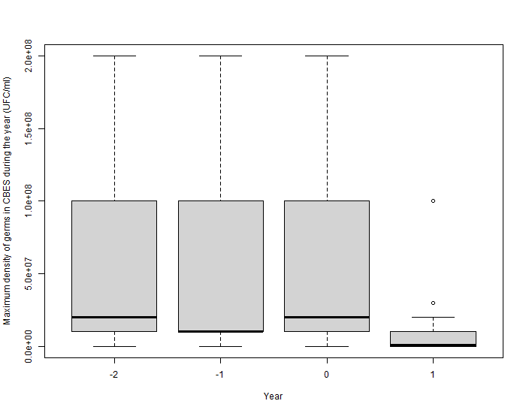
Supplementary Figure 1: Evolution of the summed density of CF pathogens in sputum cultures (Y-2: 2 years before ETI introduction, Y-1: 1 year before ETI introduction, Y0: at ETI introduction, Y+1: the year following ETI introduction)

