Beta vulgaris L. beetroot protects against iron-induced liver injury by restoring antioxidant pathways and regulating cellular functions

Oluwafemi Adeleke Ojo^{1*}, Temiloluwa Rhoda Adeyemo², Matthew Iyobhebhe², Moses Dele Adams³, Rotdelmwa Maimako Asaleye², Ikponmwosa Owen Evbuomwan⁴, Jadesola Abdurrahman², Tobiloba Christiana Maduakolam-Aniobi ², Charles Obiora Nwonuma², Olalekan Elijah Odesanmi⁵, Adebola Busola Ojo⁵
¹ Phytomedicine, Molecular Toxicology, and Computational Biochemistry Research Laboratory (PMTCB-RL), Department of Biochemistry, Bowen University, Iwo, 232101, Nigeria.
² Department of Biochemistry, Landmark University, Omu-Aran, Nigeria.
³ Clinical Biochemistry, Phytopharmacology and Biochemical Toxicology Research Laboratory (CBPBT-RL), Department of Biochemistry, Baze University, Abuja, Nigeria.
⁴ Department of Food Science and Microbiology, Landmark University, Omu-Aran, Nigeria.
⁵ Department of Biochemistry, Ekiti State University, Ado-Ekiti, Nigeria.
*Corresponding author email address: oluwafemiadeleke08@gmail.com; Phone no: +2347037824647

Table S1: Binding affinities of compounds identified from B. vulgaris fruit within the binding site of
G-6-pase
Ligand Pubchem ID | Compounds | Binding Affinity (kcal/mol)
1794427 | Chlorogenic acid | -9.3
5281675 | Orientin | -9
5280863 | Kaempferol | -8.8
9798666 | Cryptochlorogenic acid | -8.8
107721 | Taxiphyllin | -8.5
5280343 | Quercetin | -8.5
5280443 | Apigenin | -8.5
442658 | Schaftoside | -8.4
5280445 | Luteolin | -8.4
9064 | Catechin | -8.1
114776 | Iso-orientin | -7.2
162350 | 6-Glucosylapigenin | -7.1
NA | Alpha-amyline | -
445858 | Ferulic acid | -6.5
637542 | P-coumaric acid | -6.3
243 | Benzoic acid | -5.8

Table S2: Interaction table of chlorogenic acid within the binding site of G-6-pase
Name | Bond Distance | Category
A:LYS76:HZ2 - N:Chlorogenic acid:O | 2.68535 | Hydrogen Bond
A:LYS76:HZ3 - N:Chlorogenic acid:O | 2.66505 | Hydrogen Bond
A:LYS263:HZ1 - N:Chlorogenic acid:O | 2.45101 | Hydrogen Bond
A:LYS263:NZ - N:Chlorogenic acid | 4.75145 | Electrostatic
A:TYR44 - N:Chlorogenic acid | 5.3509 | Hydrophobic
N:Chlorogenic acid - A:ARG40 | 4.33542 | Hydrophobic
N:Chlorogenic acid - A:LYS263 | 3.85555 | Hydrophobic

Table S3: Binding affinities of compounds identified from B. vulgaris fruit within the binding site of
Na/K ATPase

Ligand Pubchem ID | Compounds | Binding Affinity (kcal/mol)
114776 | Isoorientin | -8.5
162350 | 6-Glucosylapigenin | -8.4
5281675 | Orientin | -7.8
9798666 | Cryptochlorogenic acid | -7.2
442658 | Schaftoside | -7.1
1794427 | Chlorogenic acid | -7
5280443 | Apigenin | -6.9
5280445 | Luteolin | -6.8
107721 | Taxiphyllin | -6.7
5280343 | Quercetin | -6.6
9064 | Catechin | -6.6
5280863 | Kaempferol | -6.5
445858 | Ferulic acid | -5.4
637542 | P-coumaric acid | -5.4
NA | Alpha-amyline | -
243 | Benzoic acid | -4.5

Table S4: Interaction table of Iso-orientin within the binding site of Na/K ATPase
Name | Bond Distance | Category
A:ARG184:HH21 - N:Isoorientin:O | 1.93602 | Hydrogen Bond
N:Isoorientin:H - A:TYR239:O | 2.57286 | Hydrogen Bond
N:Isoorientin:H - N:Isoorientin:O | 2.46773 | Hydrogen Bond
N:Isoorientin:H - N:Isoorientin:O | 2.29198 | Hydrogen Bond
A:LYS109:CA - N:Isoorientin:O | 3.33158 | Hydrogen Bond
A:THR240:CA - N:Isoorientin:O | 3.71916 | Hydrogen Bond
A:LYS112:C,O;PHE113:N - N:Isoorientin | 4.66694 | Hydrophobic
A:LYS112:C,O;PHE113:N - N:Isoorientin | 4.73504 | Hydrophobic
N:Isoorientin - A:PRO116 | 4.56352 | Hydrophobic
N:Isoorientin - A:PRO116 | 5.46411 | Hydrophobic
N:Isoorientin - A:LYS112 | 4.84646 | Hydrophobic

Table S5: Free binding energy (kcal/mol) of the ligand (chlorogenic acid) in the docked complex (G-6-pase)
Energy Component | Average | Std. Dev. | Std. Err. of Mean
ΔE (VDWAALS) | -2989.3313 | 22.0744 | 6.9805
ΔE (EEL) | -24249.0614 | 64.0489 | 20.2541
ΔE (EPB | -4189.9262 | 76.1597 | 24.0838
ΔE (ENPOLAR) | 2881.9530 | 8.0607 | 2.5490
ΔE (EDISPER) | -1601.1749 | 10.0647 | 3.1827
ΔG (Gas) | -27238.3927 | 69.4103 | 21.9495
ΔG (Solvation) | -2909.1481 | 77.3131 | 24.4485
TOTAL | -30147.5408 | 34.7678 | 10.9945

Table S6: Free binding energy (kcal/mol) of the ligand (iso-orientin) in the docked complex (Na⁺/K⁺ ATPase)
Energy Component | Average | Std. Dev. | Std. Err. of Mean
ΔE (VDWAALS) | -2172.9268 | 12.4035 | 3.9223
ΔE (EEL) | -19727.1604 | 120.3835 | 38.0686
ΔE (EPB | -3793.1319 | 113.7720 | 35.9779
ΔE (ENPOLAR) | 2497.7708 | 6.7174 | 2.1242
ΔE (EDISPER) | -1605.0195 | 8.6655 | 2.7403
ΔG (Gas) | -21900.0872 | 119.2205 | 37.7008
ΔG (Solvation) | -2900.3807 | 110.3518 | 34.8963
TOTAL | -24800.4679 | 48.1901 | 15.2390

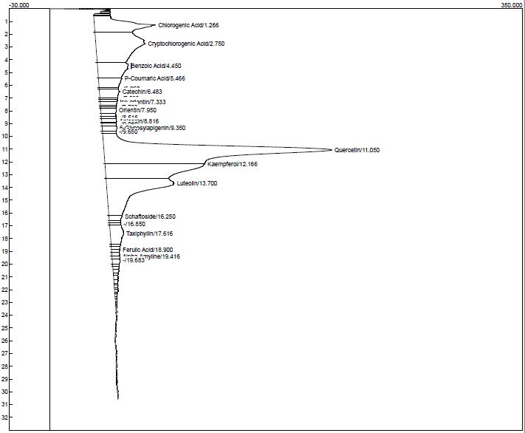
Figure S1: HPLC chromatogram of Beta vulgaris fruits

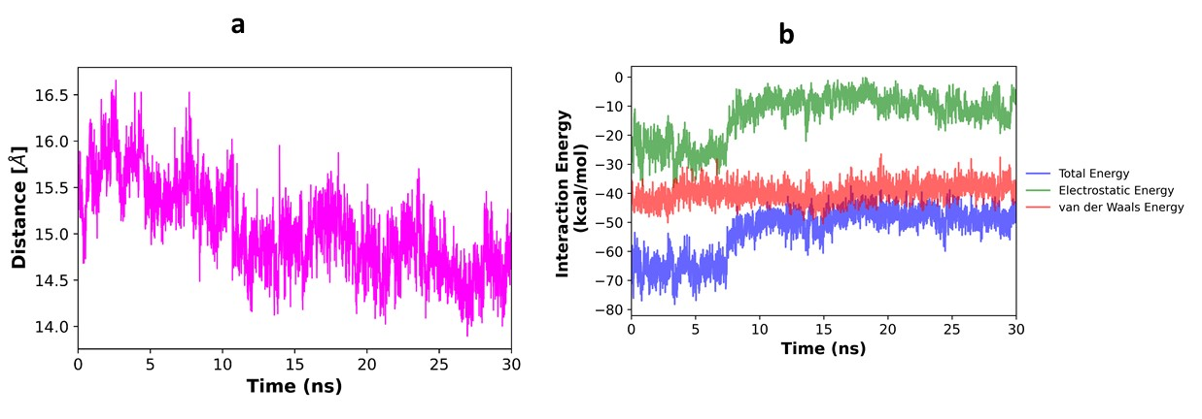
Figure S2: Distance analyses between center of mass of selected key residues and center of mass of chlorogenic acid against G-6-pase

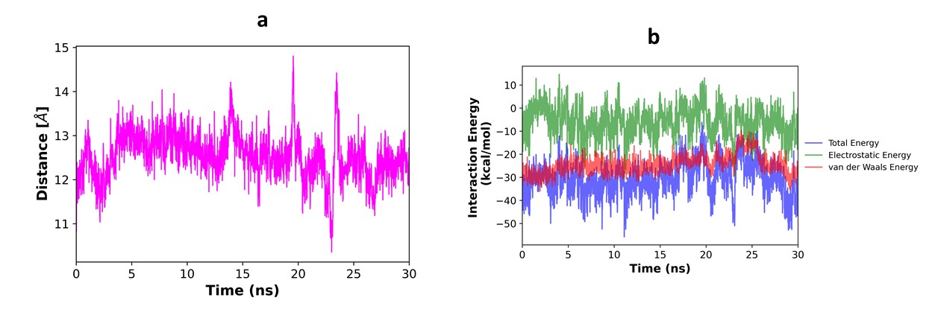
Figure S3: Distance analyses between center of mass of selected key residues and center of mass of iso-orientin against Na⁺/K⁺ ATPase

