Supplement 4. Generalized Estimating Equation (GEE) analysis on subretinal fluid (SRF) for three groups (A, B, and C)
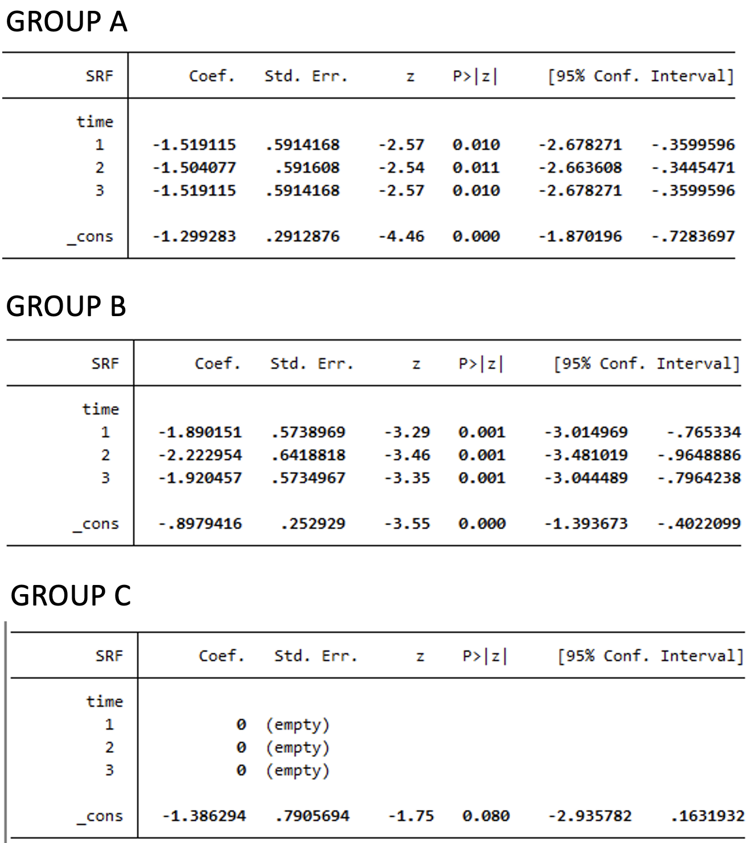
In GEE analysis, we use baseline as reference; time 1= 3 months after baseline; time 2= 6 months after baseline; time 3= 12 months after baseline.

