 | RA (n = 219) | Female (n = 143) | Male (n = 76) | p
Characteristics of the groups
Sex – female (%, n) | 65.29%, 143
Age (years, SD) | 57.59 (12.11) | 57.4 (12.31) | 57.96 (11.81) | 0.74
Body mass index (kg/m3, IQR) | 26.89  (23.54 – 30.84) | 26.54 (22.88 – 31.47) | 27.84 (25.47 – 30.58) | 0.14
Waist circumference (cm, SD) | 92.18 (14.78) | 88.27 (14.85) | 100 (11.58) | < 0.001
SBP (mmHg, IQR) | 135 (120 – 150) | 133 (120 – 146.5) | 137.5 (124.5 – 155) | 0.06
DBP (mmHg, IQR) | 80 (72 – 89) | 80 (71.50 – 87) | 82.50 (75 – 90) | 0.03
LDL cholesterol  (mg/dL, IQR) | 114 (99 – 134.5) | 114 (95.5 – 134.5) | 115 (100.8 – 134.2) | 0.49
HDL cholesterol  (mg/dL, IQR) | 66 (53 – 76) | 69 (61 – 80) | 54 (43 – 66) | <0.001
Tryglycerides (mg/dL, IQR) | 93 (69 – 128) | 88 (65 – 126.5) | 95 (74 – 128.5) | 0.31
Glucose (mg/dL, IQR) | 89 (82 – 98.5) | 89 (81.50 – 97) | 92 (83 – 101.25) | 0.14
Current smoker (%, n) | 27%, 59 | 27.27%, 39 | 26.31%, 20 | 1
Hypertension (%, n) | 57.99%, 127 | 51.74%, 74 | 69.74%, 53 | 0.02
Diabetes mellitus (%, n) | 11.41%, 25 | 11.11%, 16 | 11.84%, 9 | 1
Dyslipidaemia (%, n) | 40.63%, 89 | 39.86%, 57 | 42.10%, 32 | 0.86
Disease features
Disease duration (years, IQR) | 7 (2.50 - 13) | 8 (3 – 13.50) | 6 (2 – 11) | 0.09
DAS28-ESR (median, IQR) | 3.48 (2.67 – 4.37) | 3.59 (2.82 – 4.69) | 3.02 (2.45 – 3.76) | < 0.001
DAS28-CRP (median, IQR) | 2.21 (1.38 – 3.10) | 2.43 (1.64 – 3.28) | 1.69 (1.20 – 2.68) | <0.001
CDAI (median, IQR) | 7.20 (2.90 – 13.80) | 8.80 (4.20 – 16.35) | 4.70 (1.55 – 9.68) | <0.001
HAQ (median, IQR) | 0.38 (0 – 0.88) | 0.50 (0.13 – 0.88) | 0 (0 – 0.375) | < 0.001
Rheumatoid factor + (%, n) | 75.79%, 166 | 74.13%, 106 | 78.94%, 60 | 0.53
Anti-CCP + (%, n) | 73.97%, 162 | 74.12%, 106 | 73.68%, 56 | 1
Erosions (%, n) | 55.25%, 121 | 57.34%, 82 | 51.31%, 39 | 0.48
ESR (mm/h, IQR) | 31 (19 – 50) | 31 (19 – 53) | 28.50 (19.75 – 47.25) | 0.25
CRP (mg/dL, IQR) | 0.5 (0.2 – 0.95) | 0.4 (0.2 -0.9) | 0.5 (0.2 – 1) | 0.28
Fibrinogen (mg/dL, SD) | 444.1 (95.11) | 440 (95.56) | 459.5 (96.12) | 0.30
Treatments (%, n)
DMARDsc | 73.97%, 162 | 62.57%, 102 | 78.94%, 60 | 0.29
Biological agent | 21%, 46 | 23.77%, 34 | 15.79%, 12 | 0.23
NSAIDs | 58.44%, 128 | 58.74%, 84 | 57.89%, 44 | 1
Corticosteroids  (mean dose: 3.11 mg/day) | 52.51%, 115 | 53.15%, 76 | 51.31%, 39 | 0.91

Supplementary Table 1. Description of the general characteristics, the disease features and the treatments of the overall RA cohort and stratified by sex.
n=number of individuals, SBP=systolic blood pressure, DBP=diastolic blood pressure, HAQ=health assessment questionnaire index, anti-CCP= anti-citrullinated cyclic peptide, ESR=erythrocyte sedimentation rate, CRP=C-reactive protein, DAS28=disease activity score, CDAI=clinical disease activity index, DMARDsc=conventional disease-modifying antirheumatic drugs, NSAIDs=non-steroidal anti-inflammatory drugs, p=p value

 | Patients with metabolic disorders (n = 82) | Female (n = 58) | Male (n = 24) | p
Characteristics of the groups
Sex – female (%, n) | 58, 70.73%
Age (years, SD) | 61.50 (11.89) | 64.47 (12.37) | 58.62 (9.64) | 0.01
Body mass index (kg/m3, IQR) | 26.56 (23.34 – 29.69) | 26.59 (23.16 – 30.20) | 26.53 (24.76 – 28.47) | 0.87
Waist circumference (cm, SD) | 95.54 (13.92) | 94 (85 – 101.75) | 96.50 (92.50 – 100) | 0.20
SBP (mmHg, IQR) | 135 (123 – 149.8) | 136.5 (122.2 – 149.8) | 134.5 (123 – 148.5) | 0.97
DBP (mmHg, IQR) | 80 (10.32) | 80 (75 – 85) | 83.50 (78 – 93) | 0.04
LDL cholesterol  (mg/dL, IQR) | 123 (107 – 139) | 120.9 (33.28) | 131.7 (24.86) | 0.13
HDL cholesterol  (mg/dL, IQR) | 62 (49.5 – 75) | 66 (53 – 76) | 56.50 (42.75 – 71.75) | 0.07
Tryglycerides (mg/dL, IQR) | 93.5 (75 – 141.5) | 97.50 (75.25 – 148) | 93 (69 – 129.2) | 0.79
Glucose (mg/dL, IQR) | 94.50 (90 – 102) | 93.50 (87.25 – 102.75) | 95.50 (92.75 – 99.75) | 0.39
Current smoker (%, n) | 8, 9.75% | 6, 10.34% | 2, 8.33% | 1
Hypertension (%, n) | 50, 60.97% | 36, 62.07 | 14, 58.33% | 0.89
Diabetes mellitus (%, n) | 5, 6.09% | 4, 68.96% | 1, 4.17% | 0.96
Dyslipidaemia (%, n) | 52, 65% | 35, 60.03% | 18, 70.08% | 0.59
ESR (mm/h, IQR) | 16 (9 – 26.5) | 22 (12 – 29.50) | 9.50 (5.75 – 15) | < 0.001
CRP (mg/dL, IQR) | 0.12 (0.07 – 0.25) | 0.13 (0.08 – 0.27) | 0.12 (0.06 – 0.19) | 0.30
Fibrinogen (mg/dL, SD) | 345 (71.88) | 345 8300 – 408.5) | 306 (272 – 359) | 0.01
 | Controls (n = 64) | Female (n = 50) | Male (n = 14) | p
Characteristics of the groups
Sex – female (%, n) | 50, 78.13%
Age (years, SD) | 51.23 (9.12) | 51.82 (8.91) | 49.14 (9.87) | 0.27
Body mass index (kg/m3, IQR) | 24.61 (3.39) | 24.33 (3.58) | 25.59 (2.48) | 0.11
Waist circumference (cm, SD) | 86.28 (10.31) | 84.26 (10.23) | 93.50 (6.95) | 0.004
SBP (mmHg, IQR) | 120 (110 – 130) | 120 (110 – 130) | 126.5 (120 – 135.2) | 0.19
DBP (mmHg, IQR) | 72.34 (9.69) | 71.66 (9.35) | 74.79 (10.86) | 0.43
LDL cholesterol  (mg/dL, IQR) | 114.4 (22.12) | 112.5 (21.35) | 121.1 (24.23) | 0.14
HDL cholesterol  (mg/dL, IQR) | 69.22 (14.89) | 71.70 (13.74) | 60.36 (15.94) | 0.008
Tryglycerides (mg/dL, IQR) | 76 (57 – 93.25) | 76 (57 – 88.75) | 78.50 (71.50 – 98.50) | 0.42
Glucose (mg/dL, IQR) | 90.75 (8.38) | 90.78 (7.95) | 90.64 (10.09) | 0.87
Current smoker (%, n) | 10, 15.63% | 8, 16% | 2, 14.29% | 1
Hypertension (%, n) | 7, 10.94% | 4, 8.33% | 3, 21.42% | 0.35
Diabetes mellitus (%, n) | 0, 0% | 0, 0% | 0, 0% | 1
Dyslipidaemia (%, n) | 0, 0% | 0, 0% | 0, 0% | 1
ESR (mm/h, IQR) | 9.50 (5 – 14.25) | 12 (6.25 – 16.75) | 5.35 (2.25 – 7.50) | <0.001
CRP (mg/dL, IQR) | 0.20 (0.06 - 0.20) | 0.19 (0.05 – 0.18) | 0.21 (0.15 – 0.20) | 0.007
Fibrinogen (mg/dL, SD) | 304.5 (281 – 332.8) | 316.3 (281 – 335.2) | 296 (275.8 – 322.2) | 0.49

Supplementary Table 2. Description of the general characteristics of the patients with metabolic disorders and control subjects, of the overall cohorts and stratified by sex.
n=number of individuals, SBP=systolic blood pressure, DBP=diastolic blood pressure, ESR=erythrocyte sedimentation rate, CRP=C-reactive protein

MEN RA PATIENTS (n = 76)
 | β | p | R² | ∆R² | AIC
DAS28-ESR
Basal Model |  |  | 12.72 |  | 235.25
Area GlycB | 0.25 | 0.04 | 17.81 | 5.09 | 232.68
H/W GlycA | 0.33 | 0.01 | 20.83 | 8.11 | 229.83
H/W GlycB | 0.26 | 0.04 | 17.90 | 5.18 | 232.60
ESR
Basal Model |  |  | 12.44 |  | 689.26
Area GlycB | 8.76 | <0.001 | 27.81 | 15.37 | 676.59
H/W GlycA | 8.88 | <0.001 | 27.66 | 15.22 | 676.75
H/W GlycB | 8.69 | <0.001 | 27.57 | 15.13 | 676.84
CRP
Basal Model |  |  | 5.58 |  | 215.82
Area GlycB | 0.31 | 0.004 | 16.15 | 10.57 | 208.80
H/W GlycA | 0.30 | 0.007 | 15.31 | 9.73 | 209.56
H/W GlycB | 0.31 | 0.005 | 16.07 | 10.49 | 208.88
Fibrinogen
Basal Model |  |  | 10.86 |  | 915.90
Area GlycA | 28.36 | 0.01 | 18.60 | 7.74 | 911.04
Area GlycB | 43.31 | <0.001 | 30.25 | 19.39 | 899.27
H/W GlycA | 42.79 | <0.001 | 29.08 | 18.22 | 900.53
H/W GlycB | 43.38 | <0.001 | 30.30 | 19.44 | 899.21
WOMEN RA PATIENTS (n = 143)
 | β | p | R² | ∆R² | AIC
DAS28-ESR
Basal Model |  |  | 8.17 |  | 490.80
Area GlycB | 0.35 | 0.002 | 14.42 | 6.25 | 482.71
H/W GlycA | 0.33 | 0.003 | 13.77 | 5.60 | 483.79
H/W GlycB | 0.35 | 0.002 | 14.72 | 6.55 | 482.21
DAS28-CRP
Basal Model |  |  | 9.51 |  | 406.52
Area GlycB | 0.18 | 0.04 | 12.31 | 2.8 | 404.03
H/W GlycA | 0.20 | 0.02 | 13.28 | 3.77 | 402.43
H/W GlycB | 0.18 | 0.03 | 12.55 | 3.04 | 403.63
ESR
Basal Model |  |  | 9.61 |  | 1344.52
Area GlycB | 7.52 | <0.001 | 16.90 | 7.26 | 1334.48
H/W GlycA | 5.76 | 0.01 | 13.91 | 4.30 | 1339.54
H/W GlycB | 7.61 | <0.001 | 17.10 | 7.49 | 1334.14
CRP
Basal Model |  |  | 10.40 |  | 352.36
Area GlycB | 0.21 | 0.002 | 16.44 | 6.04 | 344.37
H/W GlycA | 0.24 | <0.001 | 17.79 | 7.39 | 342.05
H/W GlycB | 0.22 | 0.002 | 16.58 | 6.18 | 344.15
Fibrinogen
Basal Model |  |  | 6.02 |  | 1713.04
Area GlycB | 26.25 | 0.001 | 13.04 | 7.02 | 1703.94
H/W GlycA | 24.75 | 0.002 | 12.30 | 6.28 | 1705.15
H/W GlycB | 26.38 | 0.001 | 13.13 | 7.11 | 1703.79
CDAI
Basal Model |  |  | 8.36 |  | 408.33
Area GlycB | 0.19 | 0.03 | 11.68 | 3.32 | 405.05
H/W GlycA | 0.22 | 0.01 | 12.66 | 4.30 | 403.45
HW GlycB | 0.19 | 0.02 | 11.77 | 3.41 | 404.90
CONTROL WOMEN (n = 50)
 | β | p | R² | ∆R² | AIC
Fibrinogen
Basal Model |  |  | 8.53
Area GlycB | 0.45 | 0.001 | 27.3 | 18.77 | 134.94
H/W GlycA | 0.39 | 0.004 | 23.16 | 14.63 | 137.71
H/W GlycB | 0.42 | 0.002 | 25.17 | 16.64 | 136.39

Supplementary Table 3: Study of the associations between the different inflammatory parameters and the glycoprotein parameters analysed by NMR stratified by sex. Multivariate lineal models, adjusted for age, sex and BMI were used. Models with RA patients were also adjusted for RA treatment.
DAS28 = disease activity score 28; ESR = erythrocyte sedimentation rate; CRP = C reactive protein; CDAI = clinical disease activity index
β = beta coefficient; p = p-value, AIC = Akaike information criteria.

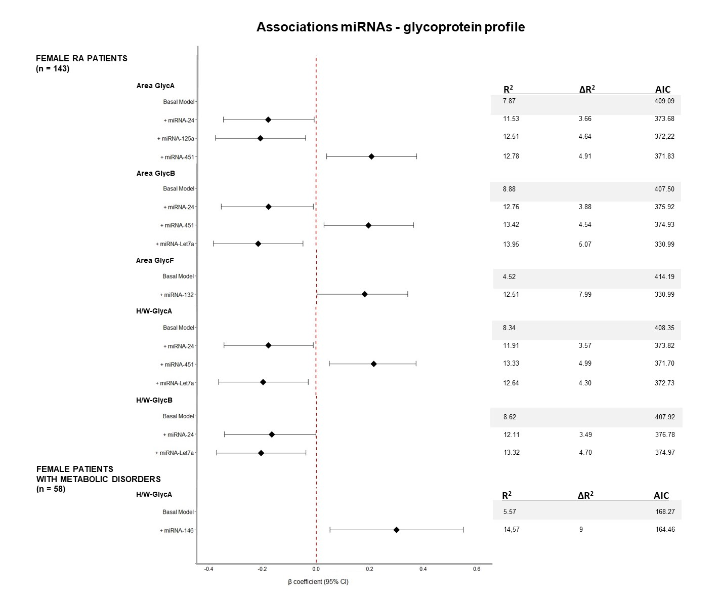

Supplementary figure 1: Study of the associations between the different miRNAs and the glycoprotein parameters analysed by NMR stratified by sex. Multivariate lineal models, adjusted for age, sex and BMI were used. Models with RA patients were also adjusted for RA treatment.
β = beta coefficient; p = p-value, AIC = Akaike information criteria.

