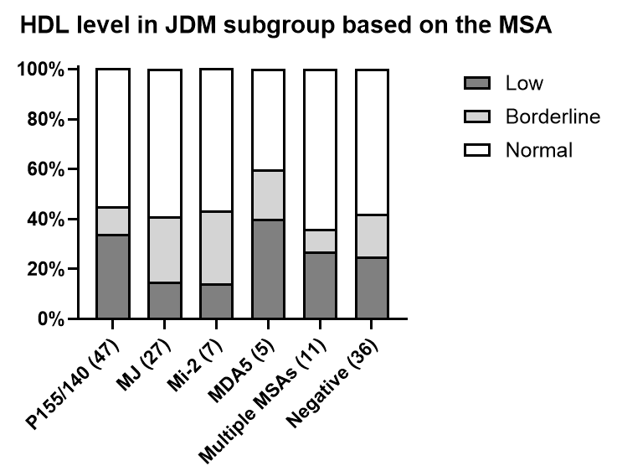
Supplemental Figure 1: Prevalence of abnormal HDL in JDM MSA subgroups.

