Supplementary data

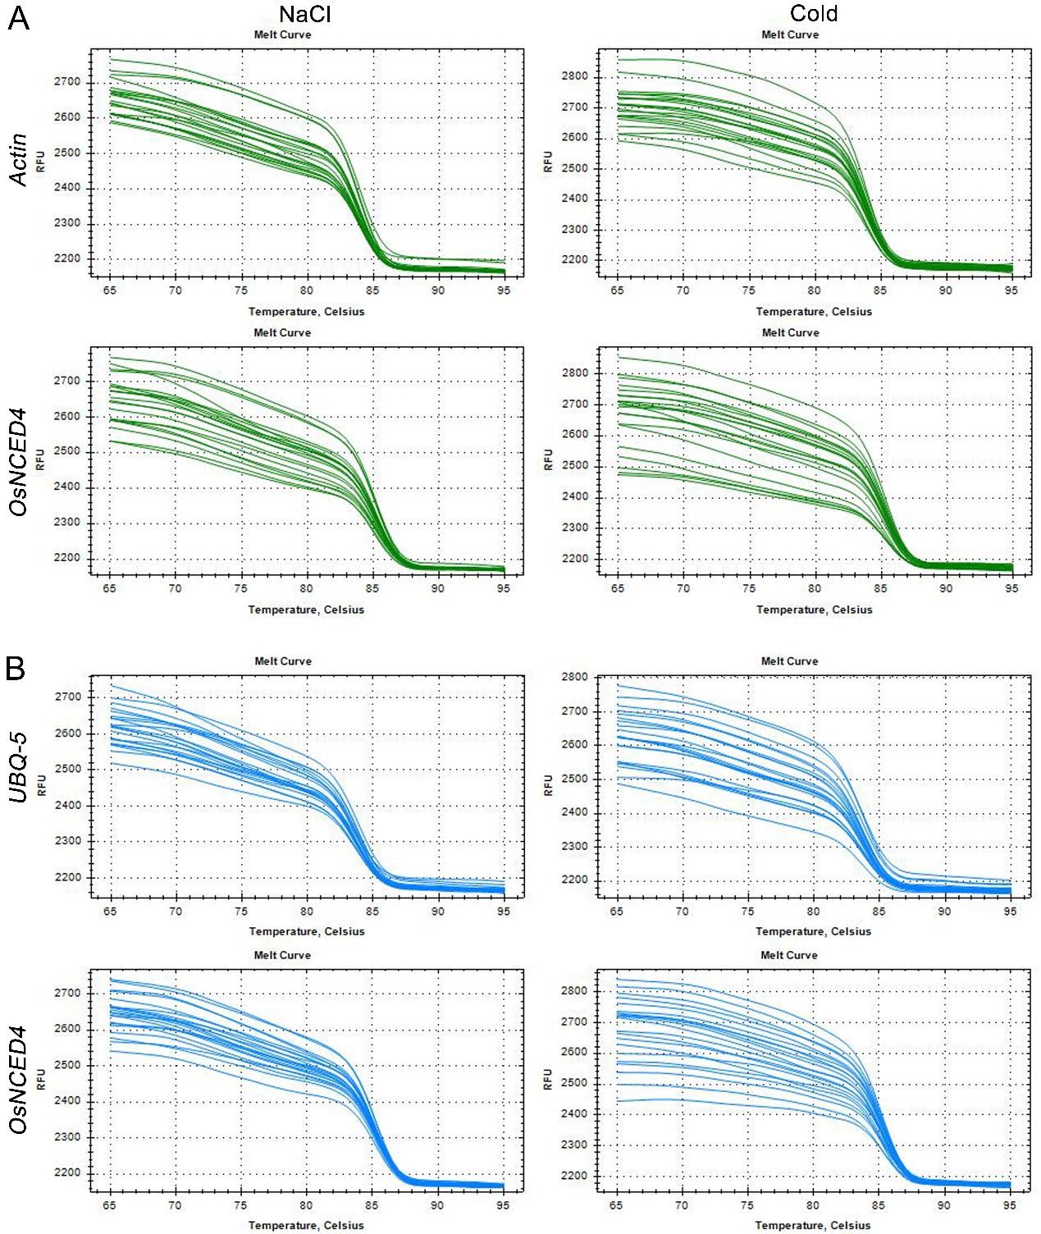
Figure S1. The melt curves of OsNCED4 and housekeeping genes by qRT-PCR.
(A) The melt curves of OsNCED4 and β-actin gene which generated by the BIO-RAD CFX384 Touch system.
(B) The melt curves of OsNCED4 and UBQ-5 gene which generated by the BIO-RAD CFX384 Touch system.
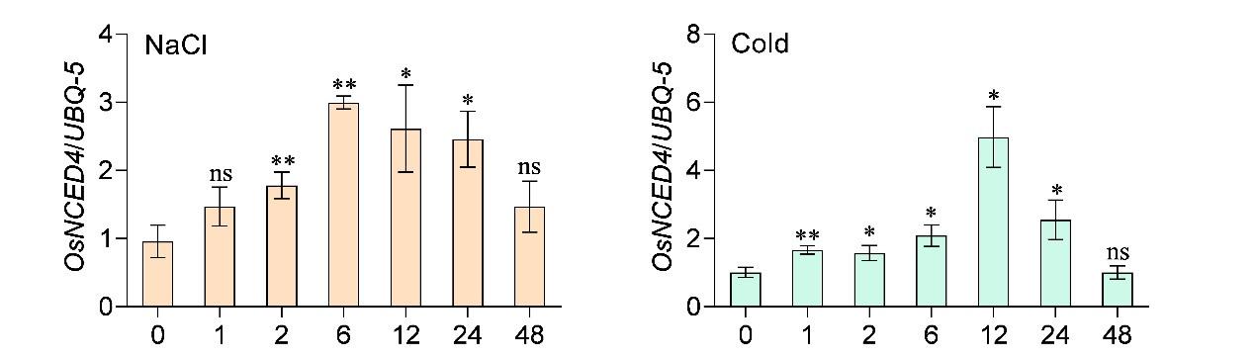
Figure S2. The time-dependent expression of OsNCED4 in rice shoots under NaCl and cold stress treatment.
The expression level of OsNCED4 gene after different time (0, 1, 2, 6, 12, 24 and 48 hours) of NaCl and cold treatment. The UBQ-5 was used as a reference gene in quantitative analysis. Data are means of at least three replicates of one experiment. Error bars represent ±SD. SD, standard deviation. *p < 0.05 and **p < 0.01 by two-tailed Student’s t-tests. ns: not significant (p < 0.05 by two-tailed Student’s t-tests).

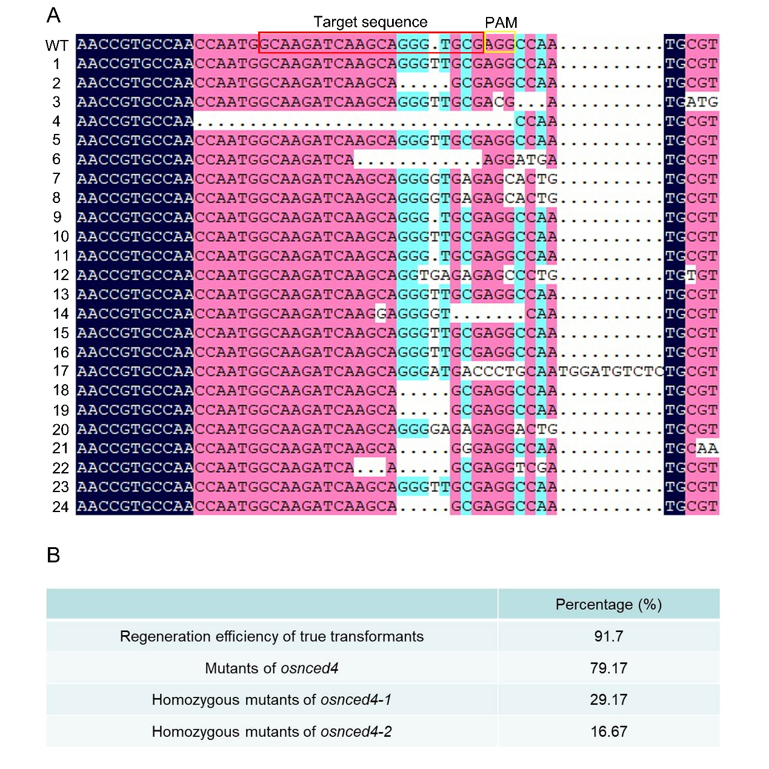
Figure S3. Acquisition efficiency of OsNCED4 mutants by CRISPR/Cas9-mediated genome editing.
(A) Sequence alignment of wild-type (WT) and 24 detected transformed plants by DNAMAN software. Red rectangular frame showed the target sequence. The PAM was indicated with yellow rectangular frame.
(B) Regeneration efficiency of true transformants and the percentage of OsNCED4 mutants.

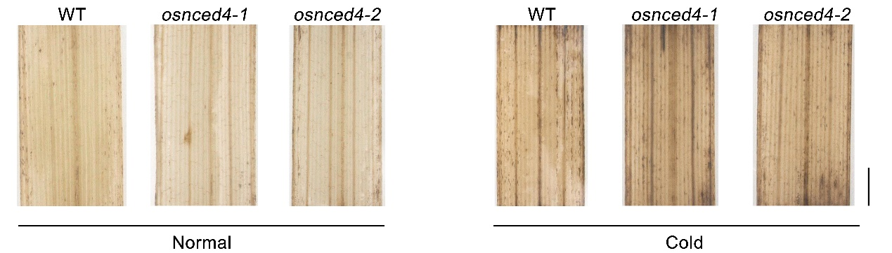
Figure S4. The DAB staining of H₂O₂ accumulation of osnced4 mutant and wild type plants under normal and cold stress conditions. Scale bar = 1 mm.

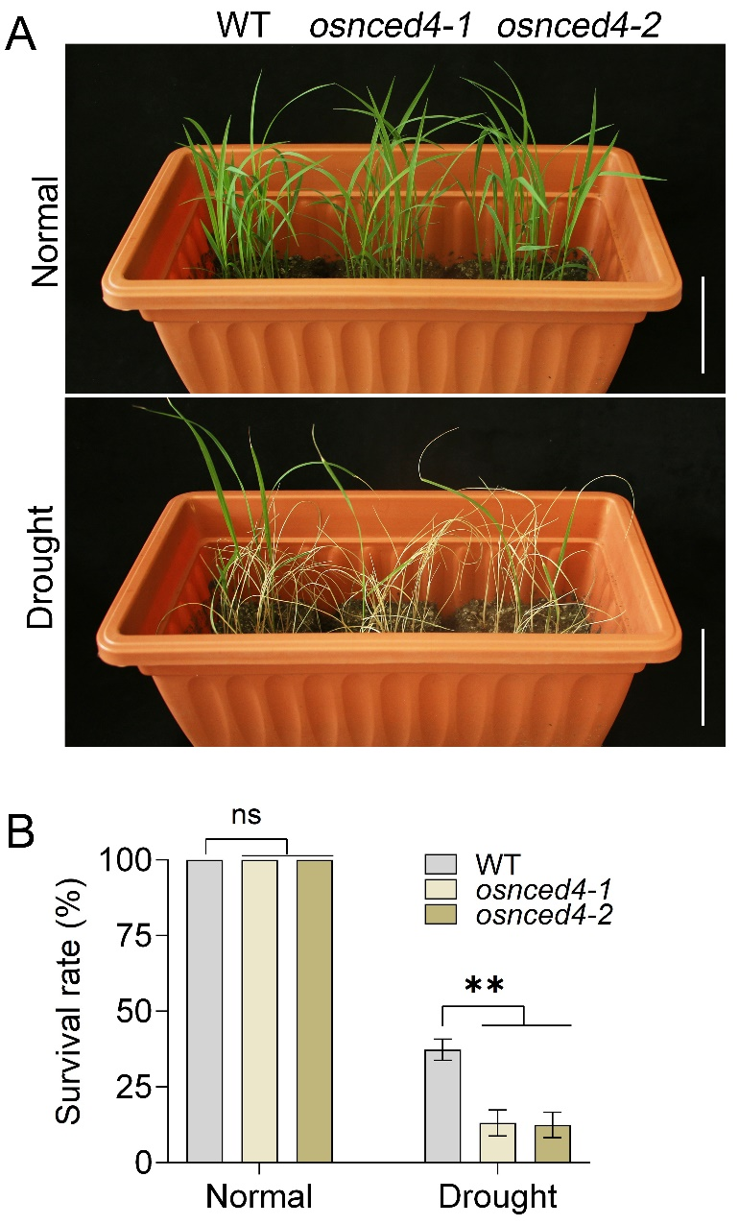
Figure S5. Disruption of OsNCED4 significantly impairs drought stress tolerance at seedling stage.
(A) Phenotype of osnced4 mutants under drought stress. 14-day-old seedlings were treated by drought stress for 10 days and recovered for 7 days. Scale bars = 5 cm.
(B) The survival rate of osnced4 mutants and wild type plants under drought stress and normal conditions was calculated.
Data are means of at least three replicates of one experiment. Error bars represent ±SD. **p < 0.01 by two-tailed Student’s t-tests. ns: not significant (p < 0.05 by two-tailed Student’s t-tests). SD, standard deviation.

Table S1. Primers used in this study.
Primer | Forward 5’-3’ | Reverse 5’-3’
OsNCED4-Cas9 | CAAGATCAAGCAGGGTGCG  gttttagagctagaaat | CGCACCCTGCTTGATCTTG cggcagccaagccagca
OsNCED4-JC | CTTCTCCCTCCTCCCAACCC | GCGGACGTACACCCCGTC
OsNCED4-GUS | tatgaccatgattacgaattcCACGTGTCCCGGTTACGTG | acgacggccagtgccaagcttTGGTGAGACGCGGCCAAG
OsNCED4-GFP | ggtacccggggatcctctagaATGGCGTCCTCCGCGCCT | agctcctcctcctcctctagaAGCTTGTCGCTGCAGCTCG
OsNCED4-qRT | CTACAATGTCGTGTCCAAGC | CGGCATAGTTCTCGGTGACG
OsActin | CTGACAGGATGAGCAAGGAG | GGCAATCCACATCTGCTGGA
OsUBQ-5 | ACCACTTCGACCGCCACTACT | ACGCCTAAGCCTGCTGGTT

