Appendix

Table 1 shows the exact mean and SD values along with the 95% confidence interval and the median value for each sphere and dimension in each analysed age group.

Table 1 Average level of the QoL in individual spheres, considering the intergroup averages
Variable | Spheres
Variable | PF | RP | RE | VT | MH | SF | BP | GH | HCh |  | MCS | PCS | ILQ
<30 [n=728]
X | 84,7 | 67,3 | 71,6 | 54,8 | 53,0 | 74,0 | 71,6 | 55,7 | 59,4 |  | 67,4 | 65,2 | 66,3
-95Cl | 83,0 | 64,3 | 66,3 | 53,7 | 51,9 | 72,0 | 69,7 | 54,2 | 57,4 |  | 65,9 | 63,8 | 64,9
+95Cl | 86,4 | 70,3 | 72,5 | 56,0 | 54,2 | 75,9 | 73.4 | 57,2 | 61,4 |  | 69,0 | 66,5 | 67,7
SD | 23,0 | 40,9 | 42,3 | 15,8 | 16,2 | 26,6 | 25,6 | 20,2 | 27,4 |  | 21,8 | 18,7 | 19,2
-95Cl | 21,9 | 38,9 | 40,3 | 15,0 | 15,4 | 25,3 | 24,3 | 19,2 | 26,0 |  | 20,7 | 17,8 | 18,2
+95Cl | 24,3 | 43,2 | 44,6 | 16,7 | 17,1 | 28,0 | 27,0 | 21,3 | 28,8 |  | 23,0 | 19,7 | 20,2
Me | 97,5 | 100,0 | 100,0 | 55,0 | 52,0 | 75,0 | 77,5 | 55,0 | 50,0 |  | 75,0 | 71,5 | 73,9
30 – 39 [n=987]
X | 81,8 | 62,5 | 67,0 | 54,1 | 52,3 | 72,8 | 69,9 | 54,2 |  | 61,2 | 66,0 | 62,7 | 64,3
-95Cl | 80,3 | 59,8 | 64,3 | 53,1 | 51,4 | 71,2 | 68,4 | 53,0 |  | 59,5 | 64,6 | 61,5 | 3,1
+95Cl | 83,3 | 65,1 | 69,8 | 55,0 | 53,3 | 74,4 | 71,5 | 55,3 |  | 62,9 | 67,3 | 63,9 | 65,5
SD | 23,8 | 42,5 | 43,5 | 15,2 | 15,7 | 25,6 | 24,6 | 18,6 |  | 27,7 | 21,5 | 19,2 | 19,2
-95Cl | 22,8 | 40,7 | 41,7 | 14,6 | 15,0 | 24,5 | 23,6 | 17,8 |  | 26,5 | 20,6 | 18,4 | 18,4
+95Cl | 24,9 | 44,5 | 45,5 | 15,9 | 16,4 | 26,8 | 25,7 | 19,5 |  | 28,9 | 22,5 | 20,1 | 20,0
Me | 95,0 | 75,0 | 100,0 | 50,0 | 52,0 | 75,0 | 67,5 | 55,0 |  | 75,0 | 72,5 | 69,8 | 69,8
40 – 49 [n=1669]
X | 75,5 | 54,2 | 63,5 | 50,6 | 49,4 | 72,1 | 67,2 | 48,7 |  | 63,9 | 63,3 | 57,0 | 60,1
-95Cl | 74,3 | 52,1 | 61,3 | 49,7 | 48,6 | 70,9 | 66,0 | 47,9 |  | 62,7 | 62,3 | 56,0 | 59,3
+95Cl | 76,8 | 56,2 | 65,6 | 51,4 | 50,2 | 73,3 | 68,4 | 49,5 |  | 65,2 | 64,3 | 57,9 | 61,0
SD | 26,5 | 43,2 | 44,2 | 16,7 | 16,2 | 24,9 | 25,1 | 16,8 |  | 25,7 | 20,6 | 18,8 | 18,6
-95Cl | 25,6 | 41,7 | 42,7 | 16,2 | 15,7 | 24,1 | 24,3 | 16,3 |  | 24,9 | 19,9 | 18,2 | 18,0
+95Cl | 27,4 | 44,7 | 45,7 | 17,3 | 16,8 | 25,8 | 26,0 | 17,4 |  | 26,6 | 21,3 | 19,5 | 19,2
Me | 85,0 | 50,0 | 100,0 | 50,0 | 48,0 | 75,0 | 67,5 | 50,0 |  | 75,0 | 67,9 | 58,5 | 61,9
50 – 59 [n=1662]
X | 70,8 | 47,5 | 58,1 | 52,9 | 51,6 | 68,9 | 58,7 | 46,7 |  | 61,9 | 59,6 | 54,2 | 56,9
-95Cl | 69,5 | 45,4 | 55,9 | 52,3 | 50,9 | 67,7 | 57,4 | 46,0 |  | 60,6 | 58,6 | 53,3 | 56,0
+95Cl | 72,1 | 49,6 | 60,2 | 53,6 | 52,2 | 70,2 | 60,0 | 47,5 |  | 63,2 | 60,7 | 55,0 | 57,8
SD | 26,2 | 43,7 | 44,3 | 13,7 | 13,9 | 25,9 | 26,3 | 16,6 |  | 27,5 | 21,2 | 18,0 | 18,4
-95Cl | 25,4 | 42,3 | 42,8 | 13,2 | 13,4 | 25,0 | 25,5 | 16,0 |  | 26,6 | 20,4 | 17,4 | 17,8
+95Cl | 27,2 | 45,3 | 45,8 | 14,1 | 14,4 | 26,8 | 27,3 | 17,1 |  | 28,5 | 21,8 | 18,6 | 19,0
Me | 80,0 | 50,0 | 66,7 | 55,0 | 52,0 | 75,0 | 57,5 | 50,0 |  | 75,0 | 62,5 | 53,1 | 56,5
60 – 69 [n=1583]
X | 60,5 | 34,1 | 43,8 | 50,3 | 50,7 | 61,6 | 53,3 | 43,3 |  | 57,3 | 52,3 | 47,2 | 49,7
-95Cl | 59,2 | 32,1 | 41,7 | 49,7 | 50,1 | 60,3 | 52,1 | 42,6 |  | 56,0 | 51,2 | 46,3 | 48,8
+95Cl | 61,9 | 36,2 | 46,0 | 51,0 | 51,4 | 62,9 | 54,6 | 44,0 |  | 58,7 | 53,3 | 48,0 | 50,6
SD | 26,8 | 41,4 | 44,3 | 13,1 | 13,0 | 26,8 | 25,9 | 14,6 |  | 27,6 | 21,1 | 17,4 | 18,2
-95Cl | 25,9 | 40,0 | 42,9 | 12,7 | 12,6 | 25,9 | 25,0 | 14,1 |  | 26,7 | 20,4 | 16,8 | 17,6
+95Cl | 27,7 | 42,9 | 45,9 | 13,6 | 13,5 | 27,7 | 26,8 | 15,1 |  | 28,6 | 21,8 | 18,0 | 18,9
Me | 60,0 | 0,0 | 33,3 | 50,0 | 52,0 | 62,5 | 55,0 | 45,0 |  | 50,0 | 50,0 | 43,8 | 46,4
70 – 79 [n=803]
X | 48,2 | 18,0 | 29,3 | 48,4 | 0,3 | 53,1 | 45,5 | 40,0 |  | 53,4 | 44,1 | 39,1 | 41,6
-95Cl | 46,4 | 15,8 | 26,6 | 47,4 | 49,4 | 51,4 | 43,8 | 39,0 |  | 51,4 | 42,7 | 38,1 | 40,5
+95Cl | 50,0 | 20,1 | 32,0 | 49,3 | 51,2 | 54,9 | 47,2 | 40,9 |  | 55,3 | 45,4 | 40,2 | 42,7
SD | 26,1 | 31,3 | 39,2 | 13,8 | 12,6 | 25,3 | 24,8 | 13,6 |  | 28,1 | 19,6 | 15,1 | 16,3
-95Cl | 24,8 | 29,9 | 37,4 | 13,2 | 12,0 | 24,1 | 23,6 | 13,0 |  | 26,8 | 18,7 | 14,4 | 15,6
+95Cl | 27,4 | 32,9 | 41,3 | 14,5 | 13,2 | 26,6 | 26,1 | 14,3 |  | 29,6 | 20,6 | 15,8 | 17,2
Me | 50,0 | 0,0 | 0,0 | 50,0 | 48,0 | 50,0 | 45,0 | 40,0 |  | 50,0 | 39,6 | 36,3 | 38,1
≥80 [n=188]
X | 33,8 | 11,0 | 20,4 | 45,0 | 49,4 | 48,4 | 35,6 | 34,4 |  | 48,0 | 37,4 | 32,2 | 34,8
-95Cl | 30,5 | 7,2 | 15,4 | 43,0 | 47,7 | 45,1 | 32,6 | 32,4 |  | 43,8 | 35,0 | 30,3 | 32,8
+95Cl | 37,2 | 14,8 | 25,4 | 47,0 | 51,2 | 51,7 | 38,6 | 36,3 |  | 52,2 | 39,7 | 34,0 | 36,7
SD | 23,5 | 26,4 | 34,7 | 13,7 | 12,2 | 22,7 | 20,9 | 13,3 |  | 28,9 | 16,1 | 12,8 | 13,5
-95Cl | 21,3 | 24,0 | 31,5 | 12,4 | 11,1 | 20,7 | 18,9 | 12,1 |  | 26,2 | 14,6 | 11,6 | 12,2
+95Cl | 26,1 | 29,4 | 38,6 | 15,2 | 13,5 | 25,3 | 23,2 | 14,8 |  | 32,2 | 17,9 | 14,3 | 15,0
Me | 30,0 | 0,0 | 0,0 | 45,0 | 48,0 | 50,0 | 32,5 | 35,0 |  | 50,0 | 34,4 | 29,8 | 32,1

PF – physical functioning; RP – role physical; RE – role emotional; VT – vitality; MH – mental health; SF – social functioning; BP – bodility pain; GH – general health; HCh - subjective sense of change in health; MCS – Mental Component Summary; PCS – Physical Component Summary; ILQ SF – 36 – Index of Life Quality

Table 2. Reliability of the SF-36 questionnaire for the analyzed dataset - Cronbach's alpha coefficient with regard to age groups.
Spheres | Cronbach’s α
Spheres | <30 [n=728] | 30 – 39 [n=987] | 40 – 49 [n=1669] | 50 – 59 [n=1662] | 60 – 69 [n=1583] | 70 – 79 [n=803] | ≥80 [n=188]
PF | 0,89 | 0,89 | 0,87 | 0,87 | 0,87 | 0,88 | 0,84
RP | 0,89 | 0,89 | 0,87 | 0,87 | 0,88 | 0,88 | 0,84
BP | 0,89 | 0,89 | 0,87 | 0,87 | 0,87 | 0,88 | 0,84
GH | 0,89 | 0,89 | 0,88 | 0,88 | 0,88 | 0,89 | 0,85
VT | 0,89 | 0,90 | 0,89 | 0,89 | 0,89 | 0,89 | 0,86
SF | 0,88 | 0,88 | 0,87 | 0,87 | 0,87 | 0,88 | 0,84
RE | 0,89 | 0,89 | 0,88 | 0,88 | 0,88 | 0,89 | 0,85
MH | 0,90 | 0,91 | 0,90 | 0,89 | 0,90 | 0,90 | 0,86
HCh | 0,92 | 0,91 | 0,90 | 0,89 | 0,90 | 0,90 | 0,87
PCS | 0,87 | 0,88 | 0,86 | 0,86 | 0,86 | 0,87 | 0,83
MCS | 0,88 | 0,88 | 0,87 | 0,86 | 0,87 | 0,88 | 0,84
ILQ | 0,88 | 0,88 | 0,86 | 0,86 | 0,87 | 0,87 | 0,83
Total | 0,90 | 0,90 | 0,89 | 0,88 | 0,89 | 0,89 | 0,86
PF – physical functioning; RP – role physical; RE – role emotional; VT – vitality; MH – mental health; SF – social functioning; BP – bodility pain; GH – general health; HCh - subjective sense of change in health; MCS – Mental Component Summary; PCS – Physical Component Summary; ILQ SF – 36 – Index of Life Quality

The reliability analysis of the tool used for the study was conducted. The Cronbach's alpha values ranging from 0.83 to 0.92 indicate a good fit of the tool. (Table2)

Table 3 Reliability of the SF-36 questionnaire for the analyzed dataset - Cronbach's alpha coefficient with regard to disease groups.
Spheres | Cronbach’s α
Spheres | CD | CVD | DM | DS | DSD-C | DSD-LS | DSD-Th | ED | LD-ENT | NS | RS | TD | UD
PF | 0,86 | 0,88 | 0,88 | 0,88 | 0,94 | 0,91 | 0,93 | 0,87 | 0,84 | 0,84 | 0,78 | 0,84 | 0,90
RP | 0,87 | 0,88 | 0,89 | 0,88 | 0,94 | 0,91 | 0,94 | 0,87 | 0,84 | 0,83 | 0,74 | 0,82 | 0,90
BP | 0,86 | 0,88 | 0,88 | 0,87 | 0,94 | 0,91 | 0,93 | 0,87 | 0,84 | 0,84 | 0,77 | 0,83 | 0,90
GH | 0,88 | 0,88 | 0,89 | 0,88 | 0,94 | 0,90 | 0,94 | 0,87 | 0,85 | 0,86 | 0,78 | 0,85 | 0,91
VT | 0,88 | 0,89 | 0,89 | 0,88 | 0,94 | 0,91 | 0,94 | 0,88 | 0,86 | 0,88 | 0,81 | 0,85 | 0,92
SF | 0,87 | 0,88 | 0,88 | 0,88 | 0,94 | 0,91 | 0,94 | 0,86 | 0,84 | 0,83 | 0,74 | 0,83 | 0,90
RE | 0,88 | 0,89 | 0,88 | 0,89 | 0,95 | 0,92 | 0,94 | 0,87 | 0,83 | 0,85 | 0,79 | 0,83 | 0,90
MH | 0,89 | 0,89 | 0,90 | 0,89 | 0,94 | 0,91 | 0,94 | 0,89 | 0,88 | 0,89 | 0,82 | 0,86 | 0,93
HCh | 0,89 | 0,91 | 0,91 | 0,89 | 0,95 | 0,92 | 0,95 | 0,89 | 0,87 | 0,87 | 0,79 | 0,87 | 0,92
PCS | 0,86 | 0,87 | 0,87 | 0,86 | 0,94 | 0,90 | 0,93 | 0,86 | 0,83 | 0,83 | 0,74 | 0,81 | 0,89
MCS | 0,86 | 0,87 | 0,88 | 0,87 | 0,93 | 0,90 | 0,93 | 0,86 | 0,83 | 0,84 | 0,75 | 0,83 | 0,90
ILQ | 0,86 | 0,87 | 0,87 | 0,86 | 0,93 | 0,90 | 0,93 | 0,86 | 0,83 | 0,83 | 0,75 | 0,82 | 0,90
Total | 0,88 | 0,89 | 0,89 | 0,89 | 0,94 | 0,91 | 0,94 | 0,88 | 0,86 | 0,86 | 0,79 | 0,85 | 0,91
* CD – cancers; CVD – cardiovascular disease; DM – diabetes mellitus; DS – disease of digestive system; DSD-C – degenerative changes of the cervical spine; DSD-LS – degenerative changes of the lumbosacral spine; DSD-Th – degenerative changes of the thoracic spine; ED – ophthalmic diseases; LD – ENT diseases; NS – diseases of the nervous system; RS – respiratory diseases; TD – thyroid diseases; UD – diseases of the kidneys and urinary system; PF – physical functioning; RP – role physical; RE – role emotional; VT – vitality; MH – mental health; SF – social functioning; BP – bodility pain; GH – general health; HCh - subjective sense of change in health; MCS – Mental Component Summary; PCS – Physical Component Summary; ILQ SF – 36 – Index of Life Quality

The analysis of the reliability of the tool conducted in specific disease units revealed a satisfactory level of the obtained Cronbach's alpha coefficient, which, in the case of almost all analyzed groups, ranged from 0.81 to 0.95. The only exception was the RS disease group, where the values of the coefficient ranged from 0.74 to 0.82. (Table 3)

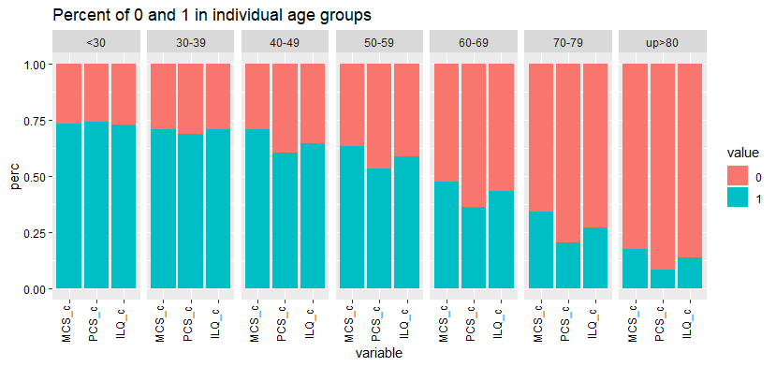
MCS_c – Mental Component Summary; PCS_c – Physical Component Summary; ILQ_c – Index of Life Quality;
Figure 1 The incidence of better and worse HR-QoL in dimensions of SF – 36 in each years group [percentage values]

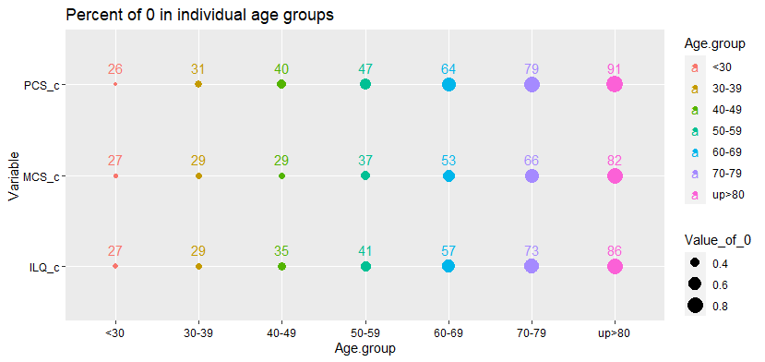
MCS_c – Mental Component Summary; PCS_c – Physical Component Summary; ILQ_c – Index of Life Quality;
Figure 2 Prevalence of worse HR-QoL in each years group considering the dimensions of MCS, PCS and ILQ [percentage values]

Below is a detailed analysis of HRQoL in the dimensions of MCS, PCS and ILQ, considering age groups and disease units. The percentage share of poorer quality of life (0) in the analysed groups of patients was indicated.

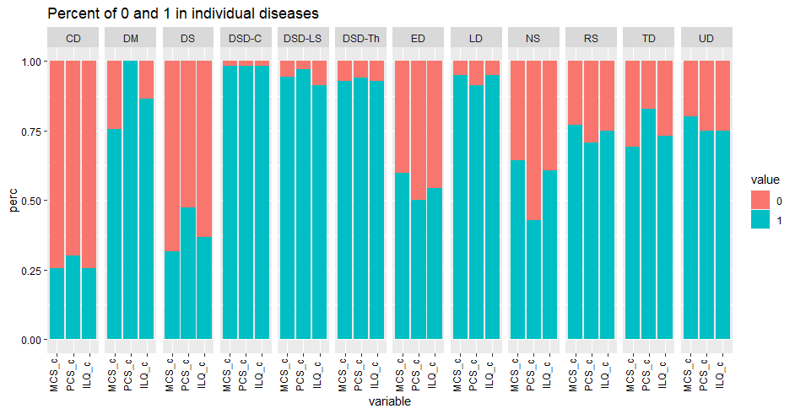
MCS_c – Mental Component Summary; PCS_c – Physical Component Summary; ILQ_c – Index of Life Quality; CD – cancers; CVD – cardiovascular disease; DM – diabetes mellitus; DS – disease of digestive system; DSD-C – degenerative changes of the cervical spine; DSD-LS – degenerative changes of the lumbosacral spine; DSD-Th – degenerative changes of the thoracic spine; ED – ophthalmic diseases; LD – ENT diseases; NS – diseases of the nervous system; RS – respiratory diseases; TD – thyroid diseases; UD – diseases of the kidneys and urinary system;

Figure 3 The incidence of better and worse HR-QoL in each of the spheres and dimensions of SF – 36 in the group >30 years old [percentage values]

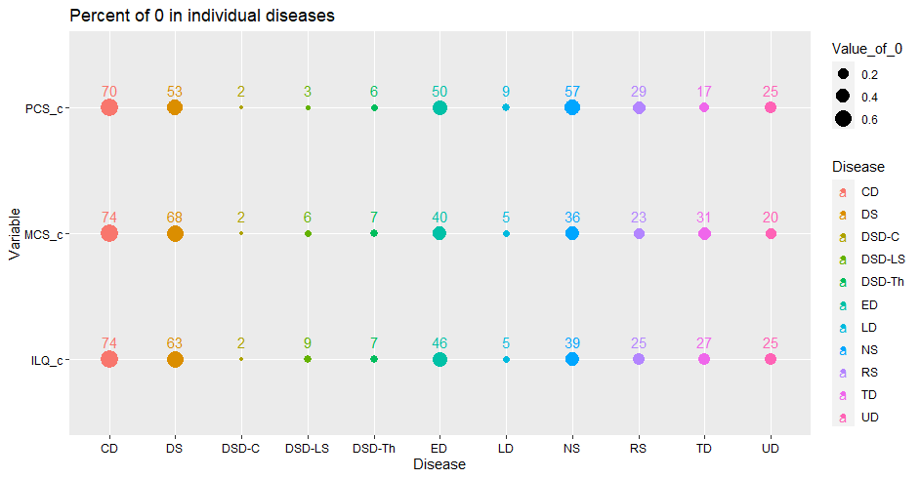
MCS_c – Mental Component Summary; PCS_c – Physical Component Summary; ILQ_c – Index of Life Quality; CD – cancers; CVD – cardiovascular disease; DM – diabetes mellitus; DS – disease of digestive system; DSD-C – degenerative changes of the cervical spine; DSD-LS – degenerative changes of the lumbosacral spine; DSD-Th – degenerative changes of the thoracic spine; ED – ophthalmic diseases; LD – ENT diseases; NS – diseases of the nervous system; RS – respiratory diseases; TD – thyroid diseases; UD – diseases of the kidneys and urinary system;
Figure 4 Prevalence of worse HR-QoL in the group >30 years old in individual diseases, considering the dimensions of MCS, PCS and ILQ [percentage values]

In the group of the youngest patients, CD, DS, ED and NS most often resulted in an unsatisfactory level of HRQoL. CD in each dimension reduced HRQoL (≥70% of respondents).
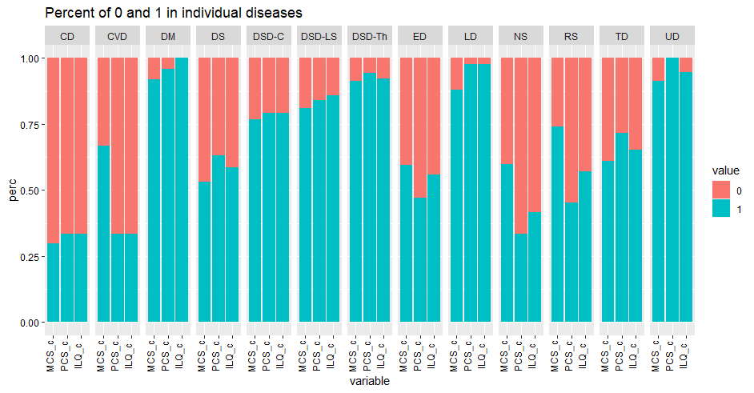
MCS_c – Mental Component Summary; PCS_c – Physical Component Summary; ILQ_c – Index of Life Quality; CD – cancers; CVD – cardiovascular disease; DM – diabetes mellitus; DS – disease of digestive system; DSD-C – degenerative changes of the cervical spine; DSD-LS – degenerative changes of the lumbosacral spine; DSD-Th – degenerative changes of the thoracic spine; ED – ophthalmic diseases; LD – ENT diseases; NS – diseases of the nervous system; RS – respiratory diseases; TD – thyroid diseases; UD – diseases of the kidneys and urinary system;

Figure 5 The incidence of better and worse HR-QoL in each of the spheres and dimensions of SF – 36 in the group 30–39 years old [percentage values]

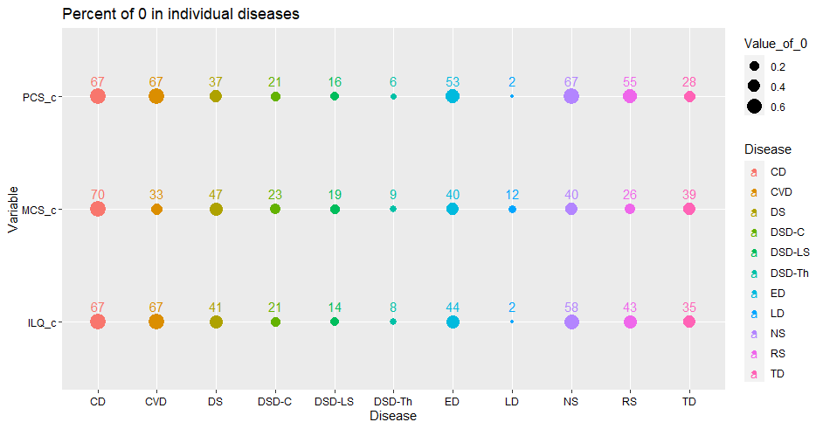
MCS_c – Mental Component Summary; PCS_c – Physical Component Summary; ILQ_c – Index of Life Quality; CD – cancers; CVD – cardiovascular disease; DM – diabetes mellitus; DS – disease of digestive system; DSD-C – degenerative changes of the cervical spine; DSD-LS – degenerative changes of the lumbosacral spine; DSD-Th – degenerative changes of the thoracic spine; ED – ophthalmic diseases; LD – ENT diseases; NS – diseases of the nervous system; RS – respiratory diseases; TD – thyroid diseases; UD – diseases of the kidneys and urinary system;
Figure 6 Prevalence of worse HR-QoL in the group 30–39 years old in individual diseases, considering the dimensions of MCS, PCS and ILQ [percentage values]

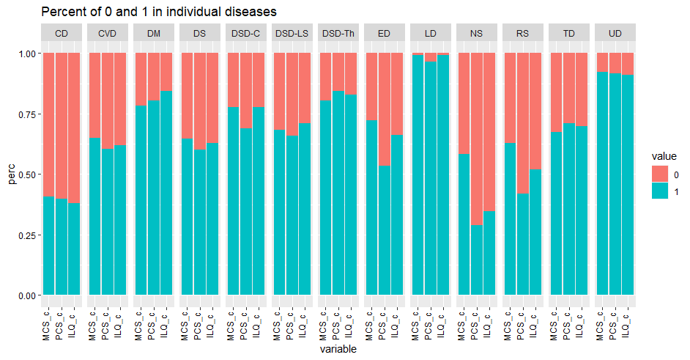
MCS_c – Mental Component Summary; PCS_c – Physical Component Summary; ILQ_c – Index of Life Quality; CD – cancers; CVD – cardiovascular disease; DM – diabetes mellitus; DS – disease of digestive system; DSD-C – degenerative changes of the cervical spine; DSD-LS – degenerative changes of the lumbosacral spine; DSD-Th – degenerative changes of the thoracic spine; ED – ophthalmic diseases; LD – ENT diseases; NS – diseases of the nervous system; RS – respiratory diseases; TD – thyroid diseases; UD – diseases of the kidneys and urinary system;
Figure 7 The incidence of better and worse HR-QoL in each of the spheres and dimensions of SF – 36 in the group 40–49 years old [percentage values]

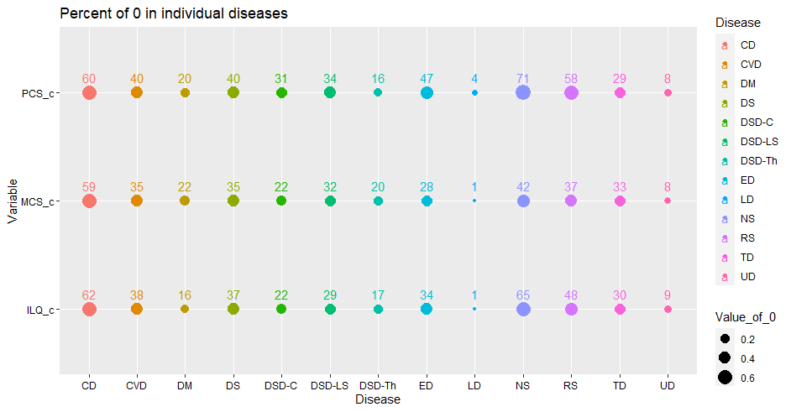
MCS_c – Mental Component Summary; PCS_c – Physical Component Summary; ILQ_c – Index of Life Quality; CD – cancers; CVD – cardiovascular disease; DM – diabetes mellitus; DS – disease of digestive system; DSD-C – degenerative changes of the cervical spine; DSD-LS – degenerative changes of the lumbosacral spine; DSD-Th – degenerative changes of the thoracic spine; ED – ophthalmic diseases; LD – ENT diseases; NS – diseases of the nervous system; RS – respiratory diseases; TD – thyroid diseases; UD – diseases of the kidneys and urinary system;
Figure 8 Prevalence of worse HR-QoL in the group 40–49 years old in individual diseases, considering the dimensions of MCS, PCS and ILQ [percentage values]

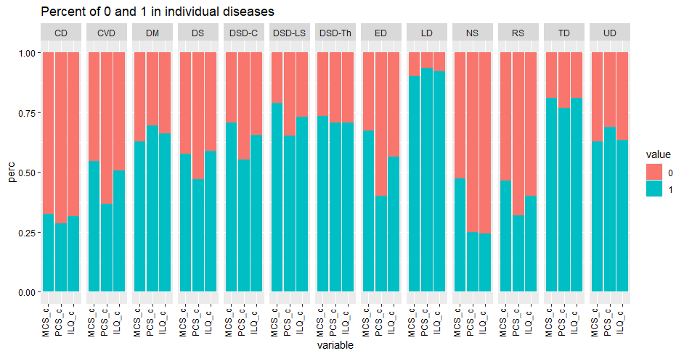
MCS_c – Mental Component Summary; PCS_c – Physical Component Summary; ILQ_c – Index of Life Quality; CD – cancers; CVD – cardiovascular disease; DM – diabetes mellitus; DS – disease of digestive system; DSD-C – degenerative changes of the cervical spine; DSD-LS – degenerative changes of the lumbosacral spine; DSD-Th – degenerative changes of the thoracic spine; ED – ophthalmic diseases; LD – ENT diseases; NS – diseases of the nervous system; RS – respiratory diseases; TD – thyroid diseases; UD – diseases of the kidneys and urinary system;
Figure 9 The incidence of better and worse HR-QoL in each of the spheres and dimensions of SF – 36 in the group 50–59 years old [percentage values]
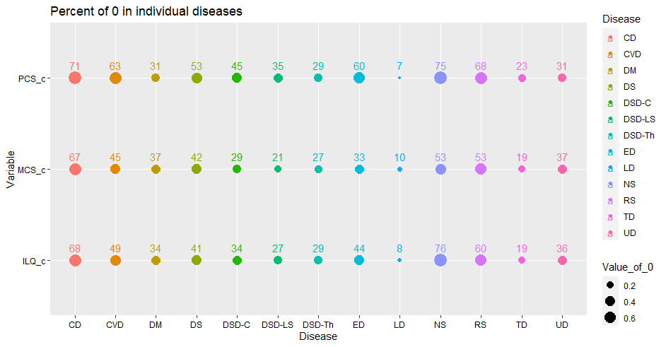
MCS_c – Mental Component Summary; PCS_c – Physical Component Summary; ILQ_c – Index of Life Quality; CD – cancers; CVD – cardiovascular disease; DM – diabetes mellitus; DS – disease of digestive system; DSD-C – degenerative changes of the cervical spine; DSD-LS – degenerative changes of the lumbosacral spine; DSD-Th – degenerative changes of the thoracic spine; ED – ophthalmic diseases; LD – ENT diseases; NS – diseases of the nervous system; RS – respiratory diseases; TD – thyroid diseases; UD – diseases of the kidneys and urinary system;

Figure 10 Prevalence of worse HR-QoL in the group 50–59 years old in individual diseases, considering the dimensions of MCS, PCS and ILQ [percentage values]

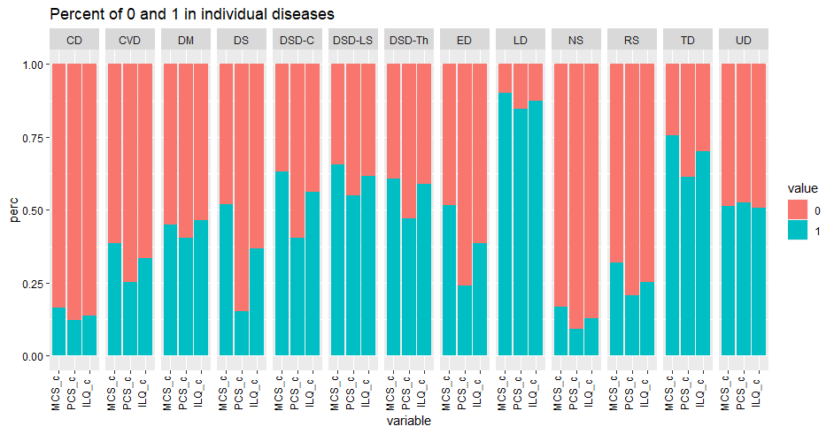
MCS_c – Mental Component Summary; PCS_c – Physical Component Summary; ILQ_c – Index of Life Quality; CD – cancers; CVD – cardiovascular disease; DM – diabetes mellitus; DS – disease of digestive system; DSD-C – degenerative changes of the cervical spine; DSD-LS – degenerative changes of the lumbosacral spine; DSD-Th – degenerative changes of the thoracic spine; ED – ophthalmic diseases; LD – ENT diseases; NS – diseases of the nervous system; RS – respiratory diseases; TD – thyroid diseases; UD – diseases of the kidneys and urinary system;
Figure 11The incidence of better and worse HR-QoL in each of the spheres and dimensions of SF – 36 in the group 60–69 years old [percentage values]

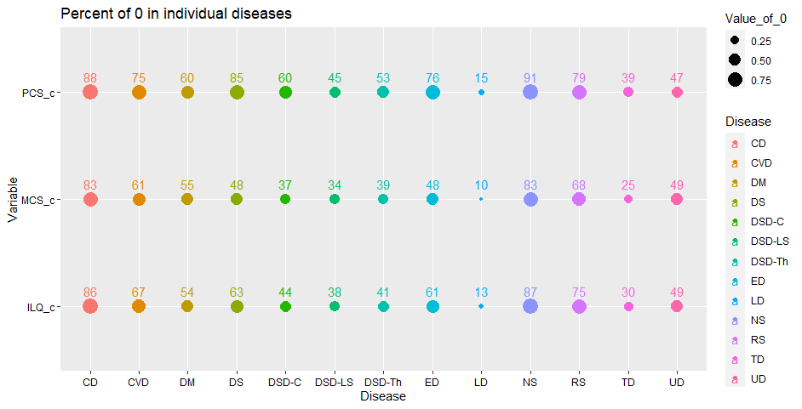
MCS_c – Mental Component Summary; PCS_c – Physical Component Summary; ILQ_c – Index of Life Quality; CD – cancers; CVD – cardiovascular disease; DM – diabetes mellitus; DS – disease of digestive system; DSD-C – degenerative changes of the cervical spine; DSD-LS – degenerative changes of the lumbosacral spine; DSD-Th – degenerative changes of the thoracic spine; ED – ophthalmic diseases; LD – ENT diseases; NS – diseases of the nervous system; RS – respiratory diseases; TD – thyroid diseases; UD – diseases of the kidneys and urinary system;

Figure 12 Prevalence of worse HR-QoL in the group 60–69 years old in individual diseases, considering the dimensions of MCS, PCS and ILQ [percentage values]

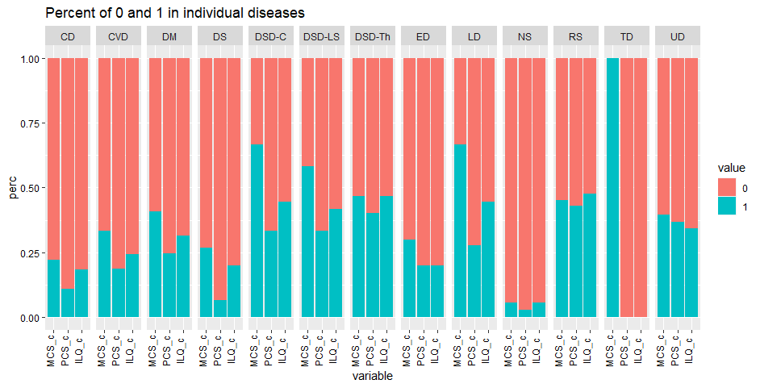
MCS_c – Mental Component Summary; PCS_c – Physical Component Summary; ILQ_c – Index of Life Quality; CD – cancers; CVD – cardiovascular disease; DM – diabetes mellitus; DS – disease of digestive system; DSD-C – degenerative changes of the cervical spine; DSD-LS – degenerative changes of the lumbosacral spine; DSD-Th – degenerative changes of the thoracic spine; ED – ophthalmic diseases; LD – ENT diseases; NS – diseases of the nervous system; RS – respiratory diseases; TD – thyroid diseases; UD – diseases of the kidneys and urinary system;
Figure 13 The incidence of better and worse HR-QoL in each of the spheres and dimensions of SF – 36 in the group 70–79 years old [percentage values]

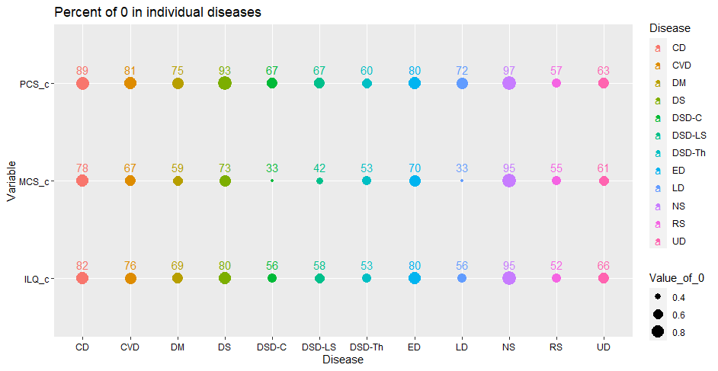
MCS_c – Mental Component Summary; PCS_c – Physical Component Summary; ILQ_c – Index of Life Quality; CD – cancers; CVD – cardiovascular disease; DM – diabetes mellitus; DS – disease of digestive system; DSD-C – degenerative changes of the cervical spine; DSD-LS – degenerative changes of the lumbosacral spine; DSD-Th – degenerative changes of the thoracic spine; ED – ophthalmic diseases; LD – ENT diseases; NS – diseases of the nervous system; RS – respiratory diseases; TD – thyroid diseases; UD – diseases of the kidneys and urinary system;
Figure 14 Prevalence of worse HR-QoL in the group 70–79 years old in individual diseases, considering the dimensions of MCS, PCS and ILQ [percentage values]

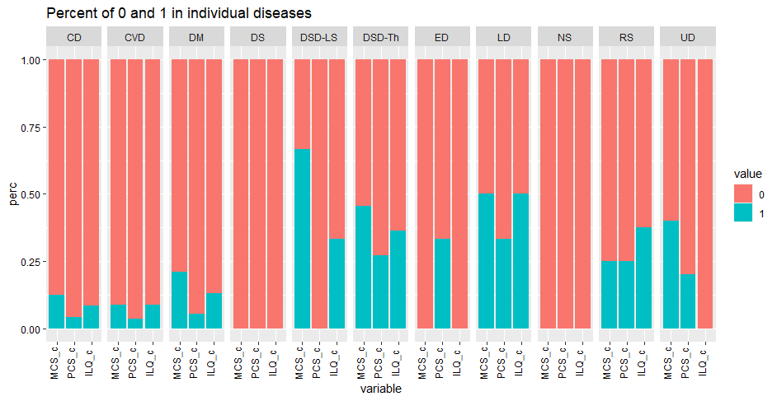
MCS_c – Mental Component Summary; PCS_c – Physical Component Summary; ILQ_c – Index of Life Quality; CD – cancers; CVD – cardiovascular disease; DM – diabetes mellitus; DS – disease of digestive system; DSD-C – degenerative changes of the cervical spine; DSD-LS – degenerative changes of the lumbosacral spine; DSD-Th – degenerative changes of the thoracic spine; ED – ophthalmic diseases; LD – ENT diseases; NS – diseases of the nervous system; RS – respiratory diseases; TD – thyroid diseases; UD – diseases of the kidneys and urinary system;
Figure 15 The incidence of better and worse HR-QoL in each of the spheres and dimensions of SF – 36 in the group >80 years old [percentage values]

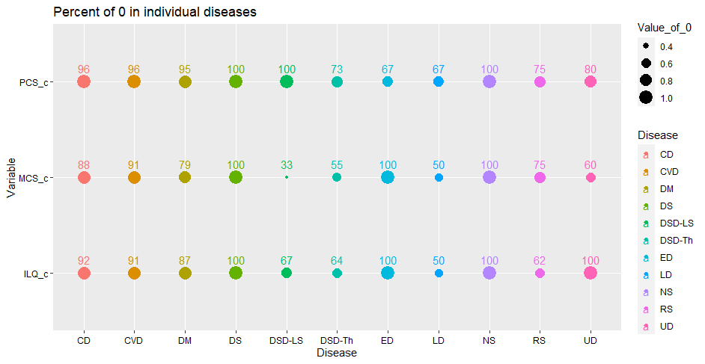

MCS_c – Mental Component Summary; PCS_c – Physical Component Summary; ILQ_c – Index of Life Quality; CD – cancers; CVD – cardiovascular disease; DM – diabetes mellitus; DS – disease of digestive system; DSD-C – degenerative changes of the cervical spine; DSD-LS – degenerative changes of the lumbosacral spine; DSD-Th – degenerative changes of the thoracic spine; ED – ophthalmic diseases; LD – ENT diseases; NS – diseases of the nervous system; RS – respiratory diseases; TD – thyroid diseases; UD – diseases of the kidneys and urinary system;
Figure 16 Prevalence of worse HR-QoL in the group >80 years old in individual diseases, considering the dimensions of MCS, PCS and ILQ [percentage values]

Correlations between subsequent age groups in the area of spheres and dimensions were also analysed. The value of the correlation coefficient (R) is shown in each figure. The following figures show the median, upper, lower quarts and outliers for each analysis carried out within the age group.

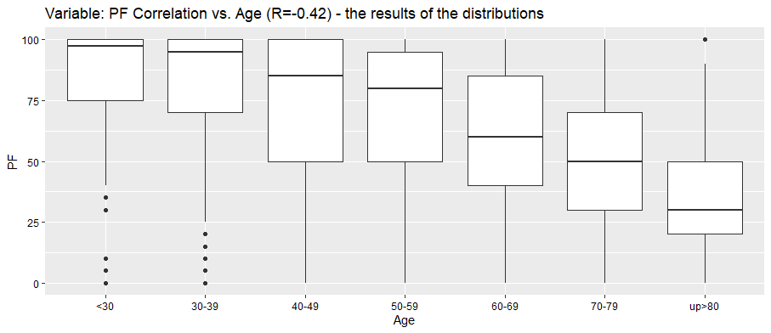
Figure 17 Comparison of scores in the PF (physical functioning) sphere and age groups (median, upper quartile, lower quartile, outliers)

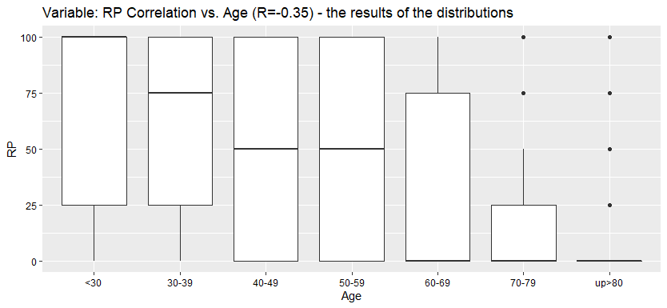
Figure 18 Comparison of scores in the RP (role physical) sphere and age groups (median, upper quartile, lower quartile, outliers)

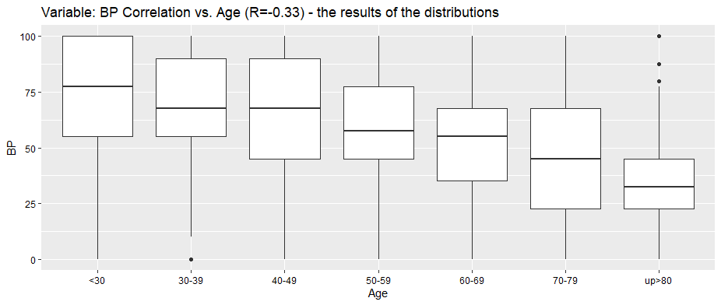
Figure 19 Comparison of scores in the BP (bodily pain) sphere and age groups (median, upper quartile, lower quartile, outliers)

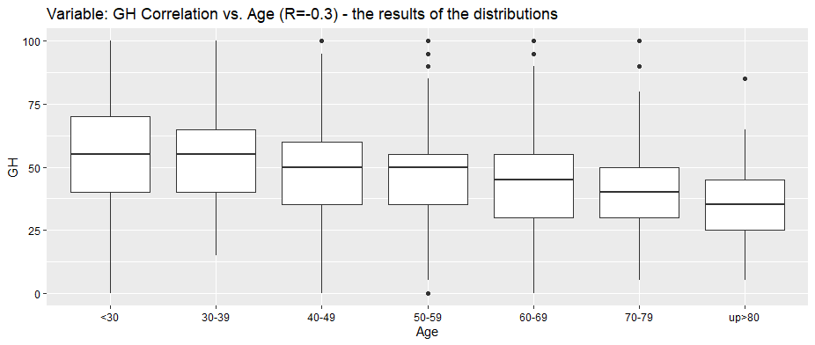
Figure 20 Comparison of scores in the GH (general health) sphere and age groups (median, upper quartile, lower quartile, outliers)

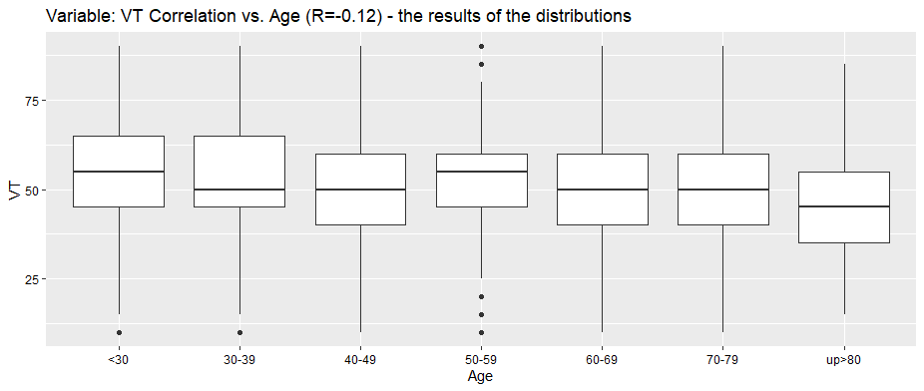
Figure 21 Comparison of scores in the VT (vitality) sphere and age groups (median, upper quartile, lower quartile, outliers)

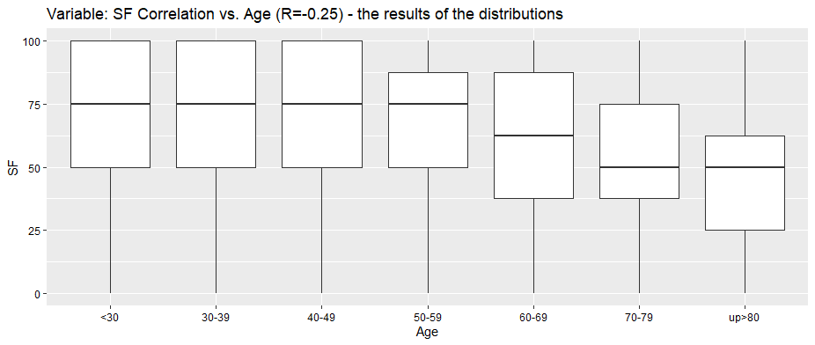
Figure 22 Comparison of scores in the SF (social functioning) sphere and age groups (median, upper quartile, lower quartile, outliers)

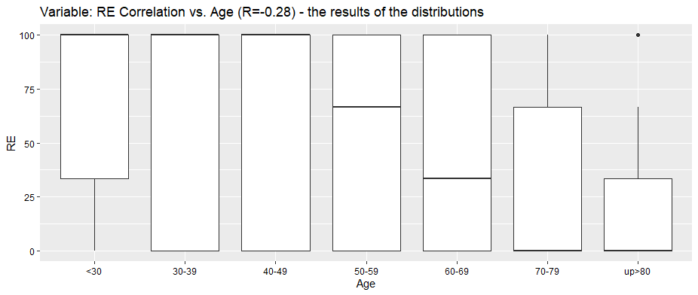
Figure 23 Comparison of scores in the RE (role emotional) sphere and age groups (median, upper quartile, lower quartile, outliers)

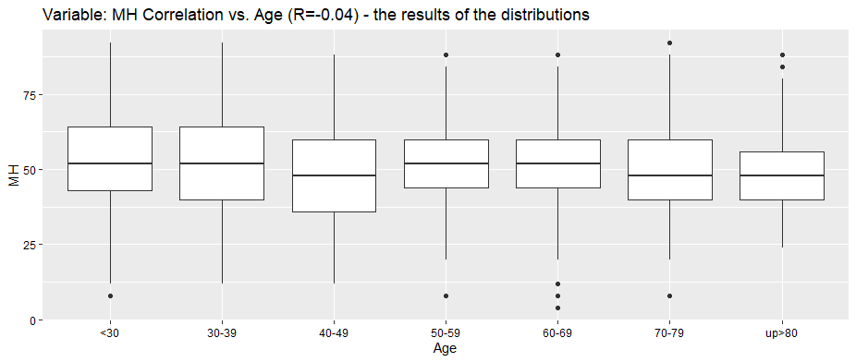
Figure 24 Comparison of scores in the MH (mental health) sphere and age groups (median, upper quartile, lower quartile, outliers)
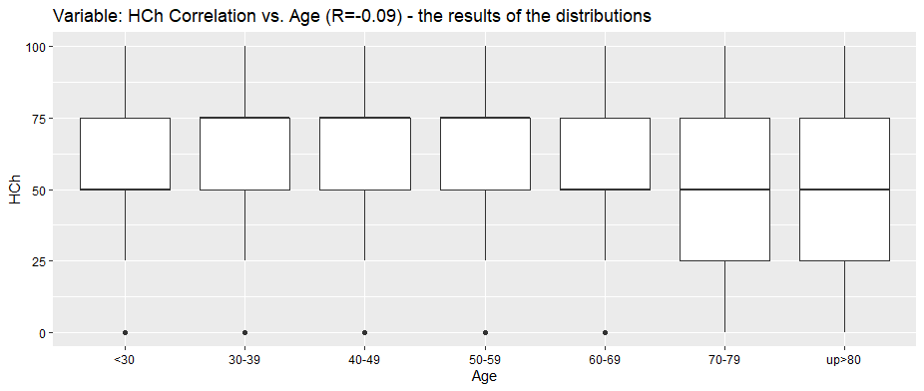
Figure 25 Comparison of scores in the HCh (subjective sense of change in health) sphere and age groups (median, upper quartile, lower quartile, outliers)

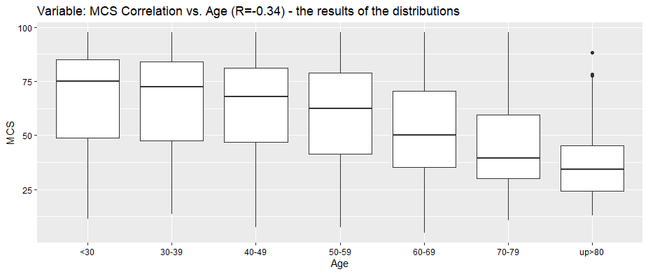
Figure 26 Comparison of scores in the MCS (Mental Component Summary) sphere and age groups (median, upper quartile, lower quartile, outliers)

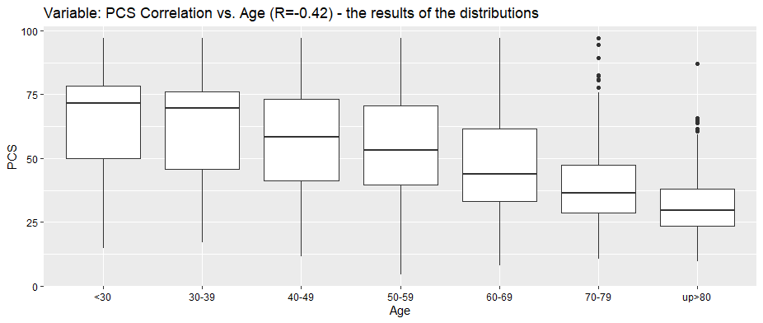
Figure 27 Comparison of scores in the PCS (Physical Component Summary) sphere and age groups (median, upper quartile, lower quartile, outliers)

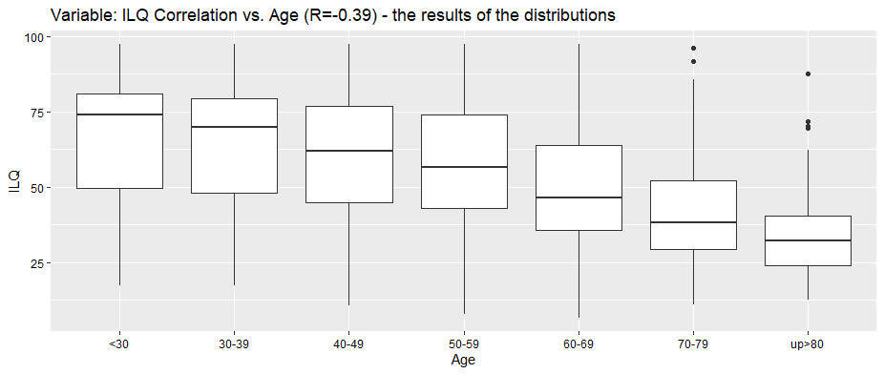
Figure 28 Comparison of scores in the ILQ (Index of Life Quality) sphere and age groups (median, upper quartile, lower quartile, outliers)
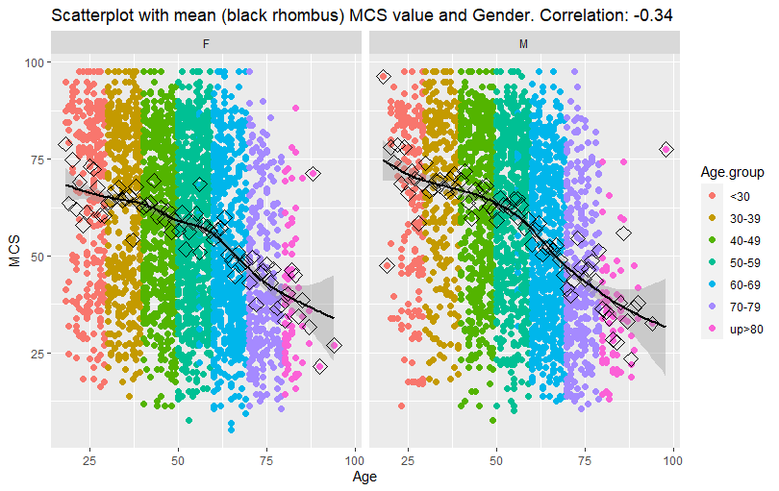
Figure 29 The variability of SF-36 results obtained in the MCS (Mental Component Summary) dimension across various age groups

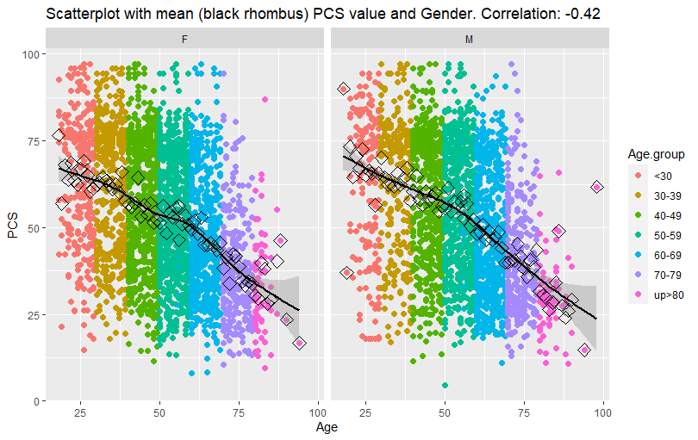
Figure 30 The variability of SF-36 results obtained in the PCS (Physical Component Summary) dimension across various age groups
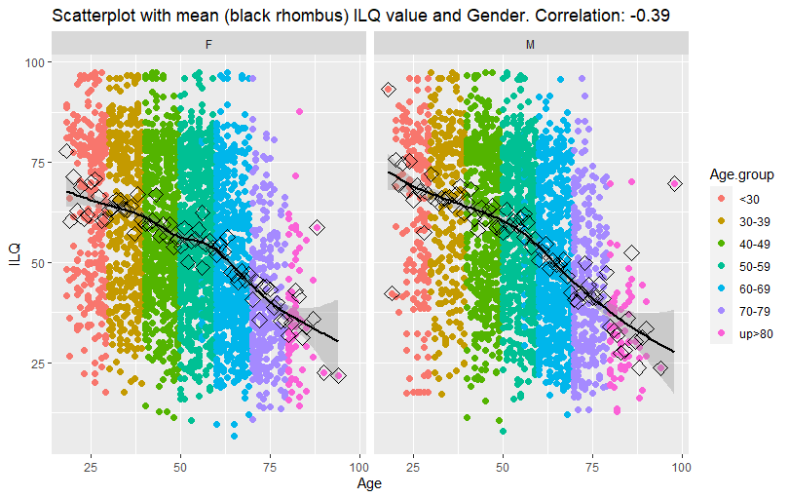
Figure 31 The variability of SF-36 results obtained in the ILQ (Index of Life Quality) dimension across various age groups

