Supplementary Information

Drought stress mitigation and improved yield in Glycine max through foliar application of zinc oxide nanoparticles
Shahin Shirvani-Naghani¹, Sina Fallah^{1*}, Lok Raj Pokhrel^{2*}, Ali Rostamnejadi³
¹Department of Agronomy, Faculty of Agriculture, Shahrekord University, Shahrekord, Iran.
²Department of Public Health, The Brody School of Medicine, East Carolina University, Greenville, NC, USA.
3Department of Electroceramics and Electrical Engineering, Malek Ashtar University of Technology, Iran.

*Corresponding authors: LR Pokhrel, Phone: 252-737-5587; Email: pokhrell18@ecu.edu
S Fallah, Phone: +983832324428; Email: fallah-s@sku.ac.ir

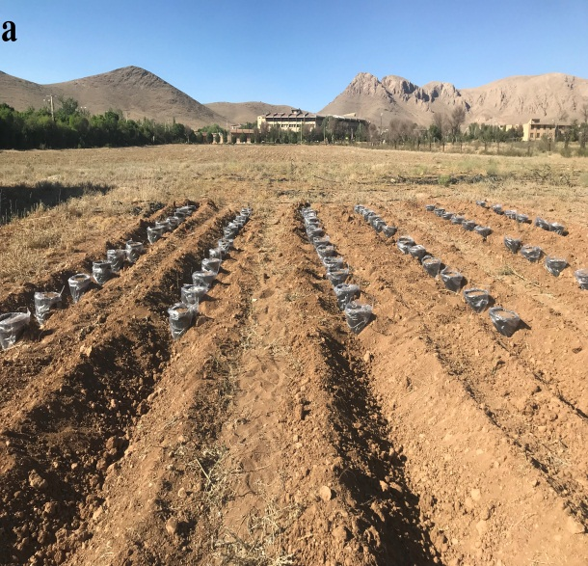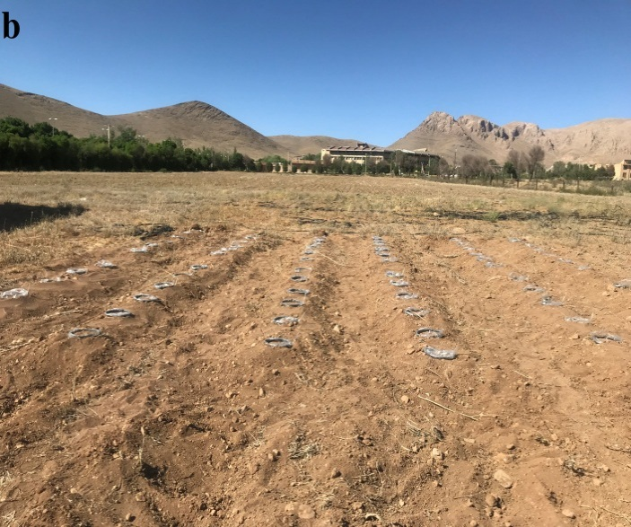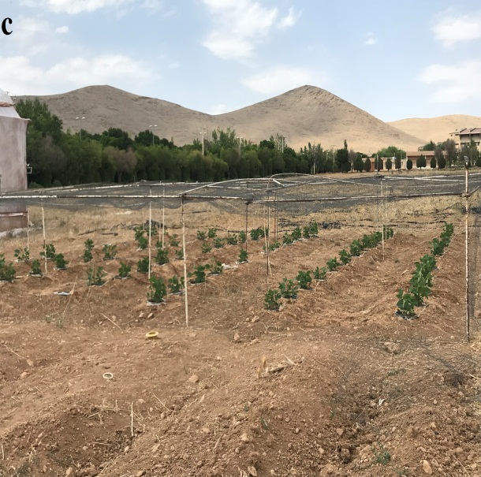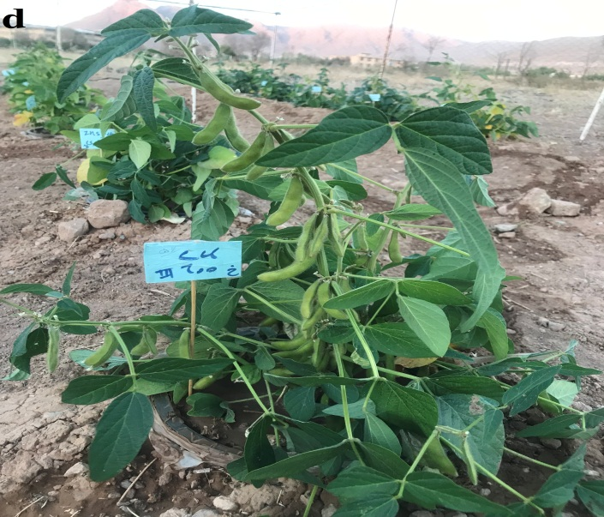
Figure S1. Pot placement in soil mounds (a and b) and vegetative and reproductive growth of soybean (c and d).

Table S1. Meteorological information of experimental site.
amount of precipitation (mm) | Average relative humidity (%) | Average temperature ˚C) | Photosynthetically active radiations (Mj/m) | Month
0.18 | 36.2 | 16.9 | 2.5 | June
0.00 | 13.5 | 23.9 | 13.8 | July
0.00 | 22.2 | 25.0 | 12.0 | August
0.03 | 22.2 | 22.9 | 11.0 | September
0.00 | 18.1 | 20.3 | 10.2 | October

Table S2. Physical and chemical properties of used soil.

Fe  mg/kg | Zn  mg/kg | Mn  mg/kg | Cu  mg/kg | K  mg/kg | P  mg/kg | Total N  % | O.C  % | pH | EC dS/m | Texture
3.0 | 0.47 | 8.4 | 0.97 | 469 | 15.9 | 0.08 | 0.66 | 8.0 | 0.65 | Clay loam

