Supplementary information for:
The reference genome of the freshwater snail Lymnaea stagnalis reveals evolutionary and molecular implications of simultaneous hermaphroditism

Supplementary Information
1. Mitogenome: species identification and common features in Lymnaeidae
2. RNA-seq analysis of Male/female organs
3. Supplementary information: Orthology

Supplementary Figures
SF1. Map of L. stagnalis mitochondrial genome.
SF2. Phylogenetic relationships among L. stagnalis nuclear receptors (full tree). In black: branch length ; in red: bootstrap values (further explanations in Figure 1, main text).
SF3. Phylogenetic analysis of 2DBD-NRs relationships across metazoans (full tree) (further explanation in Figure 2, main text).
SF4. General annotation workflow applied to the L. stagnalis genome assembly.

Supplementary Tables (ST1-ST15 : pdf files ; ST&-ST17 : txt files)
ST1. Annotation of L. stagnalis predicted protein sequences: Receptor Tyrosine Kinases
(RTK). See HUGO gene nomenclature and conserved domain database for domain definition.
ST2. Summary of nuclear receptor annotation: BLASTp Best-Hit (BH) from H. sapiens restricted or global nr NCBI database.
ST3. Annotation of L. stagnalis predicted proteins: nuclear receptor domains (DBD: DNAbinding domain; LBD: Ligand-biding domain).
ST4. List of metazoan sequences used in the phylogenetic analysis of 2DBD-NRs (see Wu and Loverde 2023).
ST5. Annotation of L. stagnalis predicted proteins: GPCRs.
ST6. Orthology analyses (summary statistics) of the L. stagnalis predicted proteome, as
performed at two distinct levels, metazoans and gastropods.
ST7. Gastropod orthology analysis. Conserved domains associated with the main OGs
exclusively contributed by euthyneuran taxa (number of proteins per species).The list is
reduced to OGs containing at least 18 sequences, and present in at least 5 of 6 euthyneuran
taxa (R. auricularia was a posteriori discared, see text for explanation).
ST8. Annotation of L. stagnalis GPCRs found organized in clusters in the genome assembly.
Groups of tandem genes (clusters) are named as a function oftheir size (4 to 26 genes) and
further numbered from 1 to n (e.g., C16-2 is the 2nd cluster of 16 genes, as based on gene
prediction identifier). "a" or "b" indicates a subdivision of the group into two different GPCRclasses (e.g., C06-6a: class_A and C06-6b: class_C).
ST9. Distribution of L. stagnalis GPCRs across B, C, E, and F families. Number of proteins with a full domain (6 to 7 transmembrane helices) versus incomplete domain (< 6 tms).
ST10. List of genes selected for the in situ expression study during L. stagnalis development.
Expression in albumen gland and prostate from RNAseq data.
ST11. Descriptive statistics of the various transcriptomic cDNA libraries used for the L.
stagnalis genome annotation.
ST12. Summary statistics of the Nanopore-sequenced cDNA libraries used to annotate the genome of L.stagnalis (raw vs NaS-corrected reads).
ST13. Genomic DNA library coverage, L. stagnalis genome project.
ST14. TE annotation of the L. stagnalis genome assembly.
ST15. Classification of transposable elements detected in the L. stagnalis genome assembly.
ST16. Primer sequences used to clone fragments for in situ hybridisation.
ST17. Full sequence information on regions used as in situ probes.
ST18. RTK predicted protein sequences.
ST19. NR predicted protein sequences.
ST20. GPCR predicted protein sequences.
ST21. Bioproject PRJEB6719: locus tag, protein ID, and blastp Best-Hit values.
ST22. L. stagnalis gene prediction mapping.
ST23. L. stagnalis predicted genes: full nucleotide sequences.
ST24. L. stagnalis predicted genes: virtual cDNA sequences.
ST25. L. stagnalis predicted genes: virtual amino-acid sequences.
1. High Molecular Weight DNA extraction

Genomic DNA was extracted at the Genoscope, via plug-DNA extraction to obtain high molecular weight (200kb) DNA fragments.
A whole individual, flash-frozen and stored at -80°C, was removed from its shell, cleaned in a physiological water bath and then ground with a mortar in the presence of liquid nitrogen. The grinded material was then resuspended in 15ml SEB1X buffer in the presence of 0.2% βmercaptoethanol and gently stirred for 15min at 4°C. This solution resulting was passed through a specific strainer in order to remove as much mucus as possible. 0.05vol of a SEB 1X-Triton mixture was added to the 14ml of filtrate recovered, then after incubation for 10min at 4°C, centrifugation was performed for 20min at 600g at 4°C. The supernatant was removed and the resulting pellet of nuclei was washed 2 times with 1X SEB buffer, then resuspended in 300µl of S buffer in the presence of 30µl of SDS.
The protocol was immediately continued by embedding the nuclei in plugs. Low Melting Point agarose 2% was prepared extemporaneously and added to the nuclei suspension, volume by volume. After gentle homogenization with a vortex, avoiding bubbles, the mixture was poured into plugs at a rate of 100µl per plug and left to polymerize on ice for 15min. The plugs were then expelled into a 50ml tube in the presence of 10m LB buffer per plug and incubated for 1h at 37°C before undergoing proteinaseK digestion. After removal of the LB, the plugs were placed in the presence of 10ml DB buffer and proteinaseK at 40µg/ml final. After removal of the LB buffer, the plugs were placed in the presence of 10ml DB and proteinase K at 40µg/ml final and incubated in an oven at 50°C overnight. The following day, the proteinaseK solution was removed and inactivated by washing with a mixture of 10ml TE 10:1 pH8 and 23µl PMSF 0.1M (40µg/ml final). Two washes of 30 min at room temperature were followed by 3 washes of 10min at room temperature with 20ml TE 10:1 pH8. The plugs were then stored in 30ml EDTA 0.5M pH8 at 4°C until extraction.
High-molecular-weight DNA was then extracted from the plugs by β-agarase treatment. After 5 washes in 20ml TE 1X buffer followed by 2 washes in 20ml MES buffer, each plug was incubated on paper, placed in a 1.5ml tube and incubated for 7min at 70°C in a dry water bath before being transferred at 42°C overnight in the presence of 16µl β-agarase.
The following day, the entire volume (~500 µl) was transferred on to a dialysis filter using a broad tip and left for 30min at room temperature. . DNA quality was checked using Opgen QCards (Opgen, Rockville, MD, USA), and concentration determined via Qubit Fluorometric Quantitation (Thermo Fisher Scientific, Waltham, MA, USA).

1. Mitogenome: species identification and common features in Lymnaeidae

BLAST searches showed mitogenomic sequence similarities for the full length of Lsta_scaffold2639. As indicated by a 127 bp sequence overlap at the termini, the scaffold represents a circular sequence. Nanopore reads confirmed that the assembled sequence is contiguous, and annotation revealed the complete standard gene complement for a metazoan mitogenome. The 13,834 bp mitogenome of L. stagnalis (Figure X) is 71.78% AT-rich. Several protein coding genes (PCGs) are delimited by downstream tRNA genes, causing the ORF to terminate with a truncated stop-codon (T- or TA-) that is completed by polyadenylation of the mRNA transcripts. The annotated L. stagnalis mitogenome has been deposited in GenBank (MW221941). The experimental sequence had 94% identity with another independently characterized L. stagnalis mitogenome sequence (13,807 bp, MT874495). The difference in length of these two mitogenomes is mostly due to indels in regions with tRNA- and rRNA genes, a two bp indel occurs at the 5’ start of ND4L. The mitogenome sequences align closely but contain abundant single nucleotide variants (including several nonsynonymous substitutions) within PCGs. The organization of the 22 tRNA genes, two rRNA genes plus 13 PCGs is generally similar to that of mitogenomes of other lymnaeid (and hygrophilid) snail species, with a few minor differences in the location of tRNA genes.
The combined use of short- and long-reads provided a high coverage of the mitogenome. This approach confirms the absence of repetitive sequence elements that may “stack up” to interfere with a correct assembly when using only short-read data. Accordingly, the mitogenome of L. stagnalis, a panpulmonate snail, does not contain long non-coding repeat regions such as reported form two prosobranch gastropod species, Potamopyrgus antipodarum and Potamopyrgus estuarinus (https://doi.org/10.1093/molbev/msad007). The AT-content of the L. stagnalis mitogenome (71.81%) is elevated relative to the nuclear genome (62.45%). This is not unusual, as invertebrate mitogenomes tend to be AT-rich and a similar pattern (69% vs 64%) was recorded from Physella acuta, (family Physidae) another species of hygrophylid snail (https://doi.org/10.1093/mollus/eyu025). The 6% difference in nucleotide content and greater length by 27 nucleotides compared to an independently characterized L. stagnalis mitogenome (as yet listed by GenBank as “unverified”, MT874495) suggests considerable genetic diversity within the mitogenome of L. stagnalis species. The order of genes in the L. stagnalis mitogenome, however, conforms to the generally uniform organization of most panpulmonate gastropods (e.g. https://doi.org/10.1093/mollus/eyu025).

2. RNA-seq analysis of Male/female organs

Using the alignment data and annotation file as input for HTseq, we counted how many reads mapped to annotated genes. All samples and organs had similar numbers of reads, but AG reads were more frequently mapped than PG reads (ca. 80 % versus ca. 40 %). The annotation file contained 22,499 genes and the number of expressed genes was roughly similar across organs. From the total set of 422 GPCR genes present in the genome, we found 29 expressed in the female albumen gland (AG) and 31 in the male prostate gland (PG). Of these GPCRs 13 overlapped, meaning that 16 were exclusively expressed in the AG and 18 exclusively in the PG. From the total set of 55 NR genes present in the genome, we found 33 of the identified NRs expressed in the AG and 36 in the PG. Of these NRs all but 3 overlapped; the 3 non-overlapping NRs were exclusively expressed in the PG. We selected the most highly expressed transcripts, that matched a complete receptor sequence, for in situ expression in the prostate and albumen gland.

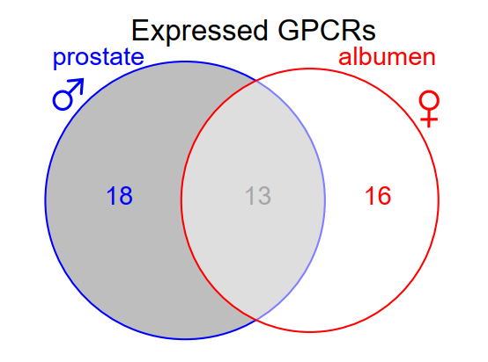
Figure 1. Distribution of GPCR genes expressed in two reproductive organes of L. stagnalis (prostate and albumen gland).

3. Supplementary information: Orthology

5.1. Orthology analysis at metazoan level

The set of L. stagnalis protein sequences predicted from the present assembly was used to determine groups of orthologues at the level of Metazoa, using predicted proteomes from 19 additional taxa representative of the main metazoan phyla (Table 1). The analysis was performed with OrthoFinder (Emms and Kelly 2020) using default parameters.

Table 1. List of species and genomic resource accessions used to infer L. stagnalis orthologs.
Phylum | Taxon | Bioproject | Assembly
Porifera | Amphidemon queenslandica | PRJNA66531 | GCF_000090795.1
Placozoa | Trichoplax adhaerens | PRJNA12874 | GCF_000150275.1
Platyhelminthes | Schistosoma mansoni | PRJEA36577 | GCF_000237925.1
Mollusca | Aplysia californica | PRJNA13635 | GCF_000002075.1
Mollusca | Biomphalaria glabrata | PRJNA290623 | GCA_000457365.1
Mollusca | Lymnaea stagnalis |  | 22499 Gene Predictions
Mollusca | Lottia gigantea | PRJNA175706 | GCF_000327385.1
Mollusca | Crassostrea gigas | PRJNA70283 | GCF_000297895.1
Mollusca | Octopus bimaculoides | PRJNA270931 | GCF_001194135.1
Annelida | Helobdella robusta | PRJNA175704 | GCF_000326865.1_
Nematoda | Caenorhabditis elegans | PRJNA13758 | GCF_000002985.6_WBcel235
Arthropoda | Folsomia candida | PRJNA299291 | GCF_002217175.1
Arthropoda | Hyalella azteca | PRJNA342675 | GCF_000764305.1
Arthropoda | Daphnia pulex | PRJNA12756 | GCA_000187875.1
Arthropoda | Drosophila melanogaster | PRJNA13812 | GCF_000001215.4
Echinodermata | Apostichopus japonicus | PRJNA354676 | GCA_002754855.1
Hemichordata | Saccoglossus kowalevskii | PRJNA42857 | GCF_000003605.1
Chordata | Branchiostoma floridae | UP000001554 | GCF_000003815.1
Chordata | Ciona intestinalis | PRJDA65419 | GCF_000224145.2
Chordata | Homo sapiens | PRJNA31257 | GCF_000001405.37_GRCh38.p11

The dataset represents 600240 genes in total. OrthoFinder identified 17669 orthogroups (OGs; Table 2), of which 10707 included L. stagnalis genes (60.6%). More than 90 % of L. stagnalis genes (20315 out of 22499) were assigned to an OG (Fig. 2), and 28OGs were specific to L. stagnalis, involving 140 genes (0.6% of the total number of predicted genes). Orthogroup full content is available upon request.

Table 2. Orthogroup (OG) overal statistics (metazoan-level analysis)
Parameter | value
Number of species | 20
Number of genes | 600240
Number of genes in orthogroups | 500283
Number of unassigned genes | 99957
Percentage of genes in orthogroups | 83.3
Percentage of unassigned genes | 16.7
Number of orthogroups | 17669
Number of species-specific orthogroups* | 1947
Number of genes in species-specific orthogroups | 12160
Percentage of genes in species-specific orthogroups | 2
Mean orthogroup size | 28.3
Median orthogroup size | 14
G50 (assigned genes) | 53
G50 (all genes) | 40
O50 (assigned genes) | 1977
O50 (all genes) | 3067
Number of orthogroups with all species present | 2312
Number of single-copy orthogroups | 2
*Orthogroups that consist entirely of genes from one species.
G50: The number of genes in the orthogroup such that 50% of genes are in orthogroups of that size or larger.
O50: The smallest number of orthogroups such that 50% of genes are in orthogroups of that size or larger.
Single-copy orthogroup: An orthogroup with exactly one gene (and no more) from each species.
Unassigned gene: A gene that has not been put into an orthogroup with any other genes.

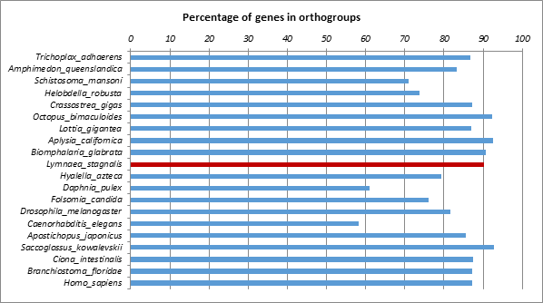
Figure 2. Percentage of genes per species attributed to an OG (orthology at metazoan level).

Gene family enrichment was explored in L. stagnalis using a Z-score (number of standard deviations from the mean) on the frequency of L. stagnalis genes that contributed to a given OG. From this test, 1149 OGs were found enriched in L. stagnalis genes. Among these, we selected the 53 OGs that contained at least 10 L. stagnalis genes and genes from at least two other species (Fig. 3), and further annotated them using InterProScan (Table 3).

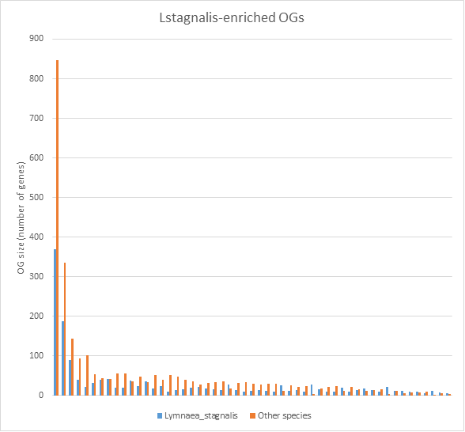

Figure 3. Size distribution of 53 OGs in which L. stagnalis genes were found over-represented (L. stagnalis Z-score>2), and contained at least 10 L. stagnalis genes (in blue) and genes from at least two other species (in orange). Blue and orange bars sum up to total OG size.

Table 3. InterProScan annotation of 53 OGs in which L. stagnalis genes were found over-represented (L. stagnalis Z-score>2), and contained at least 10 L. stagnalis genes and genes from at least two other species.

OG | OG size | Nb of molluscan* genes | IPR description | IPR accession | Proportion of Lstagnalis genes  With IPR
OG0000008 | 1215 | 1085 | GPCR, rhodopsin-like, 7TM  or  G protein-coupled receptor, rhodopsin-like | IPR017452  IPR000276 | 325/369
OG0001159 | 72 | 71 |  | IPR017452  IPR000276 | 23/24
OG0002276 | 49 | 48 |  | IPR017452  IPR000276 | 17/17
OG0002279 | 49 | 49 |  | IPR017452  IPR000276 | 6/22
OG0004949 | 30 | 30 |  | IPR017452  IPR000276 | 14/14
OG0000008 | 1215 | 1085 | Serpentine type 7TM GPCR chemoreceptor Srw | IPR019427 | 123/369
OG0001159 | 72 | 71 | Serpentine type 7TM GPCR chemoreceptor Srw | IPR019427 | 10/24
OG0001501 | 62 | 58 | Reactome: Signaling by GPCR | REACT_14797 | 4/23
OG0005798 | 27 | 24 | CATH Superfamily : Rhodopsin 7-helix transmembrane proteins | 1.20.1070.10 | 1/13
OG0005798 | 27 | 24 | TMhelix (mean number per gene (sd) = 1.09 (0.30)) |  | 10/13
OG0001885 | 55 | 55 | Reactome: Signaling by GPCR | REACT_14797 | 11/19
OG0001885 | 55 | 55 | EF-Hand 1, calcium-binding site  EF-hand domain pair | IPR018247  IPR011992 | 19/19  19/19
OG0001501 | 62 | 58 | Protein of unknown function DUF1647 | IPR012444 | 20/23
OG0001501 | 62 | 58 | TMhelix (mean number per gene (SD) = 1 (0)) |  | 17/23
OG0000047 | 524 | 422 | AIG1-type G domain profile | IPR006703 | 180/188
OG0000047 | 524 | 422 | P-loop containing nucleoside triphosphate hydrolase | IPR027417 | 183/188
OG0000168 | 233 | 230 | C-type lectin  C-type lectin-like  C-type lectin fold | IPR001304  IPR016186  IPR016187 | 87/89
OG0001607 | 60 | 32 | Rho GTPase activation protein  Rho GTPase-activating protein domain | IPR008936 IPR000198 | 13/13
OG0000400 | 133 | 94 | Tumour necrosis factor domain  Tumour necrosis factor-like domain | IPR006052  IPR008983 | 38/39
OG0006745 | 24 | 24 | Tumour necrosis factor-like domain | IPR008983 | 20/21
OG0001293 | 68 | 62 | TNFR/NGFR cysteine-rich region | IPR001368 | 29/35
OG0000446 | 123 | 59 | Antistasin-like domain | IPR004094 | 19/22
OG0000834 | 86 | 75 | Dermatopontin family | IPR026645 | 27/32
OG0000899 | 83 | 54 | Nck-associated protein 5-like | IPR026163 | 19/39
OG0000930 | 82 | 77 | EGF-type aspartate/asparagine hydroxylation site  EGF-like domain  EGF-like calcium-binding domain  Laminin EGF domain  Growth factor receptor cysteine-rich domain  EGF-like, conserved site  EGF-like calcium-binding, conserved site | IPR000152 IPR000742  IPR001881 IPR002049 IPR009030  IPR013032  IPR018097 | 27/41
OG0002579 | 45 | 43 | EGF-type aspartate/asparagine hydroxylation site  EGF-like domain  EGF-like calcium-binding domain  Growth factor receptor cysteine-rich domain  EGF-like, conserved site  EGF-like calcium-binding, conserved site | IPR000152  IPR000742  IPR001881  IPR009030  IPR013032  IPR018097 | 11/27
OG0002579 | 45 | 43 | von Willebrand factor, type D domain | IPR001846 | 3/27

Table 3. (continued)
OG0001085 | 75 | 54 | VWFC domain | IPR001007 | 15/19
OG0001107 | 74 | 72 | Major facilitator superfamily domain | IPR020846 | 1/19
OG0001107 | 74 | 72 | PMP-22/EMP/MP20/Claudin superfamily | IPR004031 | 9/19
OG0001107 | 74 | 72 | TMhelix (mean number per gene (SD) = 4.05 (1.18)) |  | 19/19
OG0003108 | 41 | 22 | Death-like domain | IPR011029 | 3/7
OG0003108 | 41 | 22 | Tetratricopeptide-like helical domain | IPR011990 | 1/7
OG0001163 | 72 | 70 | Tetratricopeptide-like helical domain | IPR011990 | 34/37
OG0001287 | 68 | 63 | LicD family | IPR007074 | 15/17
OG0001545 | 61 | 21 | Zinc finger, PHD-type  Zinc finger, FYVE/PHD-type  Zinc finger, RING/FYVE/PHD-type  Zinc finger, PHD-type, conserved site  Zinc finger, PHD-finger | IPR001965  IPR011011  IPR013083  IPR019786  IPR019787 | 7/9
OG0001802 | 56 | 21 | Zinc finger, SWIM-type  MULE transposase domain |  | 5/16  2/16
OG0002283 | 49 | 46 | Poly(ADP-ribose) polymerase, catalytic domain | IPR012317 | 16/16
OG0004505 | 32 | 30 | Poly(ADP-ribose) polymerase, catalytic domain  Protein of unknown function DUF3990 | IPR012317  IPR025051 | 12/15  11/15
OG0002338 | 48 | 38 | PC-Esterase,  SGNH hydrolase-type esterase domain | IPR026057  IPR013830 | 6/16
OG0002592 | 45 | 44 | CATH Superfamily : Lipase, subunit A | 2.10.80.10 | 10/14
OG0002682 | 44 | 29 | Aerolysin-like toxin, beta complex domain  ETX_MTX2 | pfam03318 | 10/10
OG0002908 | 41 | 29 | Metal-dependent hydrolase  TatD family | IPR032466  IPR001130 | 11/11  10/11
OG0003114 | 38 | 38 | alpha/beta hydrolase fold  Alpha/beta hydrolase fold-3 | IPR029058  IPR013094 | 10/26  10/26
OG0003123 | 40 | 33 | Neurotransmitter-gated ion-channel  Neurotransmitter-gated ion-channel ligand-binding domain  Neurotransmitter-gated ion-channel, conserved site  Nicotinic acetylcholine-gated receptor, transmembrane domain | IPR006201  IPR006202  IPR006029  IPR027361 | 10/11
OG0003532 | 37 | 36 | C-type lectin  Kringle  Metallopeptidase, catalytic domain  Sushi/SCR/CCP domain | IPR001304  IPR000001  IPR024079  IPR000436 | 5/12  7/12  5/12  8/12
 | 31 | 31 | H-type lectin domain  Coil  Agglutinin HPA-like | IPR019019  Coil  SSF141086 | 8/19  17/19  11/19
OG0004265 | 33 | 33 | Cadherin | IPR002126 | 9/9
OG0004467 | 32 | 21 | Glycoside hydrolase, family 23 | IPR002152 | 9/9
OG0004482 | 32 | 27 | TMhelix (mean number per gene (SD) = 5.55 (2.55)) |  | 9/10
OG0004489 | 32 | 31 | TMhelix ( mean number per gene(sd) = 1.09 (0.29)) |  | 22/28
OG0008071 | 18 | 18 | TMHelix (1 per gene) |  | 1/12
OG0008494 | 16 | 16 | TMHelix (1 per gene) |  | 6/9
OG0009112 | 13 | 13 | TMHelix (mean number per gene (sd) = 5.43 (2.57)) |  | 7/8
OG0004604 | 31 | 18 | Pyridoxal phosphate-dependent transferase  DegT/DnrJ/EryC1/StrS aminotransferase | IPR015424  IPR000653 | 6/9  6/9
OG0005477 | 28 | 28 | Protein-tyrosine phosphatase-like | IPR029021 |  | 15/17
OG0006418 | 25 | 25 | Zinc finger, MYND-type | IPR002893 |  | 9/10
OG0007246 | 22 | 20 | Low-density lipoprotein (LDL) receptor class A repeat | IPR002172 |  | 9/11
OG0008325 | 17 | 17 | Nucleotide-binding alpha-beta plait domain  Macro domain | IPR012677  IPR002589 |  | 3/10  1/10
OG0008493 | 16 | 10 | Cystine-knot cytokine | IPR029034 |  | 5/6
OG0008494 | 16 | 16 | Ribosomal protein L2 domain 2 | IPR014722 |  | 2/9

Table 3. (continued)
OG0009240 | 13 | 12 | Peptidase M13 (incl. catalytic, N-term and C-term domains) | IPR000718 | 11/11
OG0009997 | 10 | 9 | Zinc finger, RING/FYVE/PHD-type | IPR013083 | 2/6
OG0009997 | 10 | 9 | Immunoglobulin-like domain | IPR007110 | 1/6
OG0003414 | 38 | 38 | Immunoglobulin-like domain | IPR007110 | 17/26
OG0003872 | 35 | 35 | Immunoglobulin-like domain | IPR007110 | 5/13
OG0004489 | 32 | 31 | Immunoglobulin-like fold | IPR013783 | 4/28

5.2. Orthology analysis at gastropod level
This analysis focused on gastropod orthology, with the aim of testing the hypothesis of association between FMRF-amide receptor expansion and the evolution of simultaneous hermaphroditism in this lineage.To this end, we refined the analysis of orthology by focusing on gastropods, and used available genomic resources to balance hermaphroditic species (A. californica, B. glabrata, Bulinus truncatus, Candidula unifasciata, Elysia chlorotica, L. stagnalis, Radix auricularia, Lottia gigantea) and gonochoristic species (separate genders: Batillaria attramentaria, Gigantopelta aegis, Haliotis rubra, Littorina saxatilis, Pomacea canaliculata, Potamopyrgus antipodarum). Note that L. gigantea is a protandrous sequential hermaphrodite while all other species are simultaneously hermaphroditic.

Table 4. List of gastropod species and genomic accessions used to infer L. stagnalis orthologs.
Clade | Taxon | Reproductive system | Bioproject | Number of proteins (nb of unique sequences)
Euthyneura | Aplysia californica | simultaneous hermaphrodite | PRJNA209509 | 26643 (26643)
Euthyneura | Biomphalaria glabrata | simultaneous hermaphrodite | PRJNA962856 | 53149 (36453)
Euthyneura | Bulinus truncatus | simultaneous hermaphrodite | PRJNA680620 | 26279 (26252)
Euthyneura | Candidula unifasciata | simultaneous hermaphrodite | PRJEB41346 | 22464 (22446)
Euthyneura | Elysia chlorotica | simultaneous hermaphrodite | PRJNA484060 | 23871 (23836)
Euthyneura | Lymnaea stagnalis | simultaneous hermaphrodite
Euthyneura | Radix auricularia | simultaneous hermaphrodite | PRJNA350764 | 17338 (17334)
Patellogastropoda | Lottia gigantea | sequential hermaphrodite | PRJNA259762 | 23822 (23822)
Neomphalina | Gigantopelta aegis | gonochoric | PRJNA727593 | 33249 (29385)
Vetigastropoda | Haliotis rubra | gonochoric | PRJNA801670 | 43409 (38162)
Caenogastropoda | Batillaria attramentaria | gonochoric | PRJNA640962 | 29795 (29144)
Caenogastropoda | Littorina saxatilis | gonochoric | TSA project GHPE01000000  (PRJNA494650) | 35870 (31467)
Caenogastropoda | Pomacea canaliculata | gonochoric | PRJNA472795 | 40391 (40378)
Caenogastropoda | Potamopyrgus antipodarum | gonochoric | TSA project GGFE01000000 | 36431 (36431)

When available, protein sequences were directly retrieved from bioprojects. Otherwise, we used TRANSDECODER to predict the proteome from the genomic resource available.
This analysis generated nearly 29,500 OGs (Table 5). Because all simultaneous hermaphrodites in our analysis are members of the Euthyneura infraclass of molluscs, we also identified various OGs specific to this clade, including FMRFamide receptors, c-type lectins, cytochrome P450 cyclodipeptide synthase-associated, etc. (see Supplementary Table ST5 for annotation details). Overal OG statistics are given in Table 5. Orthogroup full content is available upon request.

Table 5. Orthogroup (OG) overal statistics (gastropod-level analysis).
Parameter | value
Number of species | 14
Number of genes | 404265
Number of genes in orthogroups | 364557
Number of unassigned genes | 39708
Percentage of genes in orthogroups | 90.2
Percentage of unassigned genes | 9.8
Number of orthogroups | 29428
Number of species-specific orthogroups* | 9158
Number of genes in species-specific orthogroups | 41817
Percentage of genes in species-specific orthogroups | 10.3
Mean orthogroup size | 12.4
Median orthogroup size | 7
G50 (assigned genes) | 19
G50 (all genes) | 18
O50 (assigned genes) | 5033
O50 (all genes) | 6101
Number of orthogroups with all species present | 3275
Number of single-copy orthogroups | 154
*Orthogroups that consist entirely of genes from one species.
G50: The number of genes in the orthogroup such that 50% of genes are in orthogroups of that size or larger.
O50: The smallest number of orthogroups such that 50% of genes are in orthogroups of that size or larger.
Single-copy orthogroup: An orthogroup with exactly one gene (and no more) from each species.
Unassigned gene: A gene that has not been put into an orthogroup with any other genes.

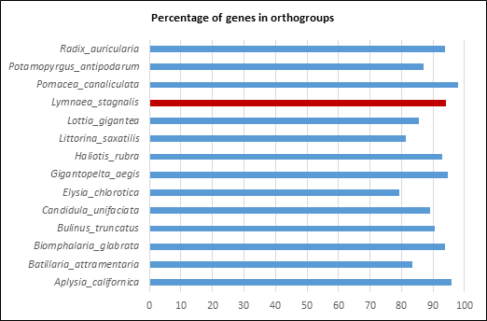
Figure 4. Percentage of genes per species attributed to an OG (orthology at gastropod level).

FMRFamide-R-like receptor distribution

CD-search produced 483 L. stagnalis gene predictions with a 7tmA_FMRFamide_R-like domain (405 of them with a complete domain, 37 incomplete in N terminal, 41 in C terminal and 1 in both N and C terminals). In the gastropod-level orthology analysis, these genes were distributed in 89 orthogroups, which contained in total 2596 genes (2564 excluding Radix auricularia genes). The contribution of each species to these 89 orthogroups was used to compare the abundance of this GPCR category in simultaneous hermaphrodites and other gastropods, in link with the hypothesis of FMRFamideR expansion in the former (Fig. 5). In this set of OGs, the cumulative abundance of genes from simultaneous hermaphroditic species (per-species mean =329.17, SD = 117.04) was significantly higher than that of genes from gonochoric species (per-species mean = 89.17, SD = 36.88) (Fisher F_{[1,10]} = 22.95 ; p <0.001). Besides, through the unique representative species Lottia gigantea, sequential hermaphrodite genes appeared particularly weakly represented in these OGs (total number = 54 genes).

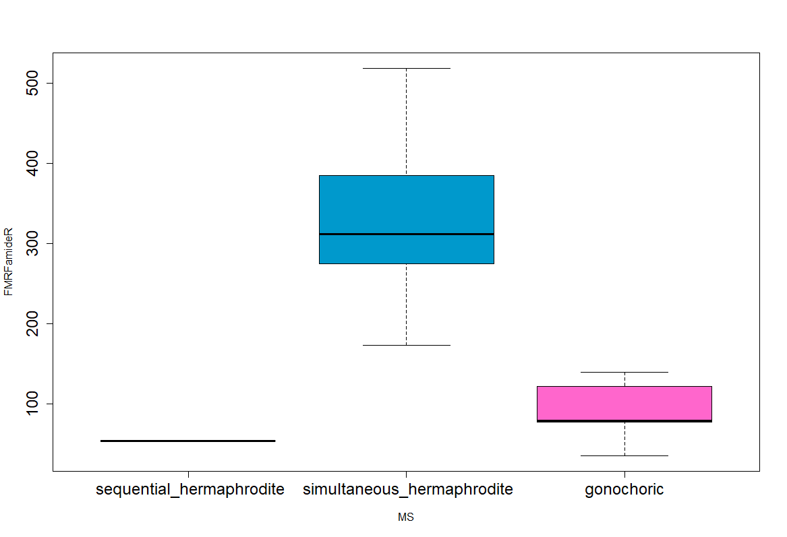
Figure 5. Mean number of FMRFamide-R like genes per species, as a function of their mating system.

Statistics on the mean number of per species genes in FMRFamide OGs

HERMA vs GONO
mean SD n
0 (gono) 89.16667 36.88044 6
1(herma) 289.85714 149.10112 7

mms sdms nms
gonochoric 89.16667 36.88044 6
herma_Seq 54.00000 NA 1
herma_Sim 329.16667 117.03575 6

> h<-lm(FMRFamideR~herma, data=fmrf)
Coefficients: (Intercept) herma
89.17 200.69

> ah<-anova(h, test="F")
Response: FMRFamideR
Df Sum Sq Mean Sq F value Pr(>F)
herma 1 130125 130125 10.21 0.008525 **
Residuals 11 140188 12744

HERMASIM vs GONO (excluding L. gigantea)
> lms<-lm(FMRFamideR~MS, data=sub)
Coefficients: (Intercept) MSherma_Si
89.17 240.00

> alms<-anova(lms,test="F")
Response: FMRFamideR
Df Sum Sq Mean Sq F value Pr(>F)
MS 1 172800 172800 22.952 0.0007337 ***
Residuals 10 75288 7529

