Supplementary information 1:
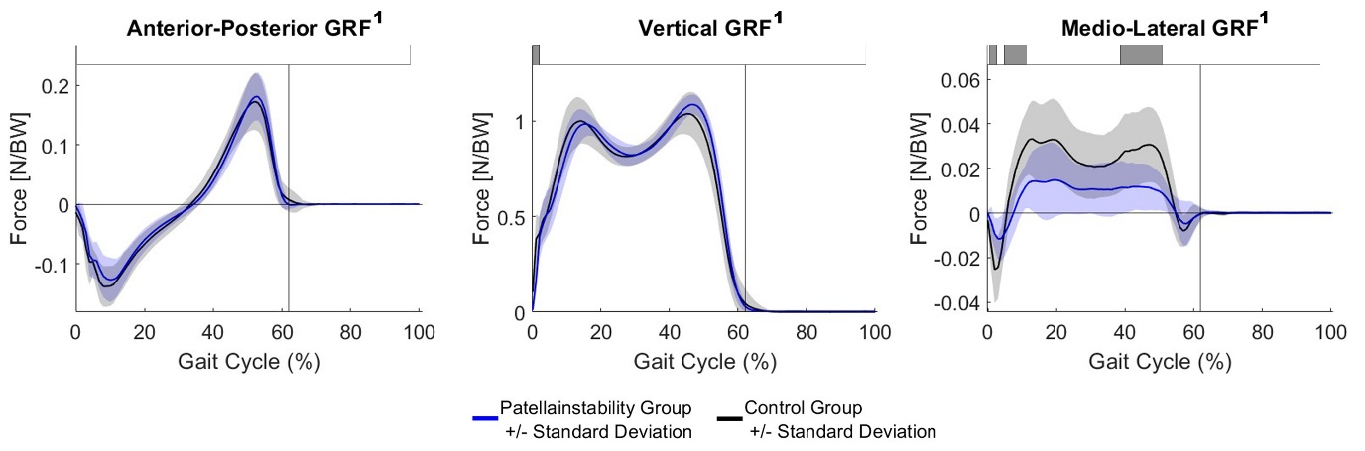
Ground reaction forces (GRF). The blue and black line represent the mean and one SD for the PFI and the control group, respectively. Horizontal grey bars at the top represent significant differences identified via statistical parametric mapping (SPM) between both groups. A superscript 1 beside the title symbols non-parametric waveform distribution and therefore use of non-parametric version of SPM. BW = body weight

