Supplemental Material to:
Title: Effect of ultrasound-guided individualized Positive end-expiratory pressure on the severity of postoperative atelectasis in elderly patients: a randomized controlled study

Authors: Junyang Ma, MD,^{1, 3} Meiqi Sun, MD,² Fengxiang Song, MD,¹ Aiqi wang, MD,¹Xiaoxia Tian, MD,¹ Yanan Wu, MD,¹ Lu Wang, MD,¹ Qian Zhao, MD,¹ Bin Liu, MD,¹ Shengfu Wang MD,¹Yuxue Qiu, MD,¹ Haitao Hou, MD,¹ Liqin Deng, MD, PHD^{1,*}

Addresses:
¹ Department of Anesthesiology and Perioperative Medicine, General Hospital of Ningxia Medicine University, No. 804 Shengli Street, Xingqing District, 750004 Yinchuan, China
²School of Clinical Medicine, Ningxia Medical University, 692 Shengli Street, Xingqing Area, Yinchuan City, 750004, Ningxia Hui Autonomous Region, China
³ Department of Anesthesiology, Maternal and Child Health Hospital of Hubei Province, No.745 Wuluo Street, Hongshan District, 430070, Wuhan, China

Supplemental material and methods
Anesthesia
Anesthesia induction involved preoxygenation with 100% oxygen for 3 minutes, followed by sequential administration of midazolam 0.02 - 0.03 mg/kg, sufentanil 0.3 - 0.5 μg/kg, etomidate 0.15 - 0.3 mg/kg, and rocuronium bromide 0.6 mg/kg for general anesthesia induction. After 3 minutes, endotracheal intubation was performed for mechanical ventilation. Anesthesia maintenance included continuous intravenous infusion of remifentanil 0.05 - 0.2 μg·kg⁻¹·min⁻¹, propofol 4 - 6 mg·k^{g-1}·h⁻¹, and targeting a BIS level between 40 and 60. Anesthesia maintenance drugs were discontinued at the end of the procedure. Postoperative analgesia involved ultrasound-guided bilateral transversus abdominis plane block (0.25% ropivacaine 40 mL) following endotracheal intubation. Patient-controlled intravenous analgesia (PCIA) with sufentanil (1–1.5 μg/kg + 100 mL 0.9% NS) and Parecoxib Sodium for Injection (40 mg) was administered postoperatively. Before anesthesia induction, radial artery catheterization is used for continuous monitoring of arterial blood pressure, with the arterial line connected to a Philips monitor, model MX550). Perioperative monitoring included invasive arterial blood pressure, non-invasive blood pressure monitoring, body temperature, pulse oximetry, electrocardiogram (Philips, model MX550), and BIS. Neuromuscular blockade was evaluated through train-of-four monitoring, and at the end of the procedure, sugammadex was administered to reverse the effects of rocuronium. The dosage and timing of administration were based on the results of muscle twitch response monitoring and the degree of spontaneous recovery. All patients received crystalloid infusion, with decisions made by anesthesia providers not involved in the study.
Intraoperative ventilation
All patients were subjected to volume-controlled ventilation (VCV) with a tidal volume (V_{T}) of 6-8 mL/kg of predicted body weight (PBW), inspired oxygen tension (FiO₂) of 0.4 or higher is maintained to keep oxygen saturation above 94%, respiratory rate starting at 12 bpm, aiming to maintain P_{ET}CO₂ between 35 and 45 mmHg, I:E ratio of 1:2, and flow rate of 2 L/min. Following surgery, patients were transferred to the Post-Anesthesia Care Unit (PACU) and administered oxygen via nasal cannula with at a flow rate of 2 liters per minute. In both groups, Trendelenburg position was employed during laparoscopic surgery, and the intra-abdominal CO₂ insufflation pressure was set at 12 mmHg.

Plasma Lung Injury Biomarkers
Blood samples were collected in EDTA anticoagulant tubes before induction of anaesthesia (T0), 10 min after entering the PACU (T7), on the first day postoperatively (D1), on the third day postoperatively (D3), and on the seventh day postoperatively (D7). The samples were centrifuged to obtain plasma, which was then stored at -80°C. A blinded researcher conducted ELISA testing on plasma samples using kits from Shanghai Jianglai Biotechnology. The tested biomarkers included interleukin IL-1 (Human IL-1 ELISA Kit, detection range 31.2 - 2000 pg/mL), IL-6 (Human IL-6 ELISA Kit, detection range 3.12 - 200 pg/mL), IL-10 (Human IL-10 ELISA Kit, detection range 0.78 – 50 pg/mL), Clara cell protein as an epithelial injury biomarker (Human CC16 ELISA Kit, detection range 1.56 - 100 pg/mL), and fibroblast growth factor 21 as a protective factor for lung injury (Human FGF21 ELISA Kit, detection range 1.56 - 100 pg/mL). Absolute biomarker levels and ratios relative to baseline (T7/T0, D1/T0, D3/T0, D7/T0) were calculated.

Outcomes （Definitions）
Secondary outcomes:
- Incidence of postoperative hypoxemia (SpO₂ of 90% or less; or any decline in SpO₂ greater than 5% if SpO₂ was previously less than 92%¹)
- PPCs within 7 days postoperatively (mainly including atelectasis, respiratory failure, bronchospasm, aspiration pneumonitis, pneumothorax, pleural effusion and respiratory infection; diagnostic criteria are provided in the supplementary materials).²
Respiratory infection, Bronchospasm, Aspiration pneumonitis are defined based on previous research.³ Include:
Respiratory infection: Antibiotics for suspected infection with one or more of the following: new or changed sputum, new or changed lung opacities, fever, white blood cell count >12 × 10⁹ litre⁻¹)
Bronchospasm: Newly detected expiratory wheeze treated with bronchodilators),
Aspiration pneumonitis: Acute lung injury after inhalation of regurgitated gastric contents
Respiratory failure: As our patients were elderly, the mean preoperative oxygenation index was 324.6 ± 29.9. Therefore, we defined postoperative respiratory failure as Postoperative PaO2: FiO2 ratio < 200 mmHg).
Atelectasis, pleural effusion, and pneumothorax: We employ ultrasound to assess atelectasis, pleural effusion, and pneumothorax.
Atelectasis (Defined as lung ultrasound score at least 2 in any of the 12 regions).
pleural effusion (Ultrasound directly images pleural fluid, which presents as anechoic fluid in the posterior dependent lung).
Pneumothorax (Typical signs of pneumothorax include absent lung sliding, the presence of a lung point, the seashore sign, and bar code sign).
- Recordings of perioperative arterial blood gas parameters, intraoperative respiratory mechanics, and hemodynamic parameters within 7 days postoperatively, including peak airway pressure (P_{peak}), plateau pressure (P_{plat}), driving pressure (ΔP), static respiratory system compliance (C_{rs}), and mechanical power (MP).
- Plasma concentrations of pulmonary injury biomarkers during the perioperative period: IL-1, IL-6, IL-10, CC16, and FGF21.
Calculations:
Driving pressure (ΔP): The ΔP is calculated as the plateau pressure minus PEEP, or $ΔP=P_{plat}-PEEP$;
Respiratory system static compliance (Crs): The Crs is calculated as the tidal volume (V_{T}) divided by the driving pressure (ΔP), or
$$C_{rs}=\frac{V_{T}}{\left(P_{plat}-PEEP\right)}=\frac{V_{T}}{ΔP};$$
Mechanical power (MP) is calculated based on formulas proposed in previous literature.⁴
$$MP=0.098×RR×V_{T}×\left[P_{peak}-\frac{1}{2}\left(P_{plat}-PEEP\right)\right]$$
pulmonary embolism (The patient presented with clinical signs suggestive of pulmonary embolism, and the CT scan indicated pulmonary embolism).

Supplementary figure 6. Plasma concentration ratios of lung injury biomarkers are shown, including markers of epithelial injury and lung protective factors (Clara cell protein 16 [CC16] and Fibroblast growth factor 21 [FGF21]) (a-h), as well as inflammatory and anti-inflammatory factors (IL-1, IL-6, IL-10) (i-t). In the box plots: The boxes represent the median (Q1, Q3) and interquartile range. The whiskers indicate the minimum and maximum. Solid points (blue and black) represent individual data points. Data between the two groups were analyzed using non-parametric tests, and differences were considered to be statistically significant if P<0.05. For details, refer to the supplementary table 7 below.

Exploratory analysis (Correlations between Lung Mechanics and PaO₂/FiO₂ Ratio
)
We observed a significant correlation between ΔP (T4) during pneumoperitoneum and Trendelenburg position in the individualized PEEP group and PaO₂/FiO₂ (T4, T6, D1) (PEEP Ind: T4: R = 0.347, P < 0.05; T6: R = 0.496, P < 0.005; D1: R = 0.352, P < 0.05). There was also a significant correlation between Crs (T4) and PaO₂/FiO₂ (T4, T6, D1) (PEEP Ind: T4: R = 0.345, P < 0.05; T6: R = 0.472, P < 0.005; D1: R = 0.331, P < 0.05) in the same group. Additionally, ΔP showed a significant correlation with Crs in both groups (PEEP Ind: T4: R = 0.854, P < 0.001; PEEP 5: T4: R = 0.900, P < 0.001). On the first postoperative day, LUSS was correlated with pulse oxygen saturation (SpO₂) (PEEP Ind: D1: R = 0.480, P < 0.005; PEEP 5: D1: R = 0.410, P < 0.05) (supplementary figure 7).
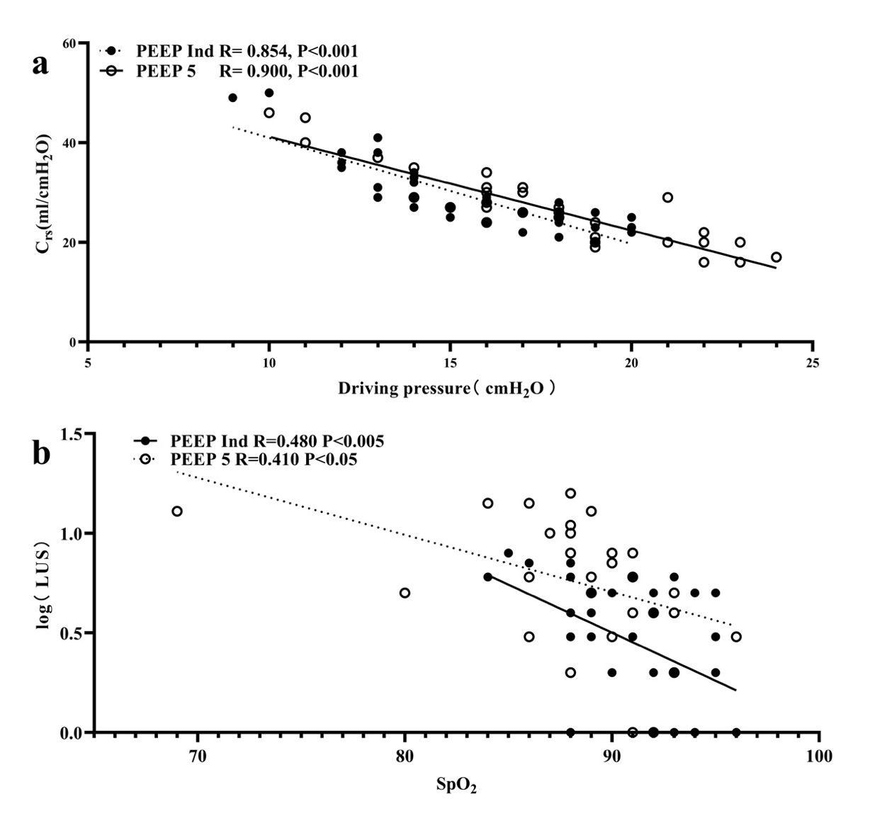
Supplementary figure7. Figure a represents the correlation between driving pressure and dynamic compliance at the T4 time point. Figure b illustrates the correlation between log-transformed lung ultrasound score (LUSS) on the first postoperative day and pulse oxygen saturation. Solid circles represent the individualized positive end-expiratory pressure group (PEEP Ind), while hollow circles represent the fixed positive end-expiratory pressure group (PEEP 5). Differences were considered to be statistically significant if P<0.05.

Supplementary table 2. Modified Lung Ultrasound Score
 | normal aeration | moderate loss of aeration | severe loss of aeration | complete loss of aeration
 | 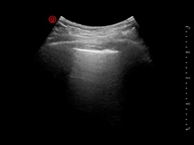 | 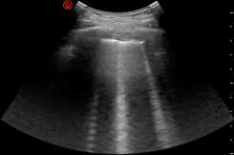 | 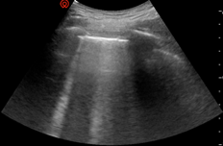 | 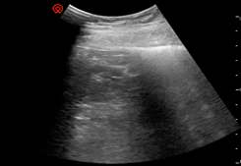
score | 0 | 1 | 2 | 3
 | A lines – max 2 B lines | Artefacts occupying ≤ 50 % of the pleura | Artefacts1 occupying > 50 % of the pleura | tissue-like pattern

Supplementary table 3. Secondary Outcomes
 | Individualized PEEP group (n = 37) | Fixed PEEP group (n = 36) | Relative risk (95% CI) | P value
Postoperative pulmonary complications（PPCs） | 18 (48.6) | 28 (77.8) | 0.625 (0.430-0.909) | 0.01^{d}
Components of PPCs
Respiratory infection | 1 (2.7) | 0 (0) | - | ＞0.99e
Atelectasisª | 15 (40.5) | 27 (75) | 0.541 (0.350-0.834) | 0.003^{d}
Respiratory failure^{b} | 1(2.7) | 2(5.6) | 0.486 (0.046-5.133) | 0.615e
Pneumothorax | 0 (0) | 0 (0) | - | -
Bronchospasm | 0 (0) | 0 (0) | - | -
Aspiration pneumonitis | 0 (0) | 0 (0) | - | -
Pleural effusion | 3 (8.1) | 6 (16.7) | 0.486 (0.132-1.799) | 0.308^{d}
Other secondary Outcomes
Hypoxemia^{c} | 17 (45.9) | 23 (63.9) | 0.719 (0.469-1.102) | 0.124^{d}
pulmonary embolism | 2 (5.4) | 2 (5.6) | 0.973 (0.145-6.541) | ＞0.99
Hospital stay, d | 7 [6, 10] | 7 [6, 13.9] | - | 0.278
ªDefined as lung ultrasound score at least 2 in any of the 12 regions. ^{b}Defined as Postoperative PaO2: FiO₂ ratio < 200 mmHg. ^{c}Defined as as SpO₂ of 90% or less; or any decline in SpO2 greater than 5% if SpO2 was previously less than 92%. Statistical tests used: ^{d}X² test; ^{e}Fisher exact test. Differences were considered to be statistically significant if P<0.05.

Supplementary table 4. Lung Ultrasound Score during Surgery and after Surgery
 | Before Induction of Anesthesia(T0) | 10 min after Application of pneumoperitoneum and Trendelenburg position(T2) | 10 min after Application of PEEP(T3) | 10 min after entering the PACU (T7) | 1 day after Surgery（D1） | 3 days after Surgery（D3）
PEEP Ind | 5 | 8[6-11] | 4[3-5] | 5[3-7] | 4[1-5] | 2[0-4]
PEEP 5 | 5 | 8[5-10] | 7[4-8] | 8[6-10] | 6[4-10] | 4[1-5]
P value | / | 0.401 | 0.005 | 0.001 | 0.001 | 0.028
Data are shown as median [interquartile range(range)]. P value <0.05 was considered statistically significant.

Supplementary table 5. Respiratory Parameters and Hemodynamic Data during Mechanical Ventilation
 |  | Before Induction of Anesthesia(T0) | 10 min after Application of Mechanical ventilation(T1) | 10 min after Application of pneumoperitoneum and Trendelenburg position(T2) | 10 min after Application of PEEP(T3) | 1 hour after Application of PEEP (T4) | 10 min after the end of pneumoperitoneum and Trendelenburg position (T5) | 10 min before extubation (T6) | 10 min after entering the PACU (T7) | P Value
 |  |  |  |  |  |  |  |  |  | Time | Group | Interaction
Mean arteria blood pressure（mmHg）
 | PEEP Ind | 96.6±9.3 | 82.3±11.6 | 87.1±8.4 | 86.8±7.2 | 87.5±8.5 | 82.7±8.3 | 84.2±8.4 |  | <0.005 | 0.102 | 0.528
 | PEEP 5 | 98.8±9.0 | 83.7±13.1 | 89.1±10.2 | 90.7±10.4 | 88.0±9.3 | 85.9±9.0 | 87.3±10.7
Tidal volume (ml)
 | PEEP Ind | / | 432.8±43.6 | 432.8±43.6 | 432.6±43.6 | 436.2±44.4 | 437.3±43.1 | 437.3±43.1 |  | 0.252 | 0.290 | 0.264
 | PEEP 5 | / | 445.4±53.6 | 446.6±51.7 | 447.4±54.6 | 447.2±54.0 | 447.4±54.6 | 447.7±54.7
Respiratory rate(/min)
 | PEEP Ind | / | 13±1 | 13±1 | 13±1 | 14±2 | 14±2 | 14±2 |  | <0.001 | 0.213 | 0.326
 | PEEP 5 |  | 12±1 | 12±1 | 13±1 | 14±1 | 14±1 | 14±1
Peak pressure (cmH₂O)
 | PEEP Ind | / | 12.3±2.1 | 19.7±3.8‡ | 25.0±3.8‡ | 25.2±3.9‡ | 16.1±3.4‡ | 16.0±3.3‡ |  | <0.001 | 0.792 | 0.005
 | PEEP 5 | / | 12.9±2.9 | 20.4±3.7† | 23.9±3.4† | 24.3±3.3† | 17.0±2.3† | 16.8±2.6†
Plateau pressure (cmH₂O)
 | PEEP Ind | / | 11.9±2.3 | 19.0±3.7‡ | 23.8±3.5‡ | 24.2±3.6‡ | 15.3±3.1‡ | 15.1±3.0‡ |  | <0.001 | 0.751 | 0.003
 | PEEP 5 | / | 12.0±2.8 | 19.4±3.7† | 22.4±3.6† | 22.8±3.6† | 15.8±2.7† | 15.6±2.8†
Driving pressure (cmH₂O)
 | PEEP Ind | / | 11.9±2.3 | 19.0±3.7‡ | 14.9±2.6*‡ | 15.4±2.9*‡ | 9.4±2.6*‡ | 9.3±2.6*‡ |  | <0.001 | 0.03 | 0.002
 | PEEP 5 | / | 12.0±2.8 | 19.4±3.7† | 17.4±3.6† | 17.8±3.6† | 10.8±2.7† | 10.6±2.8†
Static compliance（ml/ cmH₂O）
 | PEEP Ind | / | 37.9±8.8 | 23.5±4.3‡ | 30.2±6.8‡ | 29.5±7.1*‡ | 50.3±16.0*‡ | 50.7±15.7*‡ |  | <0.001 | 0.243 | 0.013
 | PEEP 5 | / | 39.4±10.9 | 24.1±5.9† | 27.4±8.5† | 26.6±7.5† | 44.5±13.9† | 45.7±16.0†
Mechanical power(J/min)
 | PEEP Ind | / | 3.3±0.7 | 5.7±1.4 | 10.1±2.5 | 10.7±2.4 | 7.1±2.2 | 6.9±2.2 |  | <0.001 | 0.293 | <0.001
 | PEEP 5 | / | 3.7±0.9 | 6.0±1.3 | 8.9±1.5 | 9.1±1.4 | 7.0±1.5 | 7.0±1.7
P_{ET}CO₂ (mmHg)
 | PEEP Ind | / | 33±3 | 33±3 | 33±3 | 35±3 | 34±4 | 33±4 |  | <0.001 | 0.977 | 0.153
 | PEEP 5 | / | 32±3 | 33±3 | 34±4 | 34±3 | 34±4 | 34±4
SPO₂ (%)
 | PEEP Ind | 95[94-96] | 99 [98-100] | 99 [98-100] | 99 [98-100] | 99 [98-100] | 99 [98-100] | 99 [98-100]
 | PEEP 5 | 96[93-97] | 99 [98-100] | 99 [98-100] | 99 [98-100] | 99 [98-100] | 99 [98-100] | 99 [98-100]
PEEP (cmH₂O)
 | PEEP Ind | / | 0 [0-0] | 0 [0-0] | 9 [7-11]*‡ | 9 [7-11]*‡ | 6 [5-7]*‡ | 6 [5-7]*‡
 | PEEP 5 | / | 0 [0-0] | 0 [0-0] | 5[5-5] | 5[5-5] | 5[5-5] | 5[5-5]
Data are shown as mean±SD, median [interquartile range], P value <0.05 was considered statistically significant. *P < 0.05 versus positive end-expiratory pressure (PEEP) 5 cmH₂O. †P < 0.05 versus 10 min after application of mechanical ventilation in PEEP 5 cmH₂O. ‡P < 0.05 versus 10 min after application of mechanical ventilation in PEEP individualized. LUSS, lung ultrasound score system. P_{ET}CO₂, end-tidal partial pressure of carbon dioxide. PaCO₂, partial pressure of carbon dioxide.

Supplementary table 6. Arterial Blood Gas Parameters during Surgery and after Surgery
 |  | Before Induction of Anesthesia(T0) | 1 hour after Application of PEEP (T4) | 10 min before extubation (T6) | 10 min after entering the PACU (T7) | 1 day after Surgery | 3 days after Surgery | P Value
PaCO₂ (mmHg) |  |  |  |  |  |  |  | Time | Group | Interaction
 | PEEP Ind | 39.3±4.2 | 42.8±5.7 | 40.7±5.9 | 40.5±4.6 | 38.0±3.5 | 37.2±5.6 | 0.009 | 0.076 | 0.433
 | PEEP 5 | 39.3±3.0 | 43.8±5.0 | 42.6±3.9 | 41.0±4.4 | 41.3±5.1 | 38.3±9.1
PaO₂/FiO₂
 | PEEP Ind | 324.6±29.9 | 262.1±61.1^ | 267.2±69.7^ | 287.9±48.6*^ | 274.7±29.2*^ | 294.9±27.6*^ | <0.001 | 0.017 | 0.015
 | PEEP 5 | 323.8±36.5 | 255.8±68.1^^ | 240.6±58.8^^ | 259.9±63.0^^ | 256.7±27.1^^ | 272.8±29.4^^
Data are shown as mean ± SD, *P < 0.05 versus positive end-expiratory pressure (PEEP) 5 cmH₂O, ^P < 0.05 versus before induction of anesthesia in PEEP individualized. ^^P < 0.05 versus before induction of anesthesia in PEEP 5 cmH₂O; Ind, Individualized.

Supplementary table 7. Plasma concentrations of biomarkers of lung injury.
 | Individualized PEEP group (n = 37) | Fixed PEEP group (n = 36) | P value
Epithelial injury
CC16
T₀ concentration, ng/mL | 2.61 [2.34, 2.87] | 2.87 [2.39, 4.57] | 0.116
T₇ concentration, ng/mL | 2.6 [2.41, 3.0] | 4.42 [3.06, 8.02] | 0.013
D₁ concentration, ng/mL | 2.97 [2.46, 5.64] | 3.22 [2.85, 4.48] | 0.267
D₃ concentration, ng/mL | 2.61 [2.34, 5.13] | 2.90 [2.38, 4.70] | 0.436
D₇ concentration, ng/mL | 2.64 [2.23, 3.53] | 2.92 [2.57, 5.32] | 0.172
T₇/T₀ | 1.04 [0.99, 1.28] | 1.51 [1.01, 1.77] | 0.037
D₁/T₀ | 1.18 [1.04, 1.8] | 1.19 [0.94, 1.36] | 0.389
D₃/T₀ | 1 [0.93, 1.72] | 0.92 [0.82, 1.04] | 0.074
D₇/T₀ | 1.03 [0.97, 1.07] | 1.03 [0.95, 1.26] | 0.775
Protect
FGF21
T₀ concentration, ng/mL | 5.41 [4.33, 7.92] | 7.88 [5.0, 13.4] | 0.267
T₇ concentration, ng/mL | 5.61 [4.83, 11.89] | 11.47 [6.28, 14.6] | 0.267
D₁ concentration, ng/mL | 10.7 [5.88, 20.32] | 12.87 [11.51, 17.72] | 0.305
D₃ concentration, ng/mL | 8.15 [7.12, 9.67] | 10.77 [6.15, 15.83] | 0.187
D₇ concentration, ng/mL | 7.2 [5.35, 9.92] | 9.6 [7.63, 17.0] | 0.081
T₇/T₀ | 1.05 [0.85, 1.48] | 1.34 [0.98, 1.61] | 0.486
D₁/T₀ | 1.62 [1.17, 2.67] | 1.65 [1.35, 2.58] | 0.806
D₃/T₀ | 1.37 [1.15, 1.68] | 1.14 [0.85, 1.90] | 0.512
D₇/T₀ | 1.14 [0.93, 1.46] | 1.29 [1.06, 1.75] | 0.512
Inflammation
IL-1
T₀ concentration, ng/mL | 97.76 [60.88, 117.34] | 92.54 [55.06, 111.68] | 0.653
T₇ concentration, ng/mL | 95.58 [56.6, 119.64] | 89.44 [60.3, 119.16] | 0.683
D₁ concentration, ng/mL | 43.16 [36.02, 45.26] | 45.0 [41.2, 47.96] | 0.074
D₃ concentration, ng/mL | 38.3 [33.82, 41.52] | 40.64 [36.14, 43.86] | 0.250
D₇ concentration, ng/mL | 42.8 [40.74, 57.78] | 43.9 [41.84, 57.92] | 0.806
T₇/T₀ | 1.03 [0.93, 1.1] | 0.97 [0.86, 1.1] | 0.624
D₁/T₀ | 0.4 [0.32, 0.71] | 0.48 [0.37, 0.77] | 0.267
D₃/T₀ | 0.38 [0.29, 0.67] | 0.48 [0.36, 0.63] | 0.305
D₇/T₀ | 0.46 [0.37, 0.85] | 0.58 [0.49, 0.71] | 0.187
IL-6
T₀ concentration, ng/mL | 34.88 [14.11, 51.2] | 12.37 [5.46, 31.2] | 0.067
T₇ concentration, ng/mL | 44.2 [20.17, 61.98] | 17.53 [5.88, 32.78] | 0.116
D₁ concentration, ng/mL | 166.77 [65.29, 195.57] | 110.42 [43.69, 143.28] | 0.187
D₃ concentration, ng/mL | 38.26 [20.77, 61.77] | 27.11 [13.82, 56.28] | 0.583
D₇ concentration, ng/mL | 26.54 [5.89, 45.77] | 21.27 [12.45, 35.18] | 0.976
T₇/T₀ | 1.21 [1, 1.32] | 1.07 [0.95, 1.48] | 0.870
D₁/T₀ | 4.19 [3.52, 5.84] | 6.84 [2.61, 14.6] | 0.267
D₃/T₀ | 1.2 [0.88, 1.8] | 2.09 [1.40, 3.47] | 0.029
D₇/T₀ | 1.03 [0.55, 1.53] | 1.53 [1.07, 2.57] | 0.131
IL-10
T₀ concentration, ng/mL | 1.32 [1.24, 1.70] | 1.35 [1.24, 2.07] | 0.683
T₇ concentration, ng/mL | 1.27 [1.05, 6.5] | 2.04 [1.06, 13.66] | 0.436
D₁ concentration, ng/mL | 1.54 [0.99, 10.21] | 1.65 [1.09, 8.34] | 0.838
D₃ concentration, ng/mL | 1.22 [1.17, 2.45] | 2.56 [1.39, 3.75] | 0.033
D₇ concentration, ng/mL | 1.19 [1.07, 1.49] | 1.82 [1.22, 2.94] | 0.026
T₇/T₀ | 1.03 [0.82, 4.37] | 1.25 [0.71, 4.61] | 0.935
D₁/T₀ | 1.05 [0.78, 6.86] | 1.14 [0.67, 3.62] | 0.250
D₃/T₀ | 1.02 [0.87, 1.34] | 1.17 [0.99, 2.69] | 0.267
D₇/T₀ | 0.84 [0.80, 1.25] | 1.04 [0.83, 1.57] | 0.264
Data are shown as median [interquartile range(range)]. P value <0.05 was considered statistically significant.

1 Bluth, T. et al. Effect of Intraoperative High Positive End-Expiratory Pressure (PEEP) With Recruitment Maneuvers vs Low PEEP on Postoperative Pulmonary Complications in Obese Patients: A Randomized Clinical Trial. Jama 321, 2292-2305, doi:10.1001/jama.2019.7505 (2019).
2 Elefterion, B. et al. Intraoperative Mechanical Power and Postoperative Pulmonary Complications in Noncardiothoracic Elective Surgery Patients: A 10-Year Retrospective Cohort Study. Anesthesiology 140, 399-408, doi:10.1097/aln.0000000000004848 (2024).
3 Miskovic, A. & Lumb, A. B. Postoperative pulmonary complications. Br J Anaesth 118, 317-334, doi:10.1093/bja/aex002 (2017).
4 Chiumello, D. et al. Bedside calculation of mechanical power during volume- and pressure-controlled mechanical ventilation. Crit Care 24, 417, doi:10.1186/s13054-020-03116-w (2020).

