Supplementary figures

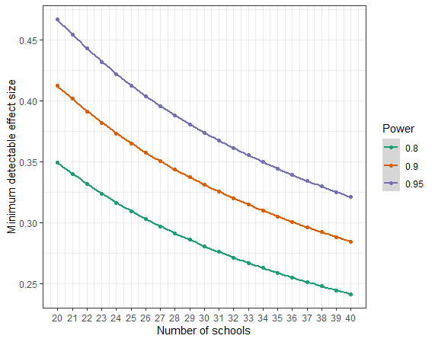
Supplementary Figure S1. Power analysis. The figure shows the minimum detectable effect size across number of schools given three commonly used levels of statistical power (0.8, 0.9, and 0.95).

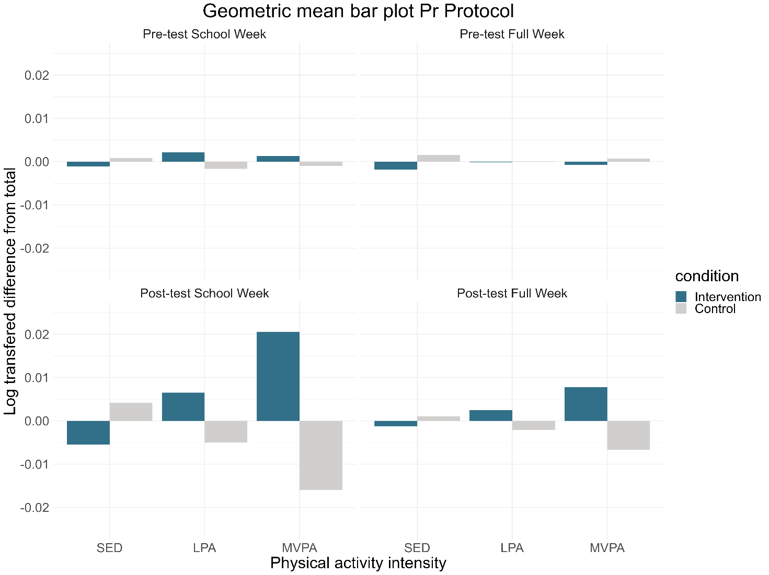

Supplementary Figure S2. Geometric mean bar plot of intensities for intervention and control groups and at pre- and post-test per-protocol.

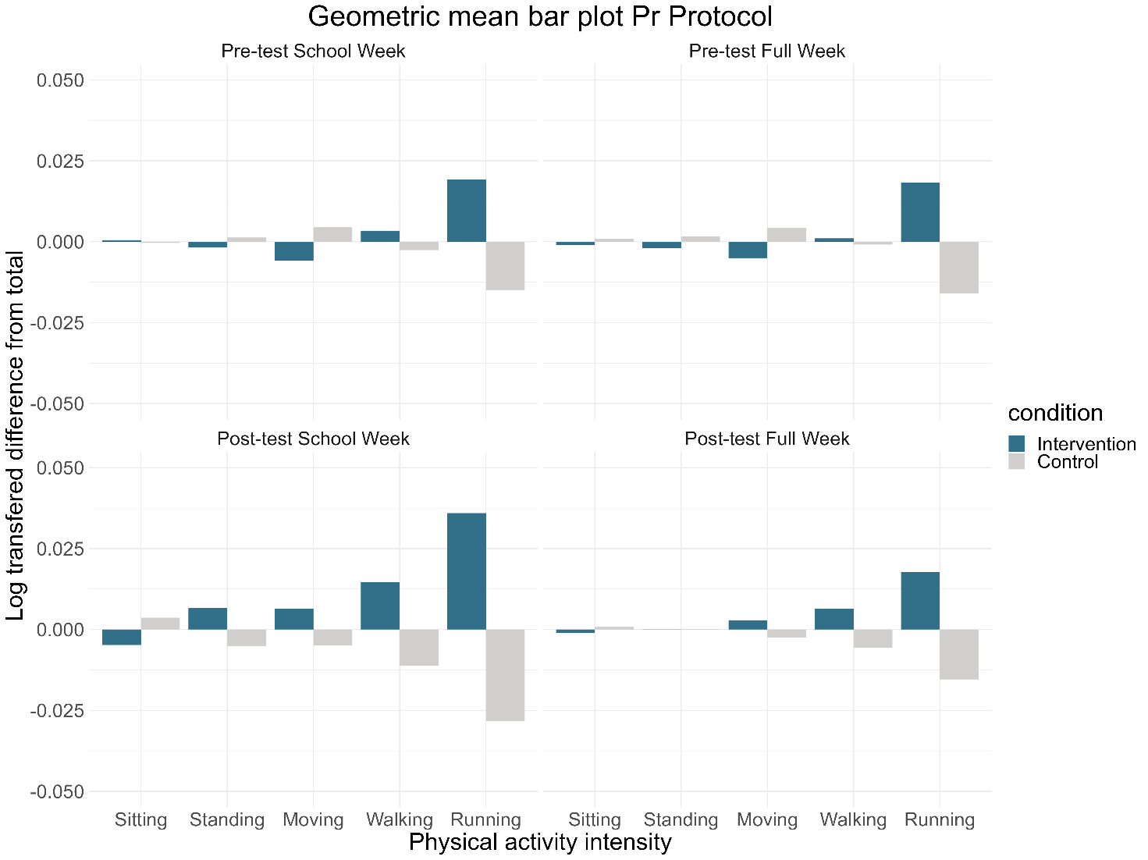

Supplementary Figure S3. Geometric mean bar plot of PA types for intervention and control groups and at pre- and post-test per-protocol.

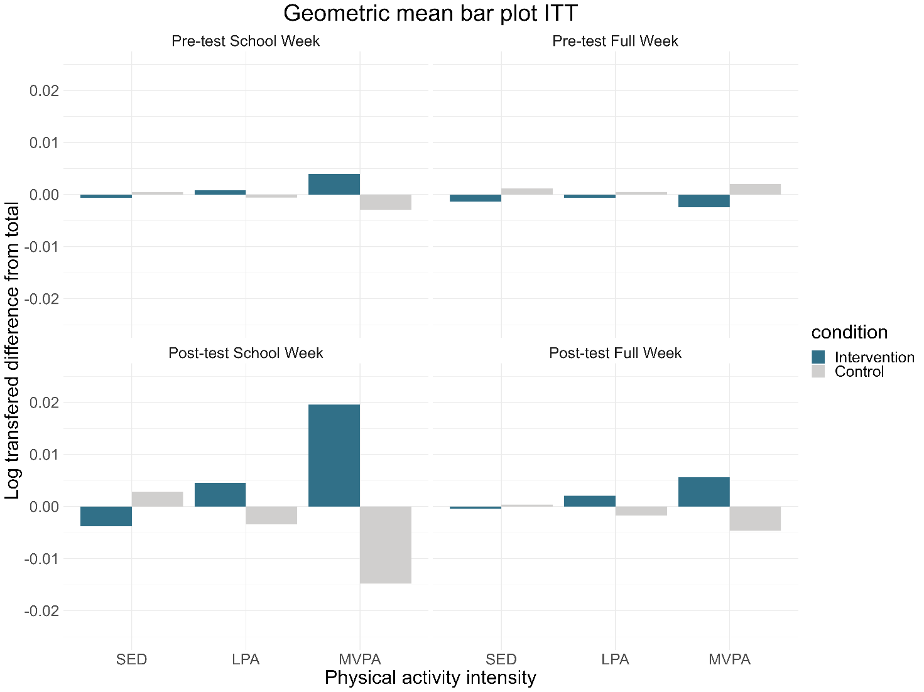

Supplementary Figure S4. Geometric mean bar plot of PA intensities for control and EOtC group at pre- and post-test intention-to-treat.

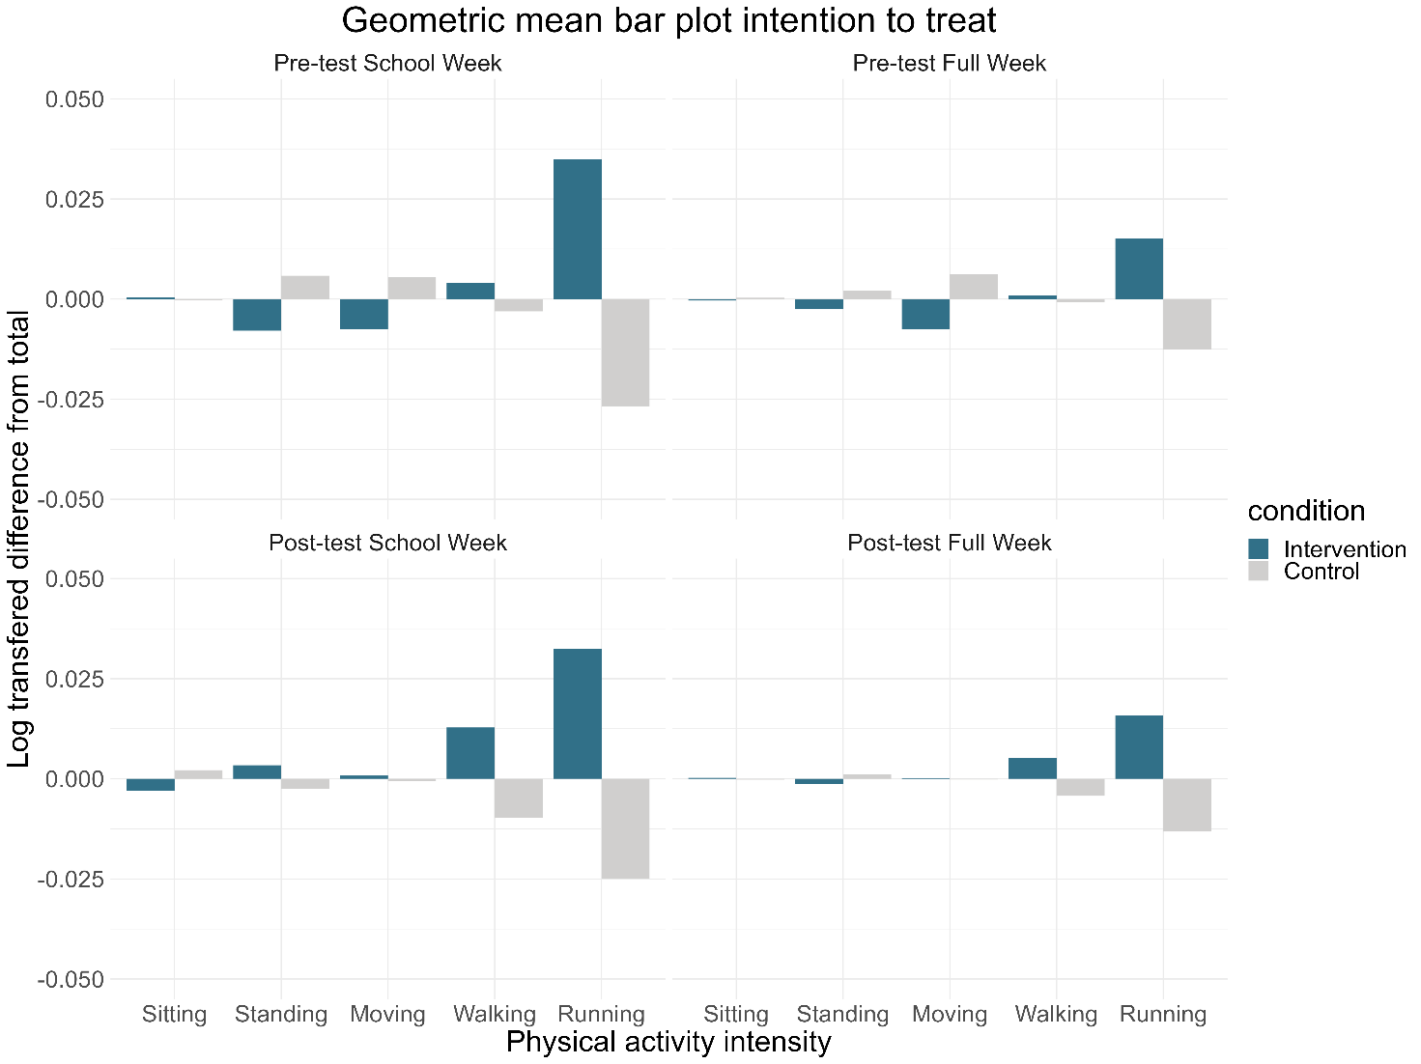
Supplementary Figure S5. Geometric mean bar plot of PA types for control and EOtC group at pre- and post-test intention-to-treat.

Supplementary Figure S6. Log Ratio difference between intervention and control groups during a school week and during a full week intention-to-treat.

