Supplementary Material

Supplementary Tables

Table S1. Participant characteristics
Variable | Mean (SD) | Range
Age | 26.39 (6.84) | 19.00-63.00
AQ Score | 9.34 (4.82) | 1.00-25.00
Attract. Rating | 5.57 (0.76) | 4.00-7.00
 | Level | N (%)
Gender | Male | 29 (46.8)
 | Female | 33 (53.2)
Vision | Not Impaired | 43 (69.4)
 | Glasses | 19 (30.6)
English Level | C1 - C2 | 45 (72.6)
 | B1 - B2 | 14 (22.6)
 | Native Speaker | 3 (4.8)

Table S2. Summary statistics for the average fixation rate on the four AOI’s over all participants
AOI | Mean | SD | Range
Eyes | 1.15 | 0.74 | 0.01 - 3.39
Mouth | 0.67 | 0.65 | 0.01 - 3.00
Face | 0.63 | 0.29 | 0.12 - 1.33
Background | 1.14 | 0.47 | 0.20 - 2.25

Table S3. F-tests (ANOVA) for the linear model (LM) fitted to the average fixation rate
Predictors | Df | Sum Sq | Mean Sq | F | p
AQ | 1 | 0.0001 | 0.0001 | 0.001 | 0.97
AOI | 3 | 4.94 | 1.65 | 17.37 | <0.001
Gender | 1 | 0.16 | 0.16 | 1.70 | 0.19
Attractiveness | 1 | 0.01 | 0.01 | 0.06 | 0.81
AQ:AOI | 3 | 0.80 | 0.27 | 2.81 | 0.04
Residuals | 238 | 22.56 | 0.09 |  | NA
Note. AQ: Autism Spectrum Quotient, AOI: Area of Interest, Attr.: Attractiveness of Interviewer. Significant p values are marked in bold.
Table S4 – Simple slope analysis for the effect of AQ at different levels of AOI
AOI | AQ Slope | SE | DF | LCL | UCL | t | p
Eyes | -0.018 | 0.01 | 238.00 | -0.034 | -0.002 | -2.17 | 0.031
Mouth | 0.014 | 0.01 | 238.00 | -0.003 | 0.030 | 1.65 | 0.100
Face | -0.003 | 0.01 | 238.00 | -0.019 | 0.013 | -0.39 | 0.700
Background | 0.007 | 0.01 | 238.00 | -0.009 | 0.024 | 0.90 | 0.368

Table S5 - F-tests (ANOVA) for the linear mixed model (LMM) fitted to the average fixation rate within questions. DenDF values were approximated using Satterthwaite’s Method.
 | Sum Sq | Mean Sq | NumDF | DenDF | F value | p
AQ | 0.17 | 0.17 | 1.00 | 60.62 | 2.12 | 0.15
Question Type | 0.52 | 0.52 | 1.00 | 653.67 | 6.41 | 0.01
AQ:Question Type | 0.04 | 0.04 | 1.00 | 657.22 | 0.51 | 0.48

Supplementary Methods
Oral instructions for participants:
“We are now going to have a short conversation. Please make yourself comfortable, so you will be able to sit in the same position for the next few minutes. Please try to avoid large movements of your head, small movements like nodding are ok. I will ask you a couple of questions and later on, you will have the opportunity to ask me some questions as well. The idea is to have as relaxed and natural a conversation as possible. If you are ready, I will now start with the first question.”

- Did you sleep well last night?
- Did you dream about anything?
- Have you eaten at a restaurant in the past week?
- Have you been out of the country in the past week?
- Have you read any book in the past week?
6. What was the last movie or TV show that you watched?
- Could you tell me about some things that you did last weekend?
- Can you tell me about your plans for the next weekend?
- What was the most interesting thing that happened to you in the past week?
- When you woke up this morning, were you looking forward to participating in this experiment or was it more of an obligation for you?
- Could you tell me a little bit about your journey to the lab?
- Do you have any questions for me?

Supplementary Results

Model Diagnostics
Model assumptions for the preregistered model (using a square-root transformation of the dependent variable) were checked in the following way: Linearity was verified using plots of residuals versus fitted values which was judged to appear sufficiently random and, thus, indicated no deviation from linearity (see Figure S1).
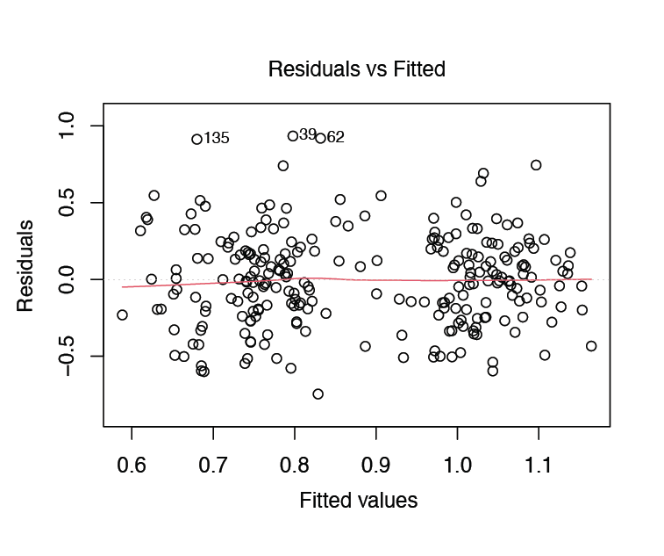
Figure S1 – Residuals versus fitted values for the preregistered linear mixed model described in Section 2.6. Points are clustered as a horizontal band around the zero line. Deviations from linearity would appear as “curved” shapes. Heteroscedasticity could be recognized by points clustering closer to zero for low versus high fitted values (a funnel shape along the x-axis).

Homoscedasticity (homogeneity of variances) was investigated using conditional boxplots (see Figure S2) and a number of homogeneity tests. Variances appear unequal for the different AOIs in boxplots. Levene’s, Brown-Forsythe and Kruskal-Wallis tests confirm this assumption (all ps < .001). However, the ratio of largest to smallest variance over AOI levels was 6.70, which is in the range of the recommended cutoff for unequal variances across groups⁶⁸.

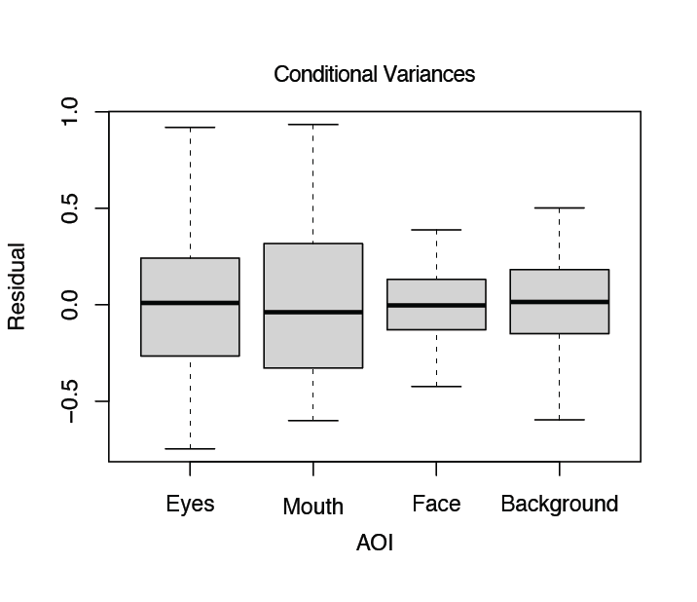
Figure S2 – Conditional boxplots for the variance of residuals in each level of area of interest (AOI). Variances appear slightly unequal for the different levels.

Normality of residuals was investigated using qqPlots, histograms and the Shapiro-Wilk test (W = 0.99, p = .12), all of which indicated no deviation from normal distribution (Figure S3). Importantly, when fitting a model without transformation of the dependent variable, both qqPlots and the Shapiro-Wilk test (W = 0.93, p < .0001) indicated a significant deviation from normal distribution, corroborating the need of a square-root transformation to account for positive skew.
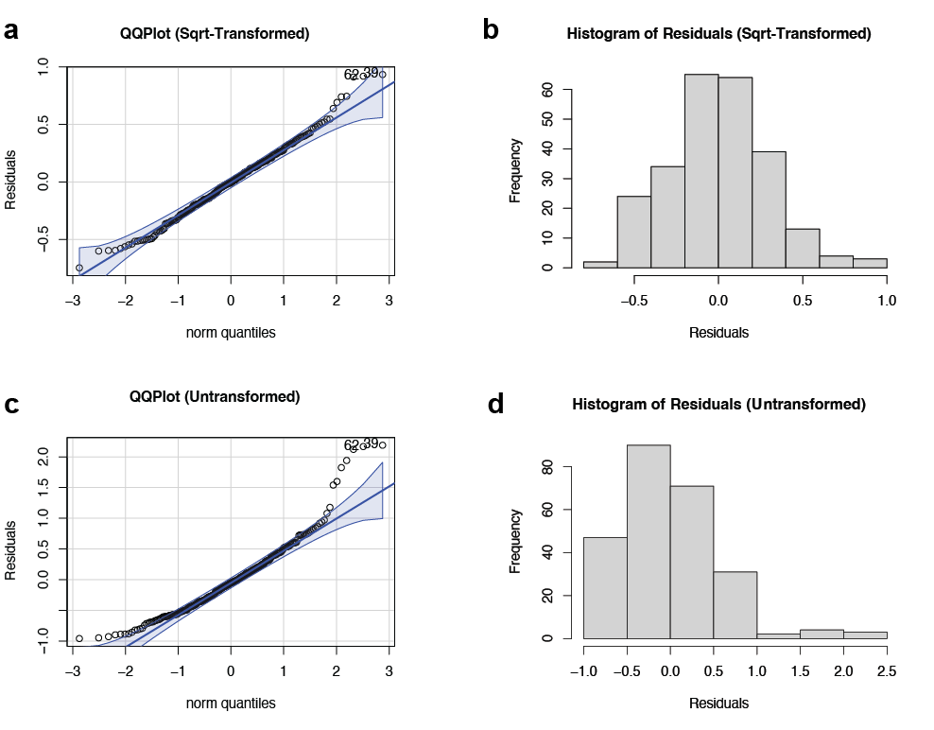
Figure S3 – QQPlots and histograms of the residuals using a square-transformation of the dependent variable (a and b) and the untransformed model (c and d). Residuals deviate from the reference line for the untransformed model (c) and show positive skew in the histogram (d), corroborating the need for a square-root transformation.

