Supplementary Figure 1. (A) Phenotypic distribution of CSH (shoot height under control condition), ASH (shoot height under alkali stress), CRL (root length under control condition), ARL (root length under alkali stress), CRN (root number under control condition), ARN (root number under alkali stress), CSFW (shoot fresh weight under control condition) and ASFW (shoot fresh weight under alkali stress) in the subpopulations Geng/japonica and Xian/indica. Different letters above the boxplot indicate significant differences according to Duncan’s multiple range post-hoc test (P < 0.05). (B) Correlations between the measured AT-related traits in the whole population, in which the numbers in the middle of the cells are the correlation coefficients and * and *** indicate significant difference at P < 0.05 and P < 0.001.
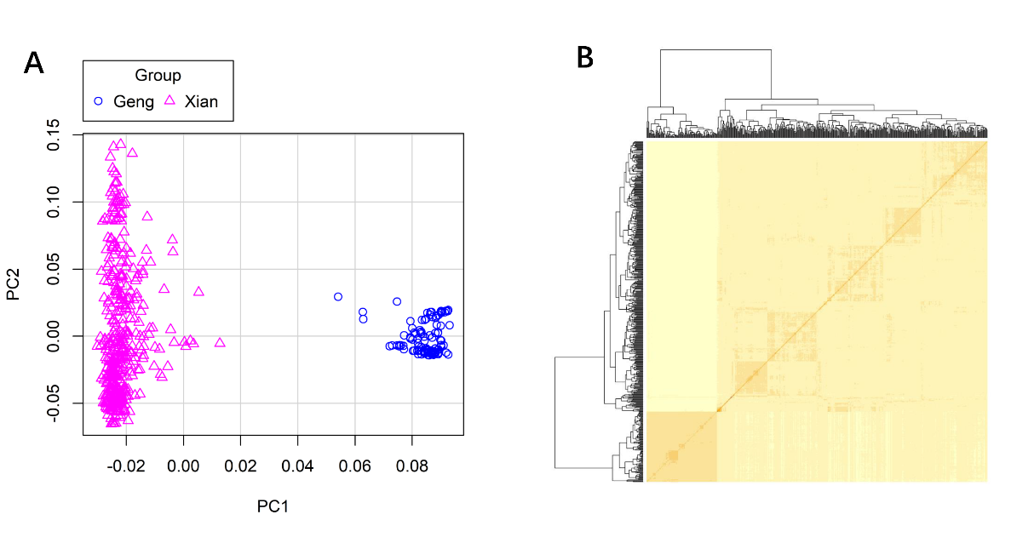
Supplementary Figure 2. Genotypic analysis. (A) PCA plot based on the screen plot in the rice diversity panel. (B) Heat map of kinship with the tree shown on the top and left.
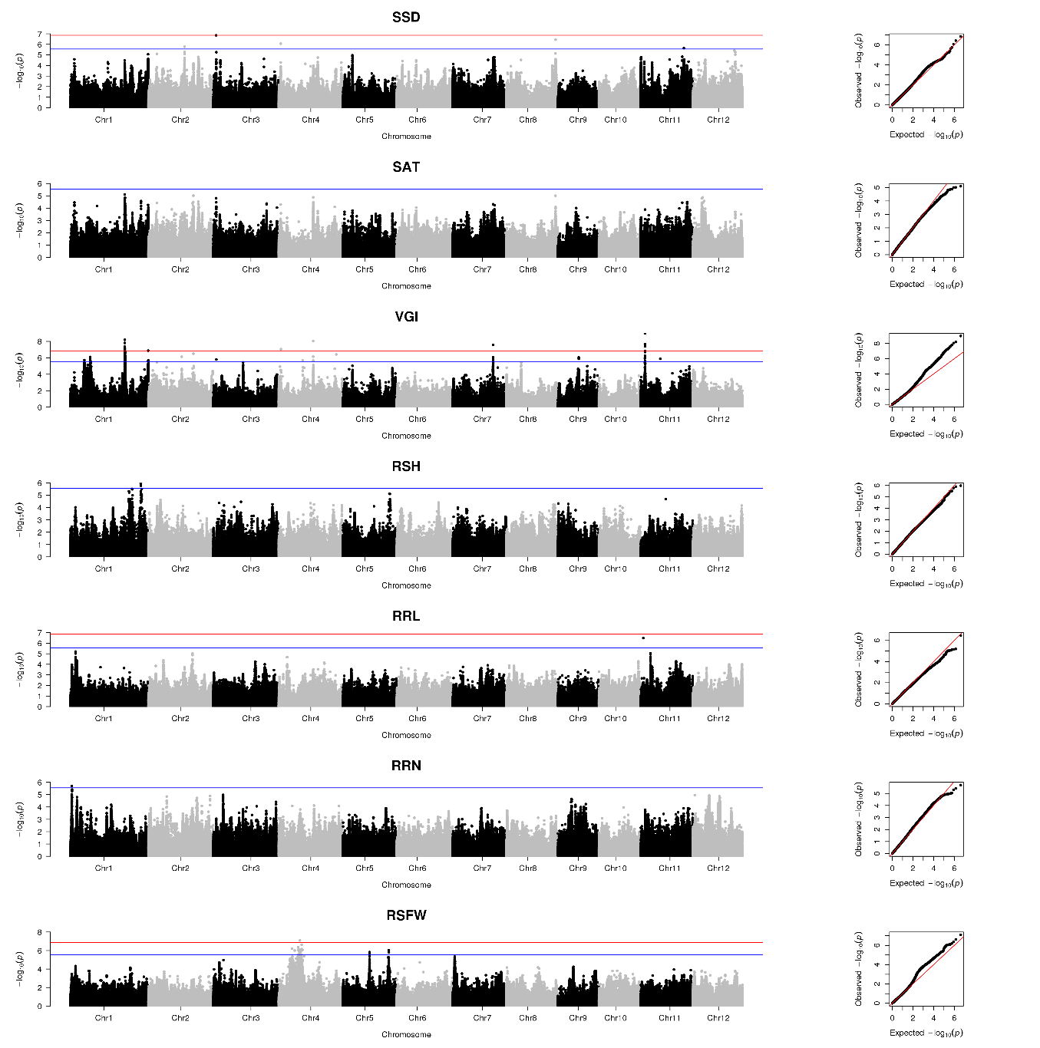
Supplementary Figure 3. GWAS of SSD, SAT, VGI, RSH, RRL, RRN, RSFW in the Xian subpopulation. Manhattan plots (left) and Q-Q plots (right). Blue and red horizontal lines indicate genome-wide suggestive and significant thresholds.
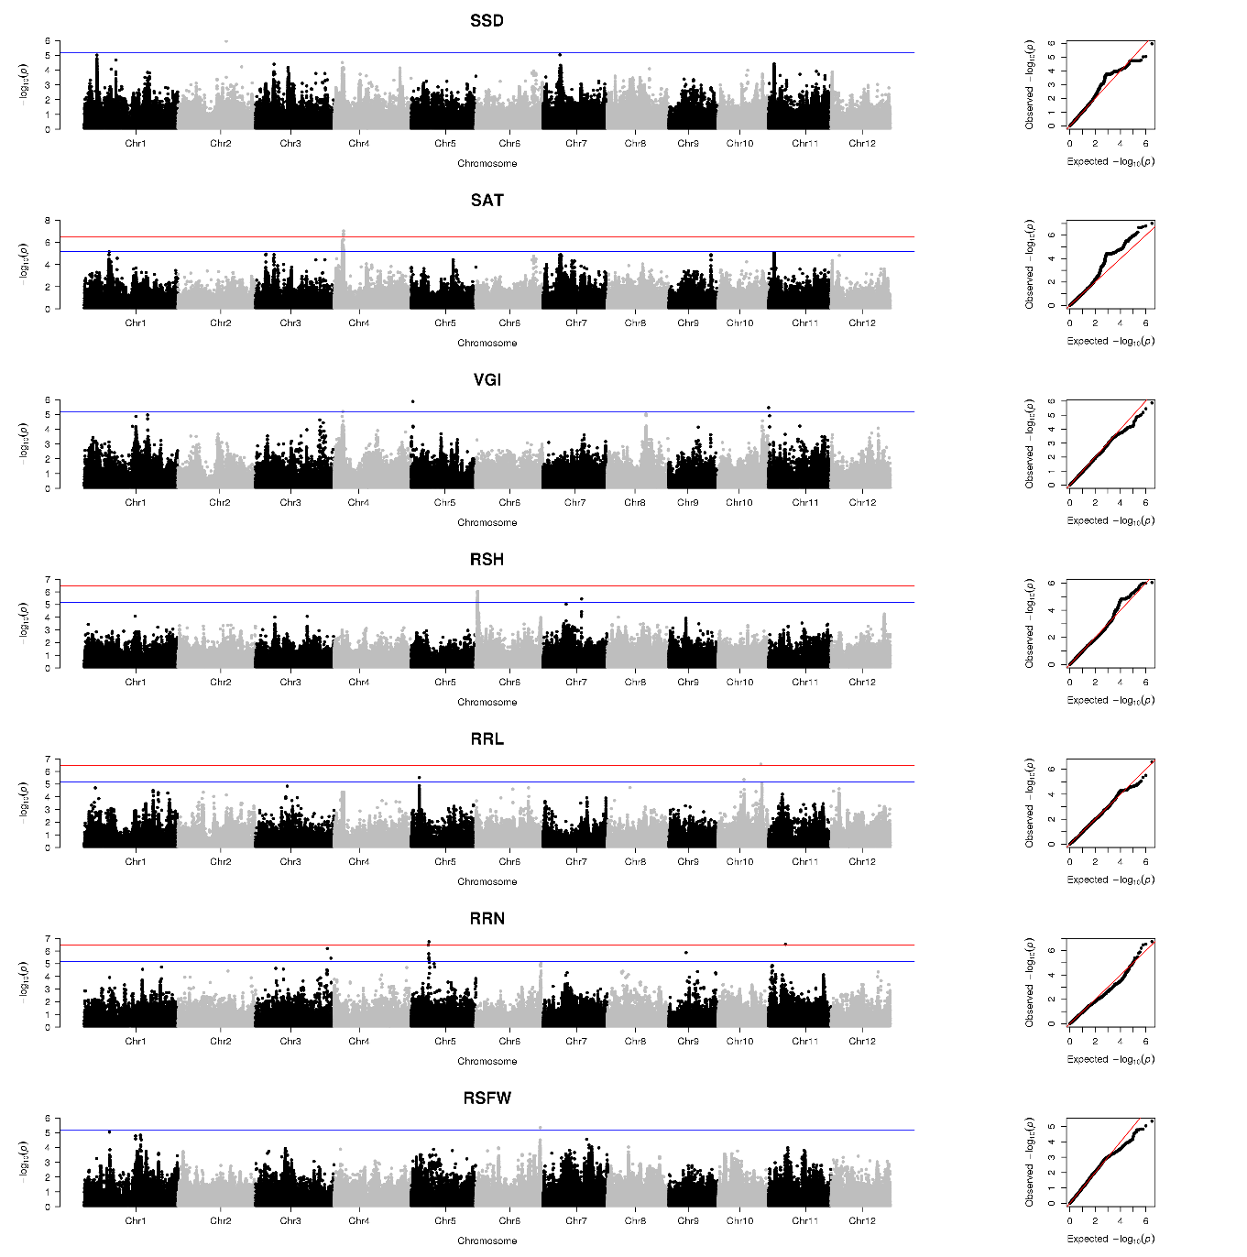
Supplementary Figure 4. GWAS of SSD, SAT, VGI, RSH, RRL, RRN, RSFW in the Geng subpopulation. Manhattan plots (left) and Q-Q plots (right). Blue and red horizontal lines indicate genome-wide suggestive and significant thresholds.

