Supplementary Tables
Supplementary Table S1. Average relative abundance of genus level taxa at each sampling point. Differentially abundant taxa between timepoints were identified using Kruskal-Wallis test and corresponding p-values and FDR corrected p-values are shown. Dots indicate lack of significance (p -values and FDR p-values > 0.05).
 | AVG _ RA (n=41) |  |  | D0 vs D7 vs D21 |  | D0 vs D7 |  | D7 vs 21 |  | D0 vs 21
Genus | D0 | D7 | D21 | p-values | FDRp | p-values | FDRp | p-values | FDRp | p-values | FDRp
Bacteroides | 0.20325 | 0.13983 | 0.17547 | . | . | 0.02565 | . | . | . | . | .
Bifidobacterium | 0.13535 | 0.21658 | 0.17378 | 0.05480 | . | 0.01907 | . | . | . | . | .
Faecalibacterium | 0.12540 | 0.12277 | 0.12478 | . | . | . | . | . | . | . | .
Blautia | 0.08152 | 0.06993 | 0.09027 | . | . | . | . | 0.02018 | . | . | .
Prevotella | 0.06636 | 0.08558 | 0.06129 | . | . | . | . | . | . | . | .
Lachnospiraceae_unclassified | 0.03499 | 0.02927 | 0.03864 | . | . | . | . | 0.02256 | . | . | .
Agathobacter | 0.02748 | 0.02344 | 0.02732 | . | . | . | . | . | . | . | .
Fusicatenibacter | 0.02022 | 0.01982 | 0.02620 | . | . | . | . | . | . | . | .
Ruminococcus | 0.02009 | 0.01713 | 0.01601 | . | . | . | . | . | . | . | .
Anaerostipes | 0.01882 | 0.02103 | 0.02728 | 0.04662 | . | . | . | . | . | 0.02832 | .
Megamonas | 0.01776 | 0.01344 | 0.01092 | . | . | . | . | . | . | . | .
Collinsella | 0.01610 | 0.04587 | 0.00971 | 0.00025 | 0.00166 | 0.00066 | 0.00538 | 0.00029 | 0.00459 | . | .
Lachnospira | 0.01601 | 0.01422 | 0.01347 | . | . | . | . | . | . | . | .
Erysipelotrichaceae_UCG_003 | 0.01503 | 0.01109 | 0.01097 | . | . | . | . | . | . | . | .
Subdoligranulum | 0.01199 | 0.01524 | 0.01500 | . | . | . | . | . | . | . | .
Fusobacterium | 0.01021 | 0.00158 | 0.00168 | 0.01516 | 0.05353 | . | . | 0.03416 | . | 0.00719 | 0.04423
Dorea | 0.00935 | 0.00837 | 0.00945 | . | . | . | . | . | . | . | .
Alistipes | 0.00904 | 0.00455 | 0.00705 | . | . | . | . | . | . | . | .
Coprococcus | 0.00865 | 0.00717 | 0.00897 | . | . | . | . | . | . | . | .
Roseburia | 0.00855 | 0.00545 | 0.00701 | 0.00159 | 0.00854 | 0.00064 | 0.00538 | 0.01149 | . | . | .
Lachnoclostridium | 0.00790 | 0.00608 | 0.01037 | 0.02760 | . | 0.02340 | . | 0.01943 | . | . | .
Sutterella | 0.00750 | 0.00455 | 0.00472 | . | . | . | . | . | . | . | .
Phascolarctobacterium | 0.00633 | 0.01047 | 0.00688 | . | . | . | . | . | . | . | .
Romboutsia | 0.00611 | 0.00734 | 0.00378 | . | . | . | . | . | . | . | .
Parasutterella | 0.00557 | 0.00259 | 0.00263 | . | . | . | . | . | . | . | .
Clostridia_UCG_014_unclassified | 0.00527 | 0.00108 | 0.00147 | 0.00424 | 0.02012 | 0.00123 | 0.00874 | . | . | 0.01863 | .
UCG_002 | 0.00493 | 0.00385 | 0.00384 | . | . | . | . | . | . | . | .
Parabacteroides | 0.00465 | 0.00431 | 0.00630 | . | . | . | . | . | . | . | .
Lachnospiraceae_NK4A136_group | 0.00457 | 0.00320 | 0.00552 | 0.00556 | 0.02563 | 0.00182 | 0.01241 | 0.03407 | . | . | .
Alloprevotella | 0.00390 | 0.00325 | 0.00349 | 0.00020 | 0.00148 | 0.00090 | 0.00669 | . | . | 0.00033 | 0.00285
Megasphaera | 0.00390 | 0.00258 | 0.00499 | 0.00033 | 0.00209 | 0.01190 | . | 0.00949 | . | 0.00092 | 0.00693
Lachnospiraceae_ND3007_group | 0.00357 | 0.00432 | 0.00608 | 0.05090 | . | . | . | 0.05373 | . | 0.01597 | .
Escherichia.Shigella | 0.00354 | 0.00355 | 0.00583 | . | . | . | . | . | . | . | .
Catenibacterium | 0.00354 | 0.00363 | 0.00076 | 0.00001 | 0.00011 | . | . | 0.00010 | 0.00195 | 0.00001 | 0.00015
Streptococcus | 0.00335 | 0.00878 | 0.00586 | . | . | . | . | . | . | . | .
Lactobacillus | 0.00319 | 0.00126 | 0.00072 | 3.40E-06 | 0.00003 | 0.00002 | 0.00031 | . | . | 0.00002 | 0.00020
Lachnospiraceae_UCG_004 | 0.00282 | 0.00244 | 0.00306 | . | . | . | . | . | . | . | .
Oscillospirales_unclassified | 0.00244 | 0.00203 | 0.00285 | . | . | . | . | . | . | . | .
Enterococcus | 0.00236 | 0.00061 | 0.00101 | 0.00158 | 0.00854 | 0.02002 | . | . | . | 0.00026 | 0.00242
Ruminococcaceae_unclassified | 0.00228 | 0.00063 | 0.00052 | 0.00293 | 0.01430 | 0.00075 | 0.00582 | . | . | 0.01823 | .
Monoglobus | 0.00228 | 0.00183 | 0.00224 | . | . | . | . | . | . | . | .
Akkermansia | 0.00222 | 0.00188 | 0.00231 | . | . | . | . | . | . | 0.05000 | .
Muribaculaceae_unclassified | 0.00218 | 0.00050 | 0.00219 | 0.00587 | 0.02634 | 0.00543 | 0.03300 | . | . | 0.01178 | .
Butyricicoccus | 0.00217 | 0.00195 | 0.00262 | 0.00037 | 0.00226 | 0.01604 | . | 0.00012 | 0.00220 | . | .
CAG_56 | 0.00209 | 0.00222 | 0.00287 | . | . | . | . | . | . | . | .
Butyricimonas | 0.00198 | 0.00083 | 0.00151 | . | . | . | . | . | . | . | .
UCG_005 | 0.00186 | 0.00092 | 0.00131 | . | . | . | . | . | . | . | .
Tyzzerella | 0.00185 | 0.00089 | 0.00140 | . | . | . | . | . | . | . | .
Burkholderia_Caballeronia_  Paraburkholderia | 0.00177 | 0 | 0 | 3.89E-12 | 1.30E-10 | 5.37E-08 | 2.97E-06 | . | . | 8.23E-08 | 2.76E-06
Other n=205 | 0.00173 | 0.00094 | 0.00114 | . | . | . | . | . | . | . | .
Christensenellaceae_R_7_group | 0.00172 | 0.00093 | 0.00234 | 0.04399 | . | . | . | 0.01169 | . | . | .
Prevotellaceae_NK3B31_group | 0.00170 | 0.00650 | 0.00081 | 3.92E-07 | 4.65E-06 | 0.00016 | 0.00206 | 1.33E-06 | 0.00005 | 0.00667 | 0.04256
Holdemanella | 0.00141 | 0.00287 | 0.00181 | 0.00181 | 0.00938 | . | . | 0.00062 | 0.00900 | 0.01824 | .
Lachnospiraceae_UCG_001 | 0.00140 | 0.00077 | 0.00161 | 0.01067 | 0.04217 | 0.00724 | 0.04097 | 0.01786 | . | . | .
Barnesiella | 0.00140 | 0.00052 | 0.00092 | . |  | . | . | . | . | . | .
Clostridium_sensu_stricto_1 | 0.00137 | 0.00167 | 0.00190 | . | . | . | . | . | . | . | .
Paraprevotella | 0.00137 | 0.00118 | 0.00112 | . | . | . | . | . | . | . | .
Intestinibacter | 0.00136 | 0.00043 | 0.00102 | . | . | . | . | . | . | . | .
Klebsiella | 0.00114 | 0.00463 | 0.00228 | 0.02943 | . | 0.03004 | . | . | . | 0.02432 | .
Lachnospiraceae_FCS020_group | 0.00113 | 0.00110 | 0.00133 | . | . | . | . | . | . | . | .
Dialister | 0.00113 | 0.00100 | 0.00175 | 0.01472 | 0.05311 | 0.02983 | . | 0.00514 | 0.04804 | . | .
Incertae_Sedis | 0.00112 | 0.00122 | 0.00191 | . | . | . | . | . | . | . | .
Bilophila | 0.00105 | 0.00127 | 0.00151 | . | . | . | . | . | . | . | .
NK4A214_group | 0.00099 | 0.00048 | 0.00122 | . | . | . | . | . | . | . | .
Oscillospiraceae_unclassified | 0.00093 | 0.00057 | 0.00106 | 0.03492 | . | . | . | 0.01056 | . | . | .
Erysipelatoclostridium | 0.00087 | 0.00054 | 0.00087 | . | . | . | . | . | . | . | .
Lachnospiraceae_UCG_010 | 0.00080 | 0.00066 | 0.00126 | 0.00903 | 0.03747 | . | . | 0.00303 | 0.03012 | 0.02725 | .
Marvinbryantia | 0.00080 | 0.00057 | 0.00058 | . | . | . | . | . | . | . | .
Haemophilus | 0.00074 | 0.00113 | 0.00059 | . | . | . | . | . | . | . | .
UCG_003 | 0.00073 | 0.00054 | 0.00093 | . | . | . | . | . | . | . | .
Syntrophococcus | 0.00053 | 0.00031 | 0.00054 | . | . | . | . | . | . | . | .
Turicibacter | 0.00049 | 0.00018 | 0.00024 | 9.86E-07 | 0.00001 | 2.62E-06 | 0.00005 | . | . | 0.00003 | 0.00033
Desulfovibrio | 0.00049 | 0.00021 | 0.00061 | . | . | . | . | . | . | . | .
Flavonifractor | 0.00046 | 0.00059 | 0.00103 | 0.01052 | 0.04217 | . | . | . | . | 0.00255 | 0.01840
Colidextribacter | 0.00045 | 0.00027 | 0.00050 | 0.01975 | . | 0.04059 | . | 0.00899 | . | . | .
Terrisporobacter | 0.00045 | 0.00002 | 0.00045 | 0.00004 | 0.00027 | 0.00058 | 0.00538 | 0.00001 | 0.00030 | . | .
Actinomyces | 0.00042 | 0.00015 | 0.00009 | . | . | . | . | . | . | . | .
CAG_352 | 0.00041 | 0.00032 | 0.00068 | 4.93E-08 | 6.29E-07 | . | . | 1.21E-06 | 0.00005 | 1.41E-06 | 0.00003
Helicobacter | 0.00039 | 0 | 0 | 3.92E-12 | 1.30E-10 | 5.43E-08 | 2.97E-06 | . | . | 8.30E-08 | 2.76E-06
Oscillibacter | 0.00038 | 0.00032 | 0.00044 | . | . |  | . | . | . | . | .
RF39_unclassified | 0.00037 | 0.00014 | 0.00015 | . | . | 0.03768 | . | . | . | . | .
Odoribacter | 0.00037 | 0.00020 | 0.00035 | . | . |  | . | . | . | . | .
Hungatella | 0.00037 | 0.00002 | 0.00019 | 0.00002 | 0.00017 | 4.01E-06 | 0.00007 | 0.00088 | 0.01097 | . | .
A2 | 0.00034 | 0 | 0 | 3.89E-12 | 1.30E-10 | 5.37E-08 | 2.97E-06 | . | . | 8.27E-08 | 2.76E-06
Christensenellaceae_unclassified | 0.00034 | 0.00023 | 0.00095 | 2.10E-06 | 0.00002 | . | . | 5.57E-06 | 0.00018 | 0.00005 | 0.00045
Prevotellaceae_UCG_001 | 0.00034 | 0.00186 | 0.00221 | 0.00622 | 0.02716 | . | . | 0.01647 | . | 0.00440 | 0.02923
Methanobrevibacter | 0.00033 | 0.00056 | 2.15E-06 | . | . | . | . | . | . | . | .
Mitsuokella | 0.00027 | 0.00041 | 0.00285 | 0.00157 | 0.00854 | . | . | 0.00124 | 0.01319 | 0.00869 | 0.04977
Senegalimassilia | 0.00027 | 0.00022 | 0.00017 | . | . | . | . | . | . | . | .
Erysipelotrichaceae_unclassified | 0.00024 | 0.00011 | 0.00016 | . | . | . | . | . | . | 0.02942 | .
Coprobacter | 0.00021 | 0.00007 | 0.00010 | . | . | . | . | . | . | . | .
Family_XIII_AD3011_group | 0.00020 | 0.00015 | 0.00022 | . | . | . | . | . | . | . | .
Eggerthella | 0.00019 | 0.00050 | 0.00041 | 0.01151 | 0.04344 | 0.00528 | 0.03300 | . | . | 0.01818 | .
Clostridia_unclassified | 0.00019 | 0.00009 | 0.00020 | 0.00134 | 0.00793 | 0.00320 | 0.02101 | 0.00090 | 0.01097 | . | .
Lachnospiraceae_AC2044_group | 0.00018 | 0.00016 | 0.00013 | . | . | . | . | . | . | . | .
UCG_010_unclassified | 0.00018 | 0.00011 | 0.00029 | . | . | . | . | . | . | . | .
Acidaminococcus | 0.00017 | 0.00035 | 0.00035 | . | . | . | . | . | . | . | .
UBA1819 | 0.00017 | 0.00017 | 0.00020 | . | . | . | . | . | . | . | .
Negativibacillus | 0.00017 | 0.00009 | 0.00016 | . | . | . | . | . | . | . | .
Desulfovibrionaceae_unclassified | 0.00017 | 1.08E-06 | 9.68E-06 | 1.29E-10 | 3.56E-09 | 1.31E-07 | 5.37E-06 | . | . | 6.61E-07 | 0.00002
Coriobacteriales_Incertae_Sedis_  unclassified | 0.00015 | 0.00015 | 0.00014 | . | . | . | . | . | . | . | .
Adlercreutzia | 0.00015 | 0.00018 | 0.00012 | . | . | . | . | 0.03989 | . | . | .
Lachnospiraceae_UCG_006 | 0.00013 | 9.68E-06 | 6.45E-06 | 1.51E-09 | 2.79E-08 | 1.32E-06 | 0.00004 | . | . | 1.59E-06 | 0.00003
ASF356 | 0.00013 | 0 | 0 | 3.58E-10 | 8.49E-09 | 9.52E-07 | 0.00003 | . | . | 5.89E-07 | 0.00002
Victivallis | 0.00013 | 0.00002 | 0.00020 | . | . | . | . | 0.01710 | . | . | .
Faecalitalea | 0.00011 | 0.00010 | 0.00008 | . | . | . | . | . | . | . | .
Veillonella | 0.00011 | 0.00020 | 0.00009 | . | . | . | . | 0.03420 | . | . | .
GCA_900066575 | 0.00010 | 0.00008 | 0.00010 | . | . | . | . | . | . | . | .
Intestinimonas | 0.00010 | 0.00003 | 0.00010 | . | . | . | . | . |  | . | .
Prevotellaceae_unclassified | 0.00010 | 0.00043 | 0.00020 | 0.03633 | . | . | . | . | . | 0.00827 | 0.04901
Eisenbergiella | 0.00009 | 0.00001 | 0.00002 | 0.00004 | 0.00027 | 0.00019 | 0.00220 | . | . | 0.00092 | 0.00693
Olsenella | 0.00009 | 0.00024 | 0.00008 | 0.00024 | 0.00163 | 0.00034 | 0.00368 | 0.00115 | 0.01301 | . | .
Tuzzerella | 0.00009 | 0.00006 | 0.00013 | . | . | . | . | . | . | . | .
Clostridia_vadinBB60_group_  unclassified | 0.00009 | 0.00002 | 0.00007 | 0.04473 | . | 0.01417 | . | . | . | . | .
Shuttleworthia | 0.00009 | 0.00004 | 0.00013 | . | . |  |  | . | . | . | .
Anaerovoracaceae_unclassified | 0.00009 | 0.00005 | 0.00008 | . | . |  |  | . | . | . | .
Family_XIII_UCG_001 | 0.00008 | 0.00002 | 0.00007 | 0.03052 | . | 0.00842 | 0.04605 | . | . | . | .
Bacteroidales_unclassified | 0.00008 | 0.00006 | 0.00006 | . | . | . | . | . | . | 0.03106 | .
Slackia | 0.00008 | 0.00008 | 0.00007 | . | . | . | . | . | . | . | .
Sellimonas | 0.00008 | 0.00003 | 0.00019 | . | . | . | . | . | . | . | .
Allisonella | 0.00008 | 0.00002 | 0.00012 | . | . | 0.04198 | . | . | . | . | .
Mucispirillum | 0.00007 | 0 | 0 | 6.11E-09 | 1.01E-07 | 5.49E-06 | 0.00009 | . | . | 8.84E-06 | 0.00013
Anaerotruncus | 0.00007 | 0.00001 | 0.00005 | 0.00261 | 0.01314 | 0.00058 | 0.00538 | 0.02334 | . | . | .
Rikenellaceae_RC9_gut_group | 0.00006 | 0 | 0 | 1.51E-09 | 2.79E-08 | 2.33E-06 | 0.00005 | . | . | 3.71E-06 | 0.00006
Holdemania | 0.00006 | 0.00002 | 0.00004 | . | . | . | . | . | . | . | .
Oscillospira | 0.00005 | 0.00004 | 0.00002 | . | . | . | . | . | . | . | .
Peptococcus | 0.00005 | 0.00006 | 0.00002 | . | . | . | . | . | . | . | .
Macellibacteroides | 0.00005 | 0 | 0 | 2.47E-08 | 3.41E-07 | 0.00001 | 0.00020 | . | . | 0.00002 | 0.00024
Eggerthellaceae_unclassified | 0.00005 | 0.00003 | 0.00004 | . | . | . | . | . | . | . | .
Paludicola | 0.00004 | 0.00002 | 0.00002 | . | . | . | . | . | . | . | .
UC5_1_2E3 | 0.00004 | 6.45E-06 | 0.00004 | . | . | . | . | . | . | . | .
Lactococcus | 0.00003 | 0.00002 | 0.00021 | . | . | . | . | 0.02510 | . | . | .
Bacteria_unclassified | 0.00003 | 0.00002 | 9.68E-06 | 0.01611 | . | . |  | . | . | 0.00338 | 0.02339
Candidatus_Stoquefichus | 0.00003 | 0.00012 | 0.00006 | . | . | . | . | . | . | . | .
Eubacterium | 0.00003 | 0.00002 | 0.00003 | . | . | . | . | . | . | . | .
Mogibacterium | 0.00003 | 0.00008 | 4.30E-06 | . | . | . | . | . | . | . | .
Succinatimonas | 0.00003 | 0.00005 | 0.00005 | . | . | . | . | . | . | . | .
Acetatifactor | 0.00003 | 0 | 0 | 0.00002 | 0.00014 | 0.00065 | 0.00538 | . | . | 0.00052 | 0.00432
DTU089 | 0.00003 | 2.15E-06 | 6.45E-06 | 0.01138 | 0.04344 | 0.01110 | . | . | . | 0.03444 | .
Angelakisella | 0.00003 | 3.23E-06 | 0.00001 | . | . | . | . | . | . | . | .
Tannerellaceae_unclassified | 0.00003 | 0.00004 | 0.00001 | . | . | . | . | . | . | . | .
UCG_009 | 0.00003 | 0.00002 | 0.00005 | . | . | . | . | . | . | . | .
UCG_008 | 0.00002 | 2.15E-06 | 0.00003 | 0.01178 | 0.04346 | 0.00635 | 0.03720 | . | . | . | .
Lactonifactor | 0.00002 | 4.30E-06 | 0.00004 | . | . | . | . | . | . | . | .
Defluviitaleaceae_UCG_011 | 0.00002 | 0.00002 | 0.00003 | . | . | . | . | . | . | . | .
Oxalobacter | 0.00002 | 0 | 1.08E-06 | 0.00780 | 0.03321 | 0.01069 | . | . | . | 0.03584 | .
Anaerofilum | 0.00002 | 0.00002 | 0.00003 | . | . | . | . | . | . | . | .
Caproiciproducens | 0.00002 | 5.38E-06 | 0.00002 | . | . | . | . | . | . | . | .
Coprobacillus | 0.00002 | 3.23E-06 | 6.45E-06 | . | . | . | . | . | . | . | .
Weissella | 0.00002 | 0.00005 | 0.00014 | . | . | . | . | . | . | . | .
Candidatus_Soleaferrea | 0.00001 | 8.60E-06 | 0.00003 | . | . | . | . | 0.02807 | . | . | .
Gordonibacter | 0.00001 | 0.00005 | 0.00003 | . | . | . | . | . | . | . | .
Raoultibacter | 0.00001 | 0.00002 | 0.00002 | . | . | . | . | . | . | . | .
Frisingicoccus | 0.00001 | 6.45E-06 | 0.00002 | . | . | . | . | . | . | . | .
Christensenella | 0.00001 | 2.15E-06 | 0.00002 | . | . | . | . | 0.05495 | . | . | .
Firmicutes_unclassified | 0.00001 | 5.38E-06 | 0.00002 | . | . | . | . | . | . | . | .
Lachnospiraceae_UCG_003 | 0.00001 | 0.00005 | 0.00001 | . | . | . | . | . | . | . | .
Phocea | 0.00001 | 3.23E-06 | 0.00002 | . | . | . | . | . | . | . | .
Mailhella | 0.00001 | 3.23E-06 | 0.00003 | . | . | . | . | . | . | . | .
Rothia | 0.00001 | 0.00001 | 0.00003 | . | . | . | . | . | . | . | .
Bifidobacteriaceae_unclassified | 0.00001 | 9.68E-06 | 0.00001 | . | . | . | . | . | . | . | .
Anaerostignum | 4.30E-06 | 9.68E-06 | 8.60E-06 | . | . | . | . | . | . | . | .
Granulicatella | 3.23E-06 | 0 | 0.00003 | . | . | . | . | . | . | . | .
Marivita | 0 | 0 | 0.00006 | 2.47E-08 | 3.41E-07 | . | . | 0.00001 | 0.00030 | 0.00002 | 0.00021
Microbacteriaceae_unclassified | 0 | 0 | 0.00016 | 1.84E-16 | 1.53E-14 | . | . | 7.44E-11 | 5.91E-09 | 1.27E-10 | 1.05E-08
Rhodobacteraceae_unclassified | 0 | 0 | 0.00246 | 1.18E-19 | 1.96E-17 | . | . | 4.76E-13 | 7.58E-11 | 8.89E-13 | 1.48E-10

Supplementary Table S2. Means, medians, standard deviations, standard errors of standardized clinical scores at each time point (N=46). Wilcoxon signed-rank test was used to compare clinical scores between timepoints and to calculate p-values.
 |  | Standarized scores |  |  |  | p-values
 | Time | Mean | Median | Std. Deviation | Std. Error | D0 vs. D7 | D0 vs. D21 | D7 vs. D21
Frequency | D0 | 0.67 | 1.00 | 0.52 | 0.08 | 0.358 | 0.039 | 0.345
Frequency | D7 | 0.76 | 1.00 | 0.48 | 0.07 | 0.358 | 0.039 | 0.345
Frequency | D21 | 0.83 | 1.00 | 0.38 | 0.06 | 0.358 | 0.039 | 0.345
Gas | D0 | -1.15 | 0.00 | 0.63 | 0.09 | 0.750 | 0.043 | 0.005
Gas | D7 | -0.17 | 0.00 | 0.74 | 0.11 | 0.750 | 0.043 | 0.005
Gas | D21 | 0.13 | 0.00 | 0.86 | 0.13 | 0.750 | 0.043 | 0.005
Energy | D0 | 0.59 | 1.00 | 0.91 | 0.13 | 0.011 | 0.006 | 0.227
Energy | D7 | 0.91 | 1.00 | 0.84 | 0.12 | 0.011 | 0.006 | 0.227
Energy | D21 | 1.02 | 1.00 | 0.83 | 0.12 | 0.011 | 0.006 | 0.227
Bristol | D0 | -0.59 | 0.00 | 0.69 | 0.10 | 0.292 | 0.078 | 0.745
Bristol | D7 | -0.46 | 0.00 | 0.62 | 0.09 | 0.292 | 0.078 | 0.745
Bristol | D21 | -0.41 | 0.00 | 0.62 | 0.09 | 0.292 | 0.078 | 0.745

Supplementary Figures
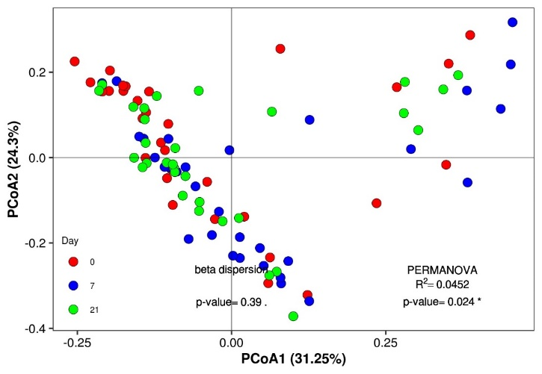
Supplementary Figure S1. PCoA plot of beta diversity of the gut microbiota based on weighted Bray-Curtis distance matrix. Samples are color coded by timepoint.
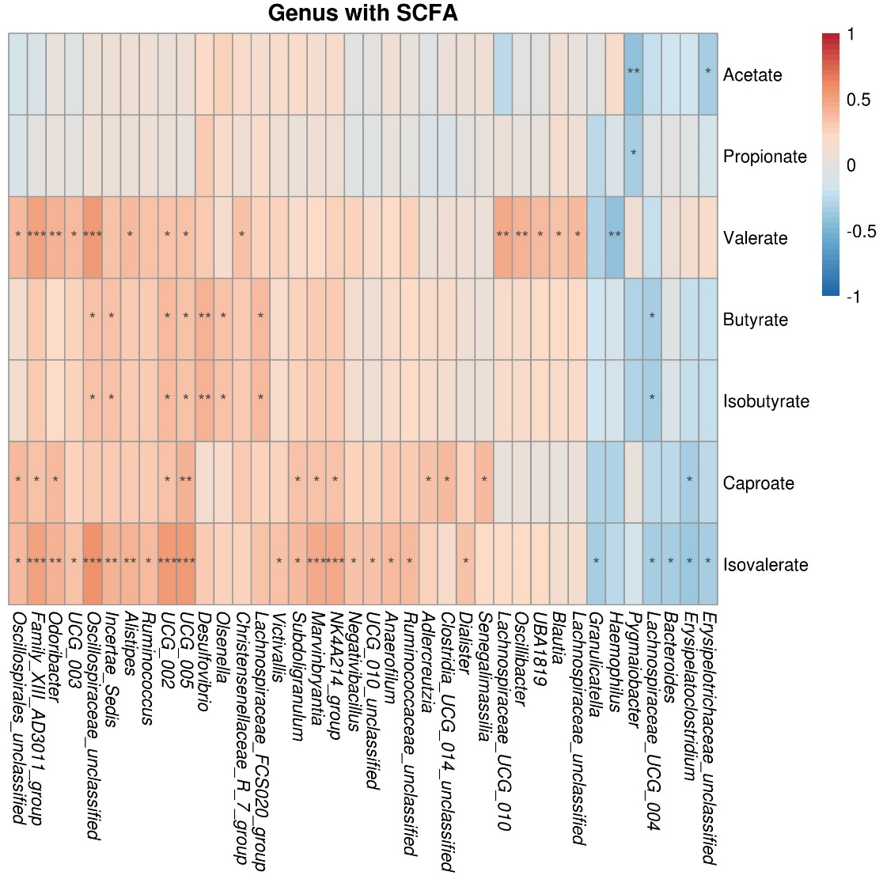
Supplementary Figure S2. Heatmap of Spearman correlations between genus level taxa and each SCFA concentration. Displayed are taxa for which at least one correlation passed a threshold of >±0.3 and statistical significance calculated using Wilcoxon signed-rank test, with FDR p-values corresponded to *≤ 0.05, ** ≤ 0.01, *** ≤ 0.001.

