SUPPLEMENTARY MATERIALS

Evolution of disease characteristics of MASLD patients with and without diabetes: A meta-analysis of the placebo arms

Han Ah Lee¹, Hye Ah Lee², and Hwi Young Kim¹

¹Department of Internal Medicine, Ewha Womans University College of Medicine, Seoul, Korea.
²Clinical Trial Center, Ewha Womans University College of Medicine, Seoul, Korea

Correspondence:
Hwi Young Kim, M.D., Ph.D.
Department of Internal Medicine, College of Medicine, Ewha Womans University
1071 Anyangcheon-ro, Yangcheon-gu, Seoul 07985, Korea
Tel: +82-2-2650-5868, Fax: +82-2-2650-2837
E-mail: hwiyoung@ewha.ac.kr
https://orcid.org/0000-0003-0723-1285

Table of Contents

Supplementary method. Search strategy…………………………………………………….….3

Supplementary Table 1. Summary of included trials……………………………………………4 3

Supplementary Figure 1. Assessment of risk of bias in the included studies………………..6

Supplementary Table 2. Subgroup analysis of secondary outcomes in patients without diabetes……………………………………………………………………..……………….…….…..7

Supplementary Figure 2. Forest plots of meta-analysis showing change in liver enzymes……………………...……..……………………………………………………….………10

Supplementary Table 3. Subgroup analysis of secondary outcomes in patients with diabetes…………………………………………………………………..……………….…….…..12

Supplementary method. Search strategy

1. (clinical adj3 trial).tw. OR (singl$ OR doubl$ OR trebl$ OR tripl$).tw. AND (mask$ OR blind$).tw. OR placebo$.tw. OR random$.tw. OR exp randomized controlled trials/ OR exp random allocation/ OR exp double-blind method/ OR exp single-blind method/ OR exp placebos/ OR research design/
2. (nash OR ((nonalcoholic OR non*alcoholic OR non alcoholic) adj3 steatohepatit*)).tw.
3. 1 AND 2

Supplementary Table 1. Summary of included trials

Author (Year) |  | Country |  | Phase |  | Treatment Arm |  | Funding |  |  | Number of participants |  | Study duration (weeks) |  | Diabetes |  | Assessment |  | Risk of Bias
Neuschwander-Tetri et al. (2015) |  | USA |  | 2 |  | Obeticholic Acid |  | Government |  |  | 109 |  | 72 |  | None |  | Histology |  | Low concern
Sanyal et al. (2010) |  | USA |  | 3 |  | Pioglitazone, Vitamin E |  | Government |  |  | 83 |  | 96 |  | None |  | Histology |  | Low concern
Shenoy et al. (2014) |  | India |  | N/A |  | Metadoxine |  | Pharmaceutical Company |  |  | 59 |  | 16 |  | None |  | Histology |  | Some Concerns
Shields et al. (2009) |  | USA |  | N/A |  | Metformin |  | None |  |  | 7 |  | 48 |  | None |  | Histology |  | Some Concerns
Li et al. (2015) |  | China |  | N/A |  | Poly-unsaturated fatty acid |  | None |  |  | 39 |  | 24 |  | None |  | Histology |  | Some Concerns
Nogueira et al. (2016) |  | Brazil |  | 3 |  | Omega 3 |  | Government |  |  | 23 |  | 24 |  | None |  | Histology |  | Some Concerns
Uygun et al. (2004) |  | Turkey |  | N/A |  | Metformin |  | None |  |  | 17 |  | 24 |  | None |  | Histology |  | Low concern
Lindor et al. (2004) |  | USA |  | N/A |  | Ursodeoxycholic acid |  | Pharmaceutical Company |  |  | 57 |  | 96 |  | None |  | Histology |  | Low concern
Loomba et al. (2020) |  | Multinational |  | 2 |  | IONIS-DGAT2Rx |  | Pharmaceutical Company |  |  | 15 |  | 13 |  | Yes |  | MRI-PDFF |  | Low concern
Kuchay et al. (2018) |  | India |  | N/A |  | Empagliflozin |  | Government |  |  | 20 |  | 20 |  | Yes |  | MRI-PDFF |  | Low concern
Latva-Rasku et al. (2019) |  | Multinational |  | 4 |  | Dapagliflozin |  | Pharmaceutical Company |  |  | 16 |  | 8 |  | Yes |  | MRI-PDFF |  | Low concern
Kuchay et al. (2020) |  | India |  | N/A |  | Dulaglutide |  | Pharmaceutical Company |  |  | 25 |  | 24 |  | Yes |  | MRI-PDFF |  | Low concern
Joy et al. (2016) |  | Canada |  | N/A |  | Sitagliptin |  | Academic Medical Organization |  |  | 6 |  | 24 |  | Yes |  | Histology, MRS |  | Some Concerns
Cusi et al. (2016) |  | USA |  | 4 |  | Pioglitazone |  | Academic Medical Organization |  |  | 51 |  | 72 |  | Yes |  | Histology, MRS |  | Some Concerns
Harrison et al. (2021) |  | USA |  | 2 |  | Berberine ursodeoxycholate |  | Pharmaceutical Company |  |  | 33 |  | 18 |  | Yes |  | MRI-PDFF |  | Some Concerns
Eriksson et al. (2018) |  | Sweden |  | 2 |  | Dapagliflozin and n-3 carboxylic acids |  | Pharmaceutical Company |  |  | 19 |  | 12 |  | Yes |  | MRI-PDFF |  | Low concern
Barchetta et al. (2016) |  | Italy |  | N/A |  | Vitamin D |  | Government |  |  | 29 |  | 24 |  | Yes |  | MRI |  | Some Concerns
Bril et al. (2019) |  | USA |  | 4 |  | Vitamin E |  | Government |  |  | 32 |  | 72 |  | Yes |  | Histology, MRS |  | Low concern
Srinivasan et al. (2015) |  | USA |  | 2 |  | Polyunsaturated fatty acids |  | Government |  |  | 19 |  | 48 |  | Yes |  | Histology |  | Some Concerns
Belfort et al. (2006) |  | USA |  | 4 |  | Pioglitazone |  | Government |  |  | 21 |  | 24 |  | Yes |  | Histology |  | Low concern
Kahl et al. (2020) |  | Germany |  | 4 |  | Empagliflozin |  | Government |  |  | 42 |  | 24 |  | Yes |  | MRS |  | Low concern
Dutour et al. (2016) |  | France |  | N/A |  | Exenatide |  | Pharmaceutical Company |  |  | 22 |  | 26 |  | Yes |  | MRS |  | Some Concerns
Cusi et al. (2018) |  | USA |  | 1 |  | Canagliflozin |  | Pharmaceutical Company |  |  | 30 |  | 24 |  | Yes |  | MRS |  | Some Concerns
Gaborit et al. (2021) |  | France |  | 3 |  | Empagliflozin |  | Pharmaceutical Company |  |  | 25 |  | 12 |  | Yes |  | MRS |  | Some Concerns
Bizino et al. (2020) |  | Netherlands |  | 4 |  | Liraglutide |  | Pharmaceutical Company |  |  | 26 |  | 26 |  | Yes |  | MRS |  | Some Concerns
Smits et al. (2016) |  | Netherlands |  | 4 |  | Liraglutide, Sitagliptin |  | Pharmaceutical Company |  |  | 17 |  | 12 |  | Yes |  | MRS |  | Some Concerns
Horibe et al. (2022) |  | Japan |  | N/A |  | Dapagliflozin |  | Pharmaceutical Company |  |  | 26 |  | 24 |  | Yes |  | MRS |  | Some Concerns
Matikainen et al. (2018) |  | Finland |  | 4 |  | Liraglutide |  | Pharmaceutical Company |  |  | 7 |  | 16 |  | Yes |  | MRS |  | Some Concerns
Kantartzis et al. (2018) |  | Germany |  | N/A |  | Resveratrol |  | Pharmaceutical Company |  |  | 54 |  | 12 |  | Yes |  | MRS |  | Low concern
Skytte et al. (2019) |  | Denmark |  | N/A |  | Carbohydrate-reduced high-protein |  | Academic Medical Organization |  |  | 16 |  | 6 |  | Yes |  | MRS |  | Some Concerns
Thomsen et al. (2022) |  | Denmark |  | N/A |  | Carbohydrate restriction |  | Academic Medical Organization |  |  | 36 |  | 6 |  | Yes |  | MRS |  | Low concern
Lazo et al. (2010) |  | USA |  | N/A |  | Intensive lifestyle intervention |  | Government |  |  | 50 |  | 48 |  | Yes |  | MRS |  | Low concern

N/A, not applicable; LFC, liver fat content; DGAT2, diacylglycerol-O-acyltransferase 2; MRI-PDFF, magnetic resonance imaging-proton density fat fraction; MRS, MR spectroscopy; BMI, body mass index

Supplementary Figure 1. Assessment of risk of bias in the included studies

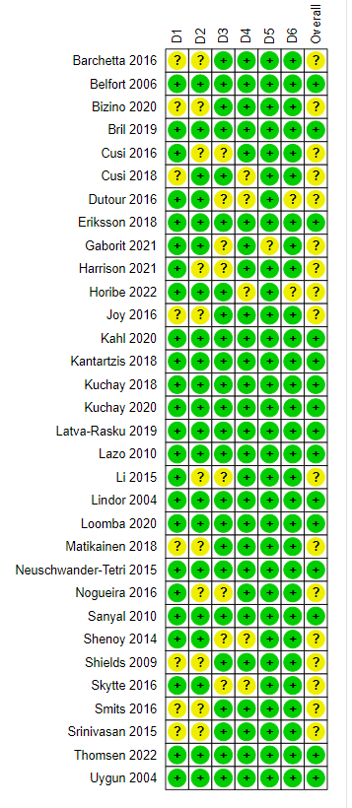
D1: Random sequence generation
D2: Allocation concealment
D3: Blinding of outcome assessment
D4: Incomplete outcome data
D5: Selective outcome reporting
D6: Other sources of bias.

Supplementary Table 2. Subgroup analysis of secondary outcomes in patients without diabetes

 |  | No of studies |  | Sample size |  | Effect size |  | 95% CI |  | I² (%) |  | Subgroup difference
Change in lobular inflammation
Center |  |  |  |  |  |  |  |  |  |  |  | 0.059
Multicenter |  | 2 |  | 181 |  | -0.20 |  | -0.32 to -0.09 |  | 0.0
Single center |  | 6 |  | 205 |  | -0.01 |  | -0.13 to 0.11 |  | 48.0
Intervention period |  |  |  |  |  |  |  |  |  |  |  | 0.041
≤24 weeks |  | 4 |  | 138 |  | 0.02 |  | -0.12 to 0.15 |  | 52.0
24-48 weeks |  | 1 |  | 10 |  | -0.12 |  | -0.62 to 0.38 |  | NA
>48 weeks |  | 3 |  | 238 |  | -0.18 |  | -0.28 to -0.08 |  | 0.0
Risk of bias |  |  |  |  |  |  |  |  |  |  |  | 0.003
Low |  | 4 |  | 255 |  | -0.17 |  | -0.26 to -0.07 |  | 0.0
Moderate |  | 4 |  | 131 |  | 0.04 |  | -0.10 to 0.17 |  | 37.1
Lifestyle modification |  |  |  |  |  |  |  |  |  |  |  | 0.656
Dietitian with exercise instruction |  | 1 |  | 10 |  | -0.12 |  | -0.62 to 0.38 |  | NA
Dietitian without exercise instruction |  | 2 |  | 40 |  | -0.15 |  | -0.34 to 0.04 |  | 0.0
Diet and exercise counseling without dietitian |  | 2 |  | 137 |  | -0.04 |  | -0.33 to 0.26 |  | 90.0
Diet counseling without dietitian |  | 1 |  | 59 |  | 0.10 |  | -0.12 to 0.32 |  | NA
Not provided or reported |  | 2 |  | 140 |  | -0.17 |  | -0.29 to-0.04 |  | 0.0
Change in hepatocyte ballooning
Center |  |  |  |  |  |  |  |  |  |  |  | 0.183
Multicenter |  | 2 |  | 181 |  | -0.20 |  | -0.31 to -0.09 |  | 0.0
Single center |  | 4 |  | 129 |  | -0.09 |  | -0.20 to 0.02 |  | 47.0
Intervention period |  |  |  |  |  |  |  |  |  |  |  | 0.384
≤24 weeks |  | 2 |  | 62 |  | -0.08 |  | -0.27 to 0.11 |  | 69.1
24-48 weeks |  | 1 |  | 10 |  | -0.28 |  | -0.67 to 0.11 |  | NA
>48 weeks |  | 3 |  | 238 |  | -0.16 |  | -0.24 to -0.08 |  | 0.0
Risk of bias |  |  |  |  |  |  |  |  |  |  |  | 0.346
Low |  | 3 |  | 238 |  | -0.16 |  | -0.24 to-0.08 |  | 0.0
Moderate |  | 3 |  | 72 |  | -0.11 |  | -0.28 to 0.07 |  | 58.8
Lifestyle modification |  |  |  |  |  |  |  |  |  |  |  | 0.742
Dietitian with exercise instruction |  | 1 |  | 10 |  | -0.28 |  | -0.67 to 0.11 |  | NA
Dietitian without exercise instruction |  | 1 |  | 23 |  | -0.20 |  | -0.40 to 0.0 |  | NA
Diet and exercise counseling without dietitian |  | 2 |  | 137 |  | -0.08 |  | -0.28 to 0.11 |  | 75.6
Not provided or reported |  | 2 |  | 140 |  | -0.15 |  | -0.25 to -0.05 |  | 8.9
Change in NAS
Center |  |  |  |  |  |  |  |  |  |  |  | 0.665
Multicenter |  | 2 |  | 181 |  | -0.60 |  | -0.84 to -0.35 |  | 0.0
Single center |  | 2 |  | 33 |  | -0.61 |  | -1.57 to 0.36 |  | 68.7
Intervention period |  |  |  |  |  |  |  |  |  |  |  | 0.379
≤24 weeks |  | 1 |  | 23 |  | -0.20 |  | -0.69 to 0.28 |  | NA
24-48 weeks |  | 1 |  | 10 |  | -1.20 |  | -2.18 to -0.22 |  | NA
>48 weeks |  | 2 |  | 181 |  | -0.60 |  | -0.84 to -0.35 |  | 0.0
Risk of bias |  |  |  |  |  |  |  |  |  |  |  | 0.665
Low |  | 2 |  | 181 |  | -0.60 |  | -0.84 to -0.35 |  | 0.0
Moderate |  | 2 |  | 33 |  | -0.61 |  | -0.16 to 0.36 |  | 68.7
Lifestyle modification |  |  |  |  |  |  |  |  |  |  |  | NA
Dietitian with exercise instruction |  | 1 |  | 10 |  | -1.20 |  | -2.18 to -0.22 |  | NA
Dietitian without exercise instruction |  | 1 |  | 23 |  | -0.20 |  | -0.69 to 0.29 |  | NA
Diet and exercise counseling without dietitian |  | 1 |  | 98 |  | -0.70 |  | -1.06 to -0.34 |  | NA
Not provided or reported |  | 1 |  | 83 |  | -0.50 |  | -0.84 to -0.16 |  | NA
Change in ALT, IU/L
Center |  |  |  |  |  |  |  |  |  |  |  | 0.720
Multicenter |  | 2 |  | 225 |  | -18.84 |  | -24.45 to -13.23 |  | 0.0
Single center |  | 5 |  | 182 |  | -22.90 |  | -33.25 to -12.56 |  | 79.6
Intervention period |  |  |  |  |  |  |  |  |  |  |  | 0.363
≤24 weeks |  | 3 |  | 115 |  | -17.78 |  | -27.82 to -7.74 |  | 79.8
24-48 weeks |  | 1 |  | 10 |  | -40.70 |  | -65.01 to -16.39 |  | NA
>48 weeks |  | 3 |  | 282 |  | -20.03 |  | -25.37 to -14.69 |  | 0.0
Risk of bias |  |  |  |  |  |  |  |  |  |  |  | 0.884
Low |  | 4 |  | 299 |  | -19.01 |  | -23.19 to -14.83 |  | 0.0
Moderate |  | 3 |  | 108 |  | -24.68 |  | -42.42 to -6.94 |  | 84.3
Lifestyle modification |  |  |  |  |  |  |  |  |  |  |  | 0.360
Dietitian with exercise instruction |  | 1 |  | 10 |  | -40.70 |  | -65.01 to -16.39 |  | NA
Dietitian without exercise instruction |  | 1 |  | 17 |  | -17.40 |  | -24.10 to -10.70 |  | NA
Diet and exercise counseling without dietitian |  | 2 |  | 181 |  | -13.61 |  | -20.36 to -6.85 |  | 69.7
Diet counseling without dietitian |  | 1 |  | 59 |  | -30.80 |  | -45.04 to -16.56 |  | NA
Not provided or reported |  | 2 |  | 140 |  | -23.29 |  | -33.38 to -13.20 |  | 24.4
Change in AST, IU/L
Center |  |  |  |  |  |  |  |  |  |  |  | 0.317
Multicenter |  | 2 |  | 225 |  | -7.09 |  | -13.15 to -1.02 |  | 58.7
Single center |  | 5 |  | 182 |  | -12.71 |  | -18.46 to -6.95 |  | 75.8
Intervention period |  |  |  |  |  |  |  |  |  |  |  | 0.587
≤24 weeks |  | 3 |  | 115 |  | -9.84 |  | -15.24 to -4.43 |  | 76.5
24-48 weeks |  | 1 |  | 10 |  | -20.10 |  | -32.25 to -7.95 |  | NA
>48 weeks |  | 3 |  | 282 |  | -10.39 |  | -18.93 to -1.85 |  | 72.1
Risk of bias |  |  |  |  |  |  |  |  |  |  |  | 0.408
Low |  | 4 |  | 299 |  | -8.58 |  | -13.21 to -3.96 |  | 61.7
Moderate |  | 3 |  | 108 |  | -15.51 |  | -20.96 to -6.07 |  | 80.3
Lifestyle modification |  |  |  |  |  |  |  |  |  |  |  | 0.755
Dietitian with exercise instruction |  | 1 |  | 10 |  | -20.10 |  | -32.25 to -7.95 |  | NA
Dietitian without exercise instruction |  | 1 |  | 17 |  | -6.80 |  | -9.60 to -4.00 |  | NA
Diet and exercise counseling without dietitian |  | 2 |  | 181 |  | -8.25 |  | -10.34 to -6.17 |  | 0.0
Diet counseling without dietitian |  | 1 |  | 59 |  | -16.67 |  | -22.74 to -10.60 |  | NA
Not provided or reported |  | 2 |  | 140 |  | -11.52 |  | -28.02 to 4.98 |  | 85.0

CI, confidence interval, NAS, nonalcoholic fatty liver disease activity score; ALT, alanine aminotransferase; AST, aspartate aminotransferase

P value <0.05 denotes statistical significance.

Supplementary Figure 2. Forest plots of meta-analysis showing change in alanine aminotransferases in patients without diabetes (A) and with diabetes (B), and aspartate aminotransferases in patients without diabetes (C) and with diabetes (D).

(A)
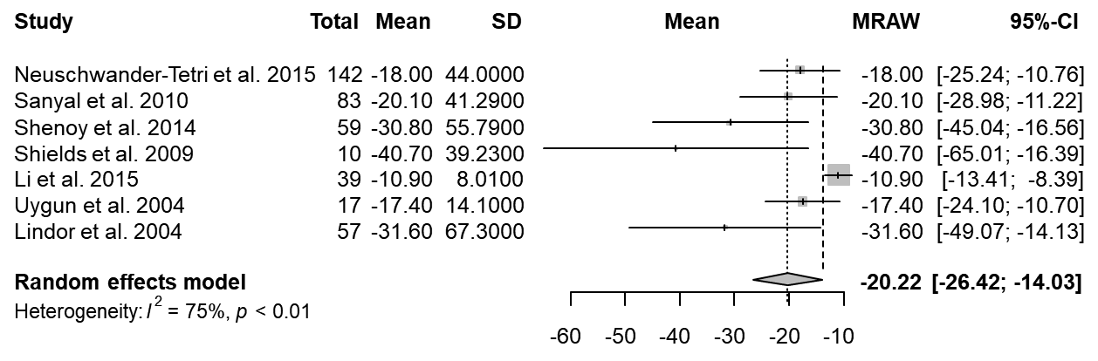

(B)
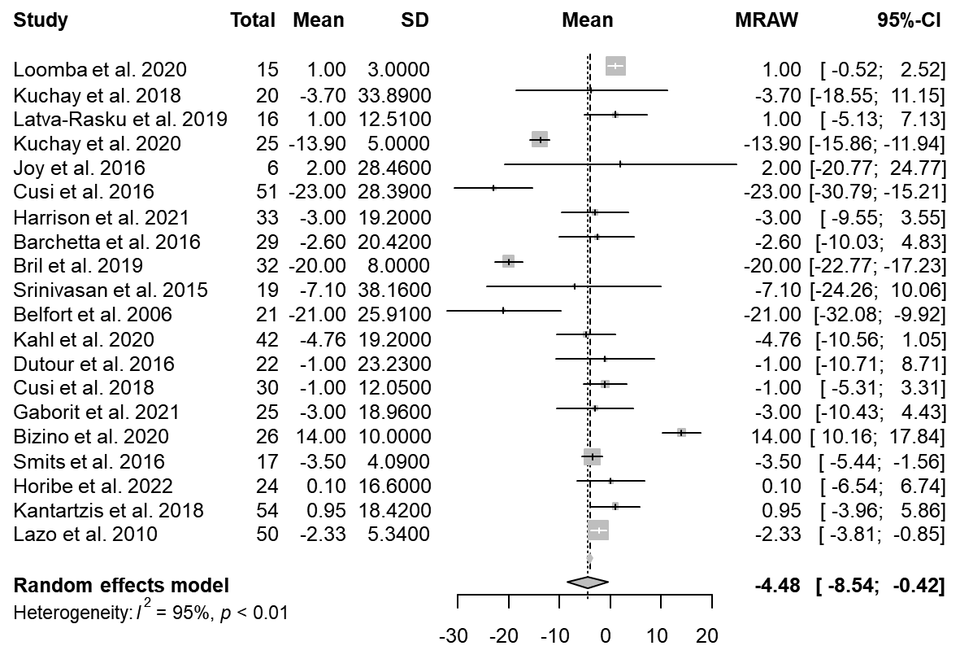

(C)
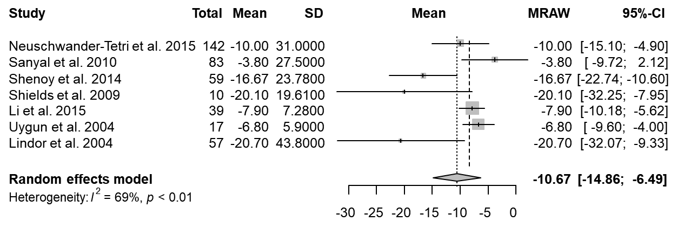

(D)
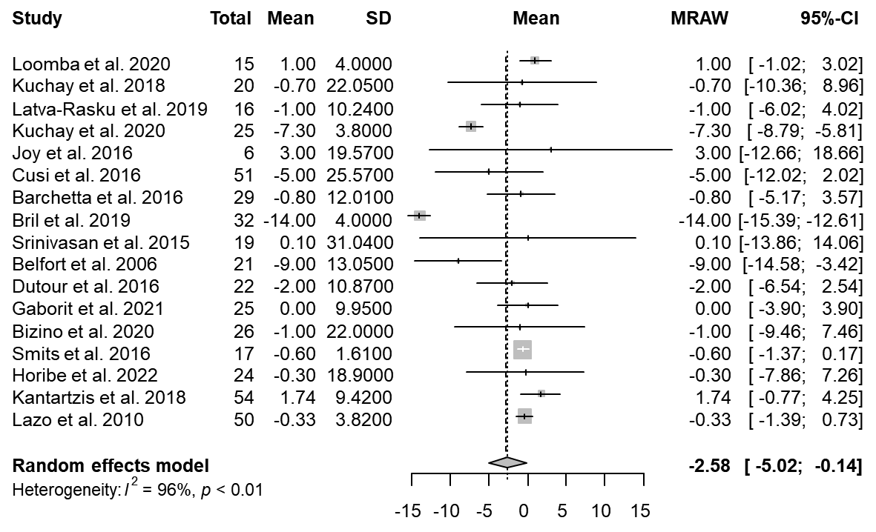

Supplementary Table 3. Subgroup analysis of secondary outcomes in patients with diabetes

 |  | No of studies |  | Sample size |  | Effect size |  | 95% CI |  | I² (%) |  | Subgroup difference
Change in lobular inflammation
Center |  |  |  |  |  |  |  |  |  |  |  | 0.614
Multicenter |  | 4 |  | 78 |  | 0.10 |  | -0.37 to 0.57 |  | 92.2
Single center |  | 1 |  | 51 |  | -0.20 |  | -0.42 to 0.02 |  | NA
Intervention period |  |  |  |  |  |  |  |  |  |  |  | 0.306
≤24 weeks |  | 2 |  | 27 |  | -0.04 |  | -0.72 to 0.63 |  | 92.3
24-48 weeks |  | 1 |  | 19 |  | 0.67 |  | 0.44 to 0.90 |  | NA
>48 weeks |  | 2 |  | 83 |  | -0.20 |  | -0.37 to -0.03 |  | 0.0
Risk of bias |  |  |  |  |  |  |  |  |  |  |  | 0.968
Low |  | 2 |  | 53 |  | 0.06 |  | -0.42 to 0.53 |  | 87.5
Moderate |  | 3 |  | 76 |  | 0.03 |  | -0.62 to 0.67 |  | 95.0
Lifestyle modification |  |  |  |  |  |  |  |  |  |  |  | 0.396
Dietitian with exercise instruction |  | 2 |  | 40 |  | 0.48 |  | 0.10 to 0.85 |  | 83.5
Dietitian without exercise instruction |  | 1 |  | 51 |  | -0.20 |  | -0.42 to 0.02 |  | NA
Diet and exercise counseling without dietitian |  | 1 |  | 32 |  | -0.20 |  | -0.48 to 0.08 |  | NA
Not provided or reported |  | 1 |  | 6 |  | -0.40 |  | -0.72 to -0.08 |  | NA
Change in hepatocyte ballooning
Center |  |  |  |  |  |  |  |  |  |  |  | 0.897
Multicenter |  | 3 |  | 57 |  | -0.17 |  | -0.40 to 0.07 |  | 40.2
Single center |  | 1 |  | 51 |  | -0.20 |  | -0.39 to 0.01 |  | NA
Intervention period |  |  |  |  |  |  |  |  |  |  |  | 0.292
≤24 weeks |  | 1 |  | 6 |  | 0.20 |  | -0.38 to 0.78 |  | NA
24-48 weeks |  | 1 |  | 19 |  | -0.31 |  | -0.51 to -0.11 |  | NA
>48 weeks |  | 2 |  | 83 |  | -0.17 |  | -0.34 to 0.00 |  | 0.0
Risk of bias |  |  |  |  |  |  |  |  |  |  |  | 0.592
Low |  | 1 |  | 32 |  | -0.10 |  | -0.41 to 0.21 |  | NA
Moderate |  | 3 |  | 76 |  | -0.23 |  | -0.36 to -0.10 |  | 28.7
Lifestyle modification |  |  |  |  |  |  |  |  |  |  |  | NA
Dietitian with exercise instruction |  | 1 |  | 19 |  | -0.31 |  | -0.51 to -0.11 |  | NA
Dietitian without exercise instruction |  | 1 |  | 51 |  | -0.20 |  | -0.39 to 0.00 |  | NA
Diet and exercise counseling without dietitian |  | 1 |  | 32 |  | -0.10 |  | -0.41 to 0.21 |  | NA
Not provided or reported |  | 1 |  | 6 |  | 0.20 |  | -0.38 to 0.78 |  | NA
Change in NAS
Center |  |  |  |  |  |  |  |  |  |  |  | NA
Multicenter |  | 2 |  | 25 |  | -1.25 |  | -2.49 to 0.00 |  | 56.5
Intervention period |  |  |  |  |  |  |  |  |  |  |  | NA
≤24 weeks |  | 1 |  | 6 |  | -0.40 |  | -1.96 to 1.16 |  | NA
24-48 weeks |  | 1 |  | 19 |  | -1.72 |  | -2.41 to -1.03 |  | NA
Risk of bias |  |  |  |  |  |  |  |  |  |  |  | NA
Moderate |  | 2 |  | 25 |  | -1.25 |  | -2.49 to -0.02 |  | 56.5
Lifestyle modification |  |  |  |  |  |  |  |  |  |  |  | NA
Dietitian with exercise instruction |  | 1 |  | 19 |  | -1.72 |  | -2.41 to -1.03 |  | NA
Not provided or reported |  | 1 |  | 6 |  | -0.40 |  | -1.96 to 1.16 |  | NA
Change in ALT, IU/L
Center |  |  |  |  |  |  |  |  |  |  |  | 0.608
Multicenter |  | 10 |  | 264 |  | -5.55 |  | -10.91 to -0.20 |  | 95.1
Single center |  | 10 |  | 293 |  | -3.46 |  | -9.71 to 2.78 |  | 95.6
Intervention period |  |  |  |  |  |  |  |  |  |  |  | 0.001
≤24 weeks |  | 14 |  | 357 |  | -3.58 |  | -6.72 to -0.45 |  | 91.8
24-48 weeks |  | 4 |  | 117 |  | 2.12 |  | -7.32 to 11.57 |  | 95.1
>48 weeks |  | 2 |  | 83 |  | -20.34 |  | -22.95 to -17.73 |  | 0.0
Risk of bias |  |  |  |  |  |  |  |  |  |  |  | 0.284
Low |  | 9 |  | 275 |  | -6.79 |  | -12.67 to -0.92 |  | 97.2
Moderate |  | 11 |  | 282 |  | -2.37 |  | -7.93 to 3.19 |  | 89.7
Lifestyle modification |  |  |  |  |  |  |  |  |  |  |  | <0.001
Dietitian with exercise instruction |  | 3 |  | 70 |  | -9.14 |  | -21.89 to 3.61 |  | 81.8
Dietitian without exercise instruction |  | 1 |  | 51 |  | -23.00 |  | -30.79 to -15.21 |  | NA
Diet and exercise counseling without dietitian |  | 5 |  | 161 |  | -5.61 |  | -13.34 to 2.12 |  | 97.7
Diet counseling without dietitian |  | 1 |  | 25 |  | -3.00 |  | -10.43 to 4.43 |  | NA
Not provided or reported |  | 10 |  | 250 |  | -1.02 |  | -6.14 to 4.11 |  | 95.2
Change in AST, IU/L
Center |  |  |  |  |  |  |  |  |  |  |  | 0.322
Multicenter |  | 7 |  | 159 |  | -3.75 |  | -8.86 to 1.37 |  | 97.8
Single center |  | 10 |  | 293 |  | -1.72 |  | -3.97 to 0.53 |  | 87.4
Intervention period |  |  |  |  |  |  |  |  |  |  |  | 0.006
≤24 weeks |  | 11 |  | 252 |  | -1.57 |  | -3.90 to 0.75 |  | 88.1
24-48 weeks |  | 4 |  | 117 |  | -0.42 |  | -1.44 to 0.60 |  | 0.0
>48 weeks |  | 2 |  | 83 |  | -10.18 |  | -18.90 to -1.47 |  | 83.6
Risk of bias |  |  |  |  |  |  |  |  |  |  |  | 0.216
Low |  | 8 |  | 233 |  | -3.83 |  | -8.02 to 0.36 |  | 97.7
Moderate |  | 9 |  | 219 |  | -0.66 |  | -1.38 to 0.06 |  | 0.0
Lifestyle modification |  |  |  |  |  |  |  |  |  |  |  | 0.659
Dietitian with exercise instruction |  | 2 |  | 40 |  | -6.79 |  | -14.44 to 0.86 |  | 29.0
Dietitian without exercise instruction |  | 1 |  | 51 |  | -5.00 |  | -12.02 to 2.02 |  | NA
Diet and exercise counseling without dietitian |  | 4 |  | 119 |  | -3.89 |  | -10.78 to 3.01 |  | 98.9
Diet counseling without dietitian |  | 1 |  | 25 |  | 0.00 |  | -3.90 to 3.90 |  | NA
Not provided or reported |  | 9 |  | 217 |  | -1.44 |  | -4.04 to 1.16 |  | 88.6

CI, confidence interval, NAS, nonalcoholic fatty liver disease activity score; ALT, alanine aminotransferase; AST, aspartate aminotransferase

P value <0.05 denotes statistical significance.

