Table S1: Details of assessment of fruit intake by cohort
Cohort | Basis for calculation of fruit servings/day
MADT | Participants were asked how often they ate a list of foods, one of which was fruit. Response options were never; 1 time or less/ mth; 2 times/mth; 1 time/wk; 2-3 times/wk; 1 time/day; 2-3 times/day; 4 times/day. Responses were recoded as follows: 0 = 0 serves/day, 1 = 0.0329 serves/day, 2 = 0.0658 serves/day, 3 = 0.1429 serves/day, 4 = 0.3571 serves/day, 5 = 1 serves/day, 6 = 2.5 serves/day, 7 = 4 serves/day.
MTSADSA | Participants were asked how often they ate a list of foods, one of which was fruit. There were 7 response options ranging from seldom/never to more than 4 times /day. Total fruit intake was calculated based on their responses were code as follow: seldom/never = 0 serves/day, less than 1/wk = 0.1429 serves/day, 1 or 2 times/wk = 0.2143 serves/day, 3 to 6 times/wk = 0.6429 serves/day, 1 or 2 times/day = 1.5 serves/day, 3 to 4 times/day = 3.5 serves/day, more than 4 times/day = 4 serves/day.
OATS | Intake was assessed using a validated FFQ (the Dietary Questionnaire for Epidemiological Studies)¹. The FFQ has been validated against weighed food records with results reported previously¹⁻³. Questions asked were a) How many pieces of fresh fruit do you usually eat per day? (count ½ cup of diced fruit, berries or grapes as one piece)”, and b) how frequently over the past 12 months they had consumed each item on a list of fruits. There were 10 response categories ranging from “never” to “3 or more times per day”. Intake in grams/day was then calculated using the NUTTAB95 food composition database⁴. Servings/day were calculated based on a servings size of 150g. Total fruit intake was calculated as the sum of tinned fruit, oranges, apples, pears, bananas, melons, pineapple, strawberries, apricots, peaches, mango and avocados.
SATSA | Participants were asked how often they normally ate of a list of foods and instructed that if the participants intake fluctuated over the year the response should be based on what they normally ate over the greater part of the year and if they had changed their diet due to sickness, they should answer based on their diet before they became sick. The list of fruit was as follows i) bananas, ii) oranges, mandarins, grapefruit & other citrus fruit, iii) apples, pears. Responses were coded as follows: > 4/week = 0.571 serves/day , 1 – 4 /week = 0.357 serves/day , 1 – 3 /month = 0.0667 serves/day, < 1/month = 0.0333 serves/day, never = 0. Total fruit was calculated as the total of the 3 fruit items.
Abbreviations: FFQ – food frequency questionnaire, MADT – Middle Age Danish Twins Study, MTSADA – Minnesota Twin/Study of Adult Development and Aging, OATS – Older Australian Twins Study, SATSA – The Swedish Adoption Twin Study of Aging
Table S2: Details of assessment of vegetable intake by cohort
Cohort | Basis for calculation of vegetable servings/day
MADT | Participants were asked how often they ate i) vegetables (boiled) and ii) vegetables (raw). Response options were never; 1 time or less/ mth; 2 times/mth; 1 time/wk; 2-3 times/wk; 1 time/day; 2-3 times/day; 4 times/day. Responses were recoded as follows: 0 = 0 serves/day, 1 = 0.0329 serves/day, 2 = 0.0658 serves/day, 3 = 0.1429 serves/day, 4 = 0.3571 serves/day, 5 = 1 serves/day, 6 = 2.5 serves/day, 7 = 4 serves/day. Total vegetable intake was calculated as the total of vegetables (boiled) and vegetables (raw). Potatoes intake was separately collected using the same method and included in vegetable intake in sensitivity analysis.
MTSADA | Participants were asked how often they ate a list of foods including i) salads, and ii) cooked vegetables. There were 7 response options ranging from seldom/never to more than 4 times /day. Responses were code as follow: seldom/never = 0 serves/day, less than 1/wk = 0.143 serves/day, 1 or 2 times/wk = 0.214 serves/day, 3 to 6 times/wk = 0.643 serves/day, 1 or 2 times/day = 1.5 serves/day, 3 to 4 times/day = 3.5 serves/day, more than 4 times/day = 4 serves/day. Total vegetable intake was calculated as the total of salads and cooked vegetables. Potatoes intake was separately collected using the same method and included in vegetable intake in sensitivity analysis.
OATS | Intake was assessed using a validated FFQ (the Dietary Questionnaire for Epidemiological Studies)¹. The FFQ has been validated against weighed food records with results reported previously¹⁻³. Questions asked were a) How many different vegetables they usually eat per day, b) given a picture of 3 portion sizes and asked which they usually consumed and c) asked how frequently over the past 12 months they had consumed each item on a list of vegetables. There were 10 response categories ranging from “never” to “3 or more times per day”. Intake in grams/day was then calculated using the NUTTAB95 food composition database⁴. Servings/day were calculated based on a servings size of 75g. Total vegetable intake was calculated as the sum of tomato sauce, tomato paste, dried tomatoes, fresh or tinned tomatoes, peppers (capsicum), lettuce, endive, other salad greens, cucumber, celery, beetroot, carrots, cabbage, Brussel sprouts, cauliflower, broccoli, silverbeet, spinach, peas, green beans, bean sprouts, alfalfa sprouts, pumpkin, onion, leeks, garlic (not garlic tablets), mushrooms and zucchini. Potatoes (roasted, fried, hot chips, potatoes cooked without fat) intake was separately collected using the same method and included in vegetable intake in sensitivity analysis.
SATSA | Participants were asked how often they normally ate of a list of foods and instructed that if the participants intake fluctuated over the year the response should be based on what they normally ate over the greater part of the year and if they had changed their diet due to sickness, they should answer based on their diet before they became sick. The list of vegetables was as follows i) tomatoes, ii) green cabbage & spinach, iii) white cabbage, iv) cauliflower, sprouts & broccoli, v) peppers: green: red, vi) lettuce, vii) green beans, peas, viii) carrots. Responses were coded as follows: > 4/week = 0.571 , 1 – 4 /week = 0.357 , 1 – 3 /month = 0.0667, < 1/month = 0.0333, never = 0. Participants were also shown a picture of a plate containing a small, medium and large serve of vegetables and asked to indicate what size portion they normally ate. If the participant indicted medium this was coded as 1 serve, small was coded as 0.75 serves and large was coded as 1.25 serves. Total vegetable serves/day was then calculated as the sum of the frequency of the 8 vegetable categories multiplied by serving size. Potatoes (boiled potatoes, fried potatoes, French fries or chips) intake was separately collected using the same method and included in vegetable intake in sensitivity analysis.
Abbreviations: FFQ – food frequency questionnaire, MADT – Middle Age Danish Twins Study, MTSADA – Minnesota Twin/Study of Adult Development and Aging, OATS – Older Australian Twins Study, SATSA – The Swedish Adoption Twin Study of Aging
Table S3 - Number of participants per cohort in each category of intake
 | Fruit |  |  | Vegetables
 | Low | Medium | High | Low | Medium | High
 | n | n | n | n | n | n
MADT | 785 | 1210 | 303 | 723 | 796 | 779
MTSADA | 75 | 96 | 219 | 111 | 128 | 151
OATS | 89 | 89 | 89 | 90 | 88 | 89
SATSA | 172 | 181 | 175 | 151 | 201 | 176
Total | 1121 | 1576 | 786 | 1075 | 1213 | 1195
 | % | % | % | % | % | %
MADT | 34% | 53% | 13% | 31% | 35% | 34%
MTSADA | 19% | 25% | 56% | 28% | 33% | 39%
OATS | 33% | 33% | 33% | 34% | 33% | 33%
SATSA | 33% | 34% | 33% | 29% | 38% | 33%
Total | 32% | 45% | 23% | 31% | 35% | 34%
Abbreviation: MADT – Middle Age Danish Twins Study, MTSADA – Minnesota Twin/Study of Adult Development and Aging, OATS – Older Australian Twins Study, SATSA – The Swedish Adoption Twin Study of Aging

Figure S1: Diagrammatic interpretation of the relationship between fruit and vegetables intake and depressive symptoms and potential confounders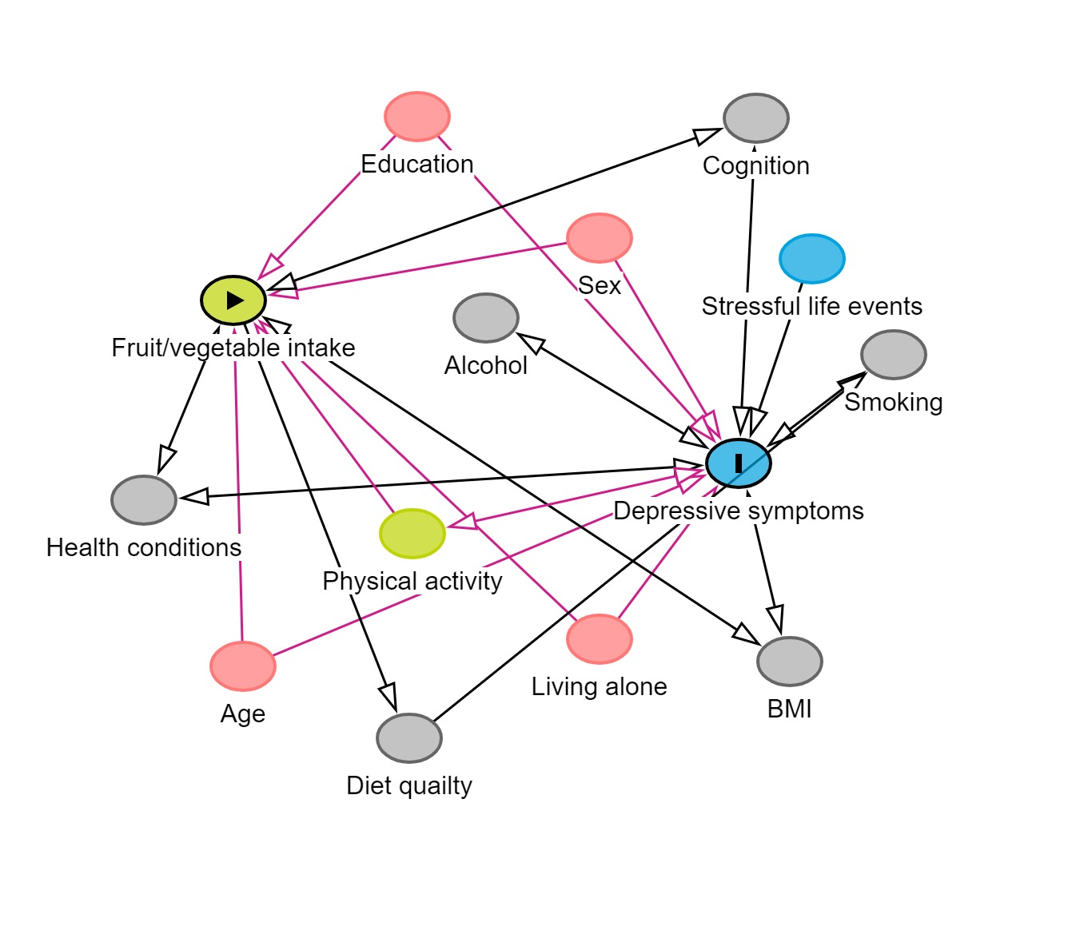
Table S4: Baseline characteristics of included versus excluded participants
 | Included  n = 3,483 | Excluded*  n = 3,998 | p-value
Age, years (SD) | 58.5 ( 8.2 ) | 61.9 ( 9.2 ) | <0.001
Female n, (%) | 51.4 % | 55.0 % | 0.002
Educational attainment, score (SD) | 3.5 ( 1.7 ) | 3.1 ( 1.7 ) | <0.001
Live alone n, (%) | 15.2% | 22.4 % | <0.001
BMI, kg/m² (SD) | 25.4 ( 3.8 ) | 25.5 ( 4.2 ) | 0.7943
Physical health, score (SD) | 1.4 ( 1.5 ) | 1.7 ( 1.7 ) | <0.001
Cognitive health, z-score (SD) | 0.2 ( 1.0 ) | -0.2 ( 1.0 ) | <0.001
Fruit intake/day, mean serves (SD) | 1.0 ( 0.8 ) | 0.9 ( 0.8 ) | <0.001
Vegetable intake/day, mean serves (SD) | 1.2 ( 0.8 ) | 1.0 ( 0.7 ) | <0.001
Depressive symptoms, score median (IQR) | 18.0 ( 4.0 ) | 19.0 ( 5.4 ) | <0.001
* Based on participants who provided this data. Abbreviations: SD – standard deviation; BMI – body mass index, IQR – Inter quartile range
S5: Sensitivity analysis: Associations between vegetable intake (including potatoes) and depressive symptoms over time (5 – 11 years), n = 3483

 | Fully adjusted
 | β | 95% CI
Vegetables including potatoes
- All cohorts – low
- MADT – moderate | -.000 | -.005, .005
- MADT – high | -.002 | -.007, .003
- MTSADA – moderate | -.003 | -.015, .010
- MTSADA – high | -.016 | -.029, .-002
- OATS – moderate | -.016 | -.028, .-004
- OATS – high | -.005 | -.017, .007
- SATSA – moderate | -.007 | -.017, .003
- SATSA – high | -.003 | -.014, .008
- Combined – moderate | -.005 | -.012, .001
- Combined – high | -.004 | -.008, .001
Analysis based on log transformed depressive symptoms. Model adjusted for age, sex, education, living alone status, BMI, physical health and cognitive ability. MADT – Middle Age Danish Twins Study; MTSADA – Minnesota Twin Study of Adult Development and Aging; OATS – Older Australian Twins Study; SATSA – Swedish Adoption/Twin Study of Aging

S6: ICEFALCON analysis: Associations between fruit vegetable intake and depressive symptoms over time (5 – 11 years), n = 2506
 | Fruit |  | Vegetable
 | β | 95% CI | β | 95% CI
Model 1 - Self
- MADT | -.000 | -.003, .003 | -.003 | -.007, .000
- MTSADA | -.008 | -.017, .000 | -.010 | -.016, -.003
- OATS | .001 | -.005, .006 | -.001 | -.007, .006
- SATSA | -.010 | -.020, .001 | -.002 | -.007, .003
- Combined | -.003 | -.008, .002 | -.004 | -.007, -.000
Model 2 - Co-twin
- MADT | -.000 | -.003, .003 | .000 | -.003, .003
- MTSADA | -.006 | -.013, .002 | -.002 | -.009, .005
- OATS | .004 | -.001, .008 | -.001 | -.006, .004
- SATSA | -.010 | -.021, .000 | .004 | -.001, .009
- Combined | -.002 | -.007, .004 | .000 | -.002, .003
Model 3 – Change between models 1 & 2
- MADT | -.000 | -.003, .003 | -.003 | -.007, .000
- MTSADA | -.008 | -.017, .000 | -.010 | -.016, .003
- OATS | .002 | -.004, .007 | -.001 | -.007, .006
- SATSA | -.010 | -.020, .001 | -.002 | -.007, .003
- Combined | -.003 | -.008, .002 | -.004 | -.007, -.000
Self – represents association between twin-self intake and twin-self depressive symptoms. Co-twin -represents association between twin-self intake and co-twin depressive symptoms. Analysis based on log transformed depressive symptoms. Fruit and vegetable serves per day residualised for age, sex, education, living alone status, BMI, physical health and cognitive ability. MADT – Middle Age Danish Twins Study; MTSADA - Minnesota Twin Study of Adult Development and Aging; OATS - Older Australian Twins Study; SATSA - Swedish Adoption Twin/Study of Aging

References
1 Ireland, P. et al. Development of the Melbourne FFQ: a food frequency questionnaire for use in an Australian prospective study involving an ethnically diverse cohort. Asia Pac J Clin Nutr 3, 19-31 (1994).
2 Hodge, A., Patterson, A. J., Brown, W. J., Ireland, P. & Giles, G. The Anti Cancer Council of Victoria FFQ: relative validity of nutrient intakes compared with weighed food records in young to middle-aged women in a study of iron supplementation. Aust N Z J Public Health 24, 576-583, doi:https://doi.org/10.1111/j.1467-842X.2000.tb00520.x (2000).
3 Xinying, P. X., Noakes, M. & Keogh, J. Can a food frequency questionnaire be used to capture dietary intake data in a 4 week clinical intervention trial? Asia Pac J Clin Nutr 13, 318-323 (2004).
4 Lewis, J., Milligan, G. C. & Hunt, A. NUTTAB95 : nutrient data table for use in Australia. (Food Standards Australia New Zealand, 1995).

