Supplementary information for: Integrating Gene Expression Analysis and Ecophysiological Responses to Water Deficit in Leaves of Tomato Plants
Bortolami Giovanni, de Werk Tobias, Larter Maximilien, Thonglim Ajaree, Mueller-Roeber Bernd, Balazadeh Salma, Lens Frederic

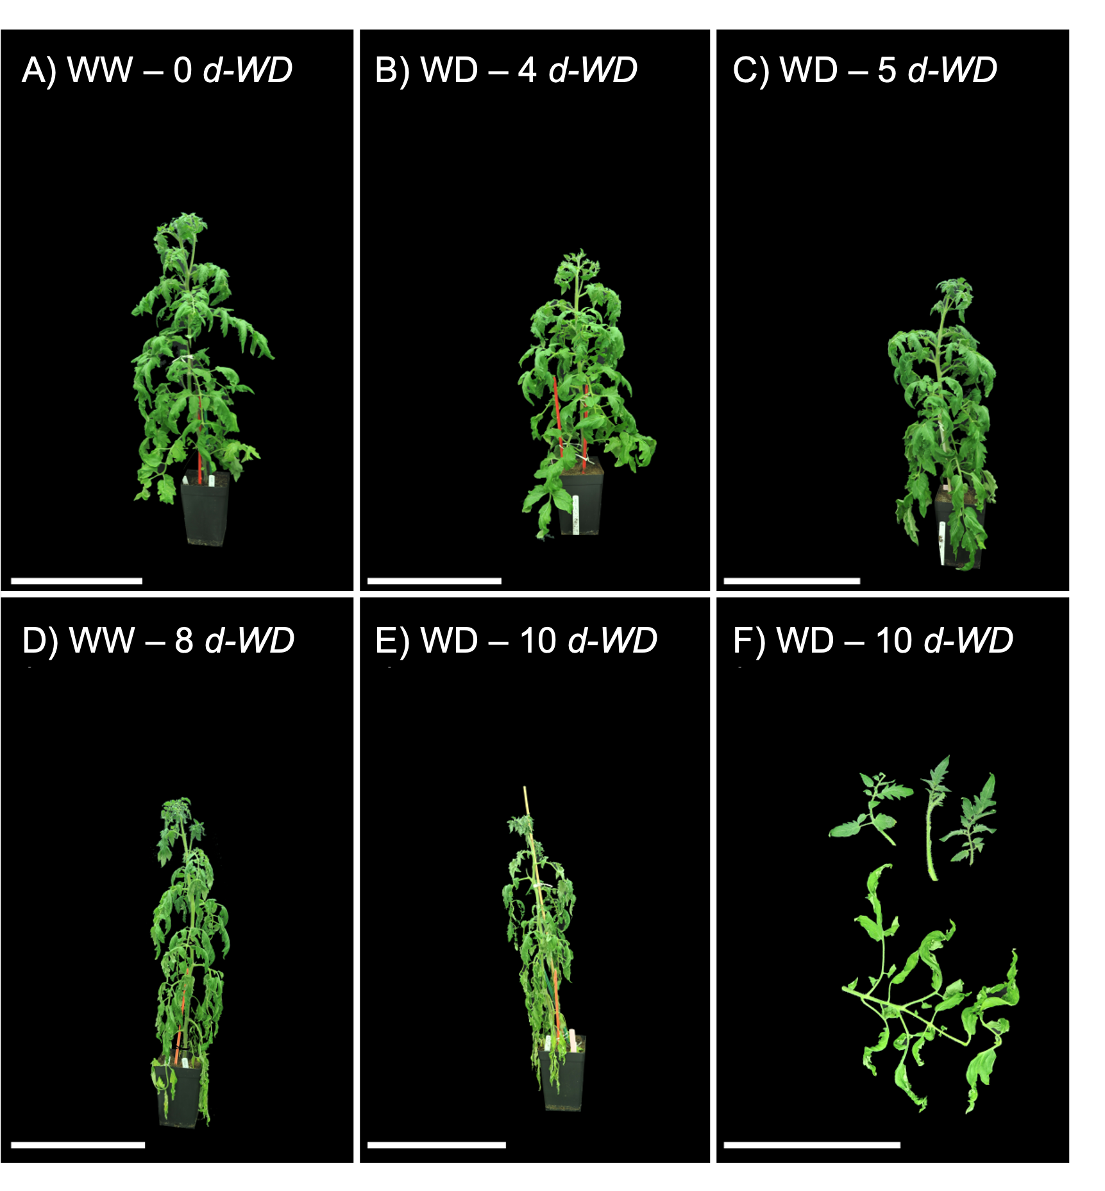
Supplementary Figure S1. Visual change of plant morphology over increasing water deficit from (A) well-watered plants to plants (E) 10 days after the start of the water deficit (d-WD). F) Detail of sampled single mature compound leaf (bottom) and three younger leaves from the same individual (top) at 10d-WD. (A-E) Scale bars=50 cm, (F) Scale bar=25cm.

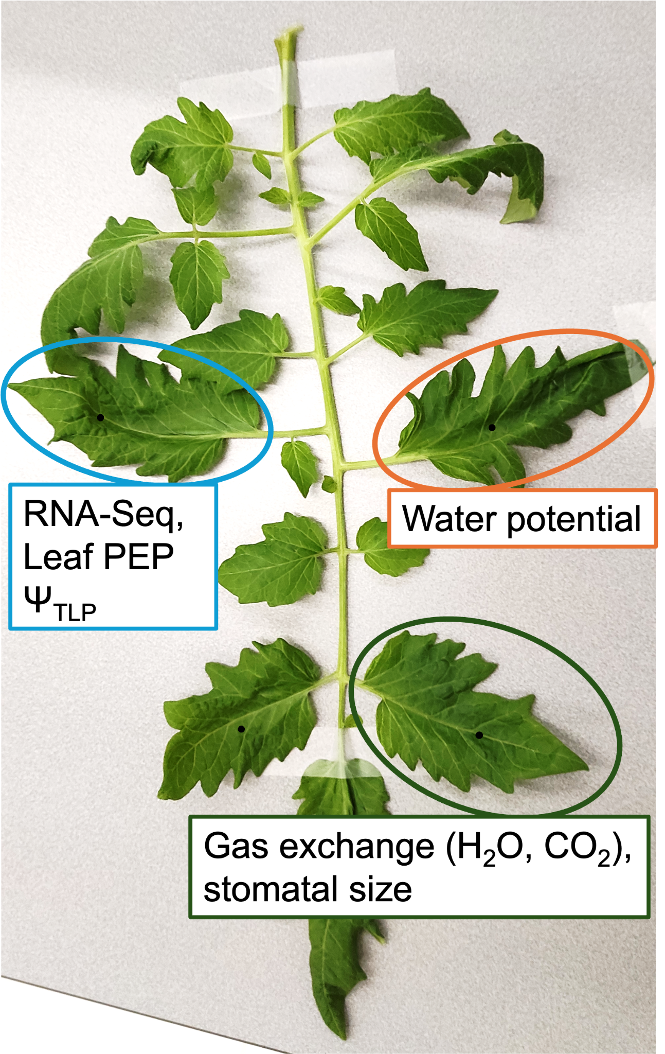
Supplementary Figure S2. A compound leaf from the 6-8th node, showing leaflets selected for gas exchange, stomatal size, RNA-Seq, leaf PEP, Ψ_{TLP,} and water potential analyses.

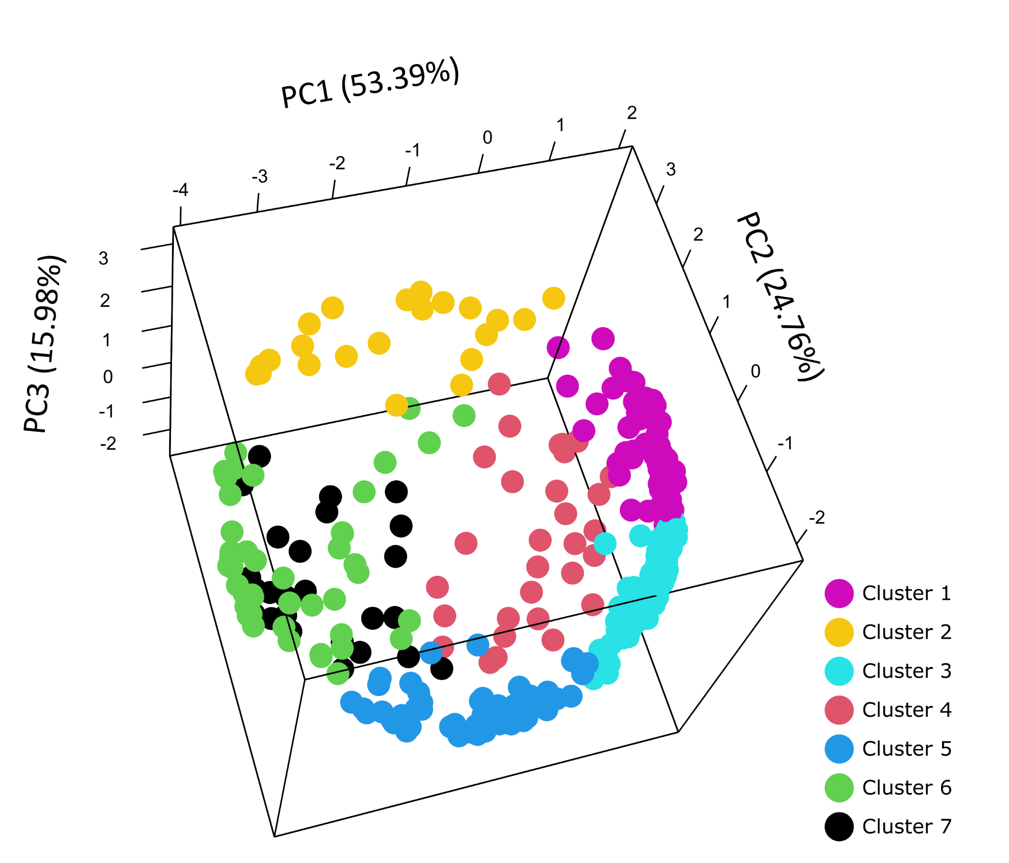

Supplementary Figure S3: Clustering accuracy as viewed on the first three principal components. Genes (dots) are colored according to cluster assignments. The explained variance of each principal component is given in brackets.
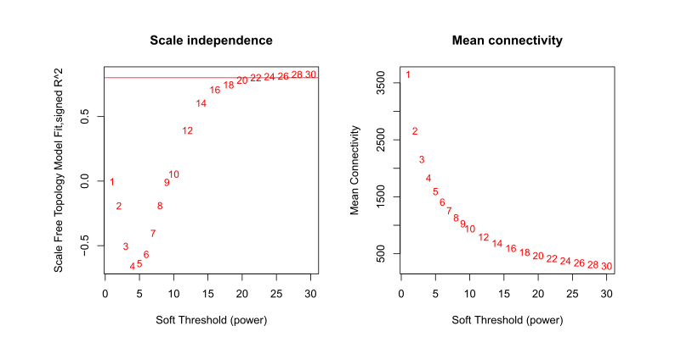

Supplementary Figure S4. Scale-free topology model fit and mean connectivity for different soft threshold powers. The left panel denotes the scale-free topology model fit (y-axis) as a function of various soft threshold powers (x-axis), with the aim of selecting a power that ensures the network adheres to a scale-free topology. The right panel shows the mean connectivity (y-axis) across the same range of soft threshold powers (x-axis). A soft-thresholding power of 20 was chosen as a trade-off between the two, achieving a scale-free fit while maintaining connectivity within the network.

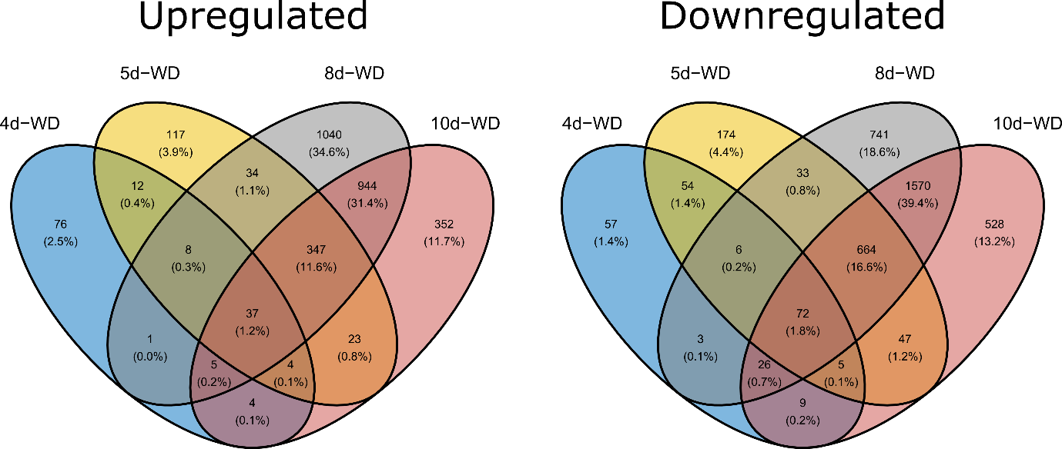
Supplementary Figure S5: Venn diagram of up- and downregulated genes per time point. The numbers of genes for a given time point or time point intersect are given in the respective section, the percentage in brackets represents the fraction of the total number of differentially expressed genes.

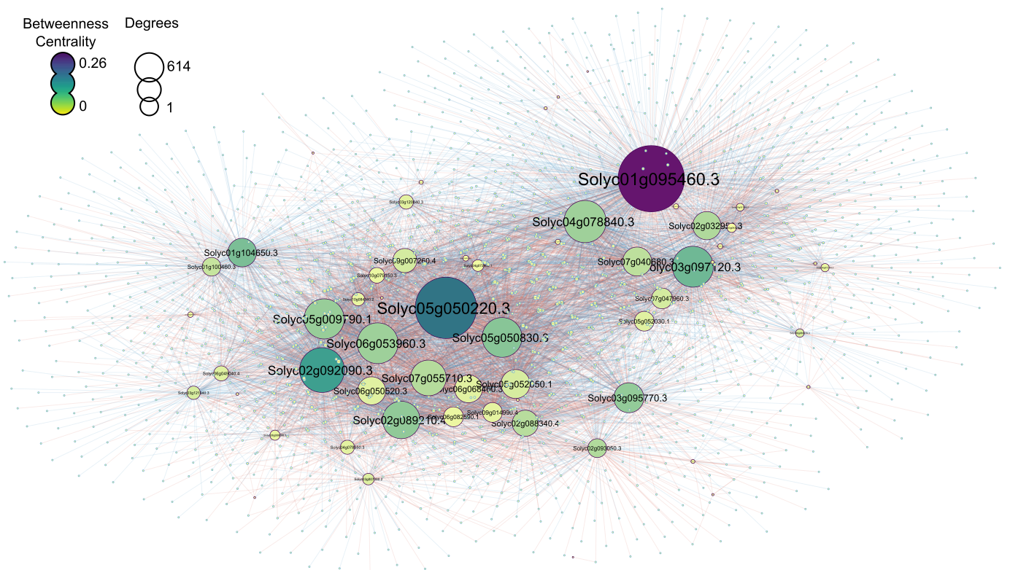
Supplementary Figure S6: Transcription factors co-expression network. Every node represents a gene encoding a transcription factor, and every edge represents a significant positive or negative correlation in their expression profile in the different treatments (WW and WD) and sampling dates. The node size was adjusted to reflect the number of edges (degree), and the color scale reflects the betweenness-centrality from yellow (low) to dark purple (high).

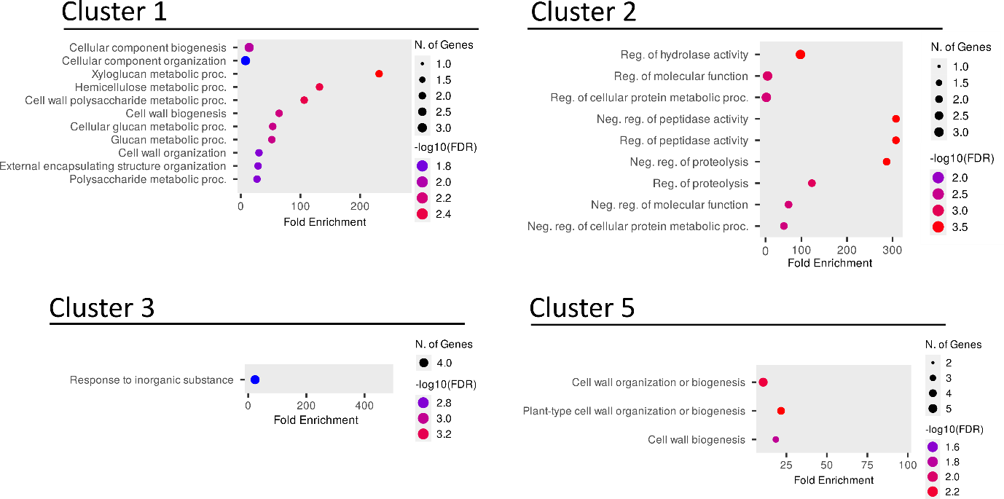

Supplementary Figure S7: Gene ontology enrichment. Dot plots denoting significantly (p_{adj} < 0.05) enriched GO terms (biological process; BP) within respective clusters. P-values are given on a color scale from more significant (lower p-value; red) to less significant (higher p-value; blue). Dot size corresponds to the number of genes within an enriched GO term; fold enrichment (observed genes / expected genes) is given on the x-axis. The plots were generated using ShinyGO v0.77 (Ge et al., 2020).

References:
Ge, S. X., Jung, D., & Yao, R. (2020). ShinyGO: A graphical gene-set enrichment tool for animals and plants. Bioinformatics, 36(8), 2628–2629. https://doi.org/10.1093/bioinformatics/btz931

