Mechanical properties of steel fiber-reinforced rubber concrete after elevated temperature
Jiongfeng Liang¹, Kaiwei Liu¹, Caisen Wang², Xuegang Wang³, Jicheng Liu ^{*4,5}

¹Faculty of Civil & Architecture Engineering, East China University of Technology, Nanchang, China
²College of Architecture and Civil Engineering, Beijing University of Technology, Beijing, 100124, China
³School of Water Resources & Environmental Engineering, East China University of Technology, Nanchang, China
⁴College of Civil and Architecture Engineering, Wenzhou University, Wenzhou, China
⁵Key Laboratory of Engineering and Technology for Soft Soil Foundation and Tideland Reclamation of Zhejiang Province, Wenzhou, China

Abstract: The frequency of engineering fires is increasing, and the study of the residual mechanical properties of steel fiber-reinforced rubber concrete (SFRRC) after high temperatures is essential for evaluating its load-bearing capacity after fire. This study examines the mechanical properties of SFRRC after subjected to elevated temperatures, considering the impacts of varying steel fiber amounts (V_{sf} =0.6, 1.2%) and different rubber substitution ratio (r_{g}=0, 5, 10, 15%) on the specimens after different temperatures (20, 200, 400, 600, 800 °C). All specimens were tested in cubic and axial compression, split tensile and four-point flexure tests. The findings indicated that steel fibers and rubber enhance the durability and safety of concrete by reducing the risk of cracking at high temperatures and inhibiting crack extension. When 1.2% steel fibers and 5% rubber particles were added, the mechanical properties of specimens after exposure to high temperatures were improved compared to normal concrete, with cube compressive strength, uniaxial compressive strength, splitting tensile strength, and flexural strength increased by 0.23-8.48%, 1.13-4.16%, 22.92-44.23%, and 3.03-19.81%, respectively. In this study, the mechanism of temperature action on SFRRC was analyzed. On the basis of experimental data, prediction models for SFRRC after high temperatures were proposed. The models were compared with experimental data and previous research results. The results of the study will help to promote the formulation of specifications in related fields and promote the practical application of SFRRC as a novel material.
Keywords: failure modes; high temperature; mechanical properties; prediction models; rubber particles; steel fiber-reinforced rubber concrete; steel fibers

1 Introduction

The management of end-of-life waste tires has become a significant global concern due to the continuous expansion of the transport sector, and the environmental pollution and sanitary infection caused by the production and disposal of a large number of waste tires has attracted great attention [1]. Currently, it is estimated that one billion tires are scrapped every year worldwide, with over half of them being improperly treated, posing a serious challenge to the environment and resources [2]. To tackle this challenge, waste tires are processed into rubber particles and integrated into the concrete preparation process to create a new material, rubber concrete (RC). When concrete is subjected to stress, the fine aggregate (FA) effectively fills the voids in the concrete by closely stacking and interlocking with each other, thus enhancing the compactness and overall performance of the concrete. The incorporation of rubber particles into concrete as a partial replacement for FA allows for the utilization of their distinctive elasticity and deformability, which enables the absorption and dispersion of stress, as well as the filling of voids within the concrete, thereby achieving a comparable filling effect to that of FA. While the incorporation of rubber particles may lead to a slight decline in the overall strength of concrete, they offer considerable benefits in terms of enhanced abrasion and frost resistance, augmented impact resistance and toughness [3-6], augmented damping ratios, reduced weight, increased ductility, and improved thermal and acoustic insulation properties [7, 8]. Consequently, rubber granules have become the material of choice for use in specific application scenarios where flexible structures or lightweight designs are required, as they are capable of partially replacing conventional sand. Due to these unique performance advantages, RC has a wide range of application potential in many fields such as civil engineering, road paving, noise barriers, etc.，and provides a strong material support for building a more environmentally friendly, energy-saving and safer modern infrastructure. Therefore, the development prospect of RC is full of attractiveness and hope.
However, while the introduction of rubber brings unique flexibility and deformability to cementitious materials, its inherent lack of strength becomes a significant challenge. The incorporation of rubber particles inevitably increases the porosity within the material, and these micropores may not only weaken the structural integrity, but also become areas of stress concentration, affecting the strengths of the material. In addition, the hydrophobicity of the rubber leads to a relatively weak interface transition zone (ITZ) between the rubber and the cement, which damages the mechanical properties of the concrete [9-11], excessive incorporation will weaken the internal connection and weaken the effect of improving brittleness. Its lower bond strength further limits the mechanical performance of RC. This has become a key issue that restricts the further development of RC. Studies have shown that steel fiber (SF), as an efficient reinforcement material, can control cracks, prevent crack width, improve shear strength and hardness, and reduce the deflection of concrete beams [12], and has gradually entered the field of vision of researchers. Studies show that adding SF to concrete can enhance its tensile strength, ductility and shear stress resistance [13-14]. More and more researchers have started to incorporate SF into RC thus exploring the prospect of steel fiber-reinforced rubber concrete (SFRRC) as a novel composite material [15-17]. Eisa et al. [18] found adding 10% rubber increased the tensile and compressive strengths of RC containing 1.0% SF by 11% and 41%, respectively. Abdulaziz et al. [19] demonstrated that the post-peak and flexural strain of SFRRC, which contained 20% rubber and 40 kg/m³ of SF, were comparable to those of normal concrete in respect of endurance and mechanical qualities. According to Alshaikh et al. [20], the structural ductility of concrete was enhanced by the incorporation of SF and rubber, and the frame deflection of SFRRC was 29.5% higher than that of ordinary frames. Fu et al.'s research [21] showed that the SF content mostly affected the tensile and flexural strength of SFRRC, whereas the rubber and SF content primarily impacted the compressive strength of the material. SF was the main determinant of the strain-hardening and softening behavior of SFRRC. According to Dong et al. [22], the overall mechanical properties of SFRRC, which contained 1.5% SF and 10% rubber particles, were better than those of normal concrete. The material's toughness damage has been reduced, while its shear, flexural, compressive strength, and elastic modulus have been increased. Rubber and SF were discovered to have a synergistic impact by scanning electron microscope and damage mechanism observation, which combined enhanced the mechanical characteristics of concrete. Lyu et al. [23] found that the incorporation of crushed rubber and SF into ultra-high performance concrete (UHPC) showed promising potential at high temperatures to mitigate the explosive spalling behavior common in conventional UHPC using a water sorptivity test, scanning electron microscope - backscatter diffraction and computed tomography analysis, the effects of SF and rubber on the microstructure of UHPC at high temperature were found. With further research, SFRRC is expected to be a major force for progress in the field of engineering materials in the future.
Globally, engineering fires have increased in frequency in recent decades, posing an important danger to property and human safety [24]. When evaluating the degree of performance deterioration of concrete structures after elevated temperature settings, one important characteristic to consider is the concrete's residual mechanical properties after high temperature. For new composite concrete materials, their mechanical properties after high temperatures are key factors in determining whether they can be widely used. Therefore, an in-depth study of the mechanical property changes of SFRRC under high-temperature conditions is not only crucial for evaluating its residual load-bearing capacity after a fire, but also provides a scientific basis and guarantee for its potential application in high-temperature environmental engineering fields, such as nuclear power plants, industrial kilns and other high-risk environments. Researches have demonstrated that adding fibers to cementitious composites may not only greatly enhance their properties at ambient temperature but also effectively mitigates the degradation of their properties after high temperatures [22, 25, 26]. Table 1 lists some studies of rubber concrete (RC) or steel fiber concrete (SFC) after the action of high temperatures [27-39], but there remains a notable dearth of investigations specifically focused on the residual mechanical properties of SFRRC after exposure to elevated temperatures.
This study focuses on exploring the intrinsic mechanisms and performance changes of SFRRC after high-temperature conditions, aiming to fill the research gap concerning the post-high-temperature performance of this material. By evaluating the impact of high temperatures on key performance indicators of SFRRC, such as cubic compressive strength (f_{cu}), axial compressive strength (f_{c}), splitting tensile strength (f_{sp,t}), and flexural strength (f_{fl}), and comparing it with normal concrete, the advantages and usability of SFRRC are demonstrated. Based on experimental data, we have established a predictive model for the residual mechanical properties of SFRRC after high-temperature exposure. Through comparison and validation with measured data and previous experimental data, the accuracy and reliability of the model have been ensured, providing a theoretical foundation for the application and optimization of SFRRC after high-temperature environments. It also provides data support for the exploration of the constitutive relationship of this material after high temperature, which is helpful to promote the formulation of specifications in related fields and promote the practical application of this new material.

Table 1 Synopsis of studies on the mechanical characteristics of SFC or RC with elevated temperatures.
Replacement materials | T(℃) | Test properties | Reference
R, RCA | AT, 200, 400, 600 | f_{c}, E, ε_{p}, M_{l}, toughness | Tang (2020) [27]
R | AT, 150, 200, 300, 400 | f_{c}, f_{fl}, M_{l}, porosity, relative fall ultrasonic velocity | Guelmine (2016) [28]
R | AT, 200, 400, 600 | f_{c}, f_{t}, M_{l}, density | Abdullah (2018) [29]
R | AT, 200, 400, 600, 800 | f_{c}, f_{t}, E, ε_{p}, M_{l} | Bengar (2020) [30]
R | AT, 400, 600, 800 | f_{c}, f_{t} | Marques (2013) [31]
R | AT, 200, 400, 600, 800 | f_{c}, f_{t}, E, ε_{p}, ε_{u}, M_{l}, toughness | Mousavimehr (2019) [32]
SF, SIF | AT, 100, 200, 300, 400, 500, 600, 700, 800 | f_{c}, f_{cu}, f_{t} | Zheng (2013) [33]
SF, PF | AT, 120, 200, 300, 400, 500, 600, 700, 800, 900 | f_{fl}, f_{t} | Li (2016) [34]
SF, SIF | AT, 200, 300, 400, 500, 600, 700, 800 | f_{c}, E, ε_{p} | Tai (2011) [35]
SF, Nano‐concrete | AT, 400, 600, 800 | f_{c}, f_{t}, f_{fl} | Zhang (2021) [36]
SF, PF | AT, 150, 300, 450, 600 | f_{c}, f_{t}, E, M_{l}, porosity | Pliya (2010) [37]
R, SF, RCA | AT, 200, 400, 600 | f_{c}, E, M_{l}, toughness | Guo (2014) [38]
R,SF,PVA,CW, PE, SIF | AT, 200, 400, 600, 800 | f_{t}, M_{l} | Zhang (2023) [39]
Note: R is the rubber, SF is the steel fiber, RCA is the recycled concrete aggregates, SIF is the silica fume, PF is the polypropylene fiber, PVA is the polyvinyl alcohol fiber, PE is the polyethylene fiber, CW is the calcium carbonate whisker, AT is the ambient temperature, ε_{p} is the peak strain, ε_{u} is the ultimate strain, E is the elastic modulus, M_{l} is the mass loss.

2 Experimental Program

2.1 Raw materials and mixing ratios

Masonry cement with a grade of 32.5 and a specific gravity of 3.05 was used in this work, achieving a strength grade of 32.5MPa after 28 days of curing. In the experiment, corrugated steel fibers made of ordinary steel were selected, featuring a cross-sectional shape, an aspect ratio of 40, a length of approximately 35mm, an ultimate tensile strength not less than 600MPa, an elastic modulus of 200GPa, a specific gravity of 7.82, and a density of 6500kg/m³. The rubber particles were continuously graded, ranging in size from 0.50 mm to 2.00 mm, with a specific gravity of 1.05, and were derived from crushed waste tires. The coarse aggregate (CA) consisted of stone fragments crushed to a size of 5-20 mm. The fine aggregate (FA) was made up of sand particles with a fineness modulus of 2.65 and a particle size of no more than 4.75mm. Natural fine aggregate grain size gradation meets the requirements of the specification for natural sand in Zone II [40]. In this test, rubber was used to replace some river sand. Table 2 shows some of the raw material properties. The rubber and SFs utilized in this study are shown in Fig. 1. The concrete grade was C30. Fig 2 illustrates the particle size classification of coarse aggregate and fine aggregate. Considering the relatively large density differences among steel fibers, rubber, and river sand, and based on practical engineering considerations, this experiment took into account the volume fraction of steel fibers when incorporating them. When adding rubber, an equivalent mass replacement of fine aggregates was adopted.

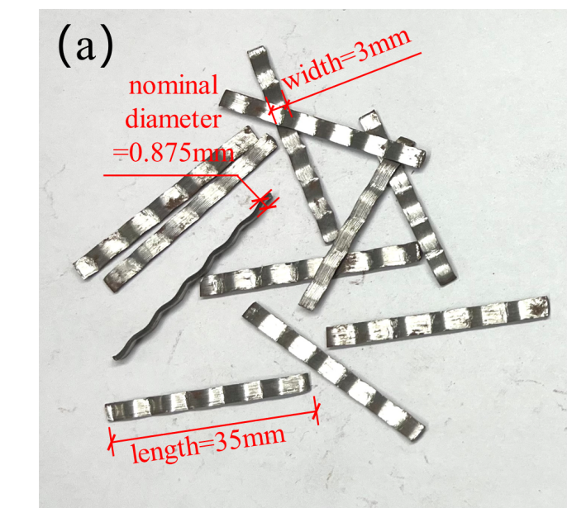 | 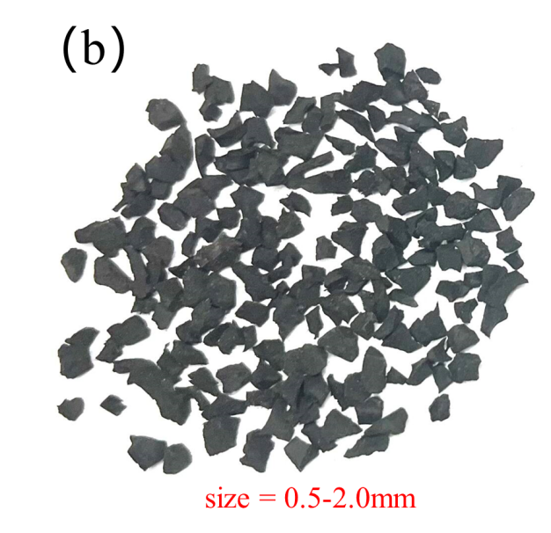
Fig. 1 Raw materials: (a) Steel fibers, (b) Rubber crumbs.

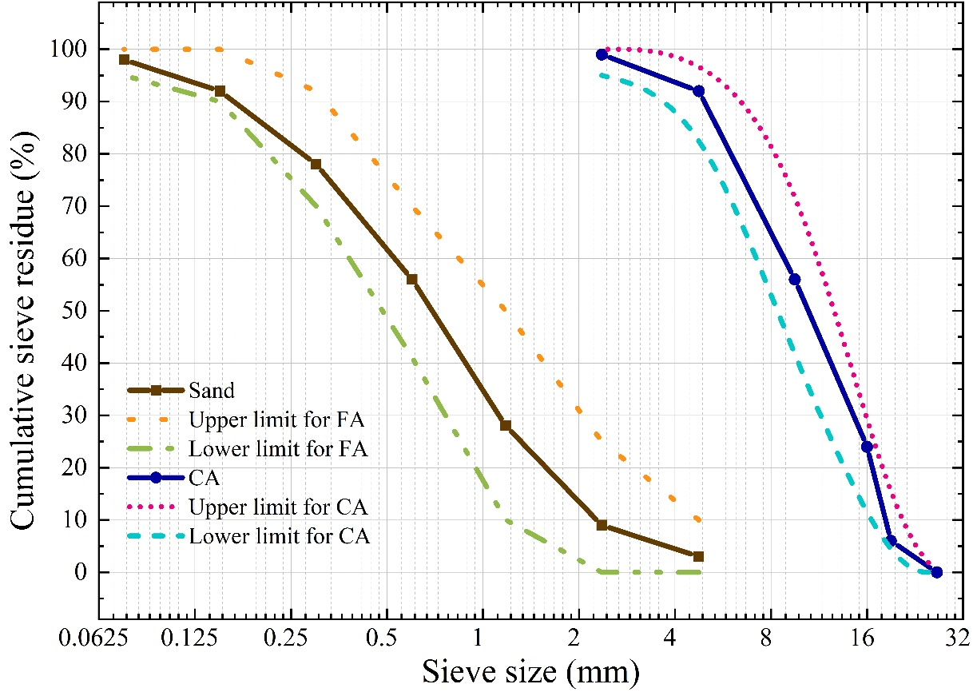
Fig. 2 Gradation curve of coarse aggregate and fine aggregate.

Table 2 Raw material properties
Material | Bulk density  (kg/m³) | Apparent density  (kg/m³) | Water absorption  (%) | Silt content  (%) | Crushing value  (%) | Fineness modulus | Specific gravity
coarse aggregates | 1493 | 2750 | 0.50 | 4.10 | 5.10 | - | 2.80
river sand | 1460 | 2570 | 1.13 | 1.56 | - | 2.60 | 2.68

In this research, nine distinct concrete mixes with varying mix ratios were created and manufactured. The mechanical characteristics of SFRRC after various temperatures were examined, and the mixes were categorized into three groups: control, SF0.6, and SF1.2 based on the SF amounts. The experimental program took into account three primary characteristics, namely the amounts of SF, the ratio of rubber substitution, and the temperature. Specifically, (a) two steel fiber amounts (V_{sf}): 0.6, 1.2%; (b) four rubber substitution ratios (r_{g}): 0, 5, 10, 15%; and (c) five temperatures (T): 20, 200, 400, 600, 800 ℃. The water-cement ratios for nine mixtures were 0.39. Table 3 summarizes the mixing ratios of the details SFRRC mix proportions.

Table 3 Mix proportion of the SFRRC.
Group | Mix | Unit volume consumption（kg/m³） |  |  |  |  |  | V_{sf} (%) | r_{g}(%)
Group | Mix | CA | FA | POC | W | SF | R | V_{sf} (%) | r_{g}(%)
control | NC | 1238 | 506 | 474 | 185 | - | - | - | -
SF0.6 | SF0.6R0 | 1238 | 506 | 474 | 185 | 39 | - | 0.6 | -
 | SF0.6R5 | 1238 | 481 | 474 | 185 | 39 | 25 | 0.6 | 5
 | SF0.6R10 | 1238 | 456 | 474 | 185 | 39 | 51 | 0.6 | 10
 | SF0.6R15 | 1238 | 430 | 474 | 185 | 39 | 76 | 0.6 | 15
SF1.2 | SF1.2R0 | 1238 | 506 | 474 | 185 | 78 | - | 1.2 | -
 | SF1.2R5 | 1238 | 481 | 474 | 185 | 78 | 25 | 1.2 | 5
 | SF1.2R10 | 1238 | 456 | 474 | 185 | 78 | 51 | 1.2 | 10
 | SF1.2R15 | 1238 | 430 | 474 | 185 | 78 | 76 | 1.2 | 15
Note: NC=normal concrete, r_{g}= the substitution ratio of rubber, V_{sf} =volume fraction of steel fibers, POC=portland cement, W=water.

2.2 Specimen preparation process

For this test, 540 concrete samples were made. All the components were weighed in accordance with the mix proportion, and the FA was replaced proportionately with rubber crumb before being combined with it. In Fig. 3, the mixing procedure is displayed. In order to ensure that the concrete has good workability, the mixing process is strictly followed in Fig. 3. During the mixing process, SF is manually added to the mixture at a consistent rate, and the entire mixing process is controlled for about 5 minutes to prevent over-mixing. After mixing, to assess the workability of the mixes, firstly, the test pieces were tested for their compatibility. The slump values of all the samples tested were within the range of 75-90 mm, indicating good flowability and ease of placing. The concrete was poured into the moulds, placed on a vibrating table, vibrated and smoothed, and then cured for 24 hours. Upon completion of curing, the specimens were removed for natural drying and cured in a curing chamber for 28 days in preparation for subsequent mechanical property testing and analysis.

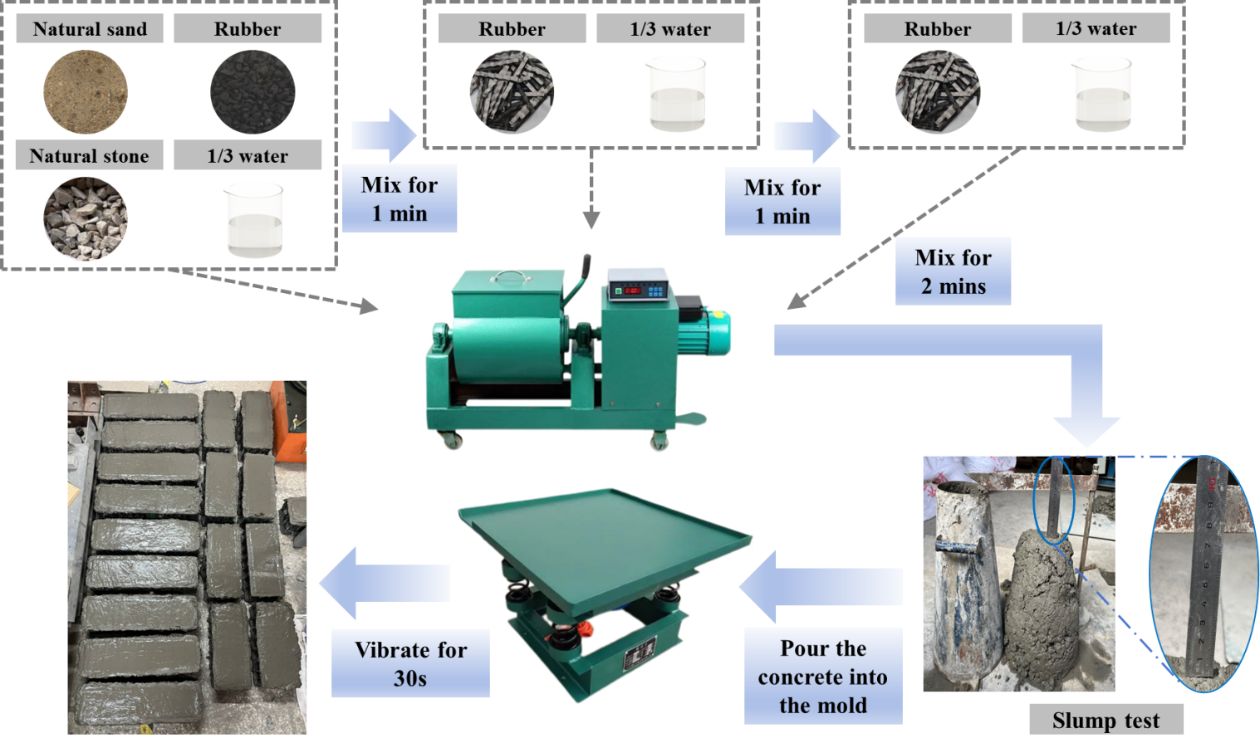
Fig. 3 Specimen preparation process.

2.3 Heating program

The heating apparatus chose the RX3-45-9 box-type resistive furnace, as seen in Fig. 4. Every sample underwent three phases of heating, followed by a three-hour period of steady temperature and cooling. In the course of the experiment, the specimens were progressively raised from room temperature (20°C) to the predetermined temperature in the furnace according to the ISO-834 standard flame profile [41]. At each temperature point, steady state was continued for three hours to ensure that the temperature in the center of the sample also reached the predetermined target. At the end of the constant temperature phase, the specimens were allowed to naturally cool down to ambient conditions, ensuring accurate and repeatable test conditions for evaluating their post-heat behavior.
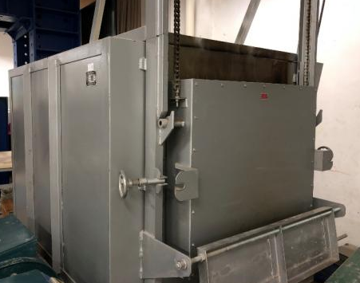
Fig. 4 RX3-45-9 box-type resistance furnace.

2.4 Mechanical Performance Test

For every concrete mix, 60 specimens of concrete were prepared. 30 cubic specimens measuring 100 mm × 100 mm × 100 mm underwent split tensile and compression tests, 15 prismatic specimens measuring 100 mm × 100 mm × 300 mm underwent axial compression tests, and 15 prismatic specimens measuring 100 mm × 100 mm × 400 mm underwent a four-point flexural test. To determine the effect of temperature upon the residual characteristics of SFRRC, specimens of identical volumes and mix ratios were examined both at ambient temperature and heated to four distinct temperatures. Each concrete mix's mechanical qualities were measured three times in parallel, with the average value serving as the test result. The YAW-3000 computer-controlled electro-hydraulic servo testing apparatus was utilized for all tests, and the test protocols were strictly adhered to the Chinese standard " GB/T 50081-2019 Standard for test methods of concrete physical and mechanical properties" [42]. During the experiment, the displacement collector installed on the lower side of the lower plate was used to automatically collect the vertical deformation data of the specimen and transmit them to the computer in real time via electrical signals.

3 Failure modes

Figs. 5-8 show the typical failure modes for some specimens after elevated temperatures. Each picture was randomly selected from three parallel specimens. The failure modes of the concrete after 800°C were essentially unaffected by steel fiber (SF) and rubber and this was comparable to the behavior of normal concrete. The failure modes of NC, SF0.6R0, SF1.2R0, SF0.6R5, SF0.6R10 after 600°C were selected as examples.

3.1 Cubic compressive failure mode

Fig. 5 illustrates the fracture modes following cubic compression after 600°C. The normal concrete specimens mainly showed a conical damage pattern, accompanied by obvious spalling phenomenon, while the unstripped portion showed vertical and through cracks. The spalling phenomenon was significantly alleviated when SF were added to the concrete. The concrete fractures got finer and the general integrity of the specimens improved as the amount of SF was increased. In addition, when the rubber was incorporated into the concrete, the specimens showed significant external bulging deformation at the time of damage, and the cracks on the surface were finer and more numerous, and this phenomenon was more pronounced with the increase of the rubber dosage. The SF was observed to effectively prevent the formation of cracks at room temperature. The rubber exhibited some flexibility and plasticity, while the concrete demonstrated a reduction in brittleness as the dosage of both materials increased. It is particularly noteworthy that the rubber particles melt under high-temperature environment, a process that helps to reduce the water vapor pressure, which in turn promotes the homogeneous dispersion of the cracks. At the same time, SF still maintains a strong restraining effect on the further expansion of cracks, leading to a gradual reduction of crack width and improving the durability and safety of concrete at high temperatures.
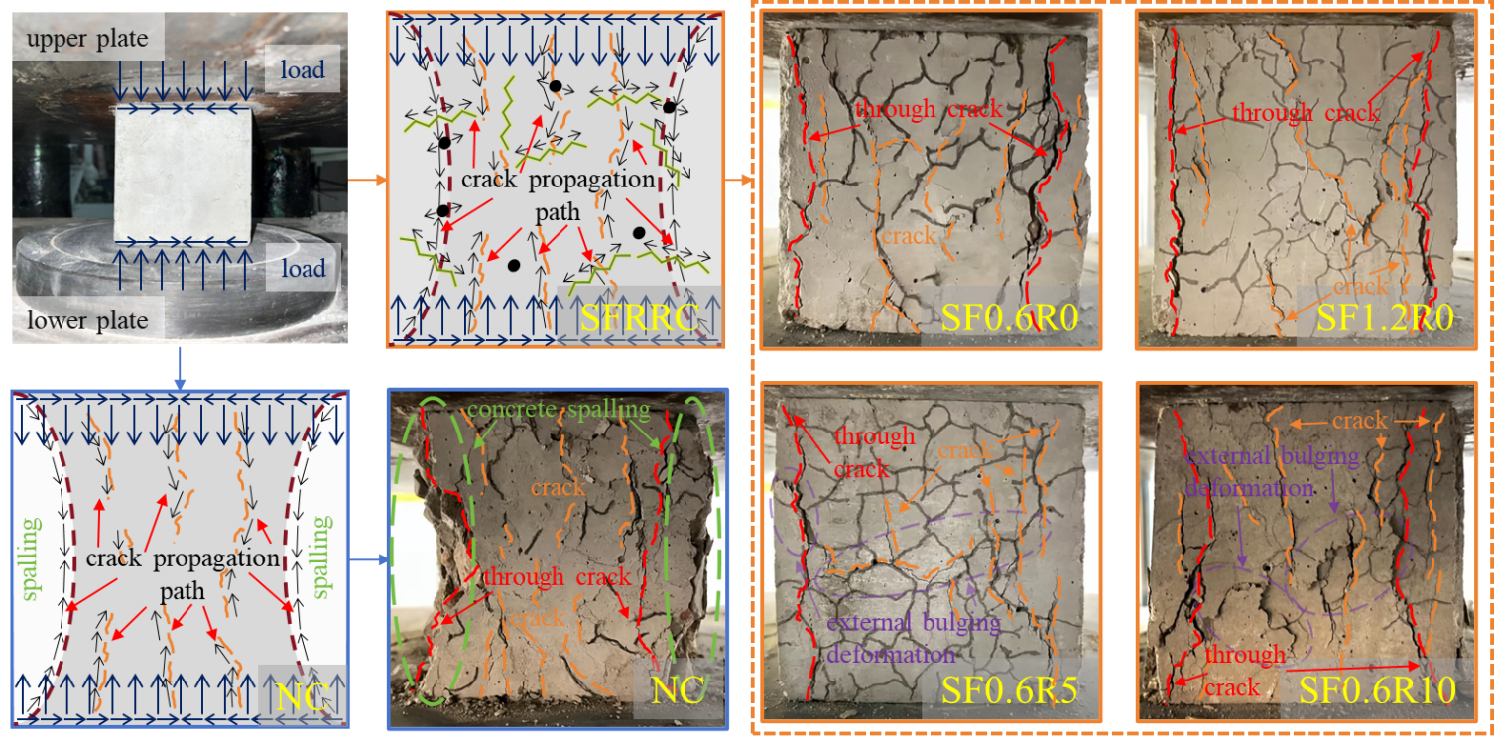
Fig. 5 Cubic compressive failure of the tested concrete.

3.2 Axial compressive failure mode

Fig. 6 illustrates the prismatic specimen's failure modes following axial compression after 600°C. The fracture behavior of the prismatic specimen under compression after high temperature and their relationship with SF and rubber doping were consistent with the case of the cubic specimen. The normal concrete prismatic specimens are easy to form a single main oblique crack under compression, and the failure risk is high. After mixing steel fiber and rubber, the rubber melts to reduce the stress, and the steel fiber significantly disperses the cracks, transforming the main cracks into multiple thin inclined cracks, promoting a more ductile failure mode and effectively reducing the risk of abrupt shear failure.

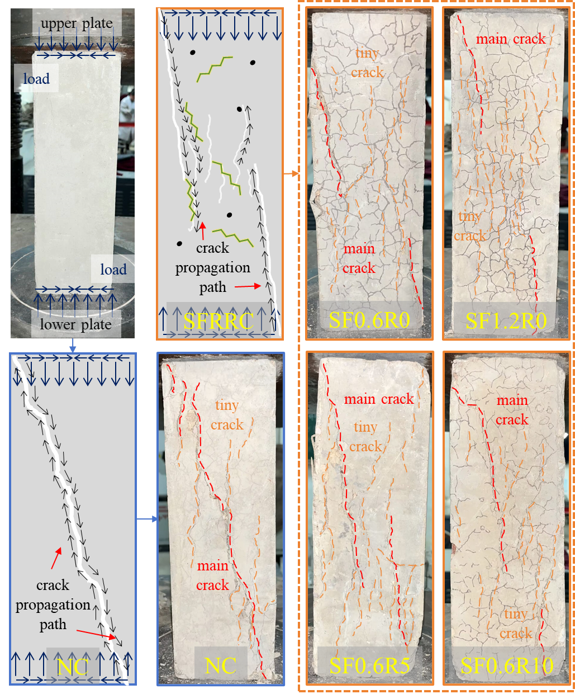
Fig. 6 Compressive failure of the tested concrete.

3.3 Split tensile failure mode

Fig. 7 displays the splitting tensile damage patterns of the specimen after 600°C. At the time of destruction, all specimens were subjected to a sudden and distinct fracture sound, which indicated that the specimens were characterized by brittle destruction. In contrast to the normal concrete cracks, which tend to split directly into two halves and form a clear single crack during damage, the specimens containing SF exhibited unique ductile damage characteristics around the main damage region. These specimens showed many micro-cracks near the damage edge, which expanded and intertwined, thus slowing down the overall damage rate. Rubber was added, which lessened the width of the main crack and the emergence of tiny cracks.

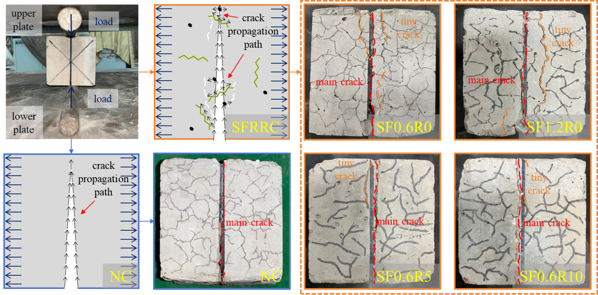
Fig. 7 Cubic compressive failure of the tested concrete.

3.4 Bending damage modes

Fig. 8 illustrates the typical failure pattern of specimens in a four-point flexural beam test after 600°C. During the test, all the specimens experienced a similar damage process under the bending force: the primary fracture started at the span's base and progressed upward. However, it is clearly visible in Fig. 8 that the normal concrete obviously fractured into two parts, showing the characteristic of brittle damage. As SF connected to both sides of the crack, the specimen containing SF was more complete and showed some characteristics of ductile damage. With the number of rubber particles increased, more micro-cracks appeared around the main crack, but did not affect the damage pattern of the specimen.

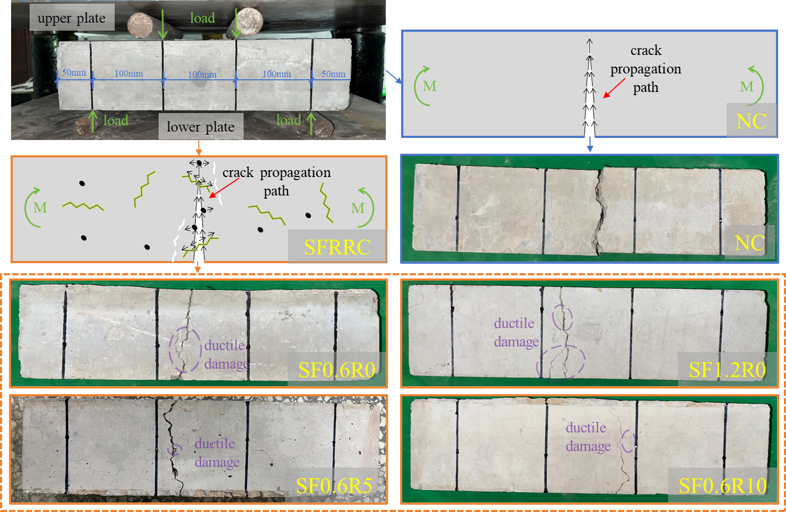
Fig. 8 Flexural failure of the tested concrete.

4 Mechanical property results and discussion

The mechanical characteristics of steel fiber-reinforced rubber concrete (SFRRC) following elevated temperature are shown in Table 4. The specimens in Group SF1.2 had larger cubic compressive strength (f_{cu}), axial compressive strength (f_{c}), splitting tensile strength (f_{sp,t}), and flexural strength (f_{fl}) than those in Group SF0.6 at any temperatures, indicating that the increase of steel fiber content can improve the residual mechanical properties of concrete after high temperature. However, with the increase of rubber substitution ratio, the mechanical properties of the specimens in both groups decreased, indicating that rubber would weaken the residual mechanical properties of concrete. Nevertheless, proper incorporation of steel fiber can effectively inhibit the generation and expansion of cracks through the bridging crack effect, so that the material has a certain residual strength after cracking [13,43], thus partially offset the negative effects of rubber. In the experiments of the SF0.6 and SF1.2 groups, the variance initially exhibited a rising trend with the gradual increasing temperature, but rapidly showed a decreasing trend after 400°C, with much smaller fluctuations in the data. This suggested that the sensitivity of SFRRC to the rubber substitution ratio initially increased with increasing temperature, but this effect decreased sharply when temperature exceeded 400°C.
Table 4 Residual mechanical properties of SFRRC after elevated temperature
 | T(℃) | NC | SF0.6R0 | SF0.6R5 | SF0.6R10 | SF0.6R15 | SF1.2R0 | SF1.2R5 | SF1.2R10 | SF1.2R15 | S²₁ | S²₂
f_{cu} (MPa) | 20 | 35.46 | 36.93 | 34.12 | 29.49 | 22.60 | 38.20 | 35.54 | 31.09 | 23.62 | 29.39 | 30.49
f_{cu} (MPa) | 200 | 30.30 | 33.98 | 29.68 | 23.65 | 17.27 | 35.40 | 30.71 | 25.12 | 18.46 | 39.72 | 40.02
f_{cu} (MPa) | 400 | 28.10 | 30.43 | 26.41 | 20.17 | 14.03 | 32.24 | 28.20 | 22.04 | 15.44 | 38.77 | 40.43
f_{cu} (MPa) | 600 | 16.50 | 20.61 | 17.20 | 13.62 | 9.06 | 21.72 | 17.60 | 14.50 | 10.21 | 18.36 | 17.76
f_{cu} (MPa) | 800 | 6.84 | 8.60 | 6.89 | 5.25 | 3.50 | 9.30 | 7.42 | 5.78 | 3.88 | 3.59 | 4.01
f_{c} (MPa) | 20 | 23.70 | 24.81 | 23.51 | 20.93 | 15.79 | 25.62 | 24.17 | 21.83 | 16.81 | 11.92 | 11.18
f_{c} (MPa) | 200 | 21.38 | 24.18 | 21.37 | 17.01 | 11.39 | 24.83 | 22.27 | 18.08 | 12.01 | 23.32 | 23.51
f_{c} (MPa) | 400 | 19.49 | 22.15 | 18.51 | 15.34 | 8.89 | 23.14 | 19.71 | 16.00 | 9.37 | 23.73 | 26.06
f_{c} (MPa) | 600 | 12.60 | 14.72 | 12.22 | 10.73 | 5.93 | 15.22 | 13.07 | 11.19 | 6.80 | 10.27 | 9.62
f_{c} (MPa) | 800 | 4.70 | 5.69 | 4.53 | 3.57 | 2.20 | 5.02 | 4.89 | 3.83 | 2.52 | 1.64 | 1.01
f_{sp,t} (MPa) | 20 | 2.34 | 2.77 | 2.51 | 2.32 | 2.19 | 3.19 | 2.95 | 2.78 | 2.55 | 0.05 | 0.05
f_{sp,t} (MPa) | 200 | 1.98 | 2.47 | 1.98 | 1.68 | 1.45 | 3.03 | 2.47 | 2.17 | 1.80 | 0.15 | 0.20
f_{sp,t} (MPa) | 400 | 1.44 | 1.90 | 1.31 | 1.14 | 1.00 | 2.16 | 1.77 | 1.55 | 1.28 | 0.12 | 0.10
f_{sp,t} (MPa) | 600 | 0.93 | 1.30 | 0.83 | 0.73 | 0.63 | 1.61 | 1.17 | 1.02 | 0.83 | 0.07 | 0.08
f_{sp,t} (MPa) | 800 | 0.52 | 0.93 | 0.44 | 0.38 | 0.31 | 1.09 | 0.75 | 0.62 | 0.46 | 0.06 | 0.05
f_{fl} (MPa) | 20 | 4.24 | 4.76 | 4.42 | 4.14 | 3.86 | 5.31 | 5.08 | 4.83 | 4.62 | 0.11 | 0.07
f_{fl} (MPa) | 200 | 3.41 | 3.98 | 3.38 | 2.86 | 2.50 | 4.60 | 3.97 | 3.39 | 3.02 | 0.31 | 0.36
f_{fl} (MPa) | 400 | 2.12 | 2.67 | 1.87 | 1.45 | 1.19 | 3.31 | 2.30 | 1.78 | 1.47 | 0.31 | 0.49
f_{fl} (MPa) | 600 | 0.99 | 1.39 | 0.75 | 0.54 | 0.42 | 1.90 | 1.02 | 0.69 | 0.53 | 0.14 | 0.28
f_{fl} (MPa) | 800 | 0.35 | 0.54 | 0.21 | 0.14 | 0.10 | 0.80 | 0.37 | 0.19 | 0.13 | 0.03 | 0.07
Note:S²₁ is the variance in Group SF0.6(SF0.6R0, SF0.6R5, SF0.6R10, SF0.6R15), S²₂ is the variance in Group SF1.2(SF1.2R0, SF1.2R5, SF1.2R10, SF1.2R15).

4.1 Cracking and spalling behavior

At ambient temperature, in the initial stage, the hydration products effectively filled the pores, and the aggregate and cement matrix experienced elastic deformation together, and the steel fiber effect was not obvious. Dong et al. [22] demonstrated using SEM techniques that the hydrophobicity of rubber particles resulted in significant gaps in the ITZ between the rubber particles and the cement paste, and that this weak interface was often the cause of the development of microcracks and initial cracks. With increasing load, the initial internal cracks start to appear and expand at the ITZ between rubber particles and cement, and steel fiber bridge between microcracks and start to play a bridging role [12], transferring stress, retarding crack propagation and preventing new cracks from forming [44]. During the loading process, the cracks gradually expand to the mesoscale, and the high strength of the steel fiber and the pulling mechanism work together to effectively transfer and dissipate the stress, limiting the formation of macroscopic cracks. When the crack tip touches the rubber particle, the viscoelastic properties of the rubber absorb part of the expansion energy, further reducing the stress of the crack tip and showing a good crack resistance effect [22]. In the process of crack propagation, the deformation of rubber particles consumes the energy of crack propagation and improves the crack resistance of concrete. In addition, rubber particles, as weak points, can induce many small cracks or shear bands, and the generation and development of these micro-cracks consume more energy and slow down the formation of main cracks. At the same time, these extensive small cracks allow more steel fibers to function, which together enhance the overall toughness of the specimen. With the gradual development of cracks to the macro scale, steel fibers are gradually pulled out or broken, and their pull-out effect is constantly weakened. Load transfer depends on the occlusion and friction between the aggregates and the support of the remaining steel fiber, and the damage accumulates continuously until a clear failure zone is formed and the specimen is completely destroyed.
All test specimens exhibited negligible surface changes below 200°C, but cracks appeared in all specimens after 400°C, some accompanied by spalling. This phenomenon became more pronounced after 600°C, and after 800°C, the surface cracks widened, and the length of the spalling increased. As the temperature increased, the number of microcracks on the surface of ordinary concrete specimens increased. Existing research has shown that there are two main reasons for cracking and spalling: (a) The evaporation of water inside the concrete leads to the accumulation of pressure within the pores. Once this stress exceeds the tensile strength of the concrete matrix, the concrete will be damaged by internal pressure, ultimately leading to cracking [45, 46]; (b) Thermal stress generated by temperature gradients causes cracking in concrete [45, 47].
The addition of SF or rubber alone can reduce the risk of thermal spalling in concrete. The microscopic conceptual diagram of the influence of steel fibers and rubber on concrete after exposure to different high temperatures is shown in Fig. 9. For steel fibers, firstly, due to the incompatibility between SF and the cementitious matrix, microcracks will develop radially along the embedded steel fibers [48]. This leads to the incorporation of steel fibers overcoming the accumulation of vapor pressure [49] and reducing the pore pressure in concrete at high temperatures [50,51]. Secondly, the application of steel fibers can improve the tensile strength of concrete, enhancing the matrix's ability to resist internal vapor pressure and thermal shock generated by high temperatures, thereby protecting the concrete from explosive spalling [52]. Thirdly, SF possesses good thermal conductivity, allowing heat to be transferred more uniformly, thus reducing cracks caused by thermal gradients in concrete [33, 53]. Fourthly, steel fibers are randomly distributed within the matrix, delaying crack formation and limiting crack propagation by reducing the displacement of crack tip openings. The bridging effect of cracks and the bond strength between steel fibers and the matrix also contribute to the improvement of fracture toughness [33].
As the temperature rises, rubber is prone to melting and volatilization, leaving more space for the evaporation of internal moisture, thereby reducing pore pressure [54]. Moreover, the hydrophobic nature of rubber results in a weak rubber/matrix interface bond. As the temperature increases, microcracks are more likely to form around these weakly bonded regions. The melting of rubber particles and the pore structure they form can guide cracks to develop radially along the rubber/matrix interface, thereby preventing cracks from spreading irregularly within the concrete. At 400℃, cracks in this region are opened and extended (as shown in Fig. 9(c)), and after 600℃, cracks are stretched and propagated to other weak regions (as shown in Fig. 9(d)). This sensitivity enhances the connectivity between microcracks and pores, which is conducive to relieving pore pressure [55]. This is also confirmed by the computed tomography and canning electron microscope - backscatter diffraction image results from [23, 54].
The microcracks in the radial direction of steel fibers interconnect with the large-scale pores left by the melting and pyrolysis of rubber, effectively releasing internal vapor pressure. Additionally, the presence of steel fibers enhances the tensile strength of the matrix interface near the rubber, inhibiting the development of large-scale pores into through-holes, highlighting the synergistic effect of the two components at high temperatures. Furthermore, the weak ITZ around rubber particles facilitates the bridging effect of steel fibers [22].
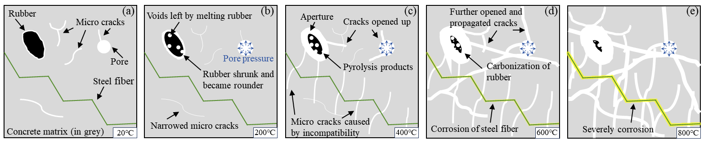
Fig. 9 Conceptual illustration of microstructure of SFRRC after different temperatures.

4.2 Mechanisms of temperature action

With the rising temperatures, the internal structure of the SFRRC underwent constant changes. The temperature action is shown schematically in Fig. 9 and Fig. 10. The following were the specific changes it exhibited under different temperature conditions:
After 200°C, all free water within the concrete evaporated, and some capillary and physically adsorbed water gradually evaporated. Decomposition of gypsum and calomel, and calcium silicate hydrate (C-S-H) gels due to heat removal of some of the water of hydration or crystalline water, all result in the creation of a number of fine cracks. The cement paste, coarse aggregate, and fine aggregate underwent slight expansion, effectively improving the microstructure of concrete by reducing the width of the interfacial transition zone and promoting the healing of microcracks [54]. During the secondary hydration process of cement, a large amount of newly generated C-S-H gel enhances the bond between aggregates and cement paste and fills pores and microcracks, making the concrete structure more compact and solid. This enhances the compactness of the cement matrix and strengthens the concrete. Some rubber particles begin to melt, shrink and become rounded, with holes forming on and inside the rubber surface after melting (as shown in Fig. 9(b)) (Effect I).
When the temperature reached 400°C, both the capillary water and the physically adsorbed water evaporated, the interlayer water and chemically bound water began to evaporate. The cement paste shrank sharply above 200°C [56, 57]. This process lead to an increase in the internal porosity of the concrete and reduce the compactness of the concrete. Due to the large difference in expansion coefficients with CA, FA, and SF, an increasing number of microcracks and pores in the ITZ until through fracture occurred. At the same time, there was a thermal stress gradient inside the concrete, which exacerbated the cracking. The main cement hydration products, such as C-S-H gel, continued to dehydrate without significant decomposition, and the overall structure of cement slurry had not changed significantly. At this stage, microcracks appeared along the radial of the steel fibers, reducing the pore pressure of the concrete after high temperatures [49,50,51], but not yet seriously affecting the overall structure (shown in Figure 9(c)). The vast majority of rubber has been completely melted and decomposed, leaving behind pore channels formed by the remaining pyrolysis products. This provided more room for internal water to evaporate, thereby reducing pore pressure. After 400°C, the pore size did not change significantly. However, if the rubber replacement ratio gradually increased, the number of pores gradually grew, leading to a decrease in the overall compactness of the concrete, rendering it more porous. This subsequently resulted in a decline in mechanical properties, significantly reducing the compactness of the concrete and severely impairing its ability to mitigate brittleness (Effect II).
During 400-600°C, interlayer water and chemically bound water continued to evaporate, and the pores inside the concrete further increased, forming more cracks. Ca(OH)₂ and C-S-H started to decompose at this stage, causing the cement slurry to change from a dense structure to a porous and loose structure, accelerating the deterioration of the mechanical properties of concrete. Additionally, the transformation of α-quartz to β-quartz [58], accompanied by volume expansion, imposed stress on the surrounding cement matrix, intensifying the damage to the microstructure and further compromising the mechanical properties and durability of the cement paste. The radial cracks in the steel fibers propagated, accompanied by slight oxidation and rusting. The oxide products that encapsulated their surfaces impeded the adhesion between the fibers and the matrix [59]. However, the development of large-scale pores to through-pores could be inhibited by improving the tensile strength of matrix interface and reducing the thermal gradient. Meanwhile, the rubber gradually carbonized during this stage, and after reaching 600°C, the rubber became brittle and could be crushed into powder, offering minimal to no improvement in brittleness (as shown in Fig. 9(d)). The more rubber added, the more pronounced this phenomenon became. However, the large-scale pores left by rubber melting and pyrolysis were further expanded and connected with radial microcracks of steel fibers, effectively releasing the internal steam pressure. Moreover, the steel fiber improved the tensile strength of the matrix interface near the rubber and inhibited the penetration of the pore (Effect III).
During 600-800°C, the water inside the concrete was almost completely evaporated, the porosity increased greatly, and cracks were widely formed. The thermal stress gradient also reached a maximum value, resulting in serious damage to the concrete structure. C-S-H continued to decompose, and some CaCO₃ also began to decompose, the porosity of cement slurry increased, and loose compounds such as CaO were formed. This causes the concrete to lose its original strength and structural integrity. The SF were severely corroded, further degrading the adhesion of the SF to the matrix, and the microstructure from the SFRRC was severely deteriorated. The radial cracks in the steel fibers widened and multiplied, interconnecting with the pores left by the melted and decomposed rubber (as shown in Fig. 9(e)), which effectively released the internal vapor pressure. After 800℃, the steel fiber and rubber had a very weak influence on the spalling resistance of the concrete, relying only on the support of the remaining steel fiber (Effect IV).
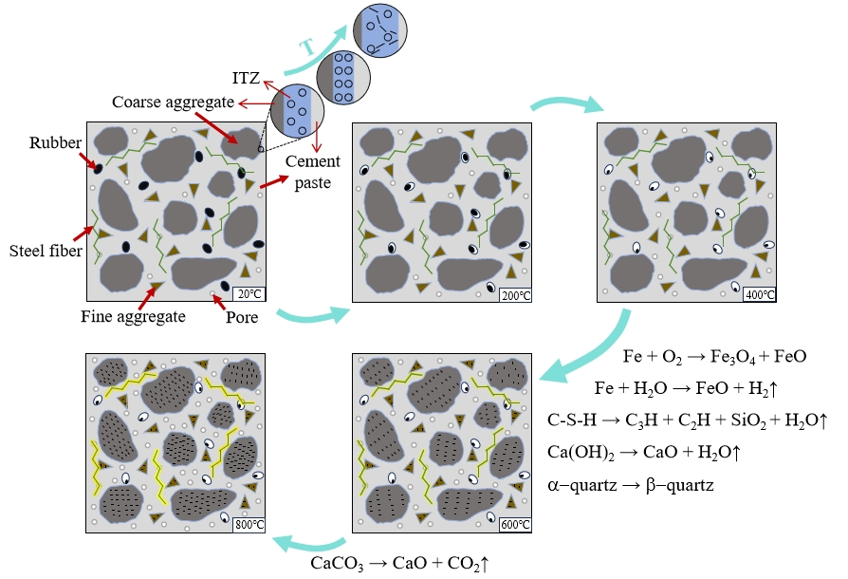
Fig. 10 Schematic representation of the temperature action of the SFRRC.

4.3 Compressive strength

Fig. 11 depicts the cubic compressive strength (f_{cu}) of SFRRC after elevated temperatures, while Fig. 12 illustrates the axial compressive strength (f_{c}). The residual compressive strength of SFRRC following elevated temperatures was most affected by the rubber substitution ratio and temperature, with temperature affecting the concrete more than the other effects. These findings were consistent with the research conducted by Wang et al. [60].
As the temperature gradually increased from 200°C to 800°C (200°C increment), the specimens with 1.2% SF incorporated showed an increase in cubic compressive strength by 16.83%, 14.73%, 31.64% and 35.96%, and prismatic axial compressive strength by 16.14%, 18.73%, 20.79% and 6.81%, respectively, as compared to normal concrete. This indicated that the incorporation of SF could increase the post-temperature compressive strength of concrete. Meanwhile, SF0.6R15 decreased the compressive strength of cubes by 49.18%, 53.89%, 56.04%, and 59.30%, and the axial compressive strength of prisms by 52.89%, 59.86%, 59.71%, and 61.34%, respectively, compared to SF0.6R0. It showed that replacing fine aggregate with rubber significantly reduced the compressive strength of concrete after high-temperature treatment, and this weakening effect became more pronounced as the temperature rose. However, after reaching a temperature of 400°C, although the compressive strength continued to decline, the rate of decrease slowed down. This was primarily attributed to the fact that most of the rubber had already melted and decomposed by then, partially mitigating the impact of further temperature increase on the decrease in compressive strength.
It showed a tendency to decline with increasing temperature in two stages: 20-400°C and 400-800°C. The cement particles, which were not hydrated at ambient temperature, became fully hydrated in the first stage due to the high temperature and water evaporation [61–63]. From effect I, the ITZ narrowed due to thermal expansion of CA; the newly formed C-S-H gel improved cement paste densification. As the rubber surface began to melt, the water evaporated, reducing the pore pressure generated by internal water vapor [27, 64]. These made concrete's compressive strength increased. However, as water evaporates, the cohesion between the C-S-H gel layers weakens [65], leading to a reduction in the interlayer distance of the C-S-H gel layers, structural disorder, and increased porosity. Consequently, the packing density and mechanical properties deteriorate, and the overall durability of the material decreases [66, 67]. Furthermore, the porosity of SFRRC was increased by the shrinking of rubber during heating until it melted and cracked. As the rubber substitution ratio increased, this porosity also increased after high temperatures, leading to a loss of strength. Effect I had a more detrimental than beneficial impact towards the compressive strength of specimen, leading to a decreasing tendency, but the gain effect was effective in slowing down the rate of decrease. The SF bridging effect effectively counteracted the adverse effects of rubber melting, cement paste shrinkage, and other factors on the concrete strength through various mechanisms, such as inhibiting the propagation of microcracks and pores [68], alleviating steam pressure, enhancing tensile strength and thermal shock resistance, promoting uniform heat conduction, and improving fracture toughness. The microstructure of the concrete continued to deteriorate in the second stage, as evidenced by effected III and IV. The calcium hydroxide and C-S-H gels underwent dewatering decomposition, α-quartz transformed into β-quartz, and the hardened cement paste's pore structure became rougher. Additionally, the holes created by the rubber melting turned into weak areas, significantly lowering the concrete's strength. The SF underwent corrosion, and their inhibitory effect on microcracks and hole expansion was greatly weakened, resulting in a decrease of residual strength. With increasing temperatures, the effects of rubber substitution ratio and SF amount on the compressive strength gradually decreased, and were even negligible when the exposure temperature reached 800 ℃.
The results showed that whether at ambient or high temperatures, when SF volume ratio was 1.2%, it could basically offset the loss of strength brought about by the rubber substitution ratio of 5%, and the relationship and values of its compressive strength with temperature changes were very close to those of normal concrete.
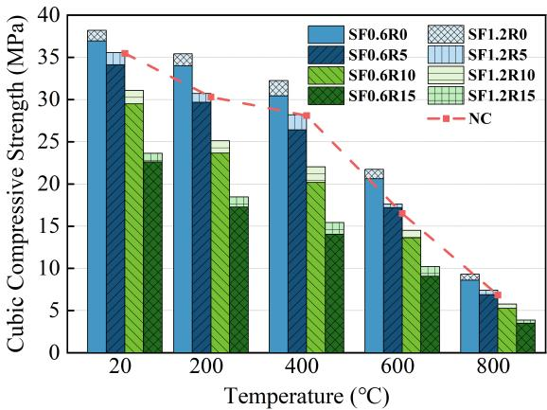
Fig. 11 Cubic compressive strength of SFRRC after high temperatures.
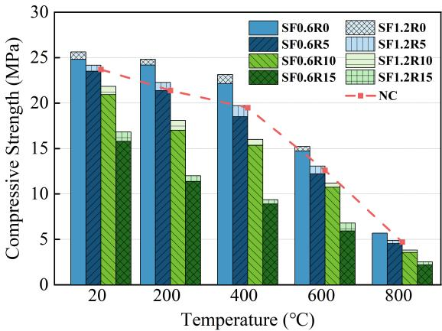
Fig. 12 Axial compressive strength of SFRRC after high temperatures..

4.4 Splitting tensile strength

The residual splitting tensile strength (f_{sp,t}) of SFRRC after different temperatures is mainly affected by temperature and SF, as shown in Fig. 13. The splitting tensile strength declined with increasing temperature, decreasing faster than compressive strength. Regardless of the temperature, the incorporation of SF significantly enhances the residual tensile strength of the specimen.
As the temperature was gradually increased from 200°C to 800°C (200°C increment), the splitting tensile strength of the samples incorporated with 1.2% SF increased by 53.03%, 50.00%, 73.12% and 109.62%, respectively, as compared to normal concrete. This indicated that SF could still withstand part of the tensile force after the concrete had been damaged by tensile force, and the higher the temperature, the more obvious this enhancement was. Simultaneously, the splitting tensile strength of SF0.6R15 specimens decreased by 41.30%, 47.37%, 51.54% and 66.67%, respectively, compared with that of SF0.6R0. The results showed replacing FA with rubber decreased the concrete splitting tensile strength after high temperatures, and the influence of rubber melting on the splitting tensile strength of the specimens became more and more obvious with increasing temperature.
The change with temperature could be divided into three stages: 20-400°C, 400-600°C, and 600-800°C. In the first stage, the splitting tensile strength of SFRRC decreased more slowly than that of NC, mainly due to the deterioration of concrete (such as water evaporation, microcrack propagation, etc.), while the tensile strength contributed by steel fibers remained stable, with pull-out failure being the dominant mode. As the second stage began, the decomposition of cement-based compounds such as Ca(OH)₂ and C-S-H resulted in a looser and weaker concrete matrix, and the formation of oxidation products on the surface of steel fibers weakened their bond with the concrete matrix, both contributing to a decrease in splitting tensile strength. However, steel fibers still maintained a certain reinforcing effect at this stage. In the third stage, high temperatures caused the cement paste of the concrete to become loose and the aggregates to deteriorate, leading to a sharp decline in splitting tensile strength. Steel fibers were severely corroded and mainly failed by rupture, but SF still had a certain reinforcing effect, slowing down the rate of strength decrease and increasing the tensile strength compared to ordinary concrete.
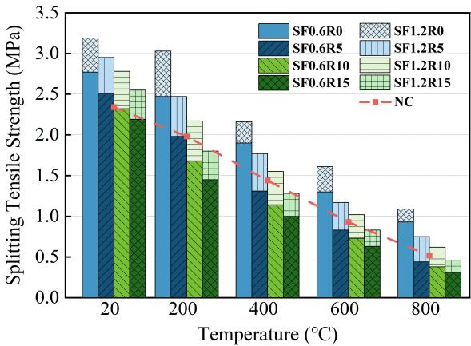
Fig. 13 Splitting tensile strength of SFRRC after high temperatures..

4.5 Flexural strength

Fig. 14 shows the SFRRC flexural strength (f_{fl}) after various temperatures. Flexural strength decreased with temperature to a similar extent as splitting tensile strength. Temperature and SF still occupied a dominant position. As compared to normal concrete, the flexural strength of the specimens with 1.2% SF increased by 34.90%, 56.13%, 91.92%, and 128.57% with the progressive increase in temperature from 200°C to 800°C (200°C increments), respectively. The flexural strength of SF0.6R15 decreased by 37.19%, 55.43%, 69.78% and 81.48% compared to SF0.6R0. With temperature increasing, the flexural strengths of all groups showed a decreasing trend in general, which was very close to the decreasing tendency in splitting tensile strength, and could be divided into three stages as well. However, the enhancement effect of SF on flexural strength was slightly lower than that of tensile strength.

The bending strength of the specimens containing 1.2% SF will gradually decrease with the increase of temperature, but it will increase compared with ordinary concrete, and the increase amplitude will gradually increase with the increase of temperature. The mechanism of steel fiber to prevent the formation of cracks, SF after exposure to different temperatures has a certain strengthening effect, compared with ordinary concrete increased tensile strength. Compared with SF0.6R0, the flexural strength of SF0.6R15 decreases more significantly. This is mainly due to the gradual increase of rubber replacement rate, which makes the whole specimen more loose and porous after high temperature, and the crack development is easier, which leads to the decline of residual flexural strength.
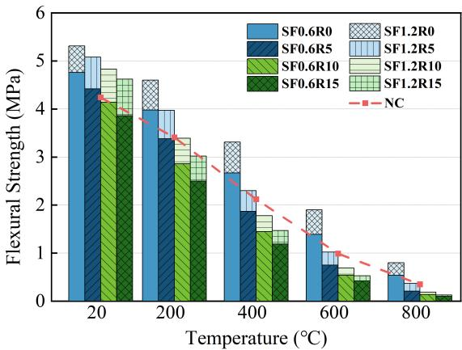
Fig. 14 Flexural strength of SFRRC after high temperatures..

After different elevated temperatures, the cubic compressive strength of specimen SF1.2R5 increased by 0.23-7.82%, axial compressive strength by 1.13-4.16%, splitting tensile strength by 22.92-44.23%, and flexural strength by 3.03-19.81% compared to normal concrete. While improving the mechanical properties of post-high-temperature concrete, SF1.2R5 also helped to solve the disposal problem of waste rubber, showing its superior performance and wide application prospects.

5 Mechanical Properties Prediction

For a better prediction of the mechanical performance of steel fiber-reinforced rubber concrete (SFRRC) after elevated temperatures, this paper proposed prediction models of residual strengths of SFRRC after elevated temperature with respect to the temperature and rubber substitution ratio derived from the experimental data and analyzed by regression. When the rubber substitution ratio was the same, the regular curves and trends for SF contents of 0.6% and 1.2%, respectively, were basically the same, except that the value increased slightly. In this paper, the SF doping amount of 0.6% was taken as an example, and the actual data were tested and analyzed in comparison to previous experimental data. Table 1 summarizes the results of previous studies. In all relational equations, the V_{sf} is the SF amount, r_{g} is the rubber substitution ratio, f ²⁰ is the SFRRC strength at ambient temperature, and f ^{T} is the SFRRC strength after temperature T.

5.1 Compressive strength

The prediction model of the residual cubic compressive strength (f_{cu}) of SFRRC after high temperature was proposed as Eq. (1):
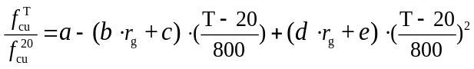 , 20℃≤T≤800℃ , 0≤r_{g}≤0.15 | (1)
where a,b,c,d are the predictive coefficients, and their values are shown in Table 5.
Table 5 Predictive coefficients for the cubic compressive strength of the SFRRC after high temperature.
V_{sf} (%) | a | b | c | d | e
0.6 | 0.984 | 4.042 | 0.006 | 3.758 | -0.793
1.2 | 0.986 | 4.409 | -0.005 | 4.15 | -0.798

Fig. 15 shows the relative cubic compressive strength of SFRRC after high temperatures, and the predicted values follow the same trend as the experimental test values and the predecessor data. SF increased the cubic compressive strength, resulting in a cubic compressive strength ratio greater than that of the predecessor data, but there was essentially no difference at 800°C, which was consistent with the previous mechanism analysis.

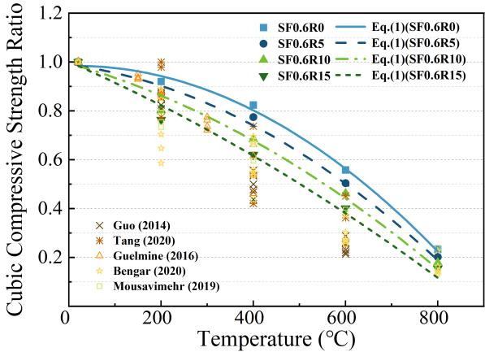
Fig. 15 Relative cubic compressive strength of SFRRC after exposure to elevated temperatures.

Through linear regression, the mathematical relationship between the residual axial compressive strength (f_{c}) and f_{cu} was obtained as Eq. (2). Fig. 16 shows the relationship between these two parameters, they were basically linearly related at the same temperature. Fig. 17 shows the theoretical and experimental f_{c} and f_{cu} of SFRRC after high temperature. The anticipated compressive strengths closely align with the experimental findings, demonstrating a high degree of congruence.

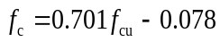 | (2)
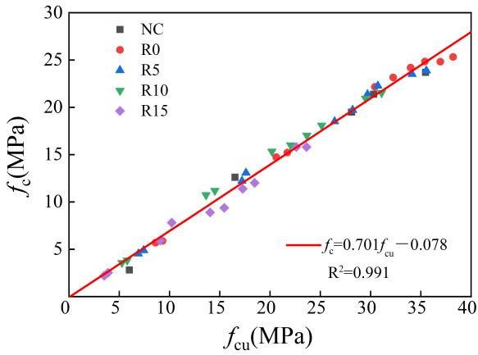
Fig. 16 Relationship between f_{c} and f_{cu} of SFRRC.
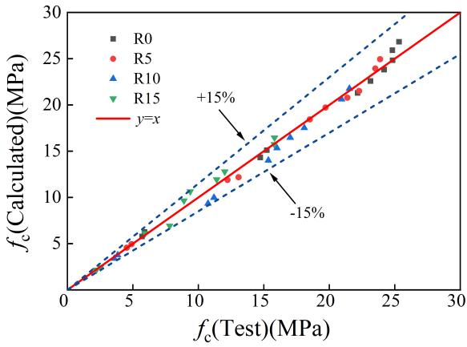
Fig. 17 Theoretical and experimental f_{c} and f_{cu} of SFRRC.

5.2 Splitting tensile strength

Table 6 shows the prediction models for SFRRC residual splitting tensile (f_{sp,t}) strength after high temperatures.
Table 6 Prediction models for the splitting tensile strength of the SFRRC after high temperature.
Prediction model | 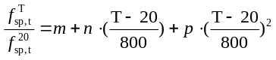 | 20℃≤T≤800℃ | (3)
V_{sf} =0.6% | 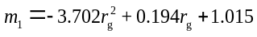 | 0≤r_{g}≤0.15 | (4)
 | 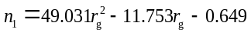 | 0≤r_{g}≤0.15
 | 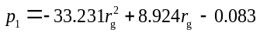 | 0≤r_{g}≤0.15
V_{sf} =1.2% | 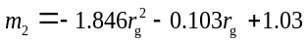 | 0≤r_{g}≤0.15 | (5)
 | 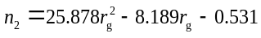 | 0≤r_{g}≤0.15
 | 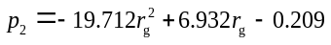 | 0≤r_{g}≤0.15

As shown in Fig. 18, Eqs. (3)-(4) with the given curves fitted the experimental data well, and the trend was similar to the trend of the prediction results of the predecessors. When exposed to 200°C, Zhang [39] specimens doped with multiscale fibers showed higher strength, resulting in slightly different curves for both, but the general trend remained similar.
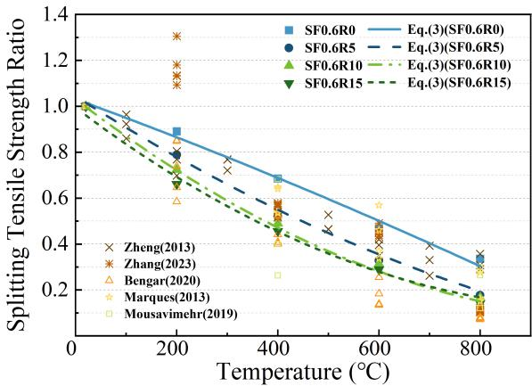
Fig. 18 Relative splitting tensile strength of SFRRC after high temperatures.

5.3 Flexural strength

Table 7 shows the prediction models for the residual flexural strength (f_{fl}) of SFRRC after high temperatures.
Table 7 Prediction models for the flexural strength of the SFRRC after high temperature.
Prediction model | 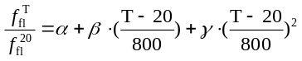 | 20℃≤T≤800℃ | (6)
V_{sf} =0.6% | 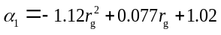 | 0≤r_{g}≤0.15 | (7)
 | 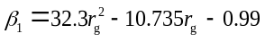 | 0≤r_{g}≤0.15
 | 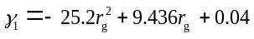 | 0≤r_{g}≤0.15
V_{sf} =1.2% | 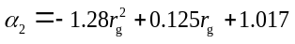 | 0≤r_{g}≤0.15 | (8)
 | 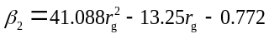 | 0≤r_{g}≤0.15
 | 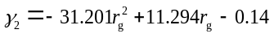 | 0≤r_{g}≤0.15

As shown in Fig. 19, Eqs. (6)-(7) with the given curves fit well with the test data. Relatively scarce research has been conducted to investigate the flexural properties of RC after high temperatures. Guelmine [28] studied the flexural characteristics of rubberized concrete after elevated temperature within 400°C and the trend is close to this paper. Husem [69] investigated the properties of high performance concrete, while Zhang [36] quantified the impact of varying SF amounts. Intriguingly, both studies exhibited comparable trends and reported numerically superior results compared to the measurements presented in this study. It indicated that the effect of high temperatures could be greatly mitigated on the flexural strength of concrete through the use of high-performance concrete or the addition of SF.
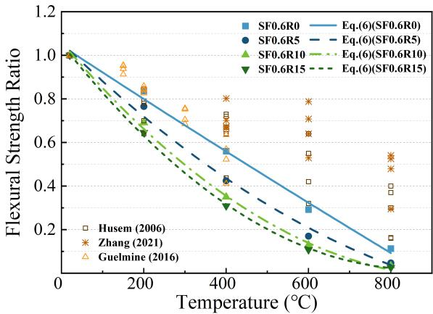
Fig. 19 Relative flexural strength of SFRRC after high temperatures.

6 Conclusion

This study analyzed the high-temperature behavior of steel fiber-reinforced rubber concrete and evaluated its post-high-temperature properties. Based on experimental data, prediction models for various mechanical properties were established, yielding the following key conclusions:
- Steel fibers and rubber reduced the risk of concrete cracking at high temperatures, improved failure modes, and enhance durability and safety by releasing pore pressure and inhibiting crack propagation.
- The residual compressive strength of rubber was more significant than that of steel fiber. When the rubber replacement ratio was 15%, the cubic compressive strength decreased 49.18-59.3%, and the axial compressive strength decreased 52.86-61.34%. And 1.2% steel fiber can improve the cubic compressive strength 7.73-35.96%, axial compressive strength 8.1-20.79%. In the range of 400-800℃, the compressive strength decreased rapidly.
- The tensile and flexural strength of steel fiber was more significant than that of rubber. When the rubber substitution ratio was 15%, the splitting tensile strength decreased by 41.3-66.7% and the flexural strength decreased by 37.19-81.48%. 1.2% steel fiber can increase the splitting tensile strength of 50-109.62%, the flexural strength of 34.9-128.57%.
- When the steel fiber content was 1.2% and the rubber substitution ratio was 5%, the cubic compressive strength, axial compressive strength, splitting tensile strength and flexural strength were increased by 0.23-8.48%, 1.13-4.16%, 22.92-44.23% and 3.03-19.81%, respectively, and the specimens had better safety and high temperature resistance.
- Formula models of mechanical properties of steel fiber reinforced rubber after high temperature were established, and the relationship between cubic and axial compressive strength was determined. Experiments and literature comparison verified its effectiveness, and helped the formulation of specifications and the promotion of new materials.

Declaration of Competing Interest
The authors declare that they have no known competing interests.

Acknowledgements

The authors are grateful to the financial support provided by the Chinese National Natural Science Foundation (No. 52068001).
Data availability
All data generated or analysed during this study are included in this published article.

Reference

- Yi O, Mills J E, Zhuge Y, et al. Performance of crumb rubber concrete composite-deck slabs in 4-point-bending[J]. Journal of Building Engineering, 2021, 40: 102695.
- Arabiourrutia M, Lopez G, Artetxe M, et al. Waste tyre valorization by catalytic pyrolysis–A review[J]. Renewable and Sustainable Energy Reviews, 2020, 129: 109932.
- Gonen T. Freezing-thawing and impact resistance of concretes containing waste crumb rubbers[J]. Construction and Building Materials, 2018, 177: 436-442.
- Siddika A, Al Mamun M A, Alyousef R, et al. Properties and utilizations of waste tire rubber in concrete: A review[J]. Construction and Building Materials, 2019, 224: 711-731.
- Liu K, Liang J, Wang C, et al. Axial compression stress-strain relationship of lithium slag rubber concrete[J]. Scientific Reports, 2024, 14(1): 23037.
- ALi H, Long W J, Khayat K H. Efficient recycling of waste rubber in a sustainable fiber-reinforced mortar and its damping and energy dissipation capacity[J]. Cement and Concrete Composites, 2023, 138: 104963.
- Osama Y ,E. J M ,Mark E , et al.Practical Application of Crumb Rubber Concrete in Residential Slabs[J]. Structures, 2022, 36837-853.
- Helmy S H, Tahwia A M, Mahdy M G, et al. The use of recycled tire rubber, crushed glass, and crushed clay brick in lightweight concrete production: a review[J]. Sustainability, 2023, 15(13): 10060.
- Thomas B S, Gupta R C. Long term behaviour of cement concrete containing discarded tire rubber[J]. Journal of Cleaner Production, 2015, 102: 78-87.
- Momotaz H, Rahman M M, Karim M R, et al. Properties of the interfacial transition zone in rubberised concrete–an investigation using nano-indentation and EDS analysis[J]. Journal of Building Engineering, 2023, 77: 107405.
- Zhang J, Niu W, Yang Y, et al. Research on the mechanical properties of polyvinyl alcohol-modified waste rubber-filled cement paste using digital image correlation technology[J]. Composite Structures, 2023, 320: 117164.
- El-Sayed T A. Flexural behavior of RC beams containing recycled industrial wastes as steel fibers[J]. Construction and Building Materials, 2019, 212: 27-38.
- El-Sayed T A, Shaheen Y B I. Flexural performance of recycled wheat straw ash-based geopolymer RC beams and containing recycled steel fiber[J]. Structures, 2020, 281713-1728.
- Ghali M K N, El-Sayed T A, Salah A, et al. Performance of RC Beams under Shear Loads Strengthened with Metallic and Non-Metallic Fibers[J]. Buildings, 2024, 14(6): 1869.
- Ismail M K, Hassan A A A. Shear behaviour of large-scale rubberized concrete beams reinforced with steel fibres[J]. Construction and Building Materials, 2017, 140: 43-57.
- Noaman A T, Bakar B H A, Akil H M. Experimental investigation on compression toughness of rubberized steel fibre concrete[J]. Construction and Building Materials, 2016, 115: 163-170.
- Zhang P, Wang C, Guo J, et al. Production of sustainable steel fiber-reinforced rubberized concrete with enhanced mechanical properties: A state-of-the-art review[J]. Journal of Building Engineering, 2024: 109735.
- Eisa A S, Elshazli M T, Nawar M T. Experimental investigation on the effect of using crumb rubber and steel fibers on the structural behavior of reinforced concrete beams[J]. Construction and Building Materials, 2020, 252: 119078.
- Alsaif A, Alharbi Y R. Strength, durability and shrinkage behaviours of steel fiber-reinforced rubberized concrete[J]. Construction and Building Materials, 2022, 345: 128295.
- Alshaikh I M H, Bakar B H A, Alwesabi E A H, et al. Progressive collapse behavior of steel fiber-reinforced rubberized concrete frames[J]. Journal of Building Engineering, 2022, 57: 104920.
- Fu C, Ye H, Wang K, et al. Evolution of mechanical properties of steel fiber-reinforced rubberized concrete (FR-RC)[J]. Composites Part B: Engineering, 2019, 160: 158-166.
- Dong S, Zhao Q, Zhu H. Mechanical properties and constitutive model of steel fiber-reinforced rubberized concrete[J]. Construction and Building Materials, 2022, 327: 126720.
- Lyu X, Elchalakani M, Ahmed T, et al. Residual strength of steel fibre reinforced rubberised UHPC under elevated temperatures[J]. Journal of Building Engineering, 2023, 76: 107173.
- Ma Q, Guo R, Zhao Z, et al. Mechanical properties of concrete at high temperature—A review[J]. Construction and Building Materials, 2015, 93: 371-383.
- Junior P R R S, de Souza Maciel P, Corrêa E C S, et al. A multiscale investigation on the performance improvement of fiber-reinforced cementitious composites after exposure to high temperatures[J]. Cement and Concrete Composites, 2022, 133: 104657.
- Wu H, Lin X, Zhou A. A review of mechanical properties of fibre reinforced concrete at elevated temperatures[J]. Cement and Concrete Research, 2020, 135: 106117.
- Tang Y, Feng W, Feng W, et al. Compressive properties of rubber-modified recycled aggregate concrete subjected to elevated temperatures[J]. Construction and Building Materials, 2021, 268: 121181.
- Lau A, Anson M. Effect of high temperatures on high performance steel fibre reinforced concrete[J]. Cement and concrete research, 2006, 36(9): 1698-1707.
- Abdullah W A, AbdulKadir M R, Muhammad M A. Effect of high temperature on mechanical properties of rubberized concrete using recycled tire rubber as fine aggregate replacement[J]. Engineering and Technology Journal, 2018, 36(8A): 906-913.
- Bengar H A, Shahmansouri A A, Sabet N A Z, et al. Impact of elevated temperatures on the structural performance of recycled rubber concrete: Experimental and mathematical modeling[J]. Construction and Building Materials, 2020, 255: 119374.
- Marques A M, Correia J R, De Brito J. Post-fire residual mechanical properties of concrete made with recycled rubber aggregate[J]. Fire Safety Journal, 2013, 58: 49-57.
- Mousavimehr M, Nematzadeh M. Predicting post-fire behavior of crumb rubber aggregate concrete[J]. Construction and Building Materials, 2019, 229: 116834.
- Zheng W, Luo B, Wang Y. Compressive and tensile properties of reactive powder concrete with steel fibres at elevated temperatures[J]. Construction and Building Materials, 2013, 41: 844-851.
- Li H, Liu G. Tensile properties of hybrid fiber-reinforced reactive powder concrete after exposure to elevated temperatures[J]. International Journal of Concrete Structures and Materials, 2016, 10: 29-37.
- Tai Y S, Pan H H, Kung Y N. Mechanical properties of steel fiber-reinforced reactive powder concrete following exposure to high temperature reaching 800 C[J]. Nuclear Engineering and Design, 2011, 241(7): 2416-2424.
- Zhang X, Lin X, Chen Y. Study on mechanical properties of steel fiber-reinforced nano-concrete (SFRNC) after elevated temperature[J]. Composite Structures, 2021, 268: 113941.
- Pliya P, Beaucour A L, Noumowé A. Contribution of cocktail of polypropylene and steel fibres in improving the behaviour of high strength concrete subjected to high temperature[J]. Construction and building materials, 2011, 25(4): 1926-1934.
- Guo Y, Zhang J, Chen G, et al. Compressive behaviour of concrete structures incorporating recycled concrete aggregates, rubber crumb and reinforced with steel fibre, subjected to elevated temperatures[J]. Journal of cleaner production, 2014, 72: 193-203.
- Zhang Y, Zhang S, Jiang X, et al. Uniaxial tensile properties of multi-scale fiber reinforced rubberized concrete after exposure to elevated temperatures[J]. Journal of Cleaner Production, 2023, 389: 136068.
- GB/T 14684-2022. Sand for Construction [S]. Standardization Administration of China; State Market Supervision and Administration of China, 2022.
- ISO 834-1. Fire-resistance Tests—Elements of Building Construction—Part 1: General Requirements [S]. International Organization for Standardization, 1999.
- GB/T 50081-2019. Standard for Test Methods of Concrete Physical and Mechanical Properties [S]. General Administration of Quality Supervision, Inspection and Quarantine of the People's Republic of China; Standardization Administration of China, 2019.
- Li Z X, Li C H, Shi Y D, et al. Experimental investigation on mechanical properties of hybrid fibre reinforced concrete[J]. Construction and Building Materials, 2017, 157: 930-942.
- Cui K, Liang K, Chang J, et al. Investigation of the macro performance, mechanism, and durability of multiscale steel fiber reinforced low-carbon ecological UHPC[J]. Construction and Building Materials, 2022, 327: 126921.
- Chen G M, Yang H, Lin C J, et al. Fracture behaviour of steel fibre reinforced recycled aggregate concrete after exposure to elevated temperatures[J]. Construction and Building Materials, 2016, 128: 272-286.
- Liu J C, Tan K H, Yao Y. A new perspective on nature of fire-induced spalling in concrete[J]. Construction and Building Materials, 2018, 184: 581-590.
- Li Y, Pimienta P, Pinoteau N, et al. Effect of aggregate size and inclusion of polypropylene and steel fibers on explosive spalling and pore pressure in ultra-high-performance concrete (UHPC) at elevated temperature[J]. Cement and Concrete Composites, 2019, 99: 62-71.
- Li Y, Tan K H, Yang E H. Synergistic effects of hybrid polypropylene and steel fibers on explosive spalling prevention of ultra-high performance concrete at elevated temperature[J]. Cement and Concrete Composites, 2019, 96: 174-181.
- Peng G F, Yang W W, Zhao J, et al. Explosive spalling and residual mechanical properties of fiber-toughened high-performance concrete subjected to high temperatures[J]. Cement and Concrete Research, 2006, 36(4): 723-727.
- Düğenci O, Haktanir T, Altun F. Experimental research for the effect of high temperature on the mechanical properties of steel fiber-reinforced concrete[J]. Construction and Building Materials, 2015, 75: 82-88.
- Bangi M R, Horiguchi T. Effect of fibre type and geometry on maximum pore pressures in fibre-reinforced high strength concrete at elevated temperatures[J]. Cement and Concrete Research, 2012, 42(2): 459-466.
- Zhang P, Kang L, Wang J, et al. Mechanical properties and explosive spalling behavior of steel-fiber-reinforced concrete exposed to high temperature—a review[J]. Applied Sciences, 2020, 10(7): 2324.
- Gao D, Yan D, Li X. Splitting strength of GGBFS concrete incorporating with steel fiber and polypropylene fiber after exposure to elevated temperatures[J]. Fire Safety Journal, 2012, 54: 67-73.
- Lyu X, Ahmed T, Elchalakani M, et al. Influence of crumbed rubber inclusion on spalling, microstructure, and mechanical behaviour of UHPC exposed to elevated temperatures[J]. Construction and Building Materials, 2023, 403: 133174.
- Liu X, Ye G, De Schutter G, et al. On the mechanism of polypropylene fibres in preventing fire spalling in self-compacting and high-performance cement paste[J]. Cement and concrete research, 2008, 38(4): 487-499.
- Piasta J. Heat deformations of cement paste phases and the microstructure of cement paste[J]. Materials and Structures, 1984, 17: 415-420.
- Khoury G A, Grainger B N, Sullivan P J E. Strain of concrete during first heating to 600 C under load[J]. Magazine of concrete research, 1985, 37(133): 195-215.
- Zheng W, Luo B, Wang Y. Stress–strain relationship of steel-fibre reinforced reactive powder concrete at elevated temperatures[J]. Materials and Structures, 2015, 48: 2299-2314.
- Xu P, Cui Y H, Dai J F, et al. Mechanical performance of textile reinforced concrete containing steel fibers and basalt fibers subjected to high temperatures [J]. Ceramics-Silikaty, 2021, 65(3): 263-272.
- Wang T, Yu M, Shan W, et al. Post-fire compressive stress–strain behaviour of steel fibre reinforced recycled aggregate concrete[J]. Composite Structures, 2023, 309: 116735.
- Poon C S, Azhar S, Anson M, et al. Strength and durability recovery of fire-damaged concrete after post-fire-curing[J]. Cement and concrete research, 2001, 31(9): 1307-1318.
- Xuan D X, Shui Z H. Rehydration activity of hydrated cement paste exposed to high temperature[J]. Fire and materials, 2011, 35(7): 481-490.
- Li L, Jia P, Dong J, et al. Effects of cement dosage and cooling regimes on the compressive strength of concrete after post-fire-curing from 800 C[J]. Construction and Building Materials, 2017, 142: 208-220.
- Li L J, Xie W F, Liu F, et al. Fire performance of high-strength concrete reinforced with recycled rubber particles[J]. Magazine of concrete Research, 2011, 63(3): 187-195.
- Babalola O E, Awoyera P O, Le D H, et al. A review of residual strength properties of normal and high strength concrete exposed to elevated temperatures: Impact of materials modification on behaviour of concrete composite[J]. Construction and Building Materials, 2021, 296: 123448.
- Yang J, Zhang W, Hou D, et al. Structure, dynamics and mechanical properties evolution of calcium silicate hydrate induced by dehydration and dehydroxylation[J]. Construction and Building Materials, 2021, 291: 123327.
- Zhao H, Liu F, Yang H. Residual compressive response of concrete produced with both coarse and fine recycled concrete aggregates after thermal exposure[J]. Construction and Building Materials, 2020, 244: 118397.
- Kodur V K R, Sultan M A. Effect of temperature on thermal properties of high-strength concrete[J]. Journal of materials in civil engineering, 2003, 15(2): 101-107.
- Husem M. The effects of high temperature on compressive and flexural strengths of ordinary and high-performance concrete[J]. Fire Safety Journal, 2006, 41(2): 155-163.

