SUPPLEMENTARY APPENDIX
Figure S1 Data cleaning flowchart.
NHANES: National Health and Nutrition Examination Survey.
Text S1
Smoking was defined as a lifetime total of 100 cigarettes, otherwise non-smokers, smokers were divided into former smokers and current smokers. Alcohol consumption was defined as having more than 12 alcoholic drinks in any given year, otherwise non-drinkers. In reference to the World Health Organization's (WHO) 2020 Guidelines on Physical Activity and Sedentary Behavior, the sum of the hours of moderate-intensity and high-intensity exercise was defined as the total number of hours of regular physical activity per week. We calculated physical activity as high-intensity work time * high-intensity MET+ moderate-intensity work time * moderate-intensity MET+ commuting (walking or cycling) time * commuting MET+ high-intensity recreation time * high-intensity MET+ moderate-intensity recreation time * moderate-intensity MET. Hypertension was defined as self-reported hypertension or recent or current use of blood pressure medications, or the mean of the MEC blood pressure measurements (≤3) had a systolic blood pressure ≥ 140 mmHg or a diastolic blood pressure ≥90 mmHg. Hyperlipidemia was defined as self-reported hyperlipidemia or current use of lipid-lowering drugs or fasting total cholesterol ≥240mg/dl or triglycerides ≥200mg/dl or low-density lipoprotein cholesterol ≥160mg/dl or high-density lipoprotein cholesterol ≤40mg/dl as determined by MEC laboratory. Diabetes was defined as self-reported diabetes or use of antidiabetic drugs, insulin injection, or fasting blood glucose ≥7.0 mmol/L or glycosylated hemoglobin ≥ 6.5 mmol/L or 2-hour glucose tolerance test (OGTT) ≥ 11.1 mmol/L as determined by MEC laboratory. According to the questions covered by the NHANES Health questionnaire, CVD was defined as any of coronary heart disease, heart failure, angina, heart disease, or stroke reported by a physician or other health professional. Cancer was defined as having been told by a doctor or other health professional that you have cancer or any kind of malignant tumor. Cognitive function is characterized by four different constructs. The Consortium for Alzheimer's Disease Registry (CERAD) Vocabulary Learning Test assesses the ability to acquire information in new language and consists of three Immediate Recall Tests (IRTs) (scores of 0-10) and Delayed Recall Tests (DRTs) (scores of 0-10) for a total of 40 points. To assess executive function, the Animal Fluency Test (AFT) measured categorical verbal fluency (one point one score). Meanwhile, the Digit Symbol Substitution Test (DSST) assessed attributes such as processing speed, coherent attention, and working memory capacity (one point in a set). Finally, these dimensions were summed to obtain a composite cognitive function score.

Table S1 Cut-off for low grip strength stratified by gender and body mass index (BMI) quartiles
BMI category, kg/m² | Cut-off for low grip strength (kg) criterion
Men
BMI ≤24 | ≤35.4
BMI 24.1–26 | ≤36.2
BMI 26.1–28 | ≤37
BMI ≥ 28 | ≤39.3
Women
BMI ≤ 23 | ≤23.4
BMI 23.1–26 | ≤23.5
BMI 26.1–29 | ≤23.3
BMI ≥29 | ≤24.5
BMI: body mass index.
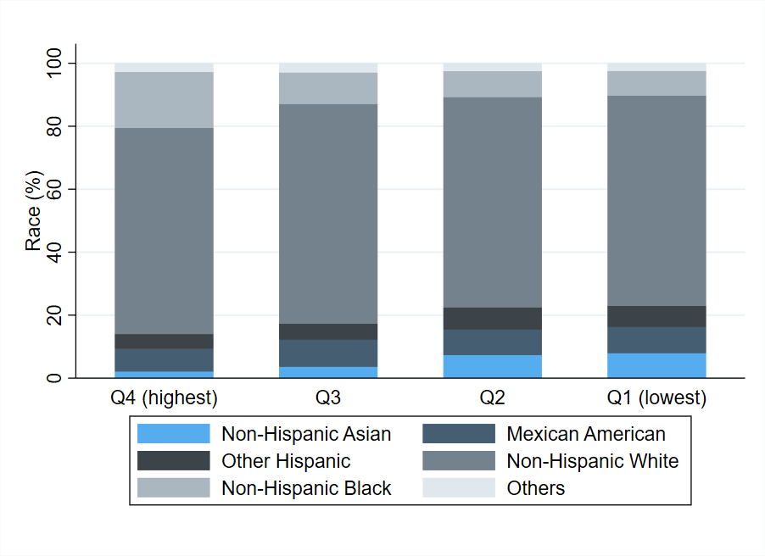
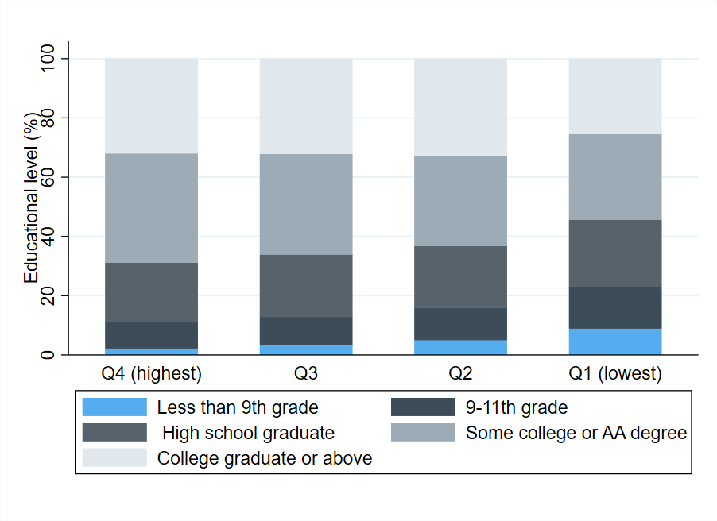
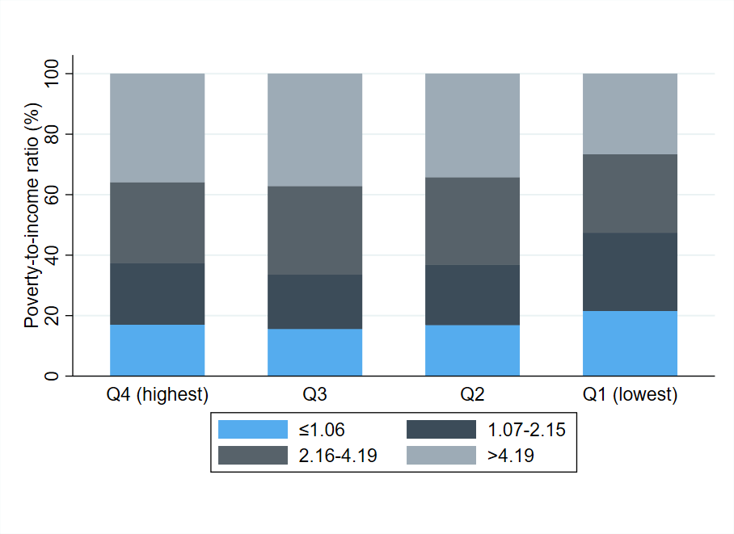
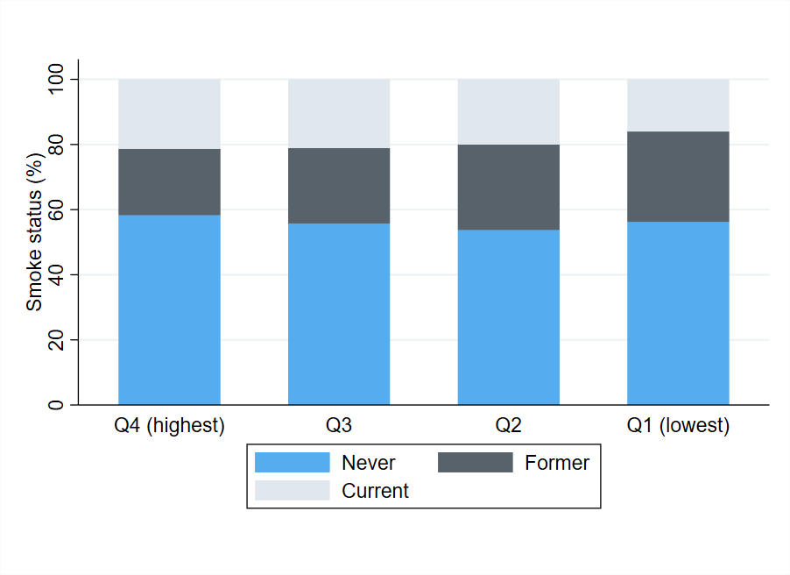
Figure S2. Stacked bar plot of multiple categorical variables by sex-specific quartiles of absolute grip strength

Table S2 Association between standardized handgrip strength measurements and risk of all-cause mortality by gender
 | Men | Women
HGS | 1.81 (1.55, 2.11) | 1.62 (1.38, 1.90)
HGS/BMI | 1.73 (1.42, 2.09) | 1.26 (1.08, 1.48)
HGS/HT² | 1.81 (1.55, 2.10) | 1.62 (1.38, 1.90)
MGS | 1.79 (1.53, 2.09) | 1.60 (1.36, 1.90)
MGS/weight | 1.59 (1.30, 1.94) | 1.19 (1.01, 1.41)
Abbreviations: HGS: the average of hand grip strength; MGS: Maximum grip strength; MGS/weight: MGS/body weight *100; HGS/HT²: HGS/height². * The results were presents as per 1 SD decrease. Cox regression model was adjusted for age, race, education level, marital status, poverty-to-income ratio, smoking status, alcohol drinking, regular exercise, baseline chronic diseases (cancer, CVD, hypertension, hyperlipidemia, diabetes). Cox regression was corrected for sample weights. HR (95% CI) in bold indicates P≤0.05.

Table S3 Association between different handgrip strength measurements and risk of all-cause mortality by age in men and women
 | Men |  | P_{interaction} | Women |  | P_{interaction}
 | <65 years | ≥65 years | P_{interaction} | <65 years | ≥65 years | P_{interaction}
Number of deaths | 64 | 122 |  | 49 | 114
Mortality rate (/1,000 PYs) | 5.6 | 43.8 |  | 4.2 | 37.1
HGS | 1.69 (1.39, 2.06) | 1.96 (1.44, 2.67) | 0.443 | 1.37 (1.02, 1.85) | 1.52 (1.23, 1.88) | 0.209
HGS/BMI | 1.69 (1.38, 2.08) | 1.76 (1.26, 2.45) | 0.679 | 1.17 (0.86, 1.58) | 1.17 (0.99, 1.39) | 0.834
HGS/HT² | 1.53 (1.28, 1.85) | 1.86 (1.44, 2.41) | 0.268 | 1.38 (1.05, 1.81) | 1.45 (1.21, 1.74) | 0.358
MGS | 1.73 (1.41, 2.12) | 1.85 (1.36, 2.51) | 0.691 | 1.31 (0.93, 1.85) | 1.53 (1.23, 1.91) | 0.155
MGS/weight | 1.59 (1.28, 1.98) | 1.57 (1.12, 2.21) | 0.934 | 1.13 (0.82, 1.55) | 1.12 (0.96, 1.31) | 0.972
Abbreviations: HGS: the average of hand grip strength; MGS: Maximum grip strength; MGS/weight: MGS/body weight *100; HGS/HT²: HGS/height²; PYs: person-years. * The results were presents as per 1 SD decrease. Cox regression model was adjusted for age, race, education level, marital status, poverty-to-income ratio, smoking status, alcohol drinking, regular exercise, baseline chronic diseases (cancer, CVD, hypertension, hyperlipidemia, diabetes). Cox regression was corrected for sample weights. HR (95% CI) in bold indicates P≤0.05.

Table S4 Association between low grip strength of different definitions and risk of all-cause mortality by age in men and women
 | Men |  | P_{interaction} | Women |  | P_{interaction}
 | <65 years | ≥65 years | P_{interaction} | <65 years | ≥65 years | P_{interaction}
Low reference grip strength | 2.12 (1.47, 3.05) | 1.97 (1.47, 2.65) | 0.371 | 1.69 (1.04, 2.76) | 1.18 (0.91, 1.54) | 0.087
Lowest 20% grip strength | 2.57 (1.53, 4.31) | 1.92 (1.31, 2.82) | 0.514 | 2.06 (1.06, 4.00) | 2.08 (1.46, 2.96) | 0.848
Men≤26kg, women≤16kg | 4.09 (1.20, 13.98) | 1.80 (1.02, 3.21) | 0.230 | 3.28 (0.67, 16.14) | 1.95 (1.29, 2.95) | 0.942
In Cox regression, participants with normal grip strength were used as reference group. Multivariable model was adjusted for age (except for low reference grip strength), race, education level, marital status, poverty-to-income ratio, smoking status, alcohol drinking, regular exercise, baseline chronic diseases (cancer, CVD, hypertension, hyperlipidemia, diabetes). Cox regression was corrected for sample weights. HR (95% CI) in bold indicates P≤0.05.
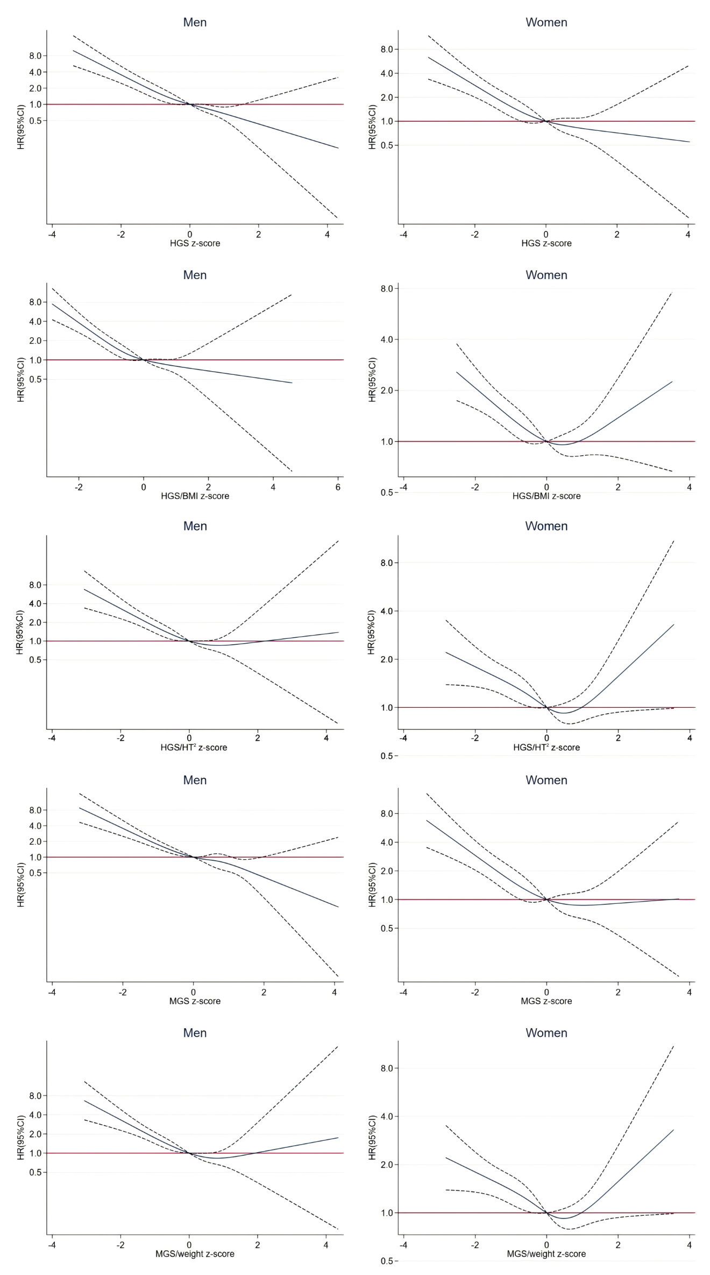

Figure S3 Association between different handgrip strength measurements and mortality in Cox regression with Restricted Cubic Spline by gender
Estimated in Cox regression with z-scores of handgrip strength measurements modelled as natural cubic splines with four knots. Z-score 0 was used as reference. HGS: the average of hand grip strength; MGS: Maximum grip strength; MGS/weight: MGS/body weight *100; HGS/HT²: HGS/height². Cox regression model was adjusted for age, race, education level, marital status, poverty-to-income ratio, smoking status, alcohol drinking, regular exercise, baseline chronic diseases (cancer, CVD, hypertension, hyperlipidemia, diabetes). Cox regression was corrected for sample weights.

Table S5 C-indices of grip strength indicators
 | Training data |  |  |  | Testing data
 | C-index | 95% CI |  |  | C-index | 95% CI
HGS | 0.861 | 0.842 | 0.880 |  | 0.860 |  | 0.841 | 0.878
HGS/BMI | 0.857 | 0.839 | 0.875 |  | 0.856 |  | 0.837 | 0.874
HGS/HT² | 0.861 | 0.843 | 0.880 |  | 0.860 |  | 0.842 | 0.878
MGS | 0.861 | 0.842 | 0.880 |  | 0.860 |  | 0.841 | 0.879
MGS/weight | 0.857 | 0.838 | 0.875 |  | 0.855 |  | 0.837 | 0.874
Abbreviations: HGS: the average of hand grip strength; MGS: Maximum grip strength; MGS/weight: MGS/body weight *100; HGS/HT²: HGS/height². C-index, the probability of concordance between observed and predicted responses, is an indicator of risk prediction, with 0.5 being equivalent to a random guess and 1.0 equivalent to perfect prediction. There was no statistically significant difference between HGS, MGS and HGS/HT², no statistically significant difference between HGS/BMI and MGS/weight, and the C-indexes of HGS, MGS and HGS/HT² were higher than that of HGS/BMI and MGS/weight, P<0.05.

Table S6 Association between different grip strength measures and risk of all-cause mortality by gender among older adults aged ≥65 years after further adjustment for cognitive function
 | Before adjustment |  |  | After adjustment
 | Men | Women |  | Men | Women
HGS | 1.96 (1.44, 2.67) | 1.52 (1.23, 1.88) |  | 1.77 (1.28, 2.46) | 1.18 (0.93, 1.51)
HGS/BMI | 1.76 (1.26, 2.45) | 1.17 (0.99, 1.39) |  | 1.54 (1.04, 2.27) | 0.98 (0.78, 1.23)
HGS/HT² | 1.86 (1.44, 2.41) | 1.45 (1.21, 1.74) |  | 1.72 (1.31, 2.27) | 1.18 (0.96, 1.44)
MGS | 1.85 (1.36, 2.51) | 1.53 (1.23, 1.91) |  | 1.68 (1.21, 2.34) | 1.19 (0.94, 1.52)
MGS/weight | 1.57 (1.12, 2.21) | 1.12 (0.96, 1.31) |  | 1.43 (0.95, 2.16) | 0.98 (0.78, 1.23)
Low reference grip strength | 1.97 (1.47, 2.65) | 1.18 (0.91, 1.54) |  | 1.84 (1.27, 2.67) | 0.88 (0.67, 1.15)
Lowest 20% grip strength | 1.92 (1.31, 2.82) | 2.08 (1.46, 2.96) |  | 1.65 (1.14, 2.37) | 1.63 (1.15, 2.29)
Men≤26kg, women≤16kg | 1.80 (1.02, 3.21) | 1.95 (1.29, 2.95) |  | 1.74 (0.96, 3.17) | 1.32 (0.78, 2.23)
Abbreviations: HGS: the average of hand grip strength; MGS: Maximum grip strength; MGS/weight: MGS/body weight *100; HGS/HT²: HGS/height²; PYs: person-years. * The results were presents as per 1 SD decrease. Cox regression model was adjusted for age (except for low reference grip strength), race, education level, marital status, poverty-to-income ratio, smoking status, alcohol drinking, regular exercise, baseline chronic diseases (cancer, CVD, hypertension, hyperlipidemia, diabetes) and cognitive function. Cox regression was corrected for sample weights. HR (95% CI) in bold indicates P≤0.05.

Table S7 Sensitivity analyses of association between different handgrip strength measurements and risk of all-cause mortality
 | Men | Women
Excluding deaths occurred in the first year of follow-up
HGS | 1.37 (1.26, 1.48) | 1.49 (1.31, 1.69)
HGS/BMI | 3.67 (2.34, 5.74) | 2.19 (1.27, 3.79)
HGS/HT² | 1.21 (1.15, 1.27) | 1.23 (1.16, 1.32)
MGS | 1.35 (1.24, 1.45) | 1.45 (1.28, 1.66)
MGS/weight | 1.04 (1.02, 1.05) | 1.02 (1.00, 1.03)
Excluding participants with CVD or cancer at baseline
HGS | 1.31 (1.18, 1.47) | 1.64 (1.40, 1.92)
HGS/BMI | 3.39 (1.87, 6.15) | 4.40 (2.38, 8.14)
HGS/HT² | 1.15 (1.07, 1.24) | 1.33 (1.21, 1.45)
MGS | 1.32 (1.17, 1.48) | 1.57 (1.32, 1.88)
MGS/weight | 1.03 (1.01, 1.05) | 1.04 (1.02, 1.05)
Abbreviations: HGS: the average of hand grip strength; MGS: Maximum grip strength; MGS/weight: MGS/body weight *100; HGS/HT²: HGS/height². *Continuous was calculated as per 5kg decrease in HGS and MGS, and per one unit decrease in HGS/BMI, HGS/HT² and MGS/weight. Cox regression model was adjusted for age, race, education level, marital status, poverty-to-income ratio, smoking status, alcohol drinking, regular exercise, baseline chronic diseases (cancer, CVD, hypertension, hyperlipidemia, diabetes), excluding participants with CVD or cancer at baseline did not adjust for CVD and cancer in the model. Cox regression was corrected for sample weights. HR (95% CI) in bold indicates P≤0.05.

Table S8 Sensitivity analyses of association between low grip strength of different definitions and risk of all-cause mortality
 | Men | Women
Excluding deaths occurred in the first year of follow-up
Low reference grip strength | 1.92 (1.56, 2.37) | 1.22 (0.99, 1.50)
Lowest 20% grip strength | 2.20 (1.71, 2.83) | 2.50 (1.81, 3.45)
Men≤26kg, Women≤16kg | 2.05 (1.32, 3.18) | 2.24 (1.55, 3.25)
Excluding participants with CVD or cancer at baseline
Low reference grip strength | 1.57 (1.20, 2.05) | 1.45 (1.08, 1.95)
Lowest 20% grip strength | 1.94 (1.29, 2.94) | 3.07 (2.01, 4.69)
Men≤26kg, Women≤16kg | 3.19 (1.49, 6.84) | 3.27 (2.21, 4.84)
In Cox regression, participants with normal grip strength were used as reference group. Multivariate model was adjusted for age (except for low reference grip strength), race, education level, marital status, poverty-to-income ratio, smoking status, alcohol drinking, regular exercise, baseline chronic diseases (cancer, CVD, hypertension, hyperlipidemia, diabetes), excluding participants with CVD or cancer at baseline did not adjust for CVD and cancer in the model. Cox regression was corrected for sample weights. HR (95% CI) in bold indicates P≤0.05.

