Appendix
- LETHAL TOOLS
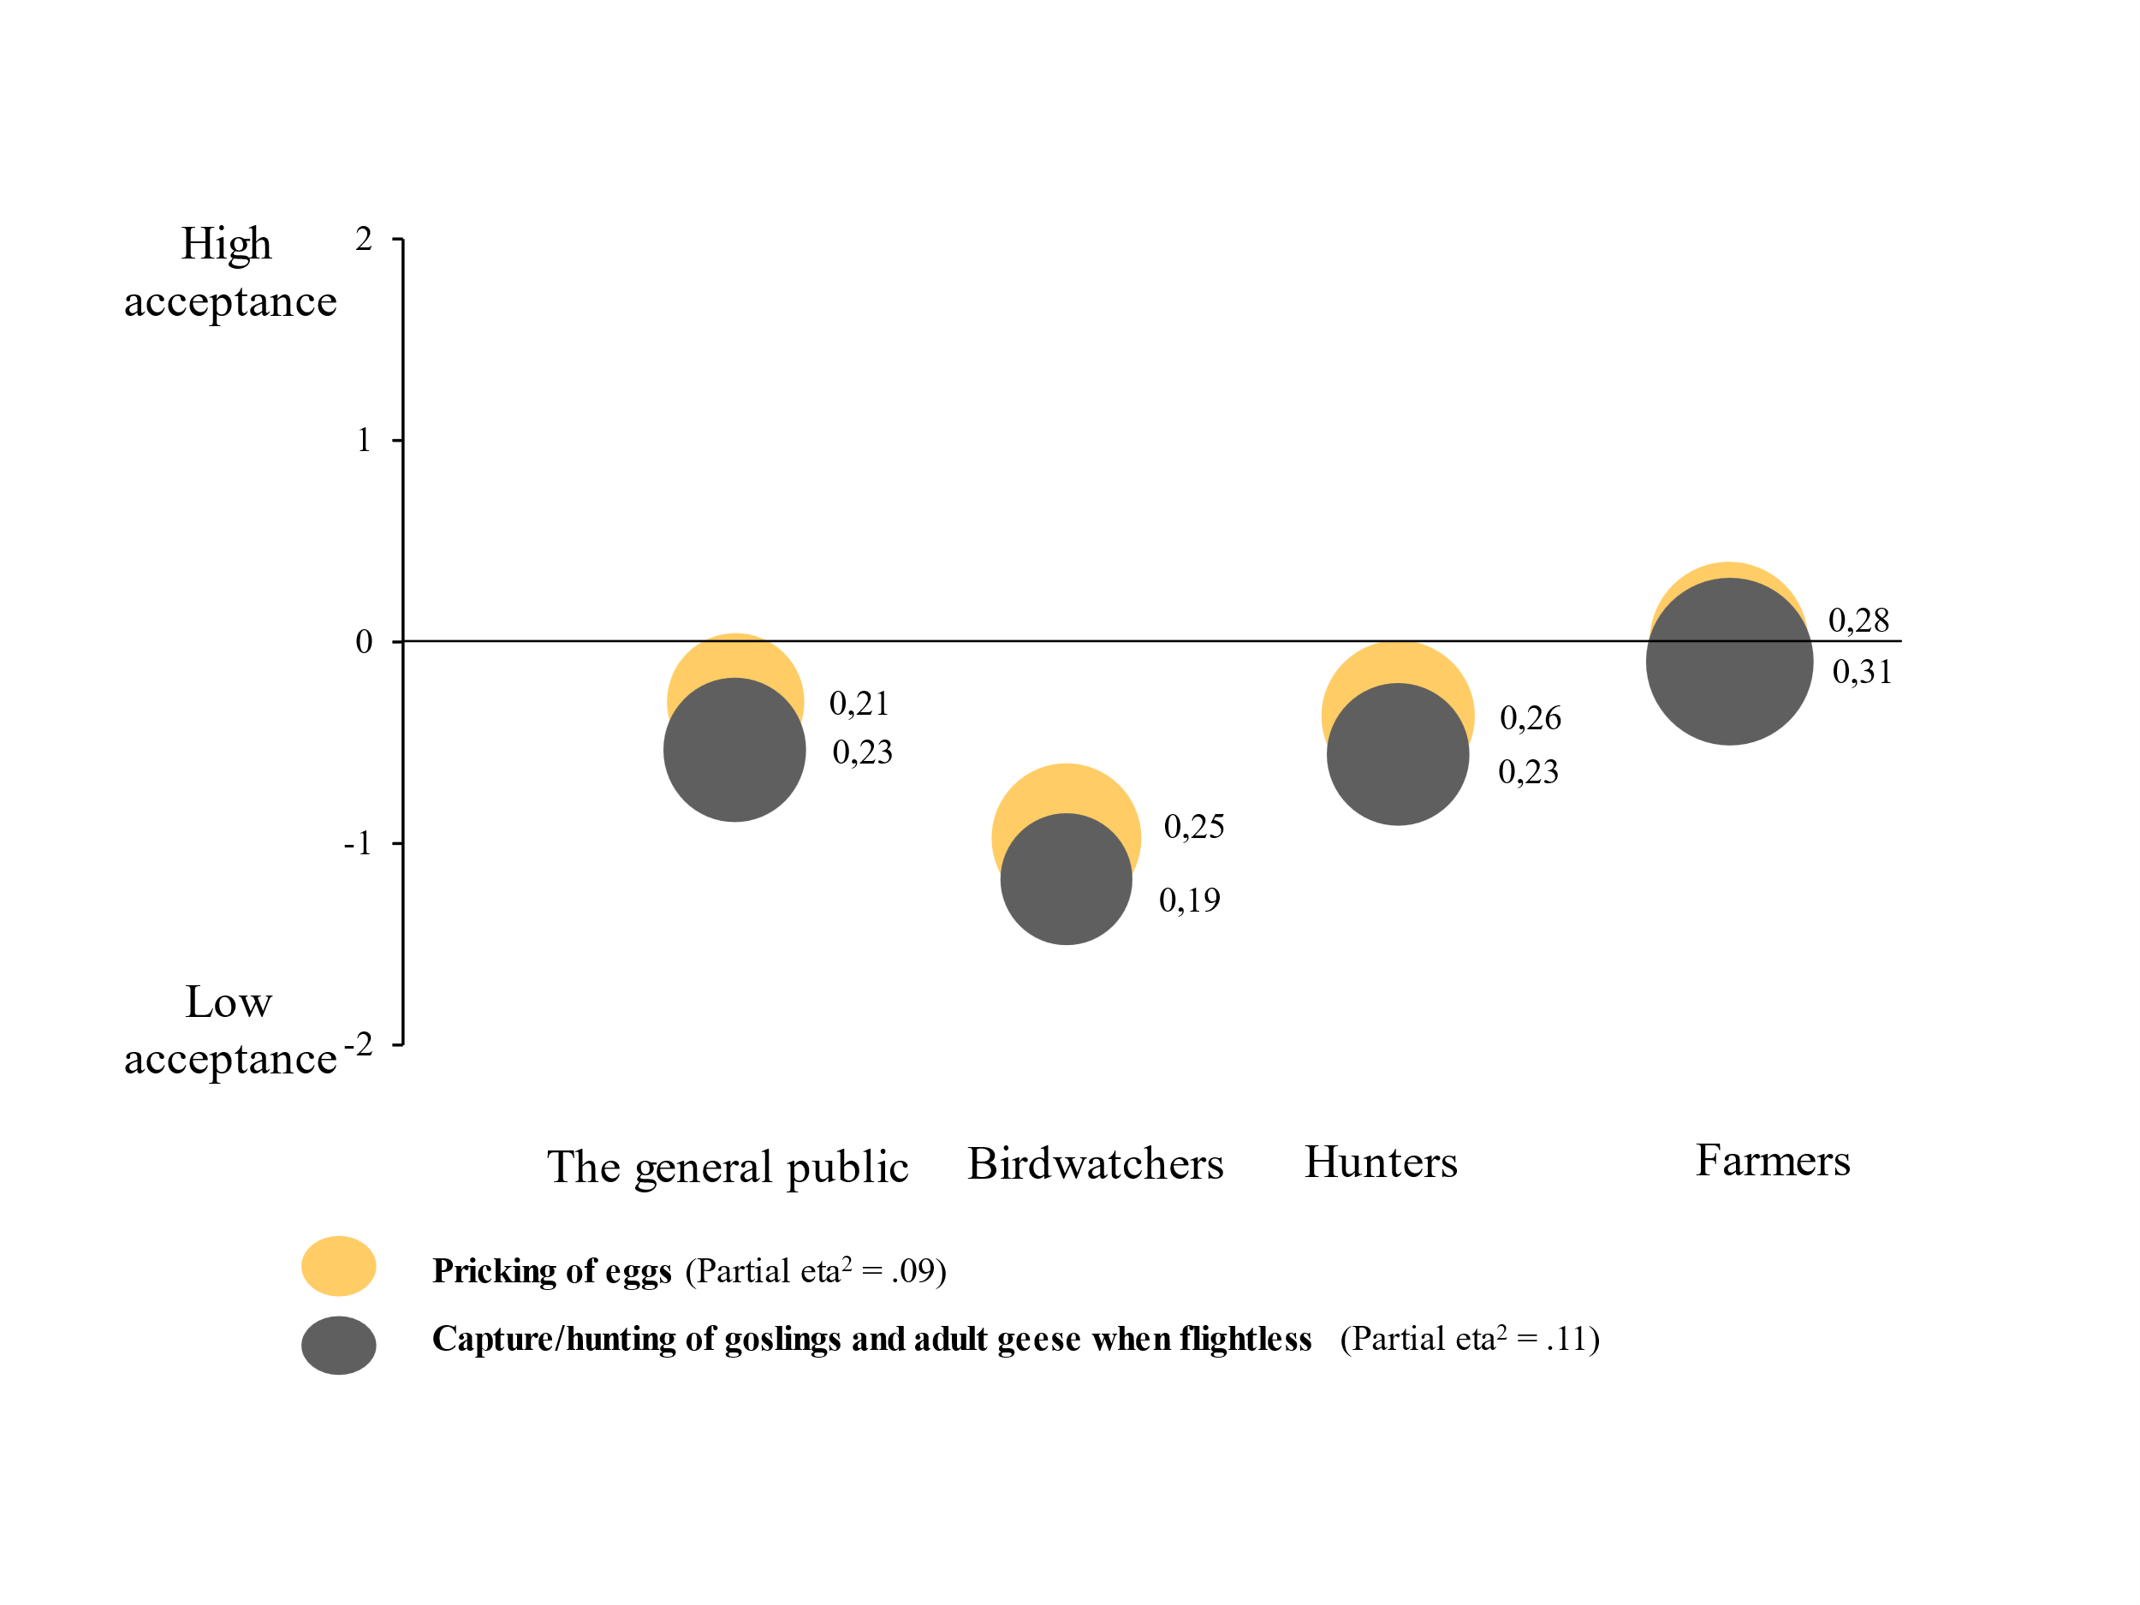
- NON-LETHAL TOOLS
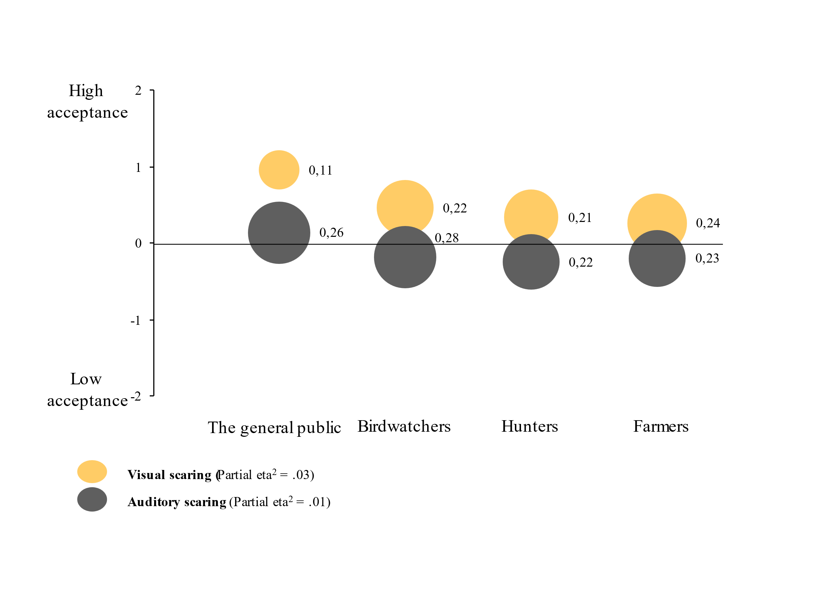
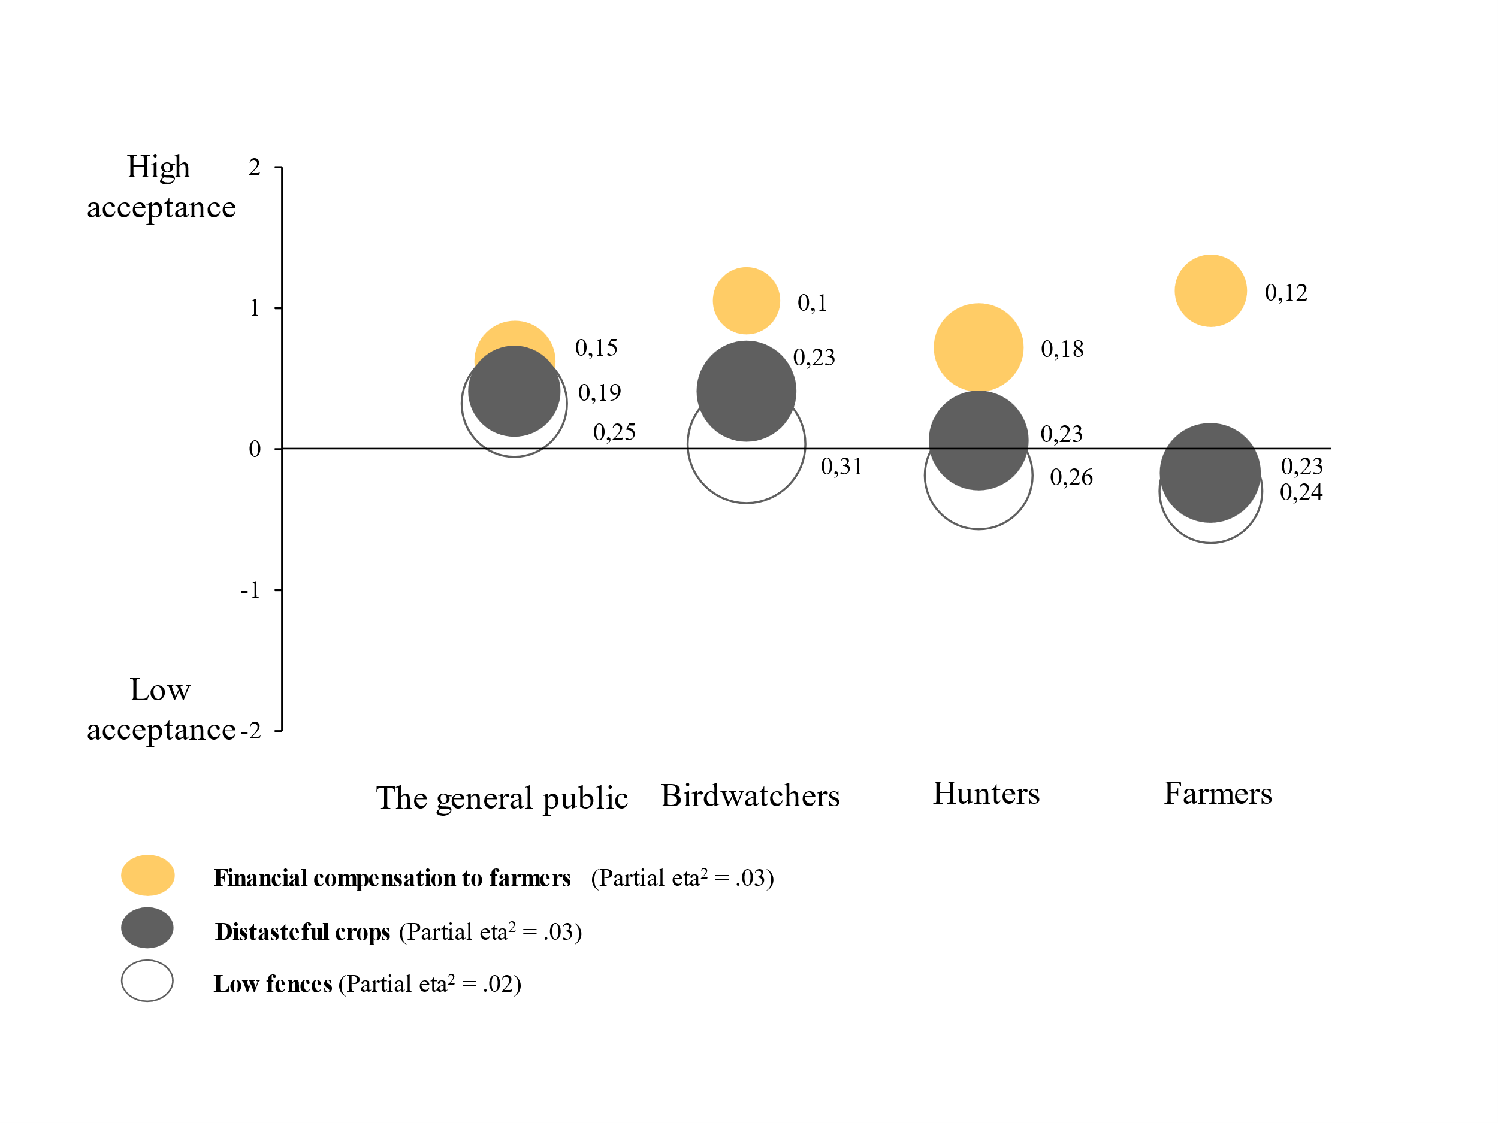

- CONSERVATION-ORIENTED TOOLS
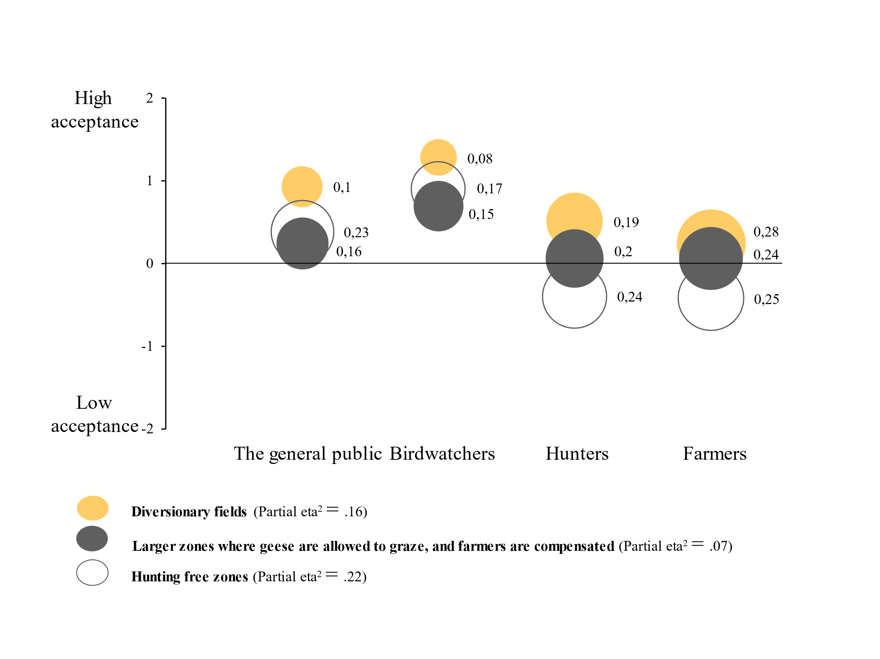

- TOOL KITS
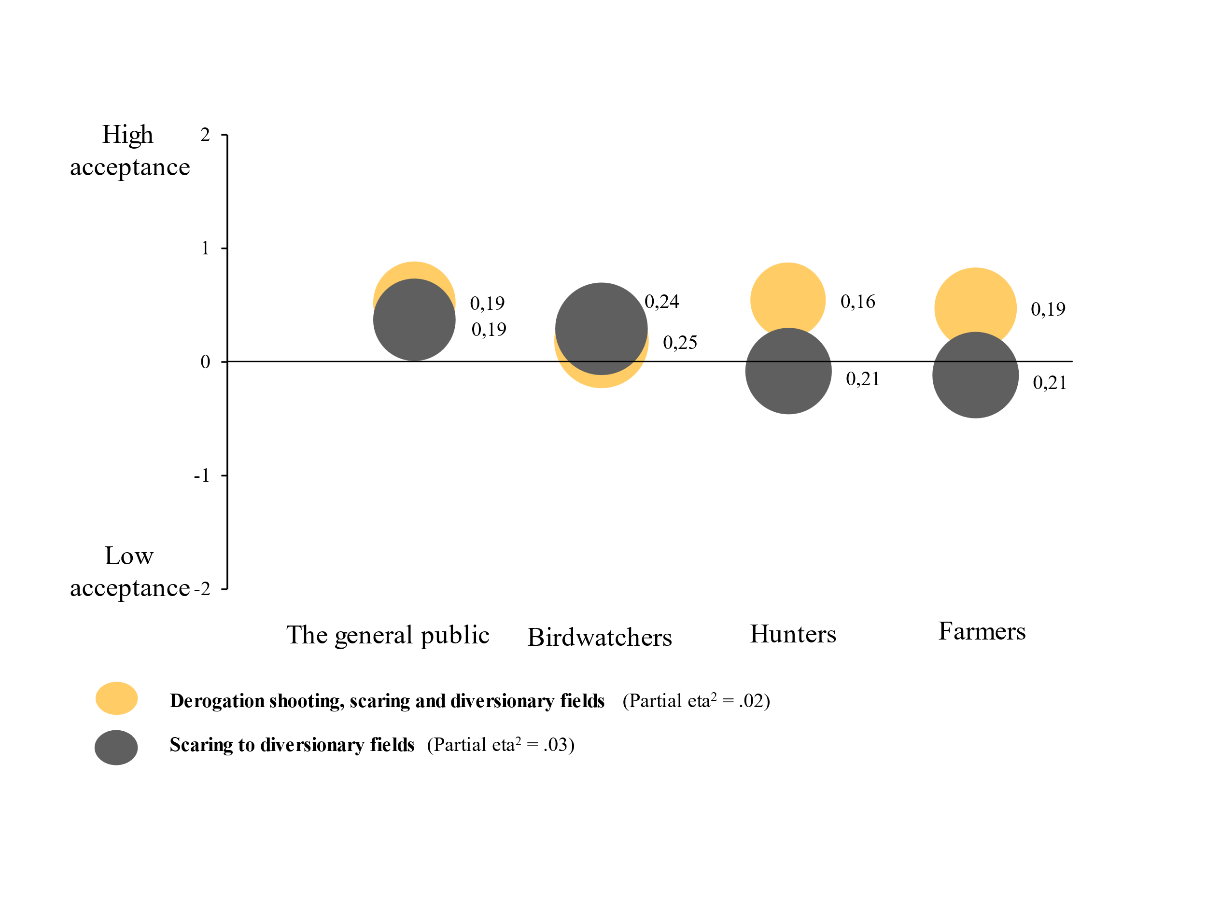
Figure 1A. Acceptance for A) Lethal tools (hunting during open hunting season and derogation shooting can be found in Figure 3), B) Non-lethal tools (top panel: Scaring: bottom panel: Remaining tools), C) Conservation-oriented tools, and D) Tool kits.

Table 1A. Bivariate correlations for wildlife value orientations, beliefs, emotions, acceptance, and experiential variables.
 | Wildlife value orientation |  | Specific beliefs |  |  | Emotions |  | Acceptance |  | Experiential variables
 | Mutualism | Domination | ES food/  hunting | ES nature | Ecosystem disservices | Positive | Negative | Acc Pres | Acc Lethal | Nature areas | Bird-watching
Mutualism ª | α = .81
Domination ª | -.27*** | α = .67
ES food/ hunting ª | -.21*** | .17*** | α = .70
ES nature ª | .43*** | -.33*** | -.03** | α = .85
Ecosystem disservices ª | -.18*** | .31*** | .20*** | -.38*** | α = .84
Positive emotions ^{b} | .43*** | -.28*** | -.11*** | .63*** | -.39*** | α = .92
Negative emotions ^{b} | -.20*** | .33*** | .06*** | -.46*** | .39*** | -.26*** | α = .90
Acc Pres ª | .40*** | -.35*** | -.14*** | .54*** | -.30*** | .48*** | -.39*** | α = .69
Acc Lethal ª | -.37*** | .43*** | .37*** | -.49*** | .47*** | -.48*** | .41*** | -.44*** | α = .72
Nature areas (D) | .11*** | -.22*** | .00 | .20*** | -.16*** | .23*** | -.19*** | .18*** | -.19***
Bird-watching (D) | .27*** | -.31*** | -.13*** | .33*** | -.20*** | .40*** | -.29*** | .33*** | -.34*** | .36***
Hunting (D) | -.32*** | .24*** | .27*** | -.28*** | .14*** | -.21*** | .20*** | -.36*** | .37*** | -.03** | -.25***
*** p < 0.001, ** p < 0.01, *** p < .05. a) Scale 1-5, b) Scale 0-6, D = Dummy. ES = Ecosystem services, Acc Pres = Acceptance Preservation approach, Acc Lethal = Acceptance lethal approach. Partial eta² for the effect of stakeholder group on: Mutualism = .15, Domination .16, ES food/hunting .08, ES nature .19, EDS .05, Positive emotions .21, Negative emotions .13, Acc Pres .22, Acc Lethal .23.

Table 2A. Tools used in goose management.
 | Short labels
Lethal tools for damage and conflict reduction
Hunting during open hunting season (certain time of the year) | Hunting during open hunting season
Derogation shooting to prevent damages only after permission by the County Administrative Board. | Derogation shooting under permission
Derogation shooting to prevent damages by own initiative (no permission required) | Derogation shooting no permission
Capture/hunting of goslings and adult birds during molt and when they are flightless during breeding | Capture/hunting of goslings and adult geese when flightless
Pricking of eggs | Pricking of eggs
Non-lethal tools for damage and conflict reduction
Economic compensation to farmers affected by damage caused by geese | Economic compensation
Visual scaring measures (e.g., flags and kites) in fields | Visual scaring
Auditory scaring measures (sound) in fields (e.g., propane cannons) | Auditory scaring
Use crops/grass that are distasteful in places where you do not want geese present (e.g., fields with growing crops and parks) | Distasteful crops
Low fences at beaches/shore pastures to keep geese out | Low fences
Conservation-oriented interventions for damage and conflict reduction
Diversionary fields, i.e., fields where geese are attracted by attractive crops/feeding and can graze undisturbed (‘sacrificial crop’) | Derivation fields
Larger zones /areas where landowners are compensated according to a scheme to allow geese to graze on their land | Larger zones where geese are allowed to graze and farmers are compensated
Hunting free zones to ensure that geese have a refuge | Hunting free zones
Tool kits for damage and conflict reduction
Combine derogation shooting with scaring measures and diversionary fields. | Derogation shooting, scaring and diversionary fields
Scaring visually or by sound to diversionary fields where they can graze undisturbed | Scaring geese to diversionary fields

Table 3A. Means and standard deviations for wildlife value orientations, beliefs about ecosystem services and disservices, and positive and negative emotions.
 | The general public | Birdwatchers | Hunters | Farmers
 | M (SD) | M (SD) | M (SD) | M (SD)
Wildlife value orientations¹
Mutualism | 3.35 (0.97)^{b} | 3.76 (0.95)ª | 2.87 (0.99)^{c} | 2.86 (0.97)^{c}
Domination | 2.27 (0.91)^{b} | 1.69 (0.69)^{c} | 2.30 (0.85)^{b} | 3.26 (1.14)ª
Ecosystem services (ES)²
Geese are beautiful to watch†† | 3.55 (1.05)^{b} | 4.22 (0.86)ª | 3.31 (1.07)^{c} | 3.15 (1.17)^{d}
Geese contribute to increased nature tourism/eco-tourism†† | 2.84 (1.23)^{b} | 3.10 (1.14)ª | 2.40 (1.10)^{c} | 2.06 (1.06)^{d}
Geese contribute to higher biodiversity†† | 3.26 (1.06)^{b} | 3.80 (1.00)ª | 3.08 (1.08)^{c} | 2.62 (1.13)^{d}
Geese are an important part of the ecosystem (e.g., graze to keep shore meadows open)†† | 3.49 (1.16)^{b} | 3.97 (0.97)ª | 3.11 (1.13)^{c} | 2.65 (1.21)^{d}
Goose hunting is appreciated† | 3.11 (1.32)^{b} | 2.44 (1.23)^{c} | 3.60 (1.10)ª | 3.23 (1.26)^{b}
Geese are good food† | 3.13 (1.41)^{b} | 3.04 (1.36)^{b} | 3.55 (1.20)ª | 3.11 (1.31)^{b}
Ecosystem services food/hunting† | 3.12 (1.24)^{b} | 2.73 (1.24)^{c} | 3.57 (1.01)ª | 3.17 (1.16)^{b}
Ecosystem services nature†† | 3.32 (0.96)^{b} | 3.81 (0.80)ª | 3.03 (0.90)^{c} | 2.71 (1.00)^{d}
Ecosystem disservices (EDS)²
Crop damage by geese in agriculture | 3.85 (1.12)^{c} | 3.51 (0.94)^{d} | 4.02 (0.94)^{b} | 4.21 (0.93)ª
Angry geese on beaches and in parks | 2.85 (1.33)ª | 2.52 (1.23)^{b} | 2.88 (1.31)ª | 2.74 (1.35)ª
Risk for collisions at airports | 3.35 (1.19)^{b} | 3.03 (1.05)^{c} | 3.25 (1.12)^{b} | 3.59 (1.16)ª
Disease transmission from geese to humans | 2.66 (1.23)^{b} | 2.07 (1.01)^{c} | 2.61 (1.14)^{b} | 3.02 (1.30)ª
Droppings in parks, on beaches and golf courses | 3.70 (1.28)^{ab} | 3.33 (1.23)^{c} | 3.79 (1.18)ª | 3.62 (1.29)^{b}
Over fertilization of water courses caused by geese | 3.26 (1.27)ª | 2.67 (1.16)^{b} | 3.19 (1.19)ª | 3.11 (1.29)ª
Ecosystem disservices | 3.32 (1.01)^{b} | 2.95 (0.91)^{c} | 3.37 (0.87)^{ab} | 3.47 (0.97)ª
Positive emotions³
Relief | 0.87 (1.45)^{b} | 1.42 (1.80)ª | 1.03 (1.31)^{b} | 0.55 (1.11)^{c}
Enthusiasm | 1.37 (1.70)^{c} | 3.09 (1.91)ª | 1.75 (1.67)^{b} | 0.93 (1.39)^{d}
Pleasure | 1.87 (1.85)^{b} | 3.25 (1.81)ª | 1.99 (1.70)^{b} | 1.23 (1.58)^{c}
Interest | 1.96 (1.77)^{c} | 2.55 (1.71)^{b} | 3.97 (1.58)ª | 1.49 (1.64)^{d}
Joy | 2.11 (1.88)^{b} | 3.75 (1.70)ª | 2.29 (1.72)^{b} | 1.37 (1.59)^{c}
Positive emotions | 1.66 (1.52)^{c} | 3.11 (1.50)ª | 1.94 (1.38)^{b} | 1.13 (1.25)^{d}
Negative emotions³
Sadness | 0.37 (1.06)^{b} | 0.15 (0.64)^{c} | 0.62 (0.96)ª | 0.71 (1.56)ª
Despair | 0.55 (1.29)^{c} | 0.19 (0.74)^{d} | 0.82 (1.22)^{b} | 1.27 (2.00)ª
Worry | 0.68 (1.30)^{b} | 0.24 (0.79)^{c} | 0.72 (1.09)^{b} | 1.06 (1.80)ª
Disgust | 0.76 (1.50)^{c} | 0.27 (0.87)^{d} | 0.97 (1.32)^{b} | 1.19 (1.87)ª
Anger | 0.79 (1.48)^{c} | 0.31 (0.91)^{d} | 1.10 (1.46)^{b} | 1.51 (2.07)ª
Fear | 0.85 (1.41)ª | 0.12 (0.49)^{d} | 0.59 (0.89)^{b} | 0.46 (1.13)^{c}
Irritation | 1.35 (1.78)c | 0.71 (1.28)^{d} | 1.71 (1.70)^{b} | 2.13 (2.21)ª
Negative emotions | 0.77 (1.13)^{c} | 0.29 (0.61)^{d} | 0.94 (0.99)^{b} | 1.24 (1.57)ª
Note. ¹ Scale 1-5. ² Scale 1-5. ³ Scale 0-6. † Ecosystem services food/hunting. †† Ecosystem services nature. Means having the same superscript letter did not differ at p < 0.05 (ANOVA with Bonferroni correction).

