Online only Supplementary Figure

Effects of Empagliflozin and Dapagliflozin in Alleviating Cardiac Fibrosis through SIRT6-Mediated Oxidative Stress Reduction

Hong-xia Ma^{1, 2, 3#}, Ke Wu^{1, 2#}, Fei-hong Dong^{1, 2#}, Bing-kun Cai^{1, 2}, Di Wu^{1, *}, Hui-yi Lu^{1, 4*}
¹ Department of Pharmacy, The Second Affiliated Hospital of Dalian Medical University, Dalian, Liaoning 116023, China
² College of Pharmacy, Dalian Medical University, Dalian, Liaoning 116044, China
³ Department of Pharmacy, Longnan Hospital, Daqing, Heilongjiang 163453, China
⁴ Dalian Kexiang Technology Development Co. Ltd., Dalian 116085, China

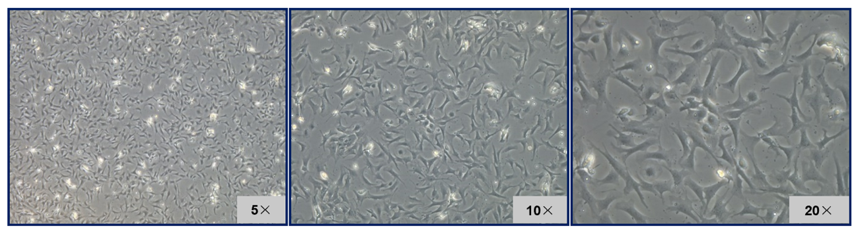
Supplemental Figure
Supplemental Figure 1 Morphology of cardiac fibroblasts under inverted phase contrast microscopy. After cardiac fibroblasts were extracted from 1-3 day-old neonatal mice and inoculated into culture flasks, the cell morphology was observed under microscope (with 5x, 10x, and 20x objective) after 6 hours, presenting as flat, spindle-shaped or star-shaped forms.

