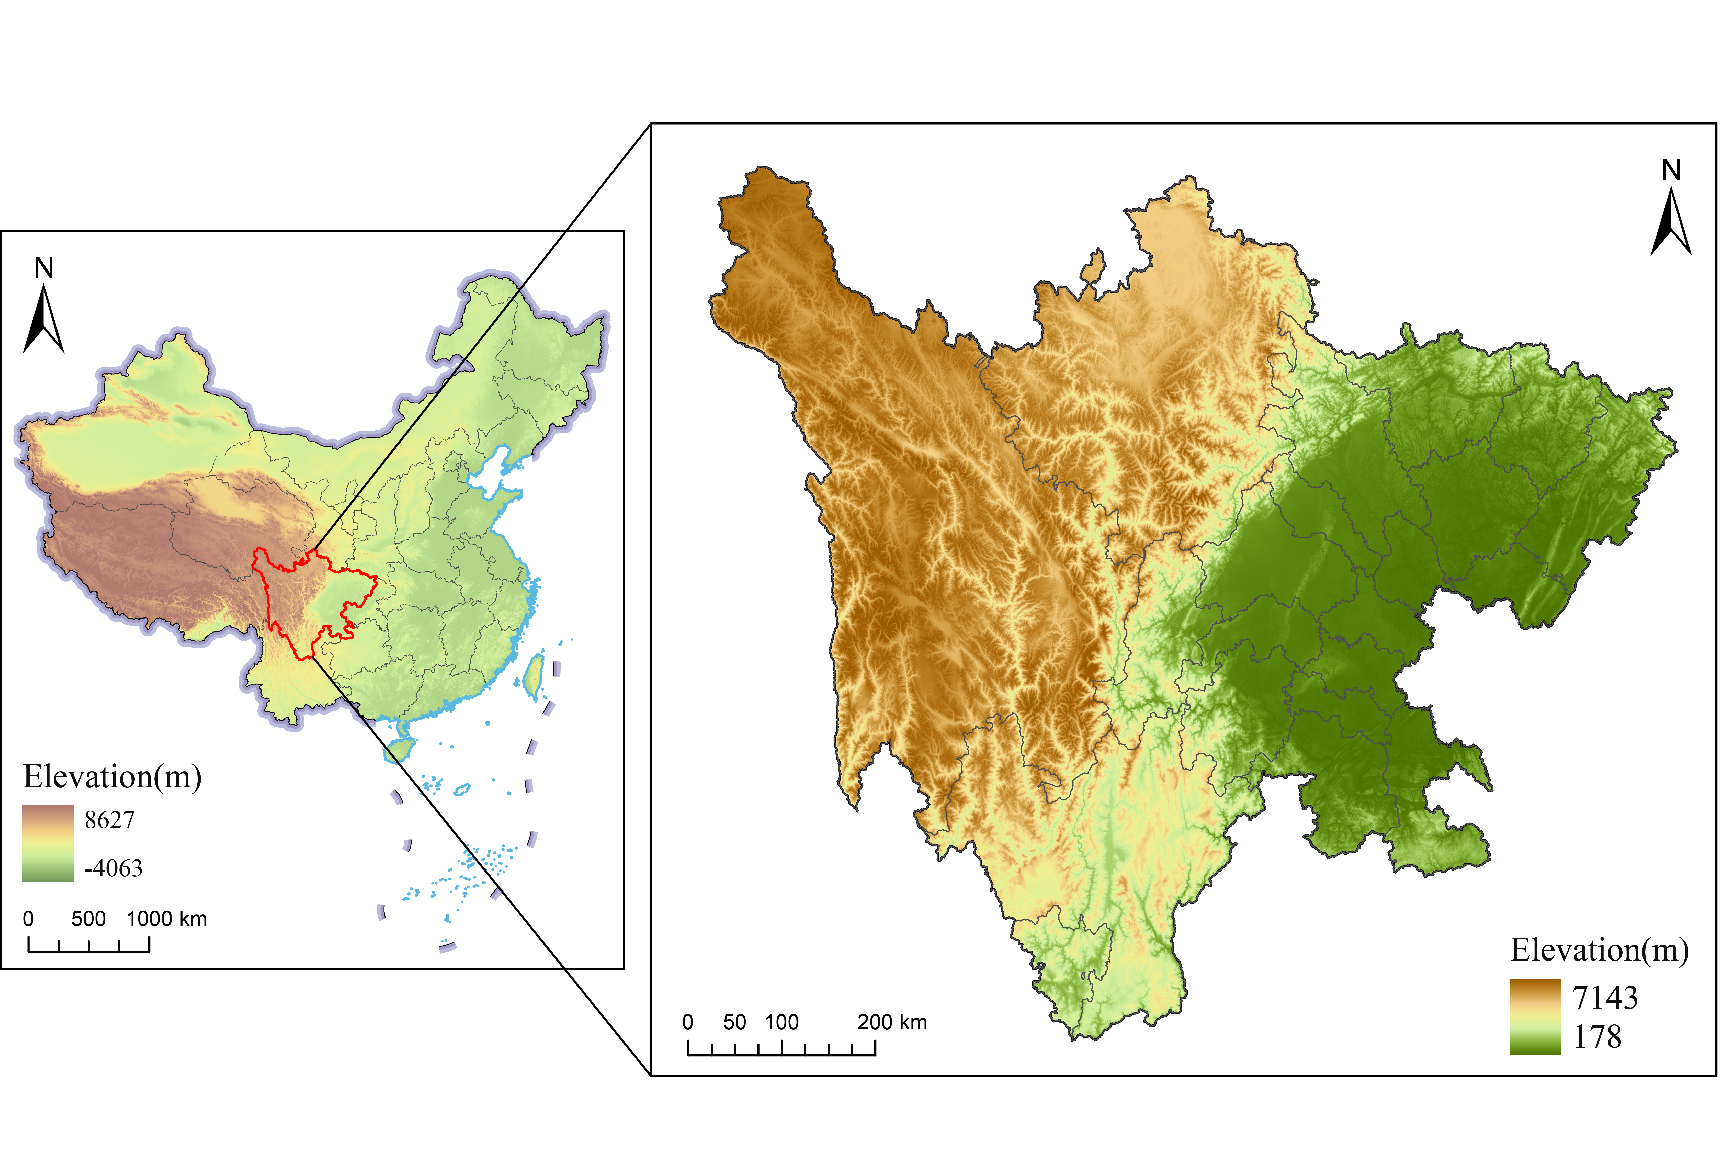
Supplementary Figure S1. Topographic map of China and its southwest. Map generated with ArcMap (version 10.2) (ESRI, Inc., https://www.esri.com/en-us/arcgis/products/arcgis-desktop/resources) using the WGS84 datum and Universal Transverse Mercator conformal projection.
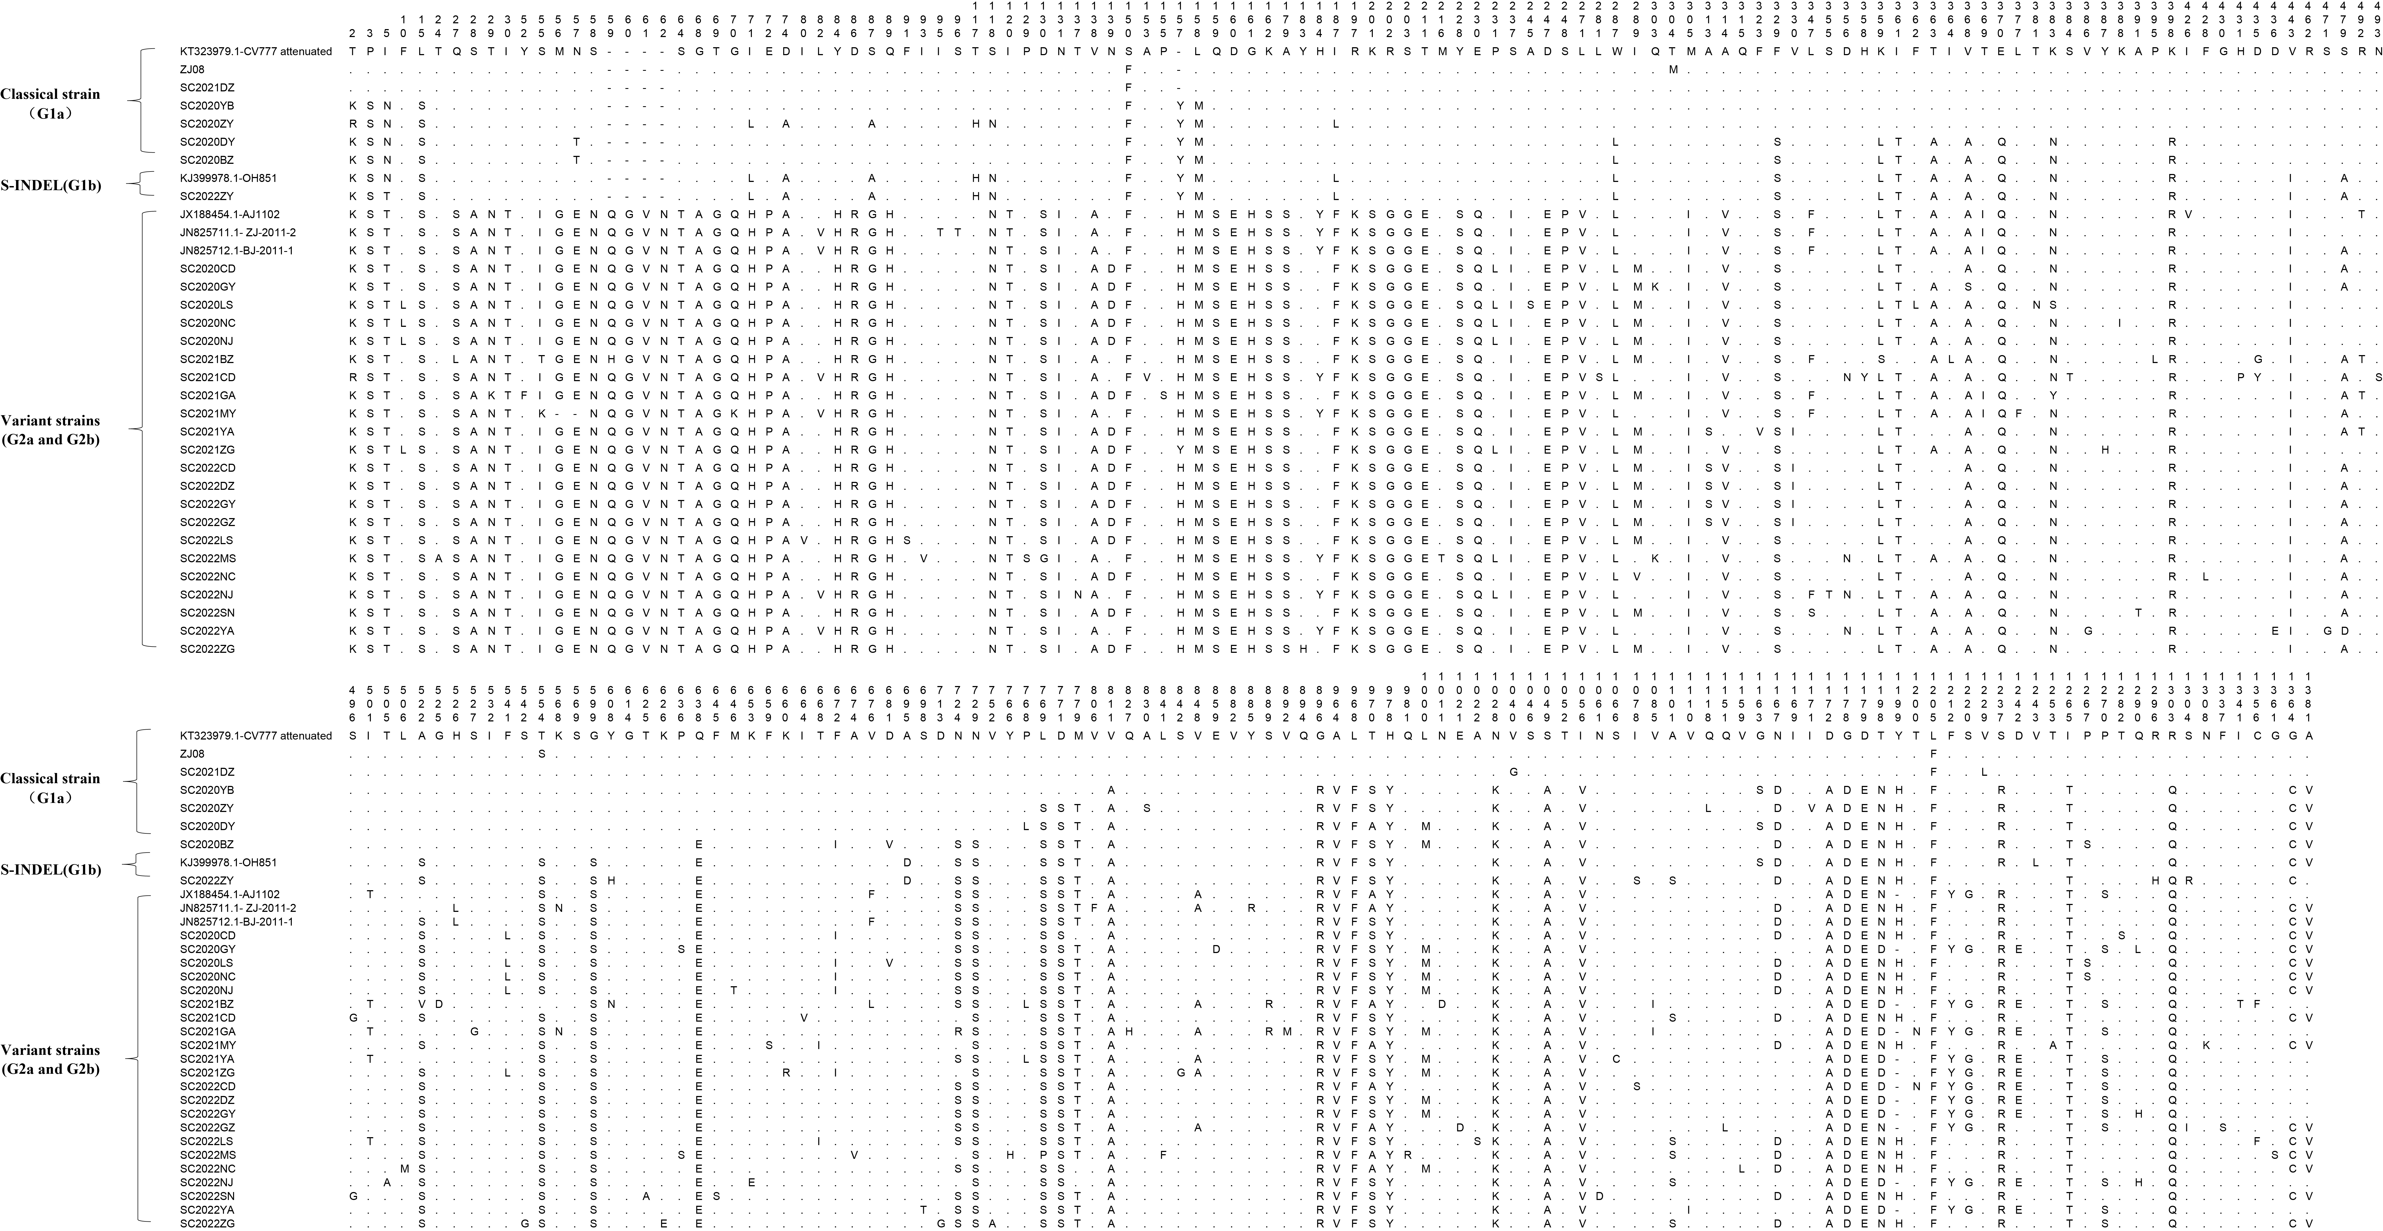
Supplementary Figure S2. A total of 232 amino acid mutations in the S protein between the 28 PEDV strains sequenced in this study and the 6 reference strains. This figure was generated using a combination of MEGA (version 7.0, https://www.megasoftware.net/dload_win_gui) and Excel (version office 2021, https://www.microsoft.com/zh-cn/microsoft-365/get-started-with-office-2021). Amino acid sequences were first aligned using MEGA, and the alignment output was exported to an Excel workbook for further editing.

