N7-methyladenosine-induced SLC7A7 serves as a prognostic biomarker in pan-cancer and promotes CRC progression in colorectal cancer

Supplementary Figures

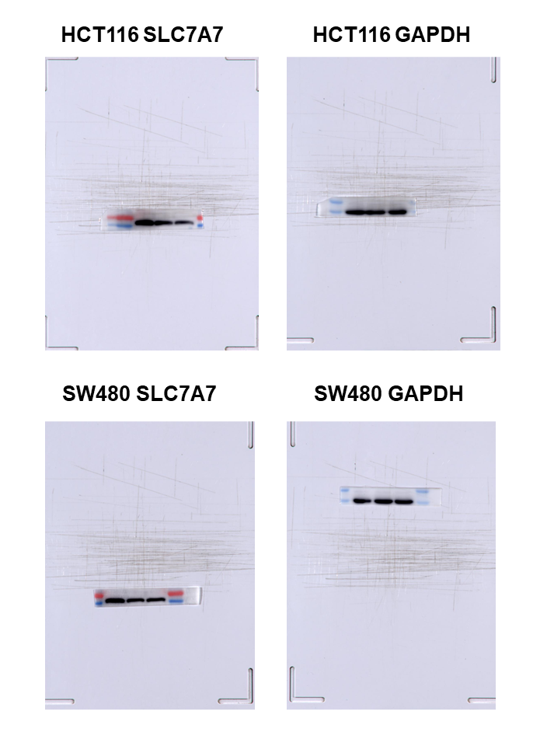
Supplemental Figure 1: The efficiency of SLC7A7 knockdown by WB

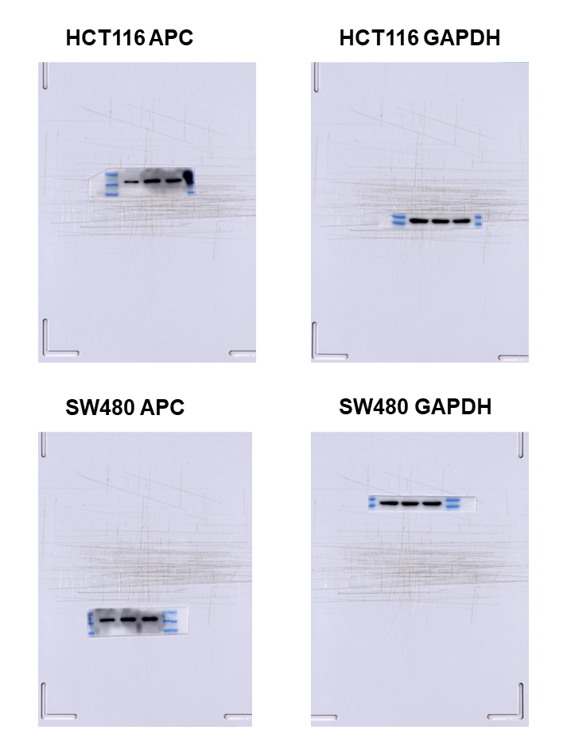
Supplemental Figure 2: The APC expression of si-SLC7A7 was analyzed by WB in HCT116 and SW480 cells
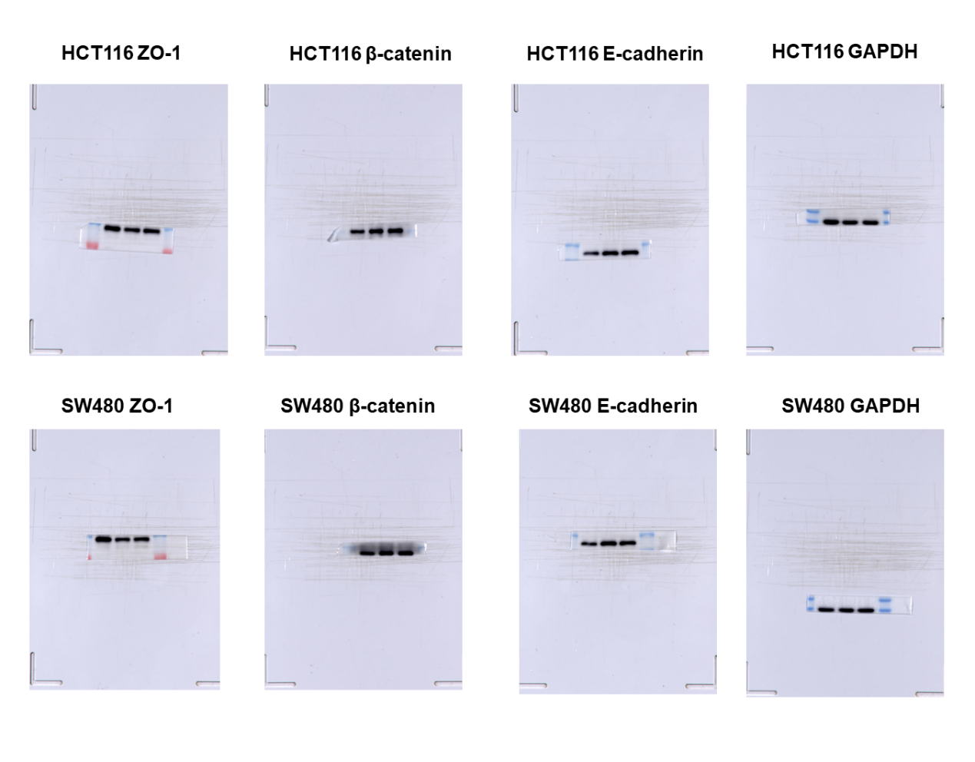
Supplemental Figure 3: EMT marker molecular WB raw images
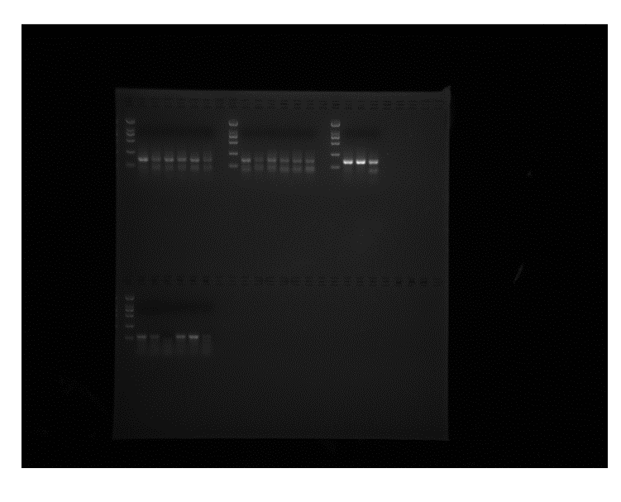
Supplemental Figure 4: M7G Nucleic Acid Gel Imaging
The upper half of the image shows the results of other experiments, and the lower half shows the results of the SLC7A7 m7G rip experiment, SW480/HCT116 two colon cancer cell line results.

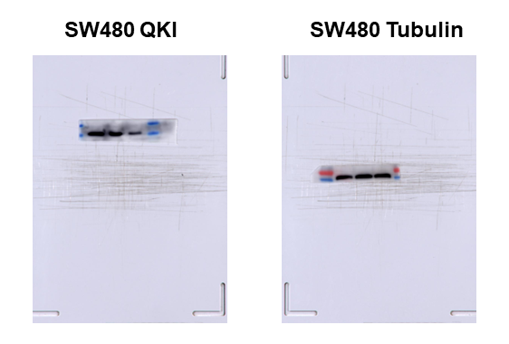
Supplemental Figure 5: The efficiency of QKI siRNA was detected using WB in SW480 cells

