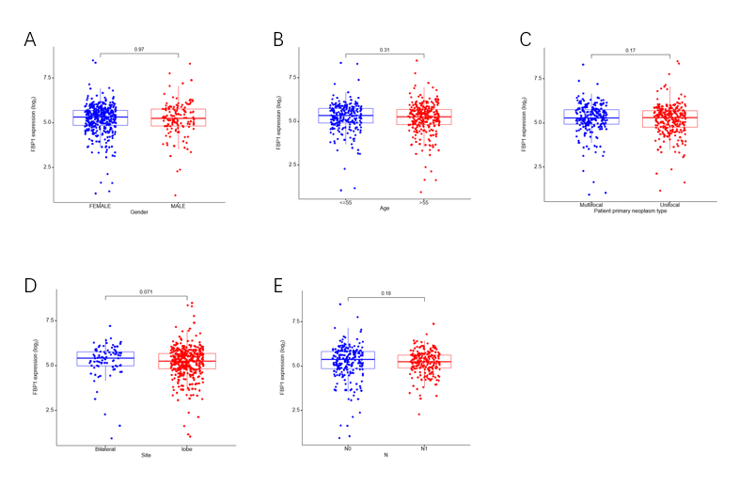
Supplement Figure 1. Comparison of FBP1 expression in gender (A), age (B), multifocality (C), bilaterality (D), or lymph node metastasis (E)

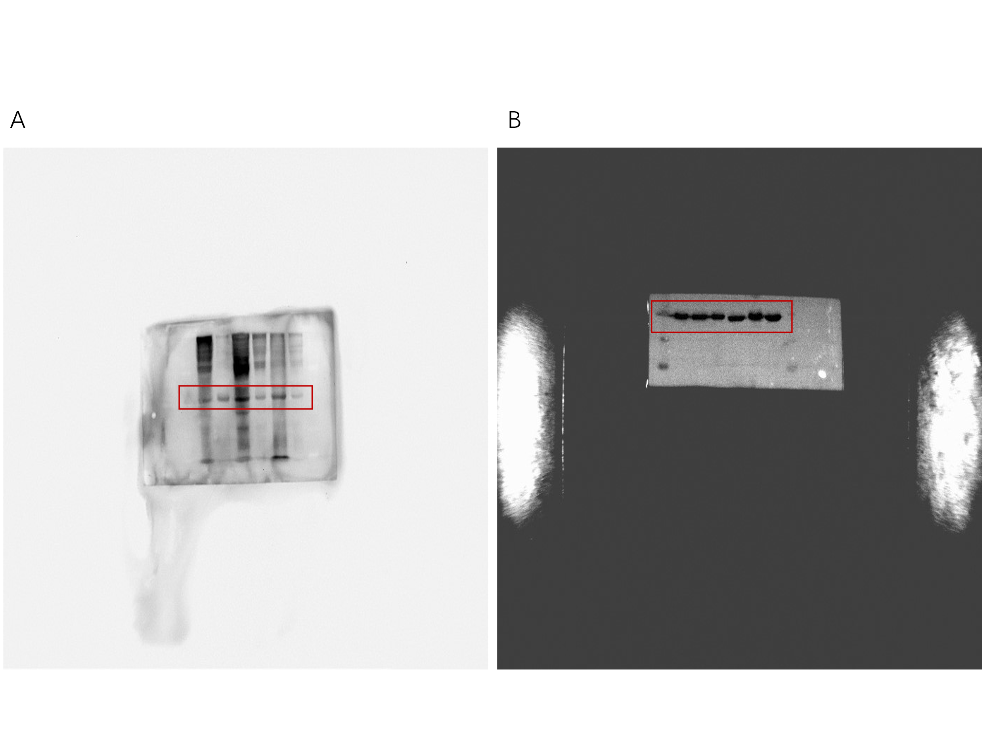
Supplement Figure 2. The original images of Figure 1. A is the original image of Fig B-FBP1, B is the original image of Fig B-actin.

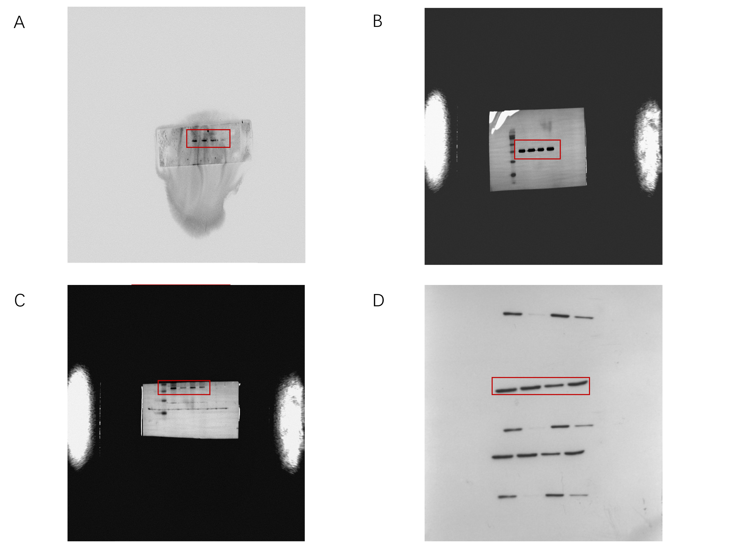
Supplement Figure 3. The original images of Figure 2. A is the original image of Fig A-TPC-FBP1, B is the original image of Fig A-TPC-actin, C is the original image of Fig A-BCPAP-FBP1, D is the original image of Fig A-BCPAP-actin

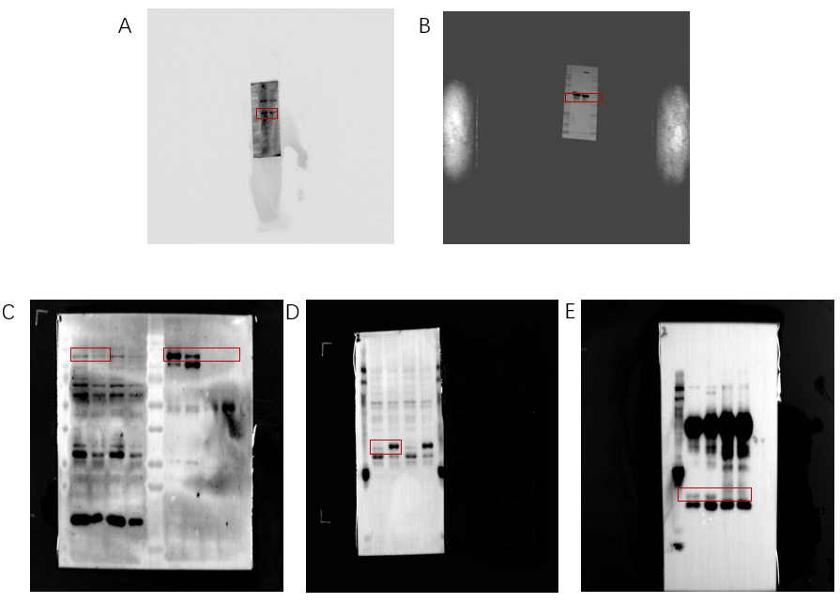
Supplement Figure 4. The original images of Figure 3. A is the original image of Fig A-HIF-1α, B is the original image of Fig A-actin, C is the original image of Fig B- HIF-1α ( Input and IP ), D is the original image of Fig B-FBP1 (Input), E is the original image of Fig B-FBP1 (IP).

