Raw data from Western blot immunodetection
The extracellular vesicle protein, tetraspanin CD63: its journey from the testis through the epididymis to mature bull sperm

Jana Jankovičová†,*, Katarína Michalková†, Petra Sečová, Ľubica Horovská, Jana Antalíková
Laboratory of Reproductive Physiology, Institute of Animal Biochemistry and Genetics, Centre of Biosciences, Slovak Academy of Sciences, Dúbravská cesta 9, 840 05 Bratislava, Slovak Republic

Ad Figure 1b

CD63: tissues α-tubulin: tissues
St Tes Cap Cor Cau St Tes Cap Cor Cau St
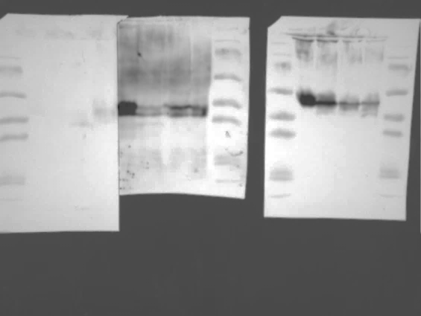

Tes- testes, Cap – caput of the epididymis, Cor- corpus of the epididymis, Cau- Cauda of the epididymis, St - Mw standards

Ad Figure 1c

CD63: extracelullar vesicles (EVs)
Cap Cor Cau SP
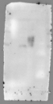

SP- seminal plasma

Ad Figure 2b

CD63: whole sperm α-tubulin: whole sperm
St Cap Cor Cau Ej Cap Cor Cau Ej St
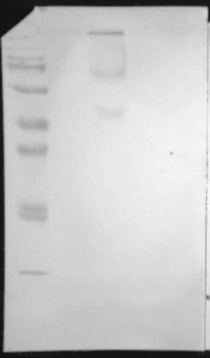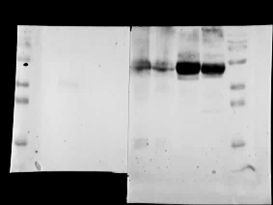

Ad Figure 2c

CD63: sperm heads (H) and tails (T)
Ej
H T St
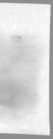
Cap Cor Cau
St H T H T H T St

Ej- ejaculated sperm
Ad Figure 2c

α-tubulin: sperm heads and tails
Cap Cor Cau Ej
St H T H T H T H T St

Ad Figure 5a

CD9: sperm heads and tails

Ej
H T St
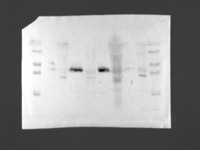
Cap Cor Cau
St H T H T H T St
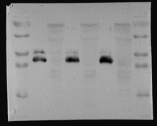

Ad Figure 5a

α-tubulin: sperm heads and tails
Cap Cor Cau Ej
St H T H T H T H T St

Ad Figure 5b

CD9: EVs
Cap Cor Cau SP
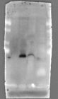

Ad Figure 5c

CD9: IP with CD63 (lane 1) and IgG1( lane 2)
St Cap St St Cor St St Cau St ST Ej

1 2 1 2 1 2 1 2

Ad Figure 6a

ITG αV: tissues α-tubulin: tissues
St St Tes Cap Cor Cau St St Tes Cap Cor Cau St
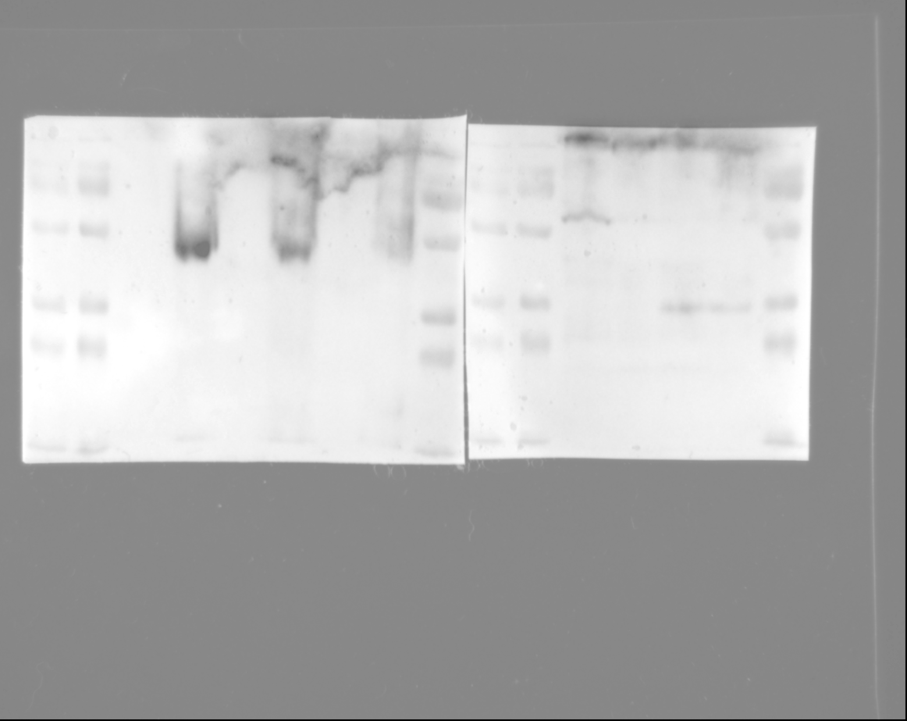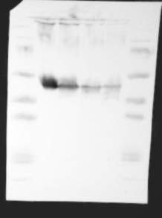

Ad Figure 6b

ITG αV: EVs
Cap Cor Cau SP
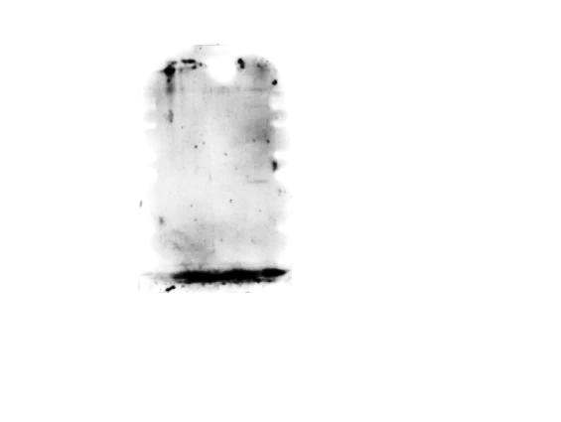

Ad Figure 6c

ITG αV: sperm heads and tails Ej
H T St
Cap Cor Cau
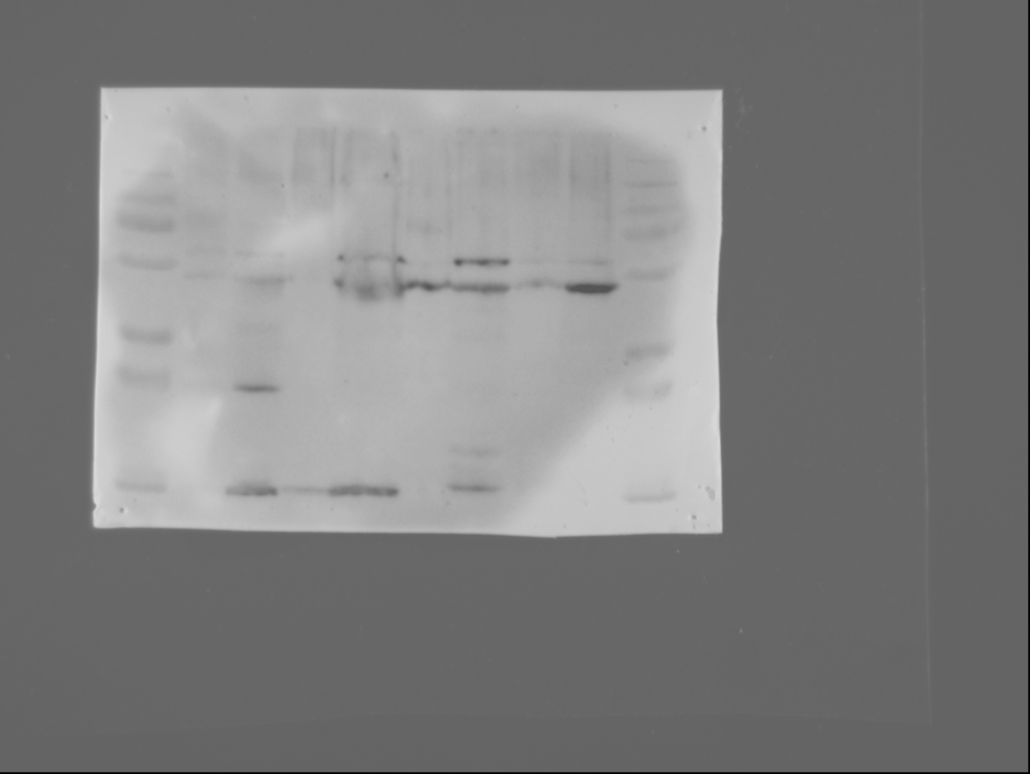
St H T H T H T St
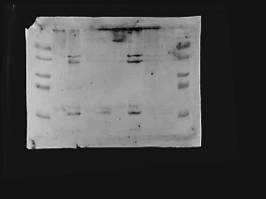

Ad Figure 6c

α-tubulin: sperm heads and tails
Cap Cor Cau Ej
St H T H T H T St H T
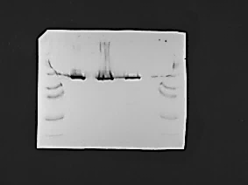

Ad Figure 6d

ITG αV: IP with CD63 (lane 1) and IgG1 (lane2)

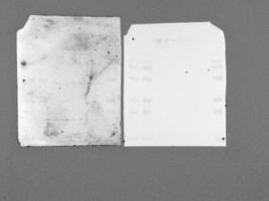
Cap Cor Cau Ej Cap Cor Cau Ej

1 1 1 1 2 2 2 2

Ad Figure 7a

SYN-1: tissues α-tubulin: tissues
Tes Cap Cor Cau St St Tes Cap Cor Cau St
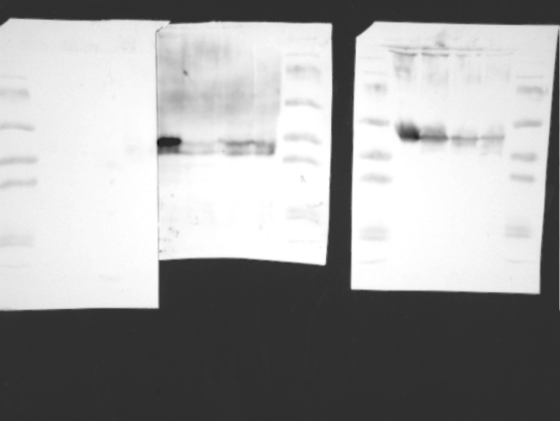

Ad Figure 7b

SYN-1: EVs
Cap Cor Cau SP St
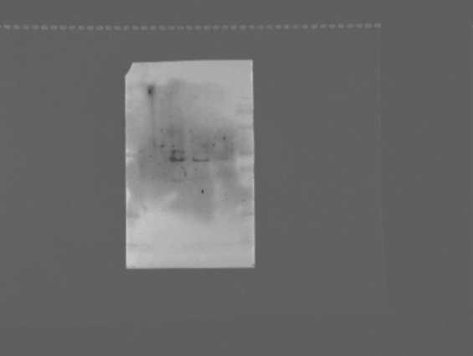

Ad Figure 7c

SYN-1: whole sperm α-tubulin: whole sperm
Cap Cor Cau Ej St St Cap Cor Cau Ej St

Ad Figure 7d

SYN-1: sperm heads and tails
Ej
Cap Cor Cau H T St
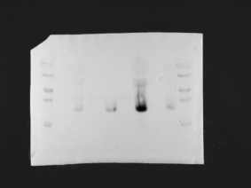
St H T H T H T St
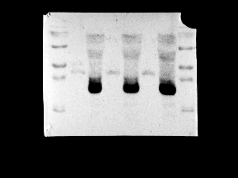

Ad Figure 7d

α-tubulin: sperm heads and tails
Cap Cor Cau Ej
St H T H T H T H T St

Ad Figure 7e

CD9: IP with CD63 (lane1) and IgG1(lane 2)

St Cap St St Cor St St Cau St St Ej St

1 2 1 2 1 2 1 2

