Extraction Method

1- Sample Storage: In the refrigerator (2-6 C°)
2- Sample preparation (Filtration):
Step 1 | Membrane Filter 1 µm pore size 47 mm diameter
Step 2 | Membrane Filter 0.45 µm pore size 47 mm diameter
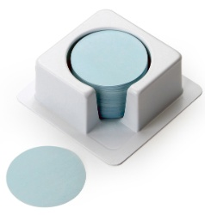
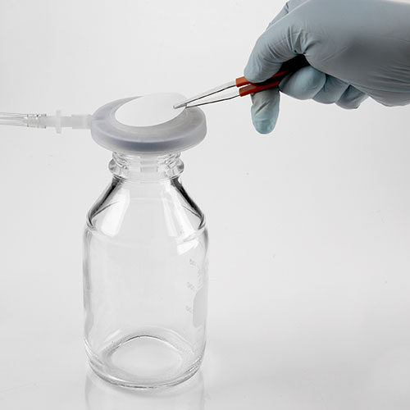
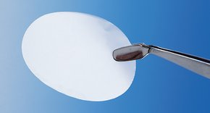

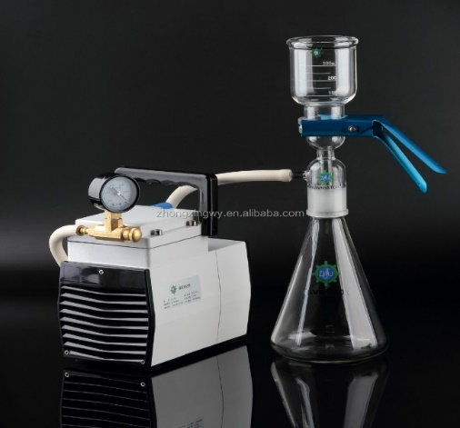
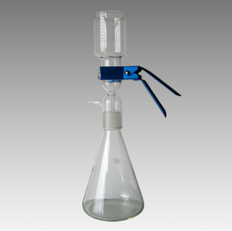
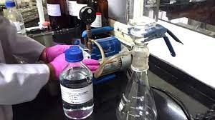

Figure 1: Schematic representation of the sample preparation process for liquid chromatography-mass spectrometry (LC-MS) analysis.
These images illustrate the processes involved in preparing leachate samples for the analysis of pharmaceutical compounds using LC-MS

3- Solid Phase Extraction:
Extraction volume: 500 ml
Final Volume: 1 ml
Degree of enrichment: 500

ENV Cartridge:
BOND ELUT (6 mL, 500 mg Sorbent per Cartridge)

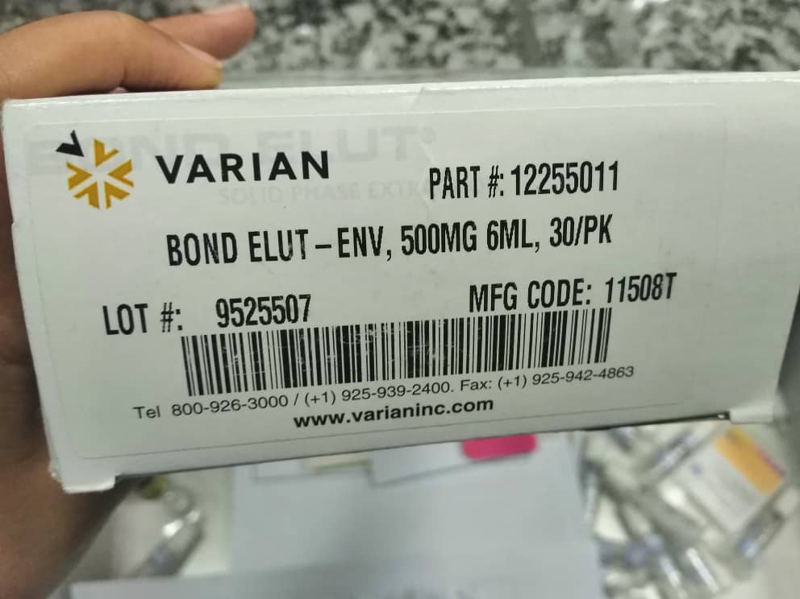
Figure 2: Packaging of Bond Elut-ENV (500 mg, 6 mL), manufactured by Varian for solid-phase extraction (SPE) processes.
The image shows a box of VARIAN Bond Elut-ENV solid phase extraction (SPE) cartridges. The specifications are:
- Part Number: 12255011
- Cartridge Specification: 500 mg, 6 mL
- Quantity: 30 cartridges per pack
- Lot Number: 9525507
- Manufacturing Code: 11508T
These SPE cartridges are used in sample preparation for isolating and concentrating analytes, particularly in the context of preparing samples for chromatographic analysis such as LC-MS.

Table 1: Sample Preparation Steps and Cartridge Conditions for LC-MS/MS Injection

Cartridge conditions | 1) 4 mL Methanol  2) 4 mL Water
Sample loading | 5-10 mL/min
Washing | 1) 5 mL $H_{2}O$
Elution | 6 mL methanol
Drying | $N_{2}$ gas (grade 5) 40 Cº
Final volume | 1 mL MeOH
Filtration | Syringe filter PTFE, 0.22 µm pore size
Injection to LC-MS/MS | 5 µL

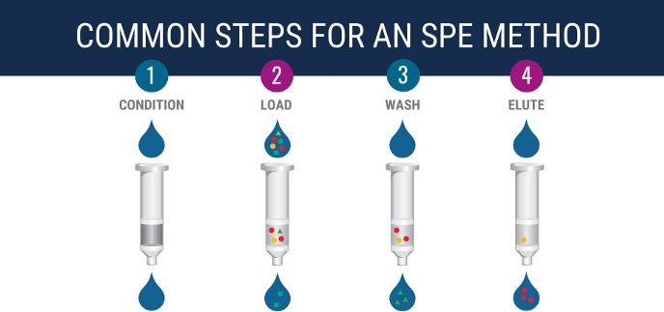
Figure 3: Common steps for a solid-phase extraction (SPE) method: Conditioning, Loading, Washing, and Elution.

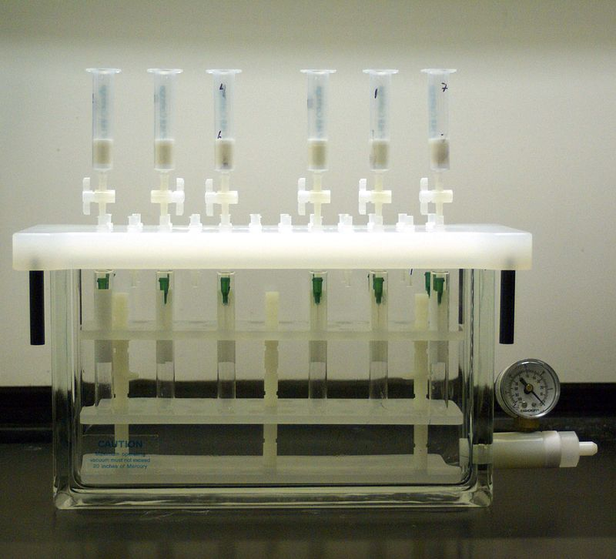
Figure 4: Vacuum manifold system used for solid-phase extraction (SPE) method in sample preparation.
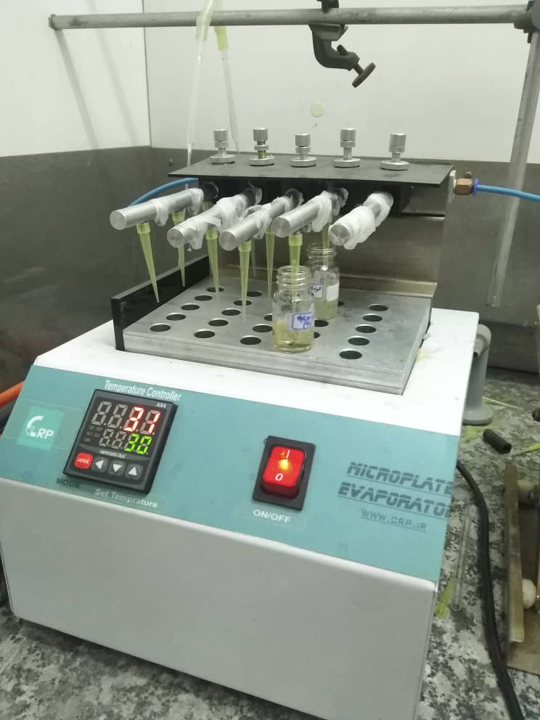
Figure 5: Microplate Evaporator used for sample concentration under controlled temperature conditions.

Images Overview: Solid Phase Extraction (SPE) Method for Sample Preparation
- Common Steps for an SPE Method:
  - Condition: The cartridge is conditioned with solvents to activate the stationary phase.
  - Load: The sample is loaded onto the cartridge, allowing target analytes to bind to the stationary phase.
  - Wash: Unwanted components are washed off the cartridge, leaving only the bound analytes.
  - Elute: The analytes are eluted from the cartridge using a suitable solvent for further analysis.

- SPE Setup:
  - This image shows a multi-syringe SPE manifold setup, where multiple samples can be processed simultaneously. The manifold system applies vacuum to draw samples and solvents through the cartridges.
- Evaporation of Eluates:
  - This image depicts a microplate evaporator used to concentrate the eluates after SPE. The evaporation process removes solvents, leaving behind concentrated analytes ready for subsequent analysis, such as by LC-MS.
These steps and equipment are essential for preparing clean and concentrated samples, crucial for accurate and sensitive detection of target compounds in analytical methods

Extraction Method
Extraction volume: 500 ml
Final Volume: 1 ml
Degree of Preconcentration: 500

