Supplementary figure legends
Figure S1 Pearson Correlation Matrix of 19 mVOCs. Note: blue indicate strong positive correlation; red indicate strong negative correlation; darker colors indicate higher correlation coefficients.

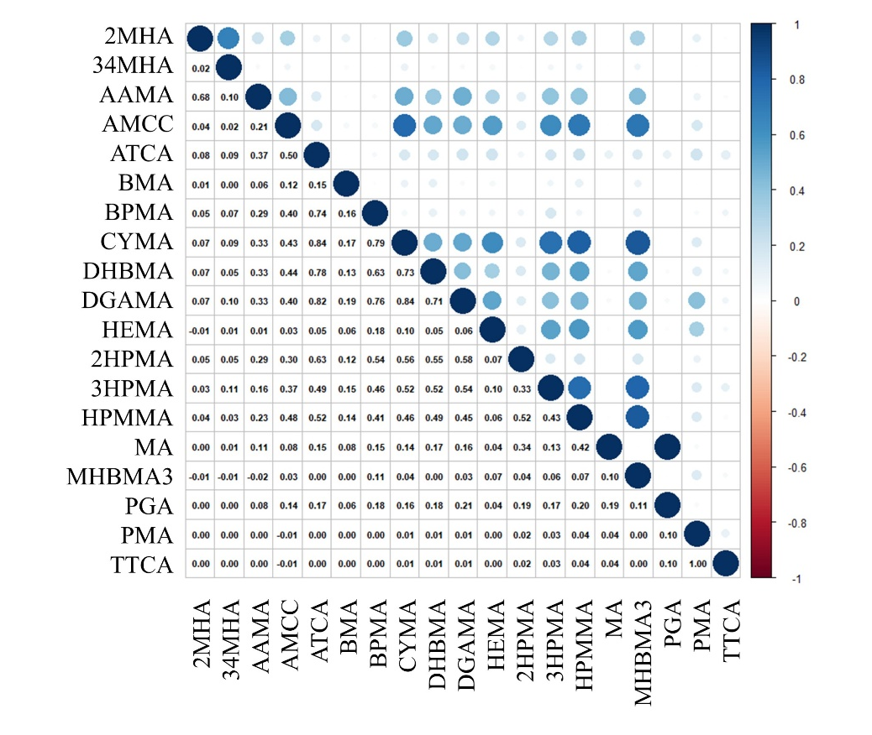

Figure S1 Pearson Correlation Matrix of 19 mVOCs.
Note: blue indicate strong positive correlation; red indicate strong negative correlation; darker colors indicate higher correlation coefficients.

