Supplemental Information

Methods

MSC potency assay
MH-S cells and human MDMs were seeded into 24 well plates at 3 x 105 cells per well. MSC conditioned media (MSC-CM) was prepared by conditioning 1% FBS RPMI-1640 for 24 hours with 1.2 x 105 MSCs/mL. MSC-CM (or media alone as control) was added to macrophages, cells were then stimulated with LPS (E. coli LPS EH100 (RA) TLR grade) (Enzo Life Science) at 1 ng/ml for MH-S and 10 ng/ml for MDMs for 24 hours. Cell supernatant was collected and frozen until required for ELISA (Enzyme linked immunosorbent assay).

Supplemental Table 1
Supplemental Table 1: Lung function parameters comparing MSC, and vehicle treated mice obtained with the FlexiVent system.
Parameter | Group | Mean ± SEM | P value
IC  (ml) | Tg PBS  Tg MSC | 1.26 ± 0.03  1.01 ± 0.07 | 0.0034
Cst  (mL/cmH2O) | Tg PBS  Tg MSC | 0.13 ± 0.01  0.10 ± 0.01 | 0.0079
Hysteresis  (mL.cmH2O) | Tg PBS  Tg MSC | 2.89 ± 0.10  2.22 ± 0.18 | 0.006
R  (cmH2O.s/mL) | Tg PBS  Tg MSC | 0.56 ± 0.02  0.57 ± 0.02 | 0.6685
C  (mL/cmH2O) | Tg PBS  Tg MSC | 0.06 ± 0.002  0.05 ± 0.003 | 0.0067
E  (cmH2O/mL) | Tg PBS  Tg MSC | 16.34 ± 0.46  21.29 ± 1.67 | 0.0132
Rn  (cmH2O.s/mL) | Tg PBS  Tg MSC | 0.20 ± 0.01  0.22 ± 0.01 | 0.1544
G  (cmH2O/mL) | Tg PBS  Tg MSC | 3.87 ± 0.10  4.12 ± 0.18 | 0.2288
H  (cmH2O/mL) | Tg PBS  Tg MSC | 13.07 ± 0.36  18.01 ± 1.72 | 0.0202

An unpaired t-test was performed for the statistical results. P < 0.05 was considered as significant. Significant values are highlighted in bold. IC: Inspiratory capacity, Cst: Static compliance, Hysteresis: Area between inspiratory and expiratory branches, R: Resistance of the respiratory system, C: Compliance of the respiratory system (ability to stretch), E: Elastance of the respiratory system (stiffness), Rn: Newtonian Resistance (central airway constriction), G: Tissue Damping (alveolar tissue constriction), H: Tissue elastance (alveolar tissue stiffness).

Supplemental Figures
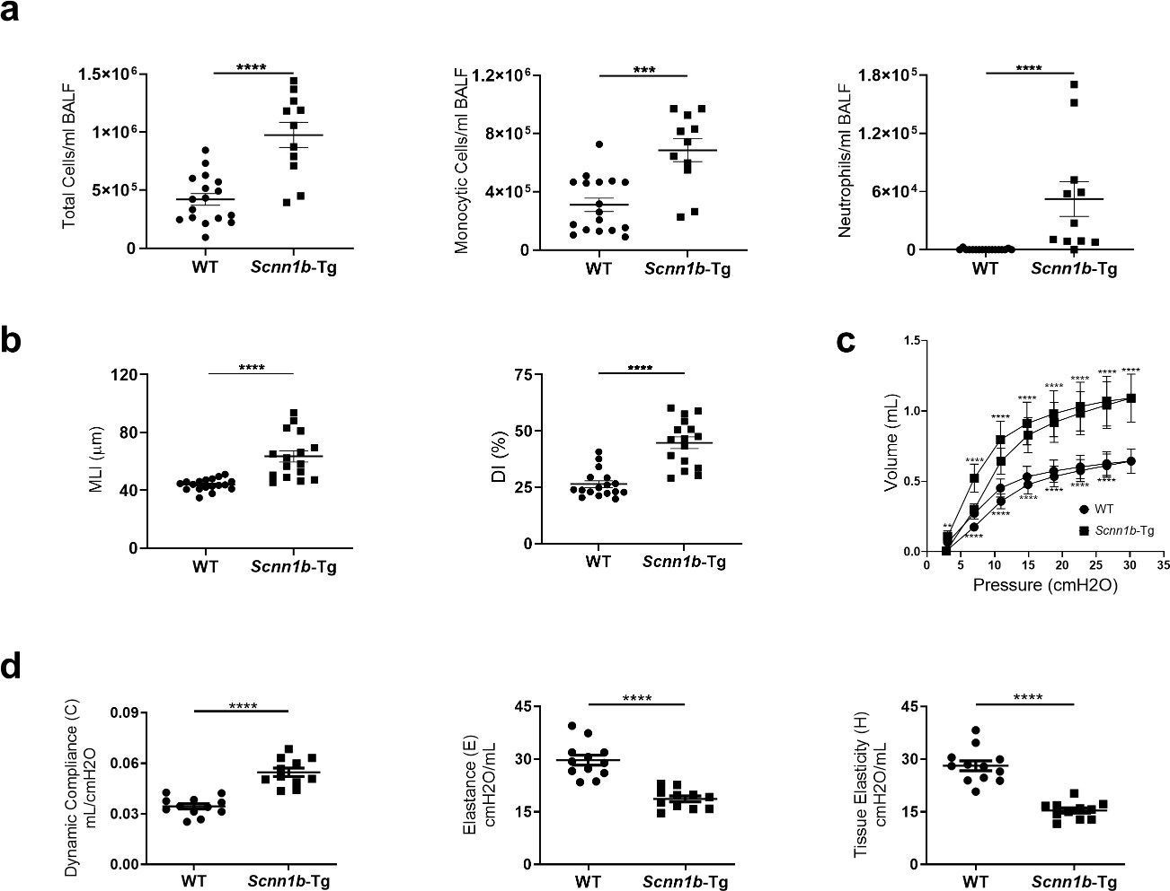

Figure S1: Characterization of inflammation, emphysema, and lung function in Scnn1b-Tg mice at 8 weeks of age.

(a) Total and differential cell counts of leukocyte populations in BALF from Scnn1b-Tg mice and wild- type (WT) littermates, with n = 11-17 per group. (b) Histological analysis of hematoxylin and eosin- stained lung tissue for mean linear intercept (MLI) and destructive index (DI), n = 16-18 per group. (c) Analysis of lung mechanics: Lung function pressure volume (PV) loop curves generated by stepped inflation and deflation maneuvers, n = 11-12 per group. (d) Lung function analysis of the entire respiratory system, including compliance, elastance and tissue elasticity of the alveolar compartment, n= 11-12 per group. Each perturbation was assessed four times before averaging for each mouse, values shown are expressed as group mean ± SEM. Statistical analysis was performed using unpaired or Mann-Whitney T-Test as appropriate, with **= P ≤ 0.01, ***= P ≤ 0.001 and ****= P ≤ 0.0001.

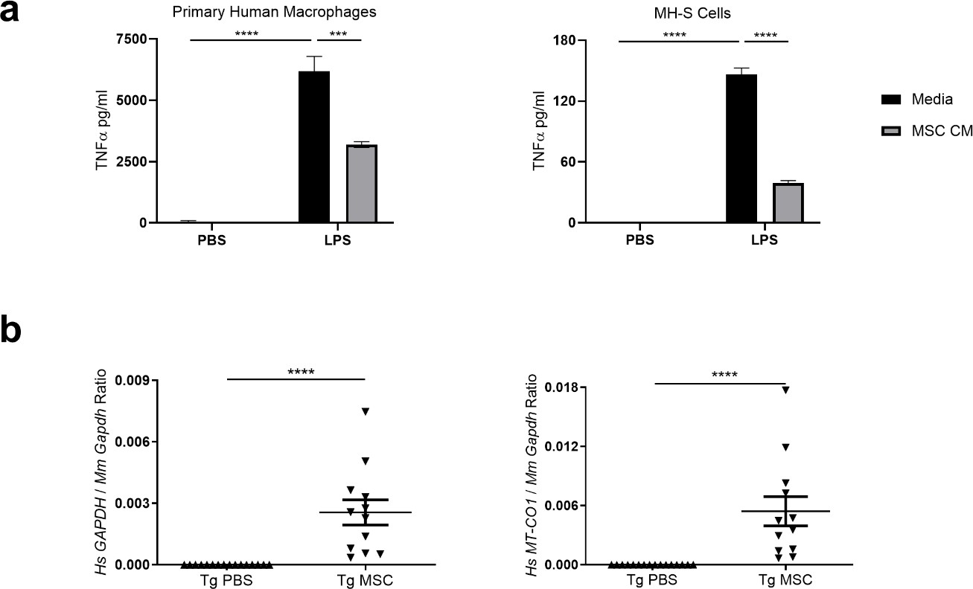

Figure S2: MSC potency assay and confirmatory detection of MSCs in the lung after intravenous administration.

(a) MSC anti-inflammatory potency assays: primary human monocyte derived macrophages and murine MH-S macrophages were treated with media alone or MSC conditioned media (MSC CM) and lipopolysaccharide (LPS) at 1 ng/ml for 24 hours before supernatant collection and analysis of TNFα by ELISA. Samples were assessed in quadruplicate and representative experiment shown. (b) Gene expression analysis of mouse lungs 24 hours after MSC I.V. to confirm the presence of human cells (Hs GAPDH) and human mitochondrial gene expression (Hs-MT-CO1). Data represents mean ± SEM with n =12-25 mice per group. Statistical analysis was conducted using t-test or two-way ANOVA with Tukey’s multiple comparison test. Statistical significance is represented as ***= P ≤ 0.001 and ****= P ≤ 0.0001.

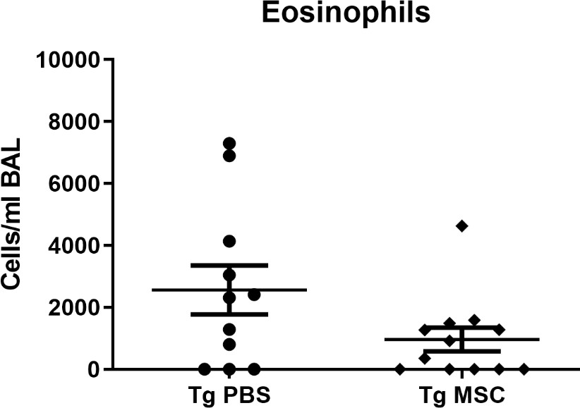

Figure S3: MSC therapy and eosinophils in the chronically inflamed Scnn1b-Tg lungs.

Mice were given 5 x 105 MSCs intravenously at 4 and 6 weeks of age before tissue analysis at 8 weeks. Differential cell counts of eosinophils in BALF from 8-week-old Scnn1b-Tg mice after MSC or vehicle (PBS) administration, n = 11-12 mice per group. Data represents mean ± SEM.

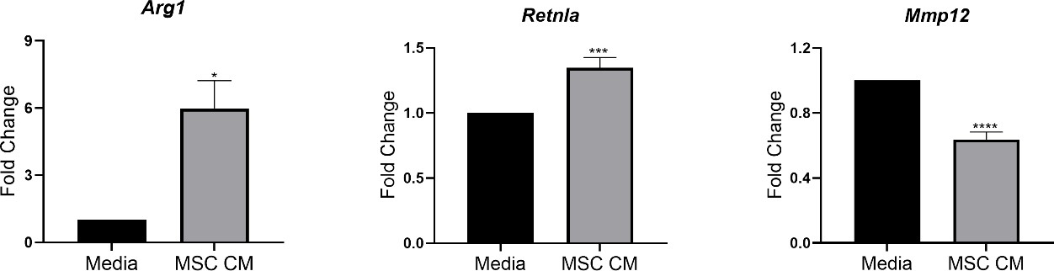

Figure S4: MSC conditioned media targets PPARγ signaling in Scnn1b-Tg alveolar macrophages.

Scnn1b-Tg macrophages treated with media alone or MSC-CM for 24 hours and analyzed for PPARγ target gene (Arg1, Retnla and Mmp-12) expression. Data shown are expressed as fold change ± SEM, with n= 10-12 mice. Statistical analysis performed using a paired T-Test, with *= P ≤ 0.05, ***= P ≤
0.001 and ****= P ≤ 0.0001.

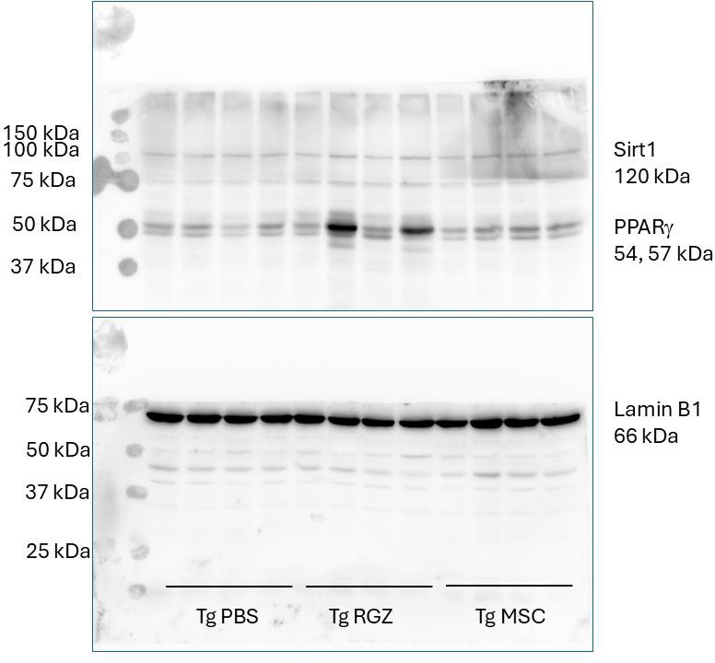

Figure S5: Original unprocessed Western blotting images probed for PPARγ and Lamin B1.

Western blot for nuclear accumulation of PPARγ in Scnn1b-Tg lung tissue treated with MSCs for 24 hours. Nuclear lysates (10 µg) were separated on 12% SDS-PAGE, probed for PPARγ then membranes stripped and reprobed for Lamin B1. Data represents 4 mice from each group.

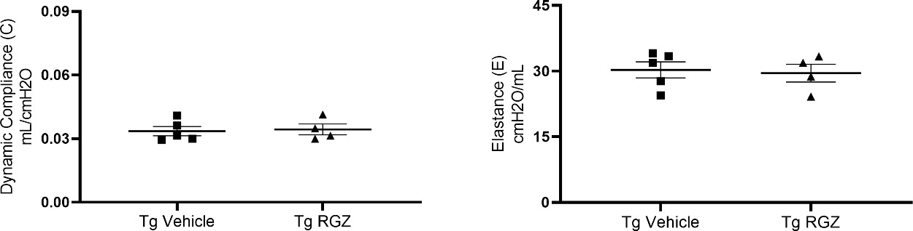

Figure S6: Rosiglitazone targeting of PPARγ in Scnn1b-Tg does not improve lung function.
Rosiglitazone (RGZ) (or vehicle control) was administered to Scnn1b-Tg animals subcutaneously at 10 mg/kg daily for 14 days from 4 weeks of age. Lung function parameters of compliance and elastance shown. Data are expressed as group mean ± SEM, with n = 4-5 per group.

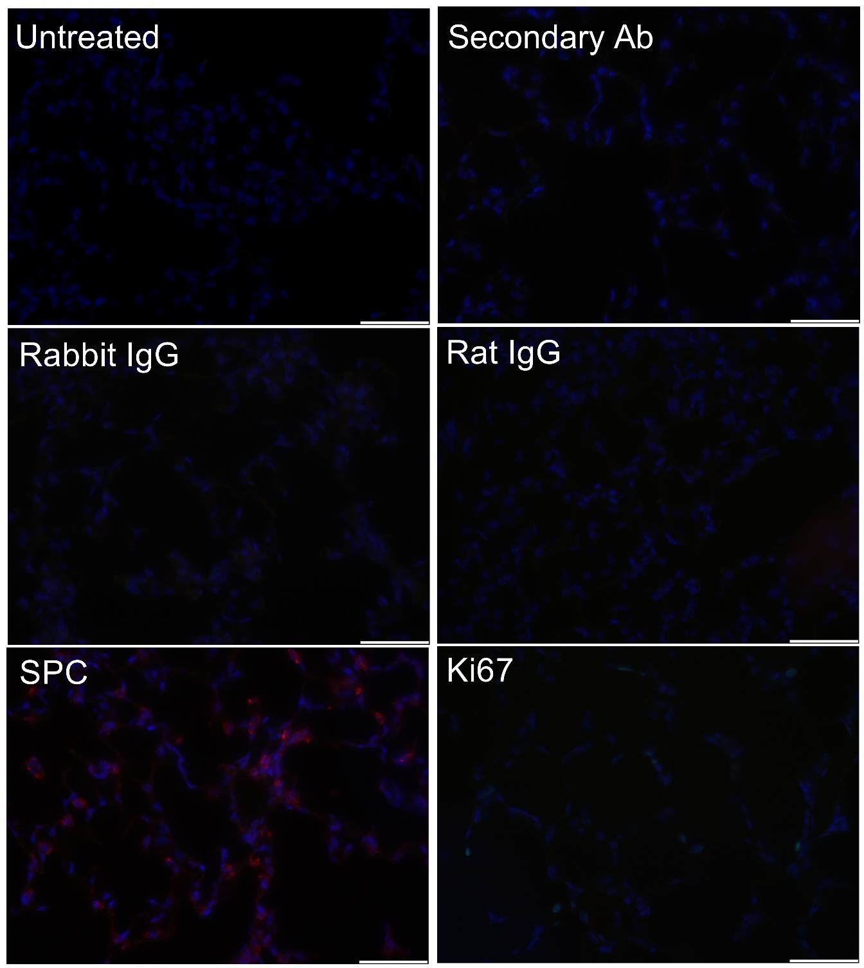

Figure S7. Immunofluorescence antibody validation and staining controls.
Staining of mouse lung parenchymal tissue with controls (Untreated, secondary only; donkey anti- rabbit alexafluor 568, rabbit and rat IgG isotype antibodies) and primary antibodies (single stain control) Rabbit anti-prosurfactant protein C (SPC) polyclonal antibody (1:100) and Rat anti-ki67-FITC (1:100). SPC is red, ki67 is green, DAPI is blue, scale bars 50 µm.

