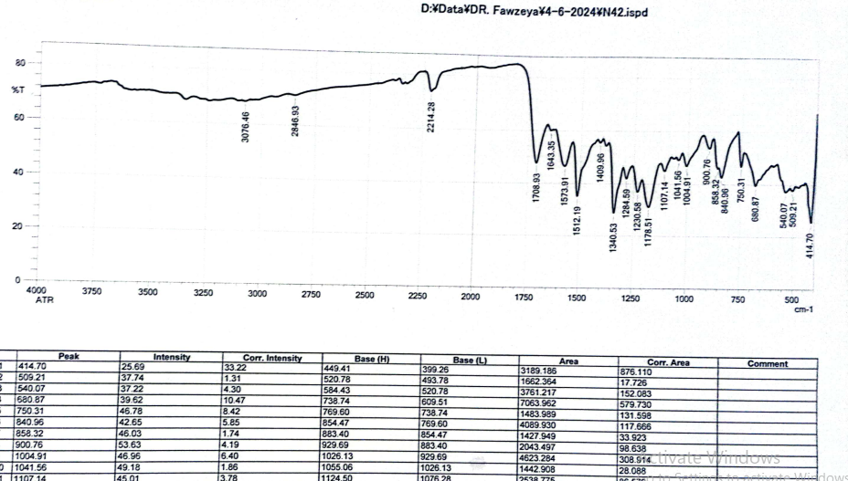
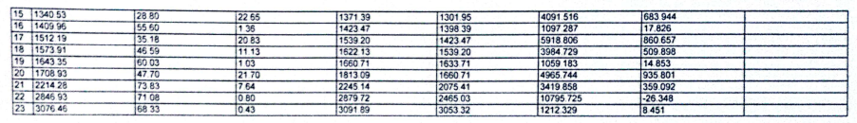
Fig. 1S. IR spectrum of the compound DIPTH.
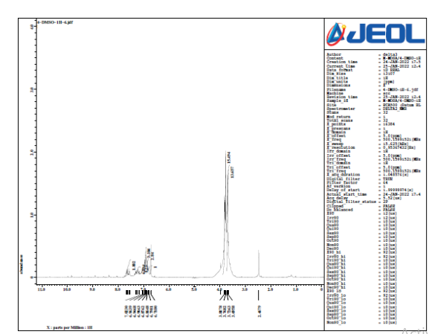
Fig. 2S. ¹H-NMR spectrum of the compound DIPTH.

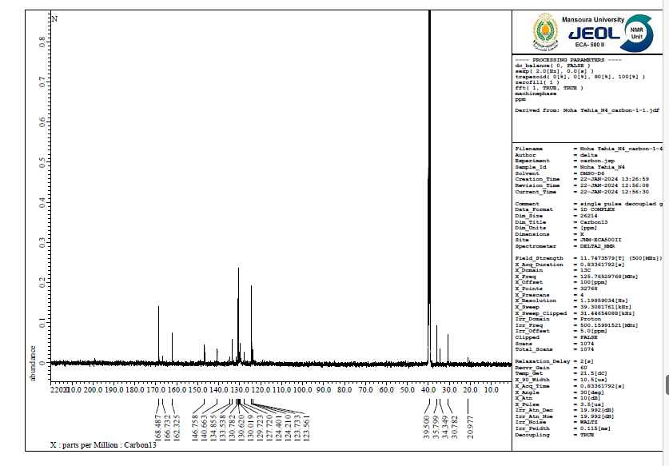
Fig. 3S. ¹³C NMR spectrum of the compound DIPTH.

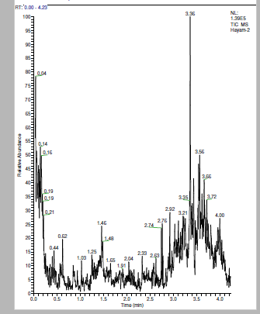
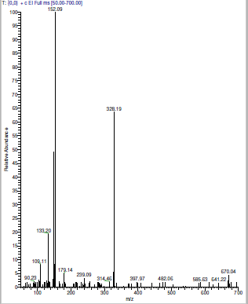

Fig. 4S. Mass spectrum of the compound DIPTH.

Fig. 5S. UV-Vis spectrum of the compound DIPTH.

Fig. 6S. The linear plot for the calculation of the molar extinction coefficient of the compound DIPTH.

