Tab. S1 Characteristics of RNA from A. sativa plant material (‘Fuchs’, Pm3 and Pm4 oat line) collected after 0 (uninoculated) 6, 12, 24, 48, 72 and 96 hours post-inoculation (hpi) with B. graminis f. sp. avenae races to generate compatible or incompatible interaction. Nucleic acid concentration and 260/280 and 260/230 absorbance ratio were determined with NanoDrop2000 Spectrophotometer.

Sample ID | B. graminis treatment | hpi | Nucleic Acid Concentration | Unit | 260/280 | 260/230
F | uninoculated | 0 | 410.4 | ng/µl | 1.93 | 2.5
F | uninoculated | 0 | 415.7 | ng/µl | 1.92 | 2.48
F | uninoculated | 0 | 410 | ng/µl | 1.93 | 2.5
Pm3 | uninoculated | 0 | 419.4 | ng/µl | 1.93 | 2.49
Pm3 | uninoculated | 0 | 411.9 | ng/µl | 1.93 | 2.49
Pm3 | uninoculated | 0 | 411 | ng/µl | 1.92 | 2.5
Pm4 | uninoculated | 0 | 398.3 | ng/µl | 1.91 | 2.5
Pm4 | uninoculated | 0 | 418.1 | ng/µl | 1.92 | 2.5
Pm4 | uninoculated | 0 | 406.9 | ng/µl | 1.92 | 2.49
F | compatible | 6 | 429.4 | ng/µl | 1.92 | 2.48
F | compatible | 6 | 423.5 | ng/µl | 1.92 | 2.48
F | compatible | 6 | 412.4 | ng/µl | 1.93 | 2.48
Pm3 | incompatible | 6 | 412.4 | ng/µl | 1.92 | 2.45
Pm3 | incompatible | 6 | 424.6 | ng/µl | 1.93 | 2.47
Pm3 | incompatible | 6 | 390.1 | ng/µl | 1.9 | 2.48
Pm3 | compatible | 6 | 423.9 | ng/µl | 1.92 | 2.47
Pm3 | compatible | 6 | 419.8 | ng/µl | 1.95 | 2.43
Pm3 | compatible | 6 | 412.2 | ng/µl | 1.91 | 2.46
Pm4 | incompatible | 6 | 423.5 | ng/µl | 1.91 | 2.48
Pm4 | incompatible | 6 | 425.4 | ng/µl | 1.91 | 2.48
Pm4 | incompatible | 6 | 350.6 | ng/µl | 1.92 | 2.49
F | compatible | 12 | 415 | ng/µl | 1.93 | 2.45
F | compatible | 12 | 419.6 | ng/µl | 1.91 | 2.48
F | compatible | 12 | 346.9 | ng/µl | 1.93 | 2.46
Pm3 | incompatible | 12 | 410.2 | ng/µl | 1.91 | 2.48
Pm3 | incompatible | 12 | 414.6 | ng/µl | 1.91 | 2.47
Pm3 | incompatible | 12 | 419.2 | ng/µl | 1.91 | 2.48
Pm3 | compatible | 12 | 423.7 | ng/µl | 1.9 | 2.46
Pm3 | compatible | 12 | 420.2 | ng/µl | 1.91 | 2.49
Pm3 | compatible | 12 | 421.6 | ng/µl | 1.91 | 2.48
Pm4 | incompatible | 12 | 415.6 | ng/µl | 1.92 | 2.48
Pm4 | incompatible | 12 | 421.9 | ng/µl | 1.91 | 2.48
Pm4 | incompatible | 12 | 418.4 | ng/µl | 1.91 | 2.48
F | compatible | 24 | 416.4 | ng/µl | 1.91 | 2.48
F | compatible | 24 | 407.2 | ng/µl | 1.91 | 2.5
F | compatible | 24 | 394.6 | ng/µl | 1.91 | 2.5
Pm3 | incompatible | 24 | 422.4 | ng/µl | 1.91 | 2.49
Pm3 | incompatible | 24 | 425.7 | ng/µl | 1.91 | 2.48
Pm3 | incompatible | 24 | 412.7 | ng/µl | 1.92 | 2.47
Pm3 | compatible | 24 | 407.8 | ng/µl | 1.89 | 2.5
Pm3 | compatible | 24 | 416.3 | ng/µl | 1.89 | 2.49
Pm3 | compatible | 24 | 420.2 | ng/µl | 1.91 | 2.49
Pm4 | incompatible | 24 | 412.6 | ng/µl | 1.9 | 2.49
Pm4 | incompatible | 24 | 418.4 | ng/µl | 1.92 | 2.5
Pm4 | incompatible | 24 | 415.1 | ng/µl | 1.9 | 2.49
F | compatible | 48 | 403.1 | ng/µl | 1.91 | 2.47
F | compatible | 48 | 406.5 | ng/µl | 1.89 | 2.49
F | compatible | 48 | 392.4 | ng/µl | 1.96 | 2.42
Pm3 | incompatible | 48 | 404.7 | ng/µl | 1.9 | 2.47
Pm3 | incompatible | 48 | 426 | ng/µl | 1.9 | 2.47
Pm3 | incompatible | 48 | 399.6 | ng/µl | 1.91 | 2.49
Pm3 | compatible | 48 | 427.3 | ng/µl | 1.9 | 2.47
Pm3 | compatible | 48 | 425.6 | ng/µl | 1.9 | 2.47
Pm3 | compatible | 48 | 422.4 | ng/µl | 1.9 | 2.47
Pm4 | incompatible | 48 | 414 | ng/µl | 1.9 | 2.47
Pm4 | incompatible | 48 | 339.7 | ng/µl | 1.89 | 2.52
Pm4 | incompatible | 48 | 415.5 | ng/µl | 1.9 | 2.47
F | compatible | 72 | 425.3 | ng/µl | 1.9 | 2.44
F | compatible | 72 | 416.9 | ng/µl | 1.9 | 2.46
F | compatible | 72 | 408.5 | ng/µl | 1.88 | 2.47
Pm3 | compatible | 72 | 424.2 | ng/µl | 1.91 | 2.47
Pm3 | incompatible | 72 | 425 | ng/µl | 1.91 | 2.48
Pm3 | incompatible | 72 | 413 | ng/µl | 1.91 | 2.46
Pm3 | incompatible | 72 | 416.2 | ng/µl | 1.89 | 2.45
Pm3 | compatible | 72 | 410.3 | ng/µl | 1.88 | 2.46
Pm3 | compatible | 72 | 423.9 | ng/µl | 1.9 | 2.47
Pm4 | incompatible | 72 | 377.3 | ng/µl | 1.89 | 2.49
Pm4 | incompatible | 72 | 414.3 | ng/µl | 1.9 | 2.47
Pm4 | incompatible | 72 | 413.9 | ng/µl | 1.89 | 2.48
F | compatible | 96 | 418.8 | ng/µl | 1.9 | 2.48
F | compatible | 96 | 408.2 | ng/µl | 1.9 | 2.47
F | compatible | 96 | 417.3 | ng/µl | 1.9 | 2.47
Pm3 | compatible | 96 | 412.8 | ng/µl | 1.9 | 2.47
Pm3 | incompatible | 96 | 404.4 | ng/µl | 1.91 | 2.43
Pm3 | incompatible | 96 | 420.3 | ng/µl | 1.93 | 2.45
Pm3 | incompatible | 96 | 409.6 | ng/µl | 1.9 | 2.46
Pm3 | compatible | 96 | 422 | ng/µl | 1.89 | 2.47
Pm3 | compatible | 96 | 406.2 | ng/µl | 1.9 | 2.47
Pm4 | incompatible | 96 | 422.1 | ng/µl | 1.91 | 2.47
Pm4 | incompatible | 96 | 410.9 | ng/µl | 1.91 | 2.49
Pm4 | incompatible | 96 | 422.1 | ng/µl | 1.91 | 2.47
Fig. S1 Agarose gel electrophoresis of first 32 RNA samples presented in Tab. S1 with Gene Ruler™ 100 bp Plus DNA Lader (L).

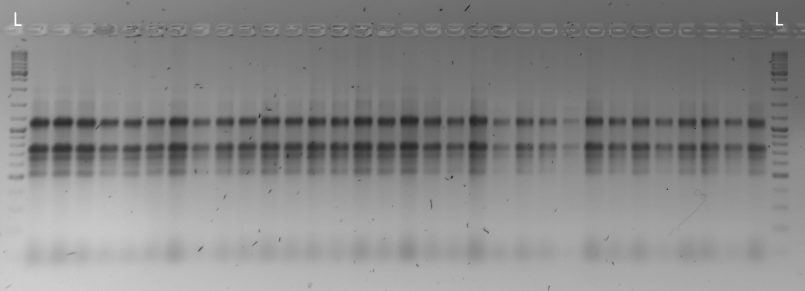

Tab. S2 Primer sequences and amplicons characteristics of candidate reference genes.

Gene symbol | Gene description | Primer sequence 5’→3’ | Amplicon size (bp) | References
ARF | ADP-ribosylation factor | F: GCCATGAATGCGGCTGAAA | 113 | (Sowa et al. 2022a; Sowa et al. 2022b)
ARF | ADP-ribosylation factor | R: AGTCCCTCGTACAATCCCTC | 113 | (Sowa et al. 2022a; Sowa et al. 2022b)
CYP | Cyclophilin | F: ATGGCCAACCCCAAGGTCT | 145 | (Sowa et al. 2022a; Sowa et al. 2022b)
CYP | Cyclophilin | R: TCTTGCCCACGCCCTTCTC | 145 | (Sowa et al. 2022a; Sowa et al. 2022b)
EF1A | Elongation factor 1-alpha | F: CAGGCAGATGATCTGCTGCT | 158 | (Wrzesińska et al. 2016)
EF1A | Elongation factor 1-alpha | R: CCTCAAAGCCAGAGATTGGAA | 158 | (Wrzesińska et al. 2016)
EIF4A | Eukaryotic initiation factor 4A-3, | F: TCTCGCAGGATACGGATGTCG | 88 | (Yang et al. 2020)
EIF4A | Eukaryotic initiation factor 4A-3, | R: TCCATCGCATTGGTCGCTCT | 88 | (Yang et al. 2020)
GAPDH | Glyceraldehyde-3-phosphate dehydrogenase | F: CGTCAGGAACCCTGAAGAAA | 146 | (Wrzesińska et al. 2016)
GAPDH | Glyceraldehyde-3-phosphate dehydrogenase | R: CTTTGCTAGGGGCTGAAATG | 146 | (Wrzesińska et al. 2016)
HNR | Heterogeneous nuclear ribonucleoprotein 27C | F: ATTGGGTTTGTCACTTTCCGTAG | 134 | (Yang et al. 2020)
HNR | Heterogeneous nuclear ribonucleoprotein 27C | R: CTTGGAGGGTGTCTCGCATCT | 134 | (Yang et al. 2020)
HSP70 | Heat shock protein | F: ATCGACGCTGCCATTCAGTG | 109 | (Sowa et al. 2022a; Sowa et al. 2022b)
HSP70 | Heat shock protein | R: TCTTGGCGATGATGGGGTTG | 109 | (Sowa et al. 2022a; Sowa et al. 2022b)
TUA | Tubulin alpha | F: CGCCGCTCCCTTGATATTGA | 151 | (Sowa et al. 2022a; Sowa et al. 2022b)
TUA | Tubulin alpha | R: TTGGGTAGGGCACCAGATTG | 151 | (Sowa et al. 2022a; Sowa et al. 2022b)
UBC | Ubiquitin conjugating enzyme (E2) | F: CTGTGCGACCCGAATCCAAA | 103 | (Sowa et al. 2022a; Sowa et al. 2022b)
UBC | Ubiquitin conjugating enzyme (E2) | R: GCTCCACGATCTCACGAACT | 103 | (Sowa et al. 2022a; Sowa et al. 2022b)
PAL | Phenylalanine ammonia lyase | F: GCAACTTCCAGGGCACCC | 95 | (Tajti et al. 2021)
PAL | Phenylalanine ammonia lyase | R: CTCCGAGAACTGAGCGAACAT | 95 | (Tajti et al. 2021)

Fig. S2 Dissociation curves obtained for tested reference genes.
ARF - ADP-ribosylation factor, CYP - cyclophilin, EF1A - elongation factor 1-alpha, EIF4A - eukaryotic initiation factor 4A-3, GAPDH - glyceraldehyde-3-phosphate dehydrogenase, HNR - heterogeneous nuclear ribonucleoprotein 27C, HSP70 - heat shock protein, TUA - alpha tubulin, UBC - ubiquitin conjugating enzyme (E2),PAL - Phenylalanine ammonia lyase.
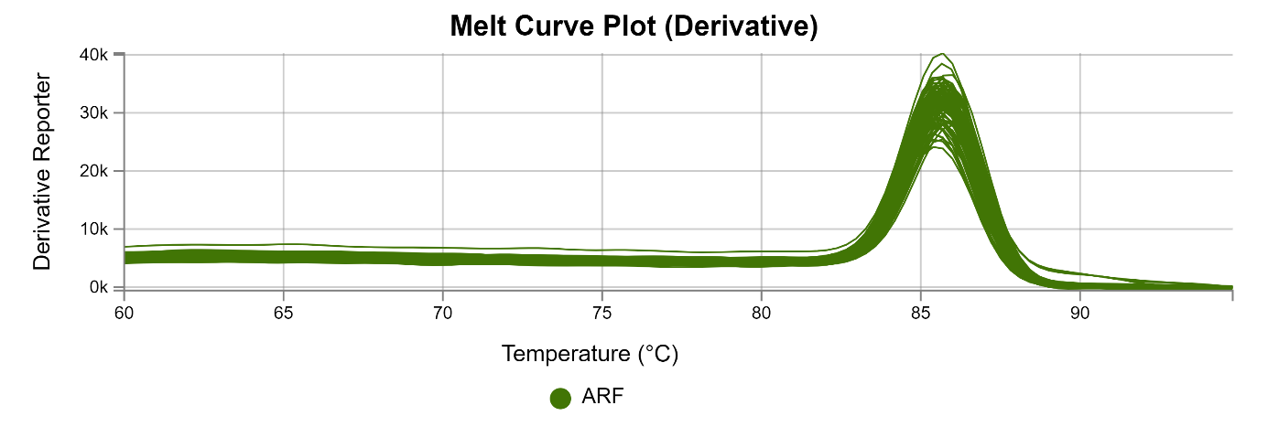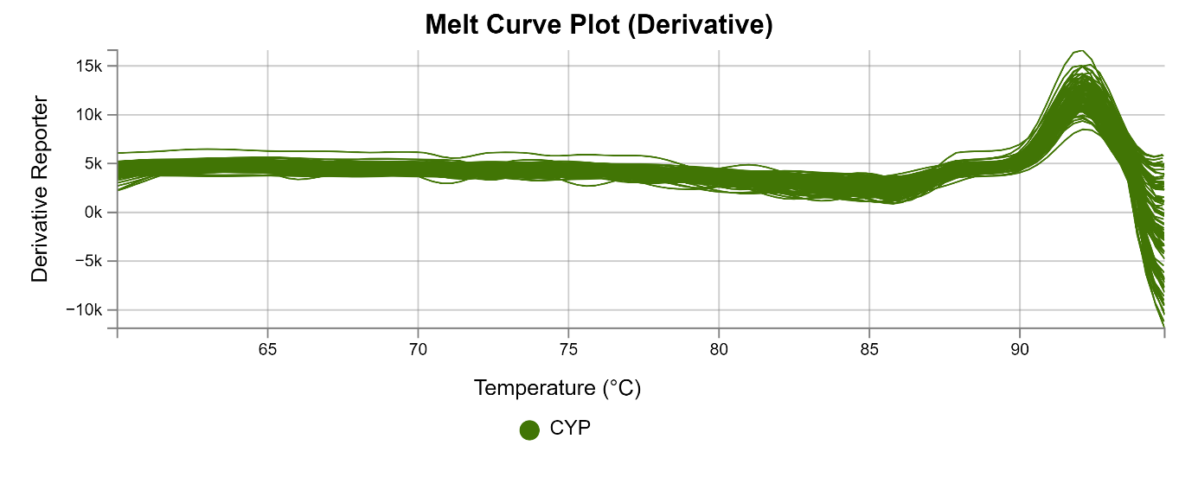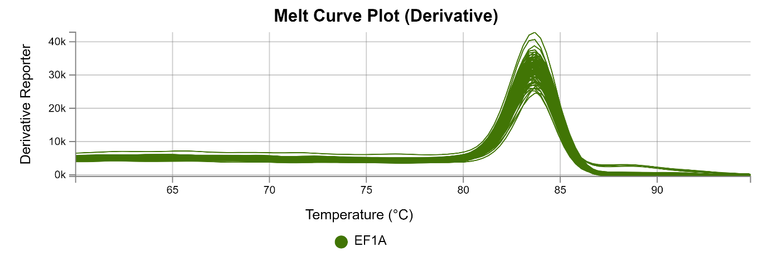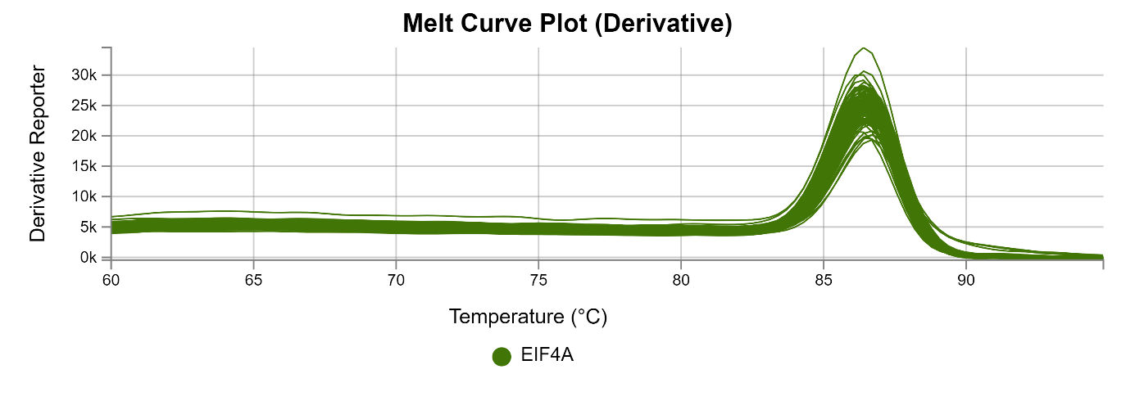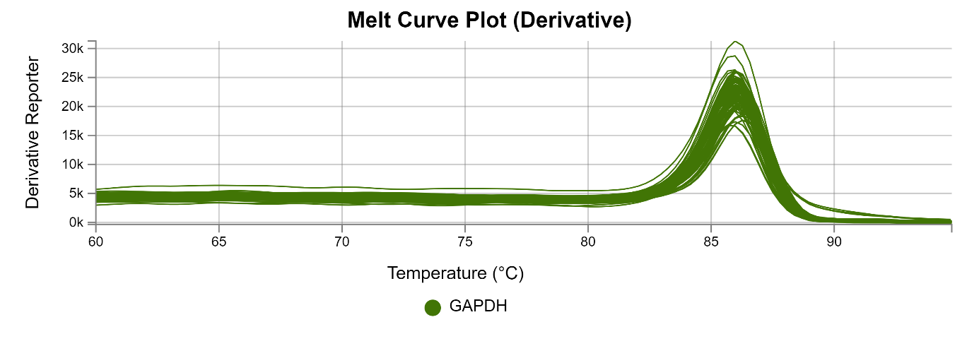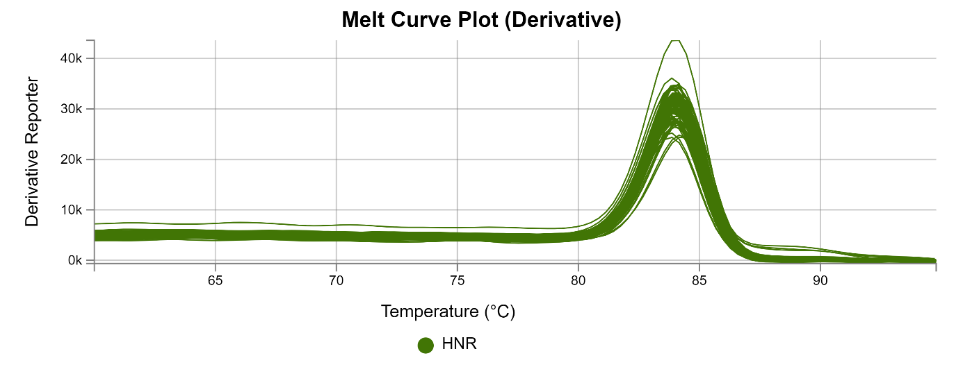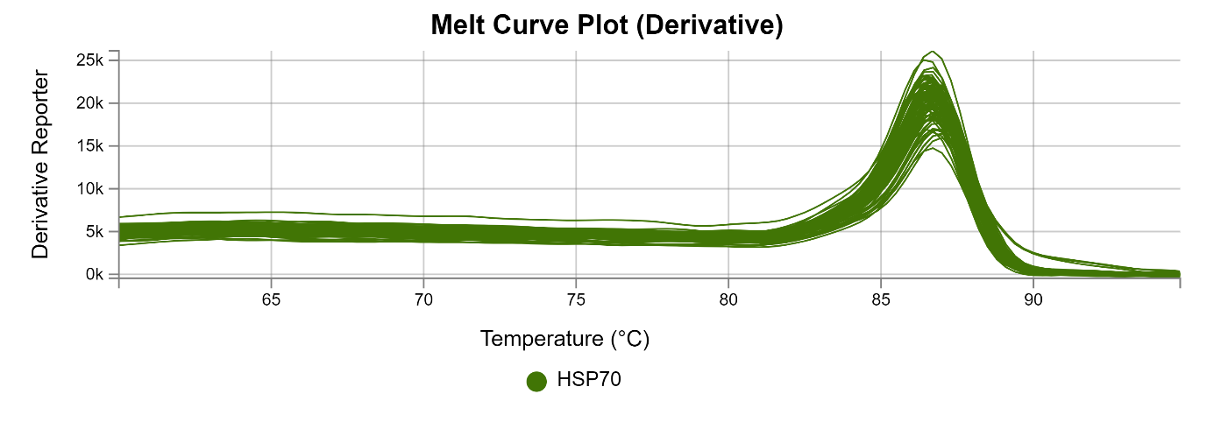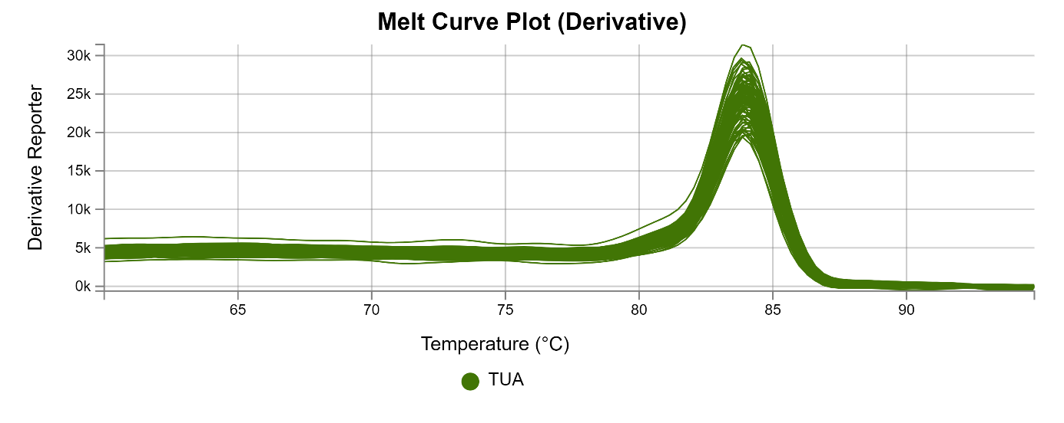
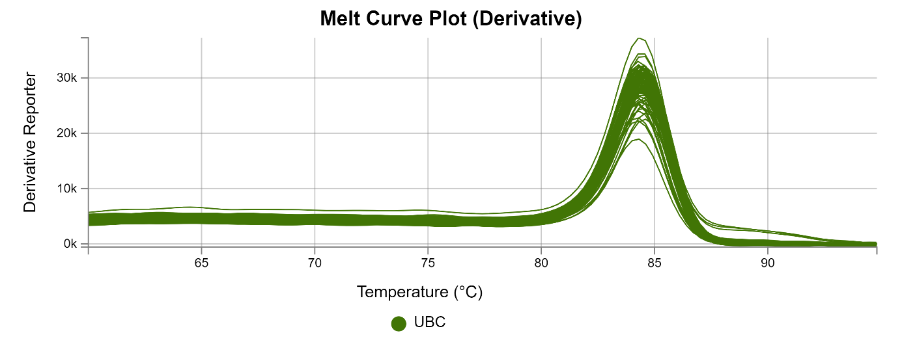
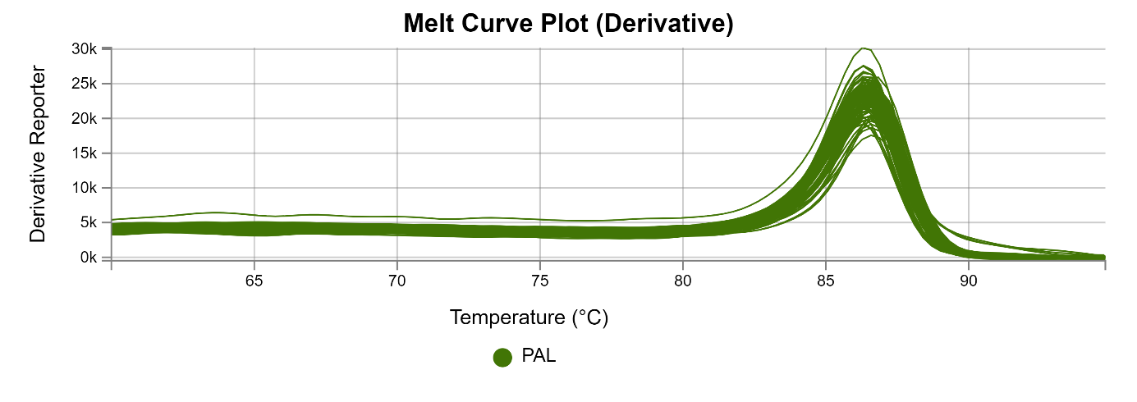
Fig. S3 The quantification cycle values (Cq) for candidate reference genes across experimental samples. Data are shown in the box plots including the minimum and the maximum value (whiskers), the sample median (line in the middle), the first and third quartiles (frame) and the dots (outlier values)
ARF - ADP-ribosylation factor, CYP - cyclophilin, EF1A - elongation factor 1-alpha, EIF4A - eukaryotic initiation factor 4A-3, GAPDH - glyceraldehyde-3-phosphate dehydrogenase, HNR - heterogeneous nuclear ribonucleoprotein 27C, HSP70 - heat shock protein, TUA - alpha tubulin, UBC - ubiquitin conjugating enzyme (E2).

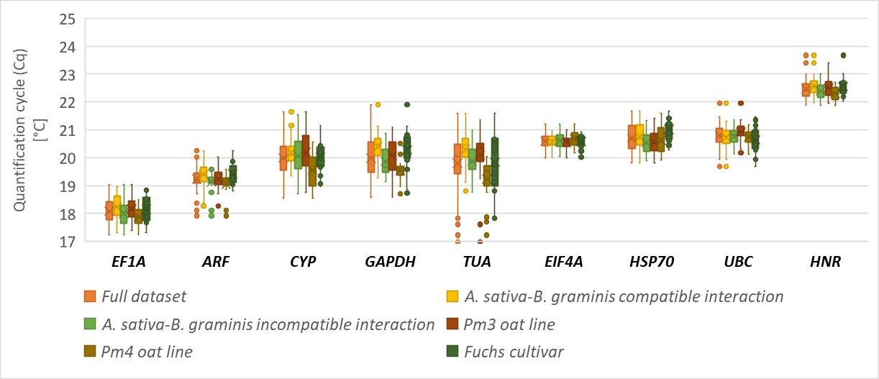

Tab. S3 Comprehensive rankings generated for analysed datasets based on the results obtained with four algorithms. Reference genes recommended for RT-q PCR data normalization are shown in bold.

 | <--- Most stable genes Least stable genes --->
 | 1 |  | 2 |  | 3 |  | 4 |  | 5 | 6 |  | 7 | 8 |  | 9
Ranking Based on the geNorm, NormFinder, ΔCt method, and BestKeeper's r results
Full dataset | HNR |  | ARF |  | EF1A |  | GAPDH |  | EIF4A | CYP |  | HSP70 | TUA |  | UBC
A. sativa – B. graminis compatible interaction | HNR | GAPDH |  | ARF |  | EIF4A |  | CYP/EF1A |  |  | TUA |  |  | HSP70 |  | UBC
A. sativa – B. graminis incompatible interaction | EF1A |  | EIF4A |  | HNR |  | ARF |  | UBC | GAPDH |  | CYP | HSP70 |  | TUA
Pm3 oat line | HNR |  | EIF4A |  | EF1A |  | ARF |  | UBC | GAPDH |  | HSP70 | TUA |  | CYP
Pm4 oat line | HNR |  | GAPDH |  | EIF4A |  | EF1A |  | CYP | ARF |  | TUA | UBC |  | HSP70
Fuchs cultivar | HNR |  | ARF |  | GAPDH |  | CYP |  | EIF4A | EF1A |  | TUA | HSP70 |  | UBC
Ranking Based on the geNorm, NormFinder, ΔCt method, and BestKeeper's SD results
Full dataset | HNR |  | ARF |  | EIF4A |  | EF1A |  | HSP70 | UBC |  | CYP | GAPDH |  | TUA
A. sativa – B. graminis compatible interaction | HNR |  | EIF4A |  | ARF |  | EF1A |  | GAPDH | CYP |  | UBC | HSP70 |  | TUA
A. sativa – B. graminis incompatible interaction | HNR |  | EIF4A |  | ARF |  | EF1A |  | HSP70 | UBC |  | GAPDH | TUA |  | CYP
Pm3 oat line | HNR |  | EIF4A |  | ARF |  | EF1A |  | UBC | HSP70 |  | GAPDH | CYP |  | TUA
Pm4 oat line | HNR |  | EIF4A |  | GAPDH |  | EF1A |  | UBC | ARF |  | HSP70 | CYP |  | TUA
Fuchs cultivar | HNR |  | EIF4A |  | ARF |  | EF1A |  | HSP70 | GAPDH |  | CYP | UBC |  | TUA
Ranking Based on the geNorm, NormFinder and ΔCt method
Full dataset | HNR |  | ARF |  | EF1A |  | EIF4A |  | HSP70 | GAPDH |  | CYP | UBC |  | TUA
A. sativa – B. graminis compatible interaction | HNR |  | EIF4A |  | ARF |  | GAPDH |  | EF1A | CYP |  | HSP70 | UBC |  | TUA
A. sativa – B. graminis incompatible interaction | HNR |  | EIF4A |  | ARF |  | EF1A |  | HSP70 | GAPDH |  | CYP | UBC |  | TUA
Pm3 oat line | HNR |  | EIF4A |  | ARF |  | EF1A |  | HSP70 | GAPDH |  | CYP | UBC |  | TUA
Pm4 oat line | HNR |  | EIF4A |  | GAPDH |  | EF1A |  | ARF | UBC |  | HSP70 | CYP |  | TUA
Fuchs cultivar | HNR |  | ARF |  | EIF4A |  | EF1A |  | GAPDH | CYP |  | HSP70 | UBC |  | TUA

Fig. S4 Gene expression profile of the PAL (phenylalanine ammonia lyase) in A. sativa Fuchs cultivar – B. graminis. The evaluation was done for A. sativa Pm4– B. graminis incompatible interaction (a) as well as Pm3 - B. graminis incompatible (b) and compatible (c) interaction against the lowest-performing reference gene (TUA) as well as two sets of the highest-performing reference genes (HNR + ARF and HNR + EIF4A), either independently or together.
Data shown as mean ± SD.
