Supporting Information

Selective delivery of G-quadruplex ligand in glioma cell lines: the power of cyclic-RGD peptide.

Valentina Pirota,^{1,§} Giovanni Bisbano,^{2,§} Amanda Oldani,³ Eric Bernardi,² Massimo Serra,^{2,}* Mayra Paolillo,^{2,}* and Filippo Doria^{1,}*

¹ Department of Chemistry, University of Pavia, viale Taramelli, 10, 27100 Pavia, Italy
² Department of Drug Sciences, University of Pavia, viale Taramelli 12, 27100 Pavia, Italy
³ PASS-Bio Med, Centro Grandi Strumenti, University of Pavia, Pavia, Italy

§ These authors equally contributed to the work
* To whom correspondence should be addressed
Table S1. Primers used to amplify RGD-binding integrin mRNA in real-time qRT-PCR experiments.
Gene | Accession number | Primer sequence
αν | NM_002210 | F: actggcttaagagagggctgtg  R: tgccttacaaaaatcgctga
β3 | NM_000212 | R: tcctcaggaaaggtccaatg  R: tcctcaggaaaggtccaatg
α5 | NM_002213 | F: agcctatctccacgcacact  R: cctcggagaaggaaacatca
β5 | NM_002205 | F: cctgctgtccaccatgtcta  R: ttaatggggtgattggtggt
β1 | NM_133376 | F: tccaatggcttaatttgtgg  R: cgttgctggcttcacaagta
β-actin | NM_001101.5 | R: atgatctgggtcatcttctc  F: gacgacatggagaaaatctg

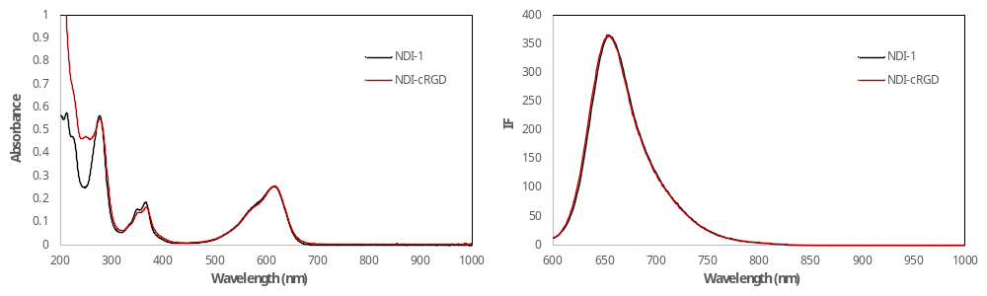
Figure S1. Absorption and Fluorescence spectra of 20 µM NDI-1 and NDI-cRGD compounds in 10 mM lithium cacodylate buffer, pH 7.2, 25°C.
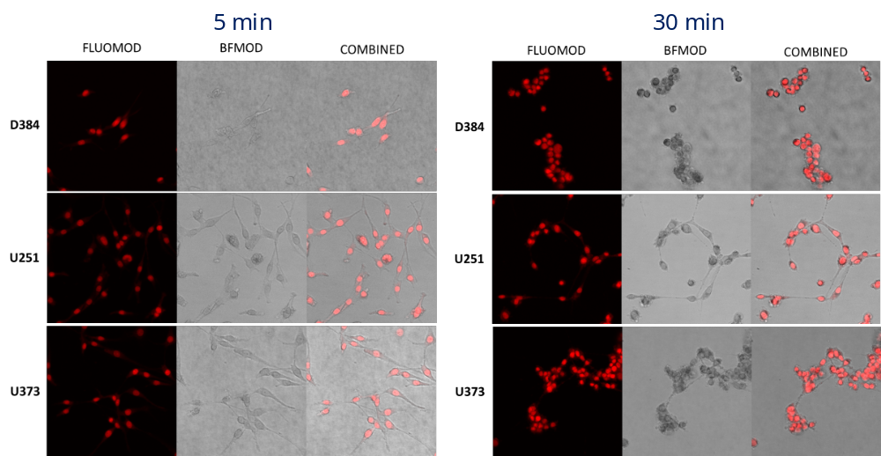
Figure S2. Representative images of NDI-1 localization in D384, U251, and U373 cell lines after 5 and 30 min of incubation with 20 µM NDI-1. Confocal z-stacks (z step 2 μm) of at least 8 fields of views were immediately acquired after the incubation time collecting NDI-1 fluorescence and transmitted light images. NDI-1 (z-stack maximum projection, left), brightfield (middle), and merge channels are shown.
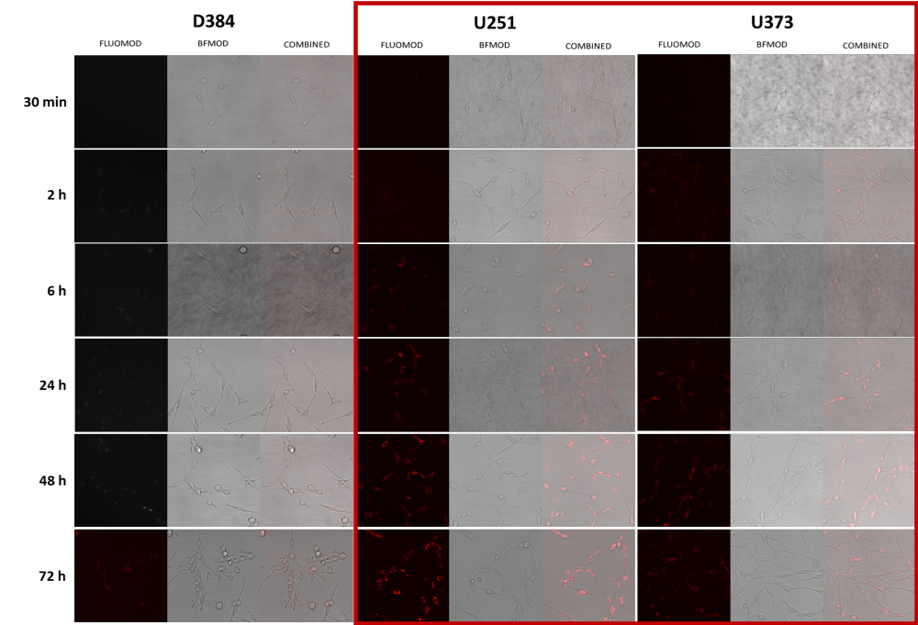
Figure S3. Confocal microscopy images of D384, U251, and U373 cell lines treated with 20 µM NDI-cRGD for 30 min, 2 h, 6 h, 24 h, 48 h and 72 h. Confocal z-stacks were collected using the same acquisition parameters to compare the amount of internalized compound in the different cell lines. NDI-cRGD (z-stack maximum projection, left), brightfield (middle), and merge channels are shown.

Table S2. Name and nucleobase sequences of the DNA model oligonucleotides here analyzed.

Name | Sequence (5’-3’) | Length
22AG | AGGGTTAGGGTTAGGGTTAGGG | 22 nt
cMyc | TGAGGGTGGGTAGGGTGGGTAA | 22 nt
VEGF | CGGGGCGGGCCGGGGGCGGGGT | 22 nt

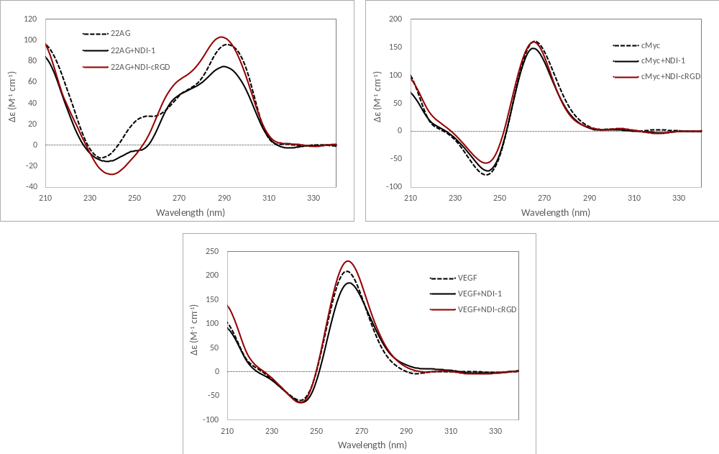
Figure S4. CD spectra of 2.5 µM model oligonucleotides (22AG, cMyc, and VEGF) alone (black dashed lines) and in the presence of 10 µM NDI-1 (black lines) or NDI-cRGD (dark red lines), in 10 mM lithium cacodylate buffer, pH 7.2, 25°C with the proper amount of KCl (20 mM for 22AG and 5 mM for cMyc and VEGF).

CD-melting curves
Denaturation curves obtained for 2.5 µM 22AG, cMyc, or VEGF in 10 mM Lithium cacodylate buffer pH 7.4, with different KCl amounts, alone or in the presence of 4 equivalents of NDI-1 or NDI-cRGD.
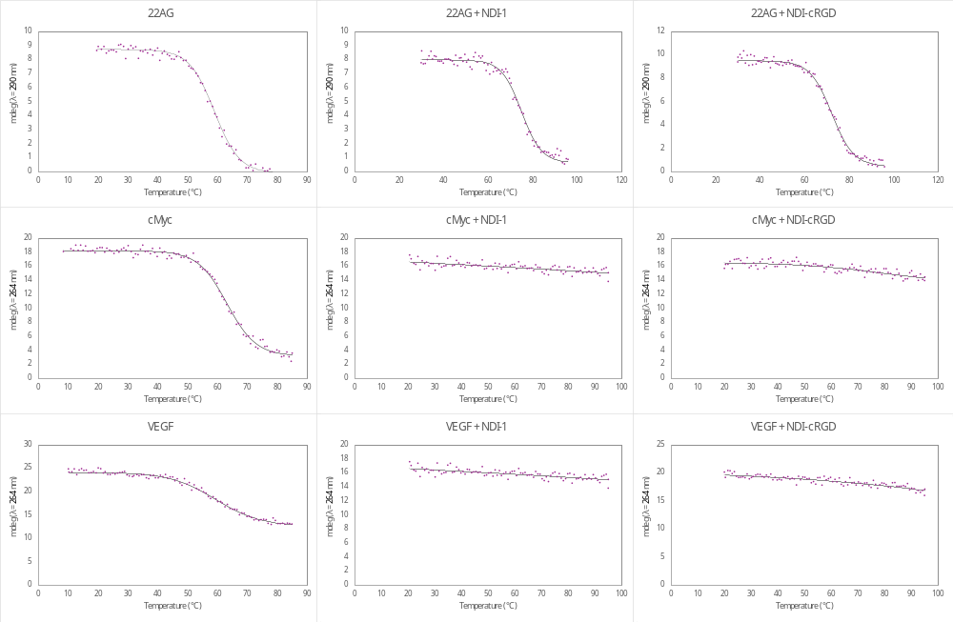
HPLC purity (λ = 254 nm)
NDI-1 (r.T. 5.40 min; 99.6%)
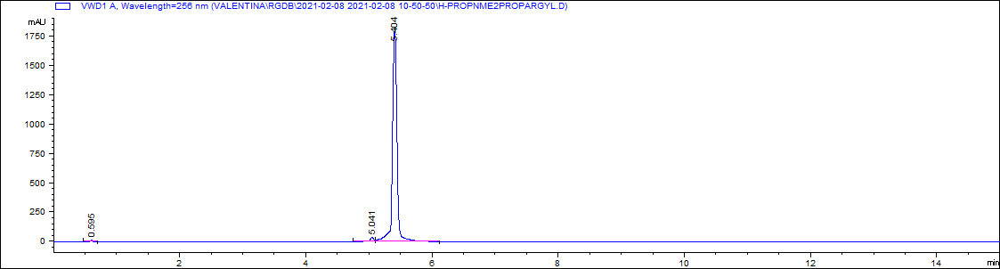
Compound 4 (r.T. 5.21 min; 100.0%)
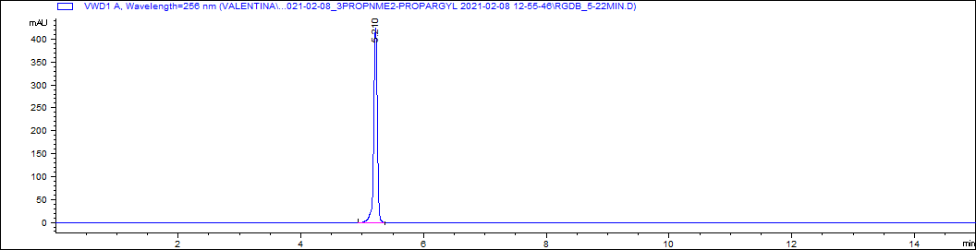

RGD-N₃ (r.T. 6.80 min; 95.8%)
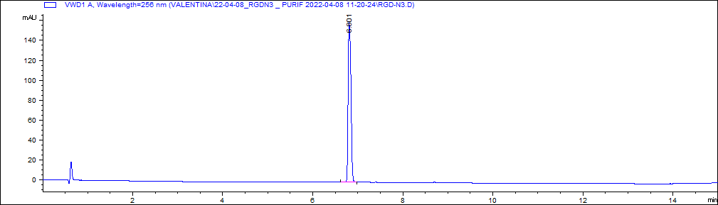
NDI-cRGD (r.T. 6.00 min; 95.7%)
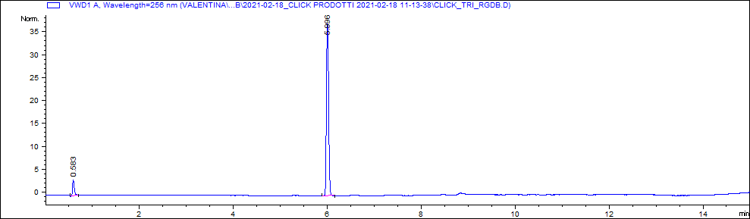
UHPLC-MS analysis

Compound 4 (Mol. Wt.: 589.6 u.m.a.)
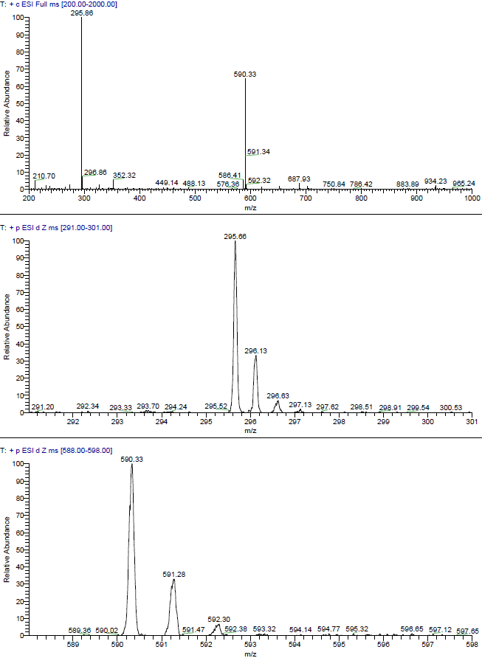
NDI-cRGD (Mol. Wt.: 1446.73u.m.a.)
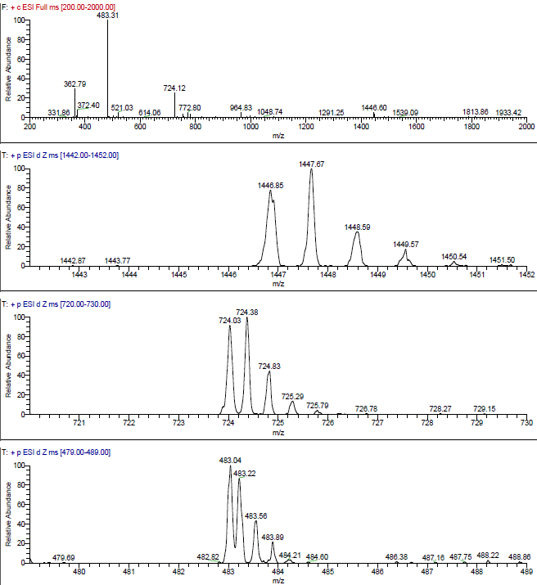

NMR spectra
Compound 4. ¹H-NMR (D₂O, 300MHz)
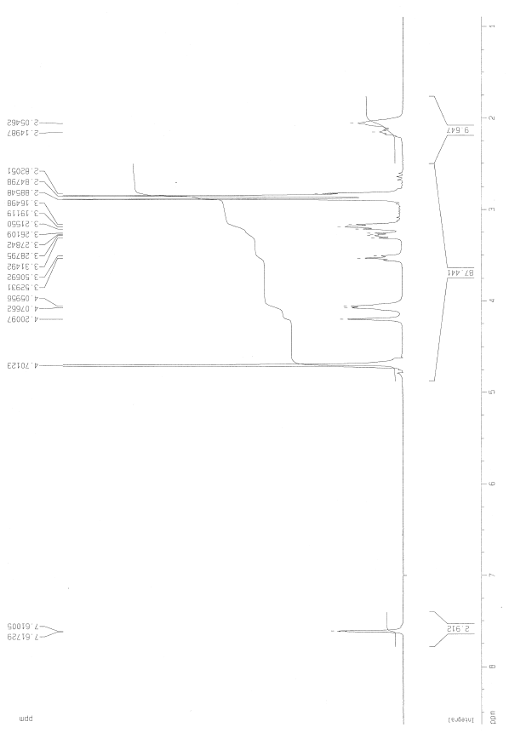
Compound 4. ¹³C-NMR (D₂O, 75MHz)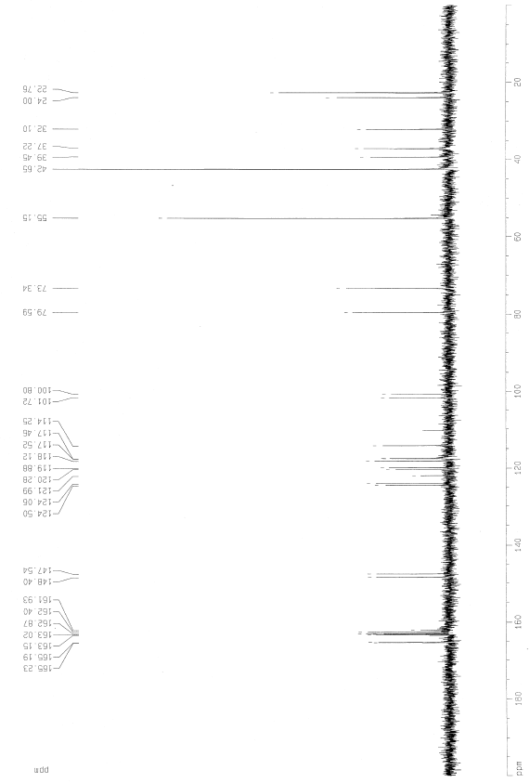

NDI-cRGD. ¹H-NMR (D₂O, 700MHz)

