Supporting Online Material

Typeface Network and The Principle of Font Pairing
by Jiin Choi and Kyung Hoon Hyun

Table of Contents
S1. Comparison of the average values of each axis in the NMF of the fonts used in each medium.
S1.1 One-Way ANOVA Post-hoc Analysis
S2. Axis Differences Through Null Model Analysis
S2.1 Null models
S3. Comparative Evaluation of Dimensionality Reduction Techniques and Justification for NMF in Typeface Analysis
S2.1 NMF: Addressing the Need for Interpretability in Typeface Analysis
S3.2 Verifying the Semantic Meaning of NMF Axes: A Detailed Correlation Analysis
S3.3 Comparative Analysis of Different Font Representation Using NMF
S3.4 Comparative Analysis of Dimensionality Reduction Techniques: NMF vs. PCA, UMAP, and t-SNE
List of Figure
S1. Matrix of p-values from statistical tests with the x-, y-, and z-axis
S2. Results of difference between real and random pairs
S3. Visual Representation of NMF 3-Axis Projections for Fonts
S4. Visual Representation of NMF 4-Axis Projections for Fonts with training data with the same dataset used in the 3D model
S5. Visual Representation of NMF 4-Axis Projections for Fonts with additional font styles such as italic, bold, and light
S6. Visual Representation of PCA 3-Axis Projections for Fonts
S7. Visual Representation of UMAP 3-Axis Projections for Fonts
S8. Visual Representation of t-SNE 3-Axis Projections for Fonts

List of Table
S1. Mean and SD of font design parameters by medium.
S2. Pearson Correlation between Axis Values and Font Curvature and Thickness (NMF)
S3. Pearson Correlation between Axis Values and Font Curvature and Thickness (PCA, UMAP, t-SNE)

S1. Comparison of the average values of each axis in the NMF of the fonts used in each medium.
S1.1 One-Way ANOVA Post-hoc Analysis
We found statistically significant differences in the X, Y, and Z values across the mediums ($F_{X}$ = 9.3008, p < 0.001; $F_{Y}$ = 15.492, p < 0.001; $F_{Z}$= 5.7044, p < 0.001). We interpreted the data based on the average values for each medium (Table S1) and the corresponding p-values (Fig. S1). For instance, printed medium like 'Magazine/Periodicals' (${Mean}_{X}$= 41.95) and 'Newspapers' (${Mean}_{X}$= 45.86) had relatively higher x-axis values, indicating a greater use of Serif. In contrast, 'Advertising' (${Mean}_{X}$= 37.68), 'Album Art' (${Mean}_{X}$= 34.21), Art/Illustration (${Mean}_{X}$= 35.69), Film/Video (${Mean}_{X}$= 36.08), and Posters/Flyers (${Mean}_{X}$= 37.52), which are related to art and design, showed significant differences from the aforementioned mediums, suggesting a different choice focusing on visual design elements. Significant differences were also observed in the y-axis values between the mediums conveying information and those related to art and design. For example, mediums like 'Advertising' (${Mean}_{Y}$ = 30.84) and 'Album Art' (${Mean}_{Y}$ = 33.98) showed significant differences (p <0.001) compared to 'Booklets/Pamphlets' (${Mean}_{Y}$ = 24.27), 'Books' (${Mean}_{Y}$ = 26.12), 'Magazines/Periodicals' (${Mean}_{Y}$ = 24.65), 'Mobile/Tablet' (${Mean}_{Y}$ = 14.80), 'Newspaper' (${Mean}_{Y}$ = 21.17), 'Software/Apps' (${Mean}_{Y}$ = 21.00), and 'Web' (${Mean}_{Y}$ = 21.73), indicating a higher usage of visually decorative elements. Lastly, mediums like ‘Album Art’ (${Mean}_{Z}$ = 22.91) and ‘Art/Illustration’ (${Mean}_{Z}$ = 22.97) had relatively lower average values compared to other mediums, indicating the use of lighter fonts. A significant difference was also observed between these mediums and digital medium such as ‘Mobile/Tablet’ (${Mean}_{Z}$ = 32.04) and ‘Web’ (${Mean}_{Z}$ = 28.02) (p < 0.05), implying that digital mediums generally use thicker fonts with an average value above 30.
Table S1. Mean and SD of font design parameters by medium. The x-axis indicates Sans-Serif to Serif, y-axis shows display level, and z-axis represents font thickness.

Formats | X |  | Y |  | Z
Formats | Mean | SD | Mean | SD | Mean | SD
Advertising | 37.62 | 21.43 | 30.71 | 27.52 | 24.25 | 22.85
Album Art | 34.21 | 21.05 | 33.98 | 28.11 | 23.4 | 22.91
Art/Illustration | 35.69 | 22.34 | 30.22 | 27.6 | 22.07 | 22.97
Booklets/Pamphlets | 40.39 | 22.18 | 24.27 | 25.32 | 26.21 | 23.65
Books | 40.58 | 22.17 | 26.12 | 26.35 | 23.18 | 22.37
Branding/Identity | 38.04 | 21.45 | 26.82 | 26.58 | 25.57 | 22.88
Ephemera | 36.98 | 21.49 | 28.46 | 26.8 | 23.64 | 23.52
Exhibition/Installation | 40.49 | 21.81 | 19.86 | 23.95 | 28.92 | 25.1
Film/Video | 36.08 | 21.05 | 29.24 | 26.99 | 26.53 | 23.83
Inforgraphics/Maps | 41.25 | 22.16 | 20.91 | 25.83 | 29.81 | 25.67
Magazines/Periodicals | 41.95 | 22.57 | 24.65 | 27.37 | 25.26 | 23.15
Mobile/Tablet | 43.8 | 22.14 | 14.8 | 19.24 | 32.04 | 24.76
Newspapers | 45.86 | 22.23 | 21.17 | 23.91 | 27.42 | 23.1
Object/Product | 36.11 | 20.5 | 31.53 | 28.45 | 28.29 | 24.44
Packaging | 37.37 | 21.72 | 28.36 | 26.68 | 23.95 | 23.5
Posters/Flyers | 37.52 | 21.28 | 29.76 | 27.84 | 25.21 | 22.8
Signs | 36.32 | 20.61 | 29.61 | 27.97 | 25.45 | 23.8
Software/Apps | 41.23 | 20.9 | 20.99 | 22.83 | 31.01 | 25.68
Web | 40.25 | 21.86 | 21.73 | 24.83 | 28.02 | 23.68
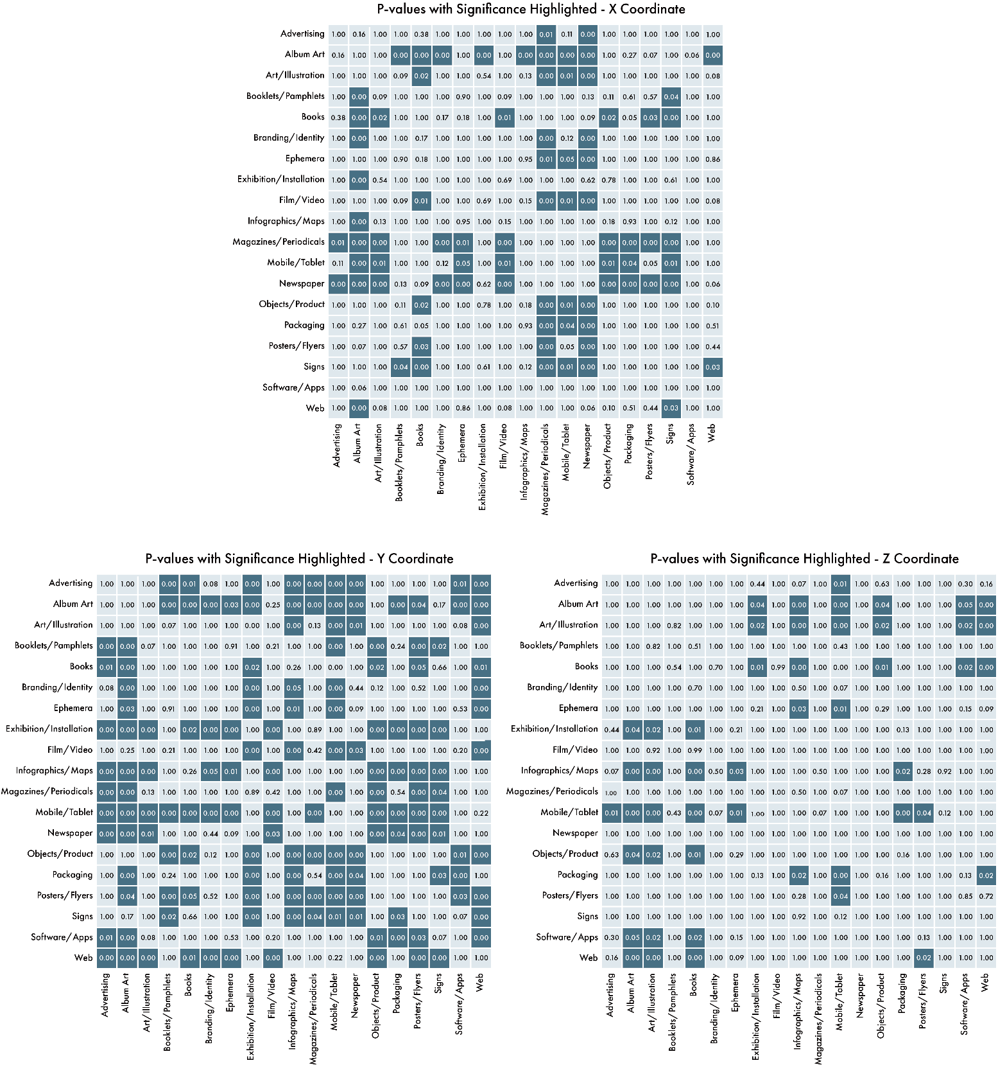

Figure S1. Matrix of p-values from statistical tests with the x-, y-, and z-axis morphological characteristics of fonts used across different mediums. Each cell represents the p-value for the comparison between the mediums on the corresponding row and column. Cells with p-values below 0.05 are highlighted, indicating statistically significant differences in font morphology between those mediums.

S2. Axis Differences Through Null Model Analysis
S2. 1 Null models
To test the robustness of our findings, we constructed several random pair datasets using a series of null models and compared the mean numbers of the x-, y-, and z-axis differences. The results of the null model are presented in Fig. S2, confirming the trends discussed in this study. The null models employed were as follows:

- Uniformly random: Random pairs are built by randomly choosing the fonts. Extremely rare fonts appear frequently in random pairs.
- Frequency conservation: We preserved the overall frequency of fonts in the dataset, regardless of the medium. Here, the frequency was calculated based on the number of uses of each font, and the sum of the frequencies of both fonts was considered the sampling weight. This implies that the more frequently a font is used, the more likely it is to be picked, thereby preserving the prevalence of each font.
- Frequency and Mediums conservation: We preserved the frequency of the fonts in each medium for sampling. In this case, real and random pairs were compared within each medium.
- Uniform random, medium conserving: For each pair, we preserved the medium of each font but did not consider the frequency of fonts. Real and random pairs were compared for each medium.

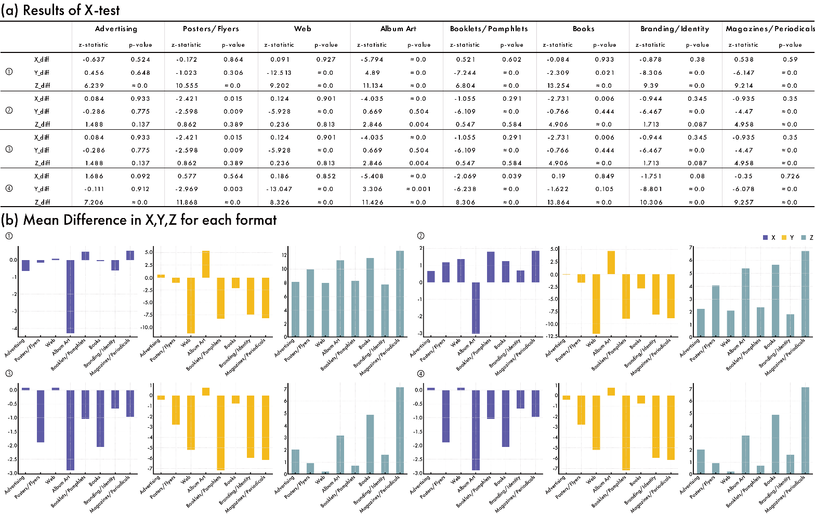
Figure S2. Results of difference between real and random pairs: (a) Results table of X-test, and (b) Mean Differences in x, y, z for each format; color represents x diff, y diff z diff.; x-axis depicts format and Y-axis depicts mean difference.

S3. Comparative Evaluation of Dimensionality Reduction Techniques and Justification for NMF in Typeface Analysis.
S2. 1 NMF: Addressing the Need for Interpretability in Typeface Analysis
The primary motivation for selecting NMF in this study is its ability to provide interpretable and intuitive results, which are essential when analyzing the morphological characteristics of fonts. Unlike other dimensionality reduction methods such as PCA, which allow negative coefficients, NMF strictly produces additive factors with non-negative coefficients. This non-negativity constraint aligns more naturally with the visual nature of font data, where negative values are not meaningful in describing characteristics such as font thickness, curvature, or boldness.
NMF offers several key advantages for our application:
- Interpretability: The non-negative components allow us to break down font characteristics into parts that are easy for designers to understand and work with. This makes it suitable for font analysis, where clarity and visual consistency are criticals
- Additive Decomposition: NMF captures the way that different visual elements (e.g., serif, curvature, boldness) combine additively to form the overall structure of the font, which is a more accurate representation of how fonts are designed and perceived.

S2. 2 Verifying the Semantic Meaning of NMF Axes: A Detailed Correlation Analysis
A key contribution of this study is the assignment of semantic meanings to the three axes derived from NMF: X-axis (Serif vs. Sans-Serif), Y-axis (Basic vs. Decorative letterforms), and Z-axis (Light vs. Bold). To ensure that these axes correspond to meaningful visual characteristics, we conducted a detailed correlation analysis using the following methods:
- Thickness Calculation: Thickness was measured using OpenCV by calculating the distance from the white pixels (representing the letter portion in binarized images) to the nearest black pixels (background). This approach allowed us to quantify the overall thickness of each letterform in the dataset.
- Curvature Calculation: Curvature was measured by extracting the outlines of the letters and calculating the curvature along each contour. Specifically, we selected three points along the contours of each letter and calculated the curvature at these points to quantify how much the letterform deviated from a straight line.
We then calculated the average values of thickness and curvature for each font and examined their correlation with the values on each NMF axis using Pearson correlation coefficients (Table S4). The key findings are summarized below:
- X-Axis (Serif vs. Sans-Serif): Higher x-axis values were positively correlated with greater curvature, supporting our interpretation that this axis represents the distinction between Serif and Sans-Serif fonts.
- Y-Axis (Basic vs. Decorative letterforms): The y-axis showed a strong association with decorative features. Fonts with high y-axis values exhibited more ornamental and complex design elements, confirming that this axis reflects the level of decoration in the letterform.
- Z-Axis (Light vs. Bold): As hypothesized, the z-axis had a high positive correlation with font thickness, indicating that it effectively captures the boldness of fonts.
This correlation analysis confirms that the NMF-derived axes accurately represent the key morphological characteristics of fonts, making them practical and intuitive for designers to use (Figure S3).
Table S2. Pearson Correlation between Axis Values and Font Curvature and Thickness (NMF): This table shows the correlation coefficients and p-values between the X, Y, Z axes and font characteristics (curvature and thickness) using the NMF. It emphasizes the relationship between the NMF axes and specific font visual characteristics, such as thickness and curvature.

Method | Axis | Curvature Correlation | Curvature p-value | Thickness Correlation | Thickness p-value
NMF | X | 0.0283 | 0.080 | 0.077 | 0.000
NMF | Y | 0.3858 | 0.000 | 0.096 | 0.000
NMF | Z | 0.6189 | 0.000 | -0.061 | 0.000

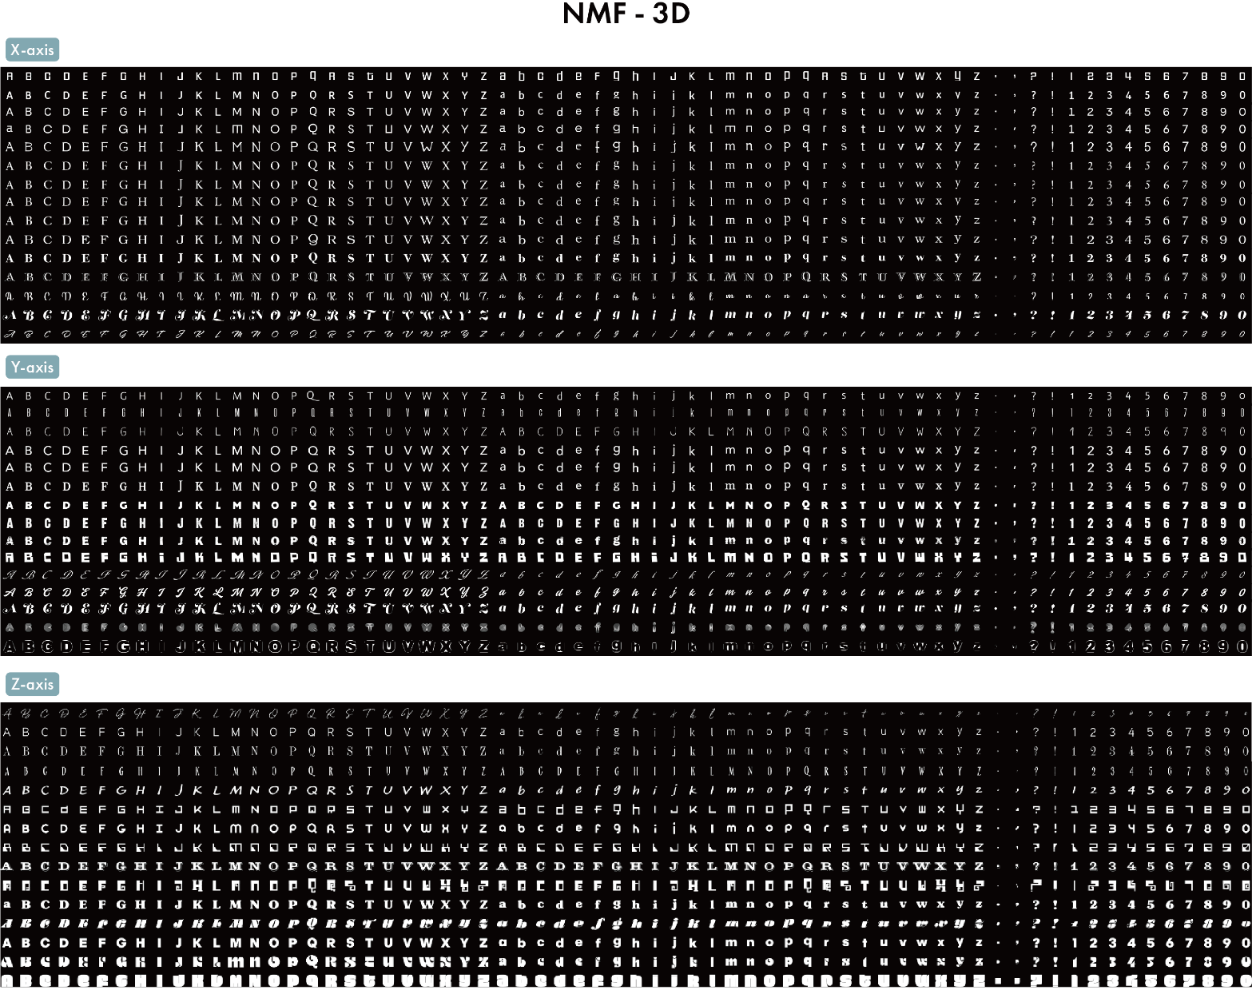
Figure S3. Visual Representation of NMF 3-Axis Projections for Fonts: This figure shows 15 evenly spaced font samples along the X, Y, and Z axes using NMF.

S3. 3 Comparative Analysis of Different Font Representation Using NMF
We conducted an analysis of the 4D representation learned through NMF using two approaches: 1), with the same dataset used in the 3D model (Figure S4), and 2), by incorporating additional font styles such as italic, bold, and light (Figure S5). In both cases, 15 samples were extracted at equal intervals for visual inspection. However, despite the extension to a 4D space, the results revealed that the fourth dimension did not yield an interpretable axis. The visual features in both models were indistinct and difficult to associate with any specific font characteristics, such as italic or bold. The added complexity of the 4D space did not contribute to a clearer or more intuitive representation of the font styles, highlighting limitations in the interpretability of this extended dimensionality.
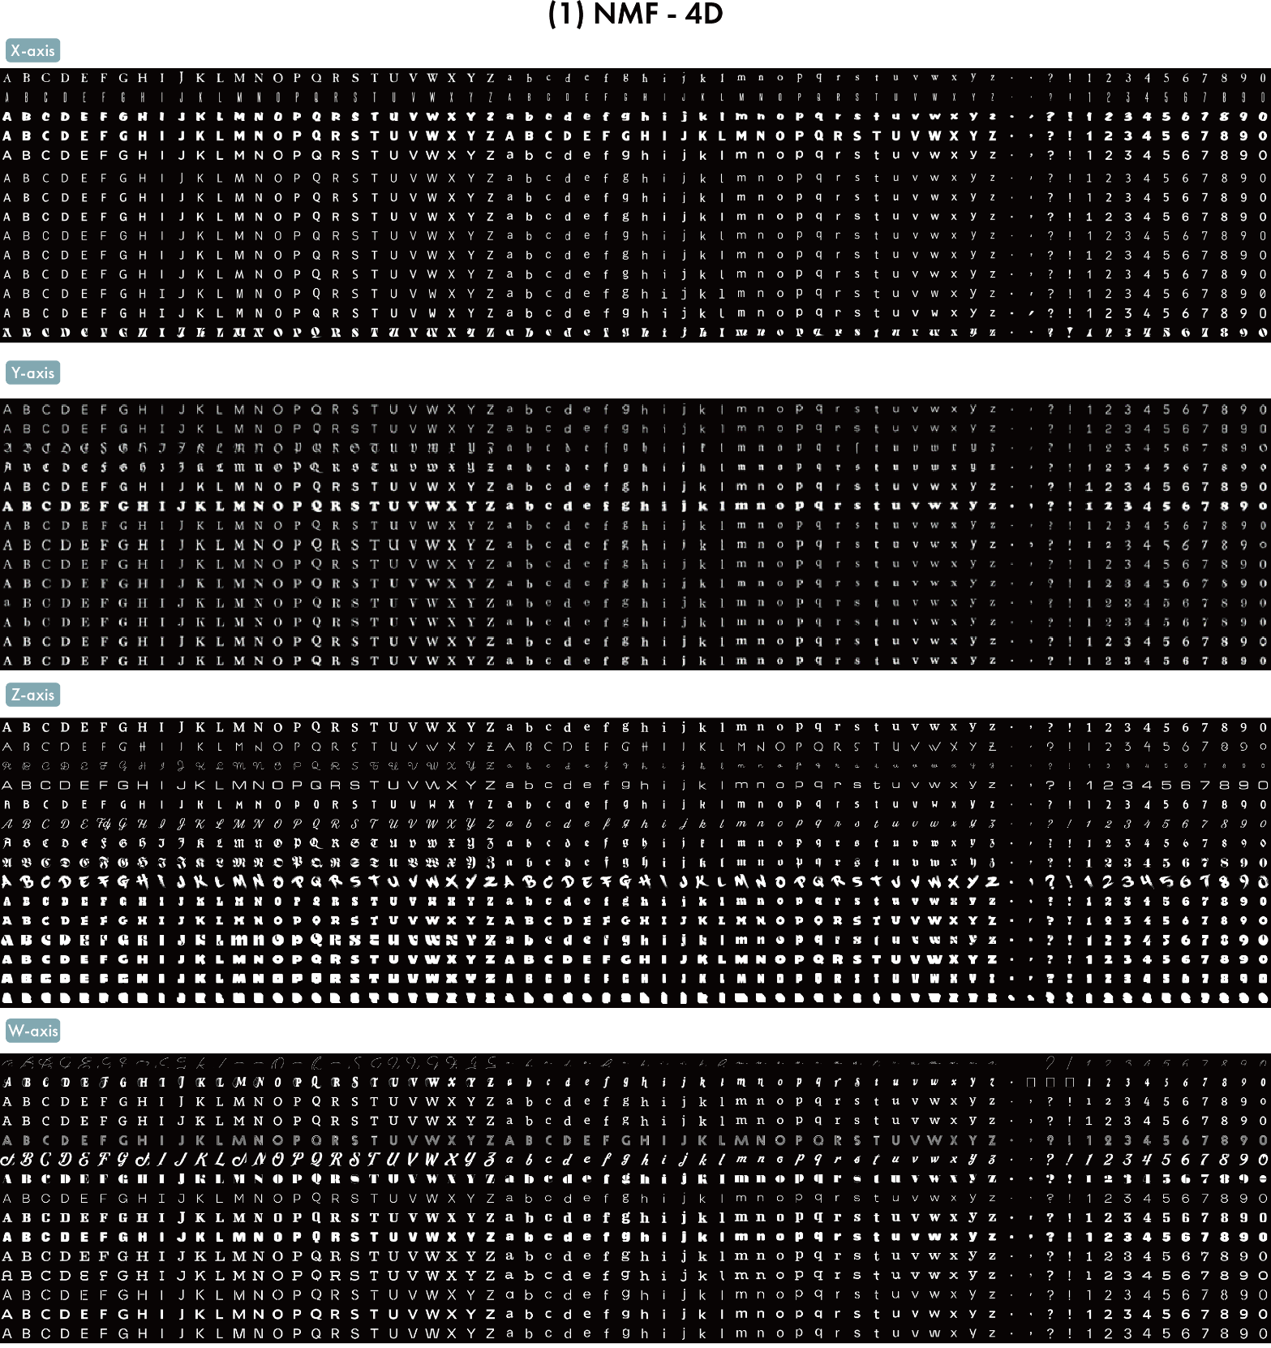

Figure S4. Visual Representation of NMF 4-Axis Projections for Fonts with training data with the same dataset used in the 3D model: This figure shows 15 evenly spaced font samples along the X, Y, and Z axes using NMF.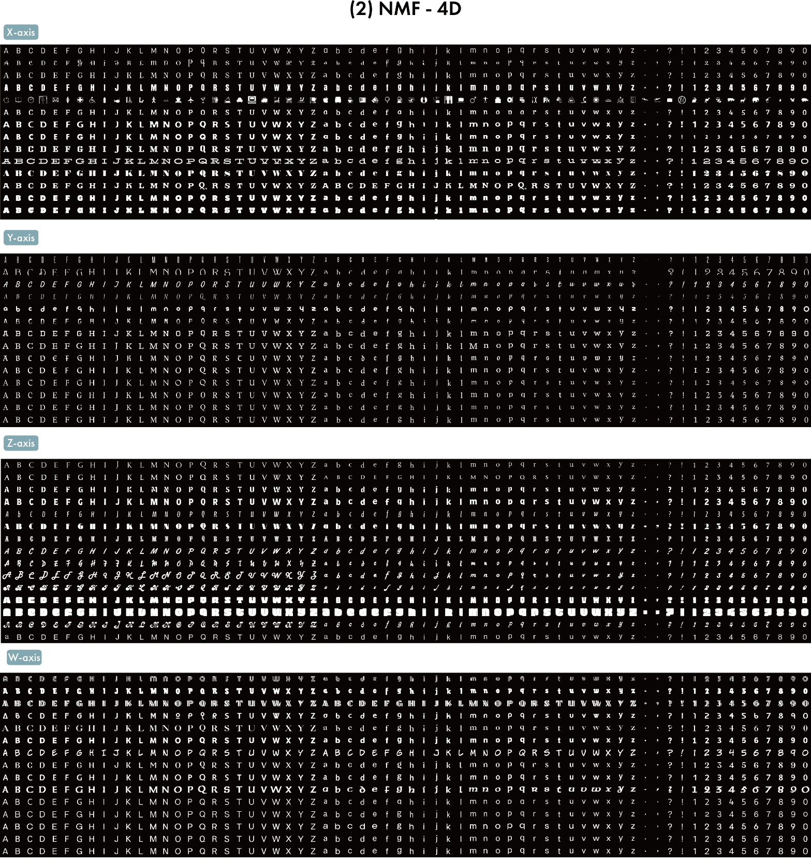
Figure S5. Visual Representation of NMF 4-Axis Projections for Fonts with additional font styles such as italic, bold, and light: This figure shows 15 evenly spaced font samples along the X, Y, and Z axes using NMF.

S3. 4 Comparative Analysis of Dimensionality Reduction Techniques: NMF vs. PCA, UMAP, and t-SNE
To further validate our use of NMF, we conducted a comparative analysis against three popular dimensionality reduction methods—PCA, UMAP, and t-SNE—focusing on how effectively each technique represents the critical visual characteristics of fonts (Table S3). Below is a summary of our findings :

a) PCA: Limitations in Capturing Font Features
PCA is a widely-used method that identifies orthogonal components representing the directions of maximum variance in data. However, for font data, PCA exhibited several shortcomings (Figure S6):
- Low Correlation with Font Characteristics: PCA showed a weak correlation between its axes and key font features, such as curvature (-0.114) and thickness (-0.469). These low correlations suggest that PCA fails to capture the essential visual elements of fonts effectively.
Insufficient Variance Explained: The first three principal components explained only 50% of the variance in the data. This indicates that PCA does not adequately preserve the important information needed for font analysis in a low-dimensional space, limiting its utility in this context.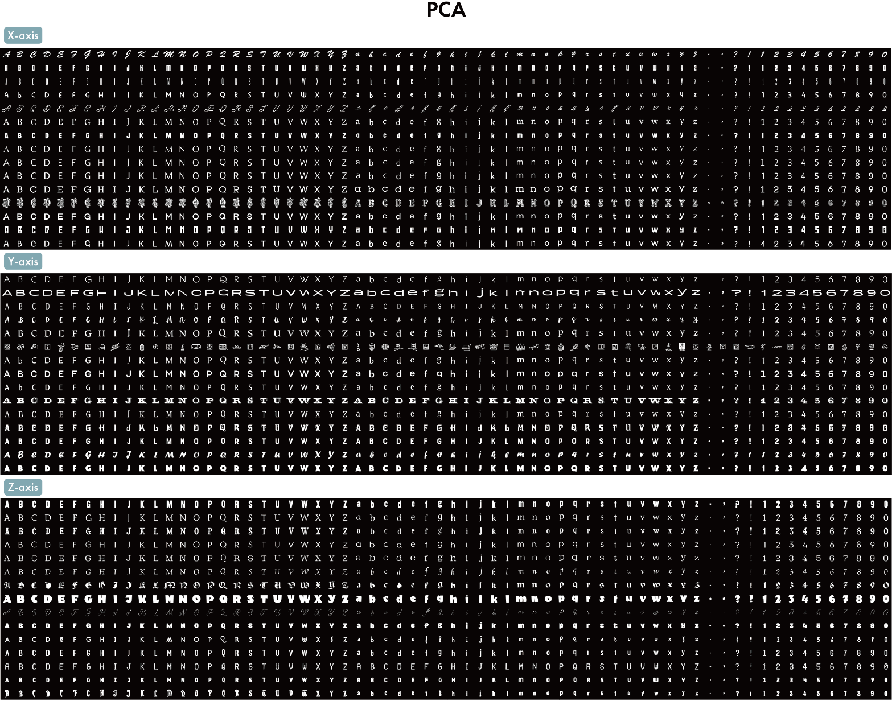
Figure S6. Visual Representation of PCA 3-Axis Projections for Fonts: This figure shows 15 evenly spaced font samples along the X, Y, and Z axes using PCA.

b) UMAP: Improved Correlation but Limited Interpretability
UMAP is a non-linear dimensionality reduction technique that excels at preserving both local and global structures in data. In our experiment (Figure S7):
- Moderate Thickness Correlation: UMAP showed a stronger correlation with font thickness (0.548 on the x-axis) compared to PCA, indicating better performance in capturing this feature. However, its correlation with curvature was lower, suggesting it still struggles to represent the complete visual characteristics of fonts.
- Limited Visual Interpretability: While UMAP provided improved correlations, its non-linear nature makes it difficult to interpret in a straightforward, additive manner as NMF does. This is a key limitation when practical design applications require easy-to-understand outputs.
Explained Variance Ratio: The first main component explains only 22.7% of the total data, and even considering the third main component, it cannot explain 50% of the data. This shows the limitation that PCA does not preserve enough important information when compressing data
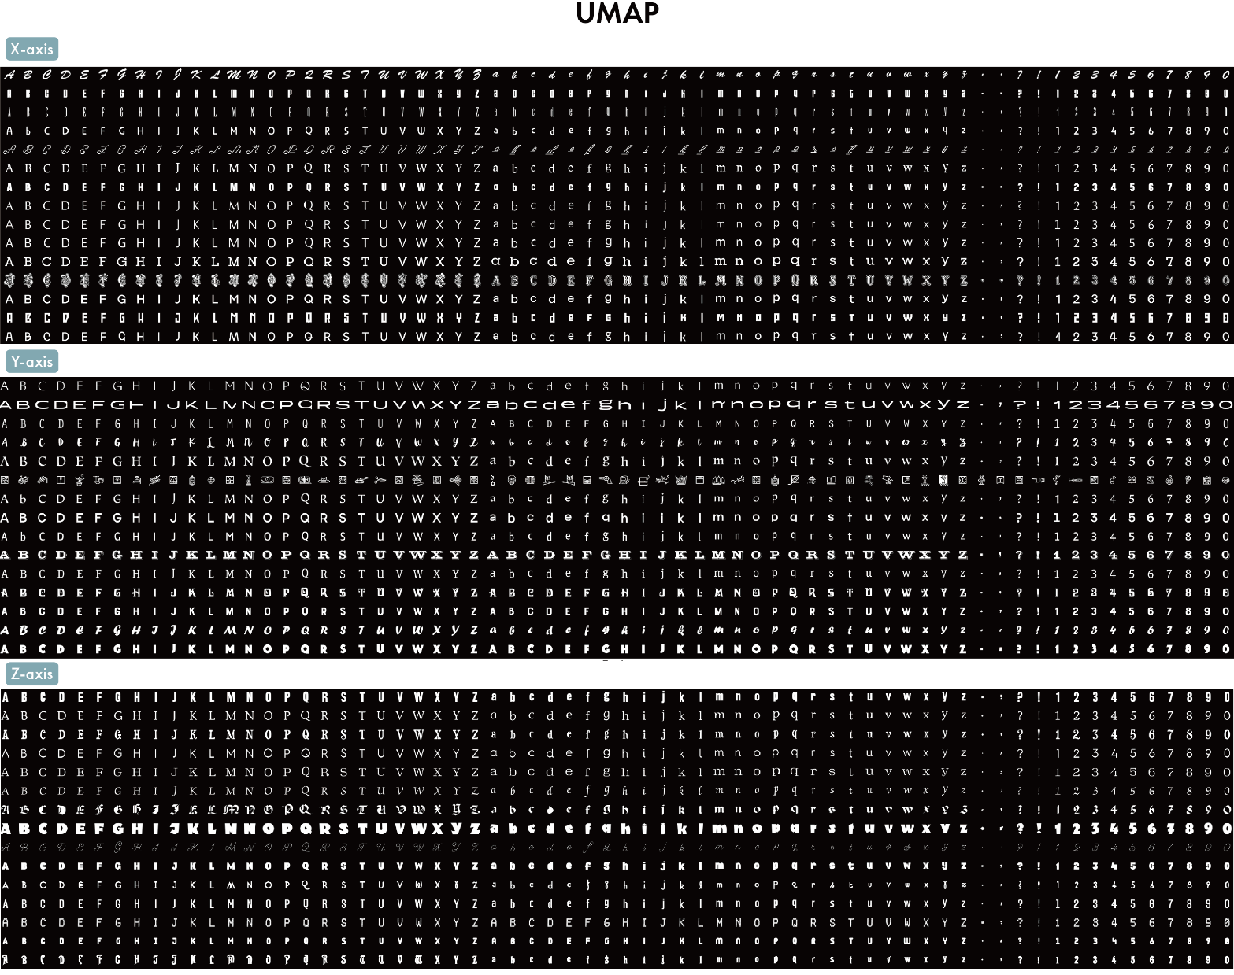
Figure S7. Visual Representation of UMAP 3-Axis Projections for Fonts: This figure shows 15 evenly spaced font samples along the X, Y, and Z axes using UMAP.

c) t-SNE: Effective for Clustering but Poor Feature Representation
t-SNE is a popular tool for visualizing high-dimensional data, particularly in clustering tasks. However, for our typeface analysis (Figure S8):
- Weak Correlations with Font Characteristics: t-SNE displayed very low correlations with both thickness and curvature, particularly with curvature (-0.070), making it unsuitable for capturing continuous visual features like those found in fonts.
Lack of Global Structure: While t-SNE is effective at preserving local structures, it does not maintain a clear global structure, which is crucial for understanding the broader relationships between fonts and their characteristics. 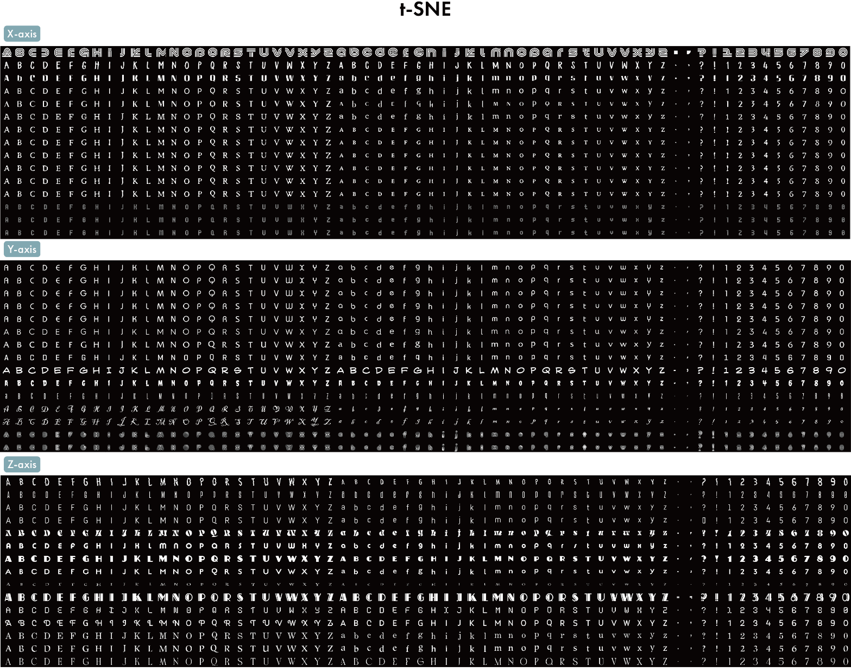
Figure S8. Visual Representation of t-SNE 3-Axis Projections for Fonts: This figure shows 15 evenly spaced font samples along the X, Y, and Z axes using t-SNE
Table S3. Pearson Correlation between Axis Values and Font Curvature and Thickness (PCA, UMAP, t-SNE): This table presents the correlation coefficients and p-values between the X, Y, Z axes and the font characteristics (curvature and thickness) using three different dimensionality reduction methods: PCA, UMAP, and t-SNE. It highlights how each method relates to the morphological features of fonts.

Method | Axis | Curvature Correlation | Curvature p-value | Thickness Correlation | Thickness p-value
PCA | X | -0.114 | 0.000 | -0.469 | 0.000
PCA | Y | 0.01 | 0.552 | 0.764 | 0.000
PCA | Z | -0.047 | 0.004 | 0.238 | 0.000
UMAP | X | 0.057 | 0.000 | 0.548 | 0.000
UMAP | Y | 0.044 | 0.007 | 0.477 | 0.000
UMAP | Z | -0.064 | 0.000 | -0.05 | 0.002
t-SNE | X | -0.037 | 0.022 | -0.563 | 0.000
t-SNE | Y | -0.125 | 0.000 | -0.151 | 0.000
t-SNE | Z | -0.07 | 0.000 | -0.037 | 0.024

