Effects of future climate and land use changes on runoff in tropical regions of China
Shiyu Xue^{1＃}, Xiaohui Guo^{1＃}, Yanhu He², Hao Cai¹, Jun Li¹, Lirong Zhu³, Changqing Ye^{1,4*✉}
*✉corresponding author: Changqing Ye
＃These two authors contributed equally to this work.
[1] School of Ecology, Hainan University, Haikou, 570228, China.
[2] Institute of Environmental and Ecological Engineering, Guangdong University of Technology, Guangzhou, 510006, China.
[3] School of Tourism, Hainan University, Haikou, 570228, China.
[4] Key Laboratory of Agro-Forestry Environmental Processes and Ecological Regulation of Hainan Province, Haikou, 570228, China.
Address for correspondence: Dr. Changqing Ye, School of Ecology, Hainan University, Haikou, China. Tel: +86 13637653039, e-mail: yechangqing2001@hotmail.com

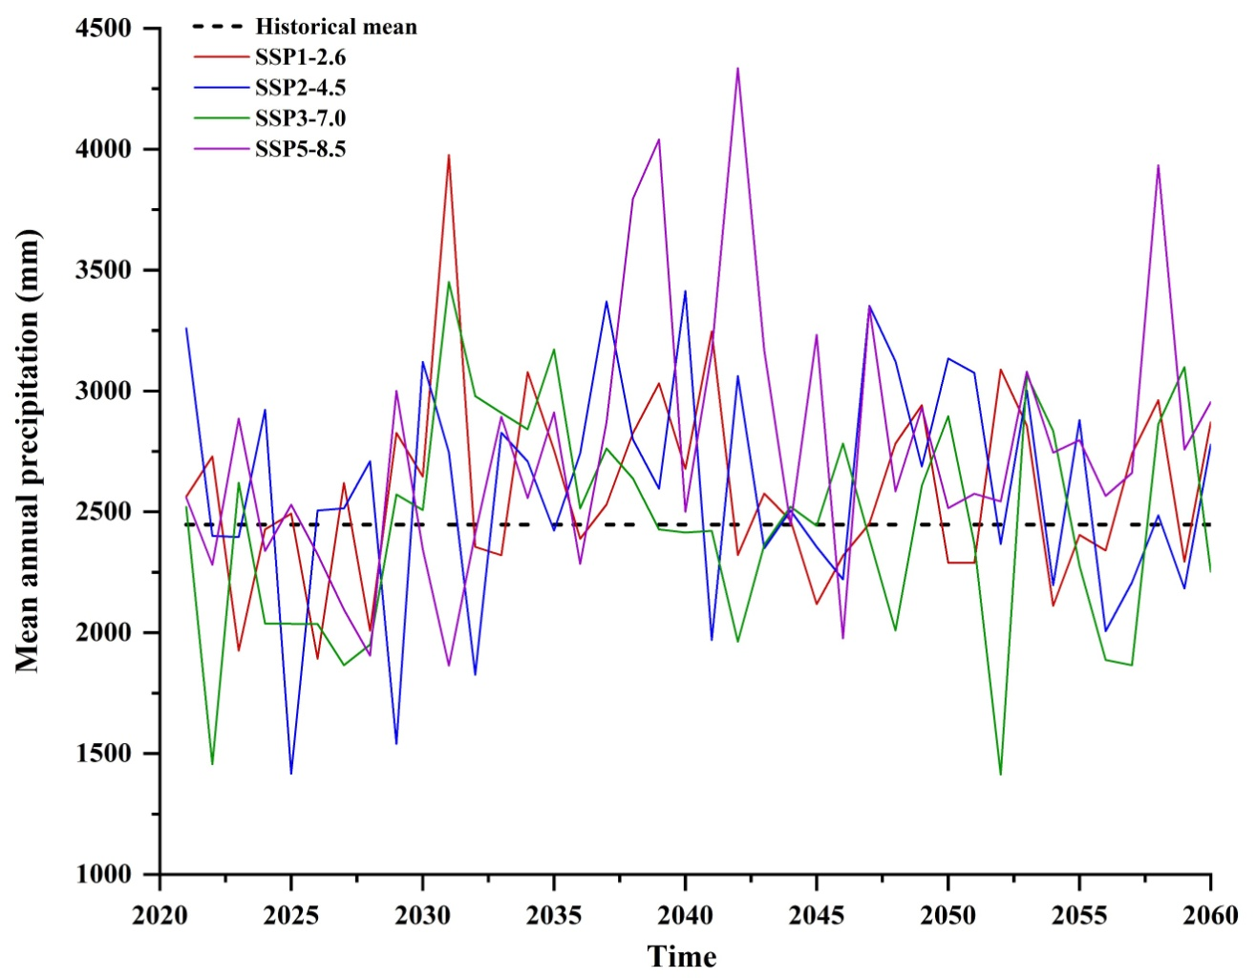
Fig.S1 Trends in precipitation variability under different climate change scenarios

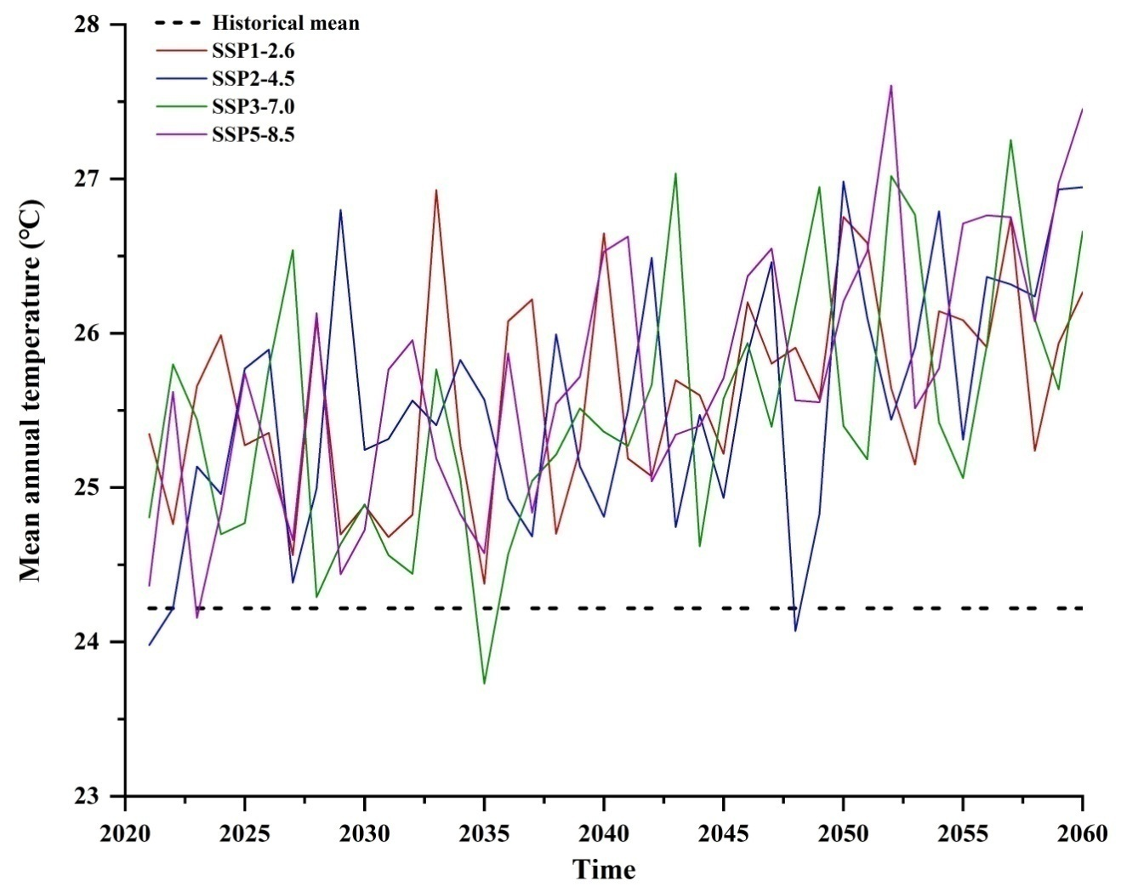
Fig.S2 Trends of future annual average temperature changes under different climate scenarios

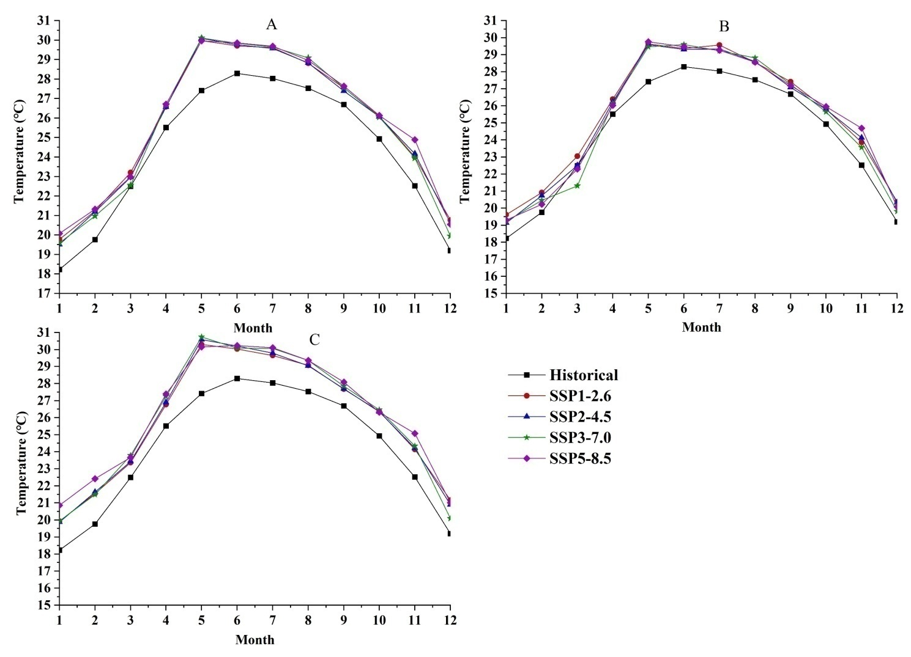
Fig.S3 Temporal variations in monthly temperature patterns across different climate scenarios (A:2021-2060; B:2021-2040; C:2041-2060)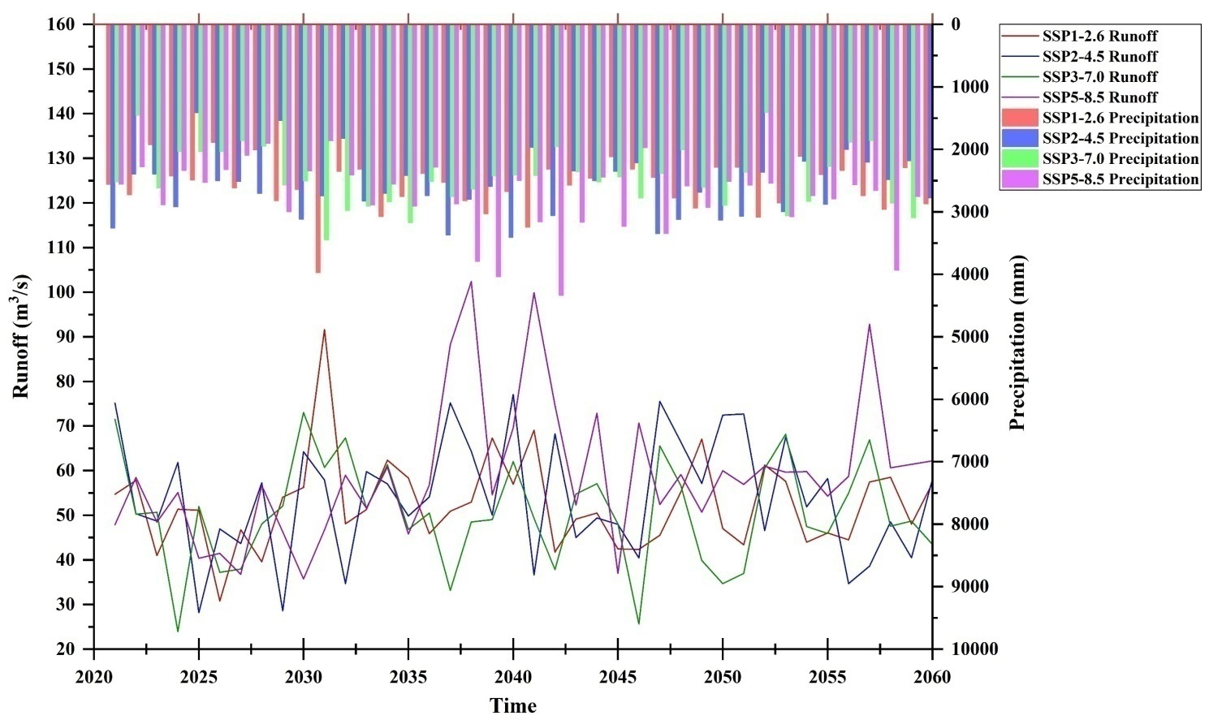
Fig.S4 Impact of climate change on runoff
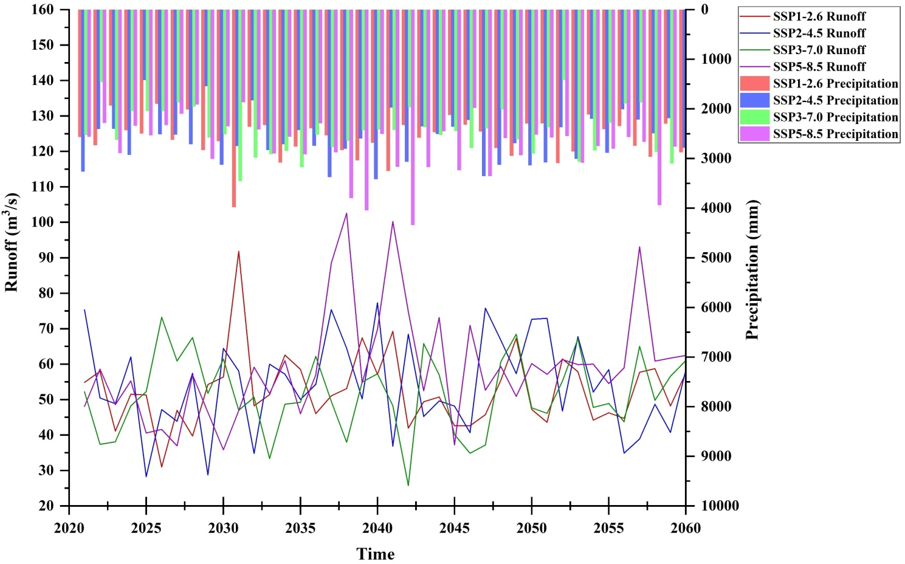
Fig.S5 The inter-annual variation of runoff under the combined impact of climate change and land use change

