Partial microglial depletion and repopulation exert subtle but differential effects on amyloid pathology at different disease stages
Le, L.¹, O’Banion, M.K.¹, and Majewska, A.K.^{1,2}*
¹Department of Neuroscience, Del Monte Institute for Neuroscience, University of Rochester, Rochester, NY
²Center for Visual Science, University of Rochester, Rochester NY
*Corresponding author

Supplementary Material

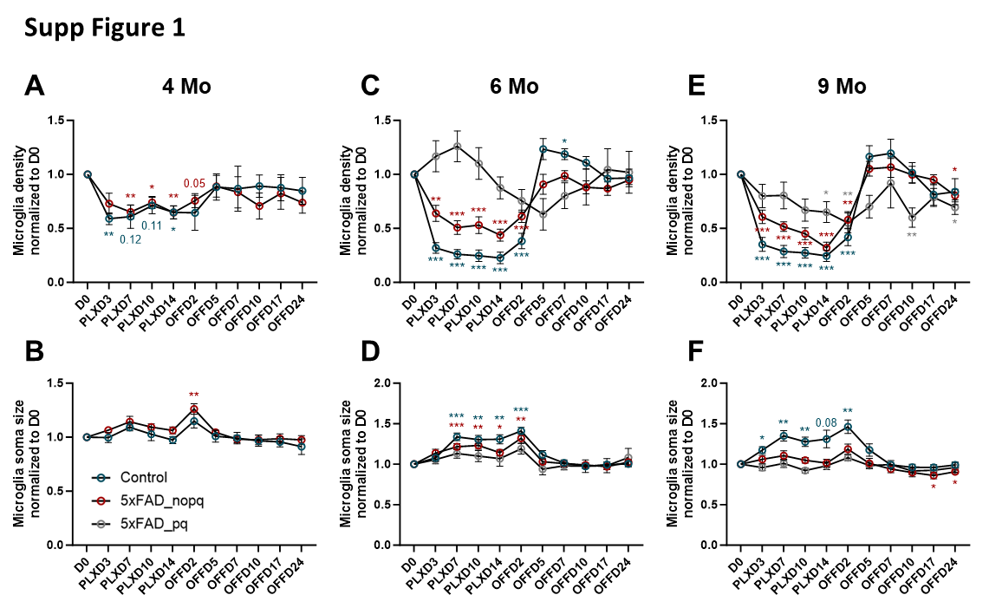
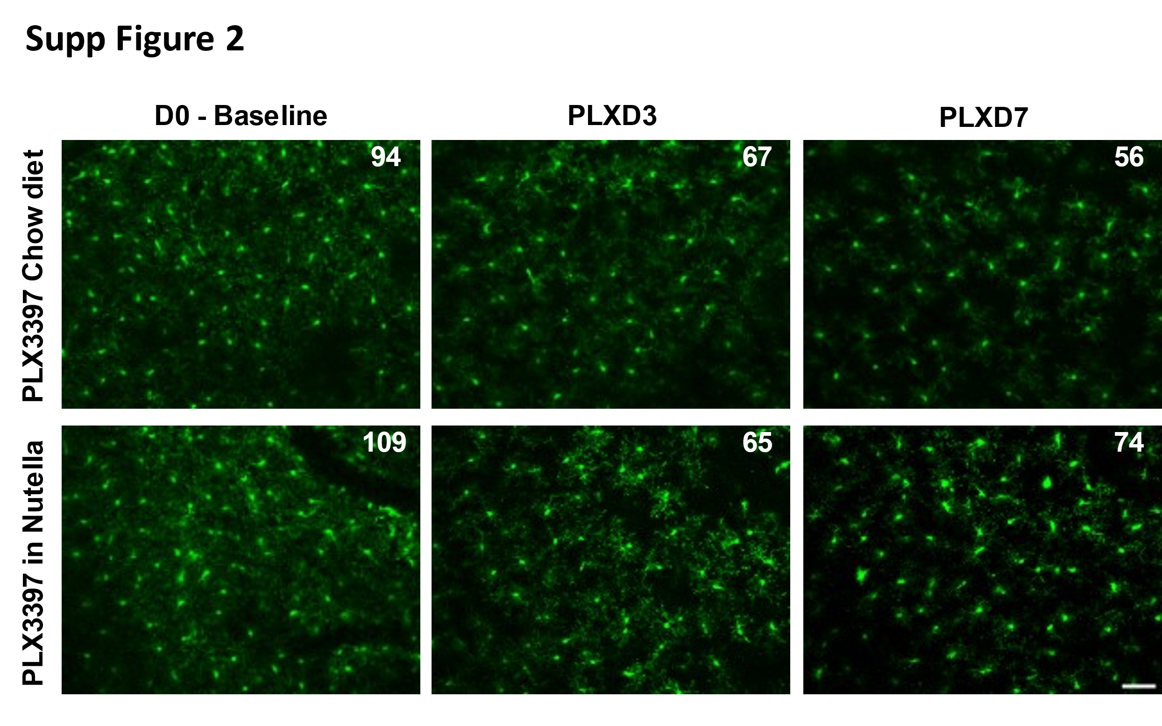
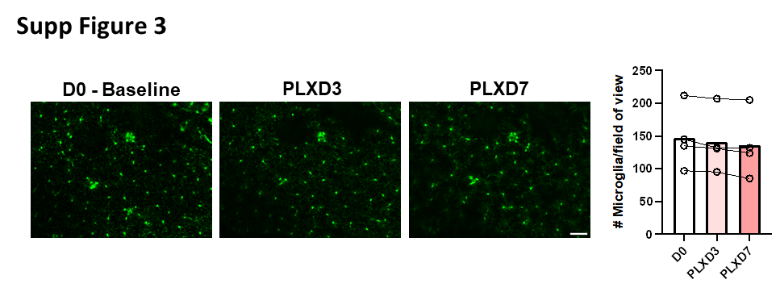

Supp Figure 1. Characterization of microglial depletion with PLX3397 at different ages.
(A, C, E) Microglia density across the depletion-repopulation imaging timeline as normalized to D0 baseline. 4-month-old mice received 1x PLX (A) while 6- and 9-month-old mice received 2x PLX (C, E). Rapid microglia depletion within the first 3 days of PLX treatment was observed in all age groups. After cessation of PLX, microglia replenished their niche within 5 days. Data are shown as follows: blue circle: control; red circle: plaque-distal microglia (5xFAD_nopq); gray circle: plaque-associated microglia (5xFAD_pq). Notice the lack of a 5xFAD_pq group at 4 months due to the low plaque load observed at this age.
(B, D, F) Average microglia soma size across the depletion-repopulation imaging timeline as normalized to D0 baseline at 4 months (B), 6 months (D), and 9 months (F).
Sample size as in Figure 2. Two-way ANOVA with Dunnett's post-hoc correction for comparisons between D0 and subsequent timepoints within the same type of microglia (i.e.: control, 5xFAD_pq and 5xFAD_nopq). *p<0.05, **p<0.01, ***p<0.001.

Supp Figure 2. Comparable removal of microglia by delivery of PLX3397 in chow and in Nutella
In vivo two-photon images showing comparable depletion of microglia between the standard PLX chow diet (290 mg/kg, upper panels) and a similar dose of PLX in Nutella (lower panels). On each image, the number of microglia in the field of view is indicated on the right-hand corner. Scale bar = 50μm.

Supp Figure 3. Microglia in aged mice are resistant to removal by standard dose of PLX3397
Representative in vivo two-photon images of aged 5xFAD microglia during PLX treatment with quantification on the right showing the lack of depletion with the standard dose PLX in aged mice (9-10 months). Individual animals are displayed as single lines and their averages are shown in bars (n=4). Scale bar = 50μm.

