Supplementary Tables and Figures

Table S1: The number of patients in each TMA by number of within-patient FFPE Blocks available by anatomical sites, and by timepoints.
Counts | TMA-1 |  |  |  | TMA-2 |  |  |  | TMA-3 |  |  |  | TMA-Recurrence
Number of within patient FFPE blocks | 3 | 3 | 4 | 5 |  | 6 | 3 | 5 |  | 6 | 7 | 8 |  | 10 | 2 | 3
Primary Sites
Adnexa | 21 | 23 | 17 | 15 |  | 3 | 0 | 1 |  | 1 | 3 | 5 |  | 2 | 4 | 10
Omentum | 0 | 17 | 15 | 11 |  | 2 | 1 | 1 |  | 0 | 2 | 4 |  | 2 | 0 | 10
Other peritoneal | 0 | 6 | 11 | 9 |  | 3 | 0 | 0 |  | 0 | 2 | 2 |  | 1 | 0 | 0
Lymph nodes and other | 0 | 2 | 2 | 0 |  | 0 | 0 | 0 |  | 1 | 1 | 0 |  | 0 | 0 | 0
Recurrence Sites
Adnexa | 0 | 0 | 0 | 0 |  | 0 | 1 | 0 |  | 0 | 2 | 1 |  | 2 | 4 | 10
Omentum | 0 | 0 | 0 | 0 |  | 0 | 0 | 0 |  | 0 | 2 | 4 |  | 2 | 0 | 0
Other peritoneal | 0 | 0 | 0 | 0 |  | 0 | 0 | 1 |  | 0 | 2 | 2 |  | 1 | 0 | 0
Lymph nodes and other | 0 | 0 | 0 | 0 |  | 0 | 0 | 0 |  | 0 | 1 | 3 |  | 0 | 0 | 0
Total Patients (Specimens) | 21  (63) | 23 (69) | 18  (72) | 15  (75) |  | 3  (18) | 1 (3) | 1 (5) |  | 1 (6) | 4  (28) | 5  (40) |  | 2 (20) | 4 (8) | 10 (30)

Table S2: Clinical characteristics of patients on each TMA relative to the entire COEUR cohort

Parameter | Total COEUR Cohort  N = 1113 | TMA 1  N = 21 | TMA 2  N = 59 | TMA 3  N = 14 | TMA 4  N = 14
Age diagnosis (years) | 62 | 64 | 61 | 59 | 57
Missing | 3 | 1 | 1 | 0 | 0
Age end of follow-up (years) | 65 | 68 | 65 | 65 | 61
Missing | 17 | 1 | 2 | 0 | 0
Follow-up time (months) | 39 | 51 | 44 | 71 | 50
Missing | 16 | 1 | 2 | 0 | 0
Histotype
high grade serous | 1,113 (100.0%) | 20 (100.0%) | 59 (100.0%) | 14 (100.0%) | 14 (100.0%)
Stage
I | 64 (5.9%) | 1 (5.0%) | 0 (0.0%) | 0 (0.0%) | 1 (7.1%)
II | 121 (11.2%) | 7 (35.0%) | 2 (3.5%) | 0 (0.0%) | 3 (21.4%)
III | 789 (72.9%) | 11 (55.0%) | 50 (87.7%) | 14 (100.0%) | 9 (64.3%)
IV | 108 (10.0%) | 1 (5.0%) | 5 (8.8%) | 0 (0.0%) | 1 (7.1%)
Missing | 31 | 1 | 2 | 0 | 0
Residual Disease
none | 195 (25.2%) | 8 (50.0%) | 12 (23.5%) | 0 (0.0%) | 8 (66.7%)
< 1 cm | 219 (28.3%) | 4 (25.0%) | 17 (33.3%) | 3 (23.1%) | 3 (25.0%)
suboptimal | 361 (46.6%) | 4 (25.0%) | 22 (43.1%) | 10 (76.9%) | 1 (8.3%)
Missing | 338 | 5 | 8 | 1 | 2
BRCA1 and BRCA2 mutation status
BRCA1 Carriers | 62 (13.6%) | 2 (14.3%) | 4 (10.3%) | 1 (7.7%) | 1 (50.0%)
BRCA2 carriers | 27 (5.9%) | 2 (14.3%) | 3 (7.7%) | 0 (0.0%) | 0 (0.0%)
double BRCA1/BRCA2 carrier | 3 (0.7%) | 1 (7.1%) | 0 (0.0%) | 0 (0.0%) | 0 (0.0%)
Mutation status known but not identified | 1 (0.2%) | 0 (0.0%) | 0 (0.0%) | 0 (0.0%) | 0 (0.0%)
Non carriers | 361 (79.3%) | 9 (64.3%) | 32 (82.1%) | 12 (92.3%) | 0 (0.0%)
wild type | 1 (0.2%) | 0 (0.0%) | 0 (0.0%) | 0 (0.0%) | 1 (50.0%)
Missing | 658 | 7 | 20 | 1 | 12
Survival rate
Alive | 324 (29.6%) | 12 (60.0%) | 19 (32.2%) | 3 (21.4%) | 9 (64.3%)
Deceased | 770 (70.4%) | 8 (40.0%) | 40 (67.8%) | 11 (78.6%) | 5 (35.7%)
Missing | 19 | 1 | 0 | 0 | 0
5-years survival rate
Alive | 426 (39.5%) | 12 (60.0%) | 25 (43.9%) | 9 (64.3%) | 10 (71.4%)
Deceased | 652 (60.5%) | 8 (40.0%) | 32 (56.1%) | 5 (35.7%) | 4 (28.6%)
Missing | 35 | 1 | 2 | 0 | 0
Chemotherapy before first progression
none | 19 (1.8%) | 0 (0.0%) | 0 (0.0%) | 0 (0.0%) | 0 (0.0%)
carbo+taxol | 841 (80.6%) | 19 (95.0%) | 47 (82.5%) | 10 (71.4%) | 14 (100.0%)
cispl+taxol | 72 (6.9%) | 0 (0.0%) | 6 (10.5%) | 2 (14.3%) | 0 (0.0%)
platinum | 56 (5.4%) | 1 (5.0%) | 3 (5.3%) | 0 (0.0%) | 0 (0.0%)
other | 56 (5.4%) | 0 (0.0%) | 1 (1.8%) | 2 (14.3%) | 0 (0.0%)
Missing | 69 | 1 | 2 | 0 | 0
Long term survivors (> 10 years) | 23 (2.1%) | 1 (5.0%) | 2 (3.5%) | 2 (14.3%) | 0 (0.0%)
Missing | 16 | 1 | 2 | 0 | 0

Table S3: Fleiss’ Kappa Summary
Biomarker | ITH Type | # patients Complete/Assessed | Estimate (95% CI) | Interpretation
Minimal Diagnostic Biomarker
WT1 (categorical) | In-situ | 47/48 | 0.25 (0.019,0.478) | Fair
WT1 (categorical) | Adnexa vs. Omentum | 60/62 | 0.37 (-0.201,0.949) | Fair
WT1 (categorical) | Adnexa vs. Other peritoneal | 31/33 | 1 (1,1) | Almost Perfect
WT1 (categorical) | Primary vs. Recurrence | 27/27 | 1 (1,1) | Almost Perfect
p53 | In-situ | 45/48 | 1 (1,1) | Almost Perfect
p53 | Adnexa vs. Omentum | 55/62 | 1 (1,1) | Almost Perfect
p53 | Adnexa vs. Other peritoneal | 29/33 | 1 (1,1) | Almost Perfect
p53 | Primary vs. Recurrence | 27/27 | 1 (1,1) | Almost Perfect
Second Line Diagnostic Biomarker
p16 | In-situ | 46/48 | 0.7 (0.528,0.881) | Substantial
p16 | Adnexa vs. Omentum | 56/62 | 0.81 (0.648,0.967) | Almost Perfect
p16 | Adnexa vs. Other peritoneal | 28/33 | 0.45 (0.118,0.785) | Moderate
p16 | Primary vs. Recurrence | 27/27 | 0.84 (0.605,1) | Almost Perfect
Second Line Diagnostic/Prognostic Biomarker
PR (categorical) | In-situ | 43/48 | 0.5 (0.291,0.699) | Moderate
PR (categorical) | Adnexa vs. Omentum | 61/62 | 0.4 (0.139,0.659) | Moderate
PR (categorical) | Adnexa vs. Other peritoneal | 32/33 | 0.56 (0.206,0.923) | Moderate
PR (categorical) | Primary vs. Recurrence | 27/27 | 0.17 (-0.244,0.577) | Slight
Potentially Prognostic Biomarker
CD8 (categorical) | In-situ | 47/48 | 0.48 (0.29,0.68) | Moderate
CD8 (categorical) | Adnexa vs. Omentum | 56/62 | 0.46 (0.225,0.704) | Moderate
CD8 (categorical) | Adnexa vs. Other peritoneal | 29/33 | 0.65 (0.36,0.947) | Substantial
CD8 (categorical) | Primary vs. Recurrence | 27/27 | 0.26 (-0.131,0.648) | Fair
Ki67 (categorical) | In-situ | 46/48 | 0.35 (0.151,0.552) | Fair
Ki67 (categorical) | Adnexa vs. Omentum | 54/62 | 0.4 (0.146,0.654) | Moderate
Ki67 (categorical) | Adnexa vs. Other peritoneal | 29/33 | 0.3 (-0.093,0.684) | Fair
Ki67 (categorical) | Primary vs. Recurrence | 26/27 | 0.23 (-0.176,0.628) | Fair

Table S4: ICC using Nested Mixed Models
Biomarker | ITH Type | # patients | Estimate (95% CI) | Interpretation
WT1 | In-situ | 48 | 0.94 (0.92, 0.95) | Almost Perfect
WT1 | Adnexa vs. Omentum | 61 | 0.97 (0.96, 0.98) | Almost Perfect
WT1 | Adnexa vs. Other peritoneal | 33 | 0.89 (0.85, 0.92) | Almost Perfect
WT1 | Primary vs. Recurrence | 27 | 0.85 (0.76, 0.89) | Almost Perfect
WT1 (categorical) | In-situ | 48 | 0.98 (0.99, 1) | Almost Perfect
WT1 (categorical) | Adnexa vs. Omentum | 61 | 0.99 (0.99, 1) | Almost Perfect
WT1 (categorical) | Primary vs. Recurrence | 27 | 0.99 (0.97, 1) | Almost Perfect
p53 | In-situ | 48 | 1 (1, 1) | Almost Perfect
p16 | In-situ | 48 | 0.99 (0.99, 1) | Almost Perfect
p16 | Adnexa vs. Omentum | 56 | 0.98 (0.98, 1) | Almost Perfect
p16 | Adnexa vs. Other peritoneal | 29 | 0.98 (0.96, 1) | Almost Perfect
p16 | Primary vs. Recurrence | 27 | 0.99 (0.98, 1) | Almost Perfect
PR | In-situ | 48 | 0.83 (0.78, 0.87) | Almost Perfect
PR | Adnexa vs. Omentum | 62 | 0.74 (0.7, 0.79) | Substantial
PR | Adnexa vs. Other peritoneal | 33 | 0.86 (0.81, 0.89) | Almost Perfect
PR | Primary vs. Recurrence | 27 | 0.34 (0.18, 0.44) | Fair
PR (categorical) | In-situ | 48 | 0.83 (0.7, 0.89) | Almost Perfect
PR (categorical) | Adnexa vs. Omentum | 62 | 0.9 (0.82, 0.99) | Almost Perfect
PR (categorical) | Adnexa vs. Other peritoneal | 33 | 0.97 (0.97, 1) | Almost Perfect
PR (categorical) | Primary vs. Recurrence | 27 | 0.81 (0.64, 0.94) | Almost Perfect
CD8 | In-situ | 48 | 0.79 (0.73, 0.83) | Substantial
CD8 | Adnexa vs. Omentum | 56 | 0.74 (0.66, 0.79) | Substantial
CD8 | Adnexa vs. Other peritoneal | 29 | 0.69 (0.56, 0.76) | Substantial
CD8 | Primary vs. Recurrence | 27 | 0.72 (0.61, 0.8) | Substantial
CD8 (categorical) | In-situ | 48 | 0.73 (0.56, 0.82) | Substantial
CD8 (categorical) | Adnexa vs. Omentum | 56 | 0.66 (0.41, 0.74) | Substantial
CD8 (categorical) | Adnexa vs. Other peritoneal | 29 | 0.72 (0.5, 0.81) | Substantial
CD8 (categorical) | Primary vs. Recurrence | 27 | 0.68 (0.47, 0.84) | Substantial
Ki67 | In-situ | 48 | 0.79 (0.72, 0.85) | Substantial
Ki67 | Adnexa vs. Omentum | 56 | 0.8 (0.73, 0.85) | Substantial
Ki67 | Adnexa vs. Other peritoneal | 29 | 0.78 (0.69, 0.84) | Substantial
Ki67 | Primary vs. Recurrence | 27 | 0.75 (0.66, 0.83) | Substantial
Ki67 (categorical) | In-situ | 48 | 0.7 (0.46, 0.8) | Substantial
Ki67 (categorical) | Adnexa vs. Omentum | 56 | 0.76 (0.58, 0.83) | Substantial
Ki67 (categorical) | Adnexa vs. Other peritoneal | 29 | 0.71 (0.48, 0.78) | Substantial
Ki67 (categorical) | Primary vs. Recurrence | 27 | 0.71 (0.53, 0.8) | Substantial
Note: Some comparisons could not be assessed due to model singularity or constant levels in the biomarker.

Table S5: IHC Protocols
antibody | supplier | clone | mouse/rabbit monoclonal | dilution 1/ | HIER/ protocol | Detection | Platform
CD8 | DAKO | 123C3 | MM | RTU | H30-X-30 | HRP based using 3,3’-diaminobenzidine (DAB) | DAKO Omnis
Ki67 | DAKO | MIB-1 | MM | RTU | L20-X-20 | HRP based using 3,3’-diaminobenzidine (DAB) | DAKO Omnis
p16 | CINtec | E6H4 | MM | 24 | 30-10M-30 | HRP based using 3,3’-diaminobenzidine (DAB) | DAKO Omnis
p53 | DAKO | DO-7 | MM | RTU | 30-10M-30 | HRP based using 3,3’-diaminobenzidine (DAB) | DAKO Omnis
PR | DAKO | PGR1294 | MM | 200 | H20-X-20 | HRP based using 3,3’-diaminobenzidine (DAB) | DAKO Omnis
WT1 | Leica | WT49 | MM | 25 | 30-10M-30 | HRP based using 3,3’-diaminobenzidine (DAB) | DAKO Omnis

Table S6: Power-Based A priori Sample Size Calculation. This calculation assumes a binary marker. The null hypothesis is that there is no heterogeneity in the
Null hypothesis | Alternate hypothesis | Prevalence of biomarker | Number of raters
kappa0 | kappa1 | props | 2 | 3 | 4 | 5 | 6
0.95 | 0.6 | 0.05 | 33 | 23 | 17 | 14 | 12
0.95 | 0.6 | 0.10 | 18 | 12 | 10 | 8 | 7
0.95 | 0.6 | 0.15 | 13 | 9 | 7 | 6 | 5
0.95 | 0.6 | 0.20 | 10 | 7 | 6 | 5 | 5
0.95 | 0.6 | 0.25 | 9 | 6 | 5 | 5 | 4
0.95 | 0.6 | 0.30 | 8 | 5 | 5 | 4 | 4
0.95 | 0.6 | 0.35 | 7 | 5 | 4 | 4 | 4
0.95 | 0.6 | 0.40 | 7 | 5 | 4 | 4 | 4
0.95 | 0.6 | 0.45 | 7 | 5 | 4 | 4 | 4
0.95 | 0.6 | 0.50 | 7 | 5 | 4 | 4 | 4
0.95 | 0.7 | 0.05 | 65 | 44 | 34 | 28 | 24
0.95 | 0.7 | 0.10 | 34 | 23 | 18 | 15 | 14
0.95 | 0.7 | 0.15 | 25 | 16 | 13 | 11 | 10
0.95 | 0.7 | 0.20 | 20 | 13 | 11 | 10 | 9
0.95 | 0.7 | 0.25 | 17 | 11 | 9 | 8 | 8
0.95 | 0.7 | 0.30 | 15 | 10 | 9 | 8 | 7
0.95 | 0.7 | 0.35 | 14 | 9 | 8 | 7 | 7
0.95 | 0.7 | 0.40 | 13 | 9 | 8 | 7 | 7
0.95 | 0.7 | 0.45 | 13 | 9 | 7 | 7 | 7
0.95 | 0.7 | 0.50 | 13 | 9 | 7 | 7 | 7
0.95 | 0.8 | 0.05 | 179 | 120 | 93 | 76 | 65
0.95 | 0.8 | 0.10 | 95 | 64 | 50 | 42 | 37
0.95 | 0.8 | 0.15 | 67 | 45 | 36 | 31 | 28
0.95 | 0.8 | 0.20 | 54 | 36 | 29 | 26 | 23
0.95 | 0.8 | 0.25 | 46 | 31 | 25 | 22 | 21
0.95 | 0.8 | 0.30 | 41 | 27 | 23 | 21 | 19
0.95 | 0.8 | 0.35 | 38 | 25 | 21 | 19 | 19
0.95 | 0.8 | 0.40 | 36 | 24 | 20 | 19 | 18
0.95 | 0.8 | 0.45 | 35 | 23 | 20 | 18 | 18
0.95 | 0.8 | 0.50 | 35 | 23 | 20 | 18 | 18

Figure S1: Flow diagram illustrating the allocation of specimens across various TMAs

Figure S2: In-situ Heterogeneity Aggregated Scores
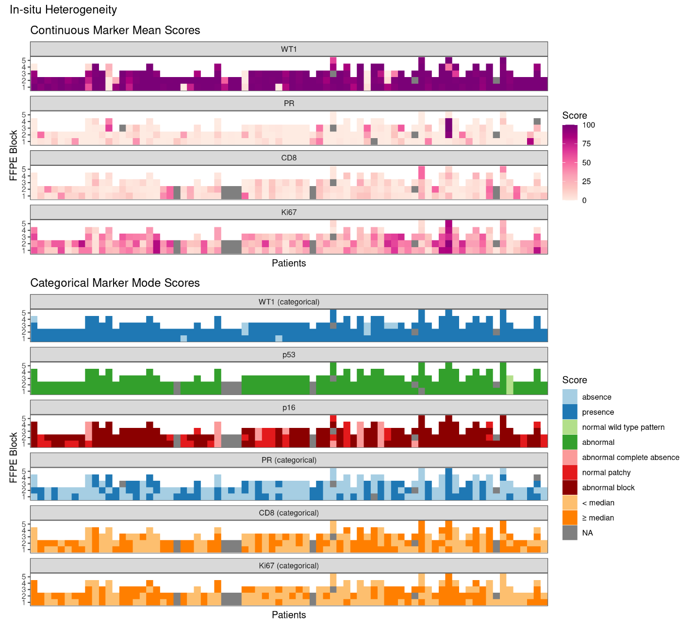

Figure S3: Adnexa vs. Other peritoneal Heterogeneity Aggregated Scores 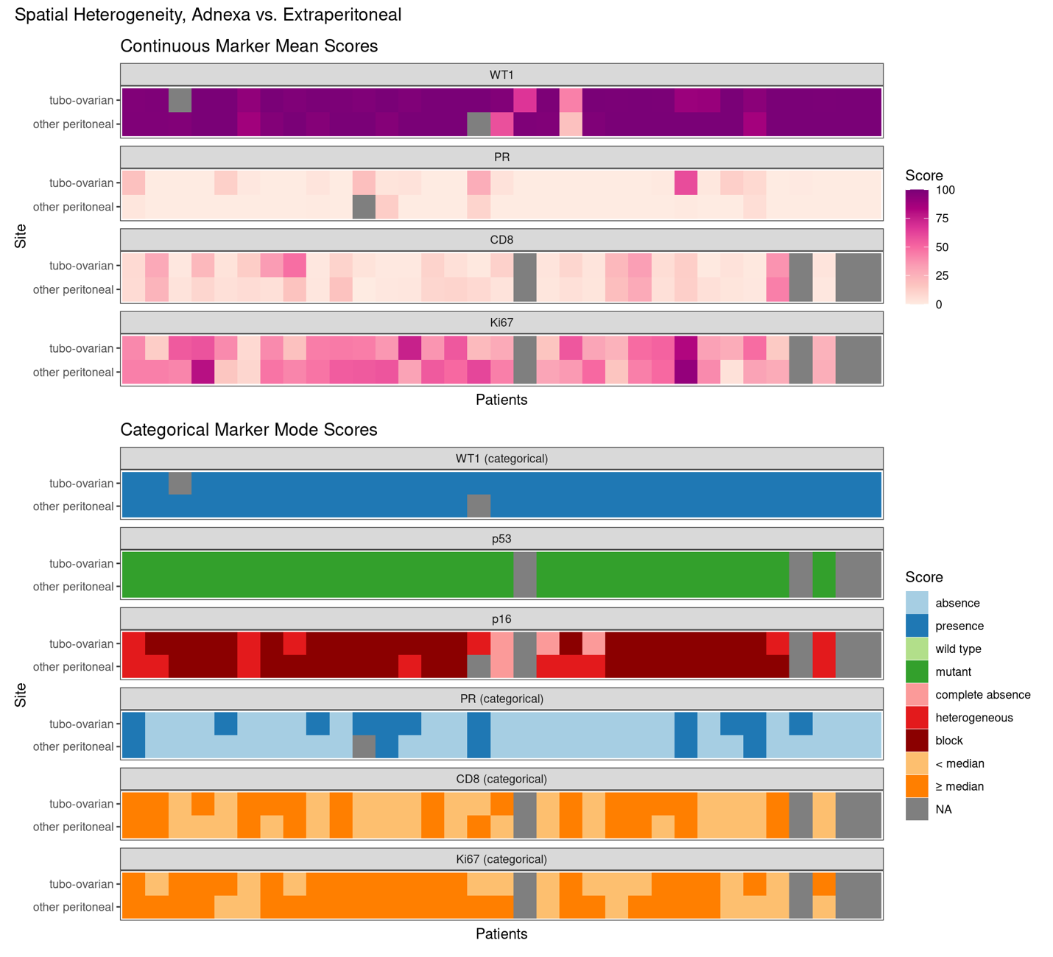

Figure S4: Primary vs. Recurrence Heterogeneity Aggregated Scores


