Supporting Information
The Assessment of Sports Performance by Grip Pressure Using a Kind of Flexible Piezoresistive Pressure Sensors in Seven Sport Event

Kebao Zhang^{1,2}, Beilei Guo³, Mingchuan Yang⁴, Yi Jia¹, Kehu Zhang^{5*}, Liu Wang ^{2*}
¹ School of Sport and Physical Education, North University of China, Taiyuan, 030051, China
² School of Recreation and Community Sport, Capital University of Physical Education and Sports, Beijing 100191, China
³ Nursing Science, Jin Cheng People's Hospital, Shanxi 048000, China
⁴ Science and Technology on Electronic Test and Measurement Laboratory, North University of China, Taiyuan 030051, China;
⁵ Publishing Center, North University of China, Taiyuan, 030051, China
Corresponding authors: wangliu@cupes.edu.cn, kehuzhang@qq.com
Part1: The current status of FPPS applications conditions
As indicated in Table S1, the application domains of flexible piezoresistive pressure sensor (FPPS)as intelligent sensing terminal primarily focus on three aspects: real-time detection and recognition of fundamental movement patterns of body parts or joints; assessment of physical fitness movements and sports techniques; and detection of physiological signals (such as joint extension and rotation, radial artery pressure in the wrist, speech recognition, finger tapping and touch pressure, and plantar pressure). The technology essentially covers the detection of both external and internal movements and physiological signals across various body parts. And the sports performance such as plank, push-ups, and sit-ups, as well as tennis and badminton, has been evaluated. The selection of materials and structures for FPPS is diversified, mainly focusing on CB\CNT\MXene\rGO, etc. There are the trends that porous sponge and 3D foam structures are most popular. In terms of sensitivity, a variety of ranges has been achieved. The detection range covers a wide spectrum from 0 to 1000 kPa. For response and recovery times, various combinations from 16-300 ms and 13-240 ms. Durability can also reach 1000-35000 cycles. These data indicate that FPPS have excellent performance and significant potential in the field of exercise, sports, and health evaluation.
As shown in Table S2, the top 5 application scenarios are joint extension 177, radial artery pressure in the wrist 111, speech recognition 88, finger tapping and touch pressure 72, and plantar pressure detection 61. The most commonly applied body parts are joints, fingers, feet, throat, and face. In terms of movement patterns, joint bending and rotation, finger tapping and touch pressure, breathing and phonation, and changes in plantar pressure are all fundamental forms of body movement.
Furthermore, through the statistics of the literature, it has been found that previous research on FPPS has primarily focused on enhancing sensor performance, such as sensitivity, detection range, response time, and durability. The main differences in research lie in the selection of different materials, structures, layers, and fabrication methods. For application scenarios mentioned above, more focus on the detection and evaluation of joint extension, wrist radial artery pressure, speech recognition, finger tapping, and plantar pressure. Therefore, the potential of FPPS in sports and health monitoring has not been fully realized due to the limited research and application in these areas.
We conducted a computer-based literature search of the following databases for the period of January 1, 2021–December 31, 2023. The retrieved database was Scopus, PubMed, Web of Science, SPORT Discus, and Google Scholar. The search terms were “flexible piezoresistive pressure sensors” OR “flexible piezoresistive strain sensors” and “human body motion” or “human health”. Full publications and abstracts were screened and all relevant papers were retrieved, and conference papers were excluded.

Table S1 Summary of main features and applications of flexible piezoresistive pressure sensors
Applications | Materials | Strategies | Structure | Sensitivity/  Gauge Factor | Sensing range  (stress/strain) | Linear | Response recovery time(ms) | Cycles | Reference
Bending | CB-PDMS | porous | 3D | 11.02 kPa⁻¹ (0-6 kPa) | 0-30 kPa | 3linear | 200 | 2000 | [1]
Rotation | PDMS/MWCNTs | fabric | 2D | 0.0058-0.024 kPa⁻¹ | 1-100 kPa | linear | 72 | 1000 | [2]
Tennis | MXene/Melamine | sponge | 3D | 5.35 kPa⁻¹ (1.1-22.2 kPa) | 33.3-266.3 kPa, | linear | 300 /180 | 5000 | [3]
Clenched fist | PANI-PDMS | micro-dome | 3D | 1.104 kPa⁻¹ | ultra-low (0.64Pa) | 3linear | 50 /60 | 10000 | [4]
Push-up | PDMS/CNT | micro pyramid | 3D | 242.4 kPa⁻¹ | 0-185.5 kPa | linear | 44/13 | 8000 | [5]
Gait monitoring | Ag-PDMS | four layers | 3D | 0.172 kPa⁻¹ | 0-312 kPa | linear | 50/74 | 1000 | [6]
Respiration rate | AgNW/MXene-TPU | microcrack | 2D | gauge factor (GF)  = 602 | 0-90% strain | NA | 60, | 1000 | [7]
Picking up | FGA/FGA@PDMS | sponge | 3D | 0-10 kPa, 22-35.84 kPa⁻¹ | 0-10 kPa | 2linear | 120/100 | 1000 | [8]
Facial expression | PWs-PDMS | NA | 3D | 15.14 kPa⁻¹ | 0.06-100 kPa | linear | 160/240 | 6000 | [9]
Drinking water or coughing | rGO@EVOH | hydrophilic  micro/nano | 3D | 130.9 kPa⁻¹ | 1-5 kPa | linear | NA | 500 | [10]
Throat vibration  and speaking | (MADH):Au/SWCNTs/MADH | Micro pyramid | 3D | 1.28-106 kPa⁻¹ | 4.51-54837.06 Pa | 3linear | NA | 2000 | [11]
Boxing force | P-CNT/CB/CIP/  silicone composite | porous | 3D | 0.304 kPa⁻¹ | 80 Pa -20 kPa | linear | NA | 4000 | [12]
Forearm muscle  contraction | TPU/MWCNT | foam | NA | 0.285 kPa⁻¹ (0-2 kPa) | 0-80 kPa | 3linear | 50/100 | 1000 | [13]
Heartbeat | (CNTs)/graphene-PDMS | porous | 3D | 300.31 kPa⁻¹(0-50 kPa);52.51 kPa⁻¹(50-200 kPa) | 0-200kPa | 2linear | 169/139 | 1000 | [14]
Clench fist | CB/MWCNT-PDMS | porous | 3D | 3.57 kPa⁻¹ (0-21 kPa) | 0-275 kPa | 2linear | 96/198 | 3000 | [15]
Radial artery  vibration | CNFs/PDMS | porous | 3D | 4.7 kPa⁻¹ | 0.03-1000 kPa | 3linear | 24/15 | 35000 | [16]
Arm muscle  contraction | Tin-Mon sulfide (SnS) | multilayer  paper | 2D | 14.8 kPa⁻¹ | 0-120 kPa | linear | 180 | 1000 | [17]
Squat test | PDMS/MWCNTs | foam | 3D | 0.172 kPa⁻¹ | NA | NA | 98/111 | NA | [18]
Waist twisting | CNT/PDMS | pyramidal | 3D | 1.51-103 kPa⁻¹ | 2.5-255.7 kPa | linear | 165/82 | 20000 | [19]
Head shaking | PPy/rGO/FSF | network | 3D | 0.51 kPa⁻¹ | 0-25.0 kPa | 3linear | 243/173 | 7500 | [20]
Sit-up exercise. | MXene/PPNs/TPUEM | network | 3D | 16.72 kPa⁻¹ | 0-32.1 kPa | 3linear | 145 /159 | 2000 | [21]
Standard posture  of planking | PDMS film was coated by silver coating | bionic | 3D | 8.5 kPa⁻¹ | 0-0.8 kPa | NA | NA | NA | [22]
Writing | (GNPs)/(PSS)/(UV) | sandwich | 3D | gauge factor=19.65 | 0-30% | 3linear | 50 | 10000 | [23]
ECG and blood  pressure | MoS2 NPs between the two LIG foam | foam | 3D | 88 kPa⁻¹ | NA | 3linear | 69 | 8000 | [24]
Sitting posture | (PPy/HNT)–(AgNF) | sponge | 3D | 3.97 kPa⁻¹ | 0-400 kPa | non | 40 | 12000 | [25]
Sleeping positions | PPy/latex | sponge | 3D | 0.084 kPa⁻¹  at below 3.12 kPa | 0-85.0% | 3linear | NA | 1800 | [26]
Triceps brachii or biceps femoris | P-ORC/CB-4 | porous | 3D | NA | 0-300% | linear | 16/40 | 2000 | [27]

Table S2 FPPS frequency of application in the field of physical movement and health detection (N=240)
Region | Motion | Objection (Real-time monitoring and identification) | number
Body | Bending /flexion | joint bending angles | 177
Body | Rotation | joint rotation angles | 3
Wrist  Hand | Finger tapping | finger pressure changes and rhythmic variations during pressing | 72
Wrist  Hand | Fingertip pulse signals | finger tremors, which can be used for the prevention and diagnosis of elderly diseases | 3
Wrist  Hand | Writing | writing different letters or symbols | 8
Wrist  Hand | Fist clenching | finger joint bending degrees and grip strength when making a fist | 5
Wrist  Hand | Radial artery vibration | breathing patterns and frequencies | 44
Wrist  Hand | Smart glove  Hand motions or | finger gestures | 18
Wrist  Hand | Mouse working | finger gestures | 13
Wrist  Hand | Blood pressure | blood pressure changes | 7
Wrist  Hand | Muscle contraction | muscle contraction and relaxation characteristics during movement, such as the biceps brachii | 7
 | Badminton | hand pressure distribution characteristics during badminton play | 1
 | Tennis | hand pressure changes characteristics during the forehand stroke technique in tennis | 1
 | Push-ups | hand pressure changes during the ascending and descending phases of push-ups | 1
Head  Neck | Facial muscles motion | facial expressions: smiling, crying, opening and closing mouth, frowning | 46
Head  Neck | Respiration motion | radial and carotid pulse, as well as pulse characteristics | 111
Head  Neck | Swallowing/coughing | basic throat movements such as swallowing and coughing | 41
Head  Neck | Nodding/head shaking | external neck movements | 6
Head  Neck | Speech | vocal cord vibration characteristics when speaking fixed characters or sentences | 88
Head  Neck | Sleeping positions | communication signals between patients and healthcare professionals | 1
Trunk | Heartbeat | cardiac physiological characteristics | 7
Trunk | Sit-up | abdominal muscle contraction and relaxation states during different stages of prone to standing | 1
Trunk | Planking | abdominal muscle contraction and relaxation states during different stages of plank | 1
Trunk | Sitting posture | pressure distribution on the seat when sitting in different postures, which can be used to evaluate sitting posture | 2
Foot | Heel/foot pressure | gait characteristics | 61
Foot | Squat test | foot pressure state during different stages of squats | 2

Part2: Details and process of data collection
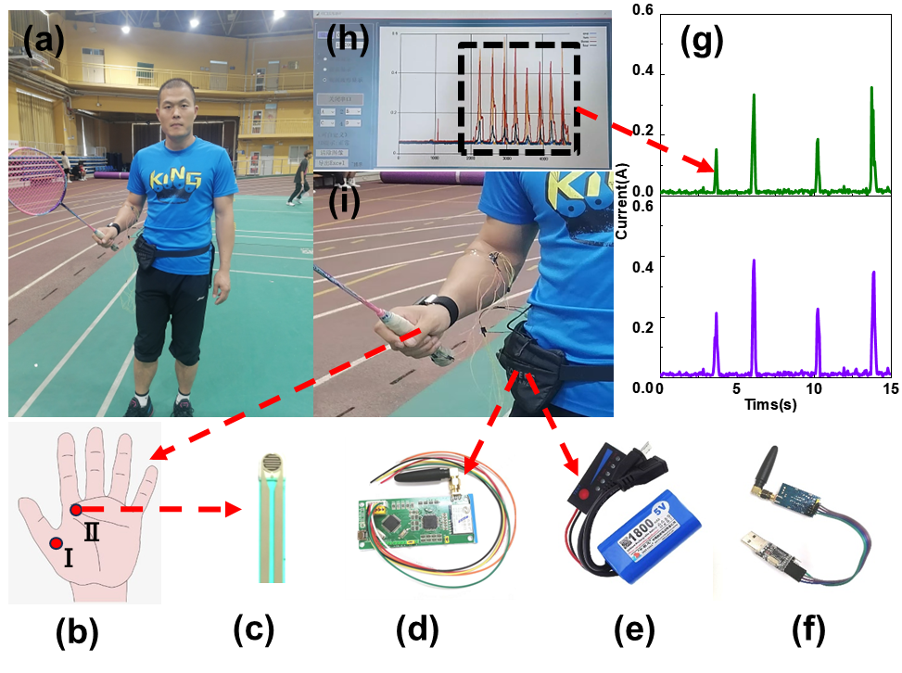
Figure S1 (a) Sports performance testing: integrated monitoring device used of the MMSS. (b) Installation positions of Sensor I-Ⅱ on the hand. (c) MMSS sensor. (d) Data storage and transmission device. (e) Power device. (f) Signal receptor device. (g) Current peaks of 2 channels (from Sensor I-Ⅱ) for 2 skills of the badminton player (net, kill shot, net, kill shot). (h) Data collection interface of computer software (i) Installation positions of data storage and transmission power device in bag. (Signed informed consent forms were obtained from all participants for publication of identifying tested data, information and images in an online open-access publication.)

The dimensions and weight of each module of the device. MMSS sensor (diameter: 7.5 mm with a thickness of 2 mm); Data storage and transmission device (11cm*3cm*0.5cm, 87g) Power device (62mm*35mm*8.5, 42g); Signal receptor device (installed in the computer port.).
The modules of the device are connected and communicate as follows: The data collection and storage module (Figure S1(d)) is linked to the signal receptor device (Figure S1(f)) by radio frequency communication with a type of wireless technology, to transmit data to the computer (Figure S1(h)). The data collection and storage module (Figure S1(d)) is connected to the sensors (Figure S1(c)) using a multi-strand high-temperature silver-plated wire with an outer diameter of 0.4mm made of Teflon. The data collection and storage module (Figure S1(d)) is connected to the power supply (Figure S1(e)) with a single-core high-flexibility drag chain cable electronic wire with an outer diameter of 2.5mm TRV.
Details of the placement of the device modules on the body: The data collection and storage module (Figure S1(d)) and the power supply (Figure S1(e)) are secured to the athlete's hip joint initially (as the hip joint is at the core position during exercise, generally serving the function of kinetic energy transfer, and has a smaller range of motion here). Additionally, to minimize interference from the wiring between the data collection and storage module (Figure S1(d)) and the sensors (Figure S1(c)) during the exercise movements, we use tape to fix them at the shoulder joint, elbow joint, and wrist joint.

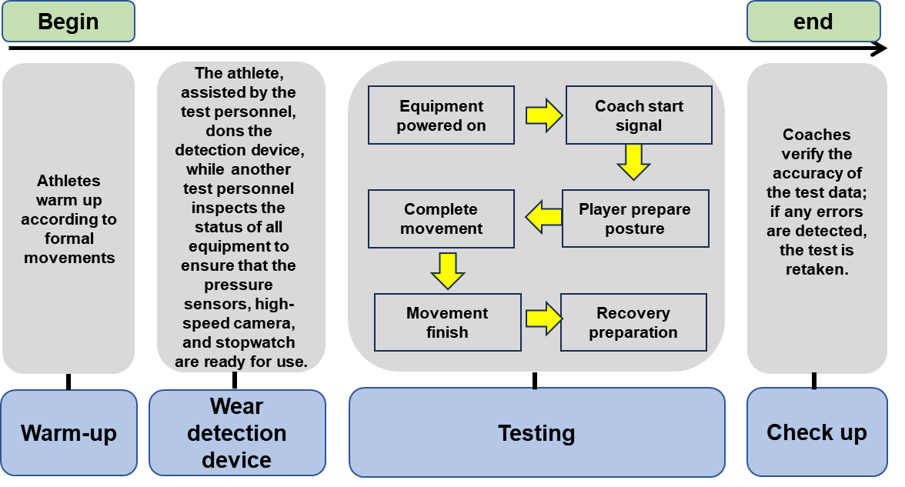
Figure S2 Test procedure flowchart for various events.

Part3: Feature extraction and recognition
The slide mean filter establishes a sample window and a filter window to accumulate and calculate the average value of the data within the sample window. And this slide mean filter can reduce random noise and maintain a clear step response, which make it the preferred filter for time-domain encoded signals. The key parameter in the sliding mean filter is the size of the sliding window and refers to the length of the convolution kernel when using a rectangular function as the convolution kernel. The filter function in MATLAB is used to achieve slide mean filter of signals. The basic syntax of the filter function is filter (b, a, x), a one-dimensional digital filter, and its rational transfer function can be expressed as：
y(n)= _{window_size}(x(n)+x(n-1)+…+x(n- (window_size-1))) (1-1)
When the window size of the convolutional kernel is set to 5, all the maximum points on the curve are determined through peak searching method. Based on the analysis of tennis performance, it can be seen that during a single swing, the maximum current point of the four technical movements corresponds to the moment before hitting the ball. An effective hit is confirmed by first determining all the the local maximum points, and then selecting the largest point among them (i.e. the maximum point). Because multiple local maximum points will appear during the swing processes and only the maximum point corresponds to a true hitting process. Setting the pressure parameters of the local maximum value within a certain action cycle as {P1, P2, ... Pn}, and filtering out the smaller local maximum points by setting a certain threshold the unique maximum point is obtained during each hitting process. The correctness of the threshold selection is confirmed by comparing the number of hits with all the maximum points. This threshold is only met when the maximum number of points is equal to the number of hits. If it does not meet the requirements, it is necessary to adjust the threshold for filtering the maximum value point and select the correct maximum value points again.
Next step is to carry out the feature extraction for curves. Feature extraction is a very important step in action recognition. The initial action signal cannot intuitively and effectively reflect the differences between actions. If the initial action signal is directly used for training the classifier model, it will often fail to achieve good classification results. Therefore, it is necessary to extract features from the initial pressure data and then train the classifier. Different strokes skills and different grip methods of the hand can result in different channels of the racket grip by observing the different movements of tennis hitting. This is also verified by combining the grip pressure data collected from key points of different movements during tennis hitting. Therefore, different stroke skills of tennis can be identified by selecting the maximum value point from the time-domain features to extract features. The maximum pressure point at each key position are selected during each swing process as the characteristic value. The extracted five feature values are merged into one feature vector and then this feature vector is used as input to the algorithm.
The next step is to perform normalization processing. Max-Min Normalization and Z-score normalization are two commonly used normalization methods. Max-Min Normalization is a linear transformation of the original data to make the results fall within the 0-1 range. The formula for quantifying the characteristics of Max-Min Normalization is as follows：
$z=\frac{x_{i}-min\left(x_{i}\right)}{\max\left(x_{i}\right)}$ (1-2)
Z-score normalization is the process of converting the values of all features into a normal distribution with a mean of 0 and a standard deviation of 1. The formula for quantifying Z-score normalization features is as follows:
$z=\frac{x_{i}-μ}{δ}$ (1-3)
The μ and δ are the mean and standard deviation of the counter-features, respectively. Since the Max-Min Normalization cannot be effectively solved the problem of outliers, Z-score normalization is chosen to process the generated features. After normalizing, the K-nearest neighbor algorithm is used for data learning and recognition. The core idea of this algorithm: if the K most adjacent data of a set of samples in the feature space belong to a certain category, it will be considered as the corresponding category and having the characteristics of that category samples. When carrying out category decisions, the KNN method is only relevant to a very small number of adjacent samples. Because the KNN method mainly relies on a limited number of surrounding samples rather than the method of distinguishing classification domains to determine their category, the KNN method can more accurately partition the sample set than other methods when there are more class domain intersections or overlaps.
In the fourth step of this experiment, a total of 400 samples were collected, including 100 shots each for forehand, backhand, serve, and forehand volleys. After preprocessing the data, the dataset is divided into a trainset and a test set. For the test sample x, the distance between it and each train sample is firstly calculated. Then the K training samples closest to x are selected and denoted as N (x). When each sample in N (x) has a category label y_{i} for classification, the Majority Voting method is used, and the classification prediction results are determined by the following formula:
$\hat{y}=\arg{max_{y}\sum_{i∈N}{Ⅱ(y_{i}}}=y)$ (1-4)
Here, $\hat{y}$ is the predicted category label, II is the indicator function, and y_{i} is the category label of the train sample. In the KNN algorithm, calculating distance is the key issue. Distance measurement is a method of calculating the distance between samples. Common distance measures include Euclidean distance, Manhattan distance, Minkowski distance, etc. The Euclidean distance measurement method is used here, which is defined as:
$ⅆ\left(x,y\right)=\sqrt{Σ_{i=1}^{n}{\left(x_{i}-y_{i}\right)}^{2}}$ (1-5)
Here, x and y represent two sample vectors, and x_{i} and y_{i} represent the i values of vectors x and y, respectively. The K-value in the KNN algorithm is usually selected through techniques such as cross-validation. In this study, five cross-validation is used to evaluate model performance and to select the optimal K-value. This evaluation method can reduce over fitting to a certain extent and maximize the use of existing data for evaluation. During the cross-validation process, the data set is divided into five parts, one of which is used as the test set and the others as the train set each time. Then the model performance is calculated under different K values, and finally K value is set to 4.

Reference
1 Zhang Y, Zhang X, Zhang X, et al. A low-cost flexible piezoresistive sensor with high sensitivity and broad detection range based on porous random microstructures for wearable electronics. SMART MATERIALS AND STRUCTURES, 2023. 32
2 Yu Z, Hu G, Chen J, et al. Resonant printing flexible piezoresistive pressure sensor with spherical microstructures. SMART MATERIALS AND STRUCTURES, 2023. 32
3 Yang M, Hou X, Wu H, et al. Arrayed piezoresistive and inertial measurement unit sensor-integrated assistant training tennis racket for multipoint hand pressure monitoring and representative action recognition. SCIENCE CHINA-TECHNOLOGICAL SCIENCES, 2023. 66: 1746-1756
4 Xu L, Liu C, Ma X, et al. Two-birds-one-stone: Flexible PANI film with bionic microstructures for multifunctional sensing of physical and chemical stimuli. CHEMICAL ENGINEERING JOURNAL, 2023. 451
5 Wang S, Deng W, Yang T, et al. Body-area sensor network featuring micropyramids for sports healthcare. NANO RESEARCH, 2023. 16: 1330-1337
6 Wang S, Deng W, Yang T, et al. Bioinspired MXene-Based Piezoresistive Sensor with Two-stage Enhancement for Motion Capture. ADVANCED FUNCTIONAL MATERIALS, 2023. 33
7 Shen Y, Yang W, Hu F, et al. Ultrasensitive wearable strain sensor for promising application in cardiac rehabilitation. ADVANCED COMPOSITES AND HYBRID MATERIALS, 2023. 6
8 Luo R, Cui Y, Li H, et al. Fragmented Graphene Aerogel/Polydimethylsiloxane Sponges for Wearable Piezoresistive Pressure Sensors. ACS APPLIED NANO MATERIALS, 2023. 6: 7065-7076
9 Luo J, Liu F, Yin A, et al. Highly sensitive, wide-pressure and low-frequency characterized pressure sensor based on piezoresistive-piezoelectric coupling effects in porous wood. CARBOHYDRATE POLYMERS, 2023. 315
10 Liu Y, Wu B, Zhang Q, et al. Micro/nano-structure skeleton assembled with graphene for highly sensitive and flexible wearable sensor. COMPOSITES PART A-APPLIED SCIENCE AND MANUFACTURING, 2023. 165
11 Liang C, Sun J, Liu Z, et al. Wide Range Strain Distributions on the Electrode for Highly Sensitive Flexible Tactile Sensor with Low Hysteresis. ACS APPLIED MATERIALS & INTERFACES, 2023. 15: 15096-15107
12 Huang C-Y, Yang G, Huang P, et al. Flexible Pressure Sensor with an Excellent Linear Response in a Broad Detection Range for Human Motion Monitoring. ACS APPLIED MATERIALS & INTERFACES, 2023
13 Huang A, Yang Z, Zhu Y, et al. A unique, flexible, and porous pressure sensor with enhanced sensitivity and durability by synergy of surface microstructure and supercritical fluid foaming. APPLIED SURFACE SCIENCE, 2023. 618
14 Zhao Y, Lei X, Xu J, et al. High-Performance Porous PDMS-Based Piezoresistive Sensor Prepared by a Modified Microwave Irradiation Process. ACS APPLIED ELECTRONIC MATERIALS, 2022. 4: 5498-5505
15 Yuan J, Li Q, Ding L, et al. Carbon Black/Multi-Walled Carbon Nanotube-Based, Highly Sensitive, Flexible Pressure Sensor. ACS OMEGA, 2022
16 Xu J, Li H, Yin Y, et al. High sensitivity and broad linearity range pressure sensor based on hierarchical in-situ filling porous structure. NPJ FLEXIBLE ELECTRONICS, 2022. 6
17 Sakhuja N, Kumar R, Katare P, et al. Structure-Driven, Flexible, Multilayered, Paper-Based Pressure Sensor for Human-Machine Interfacing. ACS SUSTAINABLE CHEMISTRY & ENGINEERING, 2022. 10: 9697-9706
18 Hu G, Huang F, Tang C, et al. High-Performance Flexible Piezoresistive Pressure Sensor Printed with 3D Microstructures. NANOMATERIALS, 2022. 12
19 Feng Q, Zhang C, Yin R, et al. Self-Powered Multifunctional Electronic Skin Based on Carbon Nanotubes/Poly(dimethylsiloxane) for Health Monitoring. ACS APPLIED MATERIALS & INTERFACES, 2022. 14: 21406-21417
20 Cheng H, Xu B, Yang K, et al. High-Sensitivity, Long-Durability, and Wearable Pressure Sensor Based on the Polypyrrole/Reduced Graphene Oxide/(Fabric-Sponge-Fabric) for Human Motion Monitoring. MACROMOLECULAR MATERIALS AND ENGINEERING, 2022. 307
21 Cheng H, Tan Y, Zhang N, et al. Multifunctional Ti3C2Tx MXene/Poly(Styrene-Methacrylic Acid)@Polypyrrole Nanospheres/Thermoplastic Polyurethane Electrospinning Membrane for High Sensitivity Pressure Sensing and Pressure-Electrothermal. ADVANCED MATERIALS INTERFACES, 2022. 9
22 Tang H, Nie P, Wang R, et al. Piezoresistive electronic skin based on diverse bionic microstructure. SENSORS AND ACTUATORS A-PHYSICAL, 2021. 318
23 Liu C, Li M, Lu B, et al. High-sensitivity crack-based flexible strain sensor with dual hydrogen bond-assisted structure for monitoring tiny human motions and writing behavior. ORGANIC ELECTRONICS, 2021. 88
24 Hao D, Yang R, Yi N, et al. Highly sensitive piezoresistive pressure sensors based on laser-induced graphene with molybdenum disulfide nanoparticles. SCIENCE CHINA-TECHNOLOGICAL SCIENCES, 2021. 64: 2408-2414
25 Du C, Zhang Y, Zhang D, et al. An in situ polymerized polypyrrole/halloysite nanotube-silver nanoflower based flexible wearable pressure sensor with a large measurement range and high sensitivity. JOURNAL OF MATERIALS CHEMISTRY C, 2021. 9: 13172-13181
26 Cheng H, Wang B, Tan Y, et al. Low-Cost, Highly Sensitive, and Flexible Piezoresistive Pressure Sensor Characterized by Low-Temperature Interfacial Polymerization of Polypyrrole on Latex Sponge. MACROMOLECULAR MATERIALS AND ENGINEERING, 2021. 306
27 Gong T, Jia J, Sun X-R, et al. Design strategy for hierarchical structure of carbon black on microporous elastomer surface toward stretchable and compressive strain sensors. CARBON, 2023. 206: 53-61

