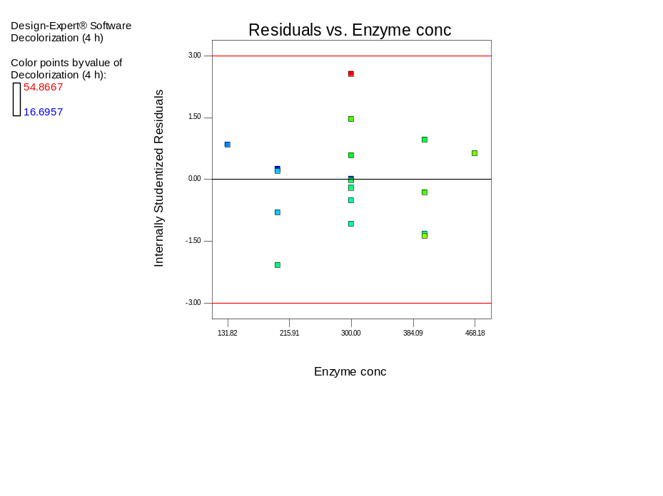
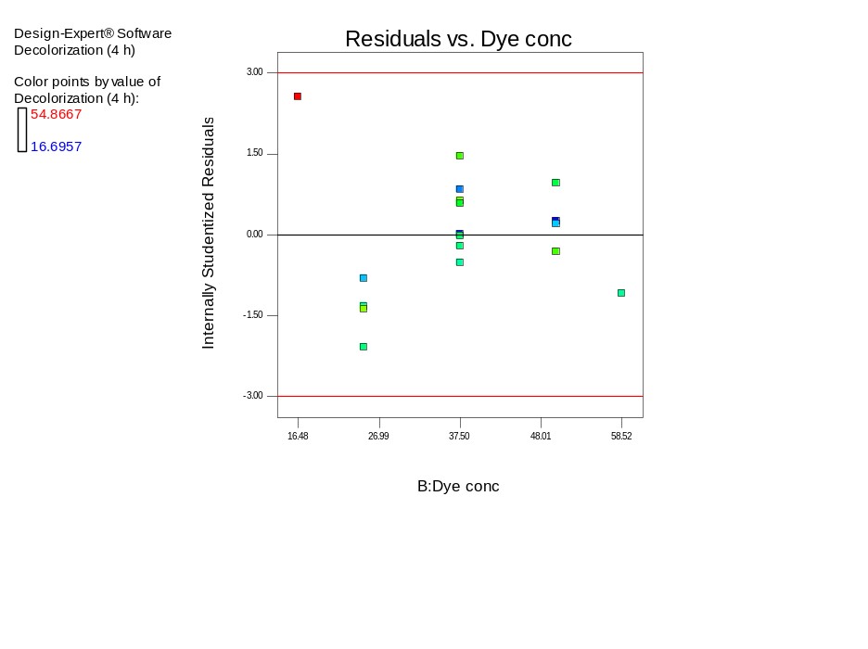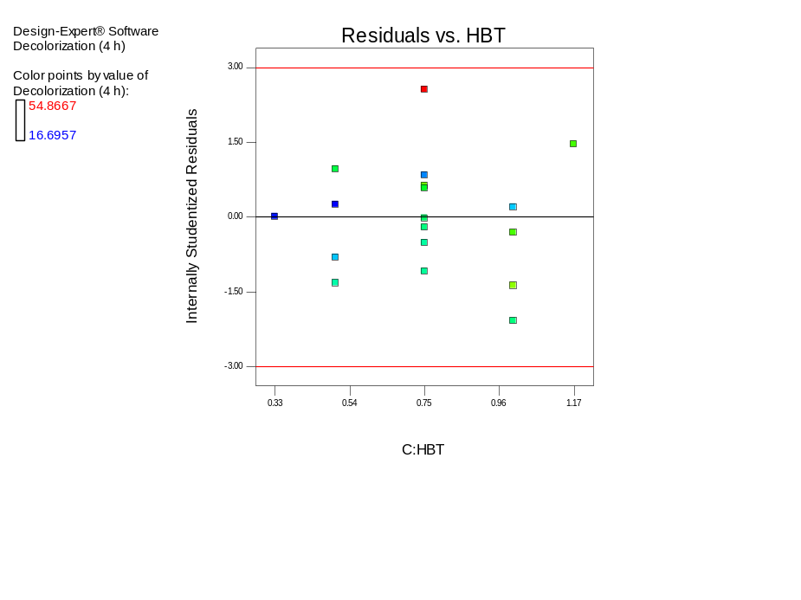
Fig S1: The residual analysis

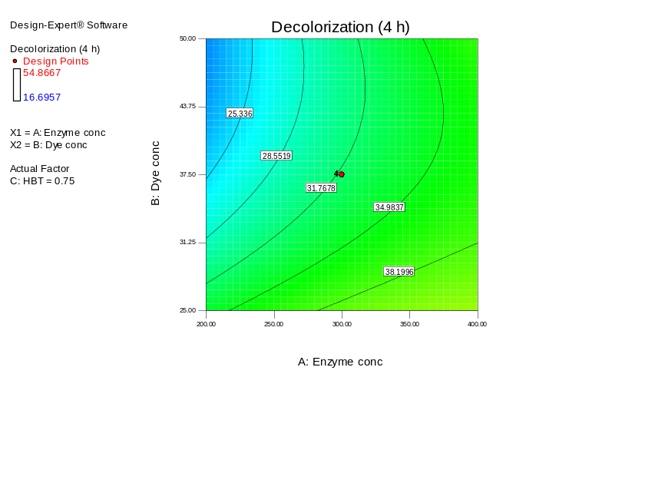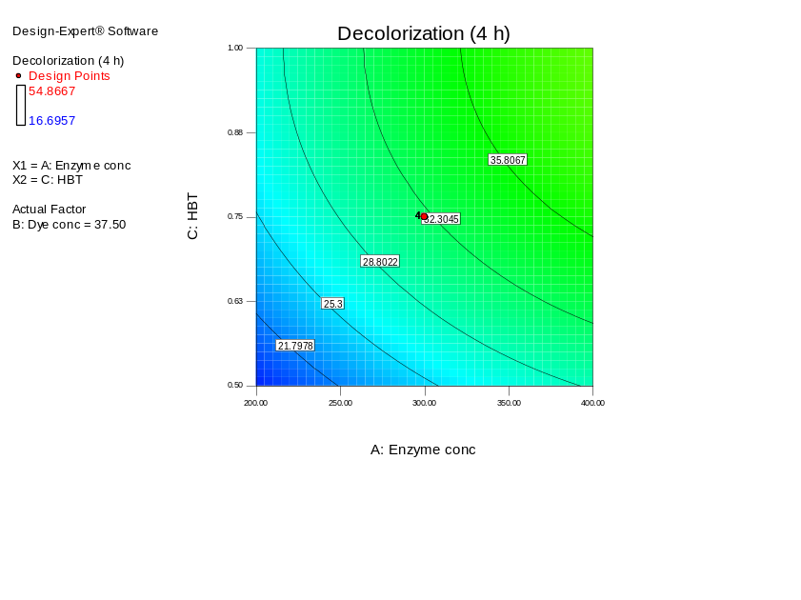
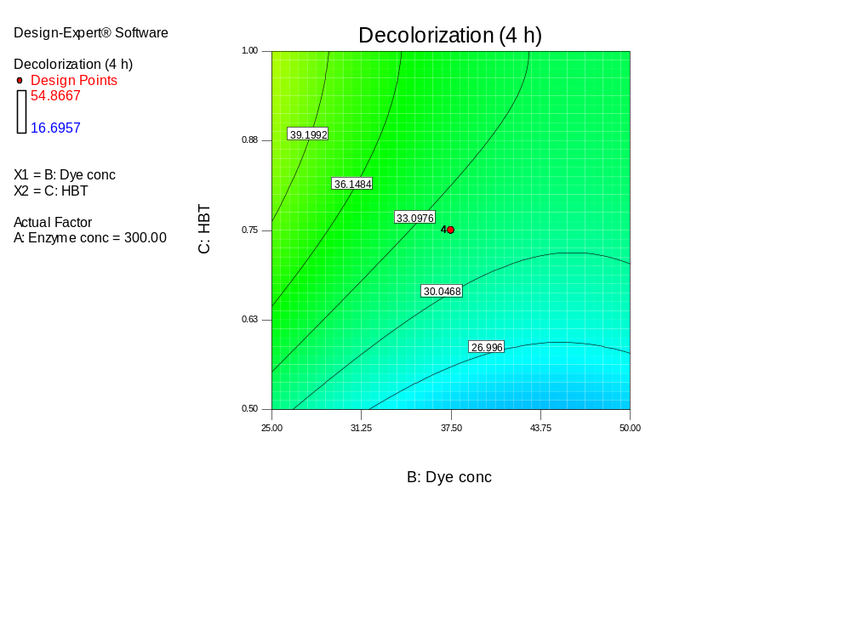
Fig. S2: counterplots of dye decolorization via CCD approach. The presented results are the effect of the two active parameters whereas the other parameter is held at 0 levels (300 µl of enzyme, 38 µl of dye, and 75 µl of HBT).

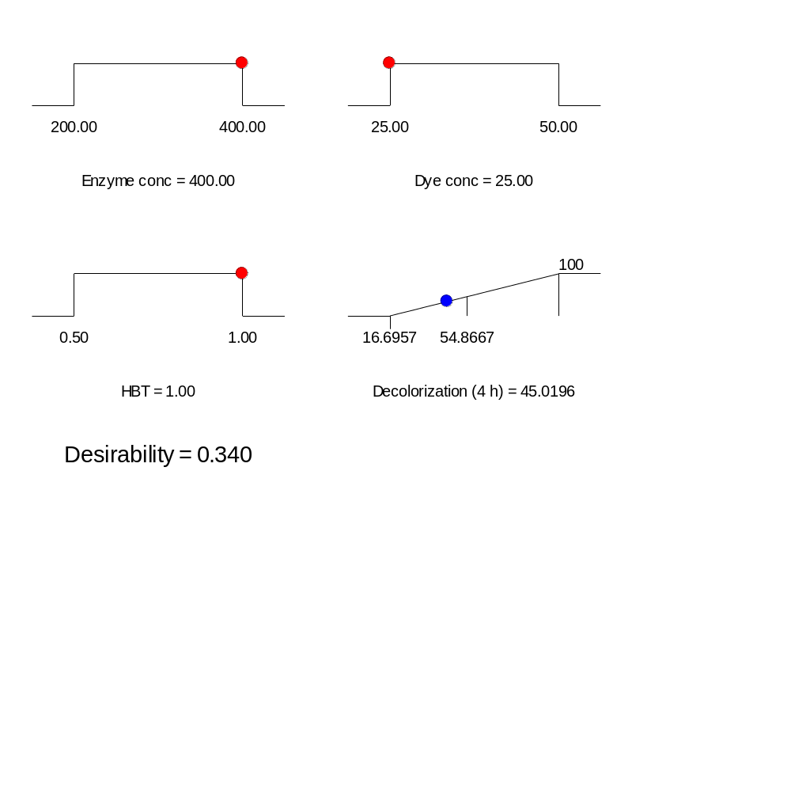

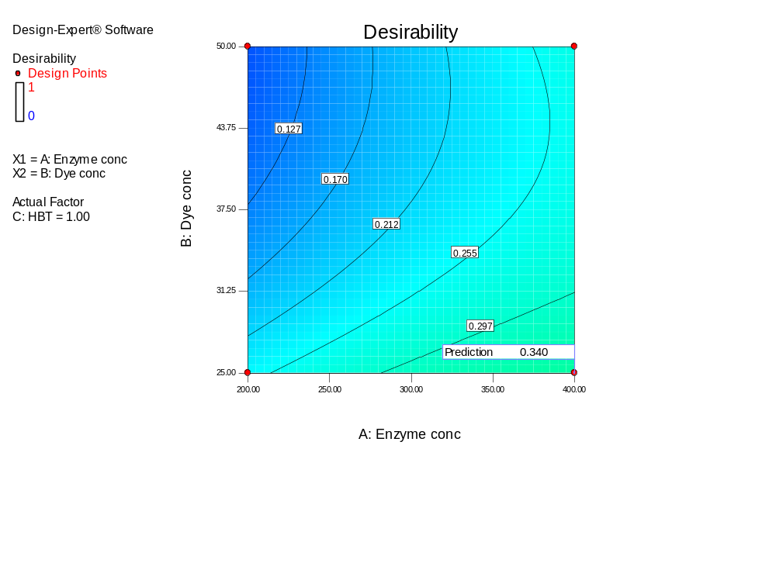
Fig S3: The desirability ramps and 3D plot for the optimization criteria

