SUPPLEMENTARY MATERIAL

Table S1. O₂ K_{m} values from climate models. Respiratory oxygen affinity constants (O₂ K_{m}) values used in climate models are often inferred by best fit to the model data, rather than from direct empirical observation. Models often set these constants in the micromolar range, contrasting with canonical microbiological knowledge of respiratory oxygen affinity constants, which are in the nanomolar range. The high K_{m} values used in models are supplied without rationale. The Hypoxic Barrier Hypothesis offer insight, as K_{m} values for catabolic oxygenase enzymes involved in the breakdown of some species of compounds found in complex organic matter fall within the micromolar range. For comparison, survey of >500 K_{m} reported values for non-respiratory oxidases found a median K_{m} value of 67 µM O₂.

K_{m} - O₂ (µM) | Domain | Reference
0.02 | North Pacific ODZ | (Penn, 2020) ¹
0.1 |  | (Slomp and Van Cappellen, 2007) ²
0.3 | Chilean OMZ | (Azhar et al., 2014) ³
1 | Global | (Sauerland et al., 2019) ⁴
1, 1, 2, 2, 1-16 | Global | (Kriest, 2017) ⁵
3.01, 6.32, 7.43, 7.53 | Global | (Pasquier et al., 2023) ⁶
4 | OMZs | (Bianchi et al., 2023) ⁷
4 to 12 | Global | (Laufkötter et al., 2017) ⁸
5 | Global | (Goosse et al., 2010) ⁹
8, 8, 8, 8, 2 | Global | (Kriest and Oschlies, 2015) ¹⁰
8 | Global | (Arndt et al., 2011) ¹¹
8 | Global | (Stock et al., 2020) ¹²
10, 15 | Gulf of Mexico | (Beck et al., 2017) ¹³
14 | Scheldt estuary | (Volta et al., 2013) ¹⁴
15 | Benguela EBUS | (Gutknecht et al., 2012) ¹⁵
20, 3 | Louisiana shelf | (Laurent et al., 2016) ¹⁶
20 | Global | (Gnanadesikan et al., 2011) ¹⁷
20 | Shelf system | (Krumins et al., 2013) ¹⁸
20 | Baltic Sea | (Reed et al., 2011) ¹⁹
20 |  | (Galbraith et al., 2009) ²⁰
30 | Bay of Marseille | (Barré et al., 2023) ²¹
30 | Global | (Matsumoto et al., 2021) ²²
31 | Idealized estuaries | (Volta et al., 2016) ²³
45.7 | Yarra Estuary | (Bruce et al., 2014) ²⁴
50, 31 | Global | (DeVries et al., 2012) ²⁵
51.25 | Idealized estuaries | (Volta et al., 2016) ²³

REFERENCES FOR TABLE S1

1 Penn, J. L. Biosphere Impacts of Ocean Hypoxia in a Warming Climate, (2020).
2 Slomp, C. & Van Cappellen, P. The global marine phosphorus cycle: sensitivity to oceanic circulation. Biogeosciences 4, 155-171 (2007).
3 Azhar, M. A., Canfield, D. E., Fennel, K., Thamdrup, B. & Bjerrum, C. J. A model‐based insight into the coupling of nitrogen and sulfur cycles in a coastal upwelling system. Journal of Geophysical Research: Biogeosciences 119, 264-285 (2014).
4 Sauerland, V., Kriest, I., Oschlies, A. & Srivastav, A. Multiobjective calibration of a global biogeochemical ocean model against nutrients, oxygen, and oxygen minimum zones. Journal of Advances in Modeling Earth Systems 11, 1285-1308 (2019).
5 Kriest, I. Calibration of a simple and a complex model of global marine biogeochemistry. Biogeosciences 14, 4965-4984 (2017).
6 Pasquier, B. et al. Optimal parameters for the ocean's nutrient, carbon, and oxygen cycles compensate for circulation biases but replumb the biological pump. EGUsphere, 1-38 (2023).
7 Bianchi, D., McCoy, D. & Yang, S. Formulation, optimization, and sensitivity of NitrOMZv1. 0, a biogeochemical model of the nitrogen cycle in oceanic oxygen minimum zones. Geoscientific Model Development 16, 3581-3609 (2023).
8 Laufkötter, C., John, J. G., Stock, C. A. & Dunne, J. P. Temperature and oxygen dependence of the remineralization of organic matter. Global Biogeochemical Cycles 31, 1038-1050 (2017). https://doi.org/10.1002/2017gb005643
9 Goosse, H. et al. Description of the Earth system model of intermediate complexity LOVECLIM version 1.2. Geoscientific Model Development 3, 603-633 (2010).
10 Kriest, I. & Oschlies, A. MOPS-1.0: towards a model for the regulation of the global oceanic nitrogen budget by marine biogeochemical processes. Geoscientific Model Development 8, 2929-2957 (2015).
11 Arndt, S., Régnier, P., Goddéris, Y. & Donnadieu, Y. GEOCLIM reloaded (v 1.0): A new coupled Earth system model for past climate change. Geoscientific Model Development 4, 451-481 (2011).
12 Stock, C. A. et al. Ocean biogeochemistry in GFDL's Earth System Model 4.1 and its response to increasing atmospheric CO2. Journal of Advances in Modeling Earth Systems 12, e2019MS002043 (2020).
13 Beck, M. W., Lehrter, J. C., Lowe, L. L. & Jarvis, B. M. Parameter sensitivity and identifiability for a biogeochemical model of hypoxia in the northern Gulf of Mexico. Ecological modelling 363, 17-30 (2017).
14 Volta, C., Arndt, S., Savenije, H., Laruelle, G. & Regnier, P. C-GEM (v 1.0): a new, cost-efficient biogeochemical model for estuaries and its application to a funnel-shaped system. Geosci Model Dev Discuss 6, 5645-5709 (2013).
15 Gutknecht, E. et al. Coupled physical/biogeochemical modeling including O2-dependent processes in the Eastern Boundary Upwelling Systems: application in the Benguela. Biogeosciences Discussions 9 (2012).
16 Laurent, A., Fennel, K., Wilson, R., Lehrter, J. & Devereux, R. Parameterization of biogeochemical sediment–water fluxes using in situ measurements and a diagenetic model. Biogeosciences 13, 77-94 (2016).
17 Gnanadesikan, A., Dunne, J. & John, J. Will open ocean oxygen stress intensify under climate change? Biogeosciences Discussions 8 (2011).
18 Krumins, V., Gehlen, M., Arndt, S., Van Cappellen, P. & Regnier, P. Dissolved inorganic carbon and alkalinity fluxes from coastal marine sediments: model estimates for different shelf environments and sensitivity to global change. Biogeosciences 10, 371-398 (2013).
19 Reed, D. C., Slomp, C. P. & Gustafsson, B. G. Sedimentary phosphorus dynamics and the evolution of bottom‐water hypoxia: A coupled benthic–pelagic model of a coastal system. Limnology and Oceanography 56, 1075-1092 (2011).
20 Galbraith, E., Gnanadesikan, A., Dunne, J. & Hiscock, M. Regional impacts of iron-light colimitation in a global biogeochemical model. Biogeosciences Discussions 6, 7517 (2009).
21 Barré, L. et al. Implementation and assessment of a model including mixotrophs and the carbonate cycle (Eco3M_MIX-CarbOx v1. 0) in a highly dynamic Mediterranean coastal environment (Bay of Marseille, France)(Part I): Evolution of ecosystem composition under limited light and nutrient conditions. Geoscientific Model Development Discussions 2023, 1-54 (2023).
22 Matsumoto, K., Tanioka, T. & Zahn, J. MESMO 3: Flexible phytoplankton stoichiometry and refractory DOM. Geoscientific Model Development Discussions 2021, 1-61 (2021).
23 Volta, C., Laruelle, G. G., Arndt, S. & Regnier, P. Linking biogeochemistry to hydro-geometrical variability in tidal estuaries: a generic modeling approach. Hydrology and earth system sciences 20, 991-1030 (2016).
24 Bruce, L. C., Cook, P., Teakle, I. & Hipsey, M. R. Hydrodynamic controls on oxygen dynamics in a riverine salt wedge estuary, the Yarra River estuary, Australia. Hydrology and Earth System Sciences 18, 1397-1411 (2014).
25 DeVries, T., Deutsch, C., Rafter, P. & Primeau, F. Marine denitrification rates determined from a global 3-dimensional inverse model. Biogeosciences Discussions 9 (2012).

Figure S1. Temporal changes in chlorophyll concentration over the course of the experiment. The 200 L phytoplankton bloom is depicted in green before transfer to the treatment carboys on day 4. The increase in chlorophyll immediately following transfer may indicate photoacclimation in viable phytoplankton cells.

Figure S2. Fluctuations in cell counts over time, as assessed using epifluorescence microscopy with DAPI staining. Cells remained at 10⁵ and 10⁶ levels throughout the duration of the 100-day experiment.

Figure S3. Jaccard distances, calculated with a binary transformation, depicting the dynamic shifts in microbial communities between hypoxic and oxic treatments over the 100-day period. Initially, both treatments cluster closely until day 14, after which they begin to diverge. Following an oxygen upshift on day 44, the communities display persistent divergence throughout the remainder of the experiment.

TABLE S2 (separate file). Hypoxia Sensitive ASVs that are significantly different in abundance between the hypoxic and oxic treatments at a p-value ≤ 0.05, determined via differential abundance analysis using DESeq2. Note that these data were aggregated to produce the taxonomical hierarchy presented in Fig. 5, and during aggregation, some recognizable taxa are lost because not all ASVs in that category have the same response, or because variability between treatments impacted the aggregate score for that taxonomic category. It's obvious in this table that some individual ASVs are highly impacted by hypoxia, but only in some cases does statistical significance propagate to higher taxonomic categories, as discussed in the main text.

Figure S4. SAR86 ASVs enriched at day 44 in the hypoxic treatment are members of the D2472 subclade. A phylogenetic tree based on 16S sequences from all SAR86 reference genomes available in NCBI’s genome database as well as the five SAR86 ASVs from our study is shown. All five SAR86 ASVs from our study are in two subclades of the tree that are part of the D2472 family of SAR86, indicated by green shading. Tree tips are colored based on sequence type, with the 16S sequences from reference genomes shown in red, and the ASVs from this study shown in blue.
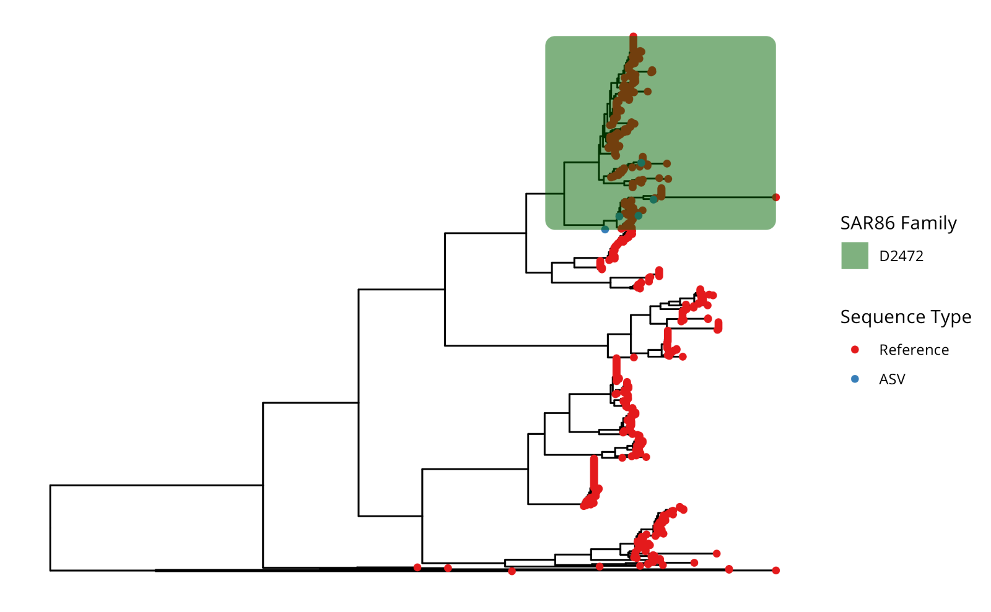

Figure S5. SAR86 D2472 family members inhabit diverse geographic locations. The latitude and longitude metadata from the SAR86 reference genomes were used to generate a world map showing the locations where the SAR86 genomes were detected worldwide. D2472 family members were found in diverse locations across the globe, at a range of longitudes and latitudes. Members of the D2472 family are shown with green circles, while all other SAR86 members are shown with blue circles.

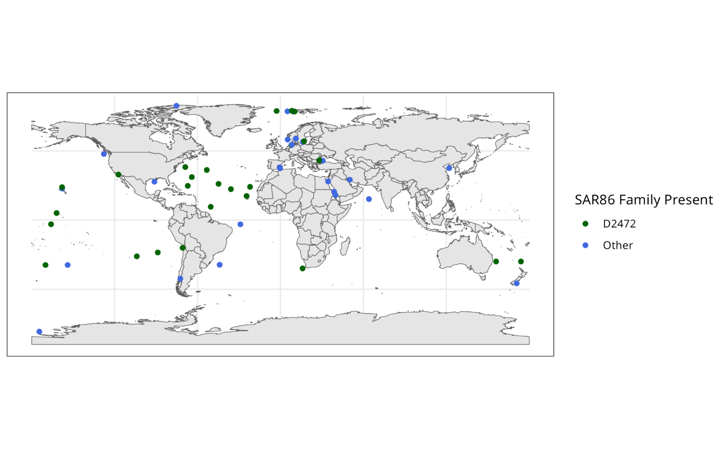

Table S3. Estimated TOU from TOC based on ARQ values. In Figure S6, ARQ values were estimated based on reported ARQs derived from community respiration measurements. ARQ values vary across systems and within a single system from ca. 0.30 to 3.10 with a median ARQ of 0.88 across marine ecosystems¹. Li and Peng’s modified Redfield ratio for the North Pacific Ocean gives an ARQ of 0.76 [P/N/C_{org}/-O₂ = 1/(13 ± 1)/ (124 ± 11)/(162 ± 11)]².

ARQ | Citation | Hypoxic  TOU (µM O₂) | Oxic  TOU (µM O₂)
0.30 | Robinson, 2019 | 1827.3 | 1932.7
0.76 | Li and Peng, 2002 | 721.3 | 723.4
0.88 | Robinson, 2019 | 623.0 | 624.8
3.10 | Robinson, 2019 | 176.8 | 177.4
Observed | - | 2192.2 | 2436.8

Figure S6. Total Oxygen Utilization (TOU) modeled from measured changes in TOC, assuming a range of different Respiratory Quotient (RQ) Values. TOU was measured experimentally in this study by integrating oxygen utilization rates over time, as described in the methods, and shown in Fig. 2B. ARQ values reported for marine systems range from 0.30 to 3.10 (Table S3). Curves below show TOU in this experiment (brown curve) and TOU estimated from changes in measured TOC, using ARQs of 0.30, 0.76, 0.88, and 3.10. These ARQs assume both carbon and nitrogen oxidation at Redfield ratios. The single asterisk (*) is an estimate of the expected TOU due to N chemolithotrophy calculated from the total change in TOC over the duration of the experiment by assuming ammonium ion was released at the Redfield ratio and oxidized to nitrate. The double asterisk (**) indicates the additional oxygen that would be needed to oxidize the TOC remaining on day 100 from an RQ of 0.30 to an RQ of 3.10, without changing TOC values. Equations and calculations are shown below the figure.

Additional text for Figure S6:

Calculating estimated TOU for Figure S6:
RQ values used to model TOU ranging from 0.3 (most reduced) to 3.1 (most oxidized).
|[∆TOC] / ARQ = Modeled TOU (µM O₂)

Asterisks on Figure S6 indicate:

* The expected TOU from N chemolithotrophy calculated from the total change in TOC (T_{i}-T_{f}) by assuming that ammonium was produced in Redfield ratios and oxidized to nitrate.

** The amount of additional oxygen needed to change the TOC remaining on day 100 from an ARQ of 0.30 to 3.10. TOC becomes more oxidized in the oceans as it is diagenetically altered. This value was calculated to give readers a sense of the scale of changes in TOU that could be attributed to changes in the oxidation state of carbon that remains at the end of the experiment. The interval we chose is a range that encompasses most ARQ values reported in the literature¹.
______

1. Calculation of potential TOU from chemolithotrophic oxidation of ammonium to nitrate, indicated by “*” on day 100 in Figure S6.

Hypoxic treatment:

[∆TOC] = TOC_{f} -TOC_{i}
684.9 µM C - 146.9 µM C = 538.0 µM C

(538 µM C)*(16/106) = 81.2 µM ammonium ion (NH₄⁺)
^{*106:16 = Redfield C:N ratio}

For each mole of NH₄⁺, a total of 2.5 moles of O₂ are consumed.

NH₄⁺ + 2 O₂ → NO₂⁻+ 2 H₂O
NO₂⁻+ 0.5 O₂ → NO₃⁻

For 81.2 µM of ammonium (NH₄⁺), the predicted concentration of O₂ consumed would be:

(81.2 µM N) * (2.5 moles O₂ / 1 mole NH₄⁺) = 202.5 µM O₂

Therefore, approximately 202.5 µM of oxygen (O₂) would be required to oxidize 81.2 µM of nitrogen (N) from ammonium (NH₄⁺) to nitrate (NO₃⁻) in the hypoxic treatment.

Oxic treatment:

The calculation for the oxic treatment yields a value nearly identical to the one above. The increase obtained by considering changes in the oxidation state of N is 9% of the observed TOU.
2. ** in Figure S6. This symbol was added to the figure to indicate the potential theoretical contribution to TOU from changes in the oxidation state of recalcitrant TOC remaining at the end of the experiment. Phrased another way, the stable amounts of TOC values observed over the final 75 days of the experiment do not necessarily mean that no further oxygen was consumed by organic carbon oxidation. At any time in the experiment changes in the net oxidation state of TOC are theoretically possible, and indeed expected based on published studies^{3,4}. To make this calculation, we assumed that the recalcitrant TOC remaining at the end of the experiment changed in RQ by a value of +2.8, the difference between the range of ARQs that have been reported (Table S3).

A. Additional oxygen needed to change the oxidation state of the amount of TOC remaining on day 100 from an RQ of 0.3 to 3.1

Hypoxic treatment:

Remaining TOC = 146.9 µM C

(146.9 µM C/0.30 C/O₂) - (146.9 µM C/3.10 C/O₂) = 489.7 - 47.4 = 442.3 µM O₂

Oxic treatment:

Remaining TOC = 152.4 µM C

(152.4 µM C/0.30 C/O₂) - (152.4 µM C/3.10 C/O₂) = 508.0 - 49.2 = 458.8 µM O₂

B. The percent increase of observed TOU that could be attributed to changes in the oxidation state of TOC between the beginning and end of the experiment:

Hypoxic treatment: (411 µM O₂ / 2192 µM O₂ compared to µM O₂) × 100 = 18.8%

Oxic treatment: (426 µM O₂ / 2437 µM O₂) × 100 = 17.5%

These estimates are an outside boundary of the amount of oxygen uptake that could be explained by assuming over the time course of the experiment that TDOC observed could have changed from an oxidation state (represented in units of ARQ) 0.3 to 3.1, which is approximately the extreme range of ARQ values that have been observed.

Conclusions: Changes in the oxidation state of ammonium and the ARQ of the residual (recalcitrant) TOC remaining in the carboys at the end of the experiment could account for approximately of a quarter of observed TOU.

REFERENCES FOR FIGURE S6

1 Robinson, C. Microbial Respiration, the Engine of Ocean Deoxygenation. Frontiers in Marine Science 5 (2019). https://doi.org/10.3389/fmars.2018.00533
2 Li, Y.-H. & Peng, T.-H. Latitudinal change of remineralization ratios in the oceans and its implication for nutrient cycles. Global Biogeochemical Cycles 16, 77-71-77-16 (2002). https://doi.org/10.1029/2001gb001828
3 Chen, J. et al. DOC dynamics and bacterial community succession during long-term degradation of Ulva prolifera and their implications for the legacy effect of green tides on refractory DOC pool in seawater. Water Research 185, 116268 (2020).
4 Ogawa, H., Amagai, Y., Koike, I., Kaiser, K. & Benner, R. Production of refractory dissolved organic matter by bacteria. Science 292, 917-920 (2001).

Figure S7. Description of the incubation experiments accompanied with calculations for an example carboy from each treatment.

Experimental design

All rate experiments were conducted in a 16C temperature-controlled room. To determine oxygen utilization rate for a given time point, 3 samples were drawn from each carboy using a sampling port. It was a completely closed system and water was siphoned into the optode vials (covered in foil) filling from the bottom to top, overflowing 3x before capping with a glass stopper and sealing with parafilm. The vials were placed into a temperature-controlled water bath and optode readings were measured without removing vials from the water bath. Oxygen concentration (µmol/L) was measured over a duration of hours, not exceeding 12 hours.

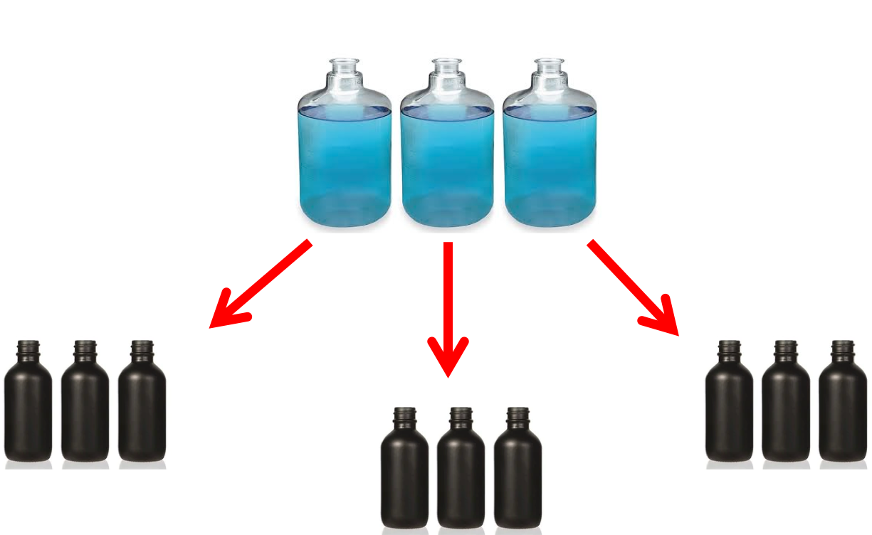

Calculating Oxygen Utilization Rate

Table S6. Example HYPOXIC Carboy:

Date/Time | Time Elapsed (minutes) | H1a  (µM) | H1b  (µM) | H1c  (µM)
6/24/21 10:30AM | 0 | 9.1 | 12.5 | 17.2
6/24/21 11:35AM | 65 | 6.8 | 10.2 | 13.9
6/24/21 12:25PM | 115 | 6.5 | 10.8 | 13.3
6/24/21 1:05PM | 155 | 5.6 | 9.3 | 12.6
6/24/21 1:46PM | 196 | 4.5 | 7.7 | 11.7
6/24/21 2:25PM | 235 | 4.3 | 7.4 | 10.8
6/24/21 3:10PM | 280 | 2.7 | 7 | 9.2
6/24/21 5:30PM | 420 |  | 5.4 | 8.7

Blue indicates measurements included in plot below for rate determination
following temperature equilibration of optode vials in water bath.

Table S5. The slope of the line determines rate of oxygen utilization per minute.

Rate per minute | 0.019 | 0.016 | 0.016
Avg per minute |  | 0.017
Rate per day | 27.504 | 22.320 | 23.472
Average rate per day | 24.432

Calculating Total Oxygen Utilization

Table S6. Hypoxic Treatment oxygen utilization rates for each sampling date (µM*d⁻¹)
Date | Time elapsed between sampling(day) | H1  (µM*d⁻¹) | H2  (µM*d⁻¹) | H3  (µM*d⁻¹) | Average of Hypoxic Carboys  (µM*d⁻¹) | St Dev
6/7/21 | 0.00 | 111.0240 | 113.1360 | 85.9200 | 103.36 | 15.14
6/11/21 | 3.82 | 45.8880 | 72.3840 | 57.4080 | 58.56 | 13.29
6/14/21 | 3.02 | 65.6160 | 98.6400 | 47.5200 | 70.59 | 25.92
6/17/21 | 3.06 | 32.4720 | 43.0560 | 35.1840 | 36.90 | 5.50
6/21/21 | 3.92 | 48.2400 | 47.6640 | 37.9200 | 44.61 | 5.80
6/24/21 | 3.00 | 24.4320 | 24.4320 | 16.7040 | 21.86 | 4.46
6/28/21 | 3.99 | 17.1840 | 25.2000 | 21.0720 | 21.15 | 4.01
7/1/21 | 3.02 | 32.4480 | 25.1040 | 25.5840 | 27.71 | 4.11
7/6/21 | 5.00 | 29.7120 | 11.1840 | 11.6640 | 17.52 | 10.56
7/13/21 | 6.99 | 12.1920 | 11.4240 | 9.0720 | 10.90 | 1.63
7/19/21 | 6.02 | 10.8000 | 9.5760 | 7.2960 | 9.22 | 1.78
7/21/21 | 1.95 | 22.0800 | 8.9760 | 9.2160 | 13.42 | 7.50
7/26/21 | 7.15 | 11.4720 | 12.4320 | 11.1840 | 11.70 | 0.65
7/29/21 | 1.86 | 19.3920 | 28.8480 | 27.1200 | 25.12 | 5.04
8/3/21 | 6.05 | 17.1840 | 13.5840 | 9.4080 | 13.39 | 3.89
8/10/21 | 6.93 | 19.2960 | 10.3200 | 20.2080 | 16.61 | 5.46
8/18/21 | 7.01 | 22.3200 | 11.5680 | 12.3840 | 15.42 | 5.99
8/24/21 | 6.00 | 12.0480 | 11.7120 | 6.1440 | 9.97 | 3.32
8/31/21 | 6.90 | 25.7760 | 16.1760 | 15.9360 | 19.30 | 5.61
9/7/21 | 7.06 | 13.6800 | 7.8240 | 9.7920 | 10.43 | 2.98
9/14/21 | 6.88 | 9.7920 | 10.2240 | 10.2720 | 10.10 | 0.26

To calculate Total Oxygen Utilization, we took the integrated area under the curve between two time points (shown as A and B below) and plotted cumulatively.

((Rate_{A} + Rate_{B})/2)*(Time elapsed between sample collection)

Table S7. Total oxygen utilization over time in hypoxic carboys
Total Time Elapsed | H1  (µM) | H2  (µM) | H3  (µM) | Average of Hypoxic Carboys  (µM) | St Dev
2 | 299.66 | 354.29 | 273.72 | 309.22 | 41.13
5 | 468.08 | 612.61 | 432.20 | 504.30 | 95.50
8 | 617.93 | 829.09 | 558.55 | 668.53 | 142.19
12 | 776.27 | 1007.06 | 701.97 | 828.44 | 159.09
15 | 885.28 | 1115.21 | 783.91 | 928.13 | 169.76
19 | 968.30 | 1214.21 | 859.26 | 1013.92 | 181.82
22 | 1043.18 | 1290.11 | 929.65 | 1087.64 | 184.30
26 | 1198.68 | 1380.89 | 1022.84 | 1200.80 | 179.04
32 | 1345.13 | 1459.90 | 1095.30 | 1300.11 | 186.42
39 | 1414.38 | 1523.15 | 1144.61 | 1360.72 | 194.90
43 | 1446.47 | 1541.26 | 1160.72 | 1382.81 | 198.09
47 | 1566.46 | 1617.82 | 1233.68 | 1472.65 | 208.55
52 | 1595.18 | 1656.23 | 1269.32 | 1506.91 | 208.01
56 | 1705.80 | 1784.56 | 1379.79 | 1623.38 | 214.60
62 | 1832.15 | 1867.35 | 1482.37 | 1727.29 | 212.84
69 | 1978.09 | 1944.11 | 1596.67 | 1839.62 | 211.09
76 | 2081.20 | 2013.95 | 1652.25 | 1915.80 | 230.70
82 | 2211.69 | 2110.17 | 1728.43 | 2016.76 | 254.81
89 | 2350.88 | 2194.83 | 1819.19 | 2121.63 | 273.30
96 | 2431.61 | 2256.90 | 1888.19 | 2192.24 | 277.42

Above are the plotted values in Figure 3B.

Table S8. Example OXIC Carboy:

Date/Time | Time Elapsed (minutes) | S6a (µM) | S6b (µM) | S6c (µM)
6/24/21 10:40AM | 0 | 299.7 | 298.9 | 317.3
6/24/21 11:35AM | 65 | 299.4 | 298 | 318.2
6/24/21 1:05PM | 155 | 299.3 | 296.1 | 315.4
6/24/21 2:25PM | 235 | 295.3 | 294 | 314
6/24/21 5:30PM | 420 | 292.1 | 292 | 312.9
6/25/21 1:05PM | 1595 | 258.2 | 277.6 | 299.6

Blue indicates measurements included in plot below for rate determination
following temperature equilibration of optode vials in water bath.

Table S9. The slope of the line determines rate of oxygen utilization per minute.

Rate per minute | 0.0223 | 0.0168 | 0.014
Avg per minute |  | 0.0177
Rate per day | 32.1120 | 24.1920 | 20.1600
Average rate per day | 25.4880

Calculating Total Oxygen Utilization

Table S10. Oxic Treatment oxygen utilization rates for each sampling date per carboy
Date | Time elapsed between sampling(day) | S4  (µM * d⁻¹) | S5  (µM * d⁻¹) | S6  (µM * d⁻¹) | Average of Oxic Carboys  (µM * d⁻¹) | St Dev
6/7/21 | 0.00 | 87.6000 | 110.1120 | 111.4080 | 103.04 | 10.92
6/11/21 | 3.82 | 76.3200 | 44.4960 | 84.9120 | 68.58 | 21.29
6/14/21 | 3.02 | 137.8080 | 107.4720 | 140.2080 | 128.50 | 18.25
6/17/21 | 3.06 | 28.9440 | 36.8640 | 39.0240 | 34.94 | 5.31
6/21/21 | 3.92 | 52.6560 | 43.2480 | 53.0880 | 49.66 | 5.56
6/24/21 | 3.00 | 20.6880 | 34.8480 | 25.4880 | 27.01 | 7.20
6/28/21 | 3.99 | 20.9760 | 25.6800 | 24.8160 | 23.82 | 2.50
7/1/21 | 3.02 | 20.0160 | 21.0240 | 43.2480 | 28.10 | 13.13
7/6/21 | 5.00 | 21.4080 | 26.0640 | 20.3040 | 22.59 | 3.06
7/13/21 | 6.99 | 9.9840 | 23.3760 | 15.9360 | 16.43 | 6.71
7/19/21 | 6.02 | 10.6080 | 14.8320 | 14.5920 | 13.34 | 2.37
7/21/21 | 1.95 | 10.5600 | 21.3120 | 20.2080 | 17.36 | 5.91
7/26/21 | 7.15 | 8.1120 | 12.0000 | 12.1440 | 10.75 | 2.29
7/29/21 | 1.86 | 4.0320 | 17.4240 | 13.2960 | 11.58 | 6.86
8/3/21 | 6.05 | 4.3200 | 18.4320 | 25.9680 | 16.24 | 10.99
8/10/21 | 6.93 | 9.5040 | 18.0000 | 23.4240 | 16.98 | 7.02
8/18/21 | 7.01 | 8.0160 | 9.6000 | 13.6320 | 10.42 | 2.90
8/24/21 | 6.00 | 4.9680 | 9.9840 | 11.1360 | 8.70 | 3.28
8/31/21 | 6.90 | 13.9200 | 13.1520 | 21.0240 | 16.03 | 4.34
9/7/21 | 7.06 | 8.4480 | 9.9840 | 8.3520 | 8.93 | 0.92
9/14/21 | 6.88 | 11.2320 | 13.7280 | 10.2240 | 11.73 | 1.80

To calculate Total Oxygen Utilization, we took the integrated area under the curve between two time points (shown as A and B below) and plotted cumulatively.

((Rate_{A}+ Rate_{B})/2)*(Time elapsed between sample collection)

Table S11. Total oxygen utilization over time in oxic carboys
Total Time Elapsed | S4  (µM * d⁻¹) | S5  (µM * d⁻¹) | S6  (µM * d⁻¹) | Average of Oxic Carboys  (µM * d⁻¹) | St Dev
2 | 313.04 | 295.26 | 374.92 | 327.74 | 41.81
5 | 636.46 | 524.79 | 714.94 | 625.40 | 95.56
8 | 891.22 | 745.31 | 988.77 | 875.10 | 122.53
12 | 1051.31 | 902.47 | 1169.47 | 1041.08 | 133.79
15 | 1161.32 | 1019.61 | 1287.34 | 1156.09 | 133.94
19 | 1244.43 | 1140.36 | 1387.68 | 1257.49 | 124.18
22 | 1306.28 | 1210.82 | 1490.37 | 1335.82 | 142.10
26 | 1409.91 | 1328.62 | 1649.36 | 1462.63 | 166.74
32 | 1519.62 | 1501.40 | 1776.01 | 1599.01 | 153.56
39 | 1581.64 | 1616.49 | 1867.97 | 1688.70 | 156.22
43 | 1602.30 | 1651.76 | 1901.92 | 1718.66 | 160.63
47 | 1669.08 | 1770.89 | 2017.63 | 1819.20 | 179.22
52 | 1680.38 | 1798.27 | 2041.30 | 1839.98 | 184.04
56 | 1705.64 | 1906.71 | 2160.04 | 1924.13 | 227.70
62 | 1753.52 | 2032.90 | 2331.12 | 2039.18 | 288.85
69 | 1814.96 | 2129.69 | 2461.07 | 2135.24 | 323.09
76 | 1853.91 | 2188.44 | 2535.37 | 2192.57 | 340.75
82 | 1919.07 | 2268.26 | 2646.33 | 2277.89 | 363.72
89 | 1997.98 | 2349.88 | 2749.96 | 2365.94 | 376.24
96 | 2065.67 | 2431.43 | 2813.84 | 2436.98 | 374.12

Above are the plotted values in Figure 3B.

