Supplementary

Supplementary table 1. Dataset 2 testing of a series of binary classification results from the automatic FS segmentation model.
 | U-net | Attention U-net | U-net++ | USE-net
DSC (SD)
1-fold | 0.733 (0.139) | 0.729 (0.138) | 0.721 (0.162) | 0.737 (0.114)
2-fold | 0.730 (0.125) | 0.710 (0.149) | 0.716 (0.144) | 0.712 (0.138)
3-fold | 0.714 (0.134) | 0.720 (0.118) | 0.736 (0.108) | 0.720 (0.123)
4-fold | 0.744 (0.164) | 0.760 (0.107) | 0.757 (0.133) | 0.750 (0.124)
5-fold | 0.738 (0.104) | 0.738 (0.139) | 0.727 (0.139) | 0.737 (0.109)
Average DSC (SD) | 0.732 (0.101) | 0.731 (0.171) | 0.731 (0.144) | 0.731 (0.135)
ICC [95% CI]
1-fold | 0.857 [0.792 - 0.902] | 0.862 [0.799 - 0.905] | 0.864 [0.802 - 0.906] | 0.861 [0.797 - 0.904]
2-fold | 0.869 [0.830 - 0.899] | 0.837 [0.789 - 0.894] | 0.862 [0.821 - 0.893] | 0.855 [0.812 - 0.888]
3-fold | 0.868 [0.837 - 0.893] | 0.843 [0.806 - 0.873] | 0.856 [0.821 - 0.883] | 0.845 [0.808 - 0.875]
4-fold | 0.873 [0.848 - 0.894] | 0.869 [0.843 - 0.891] | 0.877 [0.852 - 0.898] | 0.869 [0.843 - 0.891]
5-fold | 0.860 [0.835 - 0.881] | 0.838 [0.809 - 0.862] | 0.850 [0.824 - 0.873] | 0.842 [0.814 - 0.866]
Average ICC (SD) | 0.865 (0.006) | 0.850 (0.013) | 0.862 (0.009) | 0.854 (0.010)
The ensemble values of the five models generated from 5 fold cross-validation were averaged as the classification results depending on the cutoff volume. AUC, area under the curve.

Supplementary figure
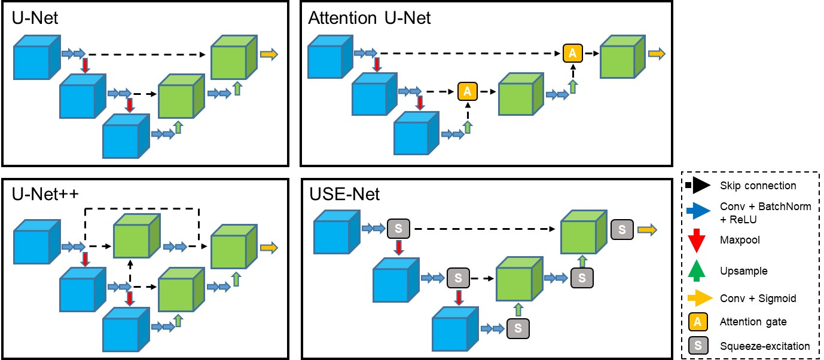
Supplementary figure 1. Summary of the 3-D U-Net based architectures compared in this study. Each architecture is illustrated with 2 layers for simplicity.

