s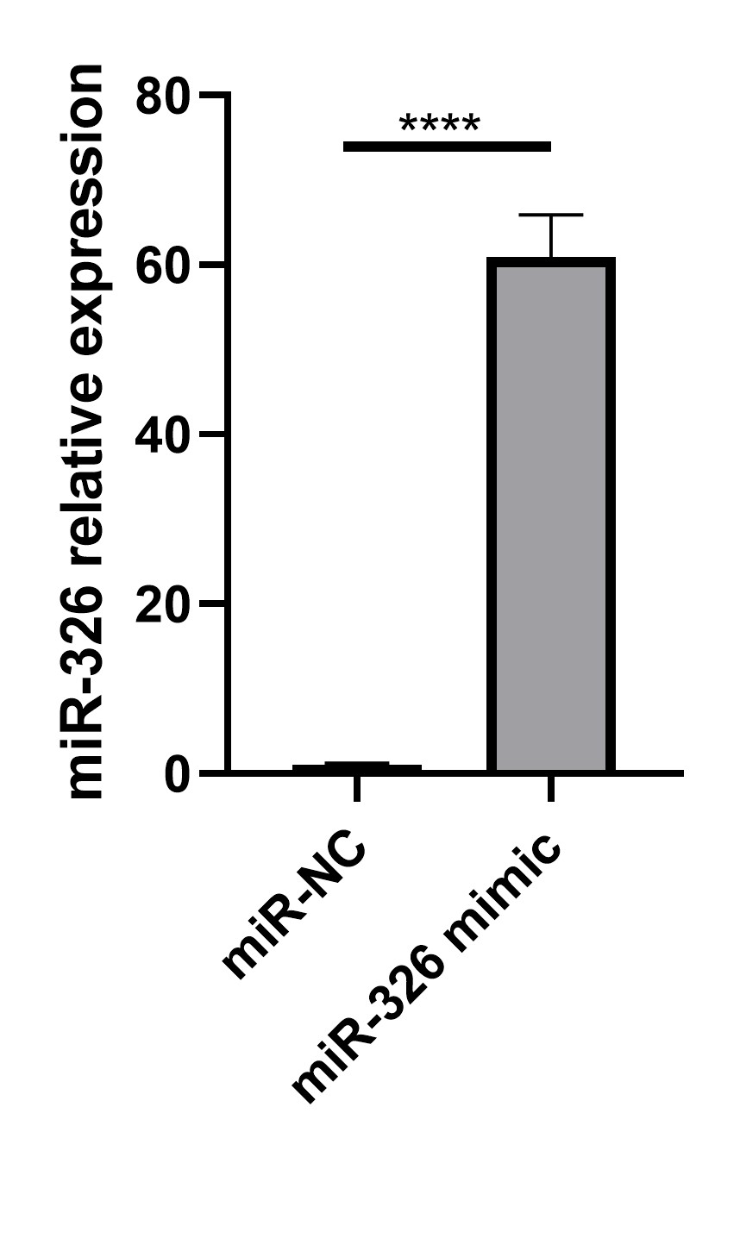
Supplementary Figure 1. The levels of miR-326 mimic HEK293T cells transfected with miR-NC and miR-326 was determined by qPCR.
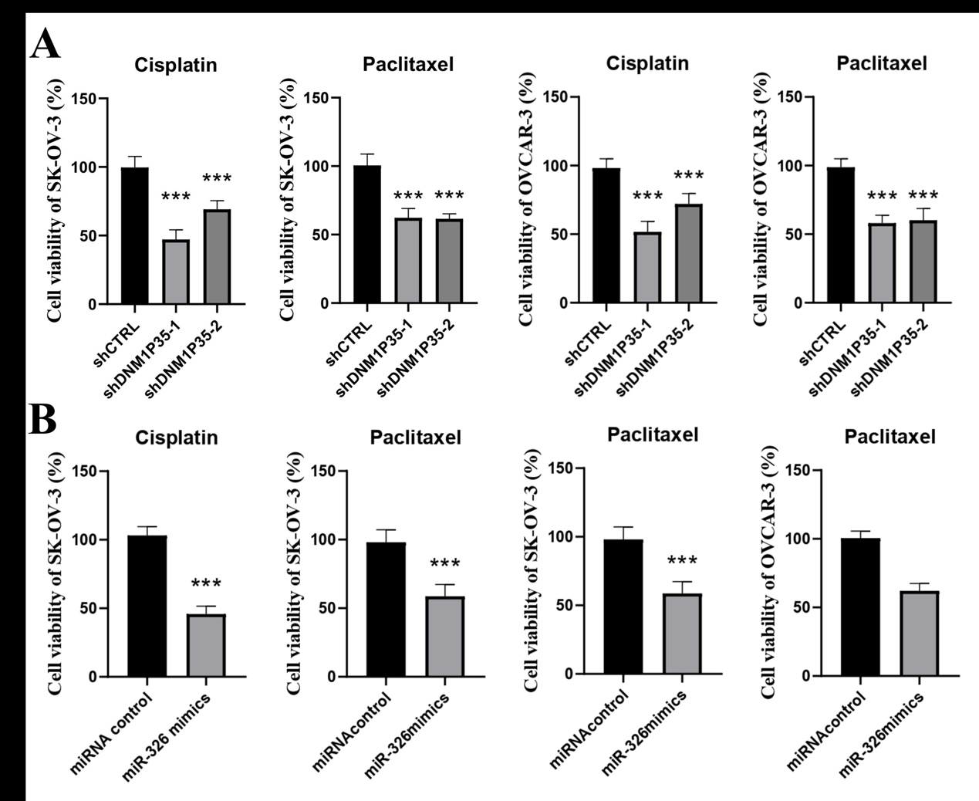
Supplementary Figure 2. A) Cell viability of SK-OV-3 and OVCAR-3 cells with DNM1P35 knockdown treated with cisplatin (10 μM) or paclitaxel (10 μM) for 72 hours were assessed by CCK-8 assay. B) Cell viability of SK-OV-3 and OVCAR-3 cells with miR-326 mimics treated with cisplatin (10 μM) or paclitaxel (10 μM) for 72 hours were assessed by CCK-8 assay.

